HACKATHON PROJECT

Requirements Specifications Document

|  |  |  |  |
| --- | --- | --- | --- |
|  | **Prepared By-** | **Reviewed By-** | **Approved By-** |
| **Name** | Brains in Jars | Deva Thilagai |  |
| **Role** | Entry Level Trainees | Batch Trainer |  |

Table of Contents

1. Introduction
   1. Intended Audience
   2. Project Scope
2. Overall Description
   1. Operating Environment
3. Requirements

3.1 Functional Requirements

3.1.1 Home Page Functionality

3.1.2 Displaying 5 Car washing services name and phone number

3.1.3 Trying to register for Free Listing

3.1.4 Retrieving all the submenu items from the Gym sub-section of fitness

1. Introduction

Justdial is an online website which provides the solutions for all your problems. We are taking and testing three different functionalities of that website(i.e.,)

* Displaying 5 Car washing services name and phone numbers
* Trying to register for Free Listing
* Retrieving all the submenu items from the Gym sub-section of fitness

**1.1 Intended Audience**

* Business Unit (BU) SME
* Academy coach
* Technical Trainer

**1.2 Project Scope**

This document defines at a functional level the business activities that are encompassed by the system and the rules that apply to them. It also encompasses some of the key high- and low-level technical requirements of the system.

It draws heavily on both proposed Framework and Business Rules and the Technical Architecture documents. The scope of the detailed analysis project phase specifies that this document will include.

Classification of requirements according to their functional areas.

· A description of each process in the system, including their inputs, outputs, and data transformation rules.

**2. Overall Description**

**2.1 Operating Environment**

* Windows operating system
* Web application

**3.. Requirements**

This part of the requirements document serves to present the “Justdial” application and the various tasks which we need to perform.

**3.1 Functional Requirements**

**3.1.1 Homepage Functionality**

3.1.1.1 Verify that page opened is Justdial.com

3.1.1.2 Verify that page with Free Listing option appears when Free Listing menu is clicked

3.1.1.3 Verify that page with Contacting customer care option appears when Customer care menu is clicked

3.1.1.4 Verify that page with JD Social menu option appears when Social menu is clicked

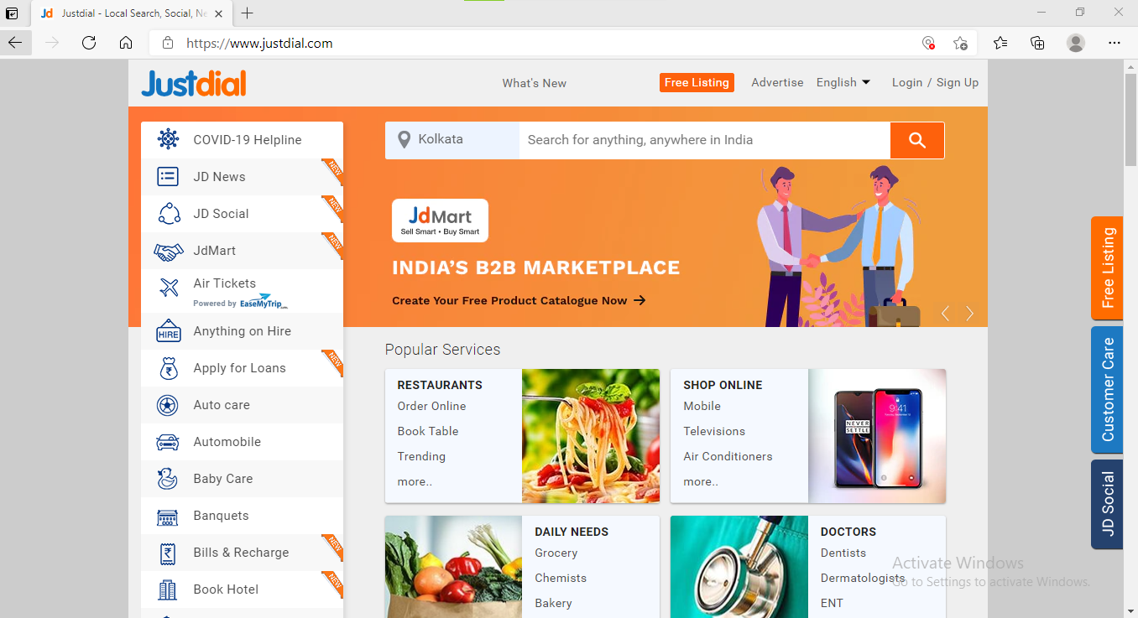

**3.1.2 Displaying 5 Car washing services name and phone numbers**

3.1.2.1 To verify the Homepage Title

3.1.2.2 To validate the Location filters

3.1.2.3 To choose the location

3.1.2.4 To verify that the search textbox is clicked

3.1.2.5 To verify that the text to be searched is entered in the textbox

3.1.2.6 To verify that the search button is clicked

3.1.2.7 To verify the title of the page after search button is clicked

3.1.2.8 To get the desired search results from the page

3.1.2.9 Return to Homepage

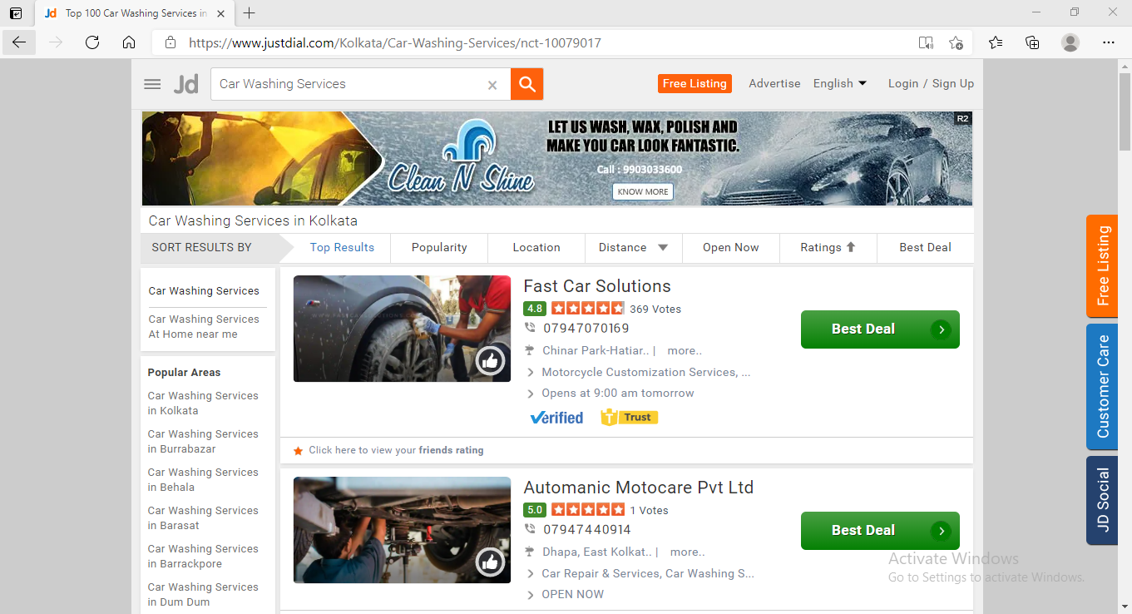

**3.1.3 Try to register for Free Listing**

3.1.3.1 Click Free listing page

3.1.3.2 To verify Free Listing page by entering an invalid input in Phone number textbox field

3.1.3.3 Click on the submit button

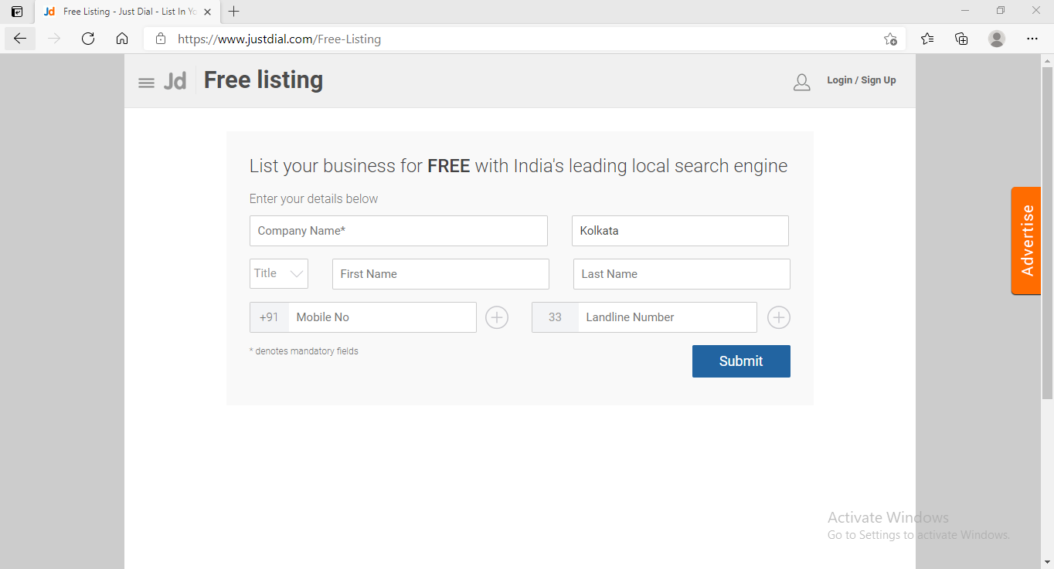

**3.1.4 Retrieving all the submenu items from the Gym sub-section of fitness**

3.1.4.1 Click on The Fitness Link

3.1.4.2 Click on the Gym link

3.1.4.3 Get the submenu items

3.1.4.4 Return to Homepage

