**Introduction:**

Through projects 3 and 4 for EECS 448, Team 1 has created Tactics. Tactics is a more complex version of Tic Tac Toe with added functionality. It utilizes a MySQL database that allows for users to create their own profiles and stores information regarding those profiles. The games include 3x3 boards and 9x9 boards. There are sorts of play the user can engage in such as local play, player vs. bot, and online play.

**Home page:**

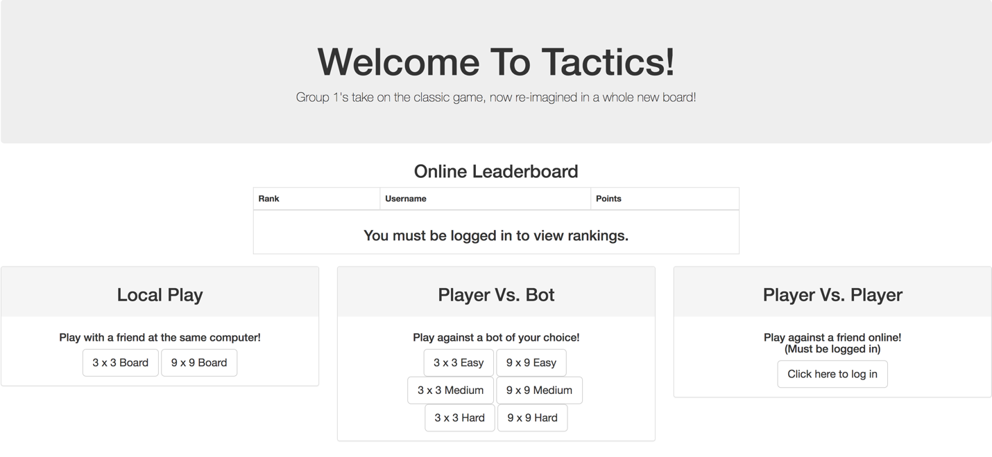When a user first accesses the website, they will be directed to the home page. The home page gives the user options to engage in local play of the 3x3 and 9x9 boards and player vs. bot play of the 3x3 and 9x9.

You are not able to take part in player vs. player mode; this is accessible once you create an account through the site. The online leaderboard will also be viewable once the user creates an account and logs in.

**Sign up: ?????**

The user can create an account by clicked on the “Sign Up” button on the main page in the top right corner. When creating an account, the user has to meet the following requirements for username and password:

* Password must be 8 characters long
* Must re-type same password in order to confirm in “Confirm password”

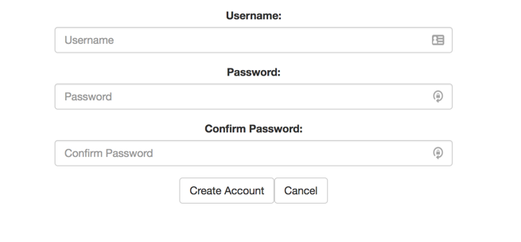

**Login:**

Once the user has created an account, they can go to the login page and login with their credentials. If the user already had an account, they can skip the sign up process and go straight to this step. If their login credentials are incorrect, they will be notified and will be prompted to go back to the home page.

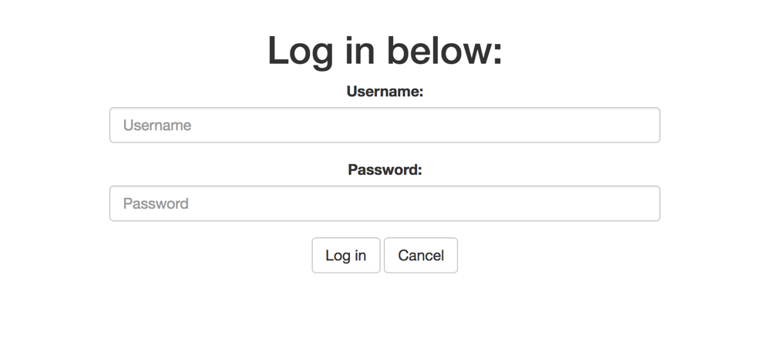

**Profile Specific Dashboard:**

Once the user has logged in, they are able to view a profile specific dashboard. The user can now see the online leaderboard and now have the option to engage in player vs. player mode. 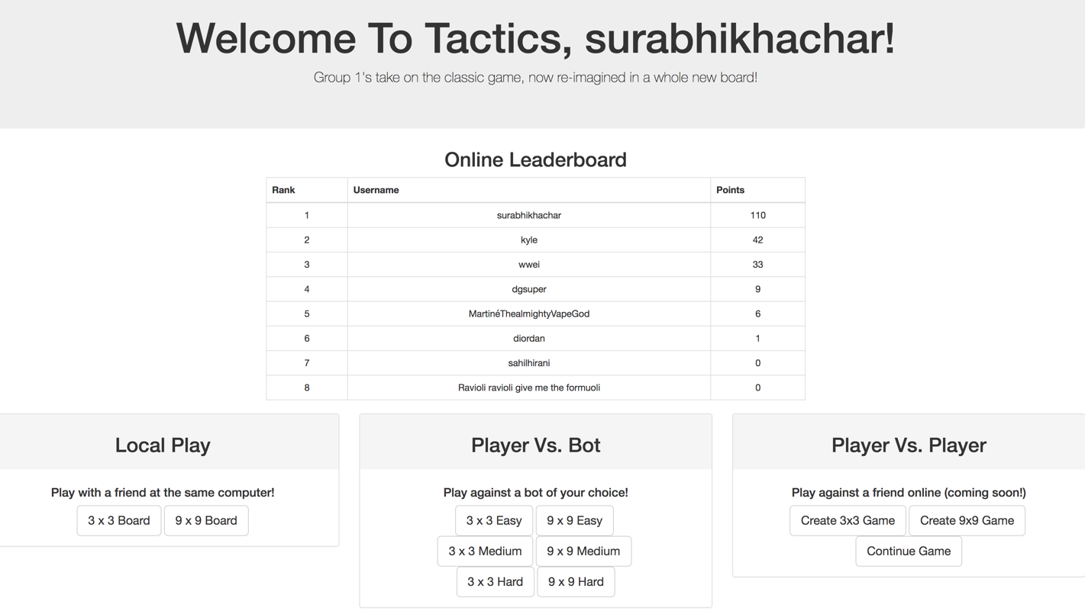

The online leaderboard shows all the users registered in the database and their ranking determined by the points they have acquired. Once the user has logged on, they are able to acquire points based on the games they win.

From this dashboard, the user can engage in local play, player vs. bot play, or player vs. player mode.

**Player vs. player Mode:**

A player can start a 3x3 or 9x9 game with another registered user. Once you hit create game, you will be prompted to type in the user’s name and make the first move. After doing that, the user can click on “Continue Game” from the dashboard and see all the current games they have in play. If it is their turn, there will be a “Continue Game” option for both 3x3 and 9x9

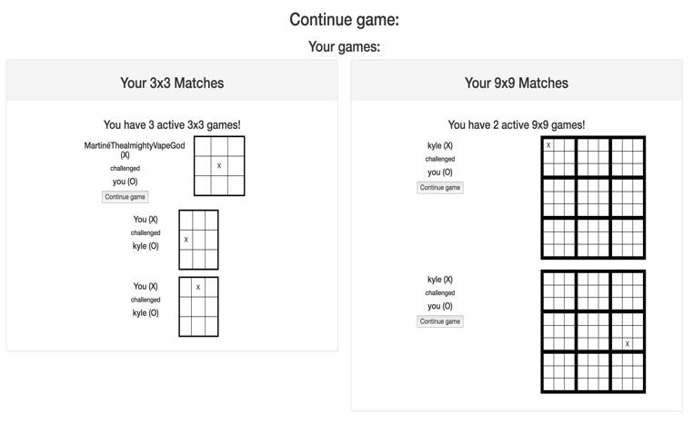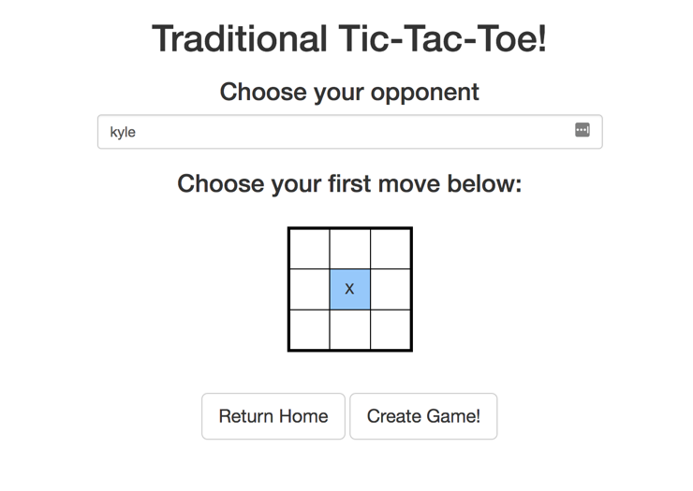games on this page.

**Social:**

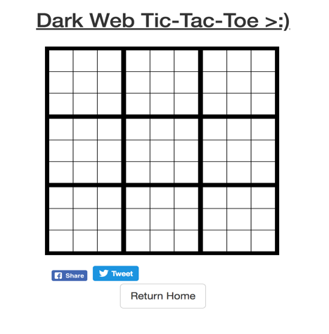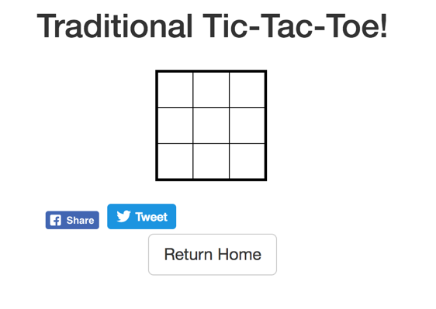 On all games of Bot mode and Local mode, the user is able to share their activity on Twitter or Facebook using the Tweet or Share buttons underneath the boards.

**User profile:**

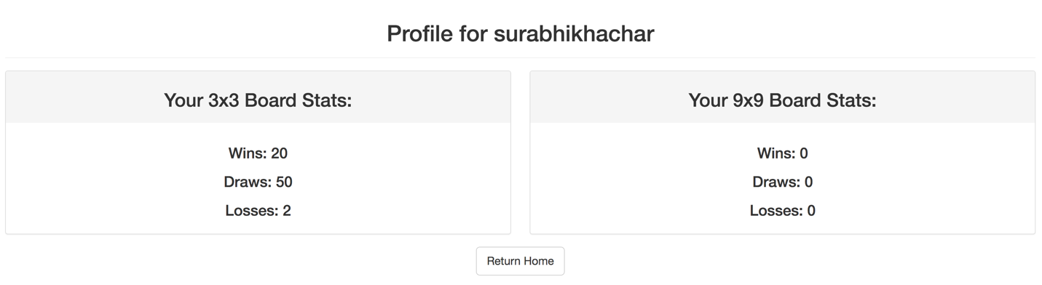 From the dashboard, the user can navigate to their profile allowing them to see their profile specific statistics regarding wins, draws, and losses.

**Logout:**

After the user is finished with the current session, they have the option to logout in the upper right hand corner, which will take them 