Portfolio Project "Road detection in satellite imagery" - Lisa Heße, Kiran Prakash, Harald Hentschke - DSR batch #15 2018-07-27
Background and motivation In the 21st century, intense road construction all over the world is anticipated, much of it in rural, poorly developed areas. Motivations for road construction are diverse, as are the repercussions. Properly planned roads foster economic development, whereas roads serving one-sided interests (e.g. illegal logging) cause many negative effects like environmental destruction¹. Any agency involved in planning land use and conservation management can only make informed decisions based on a precise knowledge of the status quo. Presently, however, there is a dearth of information on road networks in rural areas, particularly concerning the kind of road (paved vs. unpaved). In the special case of Borneo, the little information that does exist was created by human volunteers (see e.g. https://www.global-roadmap.org/volunteer/), which is unfeasible on a large scale. Hence a recent appeal to the AI community to take on the challenge², which was the key motivation for our project.
Aim and approach So far, to our knowledge, there have been no ML/deep learning attemps at detecting roads in satellite imagery in above-mentioned conditions - in rural areas, and with the additional aim of distinguishing between paved and unpaved roads. We want to implement a model which accomplishes this with a high accuracy, ideally for many different regions of the world, minimally for parts of Southeastern Borneo, for which we have training data (see below). In discussions with Chris other possible usage scenarios of a successful model became apparent (e.g. car navigation). One of our current ideas is to implement a ternary pixel-level classification task (unpaved road, paved road, no road). We are aware that sophisticated models for road detection in general exist³, and are in discussions as to the best model to start with.
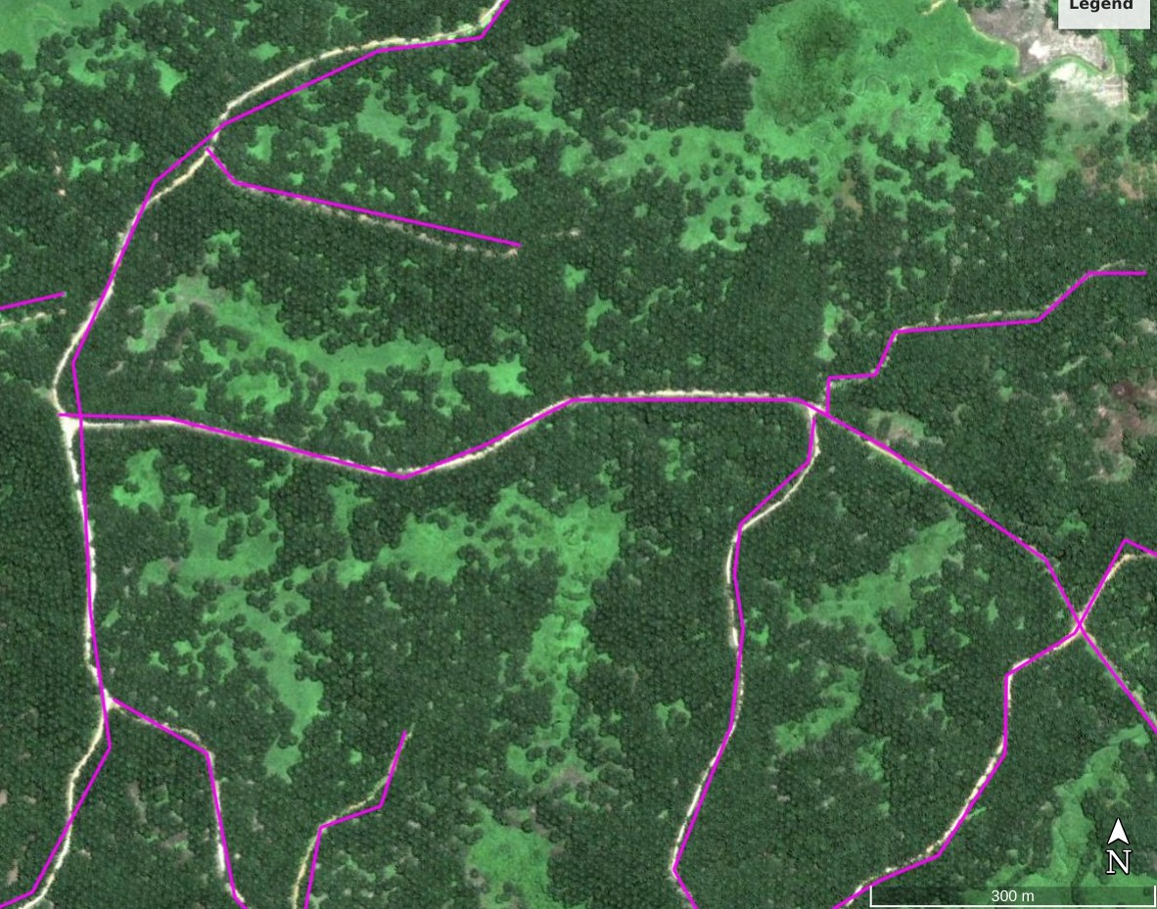
Data The Laurance group have provided us with KML data of roads in four 50 by 50 km patches of Southeastern Borneo (10,000 km² total area), manually labeled by volunteers in Google Earth. Roads are concatenated linear segments (see image); information on the type of road is in the labels (not visible in figure). Apart from not being pixel-level, the labels suffer from other problems, including incomplete and imprecise labeling of roads. Therfore, we are considering using high-quality, publicly available information from other areas with a large proportion of unpaved roads as training data. We are also currently exploring diverse satellite imagery (Sentinel-2, PlanetScope) for their suitability to the task.
1. Laurance, W. F. et al. A global strategy for road building. Nature 513, 229–232 (2014).
2. Laurance, W. F. Road mapping needs AI experts. Nature 558, 30 (2018).
3. Zhang, Z., Liu, Q. & Wang, Y. Road Extraction by Deep Residual U-Net. IEEE Geosci. Remote Sens. Lett. 15, 749–753 (2018).

