***Q.1 Write a blog on difference between document and window objects:***

***Answer:***

***Browser Object Model (BOM)***

The Browser Object Model contains objects that represent the current browser window or tab. The topmost object in the BOM is the ***window***object representing the window or tab or an iframe sometimes. Window object has properties like browser history, location and the device’s screen etc. In case of multi tab browser, *a window object represents a single tab*, but some of its properties like *innerHeight*, *innerWidth*and methods like *resizeTo()* will affect the whole browser window.

**Document Object Model**

When a web page is loaded, the browser creates a Document Object Model of the page. The *document object* represents the whole html document as a tree of Objects(HTML, HEAD, BODY, and other HTML tags). It is the root element that represents the html document.

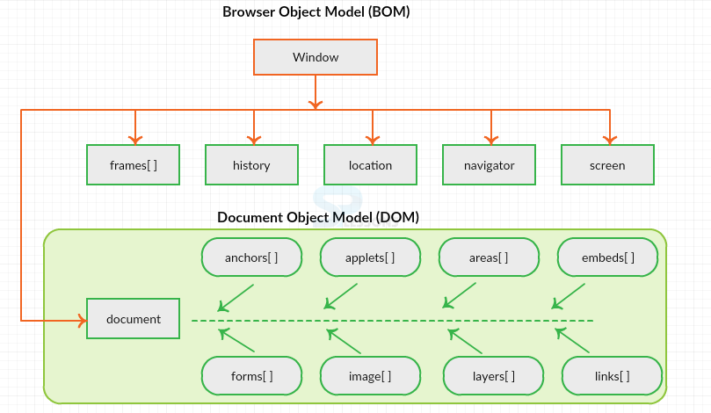

Figure 1 : Hierarchy of Window and Document object using BOM and DOM

Now lets visualize the difference between window and document.

**Window Vs Document**

**Window object** : It is the top most object and outermost element of the object hierarchy as shown in *Figure 1.*

**Document object** : Each HTML document that gets loaded into a window becomes a document object. The document contains the contents of the page. Using document object, JavaScript can modify, add and delete the HTML elements, attributes CSS styles in the page

The *window object* represents a window/tab containing a DOM document where as *document object*is property of *window object*that points to the DOM document loaded in that window.

You can access a document object either using *window.document* property or using document object directly as window is global object. In the below example, title is the property of document object.

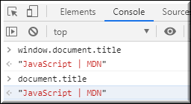

The other major difference is that both window object and document object have properties and methods. Few method names are same in both objects but with different behavior. In the below example *window.open()*opens a new tab or window and *document.open()* creates a blank document within the window.

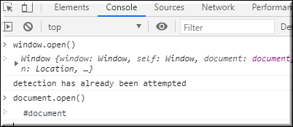

**Screen**

Screen is the window property that holds information of browser screen. It refers to screen object associated with that window **object**. Used to display screen width, height, colorDepth, pixelDepth etc

Similar to document screen can be accessed either by *window.screen* or *screen*object directly. Screen object doesn't have any methods as in window and document objects.

