

“Smyt” Events

bERN veIN BALERMO

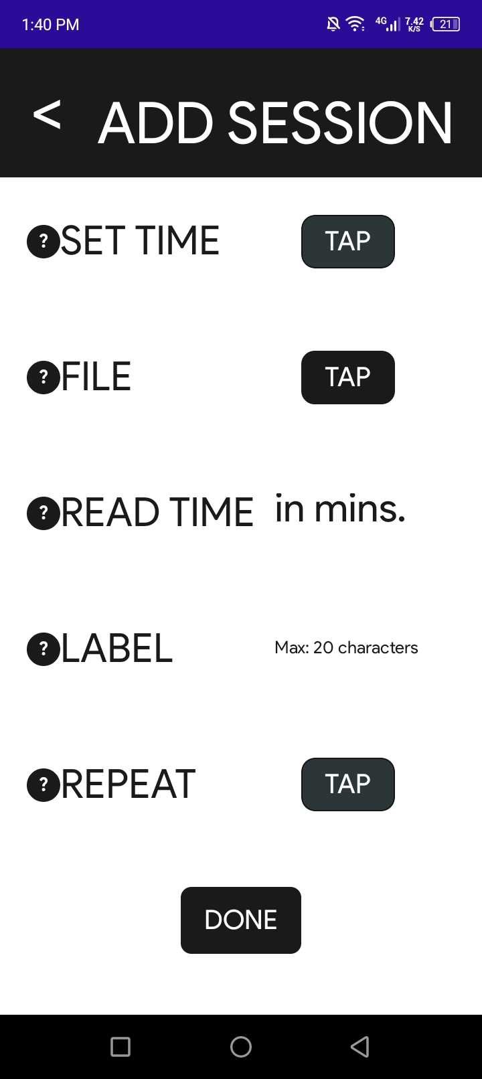

**“ADD SESSION” page events:**

1. Navigates the user back to the parent page.

2. Displays an information about the “SET TIME” field.

3. Displays an information about the “FILE” field.

4. Opens the files and lets the user pick a pdf file.

5. Displays an information about the “READ TIME” field.

6. Displays an information about the “LABEL” field.

7. Displays an information about the “REPEAT” field.

8. Adds the study session information based on the given information.

**1**

**7**

**6**

**5**

**4**

**3**

**2**

**8**

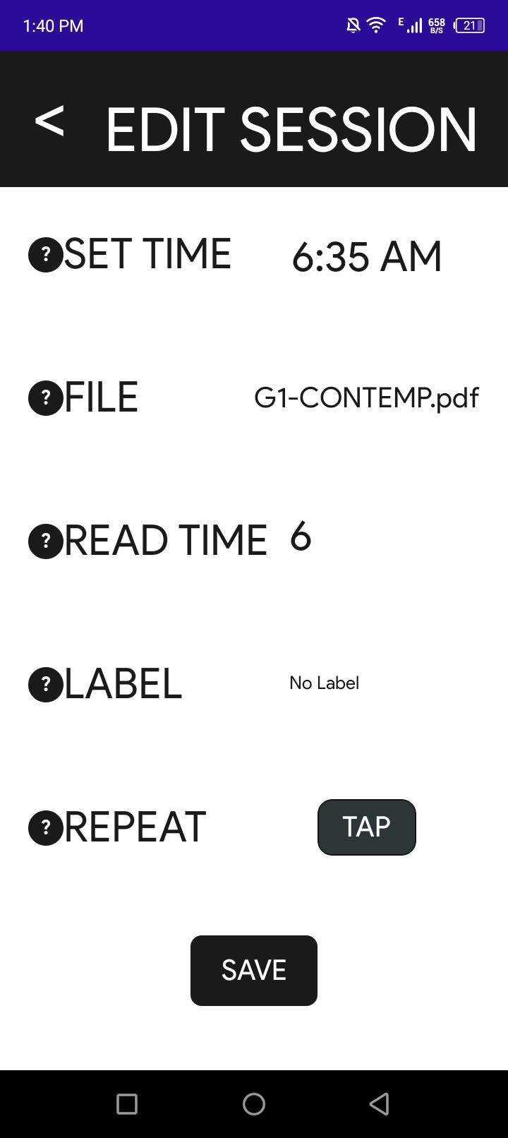

**“ADD SESSION” page events:**

1. Navigates the user back to the parent page.

2. Displays an information about the “SET TIME” field.

3. Displays an information about the “FILE” field.

4. Opens the files and lets the user pick a pdf file.

5. Displays an information about the “READ TIME” field.

6. Displays an information about the “LABEL” field.

7. Displays an information about the “REPEAT” field.

8. Updates the study session information based on the given information.

**2**

**1**

**8**

**7**

**6**

**4**

**5**

**3**

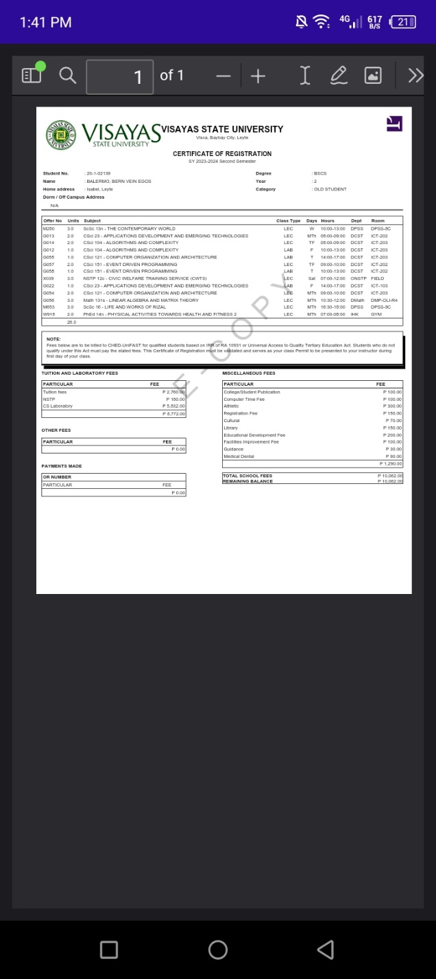

**“PDF Viewer” page event:**

1. Modified back button event. If pressed, timer will be paused, then a notification will appear with the remaining time to read the pdf file.

**1**

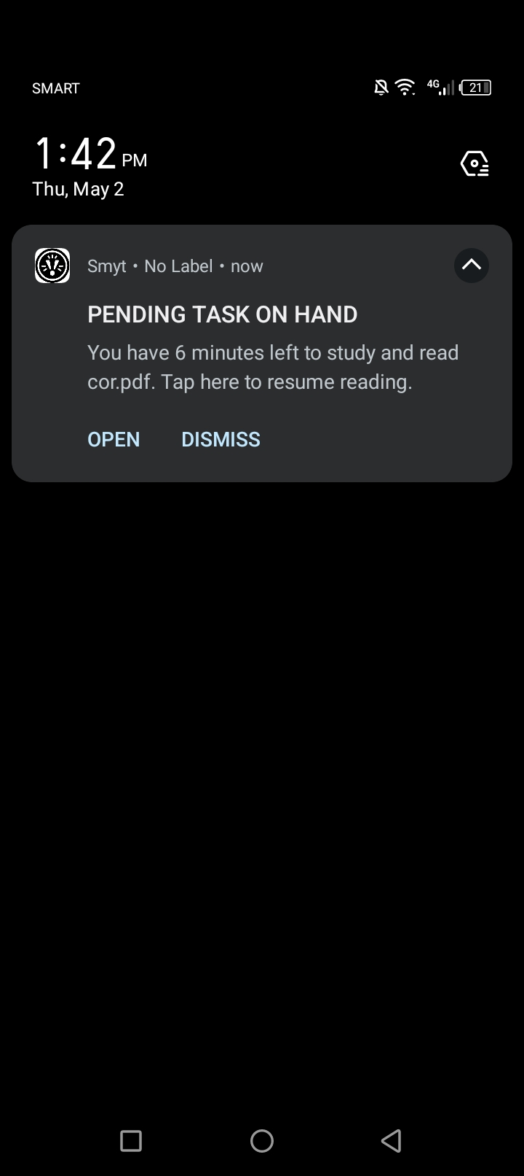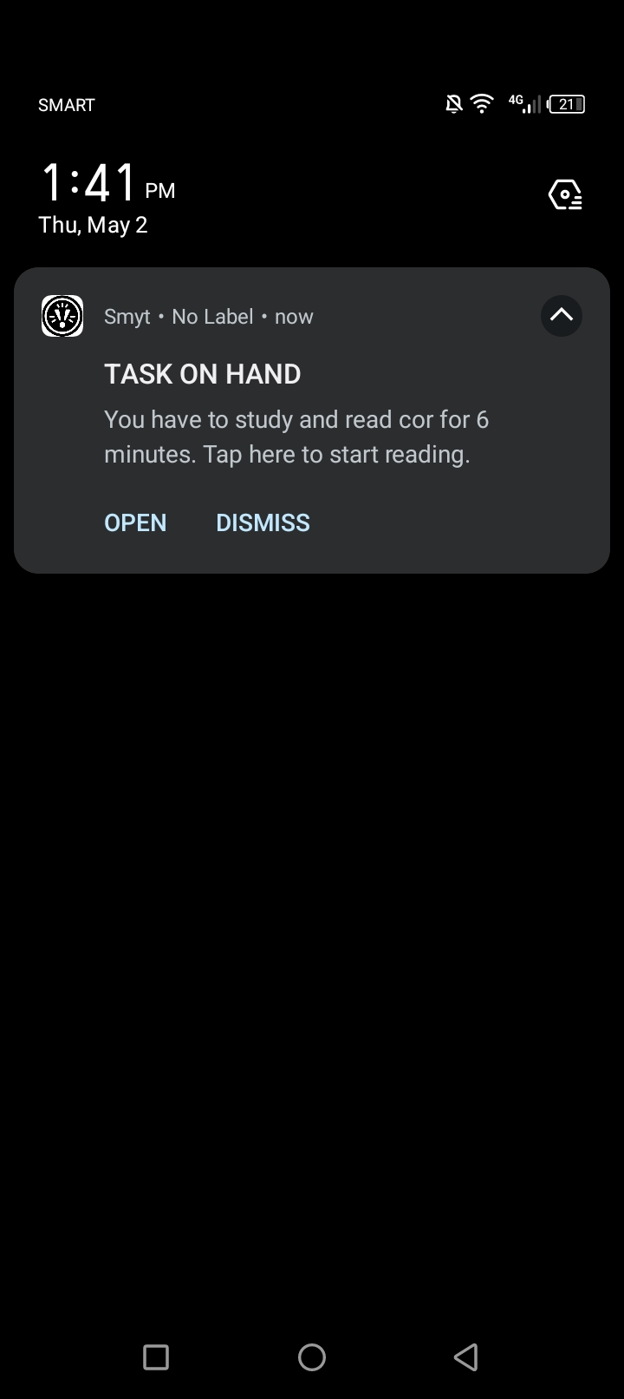s

**2**

**1**

**NOTIFICATION events:**

1. Navigates the user to the PDF Viewer page and removes the notification.

2. Navigates the user to the PDF Viewer page and removes the notification.

3. Dismisses the study session and deletes it then removes the notification.

**3**

**2**

**1**

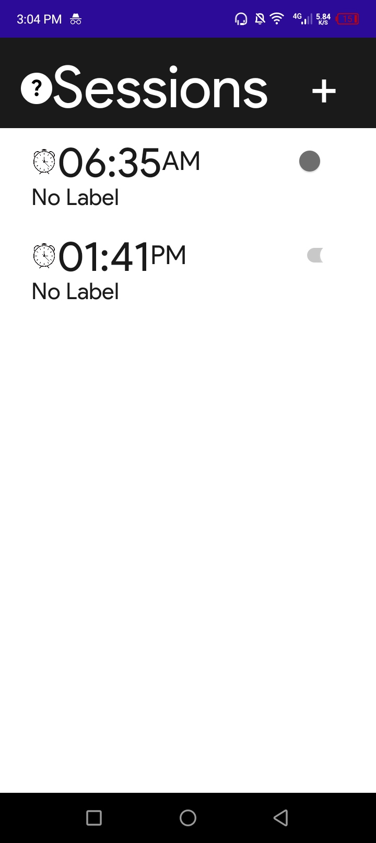

**4**

**3**

**2**

**1**

**“SESSION LIST” page events:**

1. Shows the information about a Session.

2. Navigates the user to the “ADD SESSION” page.

3. Navigates the user to the “EDIT SESSION” page.

4. Disables/Enables a session reminder.