**FLUTTER TUTORIAL SESSIONS (1:00 – 5:00 p.m.)**

|  |  |
| --- | --- |
| **Time** | **Activity** |
| 1:00 – 1:30  (07-21-2021) | 1. **How to set up firebase and connect to firebase?**  * Package * Set up firebase and firestore |
| 1:30 – 2:00  (07-21-2021) | 1. **The concept of streams**  * Like a literal stream, streams in flutter come from a higher place to a lower place * Essentially: data from a higher end go down to lower end (pages, and widgets) and can be used to display backend data in your front end |
| 2:00 – 2:30  (07-20-2021) | **Question and Answer** |
| 2:30 – 3:30  (07-21-2021) | 1. **Toggling between sign in and sign up (Source: Net Ninja)** |
| 1:30 – 3:30  (07-22-2021) | 1. **User Authentication**  * Sign in * Register * Addition:   + Forgot password   + Verify email address * Once email address is verified, it waits 3 seconds before redirecting to home |
| 3:30 – 5:30  (07-22-2021)  1:00 – 5:00  (07-23-2021) | 1. **Application of the concept of streams** 2. Accessing user information from anywhere in the application 3. List builder view  * Displaying the list of people who have already been contacted * Displaying the list of people who are searched * Displaying the list of messages |

1. **How to integrate firebase into flutter project**
2. Go to console.firebase.com
3. Click “create a project”
4. Click on the android icon



1. Write the android package name (no need tor the SHA as of the moment)

Android > App > build.gradle

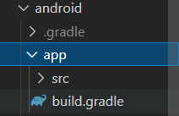

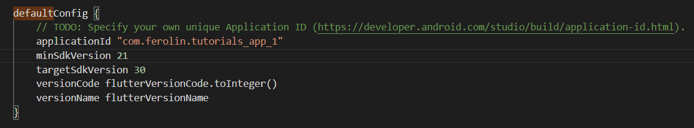

1. Download the config file

* Download google-services.json
* Save it in the app folder in the android directory

1. Add the dependencies (Android > build.gradle)

* Add the google services class path
* Android > App > build.gradle: add the apply plugin google services

1. In the side bar of the console, click “Cloud Firestore” so that we can create our database

* Start in test mode

1. In pubspec.yaml, add the dependencies:

* Firebase_core
* Firebase_auth
* Cloud_firestore

1. Initialize firebase

