SMART MEDICATION BOX

By

BERNA J ARUL (Reg. no. 9517202403023)
DHIVYASHRI A.S (Reg. no. 9517202403036)

A report for the 23EC453-Mini Project-II submitted to the faculty of

ELECTRONICS AND COMMUNICATION ENGINEERING

for partial fulfillment of the award of the degree of

BACHELOR OF ENGINEERING
in
ELECTRONICS AND COMMUNICATION ENGINEERING




DEPARTMENT OF ELECTRONICS AND COMMUNICATION ENGINEERING

MEPCO SCHLENK ENGINEERING COLLEGE, SIVAKASI
(An Autonomous Institution affiliated to Anna University Chennai)

May 2026

Register No: 9517202403023, 9517202403036
CERTIFICATE

This is to certify that it is the Bonafide work done by Ms. BERNA J ARUL (951720202403023), Ms. DHIVYASHRI A.S (9517202403036) for the 23EC453 - Mini Project - II work entitled smart medication box at Department of Electronics and Communication Engineering, Mepco Schlenk Engineering College, Sivakasi during the year 2025 – 2026.
…………………………… ……………………………
Faculty In-Charge Head of the Department

Submitted for the Practical Examination held at Mepco Schlenk Engineering College, Sivakasi on ……………………….

…………………………. …………………………
Internal Examiner - I Internal Examiner -II

ABSTRACT

Medication adherence is a critical factor in ensuring effective healthcare and patient recovery. In many cases, patients fail to follow prescribed medication schedules due to forgetfulness, busy lifestyles, or lack of proper monitoring systems. This issue is particularly serious among elderly individuals and patients suffering from chronic diseases such as diabetes, hypertension, and heart-related conditions. The Smart Medication Box is an embedded system-based solution designed to assist users by providing timely reminders for medication intake. The system is built using an Arduino Uno microcontroller, which acts as the central control unit. A Real-Time Clock (RTC) module (DS3231) is used to maintain accurate time even during power interruptions. The system compares real-time data with pre-programmed medication schedules. When the current time matches the scheduled medication time, the system activates a buzzer to generate an audible alert and an LED indicator to provide visual feedback. An optional LCD display can also be used to show the current time and reminder messages. The system is designed to be simple, cost-effective, and user-friendly, making it suitable for elderly users and home healthcare applications. This project demonstrates the effective use of embedded systems in healthcare to improve patient safety, independence, and quality of life.
.

ACKNOWLEDGEMENT

First and foremost, we express our wholehearted gratitude to the Almighty and our parents for being with us throughout extending moral support and helping us in completing this project work.
We wish to express our sincere thanks to Dr. S. Arivazhagan M.E., Ph.D., F.I.E.T.E., M.I.S.T.E., honourable Principal of our institution for offering us to take up the project in the college and extending all the facilities for the completion of the same.
Our heartfelt acknowledgement goes to the Senior Professor and Head of the Department of Electronics and Communication Engineering, Dr. R. Shantha Selva Kumari, B.E., M.S., Ph.D., F.I.E.T.E., M.I.S.T.E., for her valuable and consistent encouragement for carrying out the project.
We express our deepest gratitude to our guide Dr. S. Anand, B.E., M.E., Ph.D., Professor of the Department of Electronics and Communication Engineering, for rendering excellent guidance and for extremely kind and approachable.
We hereby acknowledge the tireless efforts of all the staff members, reviewers and technicians of Electronics and Communication Department whose help was instrumental in the completion of our project. We extend our sincere thanks to our friends for playing a vital role in completing this work, by supporting us in all our endeavours.

TABLE OF CONTENTS

CHAPTER  NO | TITLE | PAGE NO
 | ABSTRACT  ACKNOWLEDGEMENT  TABLE OF CONTENTS  LIST OF TABLES  LIST OF FIGURES | I  II  III  IV  V
1 | INTRODUCTION  - PROJECT BACKGROUND  - NEED FOR SMART MEDICATION SYSTEMS  - PROBLEM DEFINITION  - OBJECTIVES OF THE PROJECT  - SCOPE OF THE PROJET  - IMPORTANCE OF MEDICATION REMINDER SYSTEM  - ADVANTAGES OF SMART MEDICATION BOX  - APPLICATIONS OF SMART MEDICATION BOX  - STRUCTURE OF THE REPORT | 1  1  2  3  3  4  4  5  5
2 | LITERATURE REVIEW  - INTRODUCTION  - TRADITIONAL MEDICATION REMINDER METHODS  - AUTOMATED MEDICATION SYSTEMS  - ROLE OF EMBEDDED SYSTEMS IN HEALTHCARE  - REAL -TIME CLOCK (RTC) MODULE IN MEDICATION  SYSTEMS  - REVIEW OF EXISTING ARDUINO BASED PROJECTS  - LIMITATIONS OF EXISTING SYSTEMS  - RESEARCH GAP IDENTIFICATION  - PROPOSED SOLUTION  - SUMMARY | 6  6  7  8  9  9  9  10  10  10
3 | PROPOSED SYSTEM  - INTRODUCTION  - OBJECTIVE OF THE PROPOSED SYSTEM  - OVERVIEW OF THE PROPOSED SYSTEM  - BLOCKDIAGRAM OF SMART MEDICATION BOX  - COMPONENT DESCRIPTION  - CIRCUIT DIAGRAM OF THE SYSTEM  - WORKING PRINCIPLE OF THE PROPOSED SYSTEM  - SYSTEM FLOW  - FEATURES OF THE PROPOSED SYSTEM  - ADVANTAGES OF THE PROPOSED SYSTEM  - LIMITATIONS OF THE PROPOSED SYSTEM  - APPLICATIONS  - FUTURE SCOPE  - SUMMARY | 11  11  11  12  12  14  14  15  15  15  16  16  16  16
4 | DESIGN AND IMPLEMENTATION  - INTRODUCTION  - SYSTEM DESIGN OVERVIEW  4.3 HARDWARE DESIGN  4.4 CIRCUIT DESIGN AND CONNECTIONS  4.5 SOFTWARE DESIGN  4.6 DETAILED WORKING OF THE SYSTEM  4.7 EEPROM MEMORY USAGE  4.8 HARDWARE IMPLEMENTATION  4.9 TESTING AND VALIDATION  4.10 DESIGN CHALLENGES  4.11 SAFETY CONSIDERATIONS  4.12 ADVANTAGES OF THE DESIGN  4.13 LIMITATIONS OF THE DESIGN  4.14 SUMMARY | 17  17  17  18  19  20  21  21  21  22  22  22  22  22
5 | RESULTS AND DISCUSSION  - INTRODUCTION  - TESTING METHODOLOGY  - OBSERVED RESULTS  5.4 PERFORMANCE ANALYSIS  5.5 PERFORMANCE SUMMARY TABLE  5.6 DISCUSSION  5.7 LIMITATIONS  5.8 FUTURE ENHANCEMENTS  5.9 SUMMARY | 23  23  23  24  24  24  26  26  26
6 | CONCLUSION  REFERENCES | 27  28

LIST OF TABLES:

LIST OF FIGURES:
TABLE NO | TABLE TITLE | PAGE  NO
5.1 | PERFORMANCE SUMMARY | 25

FIGURE NO | FIGURE TITLE | PAGE  NO
4.1 | BLOCK DIAGRAM | 13
4.2 | CIRCUIT DIAGRAM | 15
4.3 | HARDWARE SETUP OF THE SYSTEM | 18
4.4 | SOFTWARE EXECUTION OF THE SYSTEM | 19
5.1 | GROUP 1 MEDICINE - ALERT 1 | 23
5.2 | GROUP 2 MEDICINE - ALERT 2 | 24
5.3 | GROUP 3 MEDICINE - ALERT 3 | 24

CHAPTER 1

INTRODUCTION

1.1 PROJECT BACKGROUND:
Healthcare management has become increasingly complex due to the growing number of patients suffering from chronic illnesses. Medication adherence plays a vital role in ensuring proper treatment outcomes. However, many patients fail to take medicines at the correct time due to memory issues, lack of awareness, or busy schedules. Traditional methods such as alarm clocks and manual pill boxes are not always reliable, as they depend heavily on human memory and attention. With advancements in embedded systems, it is now possible to automate medication reminders using microcontrollers and sensors. The Smart Medication Box is designed to overcome these limitations by providing an automated and reliable solution for medication reminders.

1.2 NEED FOR SMART MEDICATION SYSTEMS:
The necessity for a Smart Medication Box arises from various real-world challenges faced by patients and healthcare providers. These challenges highlight the importance of developing an automated and reliable system.

1.2.1 Increasing Elderly Population
The global population of elderly individuals is increasing rapidly. Aging is often associated with memory-related disorders such as dementia and Alzheimer’s disease, which affect a person’s ability to remember medication schedules. A smart reminder system helps such individuals maintain their medication routine independently.

1.2.2 Prevalence of Chronic Diseases
Chronic illnesses such as diabetes, hypertension, asthma, and heart diseases require strict adherence to medication schedules. Missing even a single dose can lead to severe complications. Therefore, a reliable reminder system is essential for managing these conditions.

1.2.3 Busy Lifestyle and Work Pressure
In today’s fast-paced world, individuals often forget to take medications due to work pressure, travel, and irregular routines. A smart system ensures that reminders are not missed regardless of daily activities.

1.2.4 Lack of Continuous Caregiver Support
Not all patients have access to caregivers or family members who can monitor their medication intake. This is especially true for individuals living alone. A smart medication box acts as a personal assistant in such situations.

1.2.5 Risk of Overdose or Underdose
Sometimes patients forget whether they have already taken a dose and may accidentally consume it again, leading to overdose. Similarly, missing a dose can reduce treatment effectiveness. A structured reminder system helps avoid such risks.

1.3 PROBLEM DEFINITION:
The major problem addressed in this project can be defined as follows:
“To design and develop a reliable, automated, and user-friendly medication reminder system that ensures patients take their medicines on time without relying on memory or manual intervention.”

Key Issues Identified:
- Forgetfulness in medication intake
- Lack of automated reminder systems
- Dependence on manual tracking methods
- Difficulty in managing multiple medications
- Risk of incorrect dosage timing
The solution should be:
- Simple
- Cost-effective
- Accurate
- Easy to use

OBJECTIVES OF THE PROJECT:
The objectives of the Smart Medication Box are categorized into primary and secondary goals.

Primary Objectives
- To design an automated medication reminder system using Arduino
- To implement accurate time tracking using an RTC module
- To provide alerts through buzzer and LED
- To ensure reliable and continuous operation

Secondary Objectives
- To reduce dependency on human memory
- To improve medication adherence
- To provide assistance for elderly and disabled individuals
- To develop a low-cost and portable system
- To ensure user-friendly operation

SCOPE OF THE PROJECT:
The scope of the Smart Medication Box defines the boundaries and applications of the system.

Included Scope
- Development of a standalone embedded system
- Real-time monitoring of medication schedules
- Audio and visual alert system
- Application in home healthcare environments

Extended Scope
- Integration with IoT for remote monitoring
- Mobile app notifications
- Data logging and tracking
- Wireless communication

Excluded Scope
- Advanced AI-based health monitoring
- Automatic diagnosis systems
- Complex hospital management integration

IMPORTANCE OF MEDICATION REMINDER SYSTEMS:
Medication reminder systems play a vital role in modern healthcare. Their importance can be summarized as follows:
- Ensures timely medication intake
- Reduces health risks due to missed doses
- Improves effectiveness of treatment
- Supports independent living for elderly individuals
- Minimizes human errors in medication management
- Enhances overall healthcare quality

  - ADVANTAGES OF SMART MEDICATION BOX:

1.7.1 Technical Advantages
- High accuracy due to RTC module
- Automated operation without manual intervention
- Low power consumption
- Compact and portable design

1.7.2 User Advantages
- Easy to operate
- Suitable for elderly and disabled individuals
- Provides both audio and visual alerts
- Reduces stress and confusion

1.7.3 Healthcare Benefits
- Improves patient compliance
- Reduces risk of complications
- Enhances treatment efficiency
- Supports preventive healthcare

APPLICATIONS OF SMART MEDICATION BOX:
The Smart Medication Box can be used in various environments:
- Home healthcare systems
- Hospitals and clinics
- Elderly care centers
- Rehabilitation facilities
- Smart healthcare devices
- Patient monitoring systems

STRUCTURE OF THE REPORT:
This report is organized into six chapters:
- Chapter 1 – Introduction: Covers background, need, objectives, and scope
- Chapter 2 – Literature Review: Discusses existing systems and research
- Chapter 3 – Proposed System: Explains system design and components
- Chapter 4 – Design and Implementation: Details hardware and working
- Chapter 5 – Results and Discussion: Presents performance analysis
- Chapter 6 – Conclusion: Summarizes findings and future scope

CHAPTER 2

LITERATURE REVIEW

2.1 INTRODUCTION
Medication adherence is a major concern in modern healthcare systems. It refers to the extent to which patients take medications as prescribed by healthcare professionals. Improper adherence can lead to treatment failure, worsening of diseases, increased hospitalization, and higher medical costs.
With the advancement of technology, researchers have explored various solutions to improve medication adherence. These solutions range from simple manual methods to advanced automated and smart systems. This chapter reviews existing medication reminder techniques, their advantages, limitations, and the need for developing an improved system like the Smart Medication Box.

2.2 TRADITIONAL MEDICATION REMINDER METHODS
Before the introduction of smart systems, patients relied on conventional methods to manage their medication schedules.

2.2.1 Manual Pill Boxes
Manual pill organizers are widely used to store medicines according to days or times.
Advantages:
- Simple and easy to use
- No power required
- Low cost
Limitations:
- No reminder feature
- Depends on user memory
- High risk of missing doses

2.2.2 Alarm Clocks
Alarm clocks are used to remind patients to take medicines at specific times.
Advantages:
- Provides audible alert
- Easy to operate
Limitations:
- No indication of which medicine to take
- Alarm can be ignored
- Not flexible for multiple schedules

2.2.3 Mobile Phone Reminders
Modern smartphones provide alarm and reminder applications.
Advantages:
- Customizable alerts
- Multiple alarms can be set
Limitations:
- Requires user interaction
- Notifications can be ignored
- Not suitable for elderly users unfamiliar with technology

2.3 AUTOMATED MEDICATION SYSTEMS
To overcome the limitations of traditional methods, automated systems have been developed.

2.3.1 Microcontroller-Based Systems
These systems use microcontrollers such as Arduino to automate medication reminders.
Features:
- Programmable alarm schedules
- Integration with sensors and output devices
- Reliable operation
Advantages:
- High accuracy
- Low cost
- Easy to implement

2.3.2 IoT-Based Medication Systems
Internet of Things (IoT) technology enables remote monitoring and control.
Features:
- Mobile notifications
- Real-time tracking
- Cloud data storage
Advantages:
- Remote access
- Improved monitoring
Limitations:
- High cost
- Requires internet connectivity
- Complex setup

2.3.3 Smart Pill Dispensers
These are advanced devices that automatically dispense medication at scheduled times.
Advantages:
- Accurate dosage control
- Reduces human error
Limitations:
- Expensive
- Complex design
- Requires maintenance

2.4 ROLE OF EMBEDDED SYSTEMS IN HEALTHCARE
Embedded systems have revolutionized healthcare by enabling automation and real-time monitoring.

Applications:
- Patient monitoring systems
- Wearable health devices
- Smart medical equipment

Advantages:
- High accuracy
- Real-time operation
- Reduced human error
- Improved efficiency

2.5 REAL-TIME CLOCK (RTC) MODULE IN MEDICATION SYSTEMS
The RTC module plays a crucial role in time-based applications.

Functions:
- Maintains accurate time
- Provides continuous operation
- Works even during power failure

Advantages:
- High precision
- Low power consumption
- Reliable performance

2.6 REVIEW OF EXISTING ARDUINO-BASED PROJECTS
Several Arduino-based medication reminder systems have been developed.

Common Features:
- Time-based alerts
- LCD display for user interaction
- Buzzer for notification

Observations:
- Most systems are simple and cost-effective
- Suitable for educational and basic healthcare applications
- Limited advanced functionalities

2.7 LIMITATIONS OF EXISTING SYSTEMS
Despite advancements, current systems have several drawbacks:
- High cost in commercial devices
- Complex user interface
- Dependence on internet connectivity
- Limited accessibility for elderly users
- Lack of portability
- Limited customization

2.8 RESEARCH GAP IDENTIFICATION
Based on the review of existing systems, the following gaps are identified:
- Need for low-cost solutions
- Need for user-friendly design
- Requirement for standalone operation
- Need for reliable and accurate time tracking
- Lack of simple systems for elderly users

2.9 PROPOSED SOLUTION
The Smart Medication Box is proposed to address these gaps by providing:
- Low-cost embedded system
- Accurate time tracking using RTC
- Simple user interface
- Reliable alert mechanism
- Standalone operation without internet

2.10 SUMMARY
This chapter analyzed various existing medication reminder systems and identified their limitations. It is evident that there is a strong need for a system that is affordable, reliable, and easy to use. The proposed Smart Medication Box fulfills these requirements by combining embedded system technology with real-time monitoring and user-friendly design.

CHAPTER 3

PROPOSED SYSTEM

3.1 INTRODUCTION
The increasing need for reliable medication management systems has led to the development of automated solutions using embedded systems. The proposed Smart Medication Box is designed to assist users in taking medicines on time by providing timely alerts based on real-time monitoring.
This system aims to overcome the limitations of traditional and existing systems by offering a simple, cost-effective, and user-friendly solution. It utilizes an Arduino-based platform integrated with a Real-Time Clock (RTC) module to ensure accurate time tracking and reliable performance.

3.2 OBJECTIVE OF THE PROPOSED SYSTEM
The primary objective of the proposed system is to design and implement a smart medication reminder system that:
- Provides accurate time-based alerts
- Ensures reliable operation
- Reduces dependency on human memory
- Improves medication adherence
- Supports elderly and patients with chronic diseases

3.3 OVERVIEW OF THE PROPOSED SYSTEM
The Smart Medication Box is an embedded system that continuously monitors time and compares it with pre-set medication schedules. When the scheduled time is reached, the system alerts the user using audio and visual signals.
The system consists of both hardware and software components working together to achieve the desired functionality.

BLOCK DIAGRAM DESCRIPTION

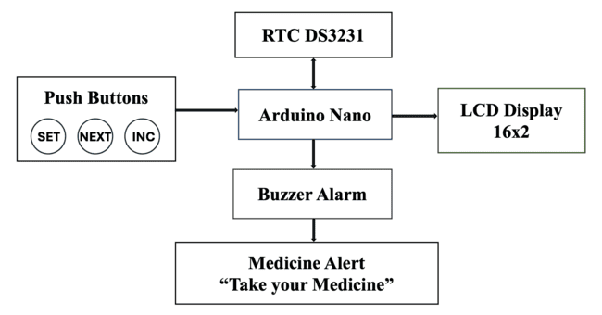
Fig. 3.1 Block Diagram of Smart Medication Box

The proposed system is composed of the following major blocks:
- Arduino Nano (Control Unit)
- RTC DS3231 Module (Time Tracking)
- Push Buttons (User Input)
- LCD Display (User Interface)
- Buzzer (Audio Alert)
- LED Indicators (Visual Alert)
Each block performs a specific function and contributes to the overall system operation.

3.5 COMPONENT DESCRIPTION

3.5.1 Arduino Nano
The Arduino Nano acts as the central processing unit of the system.
Functions:
- Reads time from RTC module
- Stores and processes alarm data
- Controls output devices (buzzer, LEDs, LCD)
- Handles user inputs

3.5.2 RTC DS3231 Module
The RTC module is responsible for maintaining accurate time.
Features:
- High precision timekeeping
- Battery backup support
- I2C communication

3.5.3 Push Buttons
Three push buttons are used for user interaction:
- SET Button → Enter alarm setting mode
- NEXT Button → Move to next setting
- INC Button → Increment values

3.5.4 LCD Display (16x2)
The LCD display provides real-time information to the user.
Displays:
- Current time and date
- Alarm settings
- Alert messages

3.5.5 Buzzer
The buzzer generates an audible alert when medication time is reached.

3.5.6 LED Indicators
LEDs provide visual indication of alerts and help identify different medication groups.

3.6 CIRCUIT DIAGRAM OF THE SYSTEM
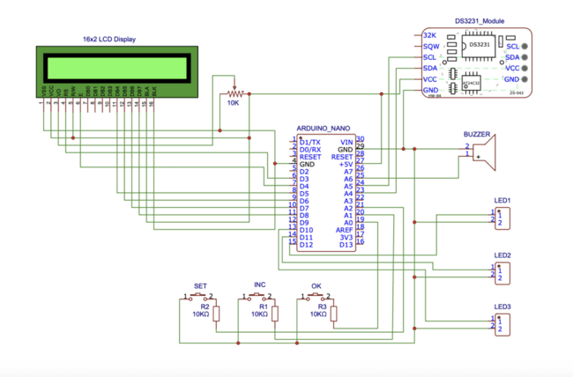
Fig. 3.2 Circuit Diagram of the System

3.7 WORKING PRINCIPLE OF THE PROPOSED SYSTEM
The Smart Medication Box operates based on real-time monitoring and comparison logic.

Step-by-Step Working:
- The RTC module continuously keeps track of current time
- Arduino reads time from RTC using I2C communication
- User sets medication timings using push buttons
- Alarm values are stored in memory
- Arduino compares current time with stored alarm times
- When match occurs:
  - Buzzer is activated
  - LED glows
  - Message displayed on LCD
- User takes medication
- System resets and continues monitoring

3.8 SYSTEM FLOW
The operational flow of the system is as follows:
- Start
- Initialize system components
- Read current time from RTC
- Display time on LCD
- Check for user input
- Compare current time with alarm
- If match → Trigger alert
- Repeat continuously

3.9 FEATURES OF THE PROPOSED SYSTEM
- Real-time monitoring
- Multiple alarm support (3 schedules)
- Audio and visual alert system
- User-friendly interface
- EEPROM-based data storage
- Low power consumption

3.10 ADVANTAGES OF THE PROPOSED SYSTEM

Technical Advantages:
- High accuracy using RTC
- Reliable and stable performance
- Low cost and energy-efficient

User Advantages:
- Easy to operate
- Suitable for elderly users
- Reduces dependency on memory

Healthcare Benefits:
- Improves medication adherence
- Reduces risk of missed doses
- Enhances patient safety

LIMITATIONS OF THE PROPOSED SYSTEM
- Limited number of alarms
- Manual setting required
- No remote notification
- No confirmation of medicine intake

APPLICATIONS
- Home healthcare systems
- Hospitals and clinics
- Elderly care centers
- Patient monitoring systems
- Smart healthcare devices

3.13 FUTURE SCOPE
The proposed system can be further enhanced by integrating advanced technologies:
- IoT-based monitoring
- Mobile application control
- SMS alert system
- Voice assistance
- Automatic pill dispensing

3.14 SUMMARY
The proposed Smart Medication Box provides a simple, efficient, and reliable solution for medication reminders. By combining embedded system technology with real-time monitoring, the system ensures timely alerts and improves medication adherence. It is cost-effective, user-friendly, and suitable for real-world healthcare applications.

CHAPTER 4

DESIGN AND IMPLEMENTATION

4.1 INTRODUCTION
This chapter describes the complete design and implementation of the Smart Medication Box. It includes both hardware and software aspects of the system. The design focuses on simplicity, cost-effectiveness, reliability, and ease of use. The implementation involves interfacing various components such as Arduino, RTC module, LCD display, push buttons, buzzer, and LEDs. The system is designed to continuously monitor real-time and provide alerts when medication is due.

4.2 SYSTEM DESIGN OVERVIEW
The Smart Medication Box consists of two main parts:
- Hardware Design – Physical components and circuit connections
- Software Design – Program logic controlling system operation
Both parts work together to ensure accurate and efficient functioning of the system.

HARDWARE DESIGN

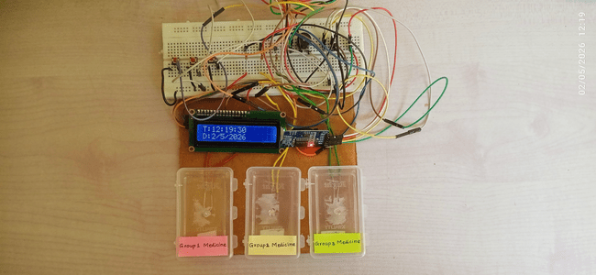
Fig. 4.1 Hardware Setup of the System

4.3.1 COMPONENTS USED
The following components are used in the system:
- Arduino Nano / Arduino Uno
- RTC DS3231 Module
- 16x2 LCD Display (I2C)
- Push Buttons (SET, NEXT, INC)
- Buzzer
- LEDs (3 indicators)
- Resistors
- Breadboard
- Connecting wires
- Power supply (5V)

4.3.2 FUNCTION OF EACH COMPONENT

Arduino:
Acts as the control unit that processes data and controls all operations.

RTC Module:
Maintains accurate time and provides real-time data to Arduino.

LCD Display:
Displays time, date, and alert messages.

Push Buttons:
Used to set and modify alarm timings.

Buzzer:
Generates sound alerts for medication reminders.

LEDs:
Provide visual indication for different medication groups.

Power Supply:
The system operates on a 5V DC supply

4.4 CIRCUIT DESIGN AND CONNECTIONS
The system is implemented using a simple and efficient circuit design.

Key Connections:
- RTC module connected to Arduino via I2C (SDA & SCL pins)
- LCD display connected using I2C interface
- Push buttons connected to digital pins with pull-up configuration
- Buzzer connected to digital output pin
- LEDs connected with current-limiting resistors

4.5 SOFTWARE DESIGN

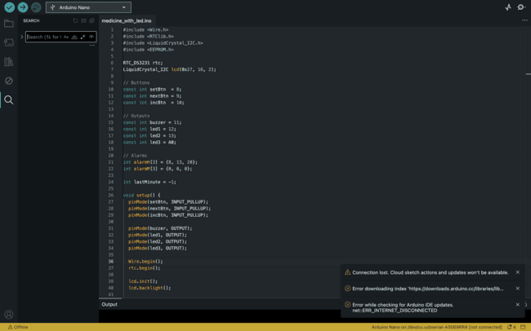
Fig. 4.2 Software Execution of the System

4.5.1 PROGRAMMING ENVIRONMENT
- Arduino IDE is used for writing and uploading code
- Embedded C language is used for programming

4.5.2 LIBRARIES USED
- Wire.h → I2C communication
- RTClib.h → RTC functions
- LiquidCrystal_I2C.h → LCD control
- EEPROM.h → Data storage

4.5.3 SOFTWARE MODULES
The program is divided into the following modules:
- Initialization Module
- Time Display Module
- Alarm Setting Module
- Alarm Checking Module
- Alert Generation Module
- Memory Storage Module

4.6 DETAILED WORKING OF THE SYSTEM
This section explains the complete operation of the Smart Medication Box in detail.

4.6.1 SYSTEM INITIALIZATION
- When power is supplied, the Arduino initializes all components
- RTC module starts providing current time
- LCD displays startup message
- Previously saved alarm values are loaded from EEPROM

4.6.2 REAL-TIME MONITORING
- The RTC continuously tracks current time
- Arduino reads time using I2C communication
- Time is displayed on the LCD in real-time

4.6.3 USER INPUT AND ALARM SETTING
- User presses SET button to enter alarm mode
- Uses INC button to increase values
- Uses NEXT button to move between settings
- Up to 3 medication alarms can be configured

4.6.4 TIME COMPARISON PROCESS
- Arduino continuously compares:
Current Time (RTC) vs Stored Alarm Time
- Comparison is done every second/minute

4.6.5 ALERT GENERATION PROCESS
- When current time matches alarm time:
- Buzzer is activated (audio alert)
- LED corresponding to medication group glows
- LCD displays message:
  - “Take Medicine”
  - Group number

4.6.6 ALERT TERMINATION
- Alert continues for a fixed duration (e.g., 5 seconds)
- Buzzer turns OFF
- LEDs turn OFF
- System resets for next cycle

4.6.7 CONTINUOUS OPERATION
- System runs continuously in loop
- Monitors time and triggers alerts repeatedly
- Ensures no medication schedule is missed

4.7 EEPROM MEMORY USAGE
- Alarm values are stored in EEPROM
- Ensures data is retained even after power OFF

Advantages:
- No need to reset alarms every time
- Improves reliability

4.8 HARDWARE IMPLEMENTATION
- Circuit assembled on breadboard
- Connections verified
- Components tested individually
- Final system integrated and tested

4.9 TESTING AND VALIDATION

Testing Steps:
- Set alarm times
- Verify RTC accuracy
- Check buzzer activation
- Observe LED indication
- Validate LCD display

4.10 DESIGN CHALLENGES
- Ensuring accurate time synchronization
- Avoiding false triggering of alarms
- Managing power stability
- Designing user-friendly interface

4.11 SAFETY CONSIDERATIONS
- Operates on low voltage (5V)
- Safe for home use
- Proper insulation of wires
- Reliable components used

4.12 ADVANTAGES OF THE DESIGN
- Simple and compact
- Cost-effective
- Easy to assemble
- Reliable performance
- User-friendly interface

4.13 LIMITATIONS OF THE DESIGN
- Limited alarm capacity (3 alarms)
- No remote communication
- Manual operation required
- No automatic pill dispensing

4.14 SUMMARY
The design and implementation of the Smart Medication Box demonstrate an efficient integration of hardware and software components. The system successfully achieves real-time monitoring and timely alert generation. It is simple, reliable, and suitable for practical healthcare applications.

CHAPTER 5

RESULTS AND DISCUSSION

5.1 INTRODUCTION
This chapter presents the results obtained from the implementation of the Smart Medication Box and provides a detailed discussion of its performance. The system was tested under various conditions to evaluate its accuracy, reliability, responsiveness, and overall effectiveness in delivering timely medication reminders.
The purpose of this chapter is to verify whether the proposed system meets the objectives defined earlier and to analyze its suitability for real-world healthcare applications.

5.2 TESTING METHODOLOGY
To ensure proper functioning, the system was tested using a systematic approach. The following steps were carried out:
- The hardware components were assembled on a breadboard and verified for proper connections.
- The Arduino program was uploaded successfully using the Arduino IDE.
- The RTC module was initialized and synchronized with the correct current time.
- Multiple alarm timings were set using push buttons.
- The system was allowed to run continuously for several cycles.
- The output devices (buzzer, LEDs, LCD) were observed at scheduled times.
- The system was tested repeatedly to ensure consistency and reliability.

OBSERVED RESULTS

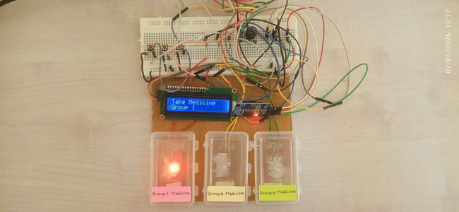
Fig. 5.1 Group 1 Medicine – Alert 1

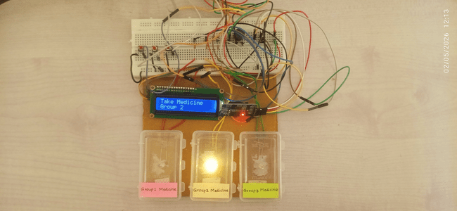
Fig. 5.2 Group 2 Medicine – Alert 2

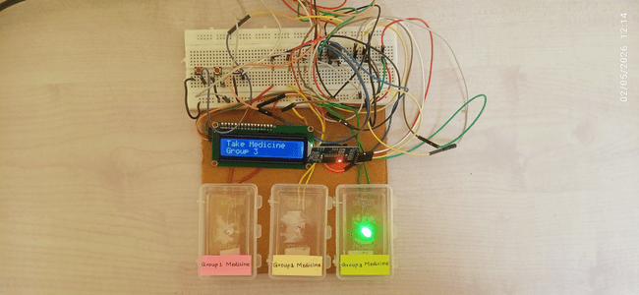
Fig. 5.3 Group 3 Medicine – Alert 3

The Smart Medication Box performed successfully during testing. The following observations were made:
- The RTC module maintained accurate and stable time throughout the operation.
- The Arduino correctly processed and compared the real-time data with stored alarm values.
- The buzzer was activated precisely at the scheduled medication times.
- The LED indicators glowed appropriately for different medication groups.
- The LCD display showed correct time, date, and alert messages clearly.
- The push buttons responded accurately during alarm setting operations.

5.4 PERFORMANCE ANALYSIS
The performance of the system was evaluated based on key parameters:

5.4.1 Time Accuracy
The RTC DS3231 module ensured highly accurate timekeeping. No noticeable deviation was observed during continuous operation.

5.4.2 Response Time
The system responded instantly when the scheduled time was reached. The delay between time matching and alert generation was negligible.

5.4.3 Reliability
The system operated reliably without any failure or malfunction over multiple test cycles.

5.4.4 User Interaction
The push-button interface allowed easy configuration of alarm timings. The LCD display improved usability by clearly presenting system information.

5.4.5 Power Efficiency
The system consumed very low power, making it suitable for long-term continuous operation.

5.5 PERFORMANCE SUMMARY TABLE

Table 5.1 Performance summary
Parameter | Expected Result | Observed Result | Remarks
Time Accuracy | High | Very High | RTC is precise
Response Time | Immediate | Instant | No delay
Reliability | High | Stable | No errors observed
Power Consumption | Low | Low | Efficient
User Interface | Simple | User-friendly | Easy operation

5.6 DISCUSSION
The results clearly indicate that the Smart Medication Box is capable of performing its intended function effectively. The integration of Arduino with the RTC module ensures accurate and reliable operation, which is essential for time-based applications such as medication reminders.
The system is particularly beneficial for elderly individuals and patients who require strict medication schedules. The combination of audio (buzzer) and visual (LED/LCD) alerts ensures that users are notified effectively, even in different environments.
The system is simple to use and does not require technical expertise, making it suitable for everyday use. The use of EEPROM for storing alarm values adds to the reliability by retaining data even after power interruption.

5.7 LIMITATIONS
Although the system performs well, certain limitations were identified:
- Limited number of alarm settings (only 3 alarms)
- No remote notification system (SMS or mobile alerts)
- Manual configuration required
- No confirmation mechanism to verify medicine intake
- No automatic pill dispensing

5.8 FUTURE ENHANCEMENTS
The system can be further improved by incorporating the following features:
- Integration with GSM module for SMS alerts
- IoT-based remote monitoring and control
- Mobile application connectivity
- Voice alert system for better accessibility
- Automatic pill dispensing mechanism
- Battery backup system for uninterrupted operation

5.9 SUMMARY
The Smart Medication Box demonstrated efficient performance with high accuracy, reliability, and user-friendly operation. The system successfully met its objectives and proved to be suitable for practical healthcare applications. It provides a simple yet effective solution for improving medication adherence and enhancing patient safety

CHAPTER 6

CONCLUSION

The Smart Medication Box successfully achieves its objective of providing a simple and effective solution for medication reminders. The system utilizes an Arduino-based embedded platform combined with a Real-Time Clock module to ensure accurate and timely alerts for medication intake. Through design, implementation, and testing, it has been demonstrated that the system is capable of delivering reliable performance with minimal delay. The buzzer and LCD display provide clear notifications, ensuring that users do not miss their medication schedules. The use of push buttons for configuration makes the system user-friendly and accessible even to non-technical users. One of the major advantages of this system is its low cost and simplicity, making it suitable for widespread use in home healthcare environments. It reduces dependency on memory and external assistance, thereby promoting independent living, especially for elderly individuals and patients with chronic illnesses.
Although the system has some limitations, such as the lack of remote monitoring and automatic dispensing, it provides a strong foundation for future enhancements. By integrating advanced features like IoT connectivity and mobile alerts, the system can be further improved into a comprehensive smart healthcare solution. In conclusion, the Smart Medication Box is a reliable, efficient, and practical device that addresses a real-world healthcare problem. It demonstrates how embedded systems can play a vital role in improving patient safety, treatment adherence, and overall quality of life.

REFERENCES

- Just Do Electronics, “Medicine Reminder with Arduino,” Just Do Electronics, 2023. Available: https://justdoelectronics.com/medicine-reminder-with-arduino/
- Circuit Digest, “Arduino Based Medicine Reminder System,” Circuit Digest, 2022. Available: https://circuitdigest.com/microcontroller-projects/arduino-based-medicine-reminder-system
- Electronics Hub, “Arduino Medicine Reminder System,” Electronics Hub, 2021. Available: https://www.electronicshub.org/arduino-medicine-reminder/
- Elprocus, “Smart Medicine Reminder System using Arduino,” Elprocus, 2022. Available: https://www.elprocus.com/medicine-reminder-system-using-arduino/
- Engineers Garage, “Arduino Based Medicine Reminder System,” Engineers Garage, 2021. Available: https://www.engineersgarage.com/arduino-medicine-reminder/
- Arduino Official Documentation, “Arduino Uno Rev3,” Arduino, 2024. Available: https://www.arduino.cc/en/Main/ArduinoBoardUno
- Maxim Integrated, “DS3231 Extremely Accurate I2C RTC,” Maxim Integrated, 2020. Available: https://datasheets.maximintegrated.com/en/ds/DS3231.pdf
- NXP Semiconductors, “I2C Bus Specification and User Manual,” NXP, 2021. Available: https://www.nxp.com/docs/en/user-guide/UM10204.pdf
- Atmel (Microchip), “ATmega328P Datasheet,” Microchip Technology, 2022. Available: https://www.microchip.com/en-us/product/ATmega328P
- IEEE Xplore, “Design of Smart Medicine Reminder System Using IoT,” IEEE, 2023.
- MDPI Sensors Journal, “Smart Medication Adherence Systems: A Review,” MDPI, 2021.
- World Health Organization (WHO), “Medication Adherence Report,” WHO, 2020.

