******SALALE UNIVERSITY**

**COLLEGE OF NATURAL SCIENCE**

**DEPARTMENT OF COMPUTER SCIENCE**

**INTERNSHIP REPORT**

**HOSTING COMPANY: AWASH INTERNATIONAL BANK HEAD QUARTER**

**INFORMATION SYSTEM INFRASTRUCTURES**

**PREPARED BY:**

|  |  |  |  |  |
| --- | --- | --- | --- | --- |
| No | Name | ID Number | Email address | Phone Number |
| 1 | **SALEM MESMER** | **RU1790/14** | [salliyemes@gmail.com](mailto:salliyemes@gmail.com) | +251 90 410 6613 |
| 2 | **SELAMAWIT TEKLU** | **RU1563/14** | selamtekluu@gimail.com | +251 96 698 7905 |

**Academic Advisor: MSc. Diriba**

**Fiche, Ethiopia**

**October 6, 2024**

# **DECLARATION**

We want to express that the internship report titled "Application Support and Network Configuration" is entirely our own work. We’ve made sure to acknowledge all the sources and materials we used along the way. This report hasn’t been submitted anywhere else for academic or professional reasons. We take full responsibility for everything in this report—the content, analysis, and findings. We genuinely stand by the authenticity of our work and confirm our agreement with this declaration through our signatures.

**Name**  **Signature** **Date**

1. Salem Mesmer ------------------------ ------------------
2. Selamawit Telklu ------------------ ------ ------------------

# **APPROVAL**

The undersigned certifies that the above candidates have fulfilled the condition of successfully carrying out their internship at the Headquarters of Awash Bank Information System (**IS)** infrastructure under my supervision and are now ready for submission to the Department of Computer Science at Salale University in Fiche, Ethiopia.

**Department Head Signature Date**

Mr. Diriba (MSc.) ---------------------- ---------------------------

# **ACKNOWLEDGEMENT**

First and foremost, we would like to extend our heartfelt gratitude to Our God for continuously blessing and supporting us in all aspects of our lives. We would also like to express our sincere pleasure to our families for their unwavering support throughout our internship journey. Additionally, we would like to thank our university for providing the internship program. Furthermore, we would like to express our deep gratitude to Mr. Diriba, our internship advisor, for his invaluable guidance and support. We are also grateful to the administrative staff of Awash Bank's Network Infrastructure crew for their assistance and the wholehearted acceptance and support they provided as a family during this internship. Furthermore, we would like to express our appreciation to the members of the Network infrastructure team, particularly Ms. Genet, for her collaborative efforts. Our opportunity to work with them was made possible by the grateful guidance of Mr. Chirinet Kebede. Lastly, we are deeply thankful to all those who have directly or indirectly assisted us throughout this internship.

**EXCLUSIVE SUMMARY**

This document aims to provide a comprehensive overview of our experiences and insights gained during our internship at the headquarters of Awash Bank, specifically focusing on the Information Systems (IS) infrastructure. The primary objective of this internship was to immerse ourselves in a practical setting, allowing us to bridge the gap between theoretical knowledge acquired in the classroom and real-world applications in a professional environment.

Throughout our time at Awash Bank, we engaged in extensive discussions regarding the various critical components of the bank's network infrastructure. These discussions were informed by our observations and analyses during the internship, enabling us to gain a deeper understanding of the operational dynamics within the organization.

A fundamental aspect of any successful internship is the commitment to utilizing our time effectively, coupled with a genuine eagerness to grasp the practical implications of our academic studies. This report encapsulates our entire journey during the internship, which spanned from Hamle 22, 2016, to Pugme 1, 2016 E.C., at Awash International Bank's headquarters.

During this period, we were fortunate to acquire a wealth of hands-on experience, which is detailed in the subsequent sections of this document. These practical insights not only enriched our understanding of the banking sector but also equipped us with valuable skills that are essential for our future careers. Our time at Awash Bank has undoubtedly been instrumental in shaping our professional development, and we are eager to share the lessons learned and experiences gained throughout this transformative internship.

# 

# **ACRONYMS**

**AIB –** Awash International Bank

**DHCP -** Dynamic Host Configuration Protocol

**E-Wallet** – Electronic Wallet

**IP** – Internet Protocol

**IS** - Information System

**LAN** - Local Area Network

**WLAN** - Wide Area Network

**Table of Content**

DECLARATION I

APPROVAL II

ACKNOWLEDGEMENT III

EXCLUSIVE SUMMARY IV

ACRONYMS V

CHAPTER ONE 1

INTRODUCTION 1

1.1. Historical Background of Awash Bank 1

1.2. Geographical Location 2

1.3.Mission 6

1.4. Vision 6

1.5. Core Values 6

1.6. Infrastructure 6

1.6.1. General Infrastructure of the Network 6

1.7. Services 8

1.8. Objectives 8

1.9. Organization Structure 9

CHAPTER TWO 10

2.1. Overall Internship Experience 10

2.1.1. The Section of the Company we have been Attending the Internship 10

2.1.2. Reason Why We Select the Organization 10

2.1.3. The Work Flow of Infrastructure 11

2.2. Tasks We Have Been Executing 12

2.2.1. First up to Second week of the internship 13

2.2.2. Third up to Fourth week of the internship 13

2.2.3. Fifth week and Sixth week of the internship 21

CHAPTER THREE 25

3.1. Introduction of the project 25

3.2. Short Summary of the project 25

3.3. Problem of the Statement 26

3.4. Scope of the project. 26

3.5. Objective of the project 26

3.5.1. General objective 26

3.5.2. Specific objective 26

3.6. Methodology 26

1. Project Planning 27

Chapter Four 32

4.1. Benefits Gained from the Internship 32

4.1.1. Theoretical Knowledge Gained 32

4.1.2. Practical Knowledge Gained 33

1. Interpersonal Communication Skills 34

2. Team Playing Skills 34

Chapter Five 36

5.1. Conclusion and Recommendations 36

5.1.1. Conclusion 36

5.1.2. Recommendations for the Organization 36

5.1.3. Recommendations for Interns 37

5.1.4. Recommendations for the University 37

References 38

**Table of Figures**

Figure 1: Awash International Bank Headquarter Office Map 6

Figure 2: Aib Organization Structure 3

Figure 3: Infrastructural Structure 6

Figure 4: A Twisted Pair Cable With Shielding 9

Figure 5: A Coaxial Cable. 9

Figure 6: Fiber Optics Cable Manufacturing 10

Figure 7: Registered Jack 10

Figure 8: Rj45 Connector 11

Figure 9: How Switch Works 12

Figure 10: How Router Works 12

Figure 11: Crimping Tool 13

Figure 12: Tester Tool 13

Figure 13: Connection Of Devices 20

Figure 14: Command Prompt 21

Figure 15: To Check Ip Address 21

Figure 16: Control Panel 22

Figure 17: Network And Internet 22

Figure 18: Network Sharing 22

Figure 19: Change Adapter Settings 23

Figure 20: Ethernet 23

Figure 21: Ethernet Status 23

Figure 22: Ipv4 Address 24

**CHAPTER ONE**

# **INTRODUCTION**

## **Historical Background of Awash Bank**

Awash Bank, Ethiopia’s pioneering private bank, was established on November 10, 1994 after the downfall of the socialist regime. The Bank was established by 486 founding shareholders with a paid-up capital of Birr 24.2 million and started banking operations on Feb. 13, 1995. Since embarking operation, the Bank has registered remarkable growth. Notwithstanding global and domestic challenges, Awash Bank has exhibited a superior operational and financial performances among private banks operating in Ethiopia. Awash Bank is currently working towards strengthening its capital base, technological capabilities, human resources and customer base.

Our name derives from the Awash River, which is extensively used in Ethiopia for small to large-scale irrigation schemes, hydroelectricity generation and for industrial activities. By that token, the tagline “nurturing like the river” implies Awash Bank’s immense contribution to the country’s socio-economic development. We also serve the population by encouraging the habit of saving, the provision of credit facilities and facilitating efficient and fast payment systems.

One of the core values of our bank is accessibility. We always strive to improve our accessibility by means of different service delivery channels. Currently, we are the most accessible private bank in the country, with a large footprint of extensive branch networks. In addition to branch networks, we provide our customers the convenience of 24/7 service through ATMs, point of sale terminals, internet, mobile and agency banking.

Corporate social responsibility lies at the heart of Awash Bank’s activities since its establishment. The Bank’s intent is to change the socio-economic situation of the communities within which it operates by plugging back funds to improve education, health and the environmental and social wellbeing of the disadvantaged strata. The positive impact of our activities is clearly indicated in the number of elementary schools built in collaboration with NGOs, the health facilities improved and the trees planted in different parts of the country and the like.

Awash Bank’s vision to be one of the Top Ten African Banks by 2030 is a sign of its ambition and commitment to growth. The bank has a clear strategy in place to achieve this vision, and it is investing in the resources and capabilities needed to succeed.

Our strategic goals and objectives are based on the aspiration: 'To be one of the Top Ten African Banks by 2030'. [1]

## **Geographical Location**

Awash bank Head Quarter, 2Q72+WGM, Addis Ababa 9.023738752475342, 38.75277141523441 Located in Mexico.

* Call center: 8980
* Head Quarter : Awash Towers, Ras Abebe Aregay St Addis Ababa, Ethiopia
* Official Website: contactcenter@awashbank.com
* Fax : +251115570136
* P.O. Box 12638 Code 100

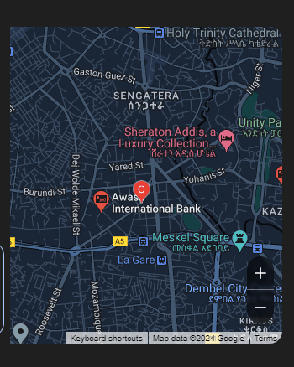

**Figure 1 Awash International Bank Headquarter Office Map**

## **Mission**

To provide the most Innovative and Accessible banking services to our customers using the most relevant technology, and motivated and talented staff to maximize stakeholder’s value and influence the life of the society positively [2]

## **Vision**

To be the best and preferred financial services provider where customers feel valued

## **Core Values**

A – Accessibility

W – Wisdom

A – Accountability

S – Socially Responsible

H – Honesty

## **Infrastructure**

### **General Infrastructure of the Network**

Awash International Bank has invested significantly in modern banking infrastructure to enhance customer experience and operational efficiency. The bank's network infrastructure includes:

Awash International Bank (AIB) boasts an extensive branch network, making it one of the most accessible private banks in Ethiopia. As of the latest reports, the bank has over 725 branches spread across the country. This widespread presence ensures that customers can access banking services conveniently, regardless of their location. To enhance customer experience and streamline operations, AIB has invested significantly in modern banking infrastructure. The bank offers a variety of digital channels, including internet banking, mobile banking, and agency banking. These digital platforms allow customers to perform a wide range of banking activities, such as fund transfers, bill payments, and account management, from the comfort of their homes or offices. AIB provides 24/7 banking services through its extensive network of ATMs. These machines are strategically located across urban and rural areas to ensure easy access to cash withdrawals, balance inquiries, and other essential banking services. The ATM network is a crucial component of the bank's infrastructure, supporting its goal of providing seamless banking services to its customers. The bank has also deployed numerous POS terminals at various merchant locations. These terminals facilitate cashless transactions, allowing customers to pay for goods and services using their debit or credit cards. This initiative supports the bank's efforts to promote a cashless economy and enhance the convenience of its customers. AIB has invested in robust IT systems to support its operations and ensure the security of customer data. The bank employs advanced cyber security measures to protect its network from potential threats and breaches. Regular updates and maintenance of IT infrastructure are conducted to keep the systems running smoothly and securely. The bank's e-banking services have significantly improved its operational efficiency and customer satisfaction. These services include online banking platforms that allow customers to access their accounts, transfer funds, and perform other banking activities online. The e-banking infrastructure is designed to be user-friendly and secure, providing a reliable alternative to traditional banking methods. Despite the advancements, AIB faces challenges related to the internet infrastructure in Ethiopia. The relatively old technology and limited internet penetration can sometimes hinder the performance of online banking services.

However, the bank is continuously working on upgrading its infrastructure and adopting new technologies to overcome these challenges and provide better services to its customers. In conclusion Awash International Bank's network infrastructure is a blend of extensive physical branches and advanced digital channels. The bank's commitment to modernizing its infrastructure and enhancing customer experience is evident in its widespread branch network, robust IT systems, and comprehensive e-banking services. While there are challenges, AIB's ongoing efforts to improve its infrastructure ensure that it remains a leading player in Ethiopia's banking sector [1] [3].

## **Services**

Some of the services that are available by the bank are listed below:

* [Saving Account](https://awashbank.com/saving-account/)
* [Lucy Women Special Saving Account](https://awashbank.com/lucy-women-special-saving-account/)
* [Special Saving Account for Elders](https://awashbank.com/special-saving-account-for-elders/)
* [Smart Children Account](https://awashbank.com/smart-children-account/)
* [Student Solution Account](https://awashbank.com/student-solution-account/)
* [Salary Drawing Solution Account](https://awashbank.com/salary-drawing-solution-account/)
* [Investment Solution Account](https://awashbank.com/investment-solution-account/)
* [Check Payment’s Solution Scheme](https://awashbank.com/check-payments-solution-scheme/)
* [Provident Fund Solution Account](https://awashbank.com/provident-fund-solution-account/)
* [Special Saving Account (SSA)](https://awashbank.com/special-saving-account-ssa/)

## **Objectives**

The banks objectives are to be the number one bank for accessibility, innovative products and diversity of customer focused banking services. Awash Bank operates in own headquarter at the hub of the Ethiopian financial district.

## New Org Structure - May 10 edited-01**Organization Structure**

**Figure 2: AIB organization structure**

# **CHAPTER TWO**

## **2.1. Overall Internship Experience**

### **The Section of the Company we have been Attending the Internship**

During our internship, we were assigned to work within the Application support, network and Hardware and also Network Infrastructure divisions of Awash Bank. This different divisions plays a pivotal role in the bank's operations by ensuring the strength and safekeeping of its network and information systems. The Application support is responsible for keeping updated every branch of the bank, helping the branches of the organization through problems on their computer and also changing roles within the organization there were also other division we will see the details in 2.6. Our involvement in this department allowed us to gain hands-on experience in managing and optimizing critical components of the bank's network.

### **Reason Why We Select the Organization**

Our decision to select this organization for our internship was influenced by several compelling reasons. One of the primary factors that drew us to this organization is the fact that it is a new bank. As an aspiring computer science student, this presents a unique opportunity such as:

1. **Industry Exposure**: As we all know Awash International Bank is a well-established company and interning at a well-established company provides invaluable exposure to industry standards, practices, and cutting-edge technologies. This experience helps bridge the gap between academic knowledge and real-world applications.
2. **Mentorship Opportunities**: Like AIB Established companies often have experienced professionals and they provide guidance and mentorship. Learning from seasoned experts significantly enhance our skills and understanding of the field.
3. **Networking Potential**: AIB is well-developed company that offers extensive networking opportunities with professionals, peers, and industry leaders. Building those kinds connections can be beneficial for future career prospects and collaborations.
4. **Structured Learning Environment**: Larger companies typically have structured internship programs that include training sessions, workshops, and projects. And AIB have structured approach ensures a comprehensive learning experience and helps interns like us to develop essential skills systematically.
5. **Reputation and Resume Value**: Interning at a reputable company adds significant value to our resume. It demonstrates us to our future employers that we have experience in a professional setting, which can make as a more attractive candidate in the job market.

### **The Work Flow of Infrastructure**

Within the various divisions we’ve seen, we gained insights into the workflow and responsibilities of various divisions:

* **Network Infrastructure Management Team**: The Network Infrastructure Management Team is dedicated to the meticulous upkeep and optimization of the bank's intricate network framework. Throughout our internship, we delved into a variety of network topologies, explored an array of network devices, and mastered diverse network configuration methodologies. This foundational knowledge proved indispensable for the successful execution of our projects, equipping us with the skills necessary to navigate and enhance complex networking environments.
* **Database Management Team**: Entrusted with the critical responsibility of overseeing and safeguarding the bank’s vast repositories of data, the Database Management Team plays a pivotal role in ensuring data integrity and security. During our tenure, we acquired a profound understanding of advanced database management techniques and robust security protocols. This exposure not only enriched our comprehension of data governance but also illuminated the best practices essential for maintaining the confidentiality and availability of sensitive information.
* **Digital Application Management and support Team**: The Digital Application Management Support Team is tasked with the comprehensive oversight and maintenance of server infrastructures that underpin the bank's digital operations. Our engagement with this division afforded us invaluable insights into various server technologies and their integral role within the institution’s operational framework. Through hands-on experience, we gained a deeper appreciation for server management practices, which are crucial for ensuring seamless functionality and reliability in the bank's digital ecosystem.

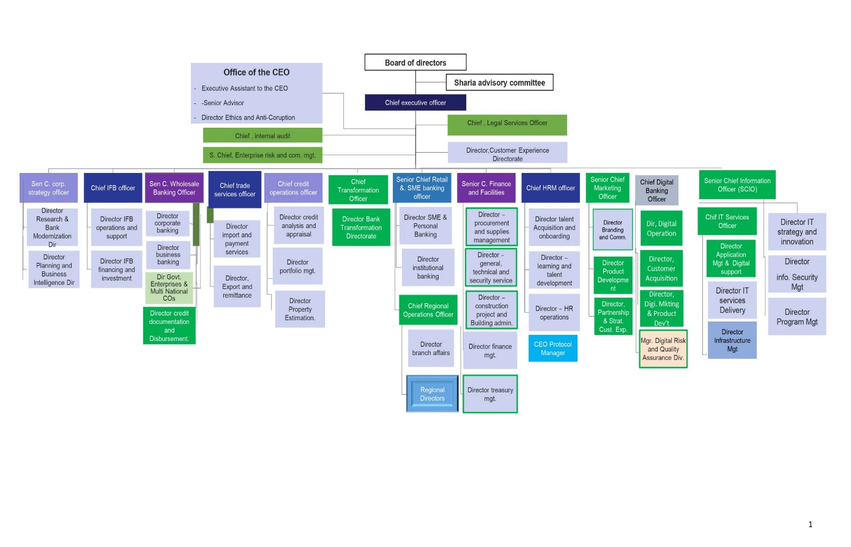

**Figure 3: infrastructural structure**

Gaining insight into these distinct divisions afforded us a profound appreciation for the intricate interdependencies that exist within the information system infrastructure. We came to recognize how each component, in its unique capacity, collaborates harmoniously to enhance the bank's operational fluidity. This holistic understanding illuminated the pivotal role that each sector plays in fostering an environment where information flows effortlessly, ensuring that the institution can navigate the complexities of modern banking with agility and precision. The synergy among these divisions not only fortifies the bank’s infrastructure but also underpins its ability to deliver exceptional service and maintain a competitive edge in the ever-evolving financial landscape.

## **Tasks We Have Been Executing**

To a considerable degree, we have acquired invaluable expertise while immersed in the intricate framework of the bank's information system infrastructure. Our responsibilities encompassed a commitment of three days each week, during which we engaged in a multitude of tasks designed to enhance our understanding and proficiency.

Throughout this period, we were subject to evaluations administered by our mentor, providing us with constructive feedback and insights into our performance. Additionally, we occasionally conducted hands-on examinations of various physical devices integral to the bank’s operations. This multifaceted approach not only enriched our practical knowledge but also deepened our appreciation for the technological underpinnings that facilitate seamless banking processes. Each experience contributed significantly to our professional growth, equipping us with the skills necessary to navigate the complexities of the financial sector with confidence and acumen.

### **First up to Second week of the internship**

Our internship commenced on July 22, 2024, a Monday that marked the beginning of an exciting journey. During our inaugural week, we were assigned to collaborate closely with the application support team. Our primary responsibility was to provide assistance to the bank's employees, specifically those stationed at various branches. The support we offered was facilitated through the bank's online help desk, a vital platform that enabled us to address their inquiries and resolve issues that could be managed remotely.

Moreover, we served as the point of contact for any personnel transfers within the organization. Whenever an employee needed to relocate to a different branch, we were the designated team to facilitate and coordinate that transition, ensuring a smooth process for all parties involved. This role not only honed our technical skills but also enhanced our ability to communicate effectively and empathetically with colleagues across the institution. Overall, our experience during this initial phase was both enlightening and rewarding, laying a solid foundation for our subsequent endeavors in the internship.

### **Third up to Fourth week of the internship**

After two weeks of dedicated work, we transitioned to our next division, which focused on hardware and network infrastructure. This segment proved to be particularly exhilarating, as it required direct, face-to-face interactions. Our primary responsibility was to provide on-site support to individuals experiencing technical difficulties. The requests for assistance were primarily routed to us by the application support teams.

Our daily tasks involved responding to calls from users encountering issues with their computers, printers, scanners, and various other hardware components. These challenges necessitated a hands-on approach, allowing us to engage personally with clients and address their concerns effectively. Additionally, we were responsible for assigning IP addresses to the computers of newcomers or in newly established offices, a crucial task within this division.

One of the most rewarding aspects of our role was the opportunity to configure networks, which not only enhanced our technical skills but also fostered a sense of accomplishment as we facilitated seamless connectivity for our clients. This experience deepened our understanding of network dynamics and reinforced the importance of collaboration in resolving complex technical issues. Overall, our time in the hardware and network infrastructure division was both fulfilling and instrumental in honing our expertise in the field.

So when we come to the configuration part we had the chance to work on some of materials like:-

* Twisted pair cable
* Registered Jack-45 (RJ45)
* Coaxial cable
* Fiber Optic
* Switch
* Router
* Crimping too
* Tester
* **Twisted pair**

[Twisted pair](https://en.wikipedia.org/wiki/Twisted_pair) cabling is a form of wiring in which pairs of wires (the forward and return conductors of a single [circuit](https://en.wikipedia.org/wiki/Electronic_circuit)) are twisted together for the purposes of canceling out [electromagnetic interference](https://en.wikipedia.org/wiki/Electromagnetic_interference) (EMI) from other wire pairs and from external sources. This type of cable is used for home and corporate [Ethernet](https://en.wikipedia.org/wiki/Ethernet) networks. Twisted pair cabling is used in short [patch cables](https://en.wikipedia.org/wiki/Patch_cable) and in the longer runs in [structured cabling](https://en.wikipedia.org/wiki/Structured_cabling).

There are two types of twisted pair cables: shielded and unshielded.

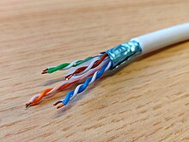

**Figure 4: A twisted pair cable with shielding**

* **Coaxial cable**

Coaxial cables form a transmission line and confine the electromagnetic wave to an area inside the cable between the center conductor and the shield. The transmission of energy in the line occurs totally through the dielectric inside the cable between the conductors. Coaxial lines can therefore be bent and twisted (subject to limits) without negative effects, and they can be strapped to conductive supports without inducing unwanted currents in them.A coaxial cable has a central conductor surrounded by a sheath of conductor with insulation in between.

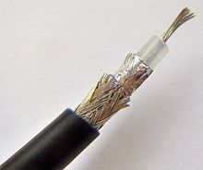

**Figure 5: A coaxial cable**

* **Fiber Optic**

An optical fiber cable consists of a center glass core surrounded by several layers of protective material. The outer insulating jacket is made of Teflon or PVC to prevent interference. It is expensive but has higher bandwidth and can transmit data over longer distances. There are two major types of optical fiber cables: shorter-range multi-mode fiber and long-range single-mode fiber.

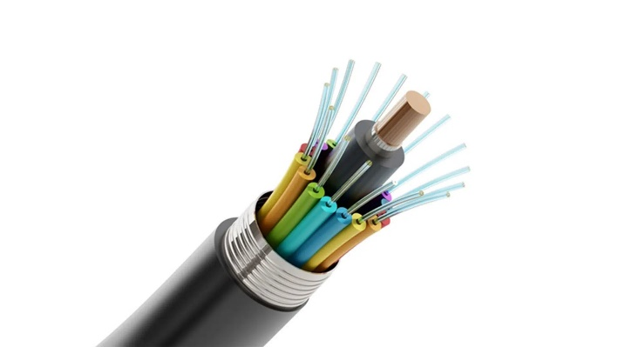

**Figure 6: Fiber Optics Cable Manufacturing**

* **Registered Jack-45 (RJ45)**

A registered jack (RJ) is a standardized physical network interface for connecting telecommunications or data equipment. Cables transmit information along the length. Only the right connection to an RJ45 interface or RJ45 connector will realize the transmission. And the cable run needs a connector termination, requiring a jack, normally an RJ45 jack, to plug into. RJ45 connectors are commonly seen with Ethernet network cables. Ethernet cables with RJ45 connectors are also called RJ45 cables. These RJ45 cables feature a small plastic plug on each end, and the plugs are inserted into RJ45 jacks of Ethernet devices. What is RJ45? Are you confused about different RJ45 interface types? Keep reading to explore more.

* **What Is RJ45 Interface?**

RJ45 interface is considered the most common twisted-pair connector for Ethernet cables and networks.

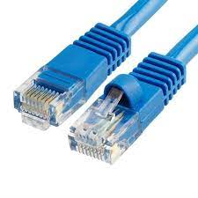

**Figure 7: Registered Jack**

"RJ" means "registered jack" — a standardized telecommunication network interface for connecting voice and data equipment to a service provided by a local exchange carrier or long-distance carrier.

"45" is the number of the interface standard.

Physically speaking, the connectors that registered jacks use are mainly the modular connector and 50-pin miniature ribbon connector types. RJ45 connector is an 8-position, 8-contact (8P8C) modular plug, and jack, applied for Ethernet-based local area networks (LAN). RJ45 cable plug is usually made of a plastic piece with eight pins on the port. Four of the pins are used for sending and receiving data, and the other four are used for other technologies or power networking devices.

You cannot plug in an RJ45 connector to an RJ11 slot but the opposite is possible. Although the smaller size of RJ11 makes it easier to be plugged into the RJ45 slot, it is not recommended to do that since this may damage the device that adopts the RJ45 slot.

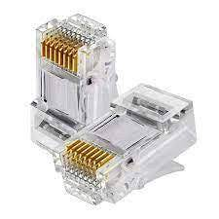

**Figure 8: RJ45 Connector**

* **Switch**

A network switch connects devices within a network (often a local area network, or LAN*) and forwards data packets to and from those devices. Unlike a router, a switch only sends data to the single device it is intended for (which may be another switch, a router, or a user's computer), not to networks of multiple devices. [4]

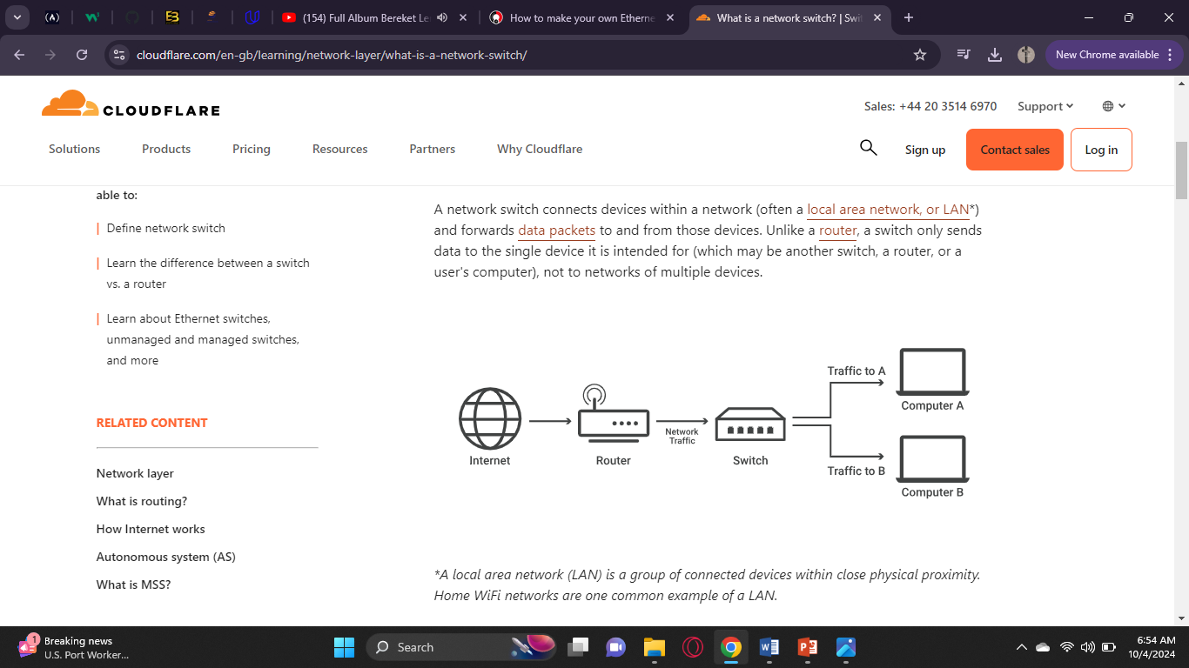

**Figure 9: How Switch Works**

* **Router**

A router is a device that connects two or more packet-switched networks or sub networks. It serves two primary functions: managing traffic between these networks by forwarding data packets to their intended IP addresses, and allowing multiple devices to use the same Internet connection.

There are several types of routers, but most routers pass data between LANs (local area networks) and WANs (wide area networks).

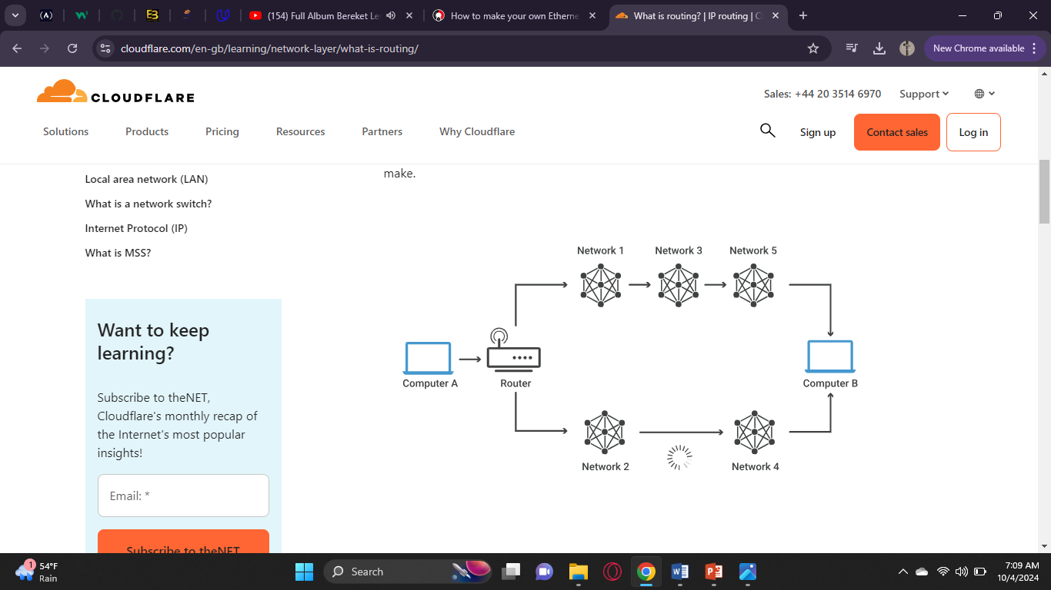

**Figure 10: How Router Works**

* **Crimping tool**

A crimping tool is a device used to conjoin two pieces of metal by deforming one or both of them in a way that causes them to hold each other. The result of the tool's work is called a crimp. A good example of crimping is the process of affixing a connector to the end of a cable.

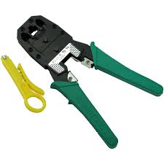

**Figure 11: crimping tool**

* **Tester**

Basically, it sends signals down each of the conductors, looking to see that they are correctly received. A good one will check the pin out, check that all conductors are working, and check for crosstalk.

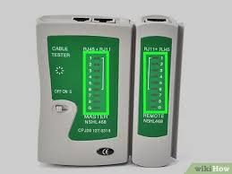

**Figure 12: Tester tool**

Additionally we worked on how to connect a cable with RJ45 and the steps are on below:-

**Step-1:** Strip the cable back 1 inch (25 mm) from the end. Insert the cable into the stripper section of the tool and squeeze it tight. Then, rotate the crimping tool around the cable in a smooth and even motion to create a clean cut. Keep the tool clamped and pull away towards the end of the wire to remove the sheathing.

* The stripping section is a round hole near the handle of the tool.
* The sheathing should come off cleanly, leaving the wires exposed.

**Step-2:** Untwist and straighten the wires inside of the cable. Inside of the cable you’ll see a bunch of smaller wires twisted together. Separate the twisted wires and straighten them out so they’re easier to sort into the right order.

* Cut off the small plastic wire separator or core so it’s out of the way.
* Don’t cut off or remove any of the wires or you won’t be able to crimp them into the connector.

**Step-3:** Arrange the wires into the right order. Use your fingers to put the wires in the correct order so they can be properly crimped. The proper sequence is as follows from left to right: Orange/White, Orange, Green/White, Blue, Blue/White, Green, Brown/White, and Brown.

* There are 8 wires in total that need to be arranged in the right sequence.
* Note that the wires labeled Orange/White or Brown/White indicate the small wires that have 2 colors.

**Step-4:** Cut the wires into an even line 1⁄2 inch (13 mm) from sheathing. Hold the wires with your thumb and index finger to keep them in order. Then, use the cutting section of the crimping tool to cut them into an even line. The cutting section of the tool will resemble wire cutters.

* The wires must be in an even line to be crimped into the RJ-45 connector properly. If you cut them in an uneven line, move further down the wires and cut them again.

**Step-5:** Insert the wires into the RJ-45 connector. Hold the RJ-45 connector so the clip is on the underside and the small metal pins are facing up. Insert the cable into the connector so that each of the small wires fits into the small grooves in the connector.

* The sheathing of the cable should fit just inside of the connector so it’s past the base.
* If any of the small wires bend or don’t fit into a groove correctly, take the cable out and straighten the wires with your fingers before trying again.
* The wires must be inserted in the correct order and each wire must fit into a groove before you crimp the connector.

**Step-6:** Stick the connector into the crimping part of the tool and squeeze twice. Insert the connector in the crimping section of the tool until it can’t fit any further. Squeeze the handles to crimp the connector and secure the wires. Release the handles, then squeeze the tool again to make sure all of the pins are pushed down.

* The crimping tool pushes small pins in the grooves down onto the wires to hold and connect them to the RJ-45 connector.

**Step-7:** Remove the cable from the tool and check that all of the pins are down. Take the connector out of the tool and look at the pins to see that they’re all pushed down in an even line. Lightly tug at the connector to make sure it’s attached to the cable.

* If any of the pins aren’t pushed down, put the wire back into the crimping tool and crimp it again. [5] [6]

### **Fifth week and Sixth week of the internship**

During the course of those two weeks, we also had the opportunity to engage with the network division. This segment of the organization operates quite differently from our previous assignments, as it predominantly involves remote oversight rather than direct, face-to-face interactions. The primary function of the network division is to meticulously monitor the operational integrity of the bank's network infrastructure, ensuring that any disruptions or outages affecting branches or automated teller machines (ATMs) are promptly identified and addressed.

Furthermore, this division plays a crucial role in managing the connectivity between our institution and other financial entities, thereby facilitating seamless transactions and communications across the banking ecosystem. Given the sensitive nature of the information and the stringent security protocols in place, our exposure to their processes was somewhat limited; however, we were granted a valuable glimpse into their operations. This experience allowed us to appreciate the complexities involved in maintaining a robust and secure network infrastructure, highlighting the critical importance of technology in the banking sector.

Through this involvement, we gained insights into the intricate balance between accessibility and security that must be maintained to safeguard both the bank's assets and its customers' information. The knowledge we acquired during this period not only broadened our understanding of network management but also underscored the significance of collaboration among various divisions within the organization to ensure operational excellence. Overall, our time spent within the network division was both enlightening and instrumental in shaping our comprehension of the multifaceted nature of banking operations in today's digital age.

**2.2.4. Seventh and eighth week of our internship**

In the concluding weeks of our internship, we were fortunate enough to explore the database management department, which provided us with a unique opportunity to engage with various professionals in the field. This visit allowed us to immerse ourselves in the intricacies of database operations and gain firsthand insights into the methodologies employed by experts in managing and optimizing data systems.

As we navigated through the division, we were able to establish meaningful connections with several individuals who generously shared their knowledge and experiences. These interactions not only broadened our understanding of database management but also fostered a collaborative spirit, encouraging us to ask questions and seek guidance on best practices.

The experience was invaluable, as it illuminated the significance of teamwork and communication in this domain. We left the division feeling inspired and more equipped with practical insights that will undoubtedly aid us in our future endeavors within the technology landscape. Overall, this exposure has significantly enriched our internship journey, leaving us eager to apply what we've learned in real-world scenarios.

**2.3. Challenges we have been facing while performing our tasks**

Throughout our internship, we encountered some challenges:

1. **Technical Skill Gaps**: In our Intern we were encountering technologies, programming languages, or tools that we haven't learned yet in their course time. This sometimes led us to the feeling of inadequacy or overwhelm when trying to complete our tasks.
2. **Real-World Application of Knowledge**: Transitioning from theoretical knowledge to practical application can be challenging. Also an Intern we were struggling with how to effectively apply what we've learned in school to solve real-world problems.
3. **Communication Barriers**: Collaborating with division team members and communicating technical concepts to non-technical stakeholders was somehow difficult. We kind of find it challenging to express our ideas clearly or to understand instructions and feedback.
4. **Time Management**: Balancing multiple tasks, deadlines, and possibly competing priorities can be overwhelming. As an Interns we need to develop better time management skills to meet expectations and complete projects on time.
5. **Adapting to Workplace Culture**: Every organization has its own culture and norms. We might find it challenging to adapt to the professional environment, including understanding workplace dynamics, expectations for behavior, and the level of formality required.

**2.8. Permanent solutions we have been using to overcome the challenges**

To overcome the challenges, we encountered during the internship, we implemented some solutions such as.

1. **Technical Skill Gaps:**
   * Encourage ourselves to complete online courses or tutorials on relevant technologies before starting the internship.
   * Scheduling frequent meetings together to discuss our lagging point and our progress and identify areas where additional training might be needed.
2. **Real-World Application of Knowledge:**
   * To assign projects that align with our academic background, gradually introducing more complex tasks as we gain confidence.
   * Organize periods that focus on applying theoretical concepts to practical problems, it can be led by experienced team members but as for us we were discovering it on YouTube and Google.
   * Provide constructive feedback on our work, and also by helping us understand how to bridge the gap between theory and practice.
3. **Communication Barriers:**

* As an intern to be present in the workspace on effective communication, focusing on both technical writing and verbal presentation skills.
* Foster an environment where we can feel comfortable asking questions and seeking clarification without fear of judgment.
* Encourage as to document our work and processes, which can help us articulate our thoughts more clearly.

1. **Time Management:**

* Clearly defining project timelines and deliverables at the outset, breaking larger tasks into manageable milestones.
* We think it would be better if any intern like us could schedule weekly or bi-weekly meetings to discuss workload, allowing intern to voice concerns about time management and receive guidance.

1. **Adapting to Workplace Culture:**

* If there is any structured onboarding program, we could join so that we get to know the company culture, values, and expectations.
* Joining if allowed in an organized team-building activities or informal gatherings to help to help us connect with colleagues and feel part of the team.
* To be encourage a culture where we can approach supervisors with questions about workplace norms and expectations without hesitation.

Furthermore, our collaborative efforts were instrumental in overcoming these obstacles. By working together, we actively addressed various challenges and readily sought support from one another. This collective approach not only facilitated problem-solving but also fostered a more seamless and enriching internship experience for everyone involved. The synergy we created allowed us to leverage our diverse skills and perspectives, ultimately enhancing our ability to navigate complexities and achieve our goals more effectively.

# **CHAPTER THREE**

## **Introduction of the project**

Throughout our internship, we encountered a pivotal challenge that required us to integrate the design of network infrastructure for a specific Analytics and Information Management Division. This involved not only establishing the network itself but also configuring users' computers to seamlessly connect to the bank's existing network. In this chapter, we will delve into the intricacies of this project, exploring the various stages we undertook, the obstacles we faced, and the solutions we implemented to ensure a successful outcome. By examining these details, we aim to provide a comprehensive understanding of the project’s scope and significance within the broader context of our internship experience.

## **Short Summary of the project**

The foremost objective of this project is to develop a robust networking infrastructure tailored specifically for the users within the organization. This endeavor involves the strategic utilization of materials such as RJ45 connectors and the deployment of twisted pair cables, with approximately seven cables are designated for this purpose. These components play a crucial role in establishing efficient communication pathways, enabling effective data transfer through their distinctive networking capabilities. By leveraging these advanced materials, the project aims to create a cohesive network that enhances operational efficiency and fosters reliable interactions among various devices. The strategic implementation of this infrastructure will empower users to navigate data exchanges with remarkable speed and accuracy, ultimately contributing to the overall productivity of the organization.

The significance of this project is further emphasized by its focus on creating a resilient network configuration to facilitate secure communication and efficient data transfer within AIB's division. To achieve this vision, we undertook a meticulous process that integrated a diverse array of network devices, advanced routing protocols, and robust security measures. Our comprehensive project report employs sophisticated simulators and emulators to provide an in-depth analysis of the network system, making it particularly beneficial for similar divisions aiming to comprehend and implement effective networking solutions. Throughout the course of the project, we successfully established seamless connections among various devices while rigorously enforcing secure control management through stringent access control protocols. Ultimately, this initiative aims to furnish Awash Bank's division with a stable and efficient network infrastructure that facilitates uninterrupted data communication, thereby significantly elevating overall productivity and operational efficiency in navigating the complexities of modern banking operations.

## **Problem of the Statement**

Because of creating a new division, the workers and the division manager requires configured computers to begin operations effectively. And we had to configure around 7computers with in specific day.

## **Scope of the project**.

The scope of this project is to guarantee that the new division is outfitted with the essential technology needed for efficient operations from the very first day. By following the defined space, we can promote a seamless transition into the new division, thereby boosting productivity and fostering collaboration among team members. This will not only enable them to hit the ground running but also create an environment conducive to teamwork and innovation.

## **Objective of the project**

### **General objective**

The general objective of this project is to configure the computers of the Analytics and Information Management Division to start working.

### **Specific objective**

* To provide an Ethernet cable for every computer that work in that division.
* To connect, each working Ethernet port to the computers.
* To configure each devise that’s in the room.
* To connect them to the banks network.
* To assign static IP addresses to each device on a network.
* To implement switching and routing protocols.
* To ensure connectivity of the division with the banks network,

## **Methodology**

To secure our success with in the specified hour we definitely needed a good methodology and below this is the methods we used

### **Project Planning**

Since we didn’t have enough time, we didn’t try to interview or observe anyone but since we had to finish as fast as possible we started working by gathering the materials we needed

1. **Equipment Acquisitio****n**

The necessary hardware materials we needed were: - computers, Ethernet cables, routers, switches,Floor Cords, clipper and tester. And from the side of the software the bank has decided when he buys the computer the software, he wanted most to be installed so we didn’t got bothered by it but still we used an operating systems additionally than the settings to check if the computer is configured correctly.

1. **Configuration Process**

In this process we started after plugging the computers and when it starts its window we started to connect to the computers and connecting Ethernet cables and ensuring proper physical setup then went to the step of configuring the networks through static IP address and setting up the computers to the users.

1. **Network Setup**

We establish the connectivity to the bank’s network implementing switching and routing protocols. After that we went on testing the connectivity to ensure all devices communicate effectively.

1. **Testing and Validation**

The way we it should be through the image is like below:-

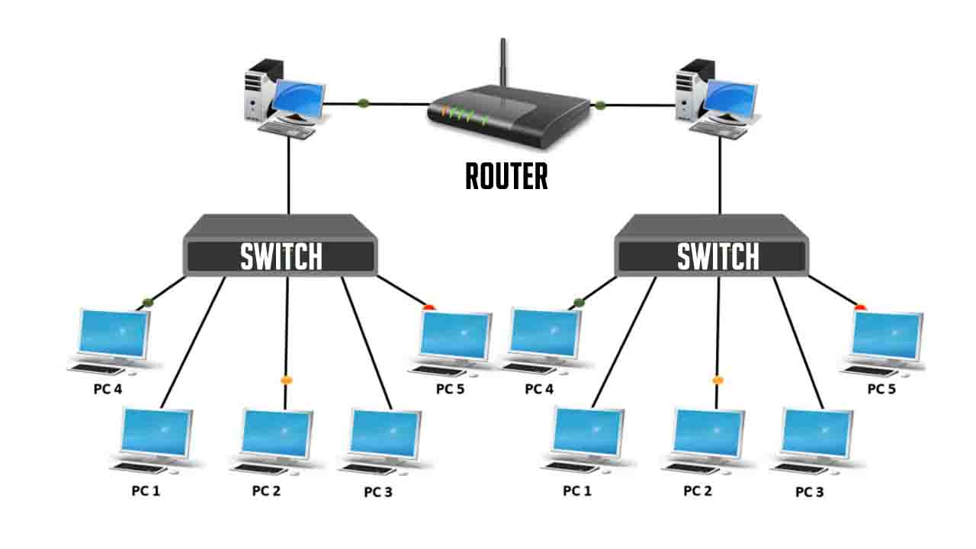

**Figure 13: connection of devices**

To check if its working there are 2 ways

**Step 1:** Open the Command Prompt.

Click the Start icon, type command prompt into the search bar and press click the Command Prompt icon.

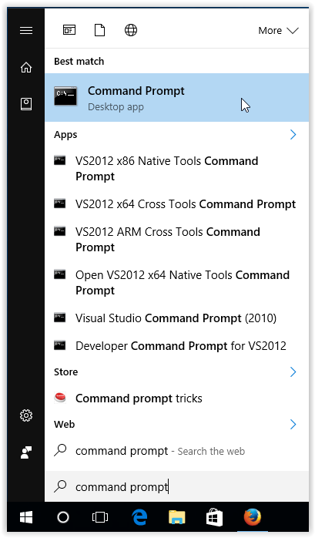

**Figure 14: command prompt**

**Step 2:**  Type ipconfig /all and press Enter.

**Step 3:**  The IP Address will display along with other LAN details.

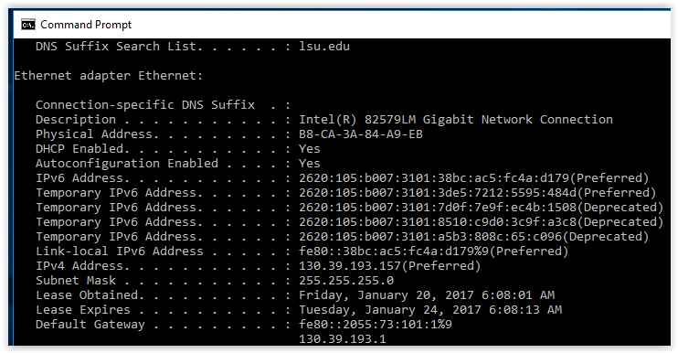

**Figure 15: To check IP address**

And the other way is

**Step 1**. Click the Start button, type in control panel, then click the Control Panel icon.

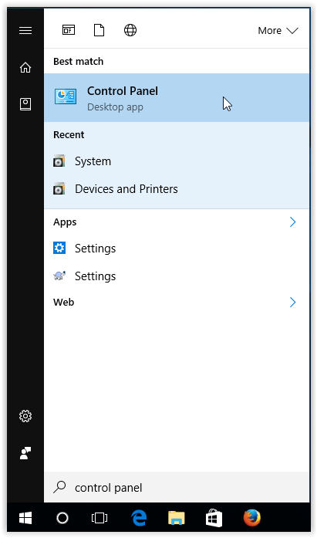

**Figure 16: control panel**

**Step 2**. Click Network and Internet when the Control Panel opens.

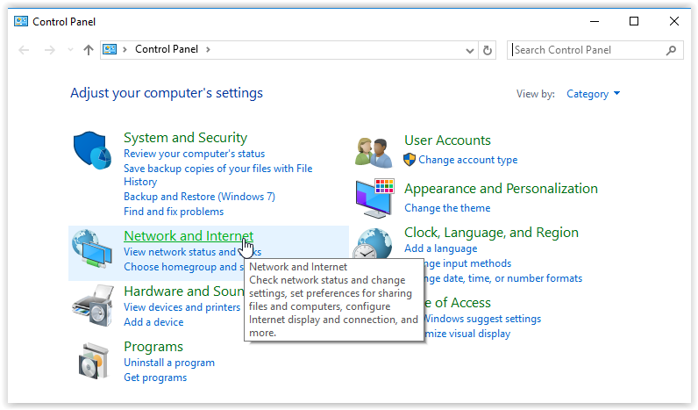

**Figure 17: network and internet**

**Step 3**. Select Network and Sharing Center.

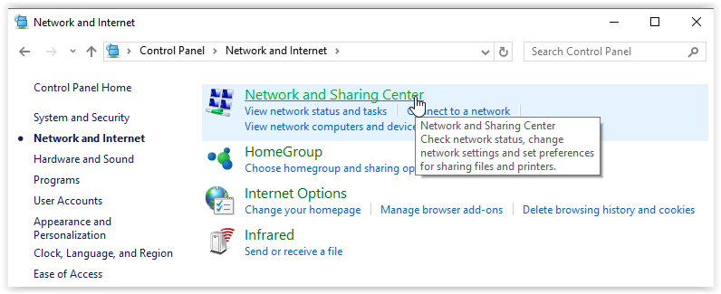

**Figure 18: network sharing**

**Step 4**. Click the Change adapter settings link, located on the left.

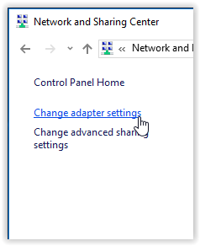

**Figure 19: change adapter settings**

**Step 5**. Double-click Ethernet.

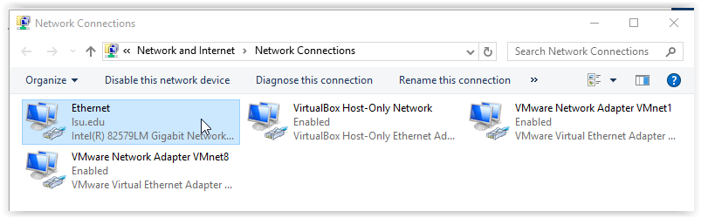

**Figure 20: Ethernet**

**Step 6**. Click Details, located under the Connection section for the Local Area Connection Status

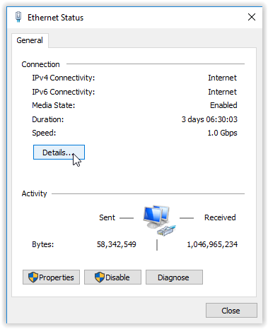

**Figure 21: Ethernet status**

**Step 7**. Scroll down until you find the IPv4 Address.

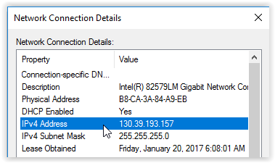

**Figure 22: IPv4 Address**

Through this way our success was completed. [7]

# **Chapter Four**

## **. Benefits Gained from the Internship**

During Throughout our internship at AIB, we have reaped numerous benefits that have significantly enriched our professional journey. These advantages include hands-on practical experience, which has allowed us to apply theoretical knowledge in real-world scenarios. Additionally, we have focused on skill development, honing both technical and soft skills that are essential in today’s job market.

One of the most valuable outcomes of this internship has been the boost in our confidence, enabling us to communicate effectively and tackle challenges with a positive mindset. The opportunity to explore various career paths has also been instrumental, giving us insights into different roles and industries that align with our interests.

Moreover, we have gained a deeper understanding of workplace dynamics, learning how to navigate team interactions and organizational culture effectively. This experience has not only enhanced our resumes but also provided us with invaluable networking opportunities, allowing us to connect with industry professionals and peers alike. Collectively, these experiences have contributed significantly to our growth in both our academic pursuits and future career aspirations.

### **Theoretical Knowledge Gained**

During our internship at Awash International Bank, we were afforded the invaluable chance to connect academic learning with practical implementation. This experience enabled us to translate the theoretical concepts we had mastered in our computer science curriculum into tangible applications within a dynamic banking setting. Throughout our time there, we significantly deepened our understanding in several critical areas, including:

* 1. **Network Security Protocols:** We gained insights into various security measures and protocols that safeguard sensitive financial data, allowing us to comprehend the importance of encryption and secure communication channels.
  2. **Data Transmission Techniques**: Our exposure to different methodologies for efficient data transfer helped us understand the intricacies of bandwidth management and latency reduction in a high-traffic environment.
  3. **Network Architecture Design:** We explored the principles of designing robust network infrastructures, learning about topologies, scalability, and redundancy that are essential for maintaining seamless banking operations.

This hands-on experience not only solidified our theoretical foundations but also equipped us with practical skills that are crucial for navigating the complexities of modern networking in the financial sector.

### **Practical Knowledge Gained**

One of the most noteworthy advantages of our internship experience has been the development of practical expertise. We engaged in a variety of hands-on activities that revolved around the management and troubleshooting of network infrastructure. This immersive experience allowed us to delve into several crucial aspects of networking, enhancing our comprehension and skill set. Here are five key areas where we significantly bolstered our practical knowledge:

1. **Network Configuration and Management:** We learned how to configure routers, switches, and firewalls, gaining insights into how these devices interact to form a cohesive network.
2. **Troubleshooting Techniques:** We developed systematic approaches for diagnosing and resolving network issues, which included using diagnostic tools and methodologies to identify bottlenecks and failures.
3. **Performance Monitoring:** We acquired skills in monitoring network performance metrics, enabling us to assess the health of the network and implement optimizations where necessary.
4. **Documentation Practices:** We learned the importance of maintaining thorough documentation for network configurations and changes, which is essential for effective communication and future troubleshooting.

Overall, this internship has not only enriched our theoretical understanding but has also empowered us with practical capabilities that are vital for a successful career in networking.

### **Interpersonal Communication Skills**

Internships provide a valuable opportunity to develop various interpersonal skills that are crucial for professional success. Here are some key interpersonal skills we often gained through our internship at AIB:

1. **Communication Skills:** We have learnt to articulate their thoughts clearly, both verbally and in writing, which is essential for effective collaboration.
2. **Teamwork:** Working with diverse teams helps us to understand group dynamics, learn to cooperate, and contribute to collective goals.
3. **Active Listening:** We have practiced listening to colleagues and supervisors, which enhances understanding and fosters better relationships.
4. **Conflict Resolution:** Even though we haven’t been in any conflicts what we have seen from our elders as general we have noticed to exposure to differing opinions and ideas helps interns develop strategies for resolving disputes and finding common ground in case any disputes.
5. **Empathy:** Engaging with coworkers from various backgrounds fosters a sense of empathy, allowed us to understand different perspectives and build rapport.
6. **Networking:** Internships provide opportunities to build professional relationships, enhancing networking skills that can be valuable throughout our career.
7. **Adaptability:** We really have learnt to adjust our communication styles based on the audience, whether it's colleagues, clients, or supervisors.

These interpersonal skills not only enhance our workplace effectiveness but also contribute to our personal growth and relationship-building in various aspects of our life.

### **Team Playing Skills**

1. **Collaboration:** We have noticed to work alongside others towards common goals, understanding the importance of each team member's contributions.
2. **Communication:** Effective communication within a team is vital. And we have practiced sharing ideas, providing feedback, and discussing projects openly.
3. **Trust Building**: Developing trust with team members encourages open dialogue and a supportive environment, which is essential for teamwork.
4. **Flexibility**: As an Interns we often need to adapt to different roles within a team, learning to be flexible and accommodating to others’ working styles.
5. **Diversity Appreciation**: Collaborating with individuals from various backgrounds enhanced our cultural competence and appreciation for diverse perspectives.
   * 1. **Leadership Skills**
6. **Decision-Making**: Internships often involve opportunities to make decisions, and this helps us to develop confidence in our judgment and problem-solving abilities.
7. **Initiative:** Taking the lead on projects or suggesting improvements fosters a proactive mindset and encourages us to step out of our comfort zones.
8. **Influencing Others**: We have seen and also learned how to motivate and inspire peers, which is crucial for effective leadership.
9. **Emotional Intelligence**: Effective leaders must understand their own emotions and those of others; and our internships have provided us opportunities to develop this skill through interactions.
10. **Crisis Management**: Handling unexpected challenges during our internship helps us to learn how to remain calm and make sound decisions under pressure.

Our time spent interning at AIB has proven to be a life-changing opportunity that has greatly expanded our understanding of both theoretical concepts and hands-on practices. This experience has significantly improved our communication abilities and fostered our capacity to work collaboratively within a team setting. Additionally, it has provided us with the chance to grow personally and professionally in a timely manner. The skills and insights we've gained during this internship will undoubtedly play a crucial role in shaping our future academic pursuits and career paths, equipping us with the tools necessary for achieving success in our respective fields. We feel more prepared and motivated to tackle the challenges that lie ahead, thanks to this invaluable experience.

# **Chapter Five**

## **5.1. Conclusion and Recommendations**

## **5.1.1. Conclusion**

Finally, we will walk away and say that we are excited to use these skills in the forthcoming final years of our academic/professional journey and hope our suggestions advance the continued success of Salale University, future interns and our respective university.

Interning with Awash Bank our learning and growth ordeal Grateful for the knowledge and skillsets we have gained. Beyond this, we have picked up many of the crucial interpersonal and teamwork skill sets over the course of our time at the bank.

Additionally, we understand the desperate need for disbursement of internship funds and suggest that the college work towards a solution to ensure that students receive their full allocation in a timely manner. A partnership with pre-approved companies would greatly improve that internship placement process for future students.

Because some organizations will have such type of procedures before allowing interns cruise control are crucial for students setting up internships so support and guidance from the college including interview skills. Assigned internship directors or advisers, weekly check-ins, and a feedback system can provide value to the broader experience.

We strongly believe that if these recommendations are put in place, the college will become more supportive and efficient in dealing with the internship program, hence being of help to the students. We would like to thank our organization for the opportunities and experience gained during the internship period, and we hope to see changes in subsequent years that will help students going through the same process.

### **5.1.2. Recommendations for the Organization**

* **Human Resource**: When we rise this point, it is not that the company is suffering due to a lack of human power; rather, just that in all branches of the regions indicating outside the capital city, the bank should have to supply people 24/7 available on the side of IT or the network system so that people wouldn't travel leaving their work.

### **Recommendations for Interns**

To future interns joining Awash Bank, we offer the following recommendations:

* **Embrace Collaboration:** Engaging in collaborative projects within the organization can provide a unique and enriching experience. Don't hesitate to explore opportunities to work together with fellow interns and experienced professionals.
* **Stay Curious:** The field of computer science and networking is continuously evolving. Stay curious, ask questions, and seek opportunities to learn about new technologies and trends.
* **Hands-On Learning:** Take full advantage of hands-on learning opportunities. Practical experience is invaluable for understanding complex concepts and gaining confidence in your abilities.
* **Document Your Experiences**: Keep a journal or document your internship experiences, including the tasks you've performed and the lessons you've learned. This documentation can be useful for personal growth and future job applications.

### **Recommendations for the University**

Besides the above proposals we did for Awash Bank, we would like to recommend some areas of improvement for the University's Internship Program for better coherency with the expected experience of the subsequent students:

* **Internship Grant Funds**: College should be able to send across disbursement of internship funds at the right time. Students will need access to the budgeted fund required for incurring expenses during the work experience.
* **Internship assignment**: The University should ease the processes involved in placing students at internship companies. Instead of giving students the headache of searching for internship opportunities, probably the college may engage a network of pre-approved companies or organizations that are willing and ready to take on interns. This would ease the complexity in the process of placement and increase the chances of placing the students at more quality companies.

# **References**

|  |  |
| --- | --- |
| [1] | A. I. Bank, "Awash international Bank," 2024. [Online]. Available: Awash International Bank. (2024). Internal Network Configuration Guidelines. [Company document].. |
| [2] | 2. Awash International Bank, "Awash International Bank, 2024," 2024. [Online]. Available: Awash International Bank. (2024). Company Overview. https://www.awashbank.com.. |
| [3] | Smith, "Smith, J. (2020). Advancements in Bank Network Security Protocols. Journal of Computer Science, 45(2), 150-160.," 2020. [Online]. Available: Smith, J. (2020). Advancements in Bank Network Security Protocols. Journal of Computer Science, 45(2), 150-160.. |
| [4] | "cloudflare," [Online]. Available: https://www.cloudflare.com/en-gb/learning/network-layer/what-is-a-network-switch/. [Accessed 1 10 2024]. |
| [5] | R. Mitchell, "wikiHow," 2023. [Online]. Available: https://www.wikihow.com/Crimp-Rj45#:~:text=Hold%20the%20RJ%2D45%20connector,small%20grooves%20in%20the%20connector.&text=The%20sheathing%20of%20the%20cable,so%20it's%20past%20the%20base.. |
| [6] | TechTips, "TechTips. (2023). How to Crimp RJ45 Connectors [Video]. YouTube.," 2023. [Online]. Available: https://www.youtube.com/TechTipsCrimpRJ45.. |
| [7] | WikiHow, "WikiHow," 2017. [Online]. Available: https://www.wikihow.com/Crimp-Rj45#:~:text=Hold%20the%20RJ%2D45%20connector,small%20grooves%20in%20the%20connector.&text=The%20sheathing%20of%20the%20cable,so%20it's%20past%20the%20base.. |
| [8] | "network devices," 8 29 2020. [Online]. Available: https://www.geeksforgeeks.org/network-devices-hub-repeater-bridge-switch-router-gateways/. |
| [9] | "pearson highered," [Online]. Available: https://www.pearsonhighered.com/assets/samplechapter/0/7/8/9/0789732548.pdf. [Accessed 7 29 2022]. |
| [10] | "netrwoking introduction," tech target, [Online]. Available: https://www.techtarget.com/searchdatacenter/definition/data-center. [Accessed 7 29 2023]. |
| [11] | "networking," tech target, [Online]. Available: https://www.techtarget.com/searchdatacenter/definition/data-center. [Accessed 7 29 2022]. |
| [12] | "introduction to networking," tech target, [Online]. Available: https://www.techtarget.com/searchdatacenter/definition/data-center. [Accessed 7 29 2023]. |
| [13] | "software," tech target, [Online]. Available: https://www.techtarget.com/searchapparchitecture/definition/software. [Accessed 8 29 2023]. |
| [14] | "GNS3 offical page," [Online]. Available: https://www.gns3.com. [Accessed 8 29 2023]. |
| [15] | "ECPE," [Online]. Available: http://www.ecpe.nu.ac.th/paisarn/slides/Networking/LAB/PT-UsingPacketTracer.pdf. [Accessed 8 29 2023]. |
| [16] | "IBM," [Online]. Available: (https://www.ibm.com/topics/vmware. [Accessed 8 29 2023]. |
| [17] | "tech target," [Online]. Available: https://www.techtarget.com/searchvmware/definition/VMware-ESXi. [Accessed 8 29 2023]. |
| [18] | free code camp, [Online]. Available: https://www.freecodecamp.org/news/what-is-an-iso-file-explained-in-plain-english. [Accessed 8 29 23]. |
| [19] | "the monitering expert," paessler, [Online]. Available: https://www.paessler.com/prtg. [Accessed 8 31 2023]. |
| [20] | Grafana Labs, [Online]. Available: https://grafana.com/. [Accessed 9 1 2023]. |
| [21] | "https://www.cloudflare.com/en-gb/learning/network-layer/what-is-a-network-switch/". |
| [22] | "cloudflare," [Online]. Available: https://www.cloudflare.com/en-gb/learning/network-layer/what-is-a-network-switch/. [Accessed 1 10 2024]. |
| [23] | [Online]. |
| [24] | G. k. base, 2024. [Online]. Available: https://networking.grok.lsu.edu/article.aspx?articleid=14842&printable=y. |