**Enhancing Home Security with IoT: Real-Time Monitoring via Serial WiFi Terminal in Alignment with Sustainable Development Goals**

A Project Presented to the Faculty of the College of Information and Communication Technology, Taguig City University, Genera Santos

Avenue, Central Bicutan, Taguig City

In Partial Fulfillment of the Requirements for Bachelor

of Science and Computer Science

By:

Alcoser, Jhuniel Fritz

Guilleno, Alvin

Polistico, Mark Jerveys

Siega, Carlo

Silapan, Francess Kyla V.

January 2025

**PROBLEM STATEMENT:**

Urban areas are increasingly facing security challenges due to rising populations, urbanization, and the complexity of modern cities. Traditional security measures often fall short in addressing modern threats effectively, leaving residents and their properties vulnerable. This project aims to address the following key challenges:

1. **Limited Accessibility to Modern Security Solutions:** Many security systems are either outdated or financially inaccessible, leaving urban and residential areas underprotected.
2. **High Incidence of Intrusions and Unauthorized Access:** Rising crime rates, including burglaries and unauthorized entries, compromise the safety and peace of mind of urban residents.
3. **Absence of Real-Time Alerts and Monitoring**: Traditional security systems lack the capability to provide real-time notifications or updates, delaying responses to potential threats.
4. **Dependency on Complex Integration:** Comprehensive security solutions often require expensive or overly complex infrastructure, which limits their adaptability and scalability in smaller-scale deployments.

This project focuses on addressing these challenges by developing a cost-effective, real-time monitoring system using an Arduino-based solution integrated with a Serial WiFi Terminal. While constrained by time, this approach prioritizes practicality and accessibility, laying the groundwork for scalable security improvements that align with Sustainable Development Goals (SDGs) to enhance safety and innovation in urban areas.

**ALIGNMENT WITH UNITED NATIONS- SUSTAINABLE DEVELOPMENT GOALS**

**SDG 11: Sustainable Cities and Communities**

Ensure access for all to adequate, safe, and affordable housing and basic services.

Provide universal access to safe, inclusive, and accessible, green, and public spaces.

While this project initially aimed to develop a comprehensive smart security system with sensors and alarms for door/window detection, the focus has shifted to a real-time monitoring solution using the Serial WiFi Terminal. This modification still contributes to the goal of enhancing safety and security in urban areas. By ensuring that residents can monitor their homes and spaces for unauthorized entries in real time, the project plays a role in fostering safer and more resilient communities.

**SDG 9: Industry, Innovation, and Infrastructure**

Develop quality, reliable, sustainable, and resilient infrastructure.

Upgrade infrastructure and retrofit industries to make them sustainable, with increased resource-use efficiency and greater adoption of clean and environmentally sound technologies.

The project leverages affordable, scalable IoT technology (Arduino and Serial WiFi Terminal) to create an innovative security solution. This approach aligns with SDG 9 by promoting sustainable, resilient infrastructure that is energy-efficient and capable of scaling with urban growth. While the full integration with real-time cloud-based monitoring was not fully realized, the alternative solution with the Serial WiFi Terminal still contributes to infrastructure resilience by enabling immediate responses to security breaches.

**OBJECTIVES**

The primary objective of this project was to develop a Smart Security System aimed at improving urban safety through real-time monitoring. Despite time constraints, the project utilized a Serial WiFi Terminal as a practical receiver for sensor data, fulfilling the goal of improving security while making adjustments to the initial vision. The revised objectives are as follows:

* **Evaluate the Effectiveness of Existing Security Systems**

Assess current security measures in urban areas to identify gaps and limitations, particularly in addressing the challenge of unauthorized access and intrusions.

* **Analyze Crime Patterns in Urban Areas**

Examine how inadequate security systems correlate with higher crime rates, especially in densely populated urban settings, and propose scalable solutions that can be implemented quickly and affordably.

* **Develop a Real-Time Monitoring System**

Design a practical real-time monitoring system using the Serial WiFi Terminal to monitor sensors in real-time. While not fully cloud-based, this solution still ensures that security breaches can be detected and acted upon promptly.

* **Integrate Security Solutions with Sustainable Urban Development**

Focus on environmentally friendly, energy-efficient, and cost-effective technologies to ensure the scalability and sustainability of urban security systems.

* **Explore Technological Innovations in Urban Securi**ty

Identify innovative, accessible technologies—like Arduino-based solutions and WiFi-enabled monitoring systems—to improve the security of urban communities without reliance on expensive infrastructure.

* **Propose a Comprehensive Urban Security Framework**

Develop a flexible urban security model that incorporates affordable, real-time monitoring with scalable technologies. This system can adapt to growing urban populations and changing security needs while integrating seamlessly with sustainable development.

**TARGETED UN-SD**

The Smart Security System with Door/Window Sensors and Alarm project, although adjusted in scope, continues to align directly with SDG 11 and SDG 9. Here's how:

**SDG 11: Sustainable Cities and Communities**

Goal: Make cities and human settlements inclusive, safe, resilient, and sustainable.

Connection:

Enhanced Urban Safety: The real-time monitoring system improves urban safety by alerting users to potential security breaches, contributing to safer neighborhoods.

Inclusive Security Solutions: By leveraging affordable technology such as Arduino and WiFi terminals, the project makes advanced security solutions accessible to broader populations, including lower-income urban areas.

Resilient Infrastructure: Even with a simplified monitoring solution, the project fosters urban resilience by enabling quick detection of security breaches, which is vital for improving response times and preventing potential crimes.

**SDG 9: Industry, Innovation, and Infrastructure**

Goal: Build resilient infrastructure, promote inclusive and sustainable industrialization, and foster innovation.

Connection:

Innovative Technology: The project utilizes Arduino and a Serial WiFi Terminal, an innovative approach that introduces affordable, scalable, and effective security solutions to urban communities.

Sustainable Infrastructure: By focusing on energy-efficient and scalable solutions, the project ensures that the security system integrates well into existing infrastructure without adding significant environmental or financial strain.

Promotion of Industry Standards: This project sets a precedent for how IoT and affordable technologies can be integrated into urban infrastructure for enhanced security, encouraging future innovation in smart city technologies.

**CONTRIBUTION OF ARDUINO UNO R3, ESP32 WIFI MODULE, AND CHOSEN SENSORS**

**Arduino Uno R3**

The Arduino Uno R3 serves as the central processing unit for the Smart Security System, handling the sensor inputs and processing the data. It communicates with the connected sensors to detect motion and door/window status changes, providing real-time updates. Its simplicity and reliability make it ideal for this project.

**Key contributions of the Arduino Uno R3 to the project:**

Affordable and Accessible: The Arduino Uno R3 provides an affordable solution for building a smart security system that can be deployed in urban areas with varying economic conditions.

Ease of Integration: The Arduino Uno R3 allows easy integration with sensors and modules, making it a flexible and scalable platform for urban security solutions.

Real-time Data Processing: The Arduino Uno R3 processes sensor data in real-time, ensuring prompt detection of security breaches.

Connectivity: It connects seamlessly with the ESP32 WiFi Module to send sensor data to a local monitoring terminal or future cloud-based solutions.

**ESP32 WiFi Module**

The ESP32 WiFi module is used to enable wireless communication for the security system. It allows the Arduino Uno R3 to send real-time sensor data to a receiver (such as the Serial WiFi Terminal) for monitoring.

**Key contributions of the ESP32 WiFi module:**

Wireless Communication: It provides wireless connectivity, allowing the security system to send updates remotely, eliminating the need for complex wiring and enabling future remote monitoring options.

Scalability: The ESP32 module is scalable, supporting additional sensors or cloud integration for future expansions of the security system.

Efficiency: The ESP32 module ensures reliable, real-time data transmission, enhancing the system's overall effectiveness in urban environments.

**Chosen Sensors**

**PIR Motion Sensor**

The PIR motion sensor detects movement in its detection range and is an integral part of the security system, providing early warning of intrusions.

**Key contributions of the PIR sensor:**

Real-Time Detection: It detects motion in specific areas, immediately triggering the Arduino Uno R3 to send an alert or update to the monitoring terminal.

Energy Efficiency: The PIR sensor is highly energy-efficient, activating only when motion is detected and ensuring minimal power usage while remaining effective.

Cost-Effective: As a widely used and affordable sensor, it provides a low-cost solution for motion detection.

**Magnetic Door/Window Sensor**

The magnetic door/window sensor is white in color and connected with a wire, which is used to monitor the opening and closing of doors and windows. The sensor is simple to connect, making it easy to activate and use in the system.

**Key contributions of the magnetic sensor:**

Intrusion Detection: It helps detect unauthorized entry by monitoring doors and windows, alerting the system when they are opened or closed.

Ease of Use: With its wire connection, the sensor is easy to set up and activate, making it an ideal choice for enhancing security at entry points.

Reliability: The magnetic sensor is durable and reliable, providing long-lasting protection for doors and windows in residential or commercial settings.

**PROPOSED SOLUTION:**

The Smart Security System aims to provide a reliable, cost-effective, and scalable solution for urban security challenges by integrating motion detection and door/window monitoring into a unified system. The solution leverages modern technology such as the Arduino Uno R3, PIR motion sensors, magnetic door/window sensors, and the ESP32 WiFi module to create an effective real-time monitoring system. While the original intention was to incorporate cloud-based monitoring, time constraints led to the use of a Serial WiFi Terminal as the receiver for real-time sensor data.

System Overview:

Sensor Integration: The system is designed to detect intrusions or unauthorized access through doors, windows, and movement within the monitored area. The PIR motion sensor detects motion, while the magnetic door/window sensor monitors the opening or closing of entry points. These sensors are connected to the Arduino Uno R3, which processes their signals and triggers corresponding alerts.

Real-Time Monitoring: The system transmits data via the ESP32 WiFi module, which provides wireless communication between the Arduino and the monitoring terminal. The data includes alerts about detected motion or changes in door/window status. This allows for immediate awareness of any potential security breaches.

Local Monitoring Terminal: Instead of the planned cloud solution, the system utilizes a Serial WiFi Terminal as a monitor for receiving real-time sensor updates. The terminal provides a visual interface to track the status of sensors, ensuring quick identification of any activity.

**Key Features of the Proposed Solution:**

* Cost-Effective: By using widely available and affordable components like the Arduino Uno R3, PIR motion sensors, and the magnetic door/window sensors, the system remains accessible to a broad population, making it suitable for various urban settings.
* Real-Time Alerts: Through the ESP32 WiFi module, the system provides real-time updates on sensor activity, enabling prompt responses to security threats.
* Scalable and Flexible: The modular design of the system ensures that it can be easily expanded with additional sensors, cloud integration, or more advanced monitoring systems in the future.
* Energy Efficiency: The sensors, particularly the PIR motion sensor, are energy-efficient, activating only when necessary, thus optimizing power consumption while ensuring effective monitoring.
* Ease of Installation: The magnetic door/window sensors are simple to install with wired connections, making them easy to integrate into any space without complicated setups.

**Addressing Project Constraints:**

Due to time limitations, the project adopted a Serial WiFi Terminal for monitoring rather than the initially envisioned cloud-based system. While cloud integration offers more flexibility and remote accessibility, the local monitoring solution via the Serial WiFi Terminal provides a workable and effective alternative for now, ensuring that the system can still be deployed within the required timeline.

**Future Expansion:**

Cloud Integration: In the future, the system can be expanded to incorporate cloud-based monitoring for remote access and more sophisticated alert systems.

**Additional Sensors:** New sensor types such as cameras, temperature sensors, and smoke detectors can be integrated to further enhance the system's capabilities.

**Mobile App Integration:** A dedicated mobile app could be developed to provide users with remote access to real-time alerts, sensor status updates, and notifications.

The proposed solution aims to enhance urban safety by providing a scalable, reliable, and easy-to-deploy security system that is fully aligned with the needs of modern cities and communities.

**BLOCK DIAGRAM:**

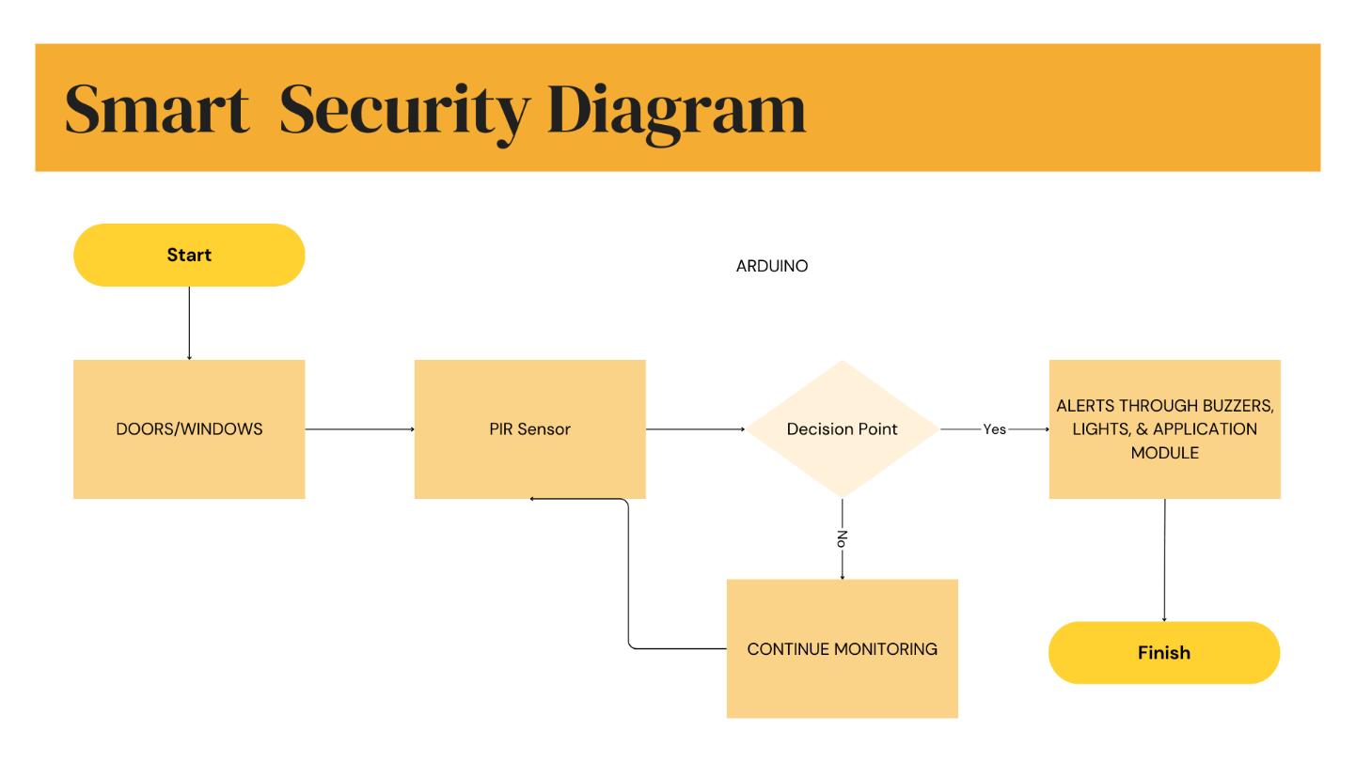

**FLOWCHART:**

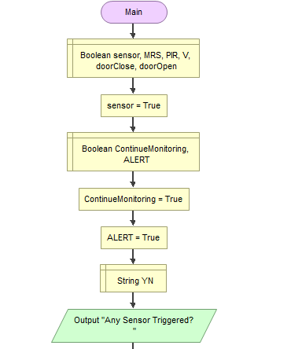

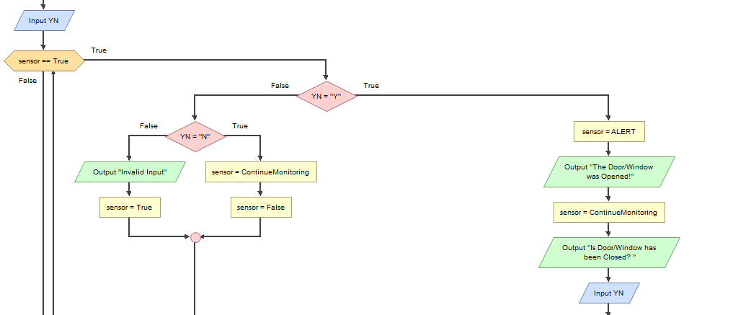

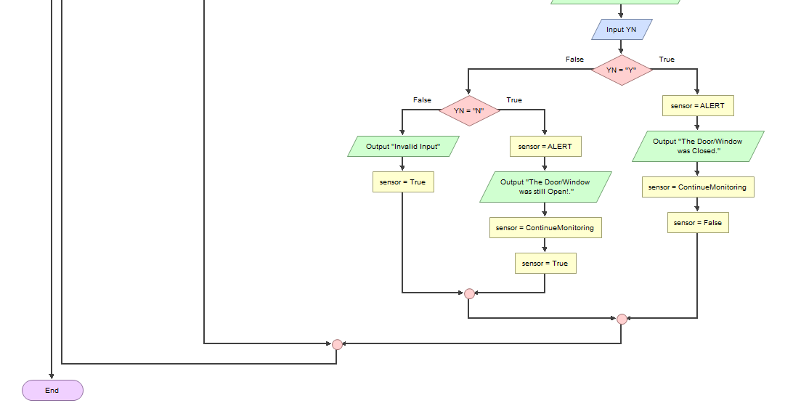

**SDG 11: Sustainable Cities and Communities**

Goal: Make cities and human settlements inclusive, safe, resilient, and sustainable.

Contribution:

**Enhanced Urban Safety:** The Smart Security System improves the safety of urban areas by providing reliable monitoring for doors, windows, and motion detection. This aligns with SDG 11’s focus on making cities safer by offering an affordable and effective solution to enhance security for residents.

**Inclusive Security Solutions:** By using cost-effective technologies such as the Arduino Uno R3 and accessible sensors like the PIR motion sensor and magnetic door/window sensors, the project ensures that advanced security measures are available to all, including residents in lower-income urban areas.

**Resilient Infrastructure:** The system contributes to the resilience of urban infrastructure by offering real-time monitoring and alerts that allow for swift responses to security threats, minimizing potential damage and ensuring a safer environment for residents and businesses.

**SDG 9: Industry, Innovation, and Infrastructure**

Goal: Build resilient infrastructure, promote inclusive and sustainable industrialization, and foster innovation.

Contribution:

**Innovative Technology:** The project integrates Arduino and modern sensor technologies, demonstrating how simple yet effective solutions can address traditional urban security challenges. By leveraging existing, reliable technologies, the project brings innovation to the field of urban safety and security.

**Sustainable Infrastructure:** The system’s modular design, powered by energy-efficient sensors like the PIR motion sensor, helps ensure that the solution is scalable and energy-conscious, aligning with sustainable infrastructure goals.

**Promotion of Industry Standards:** The implementation of a smart security system promotes the adoption of industry standards in urban security, encouraging the use of reliable, affordable, and scalable technologies for improving urban resilience and safety.

**SCALABILITY AND APPLICATION IN DIFFERENT CONTEXTS:**

**Scalability:**

**Modular Design: T**he system’s design allows for easy scaling. More sensors or features can be added to meet the specific needs of various contexts, from residential homes to large urban infrastructures.

**Cost-Effective Deployment:** With affordable components like the Arduino Uno R3 and PIR motion sensors, the system can be deployed widely in diverse urban environments, ensuring that communities of all sizes can access enhanced security without excessive costs.

**Application in Different Contexts:**

**Residential Areas: T**he system is ideal for individual homes or apartment complexes, offering enhanced security through easy-to-install sensors for doors, windows, and motion detection.

**Commercial Buildings:** Businesses can install the system to monitor and secure entry points, safeguarding their premises against unauthorized access or burglary.

**Public Spaces:** The system can be adapted for use in parks, schools, and community centers to provide safety and prevent vandalism or intrusions, promoting a safer environment for all.

**Smart Cities:** As part of a larger smart city initiative, the system can be integrated with other urban technologies such as smart lighting or traffic management, creating a comprehensive safety network that enhances city-wide security and resilience.

**By addressing the security needs of urban spaces, the Smart Security System** promotes the broader goals of sustainable development. It advances safe, inclusive, and resilient communities (SDG 11) while fostering innovation and sustainable infrastructure (SDG 9). The system’s modularity and affordability ensure that it can be deployed across diverse environments, contributing to the creation of safer, more resilient cities worldwide.

**IMPLEMENTATION PLAN:**

**Week 1: Initial Planning and Component Selection**

* The team held a meeting to decide on the components needed for the project.
* Group members conducted individual research to understand the components and the scope of the project.
* After completing individual research, the team brainstormed the best approach and identified key challenges and goals for the project.

**Week 2: Research and Component Purchase**

* The group had a second meeting to refine ideas and ensure that everyone was aligned on the project’s direction.
* After finalizing the project plan, the team decided to purchase the necessary components (PIR sensor, magnetic door/window switch sensor, Arduino Uno R3, ESP32 WiFi module, etc.) through an online store.
* The team focused on getting the best deal and ensuring timely delivery of components.

**Week 3: Design and Development Setup**

* As the components were on their way, the team worked on the design of the system.
* Each member worked on designing parts of the project, including the app's user interface (UI) and the system’s overall architecture.
* While waiting for the components, the team familiarized themselves with Arduino IDE and basic coding concepts related to sensor integration.

**Week 4: Components Arrival and Initial Testing**

* The ordered components began arriving, and the team started testing them individually.
* The PIR sensor and magnetic door/window switch sensor were successfully connected to the Arduino Uno R3 and tested for basic functionality using the Arduino IDE.
* However, the team faced delays as some components arrived later than expected, slowing down the overall testing process.
* During this time, the team also finalized the basic layout and design for the app.

**Week 5: App Development and Debugging**

* With some components arriving, the team focused on developing the app using Android Studio to receive real-time updates from the sensors.
* As the app was being built, the team tested the sensors with the Arduino Uno R3 and connected them to the app. Unfortunately, despite several attempts, the app did not function as expected due to connection issues and a lack of integration between the sensors and the app.
* Extensive debugging was performed, including watching tutorials and reviewing the code, but no success was achieved.

**Week 6: Adjusting the Approach and Continuing with Component Testing**

* Facing difficulties with the app, the team decided to temporarily shift focus back to the hardware.
* The PIR sensor and magnetic door/window sensor continued to perform well in the tests, and the team confirmed that the sensors worked correctly with the Arduino setup.
* The team reassessed the project’s goals and began searching for alternative solutions to display the sensor data.

**Week 7: Final Solution and Project Completion**

* After a thorough search, the team discovered the Serial WiFi Terminal app on Google Play, which allowed the sensors’ real-time data to be monitored effectively.
* The Serial WiFi Terminal app was integrated with the project, and the sensors successfully sent their data to the app.
* The team completed the project by ensuring that the sensor data was displayed correctly in real-time, despite the initial challenges with the app.
* The final solution met the core requirement of the project: providing a real-time monitoring system for the sensors.

**Conclusion:**

Though the project initially faced challenges in app integration, the team demonstrated flexibility and problem-solving skills by adjusting the approach. The final solution, using the Serial WiFi Terminal app, allowed the team to successfully monitor sensor data in real time, fulfilling the main objective of the project. This experience highlighted the importance of adaptability and persistence when facing technical difficulties.

**EXPECTED OUTCOME:**

The expected outcome of this project is to establish a reliable and functional smart security system that integrates Arduino, ESP32, and various sensors (PIR and magnetic door/window sensors) to monitor and detect security breaches in real-time. The outcome can be summarized in the following key points:

**Real-time Monitoring and Detection:**

The system will successfully detect motion using the PIR sensor and changes in the state of doors and windows using the magnetic sensor.

When motion is detected by the PIR sensor, it will trigger an action, indicating the presence of a person or movement in the monitored area.

The magnetic sensor will report whether the door/window is open or closed, providing real-time feedback on the security status of the premises.

**Efficient Data Communication:**

The ESP32 will reliably receive data from the Arduino Uno via UART communication (using Serial2).

The system will transmit data (motion detected or door/window status) to the Serial WiFi Terminal app, providing real-time updates on the status of the sensors.

**Improved Security Monitoring:**

The system will display motion detection alerts and door/window status changes on the Serial WiFi Terminal app, providing users with an easy-to-read and accessible interface for monitoring their security status.

The PIR sensor will show alerts when motion is detected, and the magnetic sensor will provide status updates for doors and windows (open or closed).

**Reliability of the System**:

The sensors, including the PIR motion sensor and magnetic door/window sensor, will work as expected in detecting motion and changes in door/window status.

The communication between the ESP32 and Arduino Uno will be stable, allowing seamless transmission of data between the two devices.

The system will show minimal delay in displaying updates in the Serial WiFi Terminal, ensuring that the security status is reflected accurately and in real-time.

**Successful Integration:**

The system will demonstrate the integration of hardware components (sensors and communication modules) with the software (Arduino IDE and Serial WiFi Terminal app), leading to a functional and usable smart security system.

The communication between the Arduino Uno and ESP32 via UART will be established without issues, and the app will display the expected real-time data from the sensors.

**User-Friendly Monitoring Interface:**

The Serial WiFi Terminal app will provide an intuitive interface for monitoring sensor data, enabling users to easily track motion detection and door/window status in their environment.

The app will help users monitor their security setup in real-time, making it an essential tool for home and small business security management.

Potential for Future Expansion:

The project can be further expanded by integrating additional sensors (such as vibration or smoke sensors), adding mobile app functionalities for notifications, or improving the communication methods (e.g., using Firebase or MQTT for cloud integration).

The system's scalability allows for adaptation to different environments, from small residential homes to larger commercial buildings.

**FEASIBILITY & BUDGET:**

|  |  |  |
| --- | --- | --- |
| **ITEMS** | **QUANTITY** | **COST** |
| Arduino Uno R3 | 1 | 799 |
| PIR Sensor | 1 | 449 |
| Magnetic Door/Window Sensor | 10 | 20 |
| ES32 WiFi Module | 1 | 450 |
| Battery | 1 | 50 |
| Buzzer/ Alarm System | 2 | 50 |
| Breadboard | 1 | 300 |
| Wires | 20 | 250 |
| Miscellaneous | (LED’s, Jump wires,etc.) | 200 |
| **Total =** | 55 | 2,748 |

The image shows a list of electronic components with their respective quantities and prices, likely for the smart door/window security system project. Here’s a breakdown of the information:

**Components:**

The list includes essential components for building the Smart Security System with motion detection and door/window monitoring capabilities. The core components are:

Arduino Uno R3: The microcontroller that acts as the central unit for processing the sensor data.

**PIR Sensor**: Used for detecting motion, key for the security system's monitoring feature.

**Magnetic Door/Window Sensor:** Detects whether doors or windows are opened or closed, providing essential security feedback.

**ESP32 WiFi Module**: Used for wireless communication between the system and mobile applications or cloud-based monitoring.

**Buzzer/Alarm System**: Provides an alert in case of security breaches like motion detection or door/window opening.

**Battery**: Powers the system components, allowing it to be portable and operational without constant external power supply.

**Breadboard and Wires:** For prototyping and connecting the system’s components, allowing flexible testing and assembly.

**Miscellaneous Components**: Items such as LEDs and jump wires used for providing visual feedback and making necessary connections.

1. **Quantity:**

Arduino Uno R3 (1 unit): Only one unit needed as it serves as the main controller.

PIR Sensor (1 unit): Sufficient for basic motion detection in the system.

Magnetic Door/Window Sensor (10 units): Multiple units are purchased to monitor various doors and windows for security.

ESP32 WiFi Module (1 unit): One unit is needed to enable wireless communication for remote monitoring.

Battery (1 unit): A single battery is used to power the system.

Buzzer/Alarm System (2 units): Two buzzers are used to ensure the alarm can notify users from different locations.

Breadboard (1 unit): Only one is needed for testing and prototyping.

Wires (20 units): Multiple wires for connecting different components.

Miscellaneous Components (₱200): Includes smaller components like LEDs and jump wires to facilitate the project assembly.

1. **Total Price Calculation:**

The prices of each component are in Philippine Pesos (₱), and the total cost comes to ₱2,748. This is a reasonable budget for a prototype system of this nature, which aims to integrate various sensors and wireless communication components into a functional security system.

1. **Purpose:**

The selected components suggest that the project is focused on creating an interactive smart security system with capabilities such as:

Motion detection using the PIR sensor.

Door/window monitoring through the magnetic sensors.

Wireless communication via the ESP32 module, allowing remote monitoring.

Alarm/alert functionality using the buzzer system to notify users of security breaches.

This setup is intended for environmental sensing and monitoring, specifically for security applications like home or building surveillance.

**Conclusion:**

This budget-friendly project uses commonly available electronic components to create an effective smart door/window security system. The total cost of ₱2,748 ensures the project is affordable, particularly for educational, prototyping, or hobbyist purposes. The combination of sensors, micro-controller, and wireless communication enables real-time monitoring, making the system functional for security purposes with room for future improvements or scalability.

**POTENTIAL CHALLENGES:**

**Power Supply Stability**

Challenge: Ensuring a stable power supply for all components, especially with the Arduino Uno, ESP32, and sensors, was a challenge due to concerns over battery life and reliability.

Solution: We initially used standard batteries, but to ensure continuous operation, we switched to a reliable power adapter for the ESP32 and Arduino Uno. Additionally, using DC-DC converters helped regulate voltage to ensure a stable supply to the components. We also kept an eye on the power consumption of the sensors and optimized their usage.

**Component Delivery Delays**

Challenge: One of the major setbacks was the delay in component deliveries, particularly from online suppliers, which affected our timeline and caused disruptions in development.

Solution: To address this, we divided our tasks between hardware setup and app development while waiting for the components. We focused on testing the PIR sensor and magnetic sensors that arrived first and continued working on the app's UI/UX in parallel. This approach allowed us to make progress despite the delay in receiving all components.

**Sensor Accuracy and False Alarms**

Challenge: The PIR sensor and magnetic door/window sensors initially caused some false triggers due to environmental factors like pets, traffic vibrations, and nearby disturbances.

Solution: To mitigate this, we worked on sensor calibration and adjusted the sensitivity of the PIR sensor. In the app, we added logic checks to filter out false alarms and refined the sensor's response. Though not perfect, this helped reduce the frequency of false alerts.

**App Integration and Debugging**

Challenge: We encountered significant issues when integrating the Arduino code with the Android app. The app didn’t respond as expected, and the real-time data updates from sensors were not functioning properl**y.**

Solution: After several debugging attempts, including reviewing tutorials and exploring different approaches to connect the Arduino with the app, we realized that the communication method needed to be more robust. We turned to a Wi-Fi-based solution, using the Serial Wi-Fi terminal app to display the data from the Arduino board on a phone. This workaround allowed us to meet the functional requirements of the project, even though it wasn’t the original approach.

**Component Compatibility and Integration**

Challenge: Ensuring the Arduino Uno, ESP32 module, and sensors worked together seamlessly posed some integration difficulties. The lack of clear documentation for certain components also slowed down the development.

Solution: We performed thorough individual testing of each component before integration. This included checking communication between the ESP32 and the Arduino Uno using Serial Communication (UART). Additionally, we utilized open-source libraries and examples to make the integration smoother. Regular testing and debugging ensured that each part functioned correctly before final integration.

**Signal Interference and Communication Reliability**

Challenge: The initial attempt to use 433MHz RF modules for communication had issues with signal range and interference in our testing environment.

Solution: After testing, we switched to Wi-Fi-based communication using the ESP32 for reliable long-range data transmission. This decision helped resolve the interference and ensured smoother communication between the sensors and the monitoring system.

**Scaling the System**

Challenge: While we successfully created a prototype for a single-door monitoring system, we encountered challenges when thinking about scaling the system to cover multiple doors or sensors.

Solution: We planned to make the system modular, allowing for easy addition of new sensors, but scaling the system was not a priority at this stage due to the timeline constraints. Future work will focus on improving the system’s scalability by using centralized management, allowing for easy addition of new devices and sensors.

**Security and Data Privacy**

Challenge: Since the system involved real-time data transmission over Wi-Fi, we were concerned about the security of the communication between the Arduino, ESP32, and the app.

Solution: We ensured that data transmission was encrypted using secure methods and kept the system isolated from unnecessary connections. Although not fully encrypted, we plan to implement further encryption in future iterations of the system to improve its security and protect user data.

**Conclusion:**

While the project presented several technical and logistical challenges, our team was able to adapt and find solutions by focusing on modularity, sensor calibration, and a Wi-Fi-based communication system. Through continuous testing, debugging, and adopting alternative approaches when required, we made significant progress in developing a functional smart security system that can detect motion and monitor door/window statuses. Despite the challenges faced, the project serves as a valuable learning experience, with the opportunity to further enhance and scale the system in future iterations**.**

**ETHICAL CONSIDERATION**

**Data Privacy**

Surveillance and Data Collection: As our Smart Security System utilizes sensors such as the PIR sensor and magnetic door/window sensors, continuous monitoring of movements and door/window statuses occurs. This raises privacy concerns, particularly in terms of constant surveillance. We address this by using secure communication protocols (e.g., encryption via Wi-Fi) to protect any data sent between the sensors and the monitoring app.

Consent and Transparency: Users are provided with clear information regarding the system’s data collection practices and functionality. Before activating the system, users must explicitly consent to monitoring through the app's terms of service and privacy policy, ensuring that data collection and usage are transparent. We aim to adhere to privacy laws and ensure that only the necessary data (such as sensor activity status) is shared.

**Environmental Impact**

Energy Consumption: Continuous monitoring of security data can lead to power consumption concerns, especially in IoT systems. We have opted for energy-efficient components like the ESP32 Wi-Fi module and low-power sensors (e.g., PIR sensors). Additionally, by utilizing sleep modes for non-active components, we reduce energy consumption when the system is idle. This helps minimize the environmental impact of our system while maintaining functionality.

E-Waste: The components used in our security system could contribute to e-waste when disposed of improperly. In light of this, we’ve chosen durable components and are focusing on the long-term usability of the system. To address e-waste concerns, we encourage users to recycle components once they reach the end of their lifespan, and where possible, we advise upgrading over replacing components entirely, extending the life of the project.

**Societal Effects**

Bias and Discrimination: Though our project does not involve AI-based algorithms, we recognize the potential for false triggers (e.g., pets activating the PIR sensor) which could lead to unnecessary alarms. To address this, we implemented sensor calibration to adjust for environmental variables, like the presence of pets, and ensure more accurate detection. In the future, we plan to explore further strategies to reduce false positives and improve the fairness of the system’s detection.

Job Displacement: The automation introduced by smart security systems may result in the reduced need for human security personnel. However, our project also creates new opportunities in tech by offering roles in maintenance, monitoring, system integration, and data analysis. We aim to balance technological advancement with creating new opportunities for job development and skill growth in the tech sector.

**Promoting Responsible and Ethical Technology Use**

UN Sustainable Development Goals (SDGs) Alignment:

SDG 11 (Sustainable Cities and Communities): Our Smart Security System enhances safety in urban settings, allowing for real-time monitoring and early detection of security breaches. This contributes to safer and more resilient communities, helping to reduce response times and improve urban safety overall.

SDG 9 (Industry, Innovation, and Infrastructure): By utilizing IoT technology and sensor integration through the ESP32 Wi-Fi module and mobile apps, our project promotes technological innovation. This aligns with fostering sustainable industries and supporting smart city infrastructure, enhancing the city’s ability to respond to safety threats.

**Conclusion:**

While implementing the Smart Security System, we have prioritized ethical considerations related to data privacy, environmental sustainability, and societal fairness. By addressing the challenges of false alarms and ensuring that user data is securely transmitted, we aim to provide a reliable and secure system while adhering to ethical principles. Moreover, we align our project with the UN Sustainable Development Goals, contributing to safer, smarter, and more sustainable cities, ultimately enhancing both public safety and innovation in urban environments.