LAB1: Compuertas
Date: September 19th 2025



Proffesor: Inda Ceniceros Cesar Eduardo

Students: Bernal Loma Jose Angel
Castro Bañuelos Jocelyn Dannae
Creano Rodriguez Donnovan Joel
Duran Tapia Diego Alejandro
Godoy Romo Kevin Imanol

Team: Equipo 3

INTRODUCTION
Our team did a practice where we used programming logic to solve a problem where we need to create an algorithm that allows the user to enter two numeric values and display the truth table or logic gate. This code is only intended to only insert 0 and 1.

REQUERIMENTS
- Google Chrome
- C online compiler
- Git Bash / GitHub

DEVELOPMENT
For this part of the development we create an algorithm that allows the user insert two numeric values and shows its logic gate, this depends on the users decision, if the option is 1, will shows the OR logic gate, if is 2, will shows the AND logic gate, and if it is 3, will shows the XOR logic gate.

Evidence footage

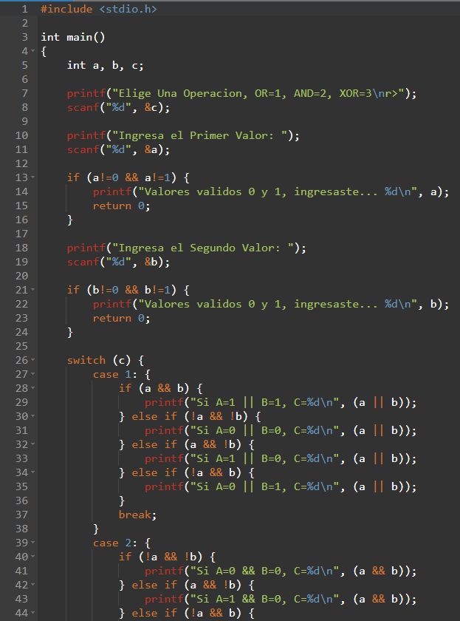

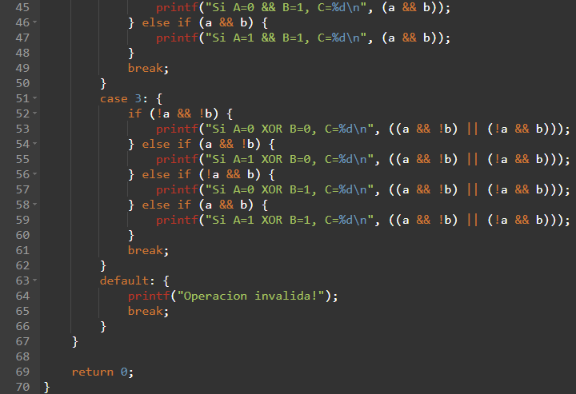

RESULTS
In the terminal of the IDE, we can see the result, where shows the logic gate of the users option
Evidence footage

OR GATE
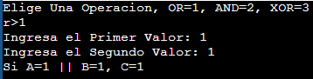
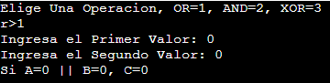
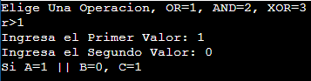
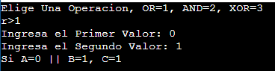

AND GATE
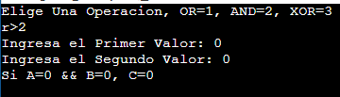
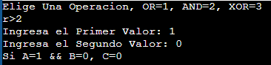
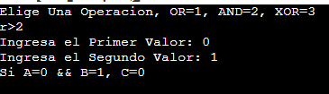
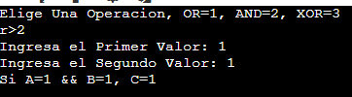

XOR GATE
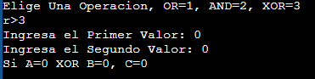
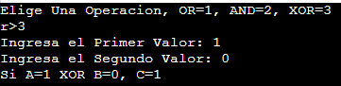
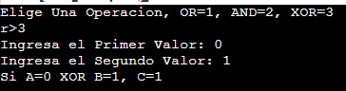
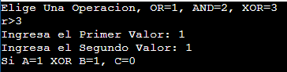

ISSUES
In this team work, we didn't have any problem with the development, we helped each other with the logic and we finished the program so fast.

CONCLUSIONS
Donnovan´s Conclusion: This activity,in the first part was so confusing, but so interesting at the same time, i already used to use the C programming lenguaje, in this teamwork i felt lost but with my effort i did the best to understand this code but throghthout the time i Will be fastest than now.

Kevin´s Conclusion: This activity was a challenge, especially with the C programming language, which was new for me. At first, I felt a bit lost, but I tried my best to understand it and help my team. It was a great experience that allowed me to practice more and, despite the difficulties, I'm happy with they goal they we did.

Danae´s Conclusion: For me, this activity was a good chance to learn more. At the beginning I made some mistakes but I tried again until I understood the code. This made me feel better and more interested. I think this practice is useful because it helps me to connect the theory with real examples and now I feel confident to keep learning C programming.

Angel´s Conclusion: In my opinion, this activity was very amazing, because i can do more coding in C, but i do code, maybe next time i can to learn about arduino programming, i hope so, but the experience was good, i’m happy with the results.

Diego´s Conclusion: Completing this project allowed me to significantly reinforce my knowledge of the C programming language, revisiting not only its syntax but also the specific role of the characters that perform various actions within a program. This review was valuable for consolidating concepts that can fade over time if they are not practiced regularly. I also realized that continuous feedback is essential for maintaining and expanding previously acquired skills.

GITHUB REPOSITORY
https://github.com/Bernal7/IA41_SE/tree/lab1_compuertas

