What was all of that?
This work history draws on my last CV - to 2025. There is some pattern to it all but at the same time I was not working to a plan. The most deliberate choices I made included not staying on the farm; later not continuing as a lawyer; and finally deciding to be a humanitarian worker, which I stuck with in different guises for over 40 years.

1. Law related activity and employment

Macquarie Legal Centre
Parramatta 1979 > Co-founder
A non-profit community legal centre established in Parramatta and run by volunteer students and staff from the Macquarie University Law School. The founders including myself were nominated for the 2003 Bar Association Law and Justice Volunteer Award. The Justice Awards recognise the contributions that individuals have made to improving access to justice in NSW, especially for socially and economically disadvantaged people.

Australians Care for Refugees (AUSTCARE)
Sydney 1980 > Research Officer
Responsible for Austcare’s monthly newsletter and special publications with a focus on refugees seeking asylum and their rights under international law.

Select Committee of the NSW Legislative Assembly upon Aborigines
Sydney 1980 > Research Officer
Member of team working out of Parliament House in Sydney. Travelled widely in NSW conducting interviews to gain information and perspectives from indigenous communities on protecting culture.

Allen Allen & Helmsley
Sydney 1981-83 > Lawyer
Practiced as a solicitor, admitted to the Supreme Court of NSW. General litigation practice and corporate legal advice with a big city law firm.

Western Desert Puntukurnuparna Aboriginal Corporation (WDPAC)
Pilbara WA 1997 > Land rights advocacy
Contracted by WDPAC to assist Martu native title claimants develop a strategy and rationale for opposing uranium mining at Kintye. Surveyed Martu concerns and interests and we came up with a visual and verbal presentation of the feared impact of uranium mining on the Martu that elders presented in person to the WA Ministry of Mines in Perth.

Ngaluma and Injibandi Native Title Claimants and Woodside Offshore Petroleum
Pilbara Western Australia 1997-98 > Design community development foundation
Together with another consultant undertook community consultations to design the Ngaluma-Injibandi Development Foundation to manage and monitor the use of compensation funds to be paid by Woodside for further development on the Burrup Peninsula. This consultancy was paid for by Woodside.

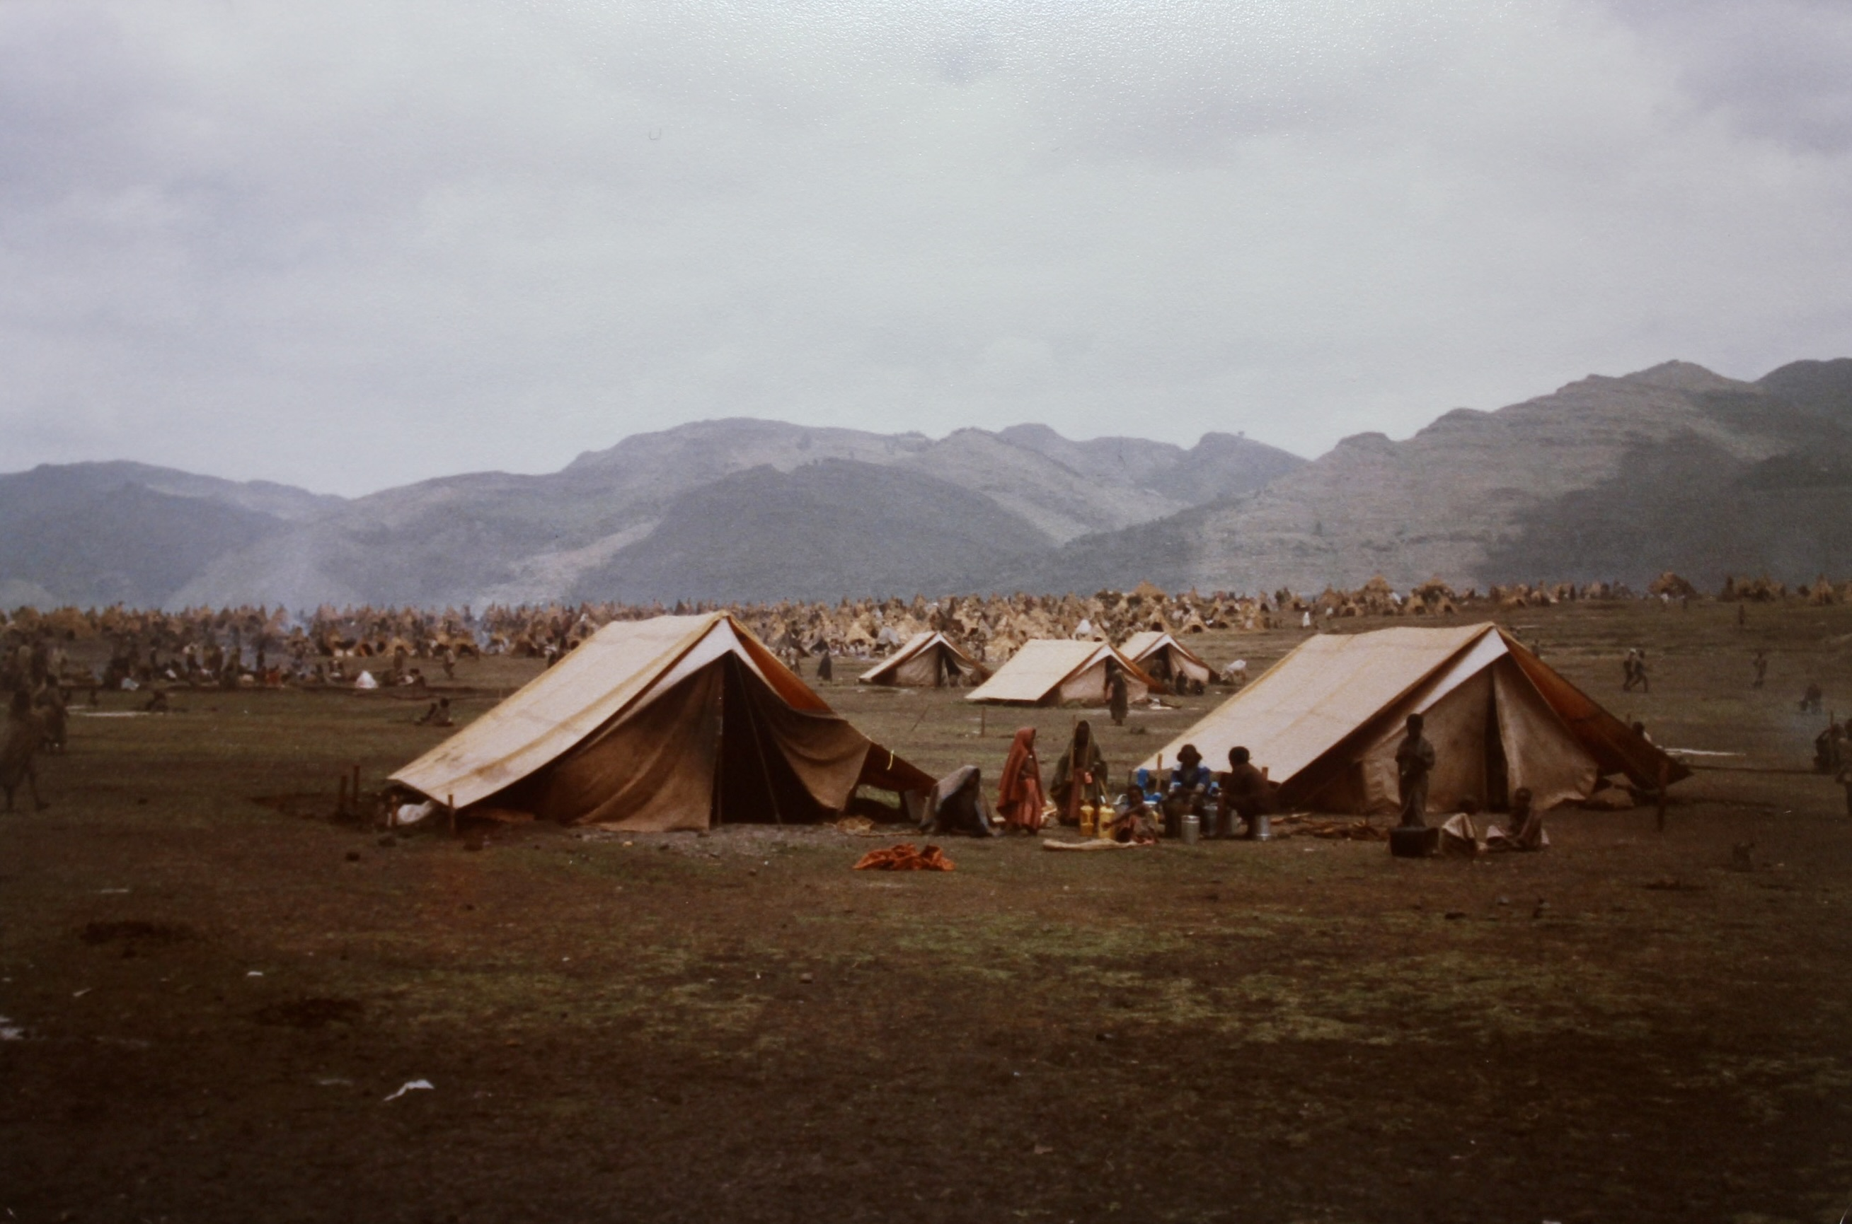
2. Employment with Humanitarian Organisations

Save the Children UK
Ethiopia 1984 > Volunteer
Helped conduct the first surveys and to establish a child feeding centre near Korem in Wollo Region during the early phase of the famine response.
Uganda 1984 > Logistician
Responsible for SCF’s central stores and helped deliver emergency medical and other supplies to hospitals and clinics in the Luwero Triangle north of Kampala which was the epicenter of the ‘bush war’ being fought between government forces and the rebel National Resistance Movement that finally seized power in January 1986.
Thousands of people displaced by war and drought from Tigray

OXFAM GB
Uganda 1984-88 > Karamoja Resettlement Project Manager
Established and managed the Lolelia Development Project in Karamoja to resettle conflict and drought affected Karamajong on productive land and seek livelihood security. After three years the number resettled around Lolelia had grown to 7,300 in 13 new villages. We had established cropping, a food coop, installed wells, built basic schools and health centres. None of it was straight-forward and we faced many problems with insecurity in the region.
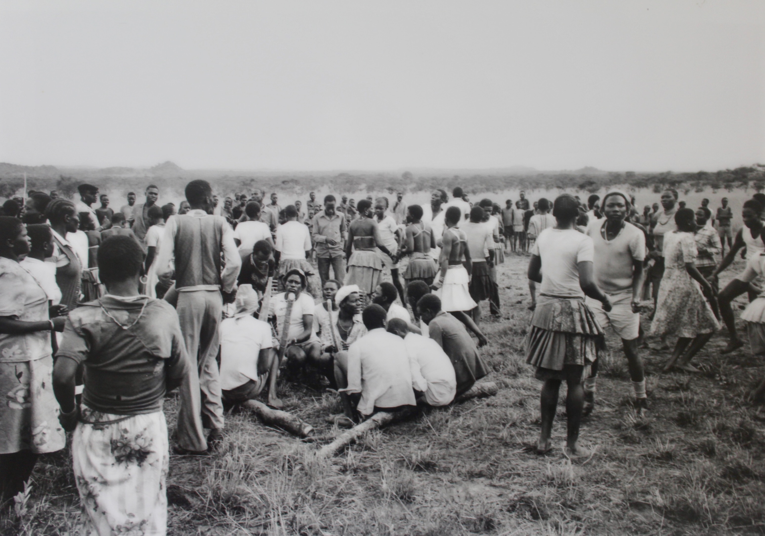
Dance led by our own band to celebrate construction of our first school in Lolelia (single classroom, grass thatched)
Somalia 1988 > Galgaduud Region Project Manager
Tasked by Oxfam UK to leave Uganda for 3 months to establish and manage, in collaboration with UNICEF, an emergency supplementary feeding project for drought affected populations, from a base in Dhuusamareeb on the Ethiopian border.
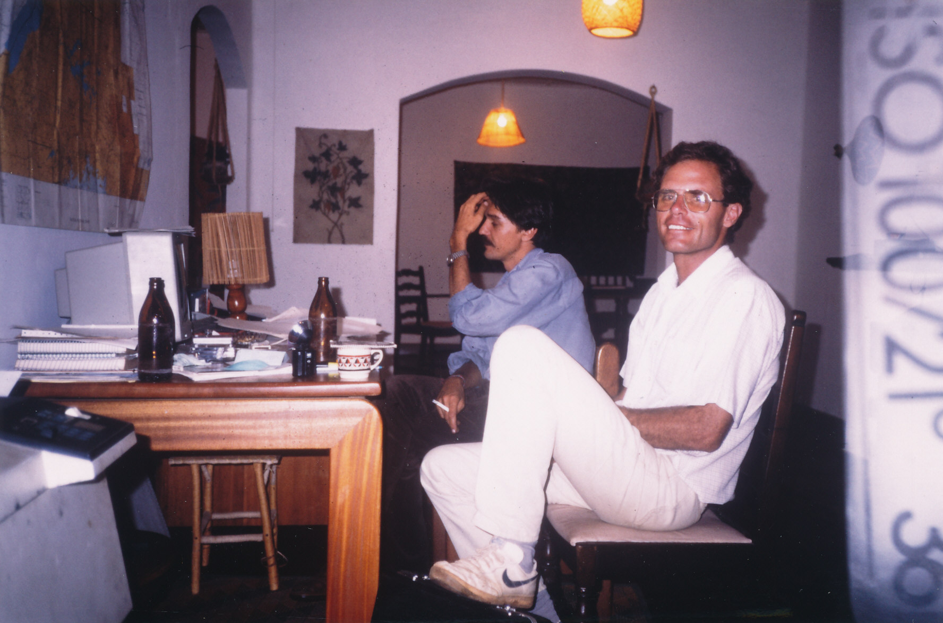
Uganda 1988-89 > Relief and Rehabilitation Coordinator
Established and managed a large food aid agricultural rehabilitation program in Kitgum District during the LRA insurgency; coordinated food aid operations in Karamoja District and managed the reception of Sudanese refugees in Kaabong Sub-County; conducted ongoing assessments in Soroti District in the context of insecurity.
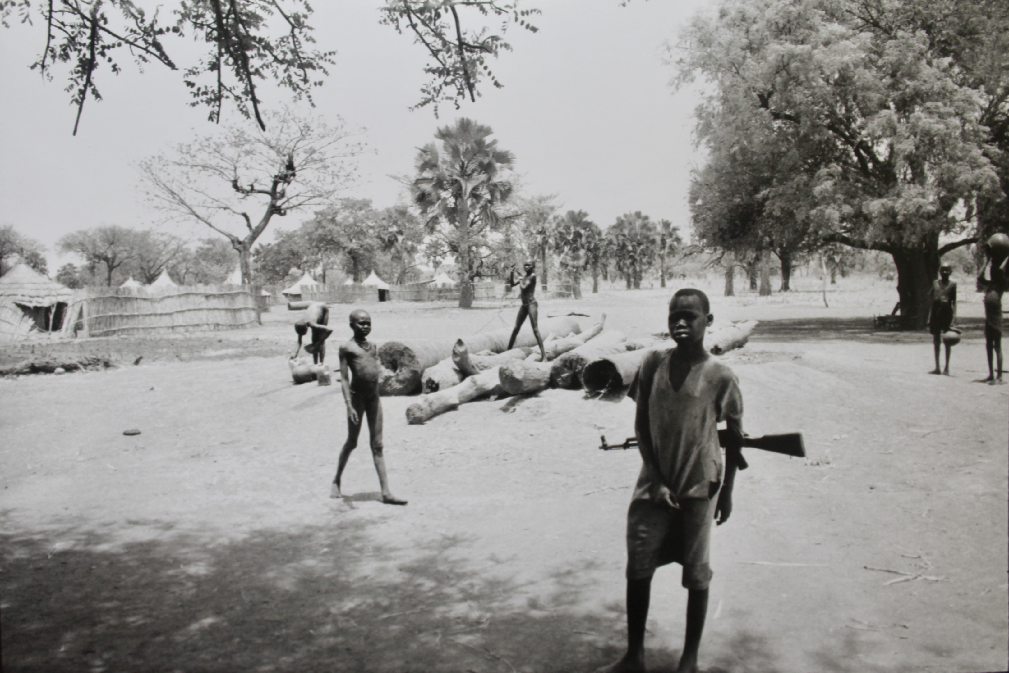
With colleague and friend Nick Stockton in Buziga, Kampala
South Sudan 1993-95 > Relief and Rehabilitation Manager
Establish and managed a rehabilitation and development program in Bahr el Ghazal and Western Equatoria. Main interventions: Distribution of cultivation tools, seeds and fishing equipment; establishing primary health care centres and veterinary services, and improving water supply and sanitation.
Drawing water from an old hand dug well - Lakes District, Eastern Bahr el Ghazal

CARE Australia
Emergencies Director 1989-1990
Based in Canberra head office. Managed the humanitarian program project budgeted at $6 million. Conducted field assessments and monitored projects in Vietnam, Thailand, Sri Lanka, Jordan, Angola, Mozambique, Malawi, Zimbabwe, Uganda and Sudan. I discovered that CARE was committing substantial systematic fraud on the Commonwealth and I was ultimately made redundant after repeatedly raising this was the National Director. In 1991 I became a whistleblower, taking the matter to the CARE Board, then AusAID and the Australian National Audit Office (ANAO) and finally the press. However, for whatever reason, government did not want to claw back the money from CARE.

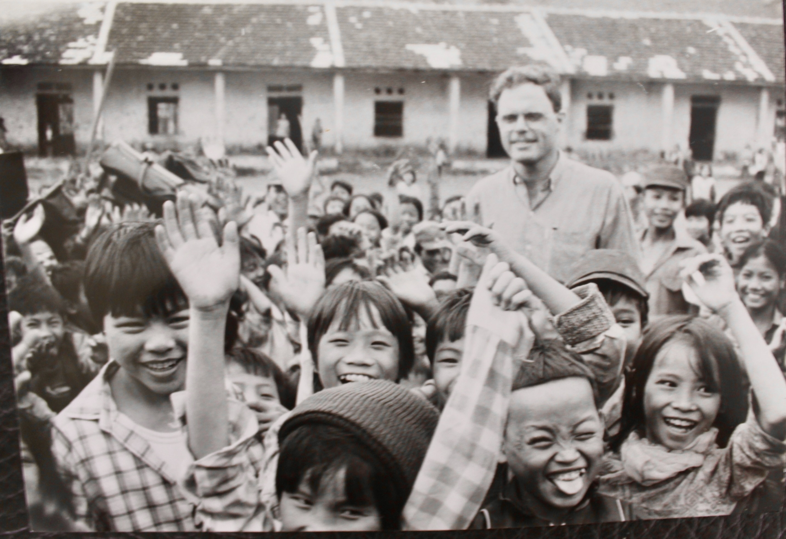
Internation Federation of the Red Cross
Development Delegate, Cambodia 1991
Assisted the Cambodian Red Cross strengthen its capacity to assess food aid and rehabilitation needs. Included training in survey techniques, project design, monitoring and review.
Repatriation Delegate, Cambodia 1992-93
In collaboration with UNHCR, managed the reception, registration and provisioning of Cambodian refugees returned from closed border camps in Thailand to areas controlled by Khmer Rouge, KPNLAF and ANKI forces in north-western Cambodia. The role included consulting with the leaders of the armed factions, establishing three reception centres, overseeing the return process and conducting monitoring to ensure the human rights of the returnees were being respected.

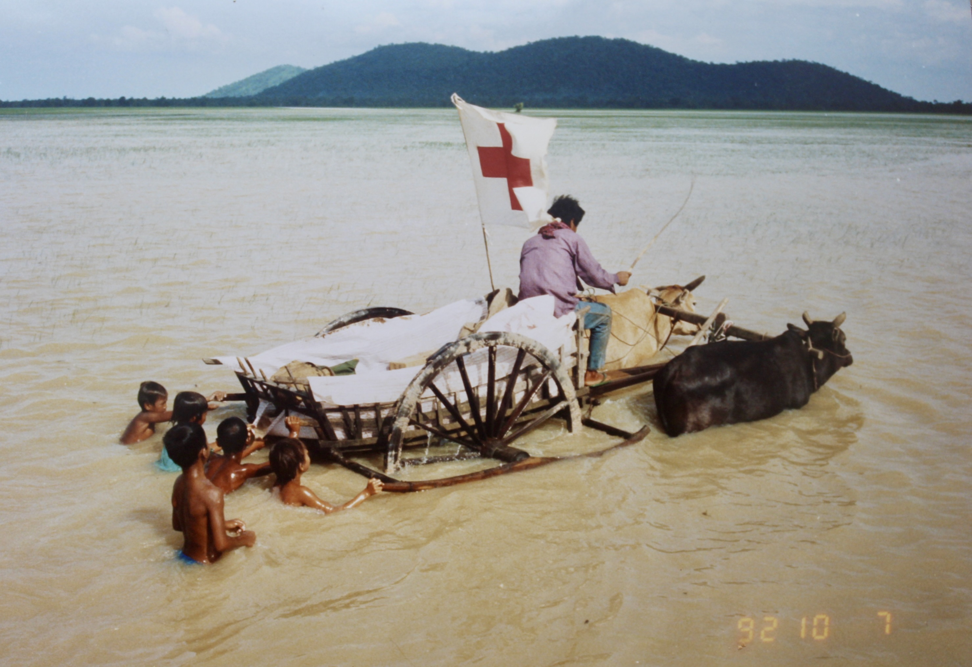
The only way I could get around in the wet season to conduct human rights monitoring

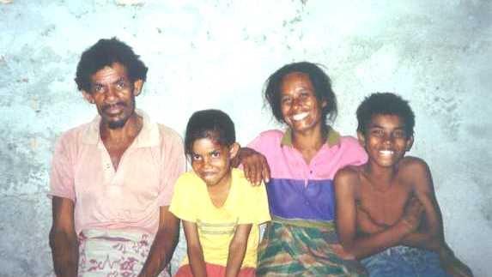
CARITAS Australia
Emergencies Coordinator, East Timor late 1999 – early 2000
Established the Caritas emergency program in the Oecussi enclave from October 1999, leading the food aid operation and planning the housing reconstruction program. Involved in country-wide logistics and for a period acted as Country Director.

Consulting contracts with Non-Government Organisations

OXFAM
Ethiopia 1995 > Internal purchase / food security evaluation
Led an evaluation of AusAID funded ‘Agricultural Rehabilitation Project’ implemented in Tigray by Oxfam Australia (then known as Community Aid Abroad) and an Ethiopian agency (REST). Involved 3 weeks fieldwork in highland and western Tigray and the use of PRA techniques.
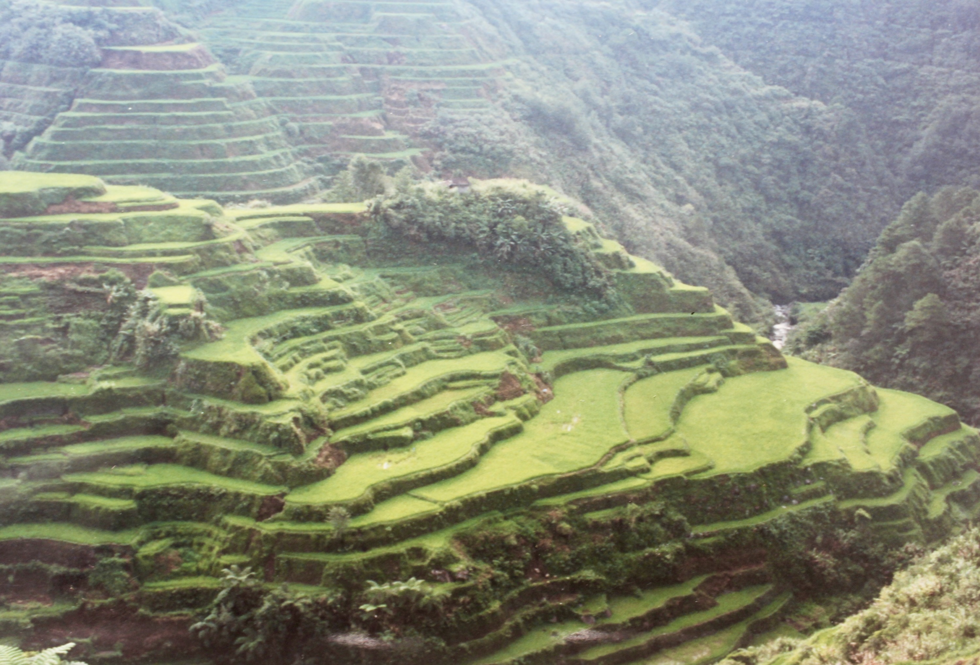
Philippines 1997 > Integrated rural development evaluation
Contracted by OXFAM Australia to lead an evaluation of the AusAID funded ‘Ifugao Northern Upland Communities Sustainable Development Project’, an integrated area development project implemented by Community Aid Abroad and the Philippines Rural Reconstruction Movement. Three weeks field work and use of participatory rural appraisal (PRA) techniques.
Rice terraces, Ifugao
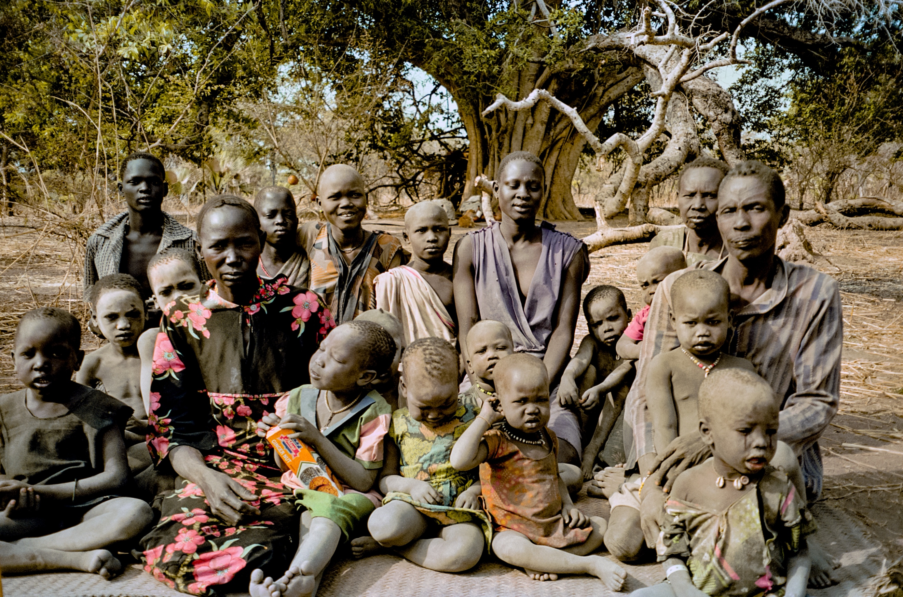
South Sudan 1999 > Primary health care project evaluation
Contracted by Oxfam Australia to conduct an Independent Completion Evaluation of the three-year AusAID funded Rumbek County Primary Health Care Project implemented by Oxfam GB.
Interviewing mothers about their access to health care, Rumbek County
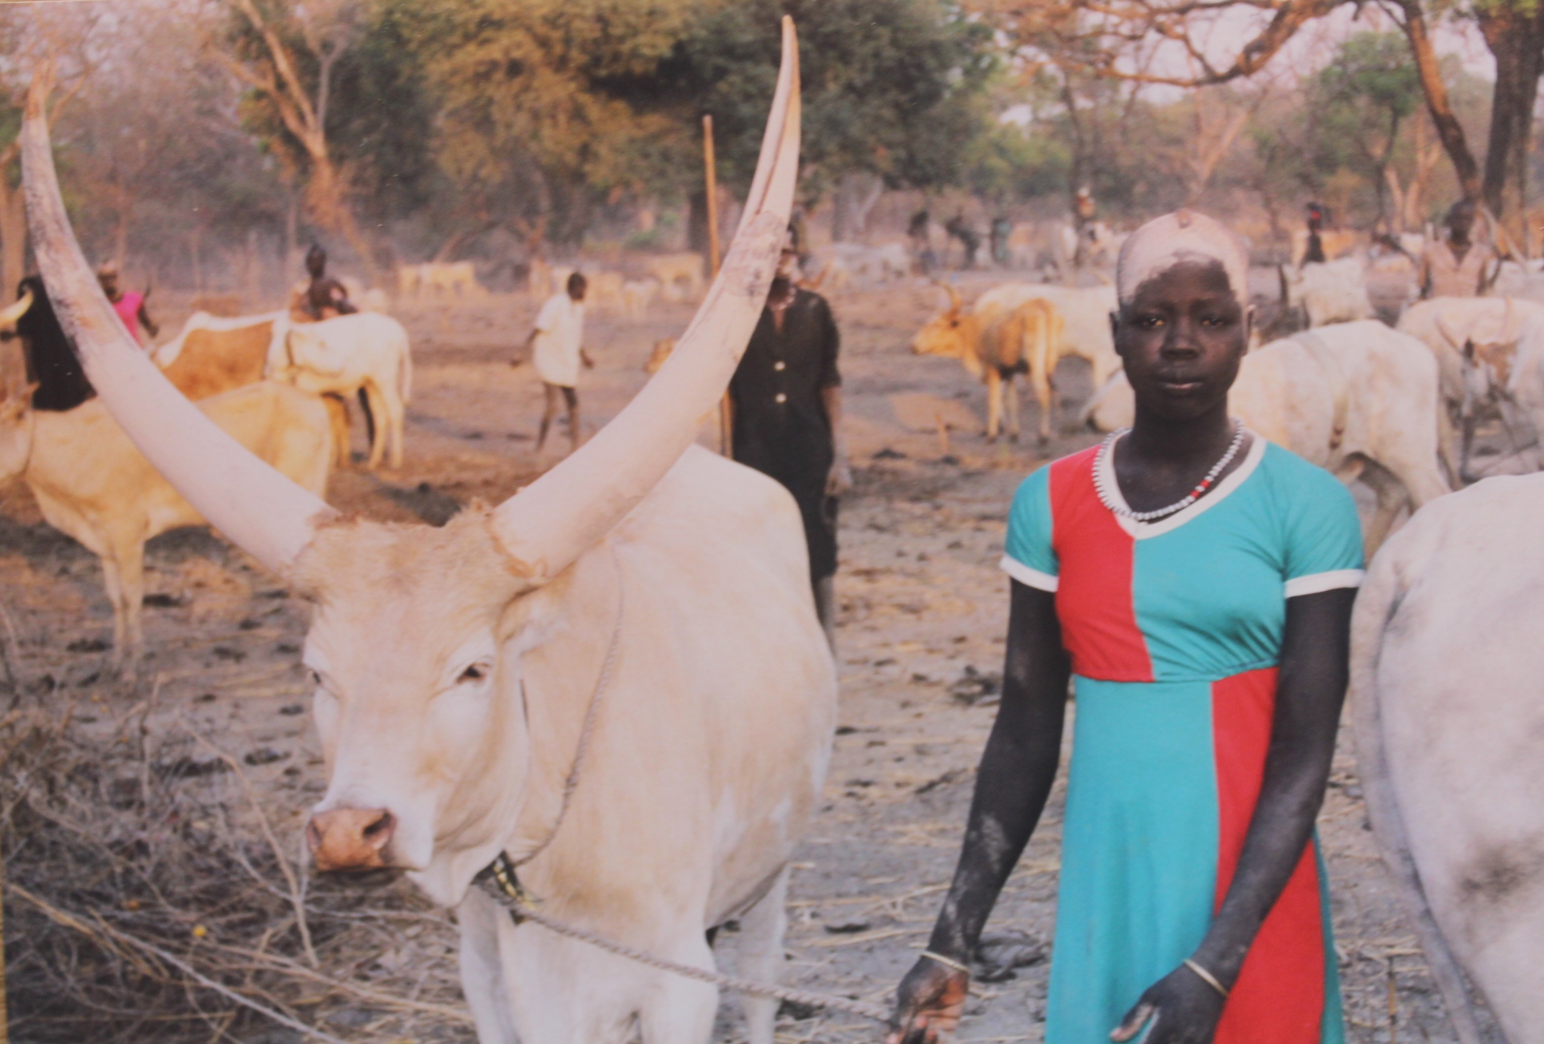
“Please photograph my uncle’s bull” - Ameth cattle camp, Rumbek County
Horn of Africa 1999 > Regional programming review
Facilitated an internal review for Oxfam Australia of their Horn of Africa Program.

National Council of Churches of Australia (NCCA)
Eritrea 1995-96 > Internal purchase / food security evaluation
Evaluated the impact on food security of the AusAID funded Agricultural Rehabilitation Project implemented by the Food Security Working Group (an Australian NGO consortium) and the Eritrean government. Involved 3 weeks field work in Eritrea and the use of Participatory Rural Appraisal techniques. Contracted through the NCCA.

Australian Council for International Development (ACFID)
Sydney and Melbourne 1996 > Emergency response training
Contracted to designed and facilitate two workshops for NGO emergency response managers on responding to complex humanitarian emergencies.
Sydney and Melbourne 1996 > Design and M&E for managers training
Contracted to designed and facilitate two workshops for NGO project managers on project design, monitoring and evaluation. In collaboration with ANUTECH.
Sydney and Melbourne 1999 > Monitoring & reporting training
Contracted to design and facilitate a series of two-day workshops in Sydney and Melbourne for NGO staff on monitoring and reporting to AusAID.
Canberra 2007 > Emergency stores supply chain review
Specialist supporting desk review by Oxfam, Australian Red Cross and World Vision of emergency response supply chain arrangements for disasters in the Asia-Pacific.

The Fred Hollows Foundation
Zimbabwe, Kenya and Ethiopia 1998 > Cataract training project review
Reviewed the AusAID and community funded ‘Cataract Microsurgical and Intraocular Lens Training Project’ implemented in Zimbabwe, Kenya and Ethiopia. The project introduced advanced surgical techniques for implanting interocular lenses.
Vietnam 1999 > Cataract blindness program evaluation
Conducted an Independent Completion Evaluation of 4-year Fred Hollows Foundation AusAID funded Cataract Blindness Eradication Program.
Pakistan 2000 > Cataract blindness program design
Conducted in-country consultations with eye care specialists and stakeholders to design a five-year cataract surgery program. Secured AusAID funding.
Canberra 2007 > Eye care program design
Prepared the design, scope of service and basis of payment for the Pakistan-Australia Pediatric and Diabetes Related Eye Care Program 2008-12. Secured AusAID funding.

World Vision International
Indonesia 1998-99 > Social safety net evaluation
Evaluated WVI’s ‘Social Safety Net Program - emergency food security and health intervention in Eastern Indonesia’ (East Sumba and Roti Island NTT) funded by AusAID and CIDA.

AngliCOR Australia
Tanzania 2008 > Rural development and conservation evaluation
Evaluated the effectiveness of a rural development and environmental conservation foundation (the JITUME Foundation) in Mpwapwa. Participatory rural appraisal (PRA)

Transparency International
Canberra 2009 > Strategic planning training
Developed and facilitated a short course on strategic planning for Transparency International’s Asia Pacific national representatives.

Land and Equity Movement Uganda
Uganda, 2010 > Planning and monitoring training
Developed and delivered training to strengthen Land and Equity Movement’s planning, monitoring and evaluation systems.

Cardno Australia
Pacific 2019 > Review of Infrastructure Partnerships in the Pacific 2019 > Team leader of a review of the localised development impact of Cardno’s partnerships with infrastructure firms in Pacific Island Countries. Case studies were conducted in PNG and the Solomon Islands.

Goal Global
Uganda 2011-12 > Food security evaluation
Peer reviewed an independent evaluation of GOAL Uganda’s Household Food Security Project in post-conflict north and north-west Uganda.

Contracts with United Nations agencies

UN World Food Program (WFP)
China 1999 > Food response to floods evaluation
Member of team evaluating WFP’s response to devastating floods in Hunan, Hubei, Jiangxi and Anhui Provinces in 1998.
Uganda 2001 > Food security evaluation
Team leader of evaluation of WFP’s Protracted Relief and Recovery Operations in Uganda - PRRO 6176 ‘Assistance to Refugees and IDPs’. For WFP Office of Evaluation (OEV), Rome
Timor-Leste 2001 > Emergency food operation evaluation
Team leader of evaluation of WFP’s Emergency Operations in East Timor, in particular EMOP 6177 ‘Emergency Food Assistance to Victims of Civil Strife’. For WFP OEV Rome.
Canberra 2002 > M&E guidelines design
Peer reviewer and contributor of material for WFP’s then new corporate Monitoring & Evaluation Guidelines. For WFP Rome HQ.
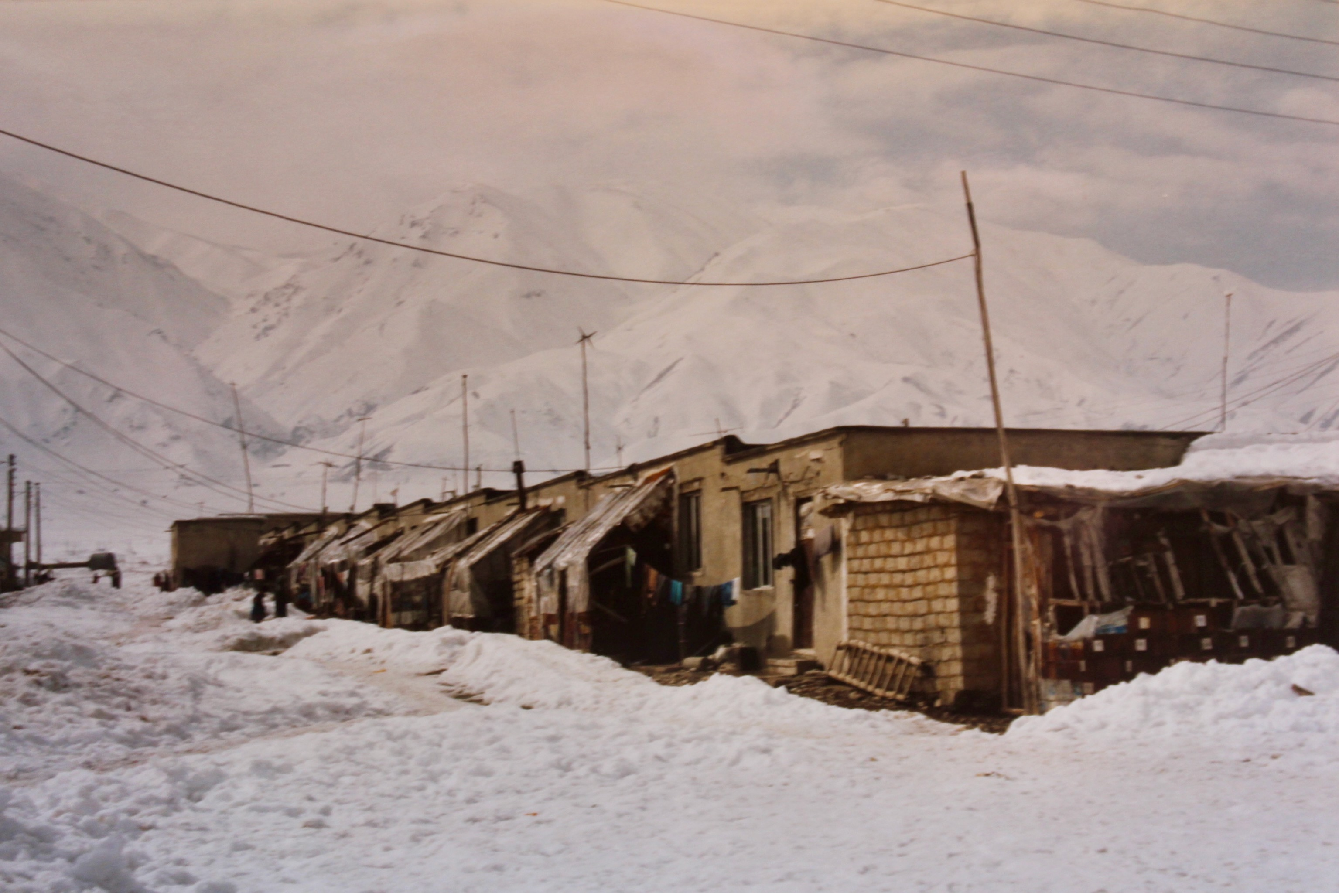
Iran 2002 > Evaluation of protracted food aid support for refugees
Team leader of an evaluation of WFP’s Protracted Relief and Recovery Operations in Iran - PRRO 6126 ‘Food Assistance and support for repatriation of Iraqi and Afghan refugees’. WFP OEV Rome http://documents.wfp.org/stellent/groups/public/documents/reports/wfp022479.pdf
Refugee block, north-west Iran, winter 2002

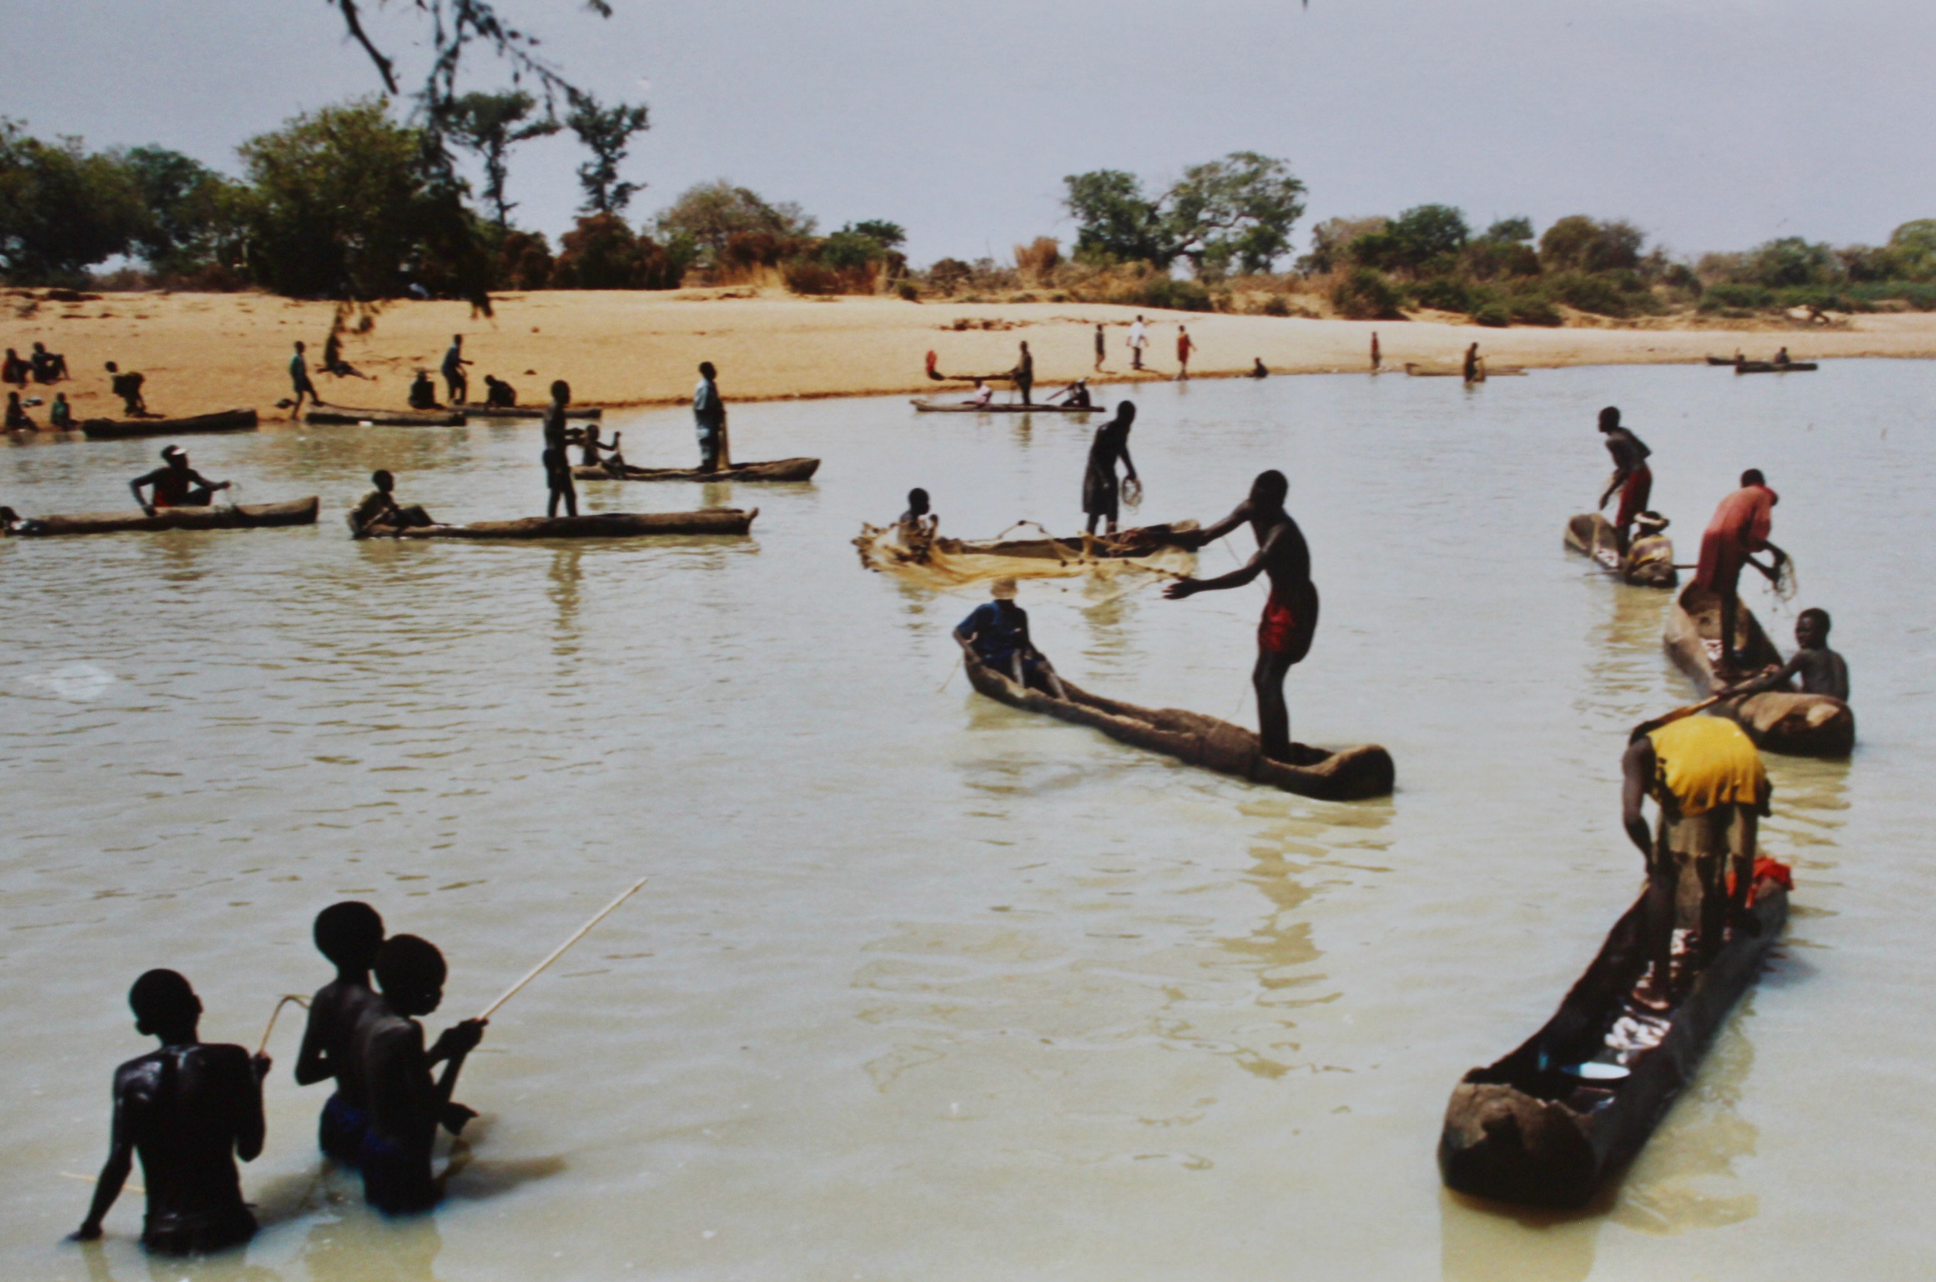
Sudan 2004 > Food aid evaluation
Team leader of an extensive evaluation of WFP’s Emergency Operations in Sudan – EMOP 10048 2001-2004 ‘Assistance to War and Drought Affected Populations’. WFP OEV Rome
Netting fish as the waters recede in the dry season
http://documents.wfp.org/stellent/groups/public/documents/reports/wfp065383.pdf
Uganda 2012 > Food assistance to refugees & IDPs evaluation
Team leader of evaluation of WFP’s Protracted Relief and Recovery Operation in Uganda- PRRO 101213 ‘Assistance to Refugees and Internally Displaced Persons’ April 2009 to March 2012. For WFP Regional Office, Nairobi.
Uganda 2013 > Workshop design and delivery
Designed and facilitated two-day workshop reviewing nutrition programs in Karamoja for UN agencies, NGO partners, and government health authorities.
Canberra 2018 > Evaluation quality assurance
Team member of the UN World Food Programme (WFP) Decentralised Evaluation Quality Assurance System (DEQAS) managed by IOD PARC UK to provide desk-based QA upon request for terms of reference, inception reports and/or draft reports (for me tasking relating to evaluations in Guinea-Bissau, Laos, Pakistan and Nepal).

UN Food and Agriculture Organisation (FAO)
Afghanistan 2004 > Food security evaluation
Team member of evaluation of WFP’s Protracted Relief and Recovery Operation – PRRO 10233 2003-2004 ‘Food Assistance to Re-establish Livelihoods and Household Food Security in Afghanistan’. Contracted through FAO.
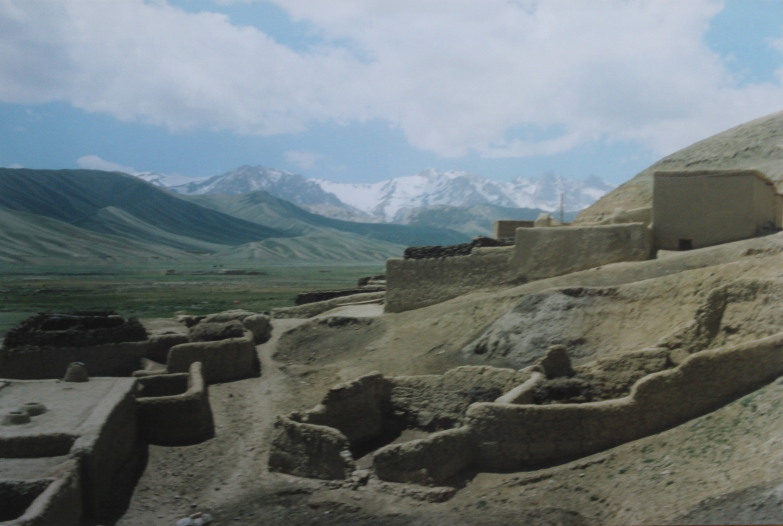
Rural Afghanistan
Myanmar 2014 > Animal health project design
Assisted FAO technical experts and other stakeholders to critique and reframe a proposed Animal Health and Production Project. Included preparing a LogFrame and M&E Framework.

UN Children’s Fund (UNICEF)
Nepal 1999 > UNICEF human rights approach review
In-country Mid-Term Review of the progress of the HMG Nepal-UNICEF Country Program in instituting a human rights approach. Team Member. Led by Human Rights Council of Australia
Russian Federation 2003 > Review of assistance to Chechnyan refugees
In-region review of UNICEF’s Emergency Program for Chechnyan refugees in the Northern Caucasus (primarily in the Republic of Ingushetia), for the period November 1999 to December 2002.
Indonesia 2006 > WASH cluster response review
In-country review of the effectiveness of the Water, Sanitation and Hygiene (WASH) cluster agencies response to the May 27 Central Java Earthquake.

UN Office for the Coordination of Humanitarian Affairs (OCHA)
UN HQ New York 2002 > Senior Evaluator
Assisted OCHA’s Evaluation and Studies Unit in New York prepare and manage a portfolio of evaluations of humanitarian operations in Afghanistan and elsewhere (3 months).
Sudan 2004-05 > Real time evaluation of the international response to the Darfur crisis
Team leader of the ‘Inter-Agency Real Time Evaluation of the International Humanitarian Response to the Crisis in Darfur’ conducted over 18 months and involving three missions to Sudan, three reports, and briefings to senior UN representatives in New York and Geneva. Commissioned by the UN Emergency Relief Coordinator and Under-Secretary General for Humanitarian Affairs
http://documents.wfp.org/stellent/groups/public/documents/reports/wfp092382.pdf

UN Capital Development Fund (UNCDF)
Uganda 1998 > Budget decentralisation pilot review
Led a review of a pilot UN Capital Development Fund project designed to test systems for the devolution of the national development budget to Districts and Sub-Counties. Involved field work in five districts and two national workshops.
Uganda 1998 > Budget decentralisation M&E design
Designed M&E system for pilot District Development Project for the decentralisation of the national budget to Districts and Sub-Counties.

UN Development Program (UNDP)
Uganda 2011 and 2012 > UNDAF reviews
In 2011 undertook the Annual Review of the UN Development Assistance Framework (UNDAF) 2010-2014 and in 2012 led the Mid Term Review of the same which involved assessing all UN activities in Uganda, identifying risks and framing recommendations for the UN Country Team for 2013-2014.

Contracts with the Department of Foreign Affairs & Trade (DFAT)
Canberra 1990 > Indonesia country program review
Researcher and author of background briefings, discussion papers and financial analysis for the review of the effectiveness of the Indonesia country program.
Mozambique, Sri Lanka, Bangladesh 1991 > Bilateral food aid review
NGO specialist on team reviewing Australia's bilateral development food aid programme. Included field visits to Mozambique and Sri Lanka.
Canberra 1991 > Lessons learned data base design
Designed and populated the data base, including defining the categories/index, researching past reviews and evaluations and framing the first 300 lessons.
Canberra 1991 > Oceanography research project design
Designed the South Pacific Oceanographic Study Project for funding by AIDAB and implemented by CSIRO/AMSAT.
Melbourne 1995 > Malaria research project design
Co-designed the Indonesia Malaria Research Project for the Walter and Eliza Hall Institute in Melbourne which was subsequently funded by AusAID.
Vietnam 1996 > Language training project design
Design specialist on team assisting the Ministry of Justice in Vietnam develop the English Language and Technical Courses Project to be funded by Australia.
Canberra 1997 > Bilateral food aid review
Author of 5 papers for review of Australian government food aid incl. ‘Recent Evaluations of Humanitarian Food Aid’, ‘When should Food Aid be the Priority Relief Response’, Needs Assessments and Targeting’, ‘The Role of Food-for-Work in Transition from Relief to Rehabilitation and Development’; ‘Funding Channels – WFP and/or Australian NGOs’.

Canberra 1997-2002 > Training AusAID staff:
- Design and M&E in rural development > Co-designed and facilitated 2 four-week courses in 1997 on design, M&E for AusAID program managers. In collaboration with ANUTECH.
- M&E in development > Co-designed and co-facilitated a four-week M&E course in 1999 for AusAID Program Managers from Indonesia, Palestine and Australia. In collaboration with ANUTECH.
- M&E in development > Co-designed and co-facilitated a four-week M&E course in 2000 for Program Managers from Indonesia, Philippines, South Africa & Mozambique.
- M&E training of trainers > Designed and delivered training in 2000 to assist Humanitarian and Emergency Section (HES) and other staff plan/manage humanitarian M&E exercises.
- Evaluation > Designed and delivered the ‘evaluation in practice’ module for design, monitoring and evaluation courses in 2001-02 for three successive groups of AusAID Program Support Staff. In collaboration with ANUTECH.
Papua New Guinea 1998 > Highland drought response evaluation
Humanitarian relief specialist on team evaluating Australian assistance to the drought in PNG, which included the provision of food relief with assistance from the Australian Defence Force. Extensive field work in the Highlands engaging with affected communities.
Philippines 1999 > Mindanao peace and development program
Appraised the proposed cooperation between the UN Development Program and the Government of Australia in the third phase Multi-donor Programme for Peace and Development in the Special Zone of Peace and Development, Southern Philippines. The partners included UNDP, UNICEF and ILO.
Indonesia 2000 > Design of HIV/AIDS program
Led design mission to Indonesia to undertake consultations with government and those directly affected by HIV to design the Indonesia-Australia HIV/AIDS Program Phase II 2002-2008, including the Project Design Document, Scope of Services and Basis of Payment.
Tanzania, Zimbabwe & South Africa 2000 > Cluster evaluation of funded NGO projects
Led Cluster Evaluation of Australian-funded NGO projects in Africa. Sample included three countries and eight NGO projects (mostly HIV/AIDS related). Focus was on monitoring systems, achievement of objectives, impact.

Canberra 2000-2007 > Appraisal, design and review tasks for several AusAID Sections:
- International Refugee Fund 2000 > Designed M&E framework for the fund, which led to broader recommendations for the Humanitarian & Emergencies Section.
- Emergency Response Cooperation Agreement 2002 > Technical assessment panel member assessing and scoring NGO bids under the AusAID/NGO Emergency Response Cooperation Agreement.
- Conflict and disasters study 2003 > Desk study to conceptualise the integration of conflict and disaster response related activities in country/regional programs and corporate management information systems.
- MEL design advice > Provided advice on the design of the Vietnam-Australia Monitoring and Evaluation Strengthening Project Phase II 2004-2007.
- Illicit drugs initiative design 2005 > Assisted Asia Transboundary Section with the concept submission and design note for the Illicit Drugs Initiative, 2005-07.
- Trafficking design appraisal 2005 > Desk appraisal of Design Document of Asia Regional Trafficking Project to ensure adherence to design standards & basis for contracting.
- M&E frameworks review 2006 > Desk review of the quality of M&E Frameworks of South Asia and Africa funded initiatives designed by UN agencies and NGOs funded by Australia.
- Sexual health project appraisal 2007 > Appraised PNG-Australia Sexual Health Improvement Project (PASHIP). Desk appraisal of project design/funding submissions from seven NGOs.
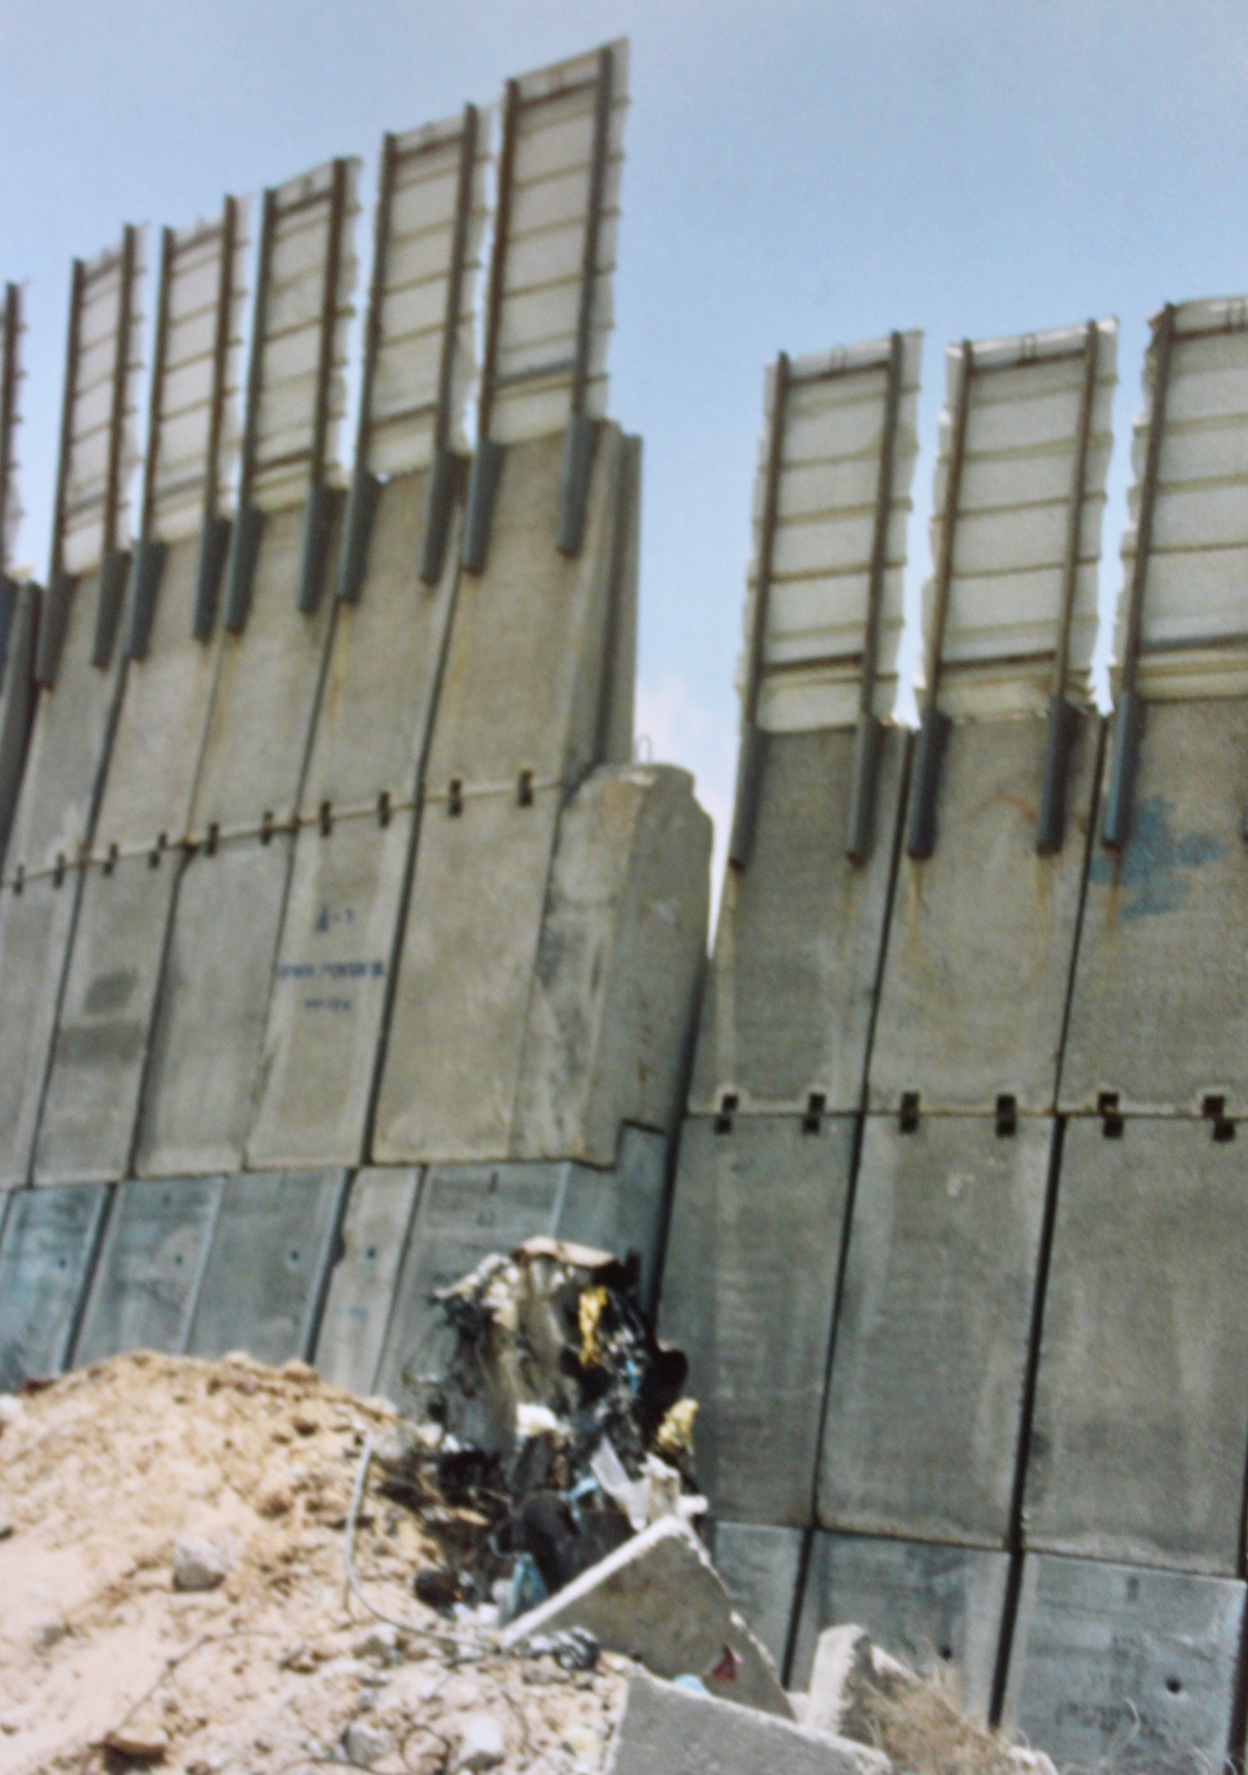
Canberra 2001-2002 > Disaster stocks and response arrangements review
Reviewed Australia’s disaster response arrangements for the Asia-Pacific, focusing on Australia’s disaster stores for natural disasters and complex emergencies held in ADF stores in Moorebank, arrangements with the ADF and support for OCHA and UNDAC.
Indonesia 2002 > Appraisal of Red Cross proposal
Consultations in Indonesia to appraise a proposal to AusAID for strengthening the disaster preparedness and response capacity of its Red Cross Society.
Occupied Palestinian Territories and Lebanon 2003 > Humanitarian strategy review and redesign
Led a review of Australian funded humanitarian assistance to Palestinians in the OPT and Lebanon and developed a revised humanitarian strategy for the Australian Government’s ongoing program. Field work in the West Bank, Gaza and refugee camps in Lebanon.
Myanmar/Burma 2003 > Humanitarian strategy review and design
Led review of Australian funded humanitarian activities in Myanmar and on the Thai-Myanmar border and developed a humanitarian strategy for the Australian Government’s aid program. Field work in Myanmar and Thailand.
Thailand 2006 > Review of Asian Disaster Preparedness Centre
Led the Mid-term Review of Asian Disaster Preparedness Center (ADPC) ‘Mainstreaming Disaster Risk Management and Institutional Development Projects’ funded by Australia. Reviewed Phase 1 and advised if should proceed to Phase 2. Consultations with ADPC, Post and others in Bangkok.
A section of Israel’s dividing wall
Canberra 2006-07 > Emergency response capacity review
Led review of AusAID’s emergency response capacity in emergency shelter and water supply. Made recommendations for improved specification of holdings and wrote guidelines for assessing requests for the release of stocks for an emergency response.

Canberra 2006-2009 > Various taskings by the Humanitarian and Emergencies Section:
- Peer reviewed an evaluation of Australia’s response to Dec 2004 Indian Ocean Tsunami
- Assisted an external team develop a fully reworked comprehensive M&E system for the Humanitarian and Emergency Section (HES)
- Advised on the design of an evaluation of Peace, Conflict and Development Policy
- As panel member appraised and scored NGO bids under NGO periodic funding agreements for disaster risk management
- Designed and facilitated a training course on emergency response procedures for HES Emergency Officers
- Wrote design guidance notes for HES staff appraising emergency response plans and proposals and assisted with developing emergency response SOPs
- Reviewed the Australian Government emerging infectious diseases facility AusReady and advised whether to continue to fund the facility (decided against)
- Developed integrated planning and monitoring frameworks for Deployable Civilian Capacity.
Indonesia 2007 > Design and proposal writing training for Indonesia’s Department of Trade
Conducted project design and donor proposal preparation training in Bali for members of Indonesia’s Department of Trade, through the Indonesia Australia Specialised Training Project 2005-2008 (AISTP III).
Sri Lanka 2008 > Review of deployment of protection officers to UN agencies
Reviewed Australia’s funding for deployment of protection officers with UN agencies (most notably UNHCR) through Austcare and RedR Australia. Field study in Sri Lanka.
Indonesia 2008 > Emergency response and preparedness evaluation
Evaluated Australian Government disaster and emergency response interventions in Indonesia over the period 2006-2007 and Australia’s preparedness to respond in future.
Indonesia 2008 > Animal health program review
As M&E specialist supported the Mid Term Review in Indonesia of the Australian funded ‘Animal Health Emerging Infectious Diseases Program’.
Indonesia 2008 > Aceh rehabilitation evaluation
Led multi-disciplinary team conducting the Independent Completion Report of the Infrastructure Component of the Aceh Rehabilitation Program. Fieldwork in Aceh, consultations in Jakarta, and debrief in Canberra.

Fiji, Samoa and Kiribati 2009 > Climate change monitoring and prediction projects review
Led multi-disciplinary team to three countries in the Pacific to conduct a combined review of two related projects –
the ‘Pacific Islands Climate Prediction Project Phase 2’ and the ‘South Pacific Sea Level and Climate Monitoring Project Phase 4’.
Under threat from climate change - Tarawa, Kiribati
Fiji, Samoa, New Caledonia and Solomon Islands 2010 > Pandemic preparedness evaluation
Led multi-disciplinary team to four Pacific countries to conduct an Independent Completion Report of ‘Pacific Influenza Pandemic Preparedness Project (PRIPP) 2006-2010’.
Canberra 2009 > Pandemic and EID Strategy
Reviewed 15 programs totalling $95 million funded under Australia’s ‘Pandemics and Emerging Infectious Diseases Strategy (2006-2010)’ and advised on a new Strategy.
Papua New Guinea 2013 > Disaster risk management review
Conducted Independent Progress Review of Australian funded ‘PNG Disaster Risk Management Program 2010-2014’, strengthening preparedness, response and disaster risk reduction. Field visits East & West New Britain.
Canberra 2013-2014 > Humanitarian advisor for ADF training exercises
Presented humanitarian imperatives and perspectives in scenarios for annual post-conflict assistance planning and training exercises at the ADF’s Australian Command and Staff College, Canberra. Contracted as a member of the Australian Civilian Corp.
Papua New Guinea 2015 > Policing partnership review
Led the Mid-Term Review in PNG of the ‘Australia–PNG Policing Partnership (PNG-APP) Phase IV 2013-2017’, implemented by the Australian Federal Police (contracted directly to the AFP).
Pacific 2016 > Design of joint NZ-Australia Humanitarian Monitoring & Evaluation Framework
Led the development of the Joint New Zealand – Australia Humanitarian Monitoring and Evaluation Framework for the Pacific, designed for disaster response and supporting real time remedial action and providing the evidence-base for results (contracted through NZ Ministry of Foreign Affairs and Trade). https://reliefweb.int/report/world/mfat-dfat-humanitarian-monitoring-and-evaluation-framework-pacific
Canberra 2014-2017 > Humanitarian M&E Adviser to Humanitarian and Emergencies Section
Tasks included designing:
- DFAT’s Humanitarian Aid Quality Check template and rating matrix
- An internal workshop on Humanitarian M&E
- Due Diligence Baseline Assessment Report for NGO seeking funding
- Theory of change, program logic and M&E framework for a civilian deployment program
- M&E plan and templates for assessing the utility of Australian Humanitarian Supplies.
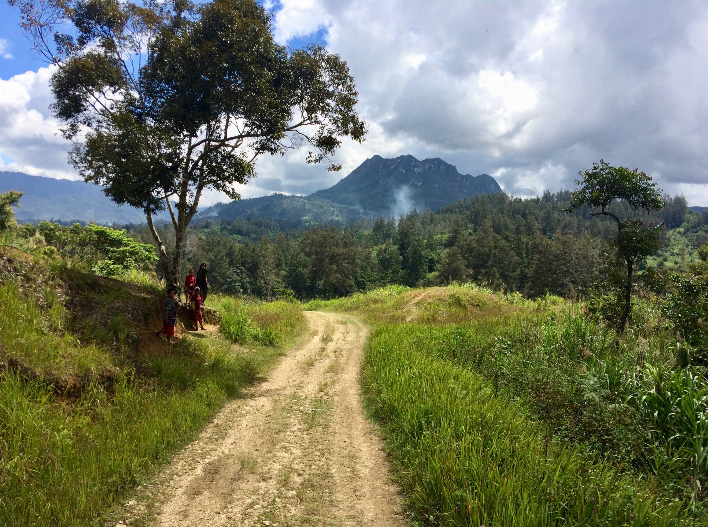
Papua New Guinea 2017 > Meta evaluation of the quality of past evaluations
Conducted desk review of the quality of 17 evaluations of PNG development projects/programs conducted from 2015 to 2017, identifying lessons for improving DFAT’s approach to evaluation in PNG and synthesizing key findings for improving program management, quality and impact.
Papua New Guinea 2017 > Evaluation of drought and frosts disaster response
Sole evaluator assessing if Australia’s response to the El Niño drought and frosts in PNG 2015-2016 was appropriate, timely, effective and efficient and to inform future responses to El Niño events and risk reduction programs. http://dfat.gov.au/about-us/publications/Pages/evaluation-of-australias-response-to-png-el-nino-drought-2015-2017.aspx
Visiting communities in highland PNG
Canberra 2017-18 > Design of Australia Assists Monitoring and Evaluation Framework
Assisted DFAT develop the program logic and monitoring, evaluation, accountability and learning framework for Australia Assists that deploys Australian specialists to work with governments, multilateral agencies and communities to prepare for, respond to, and recover from natural disasters and conflict. Subsequently contracted directly by Registered Engineers Australia (RedR), which manages Australia Assists, to support the development of key monitoring, evaluation and learning templates and processes.
Tonga 2018 > Review of vocational training program
Evaluation specialist on team conducting a mid-term review assessing the progress and management of ‘Tonga Skills for Inclusive Economic Growth Program’ funded by DFAT, including identifying gaps and analysing solutions. https://dfat.gov.au/about-us/publications/Pages/tonga-skills-for-inclusive-economic-growth-mid-term-review.aspx
Pacific 2018 > Evaluation of protection in disaster response
Led an independent evaluation assessing the extent to which Australia's responses to disasters in the Pacific 2013 to 2018 had been timely, effective and appropriate in relation to protection needs and risks with reference to commitments Australia has made and to global normative standards. https://dfat.gov.au/about-us/publications/Pages/evaluation-of-protection-in-australias-disaster-responses-in-the-pacific.aspx
Myanmar, Bangladesh, Thailand 2024 > Evaluation of Australia’s humanitarian assistance
Led an independent evaluation of the relevance, coherence, effectiveness and efficiency of Australia’s package of humanitarian investments in response to complex and protracted crises in Myanmar and across borders in Bangladesh and Thailand from August 2017 to June 2024. Included recommendations for a further package of assistance from 2026.

Contracts with other Bilateral Donors

United Kingdom, Department for International Development (DFID)
Uganda 2013 > Nutrition program evaluation
Completion Review of UNICEF and WFP’s ‘Sustaining Nutritional Assistance in Karamoja’ addressing acute malnutrition through supplementary and therapeutic feeding, health interventions, nutrition surveillance and water sanitation and hygiene promotion (WASH).
Uganda 2013 and 2015 > Review and evaluation of Red Cross DRM program
In 2013 reviewed the Ugandan/British Red Cross disaster risk management (DRM) program ‘Reducing Community Risk and Strengthening Disaster Response 2011-2014' and in 2015 returned to undertake the completion evaluation of the program.

London, Geneva, Rome, New York 2015-2016 >
Multilateral core funding evaluation
Member of team evaluating DFID’s Pilot ‘Unified’ Approach to Multilateral Core Funding designed/intended to improve the coordination and effectiveness of humanitarian assistance. Interviewed leadership of all the agencies involved in the pilot including UNHCR, UNICEF, WFP, OCHA, CERF, IOM, ICRC and IFRC.
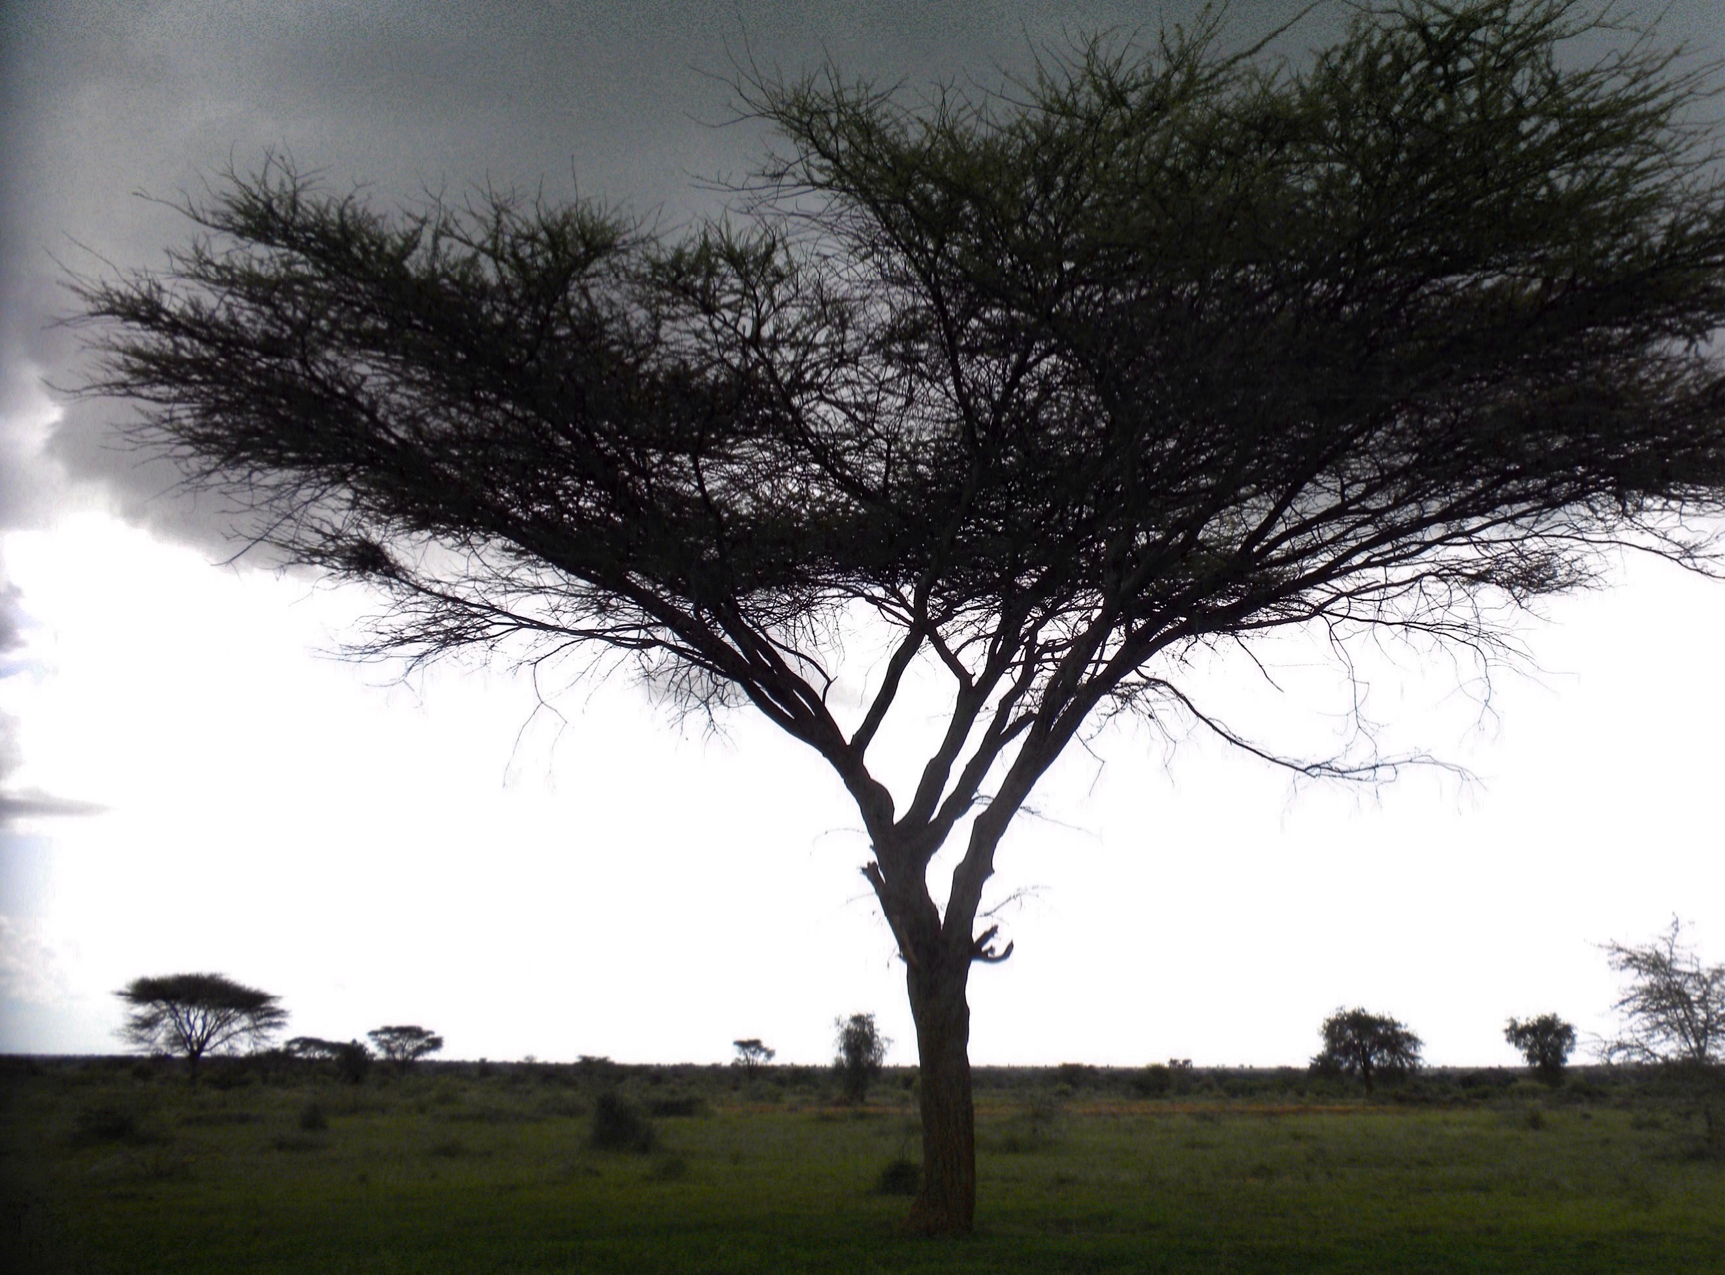

Uganda 2016 > Pastoralists Resilience Evaluation
Team leader of a final evaluation of a development program in Karamoja funded by DFID and implemented by the UN Food and Agriculture Organisation (FAO) known as ‘Strengthening Resilience and Adaptive Capacity of Agro-Pastoral communities and the Local Government to Reduce Impacts of Climate Risk on Livelihoods in Karamoja’.
Kotido District, Karamoja
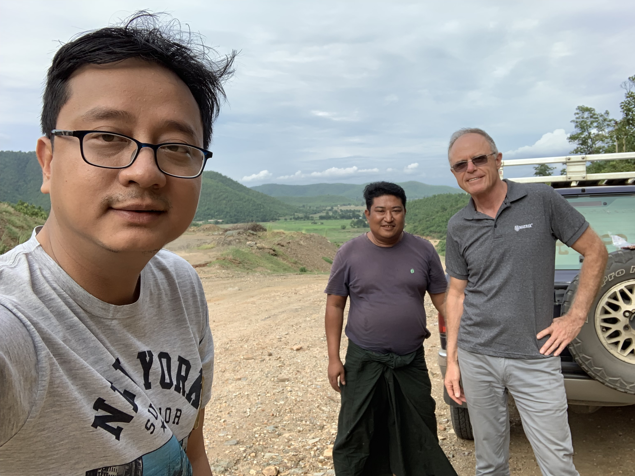
Myanmar 2019 > Field Review of National Village Loans program
Team leader of a review of the Department for Rural Development’s Mya Sein Yaung or Evergreen Village Development Programme (micro-finance) operating in over 11,000 villages across Myanmar. Qualitative focus. Field work included visits to sixteen randomly selected village units across four randomly selected Townships: Zigon (Bago Region); Katha (Sagaing Region); Tangyan (Shan North State); and Loikaw (Kayah State).
On the road to Sagaing
Supported in the field by the Enlightened Myanmar Research Foundation. Contracted through Cardno UK for the Centre for Good Governance funded by the UK Government.
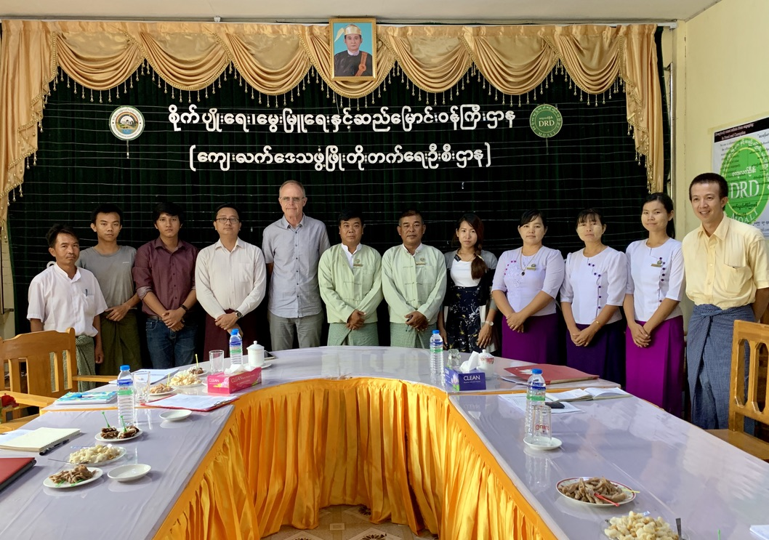
One of several formal meetings with regional offices of the Myanmar Department of Rural Development (DRD)

European Union (EU)
Uganda 2014 > Farmer Field Schools evaluation
Evaluated the Farmer Field School Components of two EU funded post-conflict rural recovery and development projects (ALREP and KALIP) implemented by UN FAO in northern Uganda and Karamoja. http://www.opm.nulep.org/documents/alrep-partner-documents/item/download/1317_93ae3080232a69f68b10c3dafb2fa76b

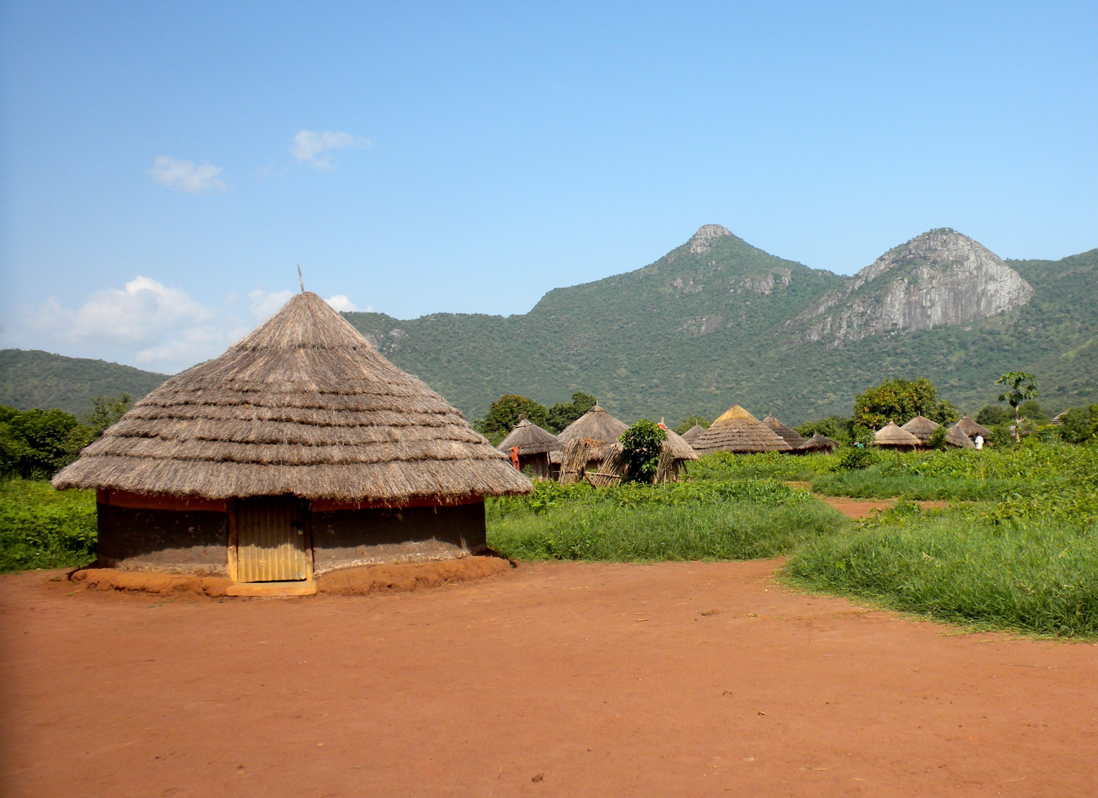
Agago District, northern Uganda

United States Agency for International Development (USAID)
Uganda 2014 > Coffee sector development design
Facilitated the design of the Uganda National Coffee Strategy 2015-2040 and assisted the Uganda Coffee Development Authority draft a national 25-year coffee development strategy. Contracted through Chemonics
Uganda 2014 > Coffee production campaign evaluation
Evaluated the impact of the national Coffee Production Campaign 2006-2015 and the effectiveness and efficiency of the Uganda Coffee Platform, which brings together private & public sector stakeholders. Through Chemonics

Netherlands, Ministry of Foreign Affairs
Sudan 2005 > Food aid evaluation
Conducted the Sudan case study (with field work in Darfur focused on support provided to WFP) for the Evaluation of Dutch Humanitarian Assistance 2000-2004.

Contracts with Multilateral Development Banks

Asian Development Bank, Independent Evaluation Department (IED)
Asia and Pacific 2020-2021 > Real Time Evaluation of ADB's COVID-19 Response
Real Time Evaluation Advisor for IED’s first real time evaluation, conducted over 18 months in 2020-2021, presenting evidence as it emerged of ADB’s performance in helping members respond to COVID-19 and identifying and articulating corrective action that needed to be taken by ADB’s Board. The methodology included interviewing the 26 recipient ministries of finance or equivalent receiving grants or loans. Special case study countries anchoring the RTE included Mongolia, Bangladesh, Cambodia, the Philippines and Papua New Guinea.
Asia and the Pacific 2022 > Evaluation of Asia Pacific Disaster Response Fund (APDRF)
Principal consultant evaluating the relevance, effectiveness, efficiency and sustainability of the APDRF over the period 2009-2021. https://www.adb.org/documents/asia-pacific-disaster-response-fund-2009-2024
Asia and the Pacific 2023 > Completion Report Validations
Contracted by IED to draft Project Validation Reports validating Project Completion Reports of COVID-19 related grants and loans to Tajikistan, Royal Marshal Islands, Bhutan, Pakistan, Kazakhstan, Nepal, Bangladesh, Solomon Islands, Cambodia, Papua New Guinea, Samoa, Azerbaijan, Vanuatu (13 in all).
Asia and the Pacific 2023 > Evaluation of ADB’s Asian Development Fund 2020-2023
Contributed as Humanitarian to IED. The ADF is the bank’s grant window. The scope of my work included assessing ADF funding: for (i) essential services in Afghanistan ($405 million delivered through four UN agencies), and (ii) road, water and other infrastructure in Cox’s Bazar ($100 million through the Bangladesh Government).
Asia and the Pacific 2023 > Capstone Report of IED’s first Real Time Evaluation (RTE)
Conducted an independent evaluation of IED’s real time evaluation of ADB’s response to the COVID-19 pandemic entitled ‘Evaluation in a crisis: How useful was IED’s Real-time evaluation of ADB’s COVID-19 support?’ The methodology included interviewing ADB Board members and ADB management to illicit their views on the RTE’s usefulness, and presenting lessons learned about the potential role of RTE for ADB in future emergency settings.

World Bank, Independent Evaluation Group (IEG)
Papua New Guinea 2021 > Country Programs evaluation design
Assisted IEG evaluation team design and plan an evaluation of World Bank support to PNG over successive country programs over the period 2008 to 2020, including: Researching and commenting on rural service delivery in previous country program strategies; assisting the team develop the Approach Paper including the ‘virtual mission’ piece and the design of the evaluation ‘pillars’; and contributing to online mission planning.

Tertiary Education and Training
Bachelor of Arts and Laws (BA.LLB)
Macquarie University Sydney, graduated 1979
Masters in International Law
University of Dar Es Salaam, Tanzania (incomplete), 1980
Masters in Development Studies
Deakin University online (incomplete), 1992-1993
Training for Advanced Facilitators
Staufen, Germany, 1997
UNICEF corporate M&E systems
Trainer-of-trainers course, New York, 2003
UN Disaster Assessment and Coordination (UNDAC)
Team training in Switzerland, Singapore, New Zealand, 2003-2009
Australian Civilian Corp
Induction training, AFP Training Centre, Canberra, 2012
Certificate IV Compliance & Risk Management
Australian Compliance Institute, 2023
Certificate III Independent Support (Aged Care & Disability)
Technical and Further Education institution (TAFE), Wollongong, 2025
Understanding Dementia MOOC
Wicking Dementia Research and Education Centre, University of Tasmania, 2025

Publications and Papers
The Claim on Behalf of a New International Order and International Law
Research paper, Macquarie University, 1979 (30 pages)
The Vietnamese Refugee Crisis and International Law
Major research paper, Macquarie University, 1979 (77 pages)
Aboriginal Cultural Issues
Research paper and recommendations, Select Committee of the Legislative Assembly of the Parliament of NSW upon Aborgines, Sydney, 1979 (72 pages)
Technology Transfer Policy Options in Southeast and East Asia
Allen Allen & Hemsley, Sydney, 1981 (20 pages)
Oil and Gas Law in Australia
Allen Allen & Hemsley, Sydney, 1982 (22 pages)
HIV/AIDS in Uganda and Africa
National Aids Bulletin, Australian Federation of AIDS Organisations Inc., Vol 5 Number 5, 1991
Humanitarian Aid and War: Dilemmas and Challenges in Sudan
Oxfam United Kingdom & Ireland, 1995
Charity or Rights? A Human Rights Framework for Complex Emergencies
Briefing Paper No 44, Australian Development Studies Network, ANU, 1996 (20 pages)
https://www.bing.com/ck/a?!&&p=62a6155d908083e346f560769af817f7efd3832cbbbc2c28e13865af727c2e76JmltdHM9MTc5MDk4NTYwMA&ptn=3&ver=2&hsh=4&fclid=09920a3c-922f-6d48-3f47-1d2b937b6cae&u=a1aHR0cHM6Ly9jYXRhbG9ndWUubmxhLmdvdi5hdS9jYXRhbG9nLzE3OTQ5MDM
Bridging the Gap - A Guide to Monitoring & Evaluating Development Projects
The guide assists NGOs establish management information systems and plan and manage reviews and evaluations. Co-authored with Jonathan Hampshire. Australian Council for Overseas Aid, 1997 (170 pages)
https://www.bing.com/ck/a?!&&p=cbcb4273413305f609c1ecff44e30b02f23efea1cb0aaf3e20a46d2881a516d9JmltdHM9MTc5MDk4NTYwMA&ptn=3&ver=2&hsh=4&fclid=09920a3c-922f-6d48-3f47-1d2b937b6cae&u=a1aHR0cHM6Ly9jYXRhbG9ndWUubmxhLmdvdi5hdS9jYXRhbG9nLzc0NjgxMTE
Guide to HIV/AIDS and Development
The guide seeks to improve the quality of Australian funded activities by documenting lessons, revising key principles and providing guidelines for different project types. AusAID, 1999 (62 pages). https://www.bing.com/ck/a?!&&p=1dfa16ed3654121a613b4ed2d60e45c98b3bd41ca19c74cc99c9c9ab087e64fcJmltdHM9MTc5MDk4NTYwMA&ptn=3&ver=2&hsh=4&fclid=09920a3c-922f-6d48-3f47-1d2b937b6cae&u=a1aHR0cHM6Ly9jYXRhbG9ndWUubmxhLmdvdi5hdS9jYXRhbG9nLzE5MjExMTE
Safe Sex or Healthy Sex?
Development Bulletin, Australian Development Studies Network, The Australian National University, Canberra, 2000 https://openresearch-repository.anu.edu.au/bitstreams/a7c05cb8-5506-44d1-b655-1e8762e3b97d/download
Conceptual Framework and Terms of Reference for a Pilot Real-Time Evaluation
OEDE/WFP Rome, 24 December 2001 (20 pages)
Planning and Management of Humanitarian Operations
OEDE/WFP Rome, 2001 (26 pages)
Coordination Tools for OCHA
UN Office for the Coordination of Humanitarian Affairs, New York, 2002
The scandal that changed the sector: a whistleblower revisits a misuse of Australian aid grants in the 1990s
Development Policy Centre Report, Crawford School of Public Policy, The Australian National University, Canberra, October 2026 (21 pages)
https://devpolicy.org/the-scandal-that-changed-the-sector-a-whistleblower-looks-back/
Bernard Broughton, 2026

In 2016 the Macquarie Legal Centre merged with two legal centres to become the Western Sydney Community Legal Centre
Prior to March 2004, known as the Australian Council for Overseas Aid (ACFOA)
Prior to November 2013, AusAID and prior to 1995, AIDAB
From September 2020, the Foreign, Commonwealth, and Development Office (FCDO)

