**FILIPINO DISH**

**Lumpia**

Lumpia are fried spring rolls that are found in Filipino and Indonesian cuisines. The rolls traditionally feature a thin pastry skin (a.k.a. a lumpia wrapper) and are often stuffed with a savory mixture of ground pork and vegetables.

Ingredients

* 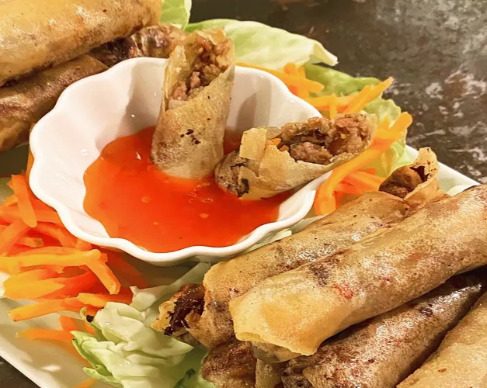1 tablespoon vegetable oil
* 1 pound ground pork
* ½ cup chopped onion
* 2 cloves garlic, crushed
* ½ cup minced carrots
* ½ cup chopped green onions
* ½ cup thinly sliced green cabbage
* 2 tablespoons chopped fresh cilantro (Optional)
* 1 teaspoon ground black pepper
* 1 teaspoon salt
* 1 teaspoon garlic powder
* 1 teaspoon soy sauce
* 30 lumpia wrappers
* 2 cups vegetable oil for frying, or as needed

## Instructions

1. Heat 1 tablespoon vegetable oil in a wok or large skillet over high heat. Add pork; cook and stir until crumbly and no pink is showing, 5 to 7 minutes. Remove pork from the pan and set aside. Drain grease from the pan, leaving just a thin coating.
2. Add onion and garlic to the pan; cook and stir until fragrant, about 2 minutes. Stir in the cooked pork, carrots, green onions, cabbage, and cilantro. Season with pepper, salt, garlic powder, and soy sauce. Remove from the heat, and set aside until cool enough to handle, about 5 minutes.
3. Assemble lumpia: Place 3 heaping tablespoons of filling diagonally near one corner of a lumpia wrapper, leaving a 1 1/2 inch space at both ends. Fold the side along the length of the filling over the filling, tuck in both ends, and roll neatly and tightly to close. Moisten the other side of the wrapper with water to seal the edge. Transfer to a plate and cover with plastic wrap to retain moisture. Repeat to assemble remaining lumpia.
4. Heat 1/2 inch vegetable oil in a heavy skillet over medium heat for 5 minutes.
5. Slide 3 to 4 lumpia into the hot oil, making sure the seams are facing down. Fry, turning occasionally, until all sides are golden brown, 1 to 2 minutes. Transfer to a paper towel-lined plate to drain. Repeat to fry remaining lumpia. Serve immediately.

## Notes:

We have determined the nutritional value of oil for frying based on a retention value of 10% after cooking. The exact amount may vary depending on cook time and temperature, ingredient density, and the specific type of oil used.

For thinner lumpia, use 60 lumpia wrappers, and half the amount of filling per wrapper (or 1 1/2 tablespoons filling each).

**Pork Sisig**

Pork sisig is a popular Filipino dish. It can be considered as a main dish or an appetizer. The composition of this dish is mainly of pig’s parts such as minced pork meat, ears, and face. Chicken liver, onions, and chili peppers are also added.

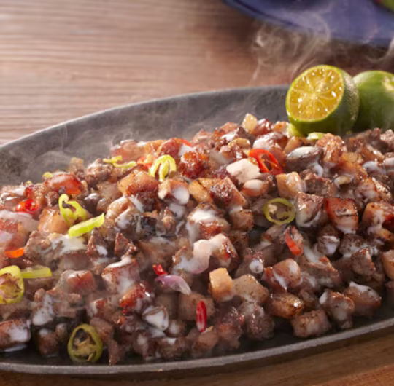Ingredients

## 1 lb. pig ears

## 1 1/2 lb pork belly

## 1 piece onion minced

## 3 tablespoons soy sauce

## 1/4 teaspoon ground black pepper

## 1 knob ginger minced (optional)

## 3 tablespoons chili flakes

## 1/2 teaspoon garlic powder

## 1 piece lemon or 3 to 5 pieces calamansi

## ½ cup butter or margarine

## ¼ lb chicken liver

## 6 cups water

## 3 tablespoons mayonnaise

## 1/2 teaspoon salt

## 1 piece egg (optional)

## Instructions

1. Pour the water in a pan and bring to a boil Add salt and pepper.
2. Put-in the pig’s ears and pork belly then simmer for 40 minutes to 1 hour (or until tender).
3. Remove the boiled ingredients from the pot then drain excess water
4. Grill the boiled pig ears and pork belly until done
5. Chop the pig ears and pork belly into fine pieces
6. In a wide pan, melt the butter or margarine. Add the onions. Cook until onions are soft.
7. Put-in the ginger and cook for 2 minutes
8. Add the chicken liver. Crush the chicken liver while cooking it in the pan.
9. Add the chopped pig ears and pork belly. Cook for 10 to 12 minutes
10. Put-in the soy sauce, garlic powder, and chili. Mix well
11. Add salt and pepper to taste
12. Put-in the mayonnaise and mix with the other ingredients
13. Transfer to a serving plate. Top with chopped green onions and raw egg.
14. Serve hot. Share and Enjoy (add the lemon or calamansi before eating)

**Laing**

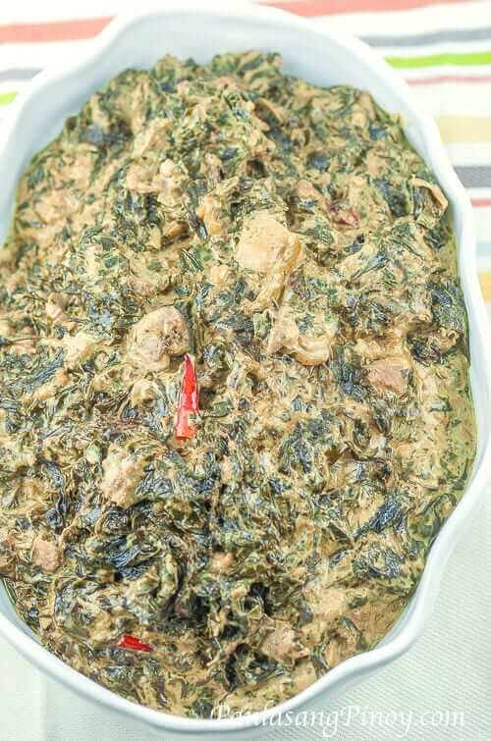Laing is a Filipino dish composed of dried taro leaves and coconut milk. It was first introduced in the province of Bicol. This dish has been very famous — it is popular within the Philippines and also outside of the country. Since the purpose of this blog is to raise awareness about Filipino Food and Recipes, I hope that this awesome dish will soon get the international credit that it deserves.

Ingredients

* 3.5 oz taro leaves (dried)
* 6 cups coconut milk
* 2 cups coconut cream
* 1/2 cup shrimp paste (bagoong or balaw)
* 1/2 lb. pork shoulder (thinly sliced)
* 5 to 7 pieces red chilies
* 1 piece onion (sliced)
* 1/2 cup sliced ginger
* 8 cloves garlic (crushed)

## Instructions

1. Combine the coconut milk, pork, shrimp paste, ginger, onion, and garlic in a cooking pot. Heat the pot and let boil.
2. Once the mixture starts to boil, gently stir to mix the ingredients. Cover the pot and simmer for 15 to 20 minutes. Make sure to stir once in a while to prevent the ingredients from sticking on the bottom of the cooking pot.
3. Add the dried taro leaves. Do not stir. Let it stay until the leaves absorb the coconut milk. This takes about 20 to 30 minutes. You can gently push the leaves down so that it can absorb more coconut milk.
4. Once the leaves absorb the coconut milk, stir the leaves and then continue to cook for to 10 minutes.
5. Pour the coconut cream into the cooking pot. Add the red chilies. Stir. Cook for 10 to 12 minutes.
6. Transfer to a serving plate. Serve.

**Tortang Talong**

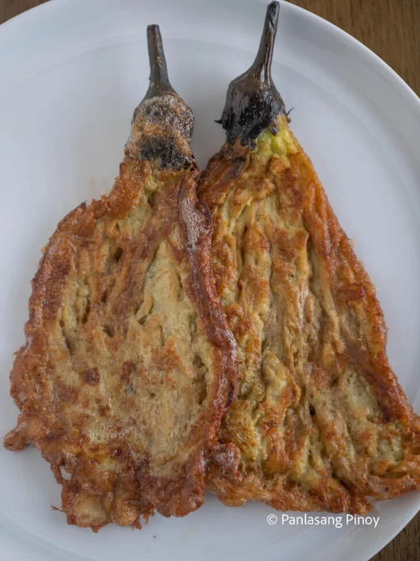Tortang talong, also known as eggplant omelette, is an omelette or fritter from Filipino cuisine made by pan-frying grilled whole eggplants dipped in an egg mixture. It is a popular breakfast and lunch meal in the Philippines.

Ingredients

* 4 pieces Chinese eggplant
* 2 pieces raw eggs
* 1 teaspoon salt
* 6 tablespoons cooking oil

## Instructions

1. Grill the eggplant until the color of skin turns almost black
2. Let the eggplant cool for a while then peel off the skin. Set aside.
3. Crack the eggs and place in a bowl
4. Add salt and beat
5. Place the eggplant on a flat surface and flatten using a fork.
6. Dip the flattened eggplant in the beaten egg mixture
7. Heat the pan and pour the cooking oil
8. Fry the eggplant (that was dipped in the beaten mixture). Makes sure that both sides are cooked. Frying time will take you about 3 to 4 minutes per side on medium heat.

**Crispy Pata**

Crispy Pata made whole pork leg boiled until tender and then deep-fried until golden and crisp. Crunchy on the outside and moist on the inside, this popular Filipino delicacy is sinfully delicious

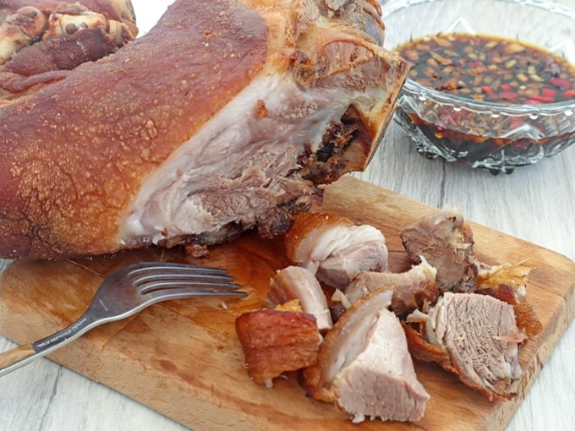Ingredients

* 1 whole pork leg
* 1 cup vinegar
* 1 can (12 ounces) 7-up or Sprite
* 1 head garlic, peeled and minced
* 1 tablespoon peppercorns
* 3 bay leaves
* salt
* 5 cups oil

For The Dipping Sauce

* 1 cup vinegar
* ¼ soy sauce
* 2 shallots, peeled and chopped
* 3 cloves garlic, peeled and minced
* 2 Thai chili peppers, peeled and minced
* salt and pepper to taste

## Instructions

1. With a knife, scrape any stray hairs on pork leg and trim off nails.
2. In a large pot over medium heat, combine pork leg, vinegar, 7-up, enough water to cover, garlic, peppercorns, bay leaves, and ⅓ cup salt. Bring to a boil, skimming scum that may accumulate on top.
3. Lower heat, cover, and then simmer for about 1-½ to 2 hours or until meat is tender but not falling apart. If the meat is drying before it is fully cooked, add more water in 1 cup increments.
4. Drain pork leg, discarding liquid and aromatics. Place on a rack and allow to cool to touch,
5. Sprinkle with about 2 tablespoons salt and massage all over. Place in a container with a lid and freeze overnight.
6. In a large, tall pot over medium heat, heat about 4 to 5 cups of oil (enough to cover the pork leg during deep-frying) to 350 F.
7. Gently add pork leg and deep-fry, turning as needed, until golden.
8. Remove pork from the pat and drain on a wire rack set over a baking sheet. Let rest for about 3 to 5 minutes before chopping. Serve hot with dipping sauce.

Dipping Sauce

1. In a small bowl, combine vinegar, soy sauce, shallots, garlic, chili peppers, and salt and pepper to taste. Stir well.

**Bopis**

Bopis is a spicy Filipino dish made from minced pigs lungs and heart. This can be served as an appetizer for beer and alcoholic beverages; it is also considered as a main dish and is best served with steamed white rice.

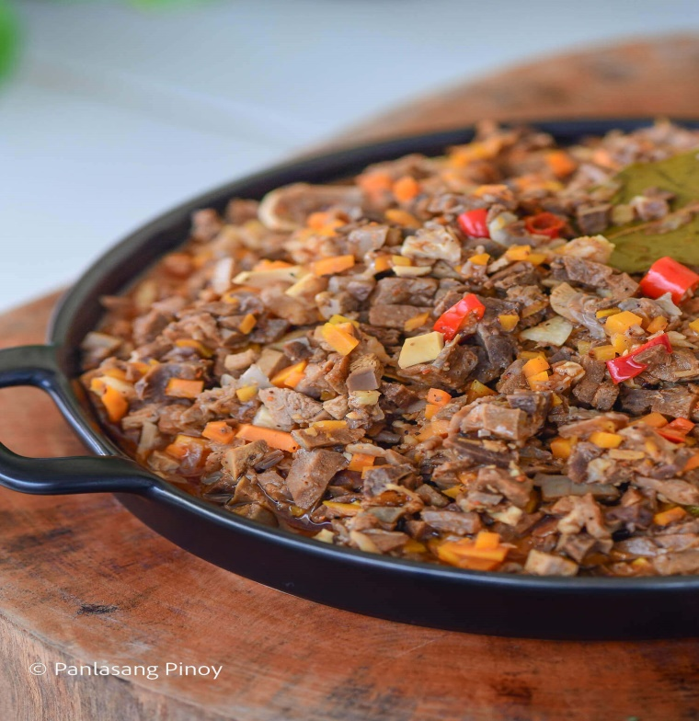Ingredients

* 3 lbs pork lungs
* 1 Knorr Pork Cube
* 5 dried bay leaves
* 2 carrots diced
* 3 thumbs ginger minced
* 1 tablespoon annatto powder
* 3 Thai chili pepper chopped
* 1 onion diced
* 5 cloves garlic minced
* 5 tablespoons vinegar
* 2 ½ cups water
* ¼ teaspoon ground black pepper
* 4 tablespoons cooking oil
* Fish sauce to taste

#### Boiling Ingredients

* 8 cups water
* 5 dried bay leaves
* 25 g sabot

## Instructions

1. In a large pot, boil 8 cups of water and then add the rest of the boiling ingredients. Put the pig’s lungs into the pot and continue boiling for 1 hour. Remove the lungs, let it cool down, and then dice into small pieces. Set aside.
2. Heat oil on a clean pot. Sauté garlic, onion, and ginger.
3. Add the diced lungs once the onion softens. Cook for 3 minutes while stirring.
4. Add vinegar. Cook for 2 minutes.
5. Pour 2 ½ cups of water into the pot. Let it boil.
6. Add Knorr Pork cube and bay leaves. Stir. Cover the pot and adjust the heat between low to medium setting. Continue cooking until the liquid reduces to half.
7. Add the carrot, chili pepper, and annatto powder. Cook for 3 minutes.
8. Season with ground black pepper and fish sauce.
9. Transfer to a serving plate. Share and enjoy!

**Papaitan**

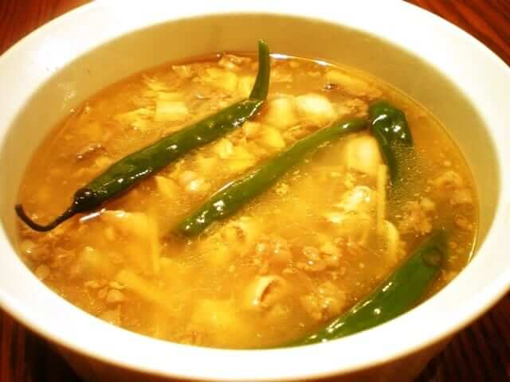Papaitan is a famous Ilocano soup dish mostly composed of cow or goat innards. The name of this dish was derived from the Filipino word “Pait”, which means “bitter”. The bitter taste of this soup comes from the bile. This is a bitter juice extracted by the liver and stored in the gallbladder to aid digestion.

Ingredients

* 1/2 lb ox tripe
* 1/2 lb cow’s small intestine
* 1/2 lb beef (thinly sliced and chopped)
* 1/2 lb cow’s heart
* 2 tbsp bile
* 2 thumbs ginger (julienned)
* 1 piece onion (diced)
* 6 cloves garlic (crushed and chopped)
* 8 cups water
* 4 to 6 pieces finger chillies
* 2 1/2 tablespoons salt
* 1/2 tablespoon ground black pepper
* 1 to 2 pieces lemon (or 5 to 8 pieces calamansi)
* 2 tablespoons cooking oil

## Instructions

1. Heat a cooking pot and pour-in 4 cups of water and put-in 1 tablespoon salt. Bring to a boil.
2. Put-in the ox tripe and small intestines and simmer until tender. This should take approximately 35 to 50 minutes.
3. Turn off heat. Remove the tender ox tripe and small intestines then slice. Set aside. Discard the water.
4. Heat a clean cooking pot and pour-in cooking oil.
5. When the oil is hot enough, sauté garlic, onion, and ginger.
6. Add the beef, heart, sliced intestines, and tripe then cook for about 3 to 4 minutes.
7. Add 1 1/2 tablespoon salt and ground black pepper then stir for a minute.
8. Pour-in remaining 4 cups of water and bring to a boil. Simmer for 40 minutes (you may add more water if needed).
9. Add bile then simmer for 5 minutes.
10. Add the finger chilies and squeeze-in the lemon juice then simmer for 3 minutes.
11. Turn off the heat and transfer to a serving bowl.
12. Serve hot. Share and enjoy!

**Tinolang Manok**

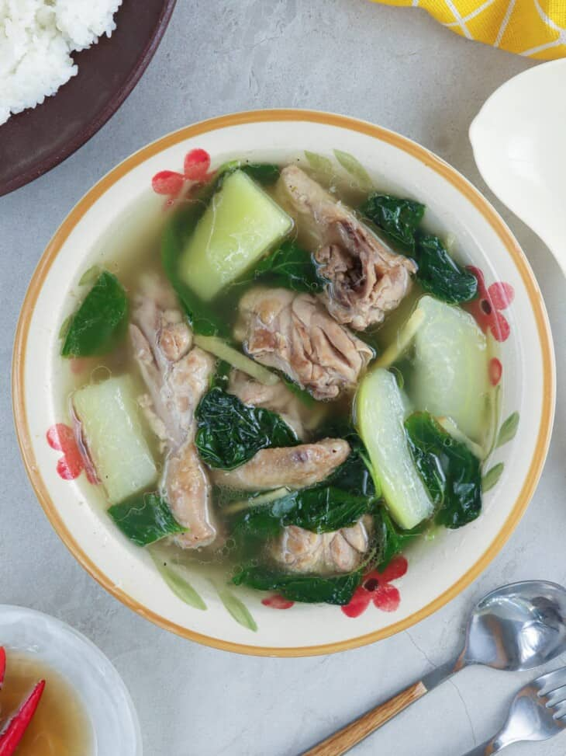Tinola is a traditional Filipino comfort food that usually consists of broth, chicken, leafy greens, papaya, and ginger. Fish sauce is a key ingredient that lends a deliciously pungent taste. Chicken tinola is often served with rice to make a hearty meal.

Ingredients

* 1 tablespoon canola oil
* 1 small onion, peeled and sliced thinly
* 3 cloves garlic, peeled and minced
* 2 thumb-sized fresh ginger
* 1 (3 to 4 pounds) whole chicken, cut into serving pieces
* 2 tablespoons fish sauce
* 5 cups water
* 1 small green papaya, pared, seeded and cut into 2-inch wedges
* 1 bunch fresh spinach leaves, stems trimmed
* salt and pepper to taste

## Instructions

1. In a pot over medium heat, heat oil. Add onions, ginger, and garlic and cook until softened.
2. Add chicken and cook, stirring occasionally, for about 5 to 7 minutes or until chicken starts to change color and juices run clear.
3. Add fish sauce and cook, stirring occasionally, for about 1 to 2 minutes.
4. Add water and bring to a boil, skimming scum that floats on top. Lower heat, cover and simmer for about 30 to 35 minutes or until chicken is cooked through.
5. Add papaya and cook for about 3 to 5 minutes or until tender yet crisp.
6. Season with salt and pepper to taste.
7. Add spinach and push down into broth. Cook until just wilted. Serve hot.

**Beef Kaldereta**

Beef Kaldereta is a main stay in any Filipino Kitchen. It is a type of beef stew cooked with tomato sauce and liver spread. Ingredients such as potato, carrots, bell peppers, and olives are also utilized when cooking this dish. This is a popular dish is served during special occasions. It is a regular item in every Filipino cookbook. Some consider kaldereta as the Philippines most famous beef stew.

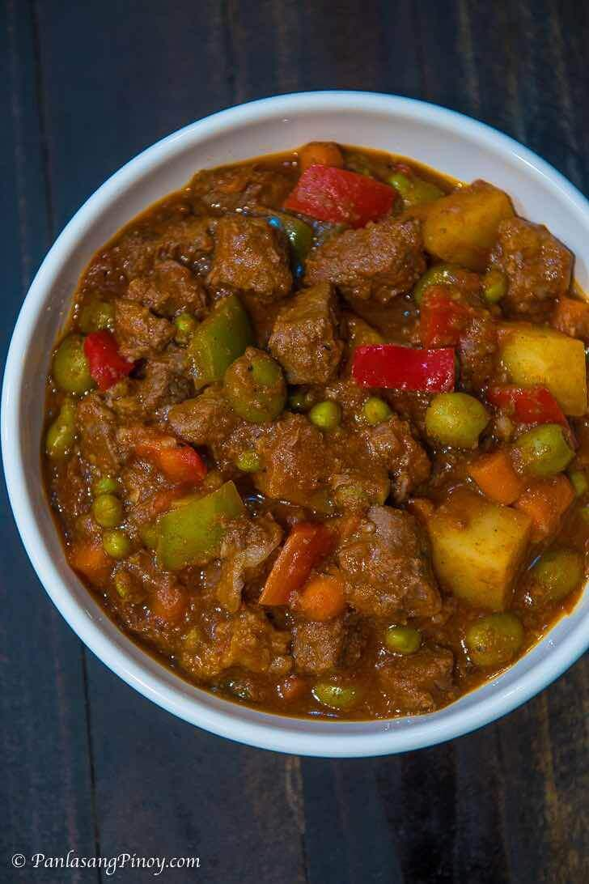Ingredients

* 2 lbs beef cubed
* 3 pieces garlic cloves crushed and chopped
* 1 piece onion finely chopped
* 2 cups beef broth
* 1 piece red bell pepper sliced
* 1 piece green bell pepper sliced
* 1 cup tomato sauce
* ½ cup liver spread processed using blender
* 1 teaspoon chili flakes
* 3 pieces dried bay leaves
* 2 cups potatoes sliced
* 2 cups carrots sliced
* 1/4 cup cooking oil
* ⅔ cup green olives
* salt and pepper to taste

## Instructions

1. Heat the cooking oil in the cooking pot or pressure cooker.
2. Sauté the onion and garlic.
3. Add the beef. Cook for 5 minutes or until the color turns light brown.
4. Add the dried bay leaves and crushed pepper. Stir.
5. Add the liver spread. Stir.
6. Pour-in the tomato sauce and beef broth.
7. Cook the beef until it becomes tender (about 30 mins if using a pressure cooker, or 1 to 2 hours if using an ordinary pot).
8. Add potato and carrots. Cook for 8 to 10 minutes.
9. Put the green olives and bell peppers in the cooking pot. Stir and continue to cook for 5 minutes more.
10. Add salt and pepper to taste
11. Serve Hot. Enjoy!

**Pinakbet**

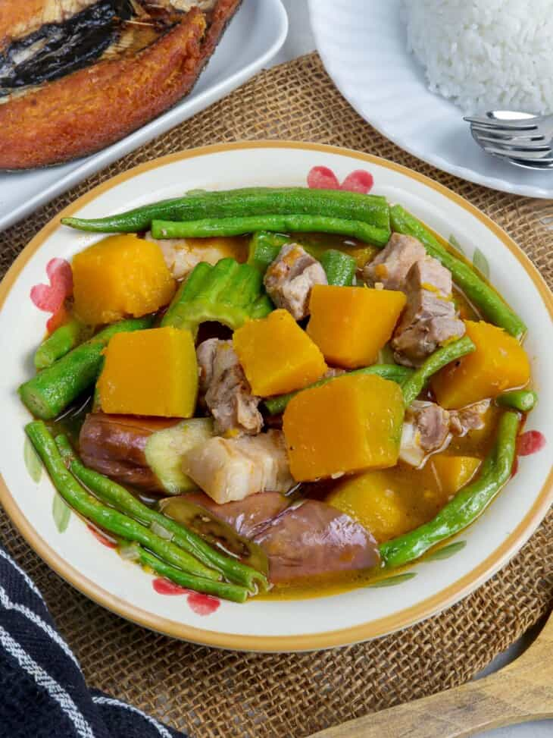Pakbet is a Filipino dish made of pork and vegetables such as eggplant, okra, bitter melon, long beans, and calabasa. It's a delicious and nutritious dish served as a main entree or a side to fried fish or grilled meat.

Ingredients

* 1 tablespoon canola oil
* 1 onion, peeled and chopped
* 2 cloves garlic, peeled and minced
* ½ pound pork belly, cut into 1-inch cubes
* 1 tablespoon shrimp paste
* 2 Roma tomatoes, chopped
* 2 cups water
* ½ small kalabasa, peeled and cut into pieces
* 8 okra, ends trimmed
* ½ bunch long beans, ends trimmed and cut into 3-inch lengths
* 1 medium ampalaya (bittermelon), seeded, halved and cut into 1-inch thick
* 1 large eggplant, ends trimmed and cut into 1-inch thick
* salt and pepper to taste

## Instructions

1. In pot over medium heat, heat oil. Add onions and garlic and cook, stirring regularly, until softened.
2. Add pork and cook, stirring occasionally, until lightly browned.
3. Add shrimp paste and continue to cook, stirring occasionally, until it begins to brown.
4. Add tomatoes and cook, mashing with the back of a spoon, until softened and have released juice.
5. Add water and bring to a boil. Lower heat, cover, and cook for about 15 to 20 minutes or until meat is tender. Add more water in ½ cup increments as needed to maintain about 1 cup of liquid.
6. Add squash and cook for about 2 minutes or until almost tender.
7. Add long beans and continue to cook until tender-crisp.
8. Add ampalaya, eggplant, and okra. Continue to cook for about 4 to 5 minutes or until vegetables are tender yet crisp.
9. Season with salt and pepper to taste. Serve hot.

**Reference**

Lumpia

<https://www.allrecipes.com/recipe/35151/traditional-filipino-lumpia/>

Pork Sisig

<https://panlasangpinoy.com/pork-sisig/>

Laing

<https://panlasangpinoy.com/laing-recipe/>

Tortang Talong

<https://panlasangpinoy.com/filipino-vegetable-food-eggplant-omelet-tortang-talong-recipe/>

Crispy Pata

<https://www.kawalingpinoy.com/crispy-pata/>

Bopis

<https://panlasangpinoy.com/bopis-pulutan-recipe/#google_vignette>

Papaitan

<https://panlasangpinoy.com/papaitan-recip/>

Tinolang Manok

<https://www.google.com/search?q=what+is+tinolnag+manol&rlz=1C1BNSD_enPH1077PH1077&oq=what+is+tinolnag+manol&gs_lcrp=EgZjaHJvbWUyBggAEEUYOTIJCAEQABgNGIAEMgkIAhAAGA0YgAQyDQgDEAAYhgMYgAQYigUyDQgEEAAYhgMYgAQYigXSAQgzMzAzajBqN6gCALACAA&sourceid=chrome&ie=UTF-8>

Beef Kaldereta

<https://panlasangpinoy.com/beef-kaldereta/>

Pinakbet

<https://www.kawalingpinoy.com/pinakbet/>