Hoisting the spinnaker short-handed – offshore sailor Pip Hare offers her tips

Break down the manoeuvre into separate parts and plan ahead. Pip Hare shares her advice for hoisting the spinnaker short-handed.

Pip Hare September 24, 2016

<http://www.yachtingworld.com/expert-sailing-techniques/hoisting-spinnaker-short-handed-pip-hare-offers-tips-93651>

Contrary to what you might think, you don’t need to grow another set of arms to perform a good spinnaker hoist double-handed. The key to making it work is to break the manoeuvre down into separate parts, delegating who is going to do what. And of course don’t forget the golden rule: prepare and communicate.

**Preparation is key**

Ten minutes spent woolling the tack/windward clew of your spinnaker could avoid a disaster if the hoist goes wrong. There’s no need to do the whole sail, just focus on the portion that will be exposed to the wind before and during the hoist. It is even worth doing this if using a snuffer, to prevent wind getting in underneath and lifting the bucket early.

Let the autopilot drive on compass mode and aim for a course as deep as possible, reducing the apparent wind, but not so deep the spinnaker will not fill (this will risk a wrap).

I recommend hoisting behind the jib in most circumstances. However if you are new to snuffers, you can hoist bare-headed; you will lose a little time, but clear sightlines up the sail will help to ensure you are rigged up correctly before launching.

Talk to your co-skipper all the time, to check you are both ready; even if it feels over the top, make it part of your standard routine. Take a look at the video below for a guide to hoisting with or without a snuffer.

<https://www.youtube.com/watch?v=vvNEz7yB2GI>

**Rigging the pole**

Set your pole up first: for a symmetric this should be at the correct height, with the downhaul preset to allow the pole to come back – If reaching pull the downhaul on straight away, if downwind in bigger breeze, aim to bring the pole back halfway.

For an asymmetric, pull out and cant the pole as required, cant to roughly half trim if downwind – remember to allow the tack to run free so it doesn’t start to pull the kite out of the bag.

Pre-set the sheet to an ‘eased’ position with tweakers off, but ensure it is ready to run. Pull the windward clew, or tack, to the end of the pole. For asymmetrics the person on the foredeck may need to help the bulk of the sail out over the guardrails to reduce friction. Verbally acknowledge you are ready to hoist then go for it.

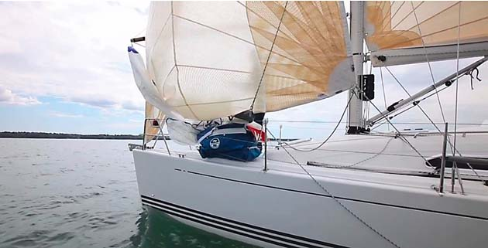

Hoisting in the lee of the jib will prevent the spinnaker from filling too quickly.

### ****Snuffers****

If using a snuffer, follow the procedure above, but initially keep the sheet a little looser. During the hoist make sure you have a loose hold of the snuffer line so it doesn’t blow out with the wind. Once the sock is at the top, trim on the sheet and raise the bucket, it may be worth heading up a couple of degrees in lighter airs to encourage the sail to fill.

Try to control the speed the bucket goes up by applying pressure to the down line – this will avoid bunching inside the sock, which may hamper the drop. Check the head of the spinnaker is visible underneath the bucket, it is easy to lose a couple of square metres of sail area this way. Tie the snuffer line down to the deck with a slip knot.

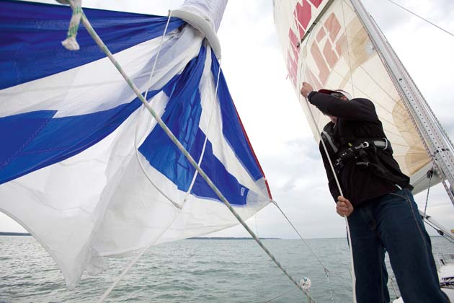

Once the snuffer is hoisted and the jib is furled, raise the bucket above the head of the spinnaker and trim on.

### ****ISAF Rule 55****

ISAF Rule 55 prevents the disposal of any items over the side while participating in a yacht race and this includes wool used to restrain the spinnaker.

It is generally agreed that woolling the kite, particularly if double-handed, is a question of good seamanship and safety, so most race committees will modify the Sailing Instructions to reflect this.

If in doubt ask your race committee to clarify the situation and from an ecological point of view always use a natural fibre wool and never rubber bands.

**Quick tips**

* Whip a mark onto your halyard so you know you have reached full hoist, even in the dark.
* Don’t even think about hoisting from the cockpit, fit cam cleats onto the mast, and hoist from the foredeck, tail through once the hoist is complete.
* Once tailed through always take the halyard out of the mast cleat after hoisting.
* Be ready to drop as soon as the hoist is complete, coiling the halyard and tackline.