OpenCpn ; Plugin « Tactics »

L’installer sous Linux / Raspbian

<https://opencpn.org/wiki/dokuwiki/doku.php?id=opencpn:opencpn_user_manual:plugins:sailing:tactics>

<http://www.cruisersforum.com/forums/archive/index.php/t-190654.html>

Woodland Hills

31-03-2018, 09:08

apparently file attacment did not work. so here is a past of contents:  
  
  
===================================================================  
1. OpenCPN build and install  
===================================================================  
  
Install all Debian packages needed to build an run OpenCPN (and opional plugins mentioned below)  
  
apt update && apt upgrade  
apt install `cat package_list.txt`  
  
where the contents of the file pacage_list.txt must be as follows :  
  
git  
cmake  
libc6  
libc6-dev  
build-essential  
libgl1-mesa-dev  
libgl1-mesa-dri   
libgl1-mesa-glx  
libglapi-mesa  
libglu1-mesa  
libglu1-mesa-dev  
freeglut3  
freeglut3-dev  
libwxgtk3.0-0v5  
libwxgtk3.0-dev  
libtinyxml2.6.2v5  
libtinyxml2-dev  
libtinyxml-dev  
libcurl3  
libcurl3-dev  
libcairo2  
libcairo2-dev  
libpango1.0-dev  
libgdk-pixbuf2.0-dev  
libgtk2.0-dev  
lbzip2  
libghc-bzlib-dev  
libelf-dev  
liblzma-dev  
wx3.0-i18n  
wx3.0-headers  
zlib1g  
zlib1g-dev  
libportaudio2  
portaudio19-dev  
  
Download latest OpenCPN source code:  
  
cd ~/Downloads  
git clone https://github.com/OpenCPN/OpenCPN.git  
cd OpenCPN  
  
change library settings to enable Debian 9 build:  
  
edit CMakeLists.txt   
replace libwxgtk3.0-0 with libwxgtk3.0-0v5   
replace libtinyxml2.6.2 with libtinyxml2.6.2v5  
  
Download a high-resolution set of world wide background maps from the following link: https://opencpn.org/wiki/dokuwiki/lib/exe/fetch.php?media=opencpn:files:charts:gshhshires.zi p, and extract the files to ~/Downloads/OpenCPN/data/gshhs )  
  
cd ~/Downloads/OpenCPN  
  
mkdir build  
cd build  
  
cmake ../  
  
check for error messages and install any missing packages not included in the list above  
  
edit CMakeCache.txt to make the following changes:  
  
replace BUNDLE_DOCS:BOOL=OFF with BUNDLE_DOCS:BOOL=ON (include documentation in build)  
  
replace BUNDLE_GSHHS:STRING=NONE with BUNDLE_GSHHS:STRING=FULL (this will include the hi-res background maps downloaded above in the build. If maps are unavailable the build will fail)  
  
replace CMAKE_INSTALL_PREFIX:PATH=/usr/local with CMAKE_INSTALL_PREFIX:PATH=/usr ( this is needed to work properly with 3rd-party plugins such as s63_pi, oesenc_pi, and some utilities without various soft links. )  
  
Compile and build OpenCPN resulting in Debian package opencpn.deb :  
  
make -j2 package (-j2 option uses two compile threads to speed up the build)  
  
sudo dpgk --install opencpn.deb  
  
================================================== =======  
2. Build and install chart plugin for oeSENC O-Charts  
================================================== =======  
  
If not done so, install the packages mentioned above under OpenCPN build  
  
Download latest version of source code:  
  
cd ~/Downloads  
  
git clone https://github.com/bdbcat/oesenc_pi.git  
  
Compile and build Debian package oesenc_pi_1.2.0-1_amd64.deb :  
  
cd oesenc_pi  
mkdir build  
cd build  
cmake ../ (check error messages)  
make -j2 package  
  
Install package :  
  
dpkg --install oesenc_pi_1.2.0-1_amd64.deb  
  
================================================== ==============  
2. Build and install chart plugin for S63 Encrypted ENC Charts  
================================================== ==============  
  
If not done so, install the packages mentioned above under OpenCPN build  
  
Download latest version of source code:  
  
cd ~/Downloads  
  
git clone https://github.com/bdbcat/s63_pi.git  
  
Compile and build Debian package oesenc_pi_1.2.0-1_amd64.deb :  
  
cd os63_pi  
mkdir build  
cd build  
cmake ../ (check error messages)  
make -j2 package  
  
Install package :  
  
dpkg --install s63_pi_1.6.0-1_amd64.deb  
  
  
Well, that sounds simple......

CapnRon47

31-03-2018, 09:34

I used this process to add the Tactics Plugin to OpenCPN on my Rpi (running Jessie) and it worked well. **See my write up in the Tactics thread**.

<http://www.cruisersforum.com/forums/archive/index.php/t-154277.html>

tom_BigSpeedy

24-05-2016, 02:14

Hi there,  
  
here is a first shot of my tactics_pi plugin ...

<http://www.cruisersforum.com/forums/showthread.php?p=2761884#post2761884>

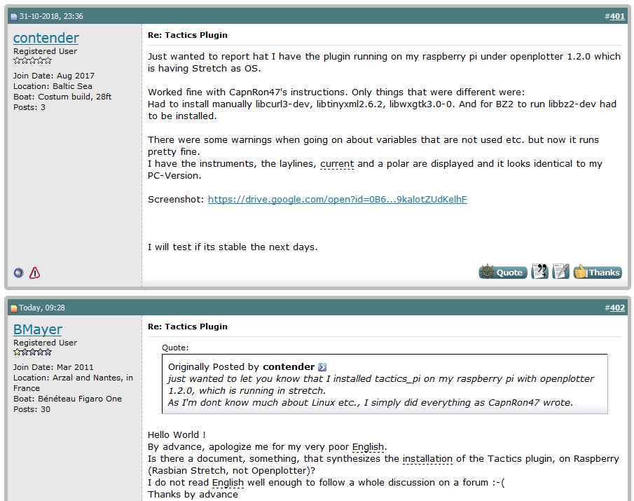

Réponse ☺ 

Donc : <http://www.cruisersforum.com/forums/f134/tactics-plugin-166909-25.html>

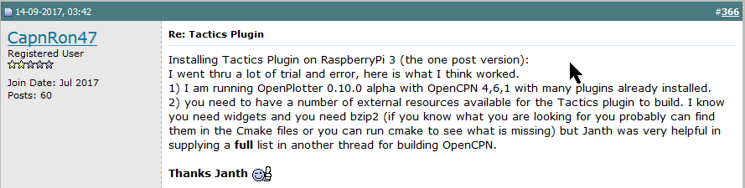

Installing Tactics Plugin on RaspberryPi 3 (the one post version):  
I went thru a lot of trial and error, here is what I think worked.  
1) I am running OpenPlotter 0.10.0 alpha with OpenCPN 4,6,1 with many plugins already installed.  
2) you need to have a number of external resources available for the Tactics plugin to build. I know you need widgets and you need bzip2 (if you know what you are looking for you probably can find them in the Cmake files or you can run cmake to see what is missing) but Janth was very helpful in supplying a **full** list in another thread for building OpenCPN.  
  
**Thanks Janth** http://www.cruisersforum.com/images/smilies/thumb.gif  
  
I Installed all packages needed to build and run OpenCPN (these worked for the Rpi3) (all the following commands required 'sudo' of course and many of these were already installed and of latest version but not all). I went thru the list line by line, but I did not keep track of which were not already installed.  
  
apt update && apt upgrade  
apt install `cat package_list.txt`  
  
where the contents of the file pacage_list.txt must be as follows :  
git  
cmake  
libc6  
libc6-dev  
build-essential  
libgl1-mesa-dev  
libgl1-mesa-dri   
libgl1-mesa-glx  
libglapi-mesa  
libglu1-mesa  
libglu1-mesa-dev  
freeglut3  
freeglut3-dev  
libwxgtk3.0-0  
libwxgtk3.0-dev  
libtinyxml2.6.2  
libtinyxml2-dev  
libtinyxml-dev  
libcurl3  
libcurl3-dev  
libcairo2  
libcairo2-dev  
libpango1.0-dev  
libgdk-pixbuf2.0-dev  
libgtk2.0-dev  
lbzip2  
libghc-bzlib-dev  
libelf-dev  
liblzma-dev  
wx3.0-i18n  
wx3.0-headers  
zlib1g  
zlib1g-dev  
libportaudio2  
portaudio19-dev  
  
3)I found the existing OpenCPN plugin directories in /usr/share/opencpn/plugins, so I created a new directory for tactics_pi, and I cloned the tactics_pi github files there.  
  
git clone <https://github.com/tom-r/tactics_pi.git>  
  
4) I opened that directory and I created a build directory, moved to the build directory and proceeded to due a UNIX style build on the parent directory containing all the git files  
  
mkdir build  
cd build  
cmake ..  
make  
make install  
  
as I had previously loaded **all** the above packages I did not find any fatal errors.  
  
5) at this point I had completed the build, but OpenCPN did not find the new plugin in its list. So I searched on another already installed plugin name and I found their library files in /usr/lib/opencpn the files where all libxxxxx.so. I copied the libtactics_pi.so file from its location in the build directory and pasted it into /usr/lib/opencpn.  
  
6) now OpenCPN found the tactics_pi in its list and I was able to enable it and run it (I believe at least I have been able to get the instruments I have tried to show up in dashboard like elements, but listed as tactics).  
  
7) I am assuming that the file I copied points to the location of all the other files needed for tactics_pi. I did find another copf of the tactics_pi data directory (with all the svg files) located in /usr/local/share/opencpn/plugins/tactics_pi/data. OpenCPN was able to find these as the tactics_pi icon shows up in the toolbar along with the Polar, Dashboard, WMM, and Grib icons of the other plugins that I enabled.  
  
8) if anyone knows how to clean this process up so that you only need to load what is needed and the files end up where they are supposed to be, please feel free to improve on this process.  
  
thanks,  
Ron

Dans le message #401 (image plus haut) :

Had to install manually libcurl3-dev, libtinyxml2.6.2, libwxgtk3.0-0. And for BZ2 to run libbz2-dev had to be installed.