<http://www.ycca.fr/#!le-tour-du-morhihan15/c1kao>

Programme prévisionnel 2015 "La Route des Îles" :

**Samedi 4 juillet . Locmiquélic .**

13h à 19h . Confirmation des inscriptions à Locmiquélic CNML 40 rue du Gelin

19h . Apéritif des équipages "Locmiquélic"

**Dimanche 5 juillet . Le Tour de Groix . Locmiquélic --> Etel**

Résultats de la course "Ria d'Etel"

Soirée des équipages à Etel

**Lundi 6 juillet . Le Tour de Belle Ile . Etel --> Quiberon-Port Haliguen**

Résultats de la course "Ville de Quiberon"

**Mardi 7 juillet . Le Tour de Houat . Quiberon-Port Haliguen --> La Trinité sur Mer**

Résultats de la course "La Trinité sur Mer"

**Mercredi 8 juillet . Le Tour de Hoëdic . La Trinité sur Mer --> Arzon-Port du Crouesty**

Résultats de la course "Port du Crouesty"

**Jeudi 9 juillet . Tour de l'Île aux Moines . Arzon-Port du Crouesty --> Arzon**

Résultats de la course "Ville d'Arzon"

Remise des prix "Tour du Morbihan 2015"

Soirée concert des équipages à la Maison du Port

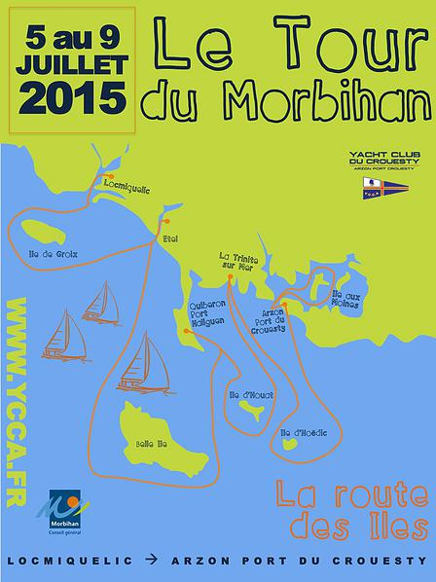

Prévoir 60€ pour le bateau, + 30€ / personne

**Ile de Groix (Port-Tudy) :** Port Navalo ¼ heure plus tard

<http://maree.info/98?d=20150627>

|  |  |  |  |  |  |  |  |
| --- | --- | --- | --- | --- | --- | --- | --- |
| **Date** | **Heure** | **Hauteur** | **Coeff.** | **Date** | **Heure** | **Hauteur** | **Coeff.** |
| [**Sam.27**](http://maree.info/98) | **01h29** 07h52 **14h10** 20h15 | **4,00m** 2,10m **4,10m** 2,10m | **42**   **45** | [**Sam.04**](http://maree.info/98) | 00h52 **06h57** 13h09 **19h17** | 0,85m **5,05m** 1,00m **5,25m** | **95**   **96** |
| [**Dim.28**](http://maree.info/98) | **02h32** 08h47 **15h01** 21h09 | **4,15m** 1,95m **4,30m** 1,90m | **49**   **54** | [**Dim.05**](http://maree.info/98) | 01h36 **07h41** 13h55 **20h04** | 0,85m **5,00m** 1,00m **5,20m** | **95**   **93** |
| [**Lun.29**](http://maree.info/98) | **03h23** 09h36 **15h46** 21h56 | **4,30m** 1,75m **4,55m** 1,65m | **59**   **64** | [**Lun.06**](http://maree.info/98) | 02h23 **08h27** 14h43 **20h53** | 0,90m **4,90m** 1,10m **5,05m** | **91**   **87** |
| [**Mar.30**](http://maree.info/98) | **04h10** 10h20 **16h28** 22h41 | **4,50m** 1,50m **4,75m** 1,40m | **69**   **74** | [**Mar.07**](http://maree.info/98) | 03h11 **09h17** 15h35 **21h47** | 1,05m **4,70m** 1,30m **4,85m** | **84**   **79** |
| [**Mer.01**](http://maree.info/98) | **04h52** 11h02 **17h09** 23h25 | **4,70m** 1,30m **4,95m** 1,20m | **79**   **83** | [**Mer.08**](http://maree.info/98) | 04h03 **10h14** 16h32 **22h46** | 1,25m **4,50m** 1,50m **4,65m** | **75**   **70** |
| [**Jeu.02**](http://maree.info/98) | **05h33** 11h44 **17h50** | **4,85m** 1,15m **5,15m** | **87**   **90** | [**Jeu.09**](http://maree.info/98) | 05h01 **11h22** 17h35 **23h55** | 1,45m **4,35m** 1,65m **4,45m** | **66**   **62** |
| [**Ven.03**](http://maree.info/98) | 00h08 **06h15** 12h26 **18h33** | 1,00m **5,00m** 1,00m **5,25m** | **93**   **94** | [**Ven.10**](http://maree.info/98) | 06h06 **12h40** 18h45 | 1,65m **4,30m** 1,75m | **60** |

|  |  |  |  |  |  |  |  |
| --- | --- | --- | --- | --- | --- | --- | --- |
| **Date** | **Heure** | **Hauteur** | **Coeff.** | **Date** | **Heure** | **Hauteur** | **Coeff.** |
| [**Sam.04**](http://maree.info/98) | 00h52 **06h57** 13h09 **19h17** | 0,85m **5,05m** 1,00m **5,25m** | **95**   **96** | [**Sam.11**](http://maree.info/98) | **01h10** 07h17 **13h55** 19h55 | **4,35m** 1,75m **4,35m** 1,70m | **58**   **59** |
| [**Dim.05**](http://maree.info/98) | 01h36 **07h41** 13h55 **20h04** | 0,85m **5,00m** 1,00m **5,20m** | **95**   **93** | [**Dim.12**](http://maree.info/98) | **02h22** 08h25 **14h58** 21h01 | **4,40m** 1,70m **4,50m** 1,60m | **60**   **63** |
| [**Lun.06**](http://maree.info/98) | 02h23 **08h27** 14h43 **20h53** | 0,90m **4,90m** 1,10m **5,05m** | **91**   **87** | [**Lun.13**](http://maree.info/98) | **03h26** 09h27 **15h52** 22h01 | **4,50m** 1,55m **4,65m** 1,45m | **66**   **70** |
| [**Mar.07**](http://maree.info/98) | 03h11 **09h17** 15h35 **21h47** | 1,05m **4,70m** 1,30m **4,85m** | **84**   **79** | [**Mar.14**](http://maree.info/98) | **04h19** 10h21 **16h37** 22h52 | **4,60m** 1,40m **4,80m** 1,30m | **73**   **77** |
| [**Mer.08**](http://maree.info/98) | 04h03 **10h14** 16h32 **22h46** | 1,25m **4,50m** 1,50m **4,65m** | **75**   **70** | [**Mer.15**](http://maree.info/98) | **05h04** 11h08 **17h18** 23h38 | **4,70m** 1,30m **4,90m** 1,15m | **80**   **82** |
| [**Jeu.09**](http://maree.info/98) | 05h01 **11h22** 17h35 **23h55** | 1,45m **4,35m** 1,65m **4,45m** | **66**   **62** | [**Jeu.16**](http://maree.info/98) | **05h44** 11h50 **17h55** | **4,80m** 1,20m **5,00m** | **84**   **85** |
| [**Ven.10**](http://maree.info/98) | 06h06 **12h40** 18h45 | 1,65m **4,30m** 1,75m | **60** | [**Ven.17**](http://maree.info/98) | 00h20 **06h19** 12h29 **18h28** | 1,10m **4,85m** 1,20m **5,00m** | **86**   **86** |