How to Photograph Sail Shape

There are a number of reasons to regularly photograph sail shape, from tracking the condition of the sail to figuring out why you can’t point. However, getting a reliable photo can be quite difficult. Quantum experts Mark Reynolds and Doug Stewart weigh in with their advice on snapping the best photos.

April 12, 2017

<https://www.quantumsails.com/en/resources-and-expertise/articles/how-to-photograph-sail-shape>

The best way to evaluate your sail shape is from a photo taken on from on board. These photos provide valuable information about trim and tuning, not to mention information about the condition of the sail.

It’s recommended that you get a good shot of your sail shape as soon as you get them. This provides a baseline as your sails age and stretch. Take at least one set of photos each year – preferably at the beginning and end of the season. A sailmaker can measure the draft (depth) and draft position to determine the shape of your sail and determine if it’s time for a recut.

Another valuable use for these photos is evaluating performance. The sail shape photos could give important clues to the problem, especially paired with the conditions. If you’re not able to diagnose the problem yourself, send them to your local Quantum loft. For example, if your sail is too full, it might be why you’re having trouble pointing. A recut or some tuning and trim adjustments could solve your problem!

In the past, photographing sails was a fairly complicated process, involving developing film and making prints, and then retaking photos if they didn’t capture what you needed. Today, with digital camera and computer measuring programs it’s very quick and easy, but it’s still a bit of a trick to get proper photos.

**All About Angle:** The most important part of taking the picture is to hold the camera on a diagonal angle. The image needs to include all of the draft stripes, giving your sailmaker the entire vision of your sail. Be mindful, the most common mistake is leaving out the lower draft stripe! They need the whole picture (pun intended!)

When photographing the sail, position yourself slightly to the windward of the sail foot, in the middle and as low as possible. Hold the camera diagonally, lining up the luff end of the lower draft line in one corner and the leech end in the opposite corner. This provides an image that includes all three draft lines for most mains and jibs. Low aspect mains and genoas are a bit tougher to photograph because of their shape, but with the right camera and angle, it’s possible to capture all three draft stripes.

To photograph the whole sail, you’ll need a wide lens. Most smartphones have fairly wide angles. If you’re using a camera, one of our favorite models is the Olympus Tough. The tough models are fully shock-proof and waterproof.

**Conditions Count:** The best photos for evaluation are taken in 7-10 knots of wind. Stronger breezes can backwind of the main. It’s also challenging to take properly-angled images in small boats when you need to be hiking out. If you are trying to compare two of the same sails, make sure the wind strength doesn’t change between snaps and that the set-up is exactly the same. If possible, keep all rig settings the same, and put up and take down all the sails in a single session. When you take the pictures, make sure to record the wind strength at the time of the photo for reference.

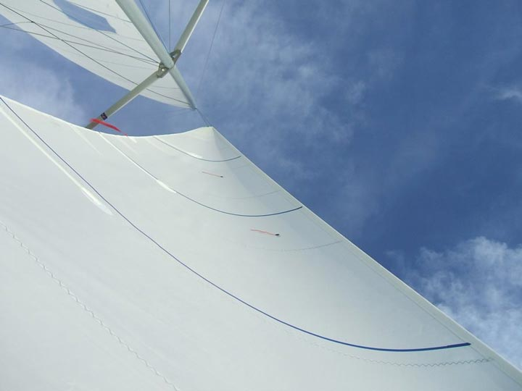

**Best Practices to Photograph a Jib:** If the foredeck is large enough, lay on the deck next to the midfoot and look up at the sail. Line up the camera diagonally with the line between the tack and clew. A simple trick is to place one finger under the forward corner of the camera so it’s aimed at the jib head. Initially you will have to experiment, then check the photos to make sure you are getting the luff and leech at the lower draft line. It’s important for the jib photos that the tell tales stream back with no luffing. On a small boat, skip the viewing screen and hold the camera on the deck in the middle of the jib foot, shooting from there. Review the photos as you go to ensure you have the correct angle and all three draft stripes.

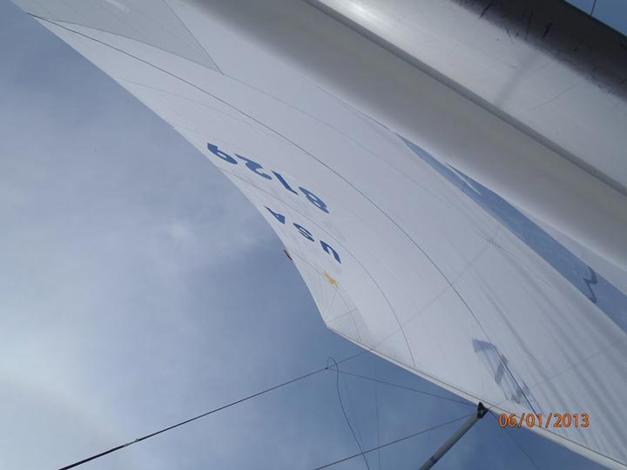

**Best Practices to Photograph a Mainsail:** On a big boat, your best bet is to lay in the cockpit directly under the mainsail and slightly to the side of the boom (on a smaller boat, position the camera like you did for the jib). Make sure the boom does not block the lower draft line, but do include the boom in the photo if possible. Hold the camera diagonally, with the luff in one corner and the leech in the opposite corner, to include the entire sail.

It takes practice to capture sail images perfectly, but in the age of digital cameras, trial and error are allowed. The most important takeaways are to include the entire sail with all of the draft stripes, and to record the wind speed from the photo shoot. Armed with these photos, you and your sail professionals will gain the best sense of what’s happening with your sails, and you can create a plan for what you can do to make them as efficient as possible.