http://www.thecoastalpassage.com/eye_splice.html

THE NORSON SPLICE
Eye splicing double braid is one of those mysteries of the sea that clog up the schedules of riggers and cost sailors money and time to get done. I hate the idea of being dependent on anybody for any boat maintenance or repair. Besides the fact not all trades people are honest and competent, what if you are somewhere they aren't? So... Several years ago I determined that I just wasn't going to waste days of time in running gear around to the pros nor pay the price so I sat down in my cockpit and worked it out.
I am a real visual type so I have arranged this to suit myself. Follow the numbered photos and the commentary beside the photos to fill in what ever isn't obvious.

(1)Before preceding, tie a knot as illustrated (about 1.5 metre from the end), then get hold of the core and pull it out the end of the cover for about 2 to 3 inches. (50 to 75mm) Wrap some PVC tape tightly around the joint and cut. This leaves you some extra cover material that will make life easier when doing the last step and the knot will keep the slack close to your work. | 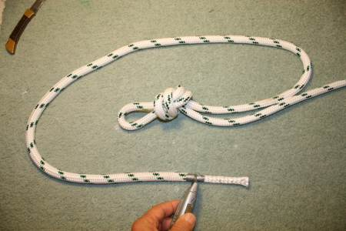
(2) Set up where your 'eye' is going to be and how much core is to be woven inside. Note; some of these photos are from an earlier version and do not have the tape in place on the end. | 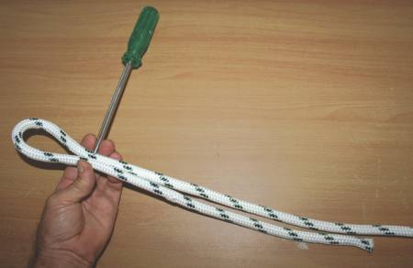
(3)Use a small fid to poke through the cover. The idea is to part the fabric gently and get the tool under and behind the core until... | 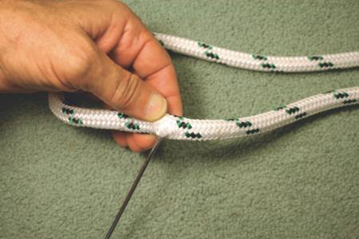
(4) you can get behind the core enough to pull the core out the side of the cover. Be careful not to get a strand of the cover by mistake when extracting the core. | 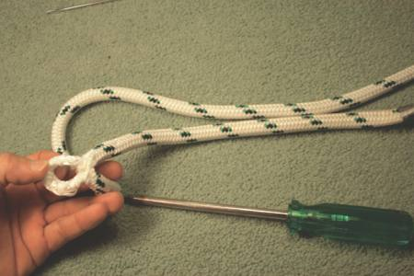
(5)This is about what it should look like. | 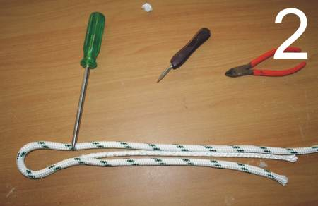
(6)Now that you have the core pulled out, cut off the cover end. | 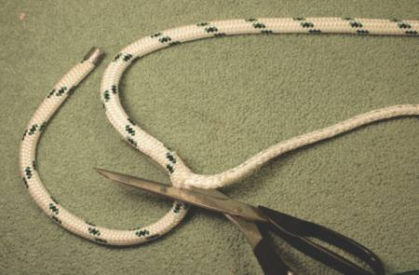
(7)This tool allows you to do the new way of securing the cover shown below. It is the "STITCH IT AWL" made in the Whitsunday's by a cruiser of best materials. Handmade of 316 stainless. Unbelievably handy and cheap. No boat should leave harbour without one. Note that this photo does not portray a part of the splicing method, it's just to show the device and it's size. | 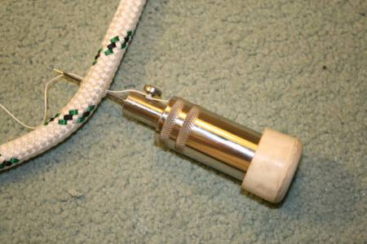
(8)What I have done here is to sew right through the cover and core with the heavy thread that comes with the Stitch It Awl, working my way all around. This prevents the cover from coming loose in the event your eye splice gets flogged about or not buried in deep enough to hold it with tension. Once sewn, cover it all with tape as in photo below so it goes smoothly through the core later. | 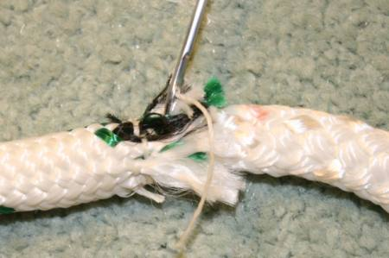
(9)Secure the cover with a snug piece of tape to the core and also do the end of the core, be tidy and taper the end if you can. I used common PVC tape. My tool in this photo is indicating where the joint is going. | 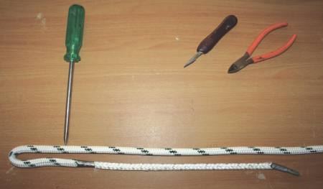
(10)At the joint selected, get behind the core again. | 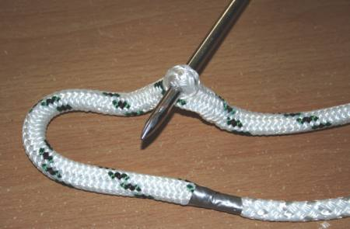
(11)Pull a length of core out of the length of the rope. It comes out easily. Note the ‘fat’ look of the cover on the long part of the rope as compared to the loop. Keep the loop snug. Don’t pull core from the loop. | 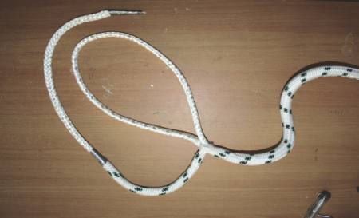
(12)Using your fid to part the fabric in the core, then pull the tail piece through as shown. | 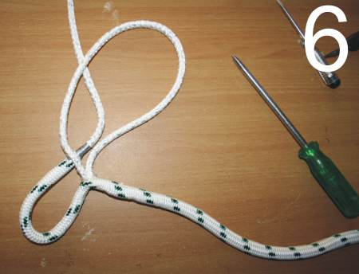
(13)Repeat the process of weaving back and forth through the core all the way to the end of the tail. | 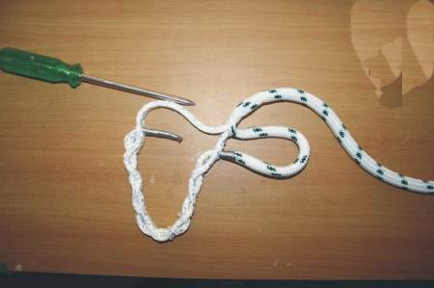
(14)Pull the tail taunt within the main core and remove the tape on the tail and put a fresh piece over the end and creating a smooth join with the main core. | 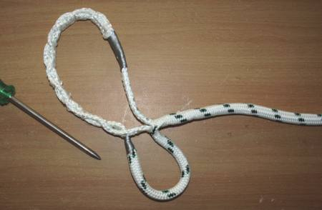
(15)Make the other end fast to something sturdy and start to pull the cover toward you.. milking. | 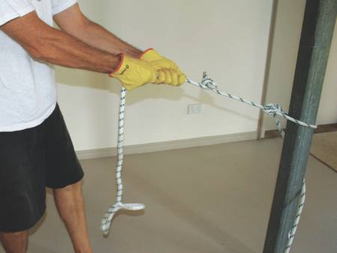
(16)And it starts sucking the whole lot back inside the cover. | 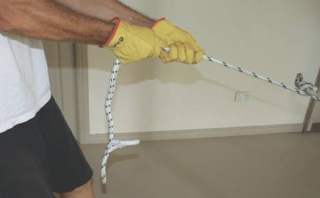
(17)Like milking a very stiff tit! Especially that last bit as is shown below | 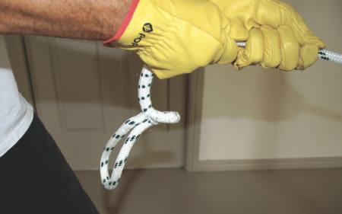
(18) Fighting for the last bit. Getting the core to dive deep into the joint. If it gets too hard... cheat! see below. | 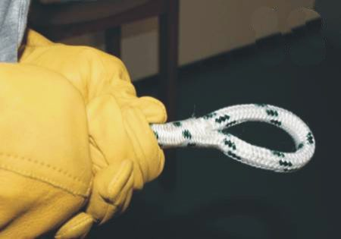
(19)This last step was always bitchy. The core can bunch up right at the end and rather than fight it, a little screw driver can be used to poke under the cover in the loop and pry it up using the bunched up core as a fulcrum. Do this gently, all around and then milk again. | 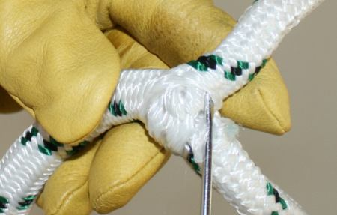
(20) Then check the fit and do a little more with the tool if required but if it is a little lumpy and still resisting you... | 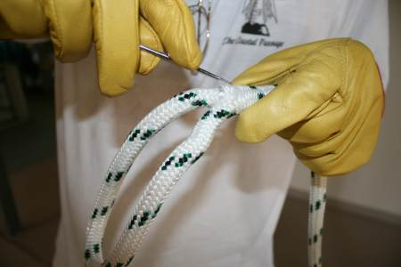
(21) A hammer (gently) on a concrete floor does a great job of getting rid of the lumps and high spots. It compacts the core. Then one last milk..  Please scroll down the page for a tip from Gary Bell of Portland Oregon that you may prefer to the hammer method shown here. Also some other general tips. Thanks for contributing Gary! Good on you.. | 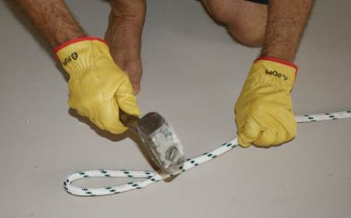
(22)Very satisfying! Now untie the knot you put in step 1 and give the loop a hard strain (the harder the better!) to test and set. Now go have a beer.. you earned it! | 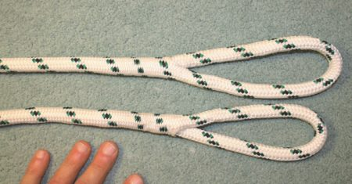

Instead of hammering on your splice, with the attendant risk of damaging
some of the fibers and ending with an uneven distribution of materials
inside the doubled section, lay the nearly finished splice on a clean
floor and using your shoe sole roll the entire doubled portion back and
forth repeatedly. This gentler pressure and repeated rolling 'works'
the uneven portions into place, whereas the hammer approach crushes the
lumps without redistributing them laterally inside the outer sheath.
This technique works fine for layed line splices as well as braid.
Another trick to make feeding ends easier and the finished splice
smoother is to cut core ends on as long a taper as you can. Wrap the
section to be cut first with masking tape, use a razor blade to make as
long a tapered cut as possible and immediately retape the resulting
tapered tip (or try the paraffin wax trick below).
Instead of taping the core end to the outside of the original core it
can be untaped and carefully worked into the interior and held in place
with a couple of Sews Awl stitches across the point where it last
entered the original core in place of the PVC tape that would end up
buried at the bitter end of your splice. That, by the way is where your
test splice broke, when the seizing/whipping tape that remained inside
the sheath was not compressing as the line stretched, but instead the
edge of that blunt end chafed the outer sheath fibers, initiating the
failure.
The spliced eye should always be made large enough that the "Y" part
(the throat) is not splayed apart much when under strain. I often seize
that area with waxed Sews Awl twine, secured at each of the three ends
with several decorative back stitches.
I have a big splicing project at hand making all new fancy custom
mooring lines for my big boat, and I intend to experiment with using
melted canning paraffin wax in place of tape to make the temporary
whippings. The melted wax can soak into the interior of the braid (or
layed) line and bind all the fibers in place when it solidifies. The
resultant wax/fiber is soft enough to be cut with a razor blade or sharp
knife, can be molded to tapered/pointed shapes by hand and is slippery
enough when cold (and wet) to pass easily through outer braid, for
instance. When the splice is finished the wax can be removed from the
interior with hot water, and any remaining will soften when the splice
heats under load, lubricating the interior, preventing 'internal
chafing.' Of course I don't expect anybody to play with a pot of melted
wax in their sailboat cockpit, but at my workbench it should work just
fine.

