5 of the Best Raspberry Pi Alternatives in 2019

By [Kenneth Kimari](https://www.maketecheasier.com/author/kennkimari/) – Posted on Jan 30, 2019 in [Hardware Guides](https://www.maketecheasier.com/category/pc-hardware/)

<https://www.maketecheasier.com/raspberry-pi-alternatives/>

<https://www.atoc2tech.fr/blog/meilleures-alternatives-raspberry-pi/>

<https://community.gladysassistant.com/t/rock64-au-lieu-dun-rpi-3-et-autres-questions/2908>

<http://syldom.fr/rock64-installation-xfce-a-partir-de-debian-strech-mini/>

<https://www.minimachines.net/actu/rk3399-59540>

When it comes to single board computers, Raspberry Pi is the undisputed champion. The $35 microcomputer has amassed enthusiasts around the globe, thanks to its ability to perform PC-based functions at a fraction of the price of commercial equipment. Sure, it’s not the most powerful or the cheapest microcomputer out there, but its explosive success has attracted a multitude of imitators.

While the Raspberry Pi ticks all the boxes with respect to performance, price, and usability, it leaves plenty of room for other boards to tweak that formula. Of late, the market has seen a release of a swathe of new boards with PC-like features.  Before we discuss the Raspberry Pi alternatives, let’s take a look at the top specs of the Raspberry Pi 3 model B to give you a picture of how it compares with the competition.

The Raspberry Pi 3 Model B comes with a 64-bit (quad-core) ARM Cortex A53 processor, clocked @ 1.2 GHz, 1GB of RAM and a 400Hz Dual Core VideoCore IV GPU. As far as connectivity is concerned, the RPi 3 features built-in support for Bluetooth and Wi-Fi.  Other top specs include 4 USB 2.0 ports and MicroSD support. Now that you’re familiar with the Raspberry Pi 3, these are the top five Raspberry Pi alternatives you’ll find on the market today.

# 1. Asus Tinker Board

The [Asus Tinker Board](https://www.amazon.com/Tinker-board-RK3288-1-8GHz-Mali-T764/dp/B06VSBVQWS?tag=maketecheas08-20) carries most of the Raspberry Pi DNA in the form factor right down to the placement of its ports. Coming from Asus – one of the largest computer manufacturers on the planet – you can expect its features to be top-notch. The Tinker Board has the same layout, size, feature set, and 40-pin connector as the Raspberry Pi 3 model B.

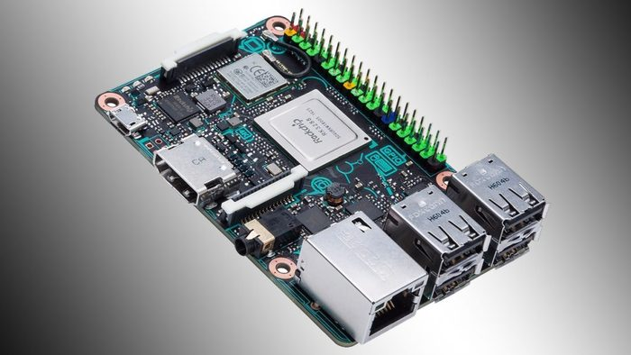

That means the Tinker Board can function as a replacement for any computer you have around. Features-wise, the Tinker Board has the edge over the Raspberry Pi, thanks to its more powerful processor and huge RAM. It comes with a high-performance quad-core ARM SoC clocked at 1.8GHz, which is way faster than the one on the RPi. Add this to the all-powerful Mali T764 GPU and the 2GB RAM, and what you get is a microcomputer that strikes a perfect balance between speed and performance.

What’s more, the Tinker Board comes with 4K video support, while the Raspberry Pi 3 model B only supports 1080p videos. Audio-wise, the Tinker Board offers support for 192k/24bit audio playback while the RPi supports up to 48k/16bit. The Asus Tinker Board is almost $30 more expensive than the RPi ($57.45), but with the price, you get more features and better speed.

# 2. ODroid XU4

The latest iteration of the ODroid, the XU4, packs a serious punch thanks to a fan-cooled Samsung 8-core CPU. Unlike Rasberry Pi, the [ODroid XU4](https://www.amazon.com/ODROID-XU4-Single-Board-Computer-Gigabit/dp/B0163GEA64?tag=maketecheas08-20) ($89) adopts a smaller form factor which is more compact. Designed from the ground up with open-source builds of Android in mind, the XU4 can run various flavors of Android, including Android 4.4 (KitKat), 5.0 (Lollipop), and 7.1 (Nougat).

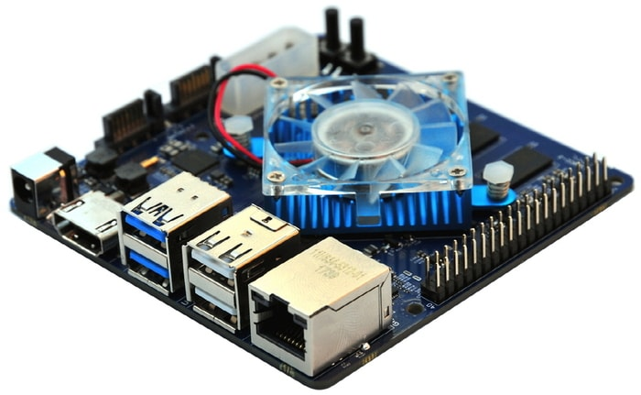

The ODroid XU4 can also run various flavors of Linux including Ubuntu 16.04. Specs-wise, the XU4 boasts of Samsung Exynos 5422 (Cortex-A15 at 2.0GHz and Cortex-A7 Octa-core) CPU. Coupled with a Mali T-628 GPU and 2GB RAM, the ODroid XU4 is also more powerful and faster than the Raspberry Pi. What’s more, the XU4 comes with USB 3.0 support and a Gigabit Ethernet interface that gives it lightning fast data transfer speeds.

**Related**: [How to Run Ubuntu 18.04 or 18.10 on Raspberry Pi](https://www.maketecheasier.com/run-ubuntu-raspberry-pi/)

# 3. Banana Pi-M64

The [Banana Pi M64](https://www.aliexpress.com/store/product/64-bit-Quad-core-mini-single-board-computer-BPI-M64-Banana-Pi-Board/302756_32766257704.html) ($52) is an improved, 64-bit version of the Banana Pi that runs on Android, Ubuntu, and Debian, among several other operating systems. It sports a dual-core Mali 400 GPU, a 1.2GHz octa-core processor, and a 2GB RAM. Additionally, it offers a whopping 8GB of onboard storage which is expandable via microSD.

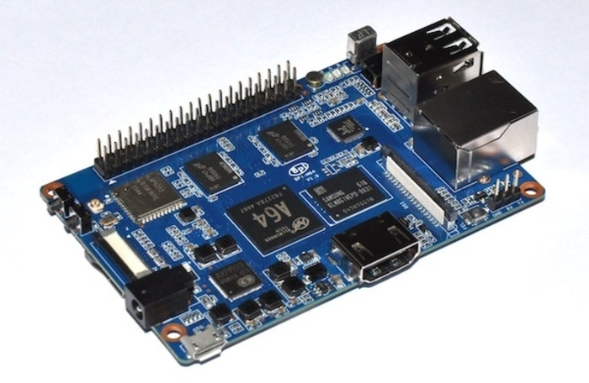

Just like Raspberry Pi, the M64 has built-in Wi-Fi and Bluetooth support. It also offers support for video playback, up to 1080p. However, the M64 edges out the RPi when it comes to storage due to the extra 1GB of RAM and the 8GB of storage which the RPi doesn’t offer. On the downside, the M64 comes with only two USB ports compared to the Raspberry Pi 3’s four USB ports.

# 4. NanoPi NEO4

The [NanoPi NEO4](https://www.friendlyarm.com/index.php?route=product/product&product_id=241) ($45) is one of the cheapest six-core single board computers on the market today. Boasting of Rockchip RK3399 (64-bit dual-core Cortex A72 + Quad-core Cortex A53) processor and Mali-T864 GPU, the NanoPi NEO4 is also one of the most powerful microcomputers available. It also comes with modern features such as USB 3.0 support and support for 4K video playback via HDMI 2.0.

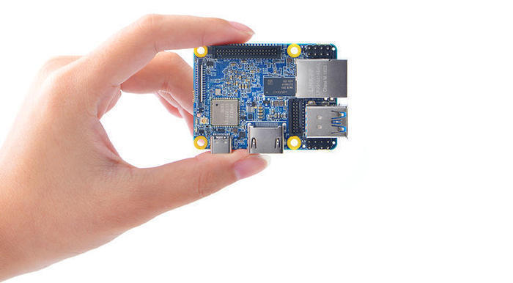

While the NEO4 outshines Raspberry Pi 3 in many ways, such as in 4K video playback and super processing power, there are a few areas that are not so attractive about it. For example, it has fewer type-A USB ports and slow Wi-Fi. The 1 GB RAM is also not competitive.

But if you’re willing to work with the aforementioned limitations, you’ll get to enjoy the board’s blazing fast data transfer speeds thanks to its USB 3.0 support and Gigabit Ethernet ports. There is also a USB 2.0 Type-C port as well as fast SSD storage.

# 5. Rock64

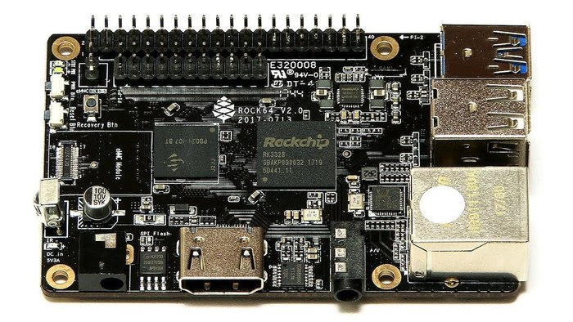

The [Rock64](https://www.amazon.com/dp/B076N9PC7Y/?tag=maketecheas08-20) single-board microcomputer ($35) is a solid Raspberry Pi alternative. It boasts of modern, high-end features that put it ahead of the competition. Unlike the RPi that offers only 1GB of RAM, the Rock64 has a 4GB variant that utilizes the ARM Cortex A53 64-bit processor. In addition to the powerful processor, the Rock64 is capable of handling 4K video at 60fps. It also comes with a 40-pin GPIO header which is ideal for performing DIY projects.

# Wrapping Up

While these are the top 5 Raspberry Pi alternatives you’ll find on the market today, the list is by no means exhaustive. Other Raspberry Pi alternatives worth trying include Latte Panda, Arduino, C.H.I.P, BeagleBoard X15, and Orange Pi, just to mention a few.

Have you tried any of these Raspberry Pi alternatives? If so, what are your experiences? Share with us in the comments section below.