The Arduino Starter Kit
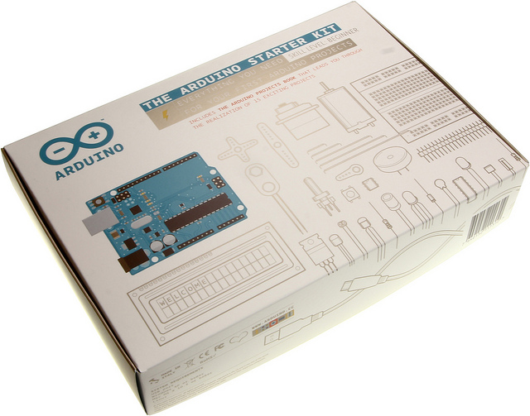
This kit walks you through the basics of using the Arduino in a hands-on way. You'll learn through building several creative projects. The kit includes a selection of the most common and useful electronic components with a book of 15 projects. Starting the basics of electronics, to more complex projects, the kit will help you control the physical world with sensor and actuators.
The projects in the kit are:
01 GET TO KNOW YOUR TOOLS an introduction to the concepts you'll need to use this kit
02 SPACESHIP INTERFACE design to control panel for your startship
03 LOVE-O-METER measure how hot-blooded you are
04 COLOR MIXING LAMP produce any color with a lamp that uses light as an input
05 MOOD CUE clue people in to how you're doing
06 LIGHT THEREMIN create a musical instrument you play by waving your hands
07 KEYBOARD INSTRUMENT play music and make some noise with this keyboard
08 DIGITAL HOURGLASS a light-up hourglass that can stop you from working too much
09 MOTORIZED PINWHEEL a color wheel that will have your head spinning
10 ZOETROPE create a mechanical animation you can play forward or reverse
11 CRYSTAL BALL a mystical tour to answer all your tough question
12 KNOCK LOCK tap out the secret code to open the door
13 TOUCHY-FEEL LAMP a lamp that responds to your touch
14 TWEAK THE ARDUINO LOGO control your personal computer from your Arduino
15 HACKING BUTTONS create a master control for all your devices!
Once you’ve mastered this knowledge, you’ll have a palette of software and circuits that you can use to create something beautiful, and make someone smile with what you invent.
Then build it, hack it and share it. Because Arduino is you!
What in the kit is listed below. Click on the name of the component to download the datasheet of the part. This document will describe the design and functionality of the component.
1 | Arduino Projects Book (170 pages)
1 | Arduino UNO board rev.3
1 | USB cable
1 | Breadboard
1 | Easy-to-assemble wooden base
1 | 9v battery snap
70 | Solid core jumper wires
2 | Stranded jumper wires
6 | Photoresistor [VT90N2 LDR]
3 | Potentiometer 10kilohm
10 | Pushbuttons
1 | Temperature sensor [TMP36]
1 | Tilt sensor
1 | alphanumeric LCD (16x2 characters)
1 | LED (bright white)
1 | LED (RGB)
8 | LEDs (red)
8 | LEDs (green)
8 | LEDs (yellow)
3 | LEDs (blue)
1 | Small DC motor 6/9V
1 | Small servo motor
1 | Piezo capsule [PKM17EPP-4001-B0]
1 | H-bridge motor driver [L293D]
2 | Optocouplers [4N35]
5 | Transistor [BC547]
2 | Mosfet transistors [IRF520]
5 | Capacitors 100nF
3 | Capacitors 100uF
5 | Capacitor 100pF
5 | Diodes [1N4007]
3 | Transparent gels (red, green, blue)
1 | Male pins strip (40x1)
20 | Resistors 220 ohm
5 | Resistors 560 ohm
5 | Resistors 1 kilohm
5 | Resistors 4.7 kilohm
20 | Resistors 10 kilohm
5 | Resistors 1 megohm
5 | Resistors 10 megohm

