How to measure current using Arduino and ACS712 Current Sensor

11 septembre 2019 par Egprojects https://www.engineersgarage.com/arduino/acs712-current-sensor-with-arduino/

In this tutorial, I am going to measure DC current using Acs712 Hall Effect-Based Linear Current Sensor and arduino uno. Acs712 can measure current precisely and accurately if properly managed. I have gone through various blogs on internet about interfacing acs712 current sensor with arduino and other microcontrollers. I found that all of them are measuring current with formulas(derived for acs712 current sensor) which are not precise. So i decided to write a tutorial on acs712 current sensor and put forward a practical example with circuit and code. In this tutorial i will define the best method and precise formula generation for measuring dc current with acs712 current sensor. I will define each and every step of code and circuit thoroughly and deeply with logic. Project code is open source and you can download and modify it according to your needs.
Acs712 current sensor can measure both direct and alternating current. For this post/tutorial/project I am going to measure only dc current. Formula which i derived and explained in the tutorial is only for direct current measurement. You can not use the below formula to measure alternating current with acs712 hall effect current sensor.

About Acs712
ACS712 is a Hall Effect-Based Linear Current Sensor it can measure both DC(Direct Current) and AC(Alternating Current). The sensor chip is made by Allegro www.allegromicro.com. Pin out and Pin description of the chip is below.
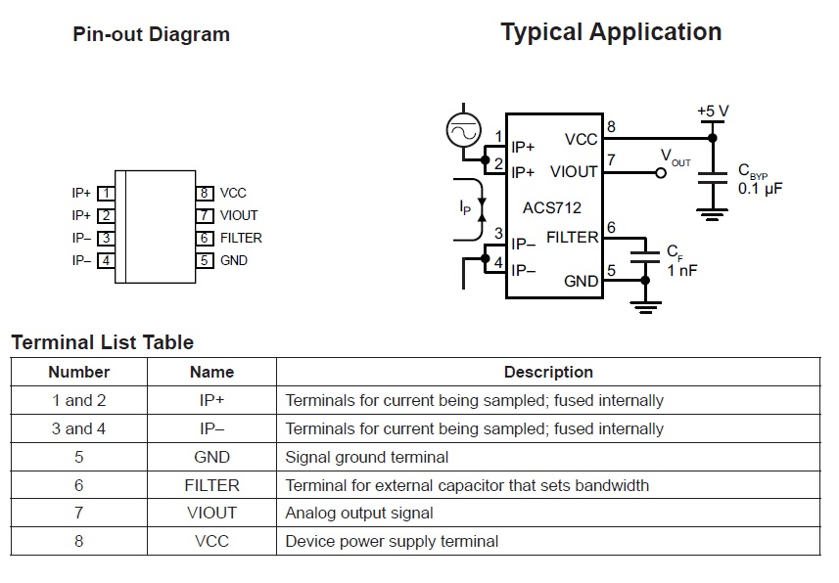
IP+ & IP-
Connect the sensor in series to the system whose current you want to measure. Cut the circuit wire and connect one end of wire to IP+ and other to IP-. Recall the high school lectures, current can be measured only in series. So don’t connect the sensor in parallel You may damage it by connecting it in parallel.
VIout
Viout is the voltage out pin. ACS712 outputs an analog signal in correspond to any variation across the IP+ and IP- pins or in other words it outputs analog voltage on VIOUT pin if their is any variation in the current.
Quiescent output voltage (VIOUT(Q)). The output of the device when the primary current is zero. For a uni-polar supply voltage,it nominally remains at VCC ⁄ 2. Thus, VCC = 5 V translates into VIOUT(Q) = 2.5 V. Variation in VIOUT(Q) can be attributed to the resolution of the Acs712. If the Acs712 is working on 5v(Vcc=5v) and their is no current flowing from input the Viout will be 2.5v. 2.5v is the base voltage at input of 5v, now any change in the input current will bring change in the output voltage. Viout decreases when current start flowing through the acs712 pins.
Acs712 is available in market in three ratings.
- ACS712ELCTR-05B-T
- ACS712ELCTR-20A-T
- ACS712ELCTR-30A-T
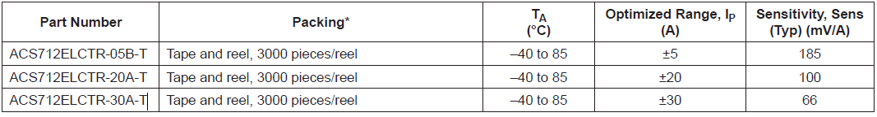
- ACS712ELCTR-05B-T can measure 5 to -5 Ampere current. Where 185mV change in Output voltage from initial state represents 1-Ampere change in Input current.
- ACS712ELCTR-20A-T can measure 20 to -20 Ampere current. Where 100mV change in Output voltage from initial state represents 1-Ampere change in Input current.
- ACS712ELCTR-30A-T can measure 30 to -30 Ampere current. Where 66mV change in Output voltage from initial state represents 1-Ampere change in Input current.
​

Acs712 Dc current measurement formula
Current = (AcsOffset – (Arduino measured analog reading)) / Sensitivity
- AcsOffset is normal voltage output at Viout pin when no current is flowing through the circuit.
- Arduino measured analog reading is the analog signal value read and converted to actual voltage from the analog channel to which acs712 output is connected.
- Sensitivity is Acs712 change in current representing 1 Ampere. For all the acs712 versions it is given in the above picture.

Arduino acs712 current sensor
Reassembled acs712 current sensor boards are available in market. They are easy to install in circuit and connections are pretty straight forward. They have three pins. Two are power pins vcc and gnd. The third one is output pin. A 2 pole connector is also present to insert the wire of device whose current is needed to be measured. A typical arduino acs712 current circuit board looks like the one given below.
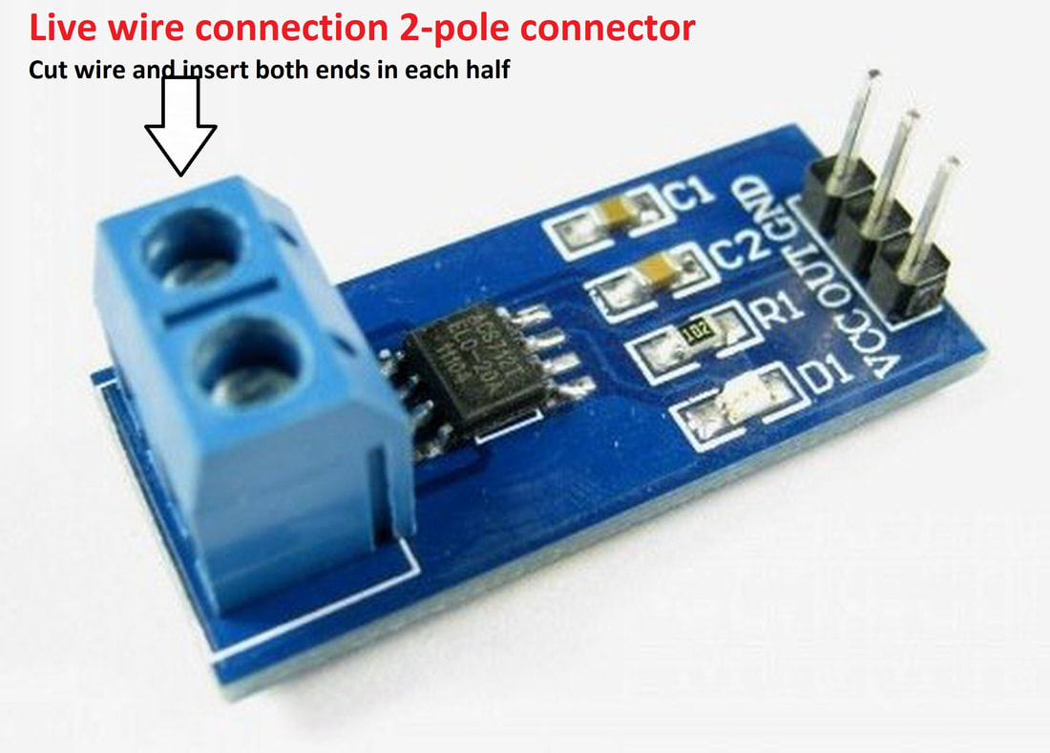
Now i am going to interface the arduino acs712 current sensor with arduino uno. I will interface all the different current rated boards one by one with arduino uno.

ACS712ELCTR-05B-T Interfacing with Arduino Uno

void setup() {
Serial.begin(9600); //Start Serial Monitor to display current read value on Serial monitor
}
void loop() {
unsigned int x=0;
float AcsValue=0.0,Samples=0.0,AvgAcs=0.0,AcsValueF=0.0;
for (int x = 0; x < 150; x++){ //Get 150 samples
AcsValue = analogRead(A0); //Read current sensor values
Samples = Samples + AcsValue; //Add samples together
delay (3); // let ADC settle before next sample 3ms
}
AvgAcs=Samples/150.0;//Taking Average of Samples
//((AvgAcs * (5.0 / 1024.0)) is converitng the read voltage in 0-5 volts
//2.5 is offset(I assumed that arduino is working on 5v so the viout at no current comes
//out to be 2.5 which is out offset. If your arduino is working on different voltage than
//you must change the offset according to the input voltage)
//0.185v(185mV) is rise in output voltage when 1A current flows at input
AcsValueF = (2.5 - (AvgAcs * (5.0 / 1024.0)) )/0.185;
Serial.print(AcsValueF);//Print the read current on Serial monitor
delay(50);

}
view raw acs712-current-sensor-with-arduino.ino hosted with ❤ by GitHub
Check out the test that i performed with Acs712-05B -5 to +5 Amperes and arduino uno. Measured current is displayed on the 16×2 lcd. It measures current precisely. Test code and results are summarized in an another post link is below.
Measuring Dc current with arduino using acs712 current sensor and 16×2 lcd

ACS712ELCTR-20A-T Interfacing with Arduino Uno

Project Code

Download the project code from the links given at the bottom of the Post.

void setup() {
Serial.begin(9600); //Start Serial Monitor to display current read value on Serial monitor
}
void loop() {
unsigned int x=0;
float AcsValue=0.0,Samples=0.0,AvgAcs=0.0,AcsValueF=0.0;
for (int x = 0; x < 150; x++){ //Get 150 samples
AcsValue = analogRead(A0); //Read current sensor values
Samples = Samples + AcsValue; //Add samples together
delay (3); // let ADC settle before next sample 3ms
}
AvgAcs=Samples/150.0;//Taking Average of Samples
//((AvgAcs * (5.0 / 1024.0)) is converitng the read voltage in 0-5 volts
//2.5 is offset(I assumed that arduino is working on 5v so the viout at no current comes
//out to be 2.5 which is out offset. If your arduino is working on different voltage than
//you must change the offset according to the input voltage)
//0.100v(100mV) is rise in output voltage when 1A current flows at input
AcsValueF = (2.5 - (AvgAcs * (5.0 / 1024.0)) )/0.100;
Serial.print(AcsValueF);//Print the read current on Serial monitor
delay(50);

}
view raw acs712-current-sensor-with-arduino.ino hosted with ❤ by GitHub

ACS712ELCTR-30A-T Interfacing with Arduino Uno

void setup() {
Serial.begin(9600); //Start Serial Monitor to display current read value on Serial monitor
}
void loop() {
unsigned int x=0;
float AcsValue=0.0,Samples=0.0,AvgAcs=0.0,AcsValueF=0.0;
for (int x = 0; x < 150; x++){ //Get 150 samples
AcsValue = analogRead(A0); //Read current sensor values
Samples = Samples + AcsValue; //Add samples together
delay (3); // let ADC settle before next sample 3ms
}
AvgAcs=Samples/150.0;//Taking Average of Samples
//((AvgAcs * (5.0 / 1024.0)) is converitng the read voltage in 0-5 volts
//2.5 is offset(I assumed that arduino is working on 5v so the viout at no current comes
//out to be 2.5 which is out offset. If your arduino is working on different voltage than
//you must change the offset according to the input voltage)
//0.066v(66mV) is rise in output voltage when 1A current flows at input
AcsValueF = (2.5 - (AvgAcs * (5.0 / 1024.0)) )/0.066;
Serial.print(AcsValueF);//Print the read current on Serial monitor
delay(50);

}
view raw acs712-current-sensor-with-arduino.ino hosted with ❤ by GitHub

Arduino direct current measurement – Project circuit diagram
Arduino uno interfacing with acs712 current sensor circuit diagram is given below. The circuit is universal and all the above three codes for different versions of acs712 current sensor can work with the same circuit given below. You just need to insert your acs712 current sensor in circuit and download its corresponding code(given in the post) in arduino uno, rest of the connections are same for all the different acs712 rated current sensors.
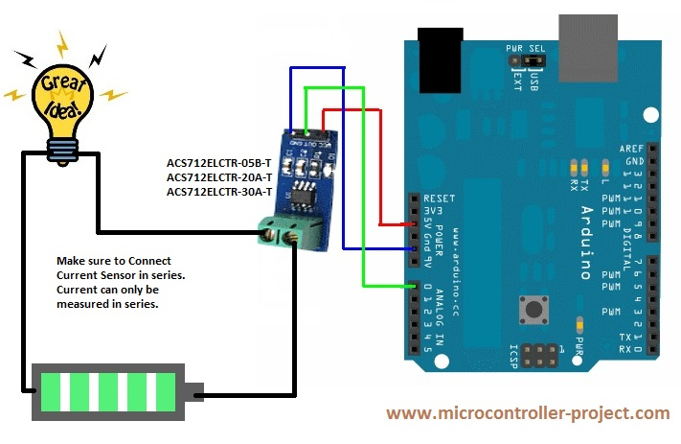
Acs712 with Arduino Uno -Circuit Diagram
After making circuit and downloading the code in arduino uno. Open the arduino serial monitor from arduino ide. As soon as you open the arduino serial monitor you will see the measured current value displaying in the arduino ide serial monitor window. If you did’t see any thing in arduino serial monitor check for all the connections. Go through all the possible physical connections. If you see broken alphabets in arduino serial monitor window then set the baud rate of arduino serial monitor window to 9600 bps in order to see the proper data characters and numbers.

