Comment faire une mesure de courant continu avec un Arduino ?
How to measure DC Current with Arduino ?

17 décembre 2019 https://solarduino.com/how-to-measure-dc-current-with-arduino/

Arduino has the ability to measure current using analog input pin. For Arduino UNO, there are 6 analog input pins (A0-A5) where you can use one of the pins to measure DC current. Arduino NANO has 8 pins while Arduino MEGA has 16 input pins. The analog input pins will map input voltages between 0 and 5V into integer values between 0 and 1023 with resolution of 4.9mV per unit (5.00V / 1024 units).
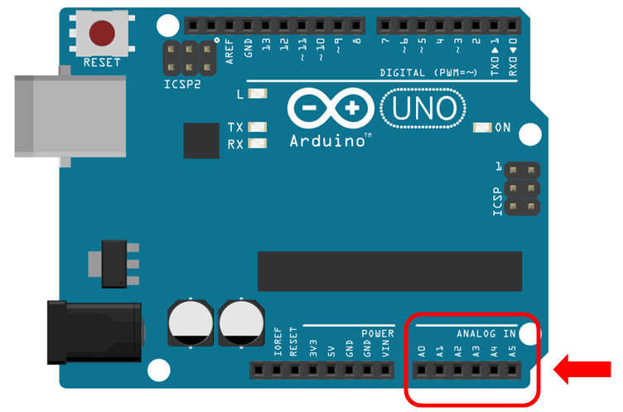
All sensors that connected to analog input must be measured by voltage value. In order to provide the current value, the sensor actually providing voltage value that related to measured current value.

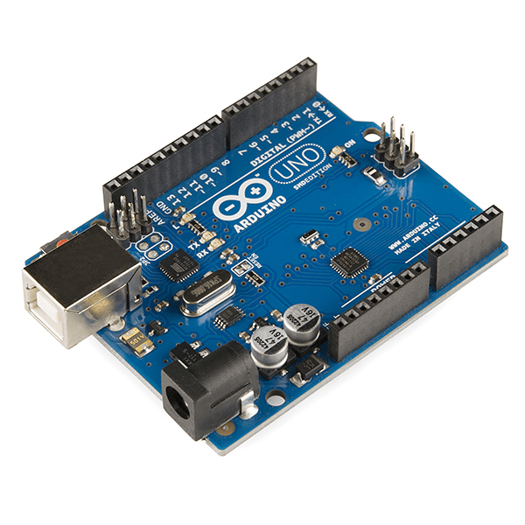
Arduino UNO (compatible board)
If you still not yet own an Arduino Micro-controller Board, you can get it cheap at our affiliate link here !!!
The current sensor that is widely used for Arduino is the ACS712 Current Sensor Module. It utilizing hall-effect phenomenon which voltage is produced from the movement of current within the region of magnetic field. The voltage produced by hall effect is directly proportional to the applied current making it suitable to estimate the applied current from the voltage sensed.
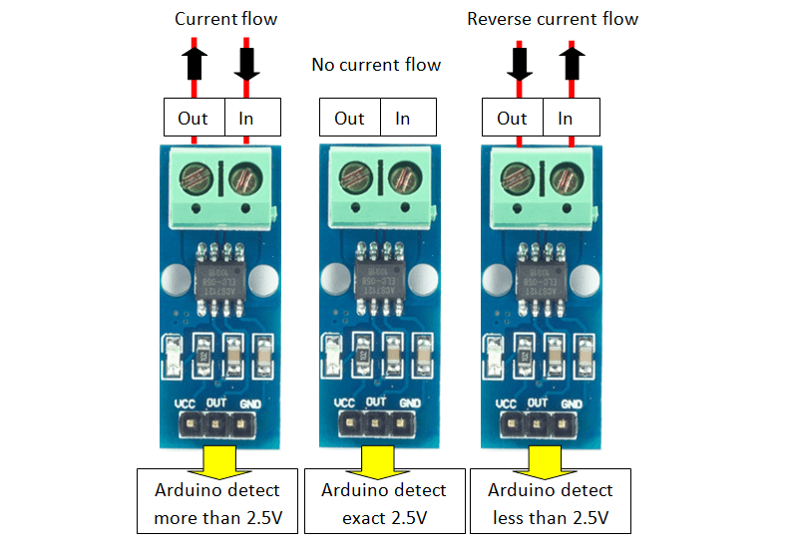
The sensor can measure current in 2 direction. Reverse current will not damage the sensor but the voltage produced will be in reduced. As we know, Arduino analog input only read positive integer values. In order to measure 2 direction, the zero point should be at half the total voltage range (0 to 5V) which is 2.5V. This is true if the supply voltage to the sensor is 5V.
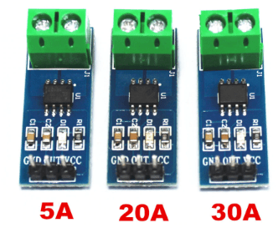
The standard ACS712 Current Sensor Module rated at 5A, 20A and 30A which are suitable to most applications. You may get them by our affiliate link here !!! The 5A module has the resolution of 185mV/ampere, 20A module has 100mV/ampere while 30A module has the resolution of 66mV/ampere.
Assume using 5V supply as standard, the 5A module will provide voltage at 2.5V +/- 0.925V, 20A module will provide voltage at 2.5V +/- 2.0V while 30A module will provide voltage at 2.5V +/- 2.0V. These modules require direct contact which I think is a major drawback. It has to be connected in series to the measured value. The wiring of the existing system need to be altered in order to fit the module into the existing system.
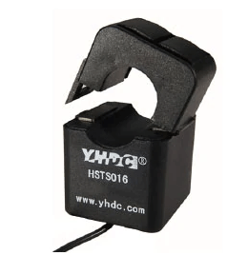
Fortunately, there is also a hall-effect sensor type with split core transformer type (as picture on left). It is the Hall-Effect Split-Core Sensor HSTS016L module. The model ranges from 10A up to 200A. With split core current sensor type, not alteration on the existing system required. You can get it via our affiliate link here !!! The output voltage of this sensor is 2.5V +/- 0.625V with decent accuracy.
Current sensor is a sensitive sensor. The output reading of the sensor produces electrical noises or fake current values even when there is no current detected. It is more obvious if the measurement is in a smaller time frame. In order to greatly reduce this phenomenon, multiple samples must be taken for averaging and initial offset must be done.
Our code is designed to display a value which is derived from averaging 1000 samples in every second. Each sample is recorded every 1 milli second (0.001 second). The single averaged value is then to be displayed at Serial Monitor and LCD Display. With this, the fluctuation of value is way lesser compare to taking 1 sample reading every second.
The second problem could be the false signal and accuracy problem. Each sensor has its own deviation error. When there is no current sensed, the sensor might not be 100% at middle point of voltage value. Some might be remaining at few milli voltages above / below the middle point even though after averaging. This might be due to voltage supplied not in exact 5V or due to the sensor itself.
Unlike Voltage Sensor, Current Sensor requires initial offset setting. You may need to manually offset the value by checking the false current when no current draws during Arduino startup and then key in offset value in the code file. Secondly, make sure the sensor cables are tight because minor movement of wires might affects on the wire terminal connections thus affecting the accuracy reading.
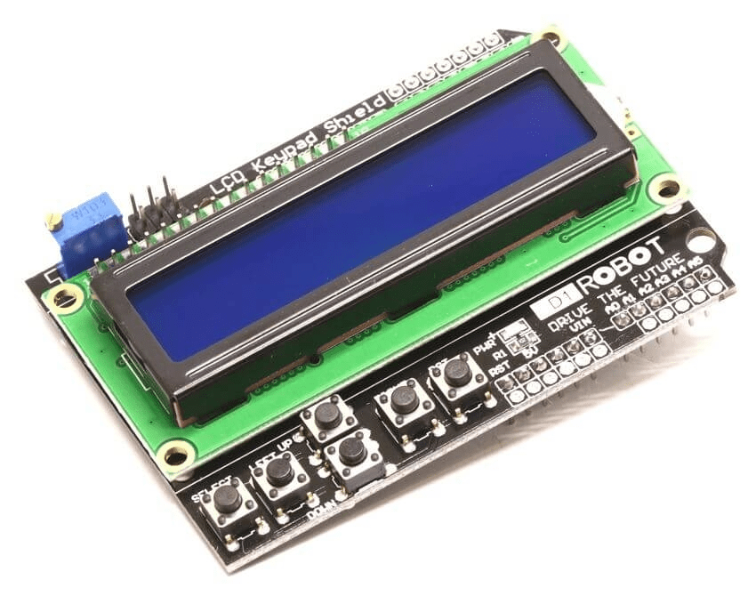
I recommend you to add a 16X2 LCD Display Shield which can be directly fit on to the top of the Arduino board without the need of extra wiring for the LCD Display. Without the LCD Display, you can only monitor the measured current value on PC via Serial Monitor. You can get the LCD Display board at our affiliate link here !!!.
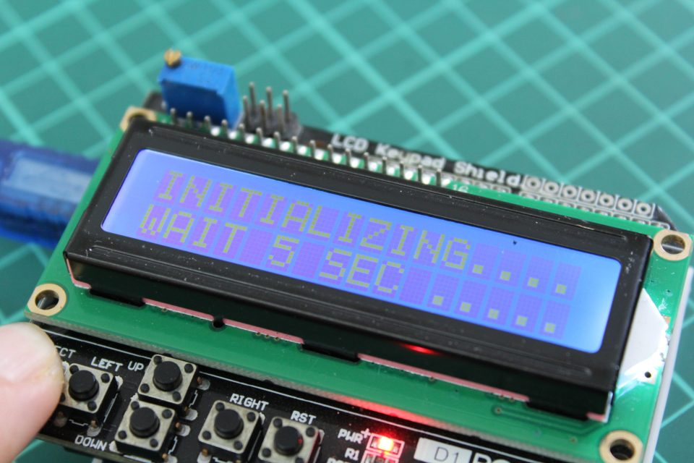
The good news is you do not need to manually calibrate the offset settings if you got the LCD Display Shield with you. Below we have attached the code that utilizes the button function that could automatically calibrate by itself when you pressed the SELECT Button. You may download from the end of this page below.
Hardware Connection – ACS712 Current Module
In order to connect wiring between Arduino board and ACS712 current module, you need the dupont line cables male to female. You can get it at our affiliate link here !!!
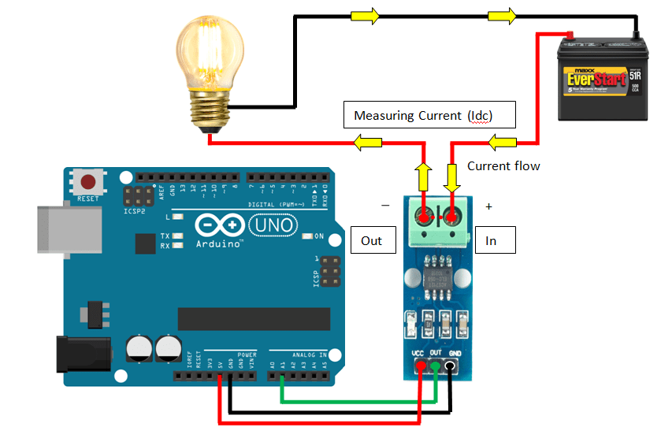

Hardware Connection – HSTS016L Split Core Current Module
You may need to find a way to fit the sensor cable into the Arduino pin. The sensor cable that I purchased came with pre-soldered at the tip, making it easy to go into the Arduino pins. Open the Split Core current module and there will show an arrow symbol which signify the way of current flow. Once everything read, make sure the split core is closed tightly.
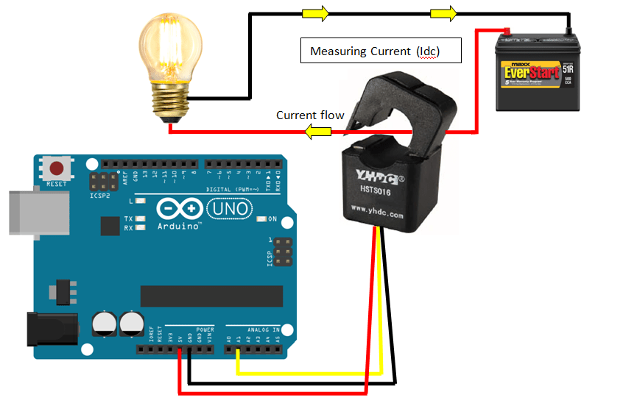

Software Codes
The final step would be adding source code onto Arduino board. I assume you have installed the Arduino Software. If you have not installed the software, the link here can bring you to the official download site. Once you have downloaded the software, you may download the code file (.ino) for this application below (right click save link).
There are two source code files attached, the first source code is normal DC current source code for people out there without the LCD Display. The measured current value can be shown in Serial Monitor using Arduino Software.
The second one is the DC current source code with LCD display shield function. Once the code is uploaded to the Arduino board, the current value will be shown on the LCD Display. We have added the auto calibrate function, once the SELECT button is pressed, the value returns to exact zero point. If first press is not satisfied, you may repeat by pressing it again.
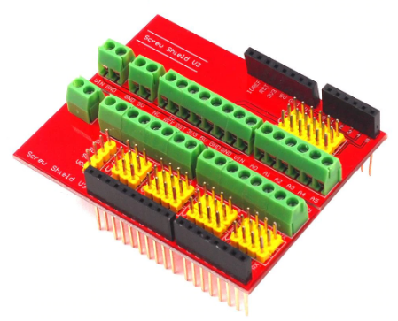
Screw Shield / Expansion Shield
When there are a lot of wiring around especially more than 1 sensor, sharing pins will be difficult as existing pins (ground and 5V) are limited. This shield provides a lot of convenient terminals for each of the input and output pins. The shield can be mounted directly on top of the Arduino Uno board or in between the shields which made it very convenient to use. You can get it at our affiliate link here !!!
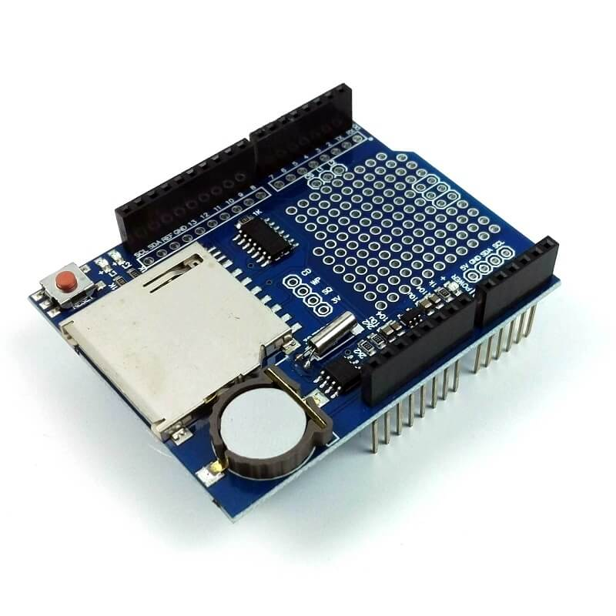
Datalogger Shield
If you plan to record the data in a proper way, you may consider this Datalogger Shield. It allows your arduino to record your data in SD Card. Datalogger shield is often installed together with LCD Display shield. Please find it at our affiliate link here !!! For more about this Datalogger Shield, kindly visit our post here.
Codes for DC Voltmeter with LCD Display Shield. Note: the codes shown here may not be 100% correct due to translation error. For accurate code, kindly download the .ino file.
// DC Current Sensor with LCD Display By Solarduino

// 0- General

int decimalPrecision = 2;

// 1- DC Current Measurement

int CurrentAnalogInputPin = A1;
float moduleMiddleVoltage = 2500;
float moduleSupplyVoltage = 5000;
float currentSampleRead = 0;
float currentLastSample = 0;
float currentSampleSum = 0;
float currentSampleCount = 0;
float currentMean ;
float finalCurrent ;
float finalCurrent2 ;

// 1.1- DC Current Measurement

int OffsetRead = 0;
float currentOffset =0.00 ;
float offsetLastSample = 0;
float offsetSampleCount = 0;

// 2 - LCD Display

#includeLiquidCrystal LCD(8,9,4,5,6,7);
unsigned long startMillisLCD;
unsigned long currentMillisLCD;
const unsigned long periodLCD = 1000;

void setup()

{

// 0- General

Serial.begin(9600);

// 2 - LCD Display

LCD.begin(16,2);
LCD.setCursor(0,0);
startMillisLCD = millis();

}

void loop()

{

// 0- General

// 0.1- Button Function

int buttonRead;
buttonRead = analogRead (0);

//Right button is pressed
if (buttonRead &lt; 60)
{ LCD.setCursor(0,0); LCD.print ("PRESS<select>"); }</select>

// Up button is pressed
else if (buttonRead &lt; 200)
{ LCD.setCursor(0,0); LCD.print ("PRESS<select>"); }</select>

// Down button is pressed
else if (buttonRead &lt; 400)
{ LCD.setCursor(0,0); LCD.print ("PRESS<select>"); }</select>

// Left button is pressed
else if (buttonRead &lt; 600)
{ LCD.setCursor(0,0); LCD.print ("PRESS<select>"); }</select>

// Select button is pressed
else if (buttonRead &lt; 800) { OffsetRead = 1; LCD.setCursor(0,0); LCD.print ("INITIALIZING..... "); LCD.setCursor(0,1); LCD.print ("WAIT 5 SEC ..... "); } // 1- DC Current Measurement if(millis() &gt;= currentLastSample + 1 )
currentSampleRead = analogRead(CurrentAnalogInputPin)-((moduleMiddleVoltage/moduleSupplyVoltage)*1024);
currentSampleSum = currentSampleSum + currentSampleRead ;
currentSampleCount = currentSampleCount + 1;
currentLastSample = millis();
}

if(currentSampleCount == 1000)
{
currentMean = currentSampleSum/currentSampleCount;
finalCurrent = (((currentMean /1024) *5000) /mVperAmpValue);
finalCurrent2 = finalCurrent + currentOffset;
Serial.print("The Current value is: ");
Serial.print(finalCurrent2,decimalPrecision);
Serial.println(" A ");
currentSampleSum =0;
currentSampleCount=0;
}

// 1.1 - Offset DC Current

if(OffsetRead == 1)
{
currentOffset = 0;
if(millis() &gt;= offsetLastSample + 1)
{
offsetSampleCount = offsetSampleCount + 1;
offsetLastSample = millis();
}

if(offsetSampleCount == 2500)
{
currentOffset = - finalCurrent;
OffsetRead = 0;
offsetSampleCount = 0;
}
}

// 2 - LCD Display

currentMillisLCD = millis();
if (currentMillisLCD - startMillisLCD &gt;= periodLCD)
{
LCD.setCursor(0,0);
LCD.print(finalCurrent2,decimalPrecision);
LCD.print("A ");
LCD.setCursor(0,1);
LCD.print(" ");
startMillisLCD = currentMillisLCD ;
}

}

