XlsxWriter

A Python module for creating Excel XLSX files.

# Pypi.python.org

XlsxWriter 0.9.6

<https://pypi.python.org/pypi/XlsxWriter>

*A Python module for creating Excel XLSX files.*

**XlsxWriter** is a Python module for writing files in the Excel 2007+ XLSX file format.

XlsxWriter can be used to write text, numbers, formulas and hyperlinks to multiple worksheets and it supports features such as formatting and many more, including:

* 100% compatible Excel XLSX files.
* Full formatting.
* Merged cells.
* Defined names.
* Charts.
* Autofilters.
* Data validation and drop down lists.
* Conditional formatting.
* Worksheet PNG/JPEG images.
* Rich multi-format strings.
* Cell comments.
* Integration with Pandas.
* Textboxes.
* Memory optimization mode for writing large files.

It supports Python 2.5, 2.6, 2.7, 3.1, 3.2, 3.3, 3.4, 3.5, Jython and PyPy and uses standard libraries only.

Here is a simple example:

import xlsxwriter

# Create an new Excel file and add a worksheet.

workbook = xlsxwriter.Workbook('demo.xlsx')

worksheet = workbook.add_worksheet()

# Widen the first column to make the text clearer.

worksheet.set_column('A:A', 20)

# Add a bold format to use to highlight cells.

bold = workbook.add_format({'bold': True})

# Write some simple text.

worksheet.write('A1', 'Hello')

# Text with formatting.

worksheet.write('A2', 'World', bold)

# Write some numbers, with row/column notation.

worksheet.write(2, 0, 123)

worksheet.write(3, 0, 123.456)

# Insert an image.

worksheet.insert_image('B5', 'logo.png')

workbook.close()

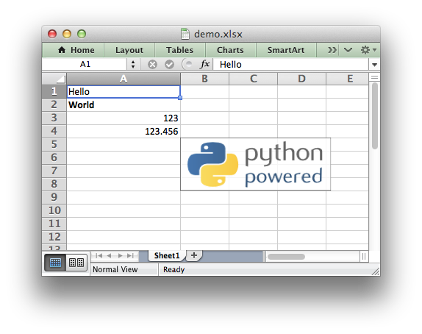

See the full documentation at: <https://xlsxwriter.readthedocs.io>

# Readthedocs.io

<https://xlsxwriter.readthedocs.io/>

**Creating Excel files with Python and XlsxWriter**

XlsxWriter is a Python module for creating Excel XLSX files.



([Sample code to create the above spreadsheet](https://xlsxwriter.readthedocs.io/example_demo.html" \l "ex-demo).)

###########################################################################

#

# A simple example of some of the features of the XlsxWriter Python module.

#

# Copyright 2013-2016, John McNamara, jmcnamara@cpan.org

#

import xlsxwriter

# Create an new Excel file and add a worksheet.

workbook = xlsxwriter.Workbook('demo.xlsx')

worksheet = workbook.add_worksheet()

# Widen the first column to make the text clearer.

worksheet.set_column('A:A', 20)

# Add a bold format to use to highlight cells.

bold = workbook.add_format({'bold': True})

# Write some simple text.

worksheet.write('A1', 'Hello')

# Text with formatting.

worksheet.write('A2', 'World', bold)

# Write some numbers, with row/column notation.

worksheet.write(2, 0, 123)

worksheet.write(3, 0, 123.456)

# Insert an image.

worksheet.insert_image('B5', 'logo.png')

workbook.close()

**XlsxWriter**

XlsxWriter is a Python module that can be used to write text, numbers, formulas and hyperlinks to multiple worksheets in an Excel 2007+ XLSX file. It supports features such as formatting and many more, including:

* 100% compatible Excel XLSX files.
* Full formatting.
* Merged cells.
* Defined names.
* Charts.
* Autofilters.
* Data validation and drop down lists.
* Conditional formatting.
* Worksheet PNG/JPEG images.
* Rich multi-format strings.
* Cell comments.
* Textboxes.
* Integration with Pandas.
* Memory optimization mode for writing large files.

It supports Python 2.5, 2.6, 2.7, 3.1, 3.2, 3.3, 3.4, 3.5, Jython and PyPy and uses standard libraries only.

This document explains how to use the XlsxWriter module. See the following sections for more information, or jump straight to the [Introduction](https://xlsxwriter.readthedocs.io/introduction.html#intro).

* [Contents](https://xlsxwriter.readthedocs.io/contents.html)
* [Introduction](https://xlsxwriter.readthedocs.io/introduction.html)
* [Getting Started with XlsxWriter](https://xlsxwriter.readthedocs.io/getting_started.html)
* [Tutorial 1: Create a simple XLSX file](https://xlsxwriter.readthedocs.io/tutorial01.html)
* [Tutorial 2: Adding formatting to the XLSX File](https://xlsxwriter.readthedocs.io/tutorial02.html)
* [Tutorial 3: Writing different types of data to the XLSX File](https://xlsxwriter.readthedocs.io/tutorial03.html)
* [The Workbook Class](https://xlsxwriter.readthedocs.io/workbook.html)
* [The Worksheet Class](https://xlsxwriter.readthedocs.io/worksheet.html)
* [The Worksheet Class (Page Setup)](https://xlsxwriter.readthedocs.io/page_setup.html)
* [The Format Class](https://xlsxwriter.readthedocs.io/format.html)
* [The Chart Class](https://xlsxwriter.readthedocs.io/chart.html)
* [The Chartsheet Class](https://xlsxwriter.readthedocs.io/chartsheet.html)
* [Working with Cell Notation](https://xlsxwriter.readthedocs.io/working_with_cell_notation.html)
* [Working with Formulas](https://xlsxwriter.readthedocs.io/working_with_formulas.html)
* [Working with Dates and Time](https://xlsxwriter.readthedocs.io/working_with_dates_and_time.html)
* [Working with Colors](https://xlsxwriter.readthedocs.io/working_with_colors.html)
* [Working with Charts](https://xlsxwriter.readthedocs.io/working_with_charts.html)
* [Working with Autofilters](https://xlsxwriter.readthedocs.io/working_with_autofilters.html)
* [Working with Data Validation](https://xlsxwriter.readthedocs.io/working_with_data_validation.html)
* [Working with Conditional Formatting](https://xlsxwriter.readthedocs.io/working_with_conditional_formats.html)
* [Working with Worksheet Tables](https://xlsxwriter.readthedocs.io/working_with_tables.html)
* [Working with Textboxes](https://xlsxwriter.readthedocs.io/working_with_textboxes.html)
* [Working with Sparklines](https://xlsxwriter.readthedocs.io/working_with_sparklines.html)
* [Working with Cell Comments](https://xlsxwriter.readthedocs.io/working_with_cell_comments.html)
* [Working with Outlines and Grouping](https://xlsxwriter.readthedocs.io/working_with_outlines.html)
* [Working with Memory and Performance](https://xlsxwriter.readthedocs.io/working_with_memory.html)
* [Working with VBA Macros](https://xlsxwriter.readthedocs.io/working_with_macros.html)
* [Working with Python Pandas and XlsxWriter](https://xlsxwriter.readthedocs.io/working_with_pandas.html)
* [Examples](https://xlsxwriter.readthedocs.io/examples.html)
* [Chart Examples](https://xlsxwriter.readthedocs.io/chart_examples.html)
* [Pandas with XlsxWriter Examples](https://xlsxwriter.readthedocs.io/pandas_examples.html)
* [Alternative modules for handling Excel files](https://xlsxwriter.readthedocs.io/alternatives.html)
* [Known Issues and Bugs](https://xlsxwriter.readthedocs.io/bugs.html)
* [Reporting Bugs](https://xlsxwriter.readthedocs.io/bugs.html#reporting-bugs)
* [Frequently Asked Questions](https://xlsxwriter.readthedocs.io/faq.html)
* [Changes in XlsxWriter](https://xlsxwriter.readthedocs.io/changes.html)