Robinson Analytics

Using Python to Harness Windows


Tutorial Notes

O’Reilly Python Conference, Monterey, 21-24 August 1999

Andy Robinson, Robinson Analytics Ltd.

These notes closely follow the slides for the tutorial and include all code samples.

Table of Contents

Table of Contents 2
1 Background 4
2 What is Python good for on Windows? 5
3 How Python works on Windows 6
4 The Pythonwin IDE 9
5 Introduction to Python and COM 16
6 Adding a Macro Language 31
7 Client Side COM and Excel 39
8 Automating Word 45
9 Distributing our Application with DCOM 52
10 Database Access 54
11 Communications 61
12 System Administration 63
13 Active Scripting 64
14 GUI Development 66
15 Delphi 68
16 C and C++ Level Integration 69

Part 1: - Fundamentals

Background

What we will cover
- How Python works on Windows
- What’s in Pythonwin
- Building applications with Python and COM
- Getting started on common tasks
- Automating Office applications
- Connecting to databases
- Communications
- GUI libraries

What we won’t cover
- Low-level Windows internals
- Hardcore COM - how it works
- NT Services
- NT processes, events and threading models

What is Python good for on Windows?

An integration tool
- Works with files
- Works with DLLs and C programs
- Works with COM
- Works with Networks
- Works with Distributed Objects

“Low-threat” needs that Python fills in the corporate world
- Adding a macro language to applications
- Rapid Prototyping of object models and algorithms
- Building test harnesses for other systems
- Data Cleaning and Transformation
- Python as Glue

How Python works on Windows

Installation and setup
Two files to download from http://www.python.org/download/download_windows.html:
- py152.exe – Python itself
- win32all.exe – Windows extensions
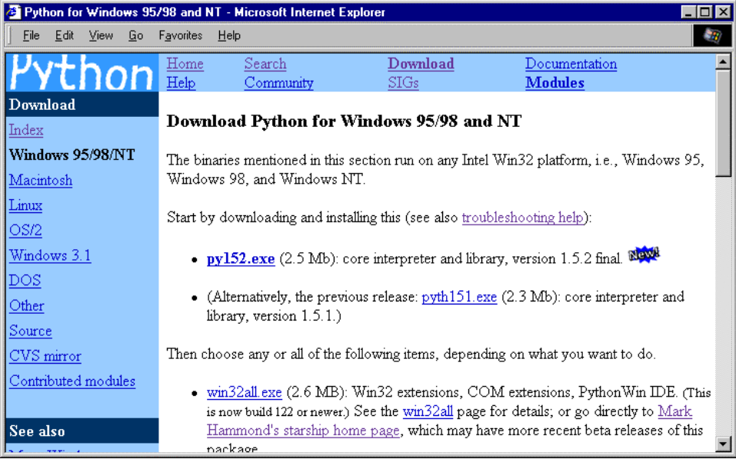
What you end up with:
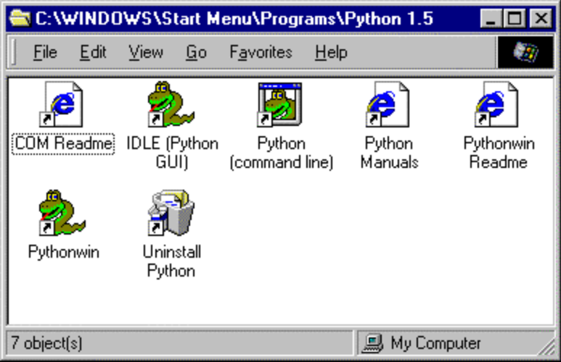

The Python Core on Windows
python15.dll – 545kb, the language, exports almost everything
python.exe – 5kb console mode program
pythonw.exe – 6kb non-console mode program – avoids ugly black DOS boxes when you don’t want standard input/outpu

Note: some people like to copy python.exe and pythonw.exe to their system directory, especially on Win95/98

Extensions and their meaning
.py Python source.
.pyc “Compiled” python source
.pyd Extension module written in C – actually a DLL which has been renamed to .pyd
.pyw (advanced) – a Python source file you wish to have run with pythonw.exe, not python.exe.
py, pyx and pyw all runnable with double-click (or right-click and choose Run).

Working with the command prompt on Win95/98
You need Python on your path, or a doskey macro!

C:\Scripts> doskey p="C:\Program Files\Python\Python.exe" $*
C:\Scripts>p hello.py
Hello from Python

C:\Scripts>doskey n=start notepad.exe $*
C:\Scripts>doskey pw=start pythonwin.exe $*
C:\Scripts>n hello.py
C:\Scripts>pw hello.py
Note also that you can drag filenames and directories from explorer into MSDOS window.

Working with the command prompt on NT
Much nicer! Readline-like recall with up and down arrows.
NT knows what a py file is, so you can type:
C:\Scripts>hello.py
Hello from Python

C:\Scripts>
You can go one further with the PATHEXT variable. To kmake it permanent, go to Control Panel | System | Environment:
C:\Scripts>echo %PATHEXT%
.exe;.bat;.cmd
C:\Scripts>set PATHEXT=%PATHEXT%;.py
C:\Scripts>echo %PATHEXT%
.exe;.bat;.cmd;.py
C:\Scripts>hello
Hello from Python

C:\Scripts>
..and of course you can use NT’s other command line tools, like the scheduler to run Python jobs.

The Python for Windows Extensions
win32all includes:
- the win32 extensions
- the Pythonwin editor and MFC framework
- The PythonCOM framework
- Lots of help and examples

The Pythonwin IDE
Pythonwin 2.0:
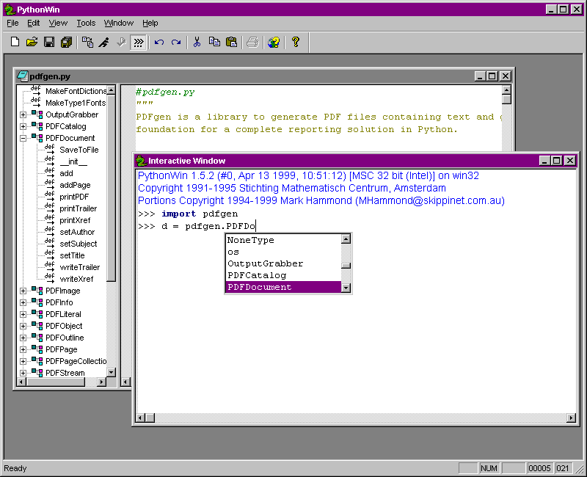

Key features:
- C editor component
- Syntax coloring
- drop-down completion (as far as is possible in Python) and argument lists
- class and function browser which operates across modules

Modes
Pythonwin support a number of command line parameters:
Command Line | Description
/edit filename | Starts Pythonwin, and opens the named file for editing
/run filename | Starts Pythonwin, and runs the specified script.
/nodde | Must be the first parameter. Starts Pythonwin without DDE support, allowing for multiple Pythonwin instances. See Pythonwin and DDE later in this section
/app appmodule | Treats the named file as a Pythonwin application. This is for advanced users only, and is discussed in Chapter ?? - GUI Development.

Interactive window
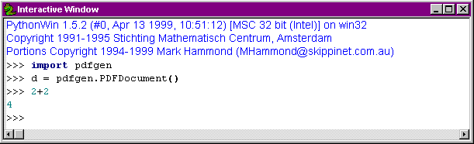Recalls previous lines
Drop-down completion available

Import feature
Saves, and reloads all necessary files

Script dialog
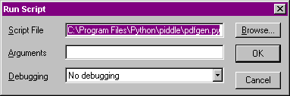
For scripts that work with files, know what directory you are in!

File | Locate
Searches path, checks in packages too

Source Code checking and tools
File | Check invokes TabNanny
Right click and View Whitespace shows tabs/spaces:
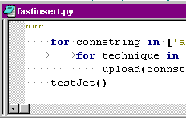

Some nice source tools, and no doubt more to come…from the context menu:
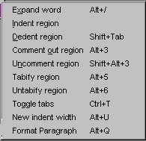

Old Object Browsers
Browse the entire top-level namespace, or a single object.
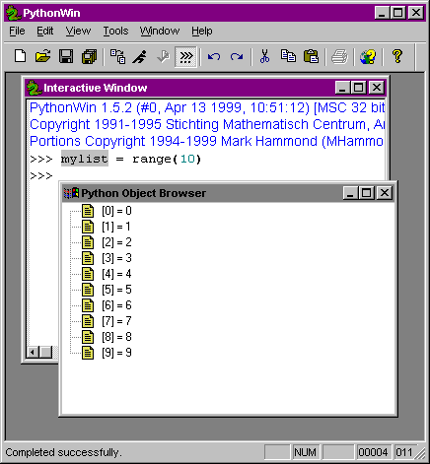

New Browser
Left pane of any script window
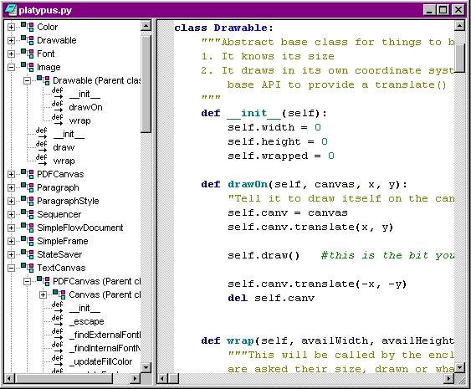
- Browses in-memory objects, must import first
- drill down to instance variables and base classes
- jumps to code definition, opening another script window if necessary

Debugging
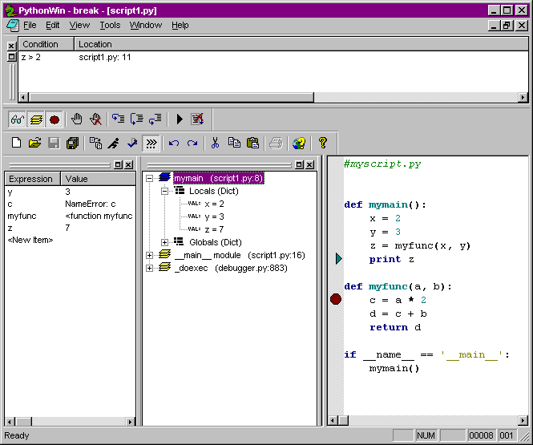
Currently stepping through, at ‘print z’ line in right pane.
- Conditional breakpoints
- breakpoints
- watch list
- Stack
- Code Browser if you wish!

Grep
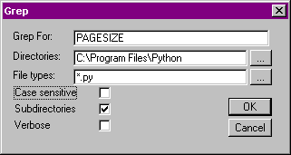
…leads to…
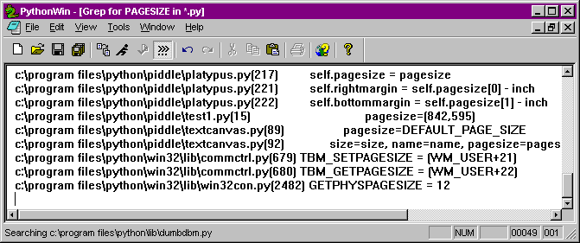
Click any line to go to source file.

Conclusion
- evolving fast,
- extensible
- not too shabby for a free editor!

Part 2: - COM

Introduction to Python and COM

What’s COM about anyway?
COM
- Lets objects in different languages talk to each other
- Lets objects in different processes talk to each other
- Lets objects on different machines talk to each other
- Hides the details from the programmer
- No performance penalties compared to DLLs

Most big apps expose their functionality through COM servers. You can borrow their functionality for your own programs.

Programming for Windows is like being in a sea of objects all waiting to help you.

Discuss: Windows – the most open Operating System?

The Registry: where COM objects find out about each other. (Not just a big INI file!)

A Minimal COM Client
Connect to Excel and insert some data
>>> from win32com.client import Dispatch
>>> xlApp = Dispatch("Excel.Application")
>>> xlApp.Visible = 1
>>> xlApp.Workbooks.Add()
<win32com.gen_py.Microsoft Excel 8.0 Object Library.Workbook>
>>> xlSheet.Cells(1,1).Value = 'What shall be the number of thy counting?'
>>> xlSheet.Cells(2,1).Value = 3
Remember to install your Office Object Model Documentation!

A Minimal COM Server

# SimpleCOMServer.py - almost as small as they come!
class PythonUtilities:
_public_methods_ = [ 'SplitString' ]
_reg_progid_ = "PythonDemos.Utilities"
# NEVER copy the following ID
# Use "print pythoncom.CreateGuid()" to make a new one.
_reg_clsid_ = "{41E24E95-D45A-11D2-852C-204C4F4F5020}"

def SplitString(self, val, item=None):
import string
if item != None: item = str(item)
return string.split(str(val), item)

# Add code so that when this script is run by Python.exe, it self-registers.
if __name__=='__main__':
print "Registering COM server..."
import win32com.server.register
win32com.server.register.UseCommandLine(PythonUtilities)

Using the minimal server from VB or VBA

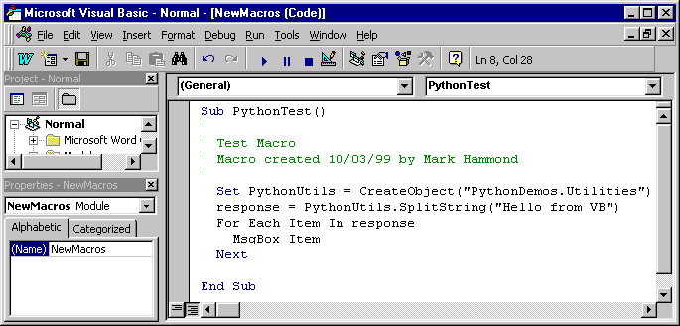

Why write Python COM Servers?
- Easiest way to expose Python functionality to your own or other applications
- Python is best at the business logic, other tools are best at other things
(e.g. VB GUIs)

Doubletalk – Sample Application
Python Financial Modelling Toolkit. Models “Sets of Books” and “Transactions”

Good candidate for this architecture because
- Very wide general applicability – from local data input app to back-office server
- Every company needs to customize it a little!
How could we sell it?
- 100% Native Windows GUI
- Distributed, Dynamic Multi-tier Network Architecture
- Embedded Scripting Language – lets you customize the way it works!
- Extensible Plug-In Architecture
- Command Prompt for Power Users
- Integration with Word and Excel
- Open Database Connectivity
- Option to run critical tasks on Unix servers without changing a line of code!
- Totally Buzzword Compliant!

Now to discuss what the app is about:

Transactions
Crudely, a movement of money.
All accounts must sum to zero!

Simple two-line (“Double-Entry”)
Date: | 01/01/1998
Comment: | Start the company
Cash |  | +10 000
Share Capital |  | -10 000

Multi-line
Date: | 10/03/1999
Comment: | Sell Widgets
Cash |  | +117.50
Sales Category 1 |  | -50.00
Sales Category 2 |  | -30.00
Sales Category 3 |  | -20.00
Sales tax on all three (owed to Customs & Excise) |  | -17.50

Functionality:
- Store
- Edit
- Add
- Validate
- effectOn(self, account)
- Extra keys/values
- add, multiply – an algebra for financial transactions!

Accounts
Accounts form a tree – this is the “Balance Sheet”…
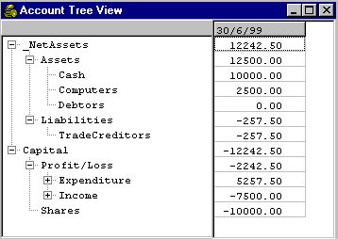
- Represent tree as dotted string notation: “MyCo.Assets.Cash.PiggyBank”
- Assets, Cash and Expenditure are positive; Liabilities, Income and Profit are negative.

BookSets
A wrapper around a list of transactions.
- Load/Save with cPickle (one of Python’s killer features!)
- Import/Export ASCII text, list/dictionary/tuple structures etc.

Fundamental change operations
- Add/Edit/Delete transactions
- Rename Account

Querying
- get history of an account
- get the ‘tree of accounts’
- get all balances on date -> Balance Sheet report
- get all changes between two dates -> Profit & Loss reports

Advanced
- map from one accounts structure to another
- analyse and trace cash flows
- Multidimensional analysis

What we’d like…
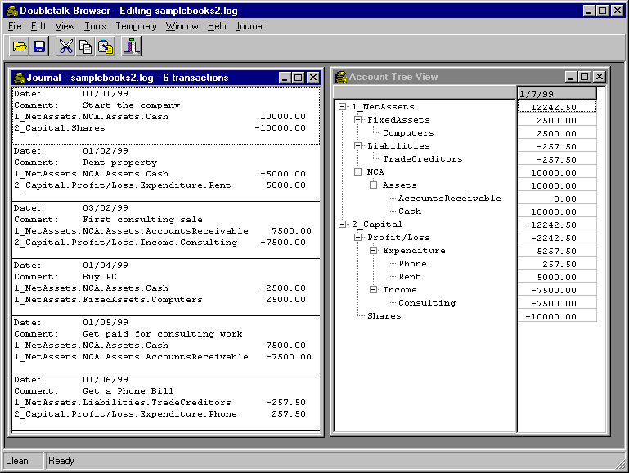

Design Patterns for the COM Server
COM servers and Python apps handle some arg types differently…
- Unicode String Handling – Gotcha Number One! (hopefully goes in 1.6)
# our ordinary save method for use from Python
def save(self, filename):
f = open(filename,'wb')
cPickle.dump(self.__journal,f)
f.close()

# what we would need for use from COM
def save(self, unicode_filename):
# convert it to a python string:
python_filename = str(unicode_filename)

f = open(python_filename,'wb')
cPickle.dump(self.__journal,f)
f.close()
- Wrap/Unwrap subobjects

…so a single class not the best design for real apps. Others options:
- COM Base Class, Python Server
- Pure Python Base Class, COM Subclass
- COM interface, Python Delegate

We go for option 3: Delegate. Keeps our Python package pure and portable.

Startup Code:
# comservers.py – to be expanded
class COMBookSet:
_reg_clsid_ = '{38CB8241-D698-11D2-B806-0060974AB8A9}'
_reg_progid_ = 'Doubletalk.BookServer'
_public_methods_ = ['double']

def __init__(self):
self.__BookSet = doubletalk.bookset.BookSet()

def double(self, arg):
# trivial test function to check it is alive
return arg * 2

if __name__ == '__main__':
win32com.server.register.UseCommandLine(COMBookSet)

Visual Basic GUI Startup Code
Public BookServer As Object

Private Sub MDIForm_Load()
InitCOMServer
frmJournal.Show
End Sub
Private Sub MDIForm_Unload(Cancel As Integer)
CloseCOMServer
End Sub

Sub InitCOMServer()
'called when the program starts
On Error GoTo InitCOMServer_error
Set BookServer = CreateObject("Doubletalk.BookServer")
Exit Sub

InitCOMServer_error:
Dim msg As String
msg = "There was an error trying to initialize the BookServer." + _
"Please check that it is properly registered and try the Python " + _
"test functions first. The program will now abort."
MsgBox msg
End
End Sub

Sub CloseCOMServer()
Set BookServer = Nothing
End Sub

Sub TestCOMServer()
'just to check it is alive
Dim hopefully_four As Integer
hopefully_four = BookServer.Double(2)
MsgBox "2 x 2 = " & hopefully_four & ", so your server is alive"
End Sub

Private Sub mnuToolsTestServer_Click()
'this helps establish if the COM server is alive
'using a minimal diagnostic function in the modMain module
TestCOMServer
End Sub
With a little luck…
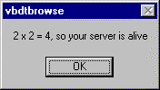

Our first view – The Journal

Goal:
Date-Ordered List of Transactions

Python Code Needed:
# more methods for COMBookSet – must be named in _public_methods_
def load(self, filename):
self.__BookSet.load(str(filename))

def count(self):
# return number of transactions
return len(self.__BookSet)

def getTransactionString(self, index):
return self.__BookSet[index].asString()

Visual Basic Code – File / Open handler
Private Sub mnuFileOpen_Click()
Dim sFile As String
With dlgCommonDialog
.DialogTitle = "Open"
.CancelError = False
'ToDo: set the flags and attributes of the common dialog control
.Filter = "Doubletalk Journal Files (*.dtj)|*.dtj"
.ShowOpen
If Len(.FileName) = 0 Then
Exit Sub
End If
sFile = .FileName
End With
BookServer.Load sFile

'display something helpful in the Journal caption
frmJournal.Caption = sFile & ", " & BookServer.count & " Transactions"
End Sub

Visual Basic – The Journal View
Public Sub UpdateView()
'make a list with a string describing each transaction

Dim count, i As Integer
Dim trantext As String
Dim tran As Object

Screen.MousePointer = vbHourglass
lstJournal.Clear

For i = 0 To frmMain.BookServer.count - 1
trantext = frmMain.BookServer.getOneLineDescription(i)
lstJournal.AddItem trantext
Next i

Screen.MousePointer = vbDefault
Caption = "Journal view - " & lstJournal.ListCount & " transactions"
End Sub

The Result
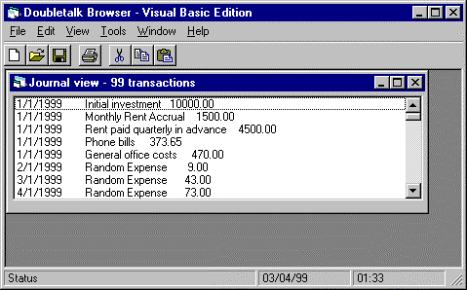

Transaction Editing
Our target: add and edit transactions in the GUI:
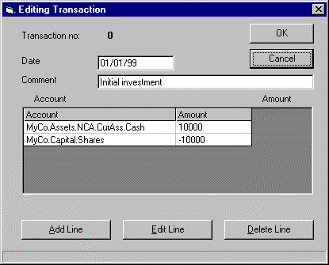
So far, only BookSet is a COM object. How to deal with Transactions?

Design Pattern for Transactions
So far we only passed back and forth integers and strings. We need to pass in and out transactions for editing, and make a choice on their design pattern. Here’s how we’d edit one from VB.

Creatable from Registry
Dim newtran As Object
Set newtran = CreateObject("Doubletalk.Transaction")
newtran.setDateString "31/12/99"
newtran.setComment "Python on Windows Royalty Cheque"
newtran.addLine "MyCo.Assets.NCA.CurAss.Cash", 5000
newtran.addLastLine "MyCo.Capital.PL.Income.Writing"
BookServer.Add newtran

Created by BookSet
Dim newtran As Object
Set newtran = BookServer.CreateTransaction
newtran.setDateString "31/3/2000"
newtran.setComment "Even more royalties"
newtran.addLine "MyCo.Assets.NCA.CurAss.Cash", 5000
newtran.addLastLine "MyCo.Capital.PL.Income.Writing"
BookServer.Add newtran

The latter means less Python code, less in the registry, and less choice / more consistency for users!

Wrapping and Unwrapping sub-objects
If you pass a Python object as an argument across a COM boundary, need to ‘wrap’ and ‘unwrap’ it: VB gets, and gives, Idispatch wrappers around Python objects.

# more methods of COMBookSet class

def createTransaction(self):
comTran = COMTransaction()
idTran = win32com.server.util.wrap(comTran)
return idTran

def add(self, idTran):
comTran = win32com.server.util.unwrap(idTran)
pyTran = comTran._tran
self.__BookSet.add(pyTran)

- pyTran = the “pure python” class, nothing to do with COM
- comTran = our wrapper class with _public_methods_ etc.
- idTran = the IDispatch object created and managed by Python COM framework – what VB gets and gives back.

Passing Arrays
Move whole lists or tables at once – FAST!
Python lists/tuples <-> COM Safe Arrays
Makes possible tabular views.

Public Sub UpdateView()
Dim table As Variant
Dim rows As Integer, cols As Integer
Dim row As Integer, col As Integer

table = frmMain.BookServer.getAccountDetails(AccountName)

rows = UBound(table, 1) - LBound(table, 1) + 1
cols = UBound(table, 2) - LBound(table, 2) + 1

grdTable.rows = rows + 1 'leave room for titles
For row = 0 To rows - 1
For col = 0 To cols - 1
grdTable.TextMatrix(row+1, col) = table(row,col)
Next col
Next row
End Sub

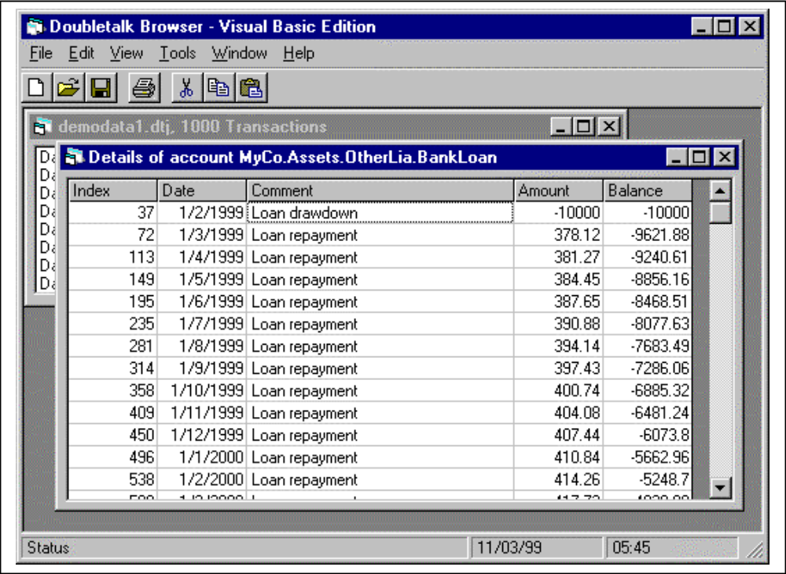

Callbacks – Python controlling VB

Make a chart view which asks Python to draw on it…
'Method of frmAccountChart
Public Sub UpdateView()
'ask Python to scribble on me
frmMain.BookServer.drawAccountChart Me
End Sub

Dummy draw method in Python
def drawAccountChart(self, vbForm):
# Make a Dispatch wrapper around the VB Form object so we can call
# any of its methods.
idForm = win32com.client.dynamic.Dispatch(vbForm)
# access a property of the VB form
idForm.Caption = "Python Drew this chart at " + \
time.ctime(time.time())

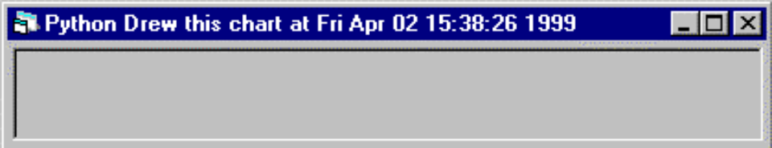
Not a very impressive chart, yet!

Here’s one we put in the oven earlier!
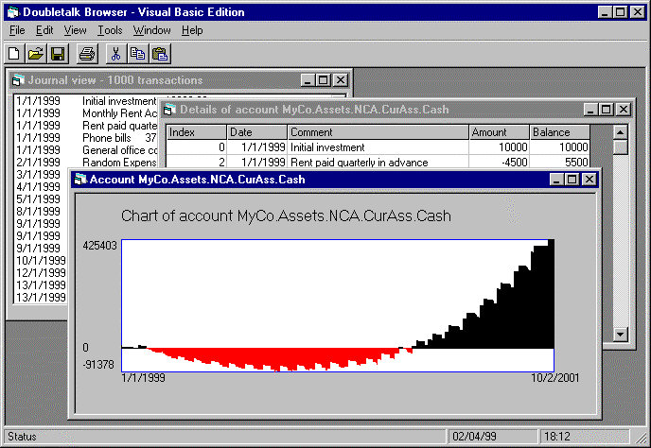

Summary of argument type passing
Type | The Rules
Integers | No problem
Floating Point | No problem
Strings | Call str() on incoming unicode strings
One-dimensional arrays and lists | Python lists <-> Safe Arrays (“Variant Arrays” in Visual Basic)
Multi-Dimensional Arrays | As above, watch out for transposal
Odd-shaped lists: [‘one’,’[‘two’,’three’],[[4,[5,6]]]] | At your own risk!
Dates | Python does not have a single native date type.  Suggest conversion methods e.g. set/getDateString, set/getCOMDate etc. Pythoncom provides needed types.
Python Objects | Wrap and unwrap

Top tips for preserving sanity
- Design and test your Python engine in Python. Write thorough test scripts.
- Use a Python client to test your Python COM Server exhaustively.
- Use the Trace Collector Debugging Tool
- Use a Reload button
- VB can and will crash, so:
- back up often
- do a full compile, and test from the compiled app with VB minimized.

Conclusions

What have we achieved?
- An industry-standard, 100% Windows User Interface
of the kind users expect
- An embedded and portable Python engine
- Techniques to add Python into an existing application
- Use Python where Python does best, VB where VB does best

Notes on other languages
Works with most of them. Tried and tested with Delphi, PowerBuilder.
Callbacks take extra work in Delphi; we got away with it here as “every VB object is a COM object” (supports IDispatch). But they are bad design anyway.

Adding a Macro Language

Goal: Make our application extensible.
Let users:
- Write scripts
- Handle events (adding, editing, deleting transactions)
- Create Validation Rules
- Create User-Defined Views
- Work at a command prompt

Dynamic Evaluation Background

In Python, the interpreter is always available!
eval(expression, [globals[, locals]]) evaluates a string,
exec(expression, [globals[, locals]]) executes one.
>>> exec("print 'this expression was compiled on the fly' ")
this expression was compiled on the fly
>>> exec("x = 3.14")
>>> eval("x + 1")
4.14

Namespaces can be accessed too
>>> # where is the 'x' kept?
>>> for item in globals().items():
... print item
...
('__doc__', None)
('pywin', <module 'pywin'>)
('x', 3.14)
('__name__', '__main__')
('__builtins__', <module '__builtin__'>)
>>>
Variables at the command prompt go in a namespace accessible through globals()
A namespace is just a dictionary.

…so make our own namespace and expose it
# COMBookSet methods again
def __init__(self):
self.__BookSet = doubletalk.bookset.BookSet()

# create a custom namespace for the user to work with
# with one variable name already defined
self.userNameSpace = {'TheBookServer', self.__BookSet}

def interpretString(self, exp):
"""Makes it easier to build consoles.
"""
if type(exp) not in [type(''), UnicodeType]:
raise Exception(desc="Must be a string", \
scode=winerror.DISP_E_TYPEMISMATCH)
try:
# first, we assume it is an expression
result_object = eval(str(exp), self.userNameSpace)
if result_object == None:
return ''
else:
return str(result_object)
except:
#failing that, try to execute it
exec str(exp) in self.userNameSpace
return ''

Grabbing Python’s output

Goal : see console output in a VB window.
Python lets you redirect its own standard output to any object with a write() method. Example:

>>> import sys
>>> mylogfile = open('c:\\temp\\mylog.txt', 'w')
>>> sys.stdout = mylogfile
>>> print ‘hello’
>>> # no output on console, it’s in the file!

Our plan
- give the COMBookSet a write() method
- ways to start trapping output, end trapping it, and retrieve any available output.
- Keep it in a list of strings

Implementation
def beginTrappingOutput(self): # exposed as public method
self.outputBuffer = []
self.old_output = sys.stdout
sys.stdout = self

def write(self, expr): # private
""" this is an internal utility used to trap the output.
add it to a list of strings - this is more efficient
than adding to a possibly very long string."""
self.outputBuffer.append(str(expr))

def getStandardOutput(self): # exposed as public method
"Hand over output so far, and empty the buffer"
text = string.join(self.outputBuffer, '')
self.outputBuffer = []
return text

def endTrappingOutput(self): # exposed as public method
sys.stdout = self.old_output
# return any more output
return self.getStandardOutput()

Warning: Conflict with Trace Collector
There is a Python utility called the Trace Collector debugging tool which can also be set up to capture the output, so you can use ‘print’ debugging with COM servers. This also tries to capture the standard output, and will win if running!

Now we can build a console for our app…
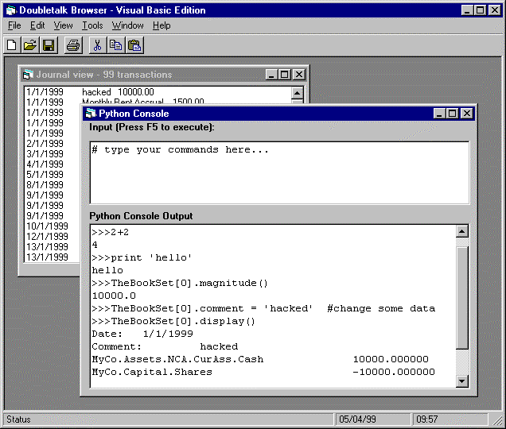
This lets the users do pretty much anything they could at a Python prompt.

Let’s hope someone will do this well, once, and share it! (PythonConsole.OCX?)

Tips on console design:
- Scintilla
- Code.py
- Interact.py

More macro-related features

Executing Scripts:
- Menu option to run a script
- exec(expression, [globals[, locals]]) does the work in one line.

Importing Scripts
- Python imp module exposes import mechanism; need to grab the module object and add it to our namespace.
- Add an importFile() method to COMBookSet

Startup Script in Options
- Highly useful for users

Reload option
- Useful for users, and for us! Closes and reloads BookServer.
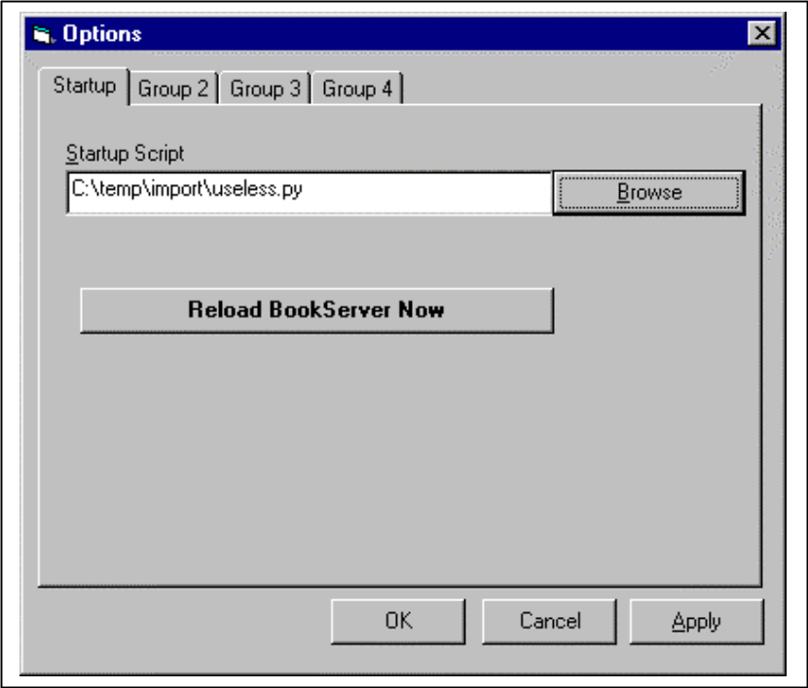

Define user and system code directories
- Get added to Python path at startup.

Making the app extensible

Changing the delegate class
Feasible, as COMBookSet creates BookSet at startup. An options dialog could specify the module and class. But puts a big onus on the user – must implement every method.

Delegation Framework: Views and Validators
- a Validator is an object which a BookSet notifies before changing data, asking for permission to proceed.
- a View is an object which the BookSet notifies after changes have been made. It also has a method to return a two-dimensional array of data on demand, which could contain whatever the user wished.
- class UserBookSet maintains a list of Views and Validators, and notifies them of changes
Users now only need to write a new view, not a whole new Bookset.

What do Views return?
Our convention: a 2-d array of data to go in a grid. Your app may differ.

Base class for User-Defined Views
class View:
"""This delegate is informed of all changes after they occur,
and returns a 2d array of data when asked."""
def setBookSet(self, aBookSet):
self.BookSet = aBookSet
self.recalc()
def getDescription(self):
return 'abstract base class for Views'
# hooks for notification after the event
def didAdd(self, aTransaction):
pass
def didEdit(self, index, newTransaction):
pass
def didRemove(self, index):
pass
def didRenameAccount(self, oldname, newname):
pass
def didChangeDrastically(self):
#can be used to notify of major changes such as file/open
self.recalc()
def recalc(self):
#override this to work out the data
pass
def getData(self):
return [()] # simple 2-d array for display

What can you do with Views and Validators?

- Add an audit trail (logs all add/edit/delete/rename operations)
- Security
- Only the Finance Director can modify last quarter’s data.
- Read-only for the relevant people
- Editing “time window” to stop them entering 1989 data by mistake!
- New back ends – fetch from and store to a relational database on demand
- Update other programs when certain changes happen
- Cache to improve performance – a View to hold pre-computed month-end balances for all accounts and months.

Front End
Maintain a list of modules and class names. Short chunk of Python passed to interpretString() to instantiate them.
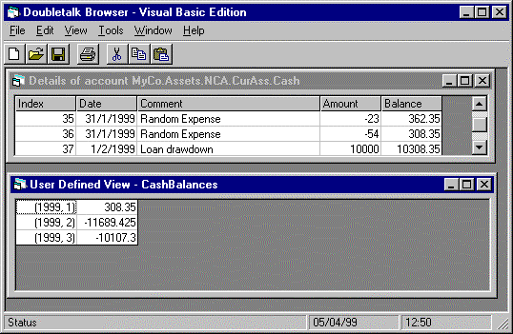

Macro Languages Conclusion
We’ve built a powerful cross-platform engine in a pure Windows GUI. Now we’ve just added a macro language so users can customize the system for their own needs.

This goes beyond normal Windows development and into an area which is one of Python’s greatest strengths – extensibility.

This kind of extensible app would be prohibitively expensive and difficult without Python. Macro languages are normally only available to Microsoft, Visio et al. With Python it is straightforward.

Client Side COM and Excel

Why Excel?
- Very widely used in financial and scientific circles.
- Key source and destination for numeric data.

Learning the Excel Object Model
- There’s not much to be learned about client side COM. But there’s a lot to be learned about the object model of each target application.
- Excel has many objects; the Range alone has 84 properties and 72 methods
- Don’t learn it from Python, do it from VBA!
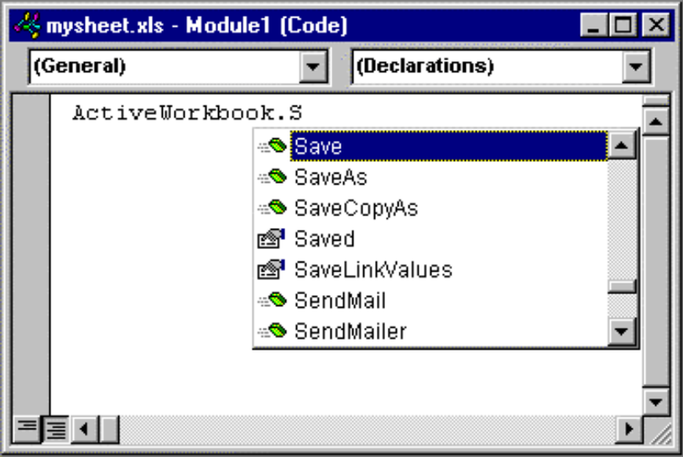

Connecting to the client

Starting up Excel
>>> from win32com.client import Dispatch
>>> xlApp = Dispatch("Excel.Application")
>>> xlApp.Visible = 1
>>> xlApp.Workbooks.Add()
<win32com.gen_py.Microsoft Excel 8.0 Object Library.Workbook>
>>>

If you can, run MakePy first…
- MakePy runs a bit faster
- MakePy provides type info
- MakePy provides all the constants!

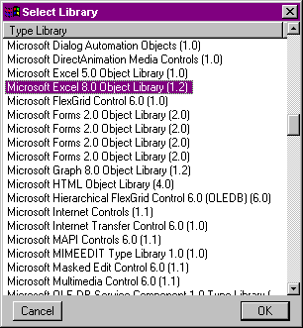

Object model basics and warnings

Navigating through collections: How to modify Cell at top left
There’s more than one way to do it!
xlApp.ActiveSheet.Cells(1,1).Value = 'Python Rules!'
>>> xlApp.ActiveWorkbook.ActiveSheet.Cells(1,1).Value = 'Python Rules!'
>>> xlApp.Workbooks("Book1").Sheets("Sheet1").Cells(1,1).Value = "Python Rules!"
>>> xlApp.Workbooks(1).Sheets(1).Cells(1,1).Value = "Python Rules!"
>>> xlApp.Workbooks(1).Sheets(1).Cells(1,1).Value = "Python Rules!"
>>>
>>> xlBook = xlApp.Workbooks(1)
>>> xlSheet = xlApp.Sheets(1)
>>> xlSheet.Cells(1,1).Value = "Python Rules!"
>>>
Recommendation: Get hold of the sheet in a variable, and use that.

Round and Square Brackets,
>>> xlBook.Sheets(1)
<win32com.gen_py.Microsoft Excel 8.0 Object Library._Worksheet>
>>> xlBook.Sheets[1]
<win32com.gen_py.Microsoft Excel 8.0 Object Library._Worksheet>
>>> xlBook.Sheets["Sheet1"]
(some error details omitted)
TypeError: Only integer indexes are supported for enumerators
>>>
String arguments only work with round brackets.

One-and Zero-based collections
>>> xlBook.Sheets(1).Name
'Sheet1'
>>> xlBook.Sheets[1].Name
'Sheet2'
>>>
Square brackets always count from 0.
Round brackets count the way the author intended. Most office apps count from 1
Recommendation: use round brackets, and read your object model’s documentation to find out the base. Most office apps count from 1.

Keyword Arguments
Excel likes these a lot:
expression.SaveAs(Filename, FileFormat, Password, WriteResPassword, ReadOnlyRecommended, CreateBackup, AddToMru, TextCodePage, TextVisualLayout)
Supply what you need:
>>> xlBook.SaveAs(Filename='C:\\temp\\mysheet.xls')
>>>
Watch the capitalisation! Microsoft are not always 100% consistent.

Passing data in and out

Use the Value property:
>>> xlSheet.Cells(1,1).Value = 'What shall be the number of thy counting?'
>>> xlSheet.Cells(2,1).Value = 3
>>> xlSheet.Cells(1,1).Value
'What shall be the number of thy counting?'
>>> xlSheet.Cells(2,1).Value
3.0
>>>

Converting times and dates – MS apps and Python have different standard
>>> import time
>>> now = time.time()
>>> now # how many seconds since 1970?
923611182.35
>>> import pythoncom
>>> time_object = pythoncom.MakeTime(now)
>>> int(time_object) # can get the value back...
923611182
>>> xlSheet.Cells(3,1).Value = time_object # ...or send it
>>> xlSheet.Cells(3,1).Value
<time object at 188c080>

Modify formulae with the Formula (!) property
>>> xlSheet.Cells(4,1).Formula = '=A2*2'
>>> xlSheet.Cells(4,1).Value
6.0
>>> xlSheet.Cells(4,1).Formula
'=A2*2'
>>>

Empty Cells accept/return Python Value “None”
>>> xlSheet.Cells(1,1).Value = None # clear a cell
>>> xlSheet.Cells(1,1).Value # returns None
>>>

Use Range objects to work with more than one cell
>>> myRange1 = xlSheet.Cells(4,1) # one-cell range
>>> myRange2 = xlSheet.Range("B5:C10") # excel notation
>>> myRange3 = xlSheet.Range(xlSheet.Cells(2,2), xlSheet.Cells(3,8))
>>>
Ranges have about 80 methods for formatting and modifying their data.

You’re going to love working with Arrays
In our VB app, we fetched a 2d array, then wrote code to loop over it putting it into the GUI. Excel works directly with COM arrays.
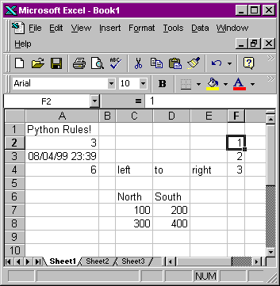

Horizontal range:
>>> xlSheet.Range('C3:E3').Value
((L'left', L'to', L'right'),)
>>>

Matrix with several rows and columns
>>> xlSheet.Range('C5:D7').Value
((L'North', L'South'), (100.0, 200.0), (300.0, 400.0))
>>>
Note: this is just how we’d represent it in Python!

Vertical Range
>>> xlSheet.Range('F2:F4').Value
((1.0,), (2.0,), (3.0,))
>>>
Passing arrays is FAST – 60 columns, 100 rows in an eyeblink!

Make your own wrapper
For example (showing headers only):
class easyExcel:
"""A utility to make it easier to get at Excel. Remembering
to save the data is your problem, as is error handling.
Operates on one workbook at a time."""
def __init__(self, filename=None):
def save(self, newfilename=None):
def close(self):
def getCell(self, sheet, row, col):
def setCell(self, sheet, row, col, value):
def getRange(self, sheet, row1, col1, row2, col2):
def setRange(self, sheet, leftCol, topRow, data):
def getContiguousRange(self, sheet, startrow, startcol):
# and rather importantly, for cleaning up,
def fixStringsAndDates(self, aMatrix):

Let your wrapper grow with time. Share it with me!

Exercise – Financial Data Import
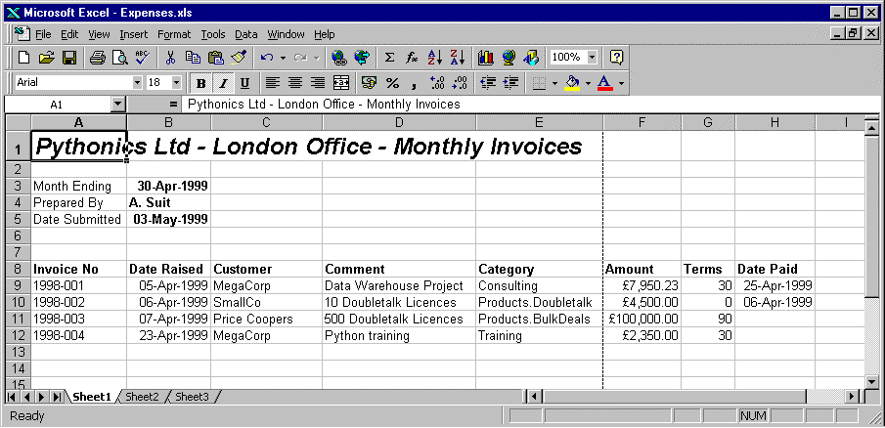

How would you turn these into transactions in a BookSet?

Automating Word

When to use Word
- when a Word document would be intrinsically useful (e.g. correspondence database)
- obviously, to acquire Word data – thankfully a rare occurrence!

When not to use Word
- when you just want a dead tree edition
- when you don’t want the output tampered with
- target readers on other platforms
Shameless Plug - Use PDFgen instead!

Our target: Management accounts
- Text with given paragraph styles
- Charts and other Images
- Tables of nicely formatted data

Hello, Word

from win32com.client import Dispatch
MYDIR = 'c:\\data\\project\\oreilly\\examples\\ch12_print'

def simple():
myWord = Dispatch('Word.Application')
myWord.Visible = 1 # comment out for production

myDoc = myWord.Documents.Add()
myRange = myDoc.Range(0,0)
myRange.InsertBefore('Hello from Python!')

# uncomment these for a full script
#myDoc.SaveAs(MYDIR + '\\python01.doc')
#myDoc.PrintOut()
#myDoc.Close()

Why work harder? Use a template…
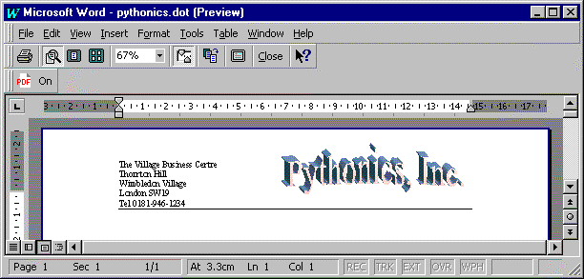

Construct it supplying the template as an optional argument.
>>>myDoc = myWord.Documents.Add(template=MYDIR + '\\pythonics.dot')
Design all the graphic elements in Word. Bookmark your insertion points. Only insert the text you need to.

Word Wrapping
As before, we will wrap Word up in a class which makes it easy to generate documents.

Creating, printing and saving:
class WordWrap:
"""Wrapper aroud Word 8 documents to make them easy to build.
Has variables for the Applications, Document and Selection;
most methods add things at the end of the document"""
def __init__(self, templatefile=None):
self.wordApp = Dispatch('Word.Application')
if templatefile == None:
self.wordDoc = self.wordApp.Documents.Add()
else:
self.wordDoc = self.wordApp.Documents.Add(
Template=templatefile)
#set up the selection
self.wordDoc.Range(0,0).Select()
self.wordSel = self.wordApp.Selection
#fetch the styles in the document - see below
self.getStyleDictionary()

def show(self):
# convenience when developing
self.wordApp.Visible = 1

Save and Print
def saveAs(self, filename):
self.wordDoc.SaveAs(filename)

def printout(self):
self.wordDoc.PrintOut()

Adding text
Move the selection to the end, and insert into selection
def selectEnd(self):
# ensures insertion point is at the end of the document
self.wordSel.Collapse(0)
# 0 is the constant wdCollapseEnd; don't want to depend
# on makepy support.

def addText(self, text):
self.wordSel.InsertAfter(text)
self.selectEnd()

Insert a paragraph in a named style
Fast, versatile, and lets graphic designers set the styles in Word.
>>> from win32com.client import constants
>>> mySelection.Style = constants.wdStyleHeading1
>>>
However, (a) this is limited to the built-in styles, and (b) won’t work without MakePy.
Our solution: get a style list back at run time, and use it to add them by name:
def getStyleList(self):
# returns a dictionary of the styles in a document
self.styles = []
stylecount = self.wordDoc.Styles.Count
for i in range(1, stylecount + 1):
styleObject = self.wordDoc.Styles(i)
self.styles.append(styleObject.NameLocal)

def addStyledPara(self, text, stylename):
if text[-1] <> '\n':
text = text + '\n'
self.wordSel.InsertAfter(text)
self.wordSel.Style = stylename
self.selectEnd()

Time for a test:
>>> import easyword
>>> w = easyword.WordWrap()
>>> w.show()
>>> w.addStyledPara('What I did on Holiday', 'Heading 1')
>>> w.addStyledPara('blah ' * 50, 'Normal')
>>>
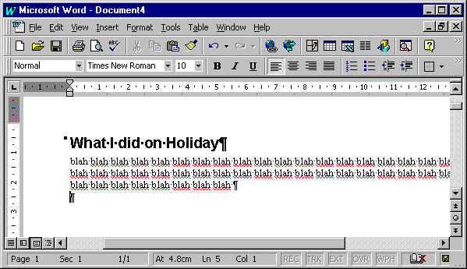
Styles and templates together give a very easy way to build up a sophisticated document.

Adding Tables
Let’s be lazy and use AutoFormat – saves a lot of code: Fortunately, most arguments are optional!
Table.AutoFormat(Format, ApplyBorders, ApplyShading, ApplyFont, ApplyColor, ApplyHeadingRows, ApplyLastRow, ApplyFirstColumn, ApplyLastColumn, AutoFit)
Create a block of tab-delimited text, then ask Word to turn it into a table:
def addTable(self, table, styleid=None):
# Takes a 'list of lists' of data.
# first we format the text. You might want to preformat
# numbers with the right decimal places etc. first.
textlines = []
for row in table:
textrow = map(str, row) #convert to strings
textline = string.join(textrow, '\t')
textlines.append(textline)
text = string.join(textlines, '\n')

# add the text, which remains selected
self.wordSel.InsertAfter(text)

#convert to a table
wordTable = self.wordSel.ConvertToTable(Separator='\t')
#and format
if styleid:
wordTable.AutoFormat(Format=styleid)

Adding Charts and Images
Let’s assume we’ve set up and saved an Excel sheet with the right chart in it already.
def addInlineExcelChart(self, filename, caption='',
height=216, width=432):
# adds a chart inline within the text, caption below.
# add an InlineShape to the InlineShapes collection
#- could appear anywhere
shape = self.wordDoc.InlineShapes.AddOLEObject(
ClassType='Excel.Chart',
FileName=filename
)
# set height and width in points
shape.Height = height
shape.Width = width

# put it where we want
shape.Range.Cut()
self.wordSel.InsertAfter('chart will replace this')
self.wordSel.Range.Paste() # goes in selection
self.addStyledPara(caption, 'Normal')

All the more obvious approaches failed, but it works!
Tip: Avoid shapes on the drawing layer – they are really hard to control from a programming language.

TaDa!
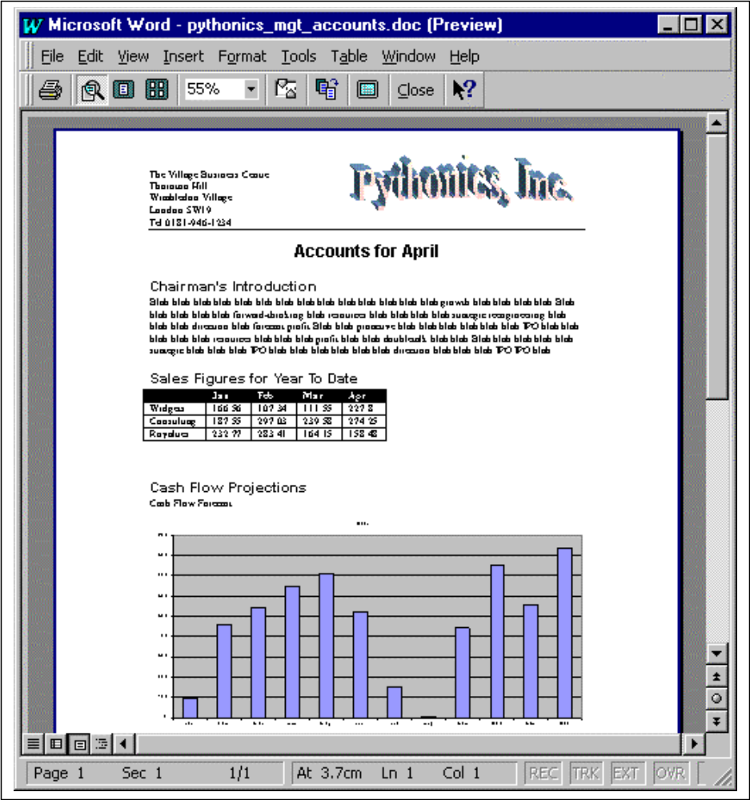

Inserting HTML: A Really Powerful Shortcut
Word can import and export HTML. The following line inserts an entire file into the current document.
>>> wordSelection.InsertFile(MYDIR + '\\tutorial.html')
>>>
You don’t even need a full HTML document - just a fragment saved with the extension HTML.

The Last Word
Word is hard to work with, so.
- Prototype your code in VBA to get it right
- Expect Word to fall over if you feed it bad arguments in development
- Consider ‘pull technology’ – Word template with VBA macro connects to Python COM server to get the data.

Distributing our Application with DCOM
DCOM does all the work for you.

Goal:
Our BookServer running in the back office, VB clients elsewhere

Configuration
DCOM needs to be enabled on the remote server. Choose Start -> Run and enter DCOMCNFG.EXE. A configuration dialog starts up. Select the Default Properties tab and check the box for Enable Distributed COM on this computer.
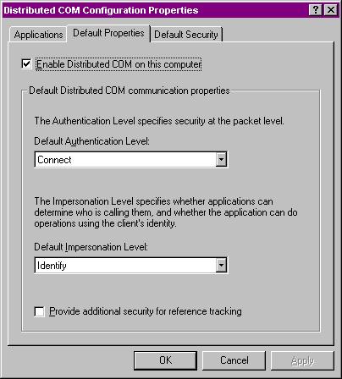

Implementation
Visual Basic startup code needs one extra argument
Set BookServer = CreateObject("Doubletalk.BookServer", RemoteMachine)
That’s all!

…apart from Singletons, threads etc. – need to ensure multiple clients reach the same server instance, simultaneous clients don’t create a problem etc. Read the book!

Part 3: - Cookbook

Database Access

Why do database work with Python?
- Connect to anything
- Lists and Dictionaries make data handling tasks trivial

DAO, ADO, ODBC, OLEDB
and other GBFLAs

ODBC | Open Database Connectivity – industry standard C API for connecting to client-server SQL databases. Mature, stable and well supported.
DAO & Jet | COM object model for manipulating Access databases. ODBC support grafted on later, but not designed for client-server use. Used by the infamous Data Control in VB.
RDO | Remote Data Objects – Another COM hierarchy on top of ODBC, presents a DAO-like API, but much better remote server performance than DAO. Behind the slightly better Remote Data Control in VB.
OLEDB | Low-level COM interfaces suited to C programmers. Extends ODBC concept to query arbitrary data providers like hierarchical file systems, mail stores etc. Most existing OLEDB drivers use ODBC for connecting to relational databases.
ADO | ActiveX Data Objects – easy-to-use DAO-like COM object model sitting on top of ODBC. Good performance on remote databases; bells and whistles like client-side datasets and synchronization.

We will look at ODBC for client-server work, and DAO/ADO for getting at Access databases.

ODBC Data Source Administration
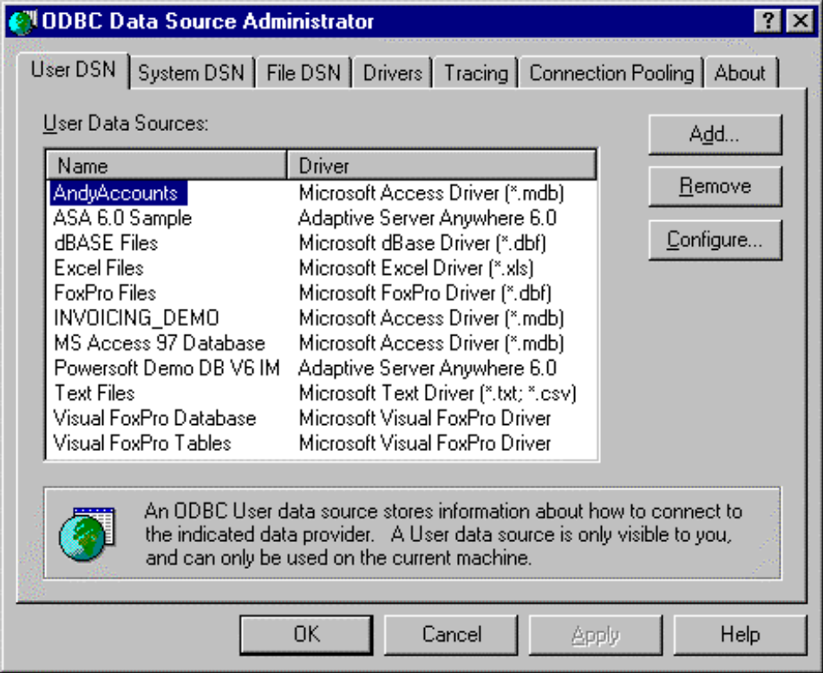

Python’s own database API and libraries
Currently on version 2.0. Most database extensions comply with it
Your options
- ODBC module in Pythonwin (version 1.0 only)
- mxODBC and mxDateTime (recommended for serious work)
- Various server-specific modules.
- Sam Rushing’s calldll-based ODBC library

Recommendations:
- ODBC module in Pythonwin for occasional use
- mxODBC for regular database work,
- Sam Rushing’s library if you love the raw ODBC API

Connecting with mxODBC

>>> import ODBC.Windows
>>> conn = ODBC.Windows.Connect('PYDBDEMOS')
>>> cursor = conn.cursor()
>>> cursor.execute('SELECT InvoiceID, ClientID, InvoiceDate FROM Invoices')
>>> from pprint import pprint
>>> pprint(cursor.description)
(('InvoiceID', 4, None, None, 10, 0, 1),
('ClientID', 12, None, None, 10, 0, 1),
('InvoiceDate', 11, None, None, 19, 0, 1))
>>> data = cursor.fetchall()
>>> pprint(data)
[(199904001, 'MEGAWAD', 1999-04-15 00:00:00.00),
(199904002, 'MEGAWAD', 1999-04-14 00:00:00.00),
(199904003, 'MEGAWAD', 1999-04-21 00:00:00.00),
(199904004, 'NOSHCO', 1999-04-22 00:00:00.00)]

Note those handy mxDateTime objects!

mxDateTime
>>> import DateTime
>>> DateTime.DateTimeFromCOMDate(0) # the Microsoft system
1899-12-30 00:00:00.00
>>> aDateTime.COMDate() # convert to Microsoft COM/Excel dates
36265.0
>>>
>>> DateTime.now() - aDateTime # RelativeDateTime object
<DateTimeDelta object for '16:23:40:16.18' at 1106530>
>>> aDateTime + DateTime.RelativeDateTime(months=+3)
1999-07-15 00:00:00.00
>>> # first of next month...
>>> aDateTime + DateTime.RelativeDateTime(months=+1,day=1)
1999-05-01 00:00:00.00
>>> DateTime.now()
1999-05-01 23:42:20.15
>>> DateTime.Feasts.EasterSunday(2001)
2001-04-15 00:00:00.00
>>> DateTime.Parser.DateFromString('Friday 19th October 1987')
1987-10-19 00:00:00.00
>>>
Databases are full of dates. This is really useful.

Support for Prepared Statements
Database engines do two things: parse the SQL, then execute the query.
If doing many similarly-structured statements (e.g. 1000 imports), it only need be parsed once.
This saves memory on the server as well as time.

Cursors keep a handle to the last statement and reuse it.

SLOW: Cursor.execute(operation)
cursor.execute("""INSERT INTO analysis
(tranid, trandate, account, amount) VALUES
(1, {d '1999-12-31 23:59:59'}, 'Cash',100.00)""")

FASTER: Cursor.execute(operation[,parameters])
cursor.execute("""INSERT INTO analysis
(tranid, trandate, account, amount)
VALUES (?,?,?,?)""", (2, aDate, 'Cash', 117.50))

FASTEST: Cursor.executemany(operation,seq_of_parameters)
cursor.execute("""INSERT INTO analysis
(tranid, trandate, account, amount)
VALUES (?,?,?,?)""", [
(2, aDate, 'Cash', 117.50)
(3, aDate, 'Shares', -117.50)
# and so on
])
More importantly, parsing SQL takes memory on the server. Apps using prepared ones can support many more users while maintaining performance.

Benchmarking
accessdemo/slow: 141.643058/second
accessdemo/faster: 117.619382/second
accessdemo/fastest: 148.148148/second
asademo/slow: 292.825772/second
asademo/faster: 426.621164/second
asademo/fastest: 528.262016/second
Jet raw SQL inserts: 113.352981/second
Jet AddNew/Delete: 186.985792/second
Conclusions:
- Access doesn’t know about prepared statements and is best accessed through DAO
- SQL databases are faster
- SQL databases go 80% faster with prepared statements

Connecting with Data Access Objects

Connecting
>>> import win32com.client
>>> daoEngine = win32com.client.Dispatch('DAO.DBEngine')
>>> daoDB = daoEngine.OpenDatabase('C:\\MYDIR\\pydbdemos.mdb')
>>> daoRS = daoDB.OpenRecordset('SELECT ClientID, InvoiceDate, \
Consultant, Hours FROM Invoices')

Iterating through Recordset
>>> daoRS.MoveLast()
>>> daoRS.Fields('ClientID').Value # reference fields by name
'NOSHCO'
>>> daoRS.Fields(3).Value # or by position
18.0
>>> for i in range(daoRS.Fields.Count):
... daoField = daoRS.Fields[i]
... print '%s = %s' % (daoField.Name, daoField.Value)
...
ClientID = NOSHCO
InvoiceDate = <time object at 1191860>
Consultant = Tim Trainee
Hours = 18.0
>>>

Grabbing Bulk Data with GetRows()
>>> daoRS.MoveFirst()
>>> data = daoRS.GetRows(4)
>>> pprint(data)
((L'MEGAWAD', L'MEGAWAD', L'MEGAWAD', L'NOSHCO'),
(<time object at 11921f0>,
<time object at 11921d0>,
<time object at 11921b0>,
<time object at 1192190>),
(L'Joe Hacker', L'Arthur Suit', L'Joe Hacker', L'Tim Trainee'),
(42.0, 24.0, 57.0, 18.0))
Note
- We get columns, not rows!
- We get COM dates and Unicode strings , just as from Excel

Regrettably there is no PutRows – need mxODBC for that!

Editing and Adding Data – Edit(), AddNew()
>>> daoRS2 = daoDB.OpenRecordset('SELECT * FROM Clients')
>>> daoRS2.AddNew() # or Edit() for existing ones
>>> daoRS2.Fields('ClientID').Value = 'WOMBLES'
>>> daoRS2.Fields('CompanyName').Value = 'Wimbledon Disposal Ltd.'
>>> daoRS2.Fields('ContactName').Value = 'Uncle Bulgaria'
>>> daoRS2.Update() # save the record
>>> daoRS2.Close()

Connecting with ADO

Connecting is similar to DAO…
>>> import win32com.client
>>> adoConn = win32com.client.Dispatch('ADODB.Connection')
>>> adoConn.Open('PYDBDEMOS') # use our ODBC alias again
>>> (adoRS, success) = adoConn.Execute('SELECT * FROM Clients')
>>> adoRS.MoveFirst()
>>> adoRS.Fields("CompanyName").Value
'MegaWad Investments'
>>>

The rest works exactly like DAO!

Gadfly – Pure Python Relational Database
Gadfly is intended to give Python programs relational database capabilities without relying on any external database engines. It offers the following features:
- Compliance with the Python Database API
- Transaction handling
- Total portability between platforms
- A transaction log and recovery procedure
- a built-in TCPIP server mode, allowing it to serve clients on remote machines
- Security policies to prevent accidental deletion of data
It is NOT intended as a multi-user production system, and some features are missing at present - notably Null values and Date/Time variables.
It also offers a TCPIP Network Client in just 15k of code!

The usual proof that it works…
>>> from gadfly import gadfly
>>> connection = gadfly("test", "c:\\mydir\\gadfly\\dbtest")
>>> cursor = connection.cursor()
>>> cursor.execute('SELECT * FROM Frequents')
>>> from pprint import pprint
>>> cursor.description # only does fieldnames at present
(('PERWEEK', None, None, None, None, None, None),
('BAR', None, None, None, None, None, None),
('DRINKER', None, None, None, None, None, None))
>>> print cursor.pp() # it can format its own output
PERWEEK | BAR | DRINKER
============================
1 | lolas | adam
3 | cheers | woody
5 | cheers | sam
3 | cheers | norm
2 | joes | wilt
1 | joes | norm
6 | lolas | lola
2 | lolas | norm
3 | lolas | woody
0 | frankies | pierre
1 | pans | peter
Note nice console output!

Communications
- Serial I/O
- Remote Access
- Sockets

Serial I/O
Roger Burnham’s Serial module – wraps MarshallSoft’s WSC libraries.
from Serial import Serial
#fill a special dictionary with the settings we want
cfg = Serial.PortDict()
cfg['port'] = port
cfg['baud'] = Serial.Baud9600
cfg['parity'] = Serial.NoParity
cfg['stopBits'] = Serial.OneStopBit
cfg['timeOutMs'] = 10000 # ten seconds

# create a Port object based on these settings
prt = Serial.Port(cfg)
prt.open()

#read some data
header = prt.read(22,timed=1)
prt.close()

High level wrappers – read() allows time interval.
Good excuse to play with threads!

Remote Access
win32ras extension exposes Remote Access management. Dial out under script control.
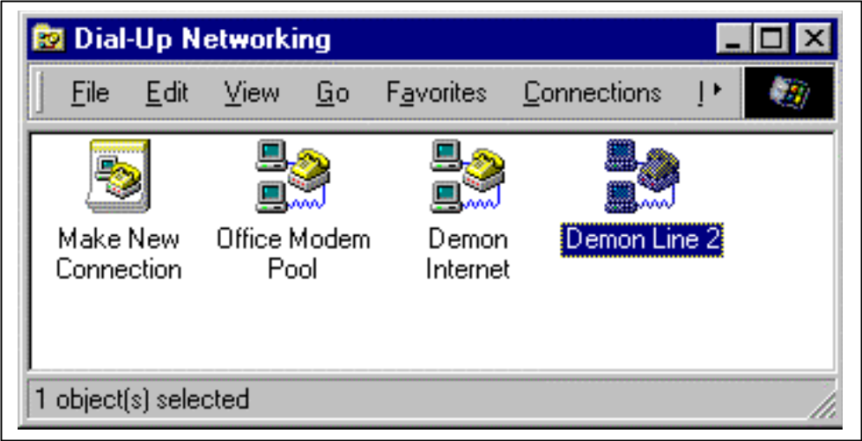

Also provides callbacks you can set to be triggered on connection.

>>> import win32ras
>>> myParams = ('Demon Internet','0845-3535666','', \
'username','password','')
>>> (hras, success) = win32ras.Dial(None, None, myParams, None)
>>> # do your stuff on the network now
>>> win32ras.HangUp(hras)
>>>

Sockets, TCPIP and Internet Protocols
The Python library includes
- TCP/IP Sockets
- Web servers
- FTP libraries
- Email and News libraries
Connect to anything internet-based.

System Administration

User Names:
>>> import win32api
>>> userName=win32api.GetUserName()

User Info:
Windows API structs exposed as editable dictionaries (if you have permission)
>>> import win32net
>>> info=win32net.NetUserGetInfo(None, userName, 1)
>>> print info['name'] # print just the user name
skip
>>> dump(info)
priv = 2
home_dir = c:\winnt\profiles\skip\personal
password = None
script_path =
name = skip
flags = 66049
password_age = 23792806
comment =
>>>
This is level 1 – others levels offer around 30 pieces of information.

Adding Users
>>> d={}
>>> d['name'] = "PythonTestUser"
>>> d['password'] = "Top Secret"
>>> d['comment'] = "A user created by some Python demo code"
>>> d['flags'] = win32netcon.UF_NORMAL_ACCOUNT | win32netcon.UF_SCRIPT
>>> d['priv'] = win32netcon.USER_PRIV_USER
>>> win32net.NetUserAdd(None, 1, d)
>>>
We said the dictionaries were editable…

What else?
Similar functions for working with
- groups
- servers
- network shares (e.g. create users and their shares in bulk)
- rebooting the system

Active Scripting
Lets you embed any scripting language using COM.
Use Python in
- Internet Information Server
- Internet Explorer
- Windows Scripting Host

Internet Explorer
Insert this in an hTML page
<SCRIPT Language=Python>
alert("Hello there")
</SCRIPT>

But how many people’s browsers can you count on to have Python set up?

Internet Information Server <!--
ServerSample.asp - an example of Python
and Active Scripting
-->

<%@ Language=Python %>

<%
# Save the URL into a local variable
url = Request.ServerVariables("PATH_INFO")
%>

<H2>Current Document</H2>
The URL to this file is <pre><%= url %></pre><p>
The local path to this URL is <pre><%= Server.mappath(url) %></pre>

<H2>Client Request Headers</H2>
<%
for key in Request.ServerVariables:
Response.Write("%s=%s<br>" % (key, Request.ServerVariables(key)))
%>

Windows Scripting Host

Easy-to-use COM objects for manipulating drives, users etc.

# wsh.pys
# A Windows Scripting Host file that uses Python.

WScript.Echo("The script name is", WScript.ScriptName)
if len(WScript.Arguments):
WScript.Echo("The first argument is", WScript.Arguments(0))

net = WScript.CreateObject("Wscript.Network")

netInfo = net.EnumNetworkDrives()
WScript.Echo(netInfo[0], "=", netInfo[1])

You can also access these objects from ordinary Python scripts.

GUI Development
Options:
- Tkinter
- WxWindows
- PythonWin
- Embed via COM
- Embed at C level (C++, Delphi)

Pythonwin GUI
For MFC lovers. Extend Pythonwin, or write a whole app. You’ve seen enough screens.

Tkinter - Python’s own platform-independent GUI.
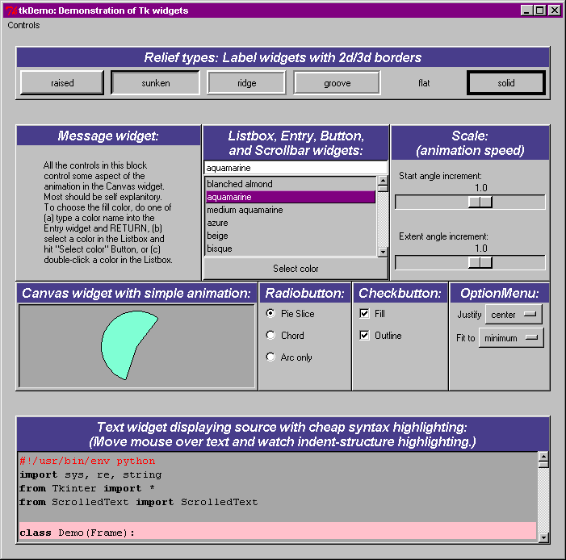

wxWindows
Cross-platform, but based on heavily on Windows.
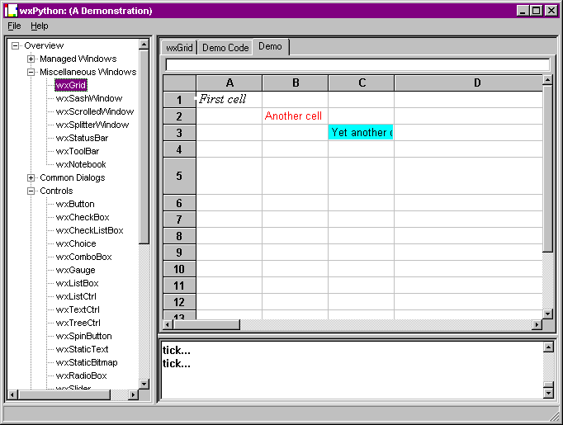

Delphi
C-Level API.
Python wrapped up as Pascal module
Python VCL components make it much easier than embedding in a C++ app.
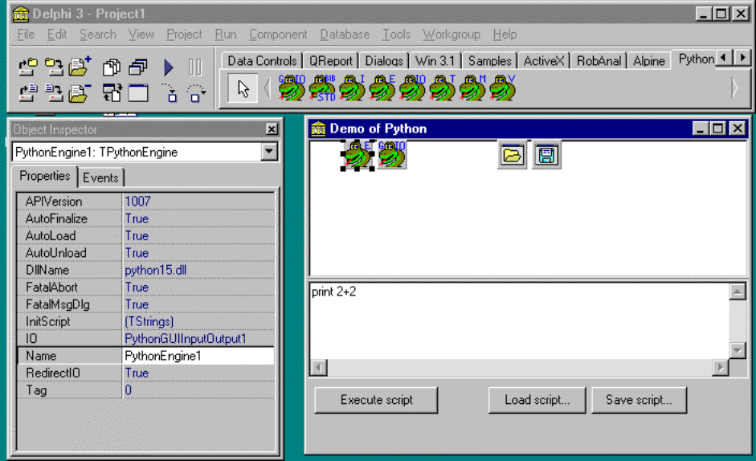

C and C++ Level Integration
Python is written in ANSI C, and is highly modular
- You can write new extension modules
- You can include Python in your existing C/C++ programs
- The win32 extensions are examples of this.
- Simplified Wrapper and Interface Generator (SWIG) helps automate the process of building extensions
- CallDLL/WinDLL dynamically calls DLLs without a C compiler

Win32 extensions
Module | Description
mmapfile | Interfaces to Windows memory-mapped files, a mechanism that allows data to be shared among multiple processes.
odbc | An interface to the Open DataBase Connectivity API, a portable API for connecting to multiple databases.
win32api | Access to many of the common and simple Windows APIs. A very general-purpose module with a cross-section of API support.
win32event | Access to the Windows event and signaling API. Allows you to manipulate and wait for Windows Events, Semaphores, Mutexes, and so forth.
win32evtlog  win32evtlogutil | An interface to the windows NT Event Log. The win32evtlog module provides a raw interface to the Windows NT API, while the win32evtlogutil module provides utilities to make working with the module much simpler. This is discussed in Chapter 18, Windows NT Services.
win32pdh | An interface to the Windows NT Performance Monitor. This module uses a helper DLL provided by Microsoft knows as the “Performance Data Helper”, or PDH, hence the name.
win32pipe | Access to the pipe related Win32 functions. These include functions for creating and using pipes, included named pipes. We discuss pipes briefly in Chapter 17, Files and Processes, and use a pipe from the win32pipe module in Chapter 18, Windows NT Services.
win32file | Access to the file-related Win32 functions. This exposes a low-level, raw interface to files on Windows, and is only used when the standard Python file object is not suitable. Python files, and the win32file module are discussed in Chapter 17, Files and Processes.
win32lz | An interface to the Windows LZ compression library. Note that Python also ships with support for the gzip compression format, but win32lz is handy as it does not require any external DLLs (eg, zlibp.dll) to be installed.
win32net  win32wnet | Interface to the Windows networking API.
win32print | Interface to the printer-related Windows APIs.
win32process | Interface to the process related Windows APIs. This is discussed in detail in Chapter 17, Files and Processes.
win32ras | Interface to the Windows Remote Access Service (RAS). Used for establishing remote connections to Windows NT Servers, typically using a modem.
win32security | Access to the Windows NT security related functions.
win32service  win32serviceutil | Access to the Windows NT Services-related API. This is discussed in detail in Chapter 18, Windows NT Services.
win32trace  win32traceutil | Debugging related modules. These modules allow you to collect the output of a Python process in a separate process. This is most useful when debugging server-style applications, where Python error and other messages are not available.

CallDLL/WinDLL
www.nightmare.com
Tiny (14k) Python extension giving you pointers, memory buffers, LoadLibrary() and GetProcAddress().
Windll wraps it up nicely: call any DLL!
>>> from dynwin.windll import *
>>> mod1 = module('c:\\temp\\simple') # loads the DLL
>>> mod1.handle # it can report its location in memory
22806528
>>> mod1.Min(27, 28) # loads and executes Min function
27
>>> mod1.Min # we now have a 'callable function' object...
<callable function "Min">
>>> mod1.Min.address #...which knows its address too
22836704

>>> inBuf = cstring('spam') # make a buffer holding a c string
>>> outBuf = cstring('',50) # make another big enough for output
>>> mod1.StringRepeat(inBuf, outBuf, 10) # returns the length of out string
40
>>> outBuf
'spamspamspamspamspamspamspamspamspamspam'

Of course, this also gives you the ability to crash, unlike a well-made Python extension.

The End

Great Big Five Letter Acronyms

