Le tuto date de 2011, la méthode d’installation (pour Juno) a changé, et WindowBuilder est désormais intégré à Eclipse.
Voir http://stackoverflow.com/questions/18134193/gui-builder-for-eclipse-juno-4-2

http://www.java-javafx.com/2011/01/windowbuilder-pro-hello-world-java.html

WindowBuilder Pro, Hello World Java Swing

>> 25 January 2011
A step by step tutor with images, Hello World Java Swing application, using WindowBuilder. This tutor describe the installation and Hello World Swing application.
WindowBuilder is a powerful and easy to use bi-directional Java GUI designer. It is composed of SWT Designer, Swing Designer and GWT Designer.
WindowBuilder Pro is built as a plug-in to Eclipse.
Very easy to use with it's WYSIWYG layout, with a drag and drop capabilities.
After Google have acquired Instantiations, WindowBuilder becomes new open source project with major code contribution to Eclipse Foundation.
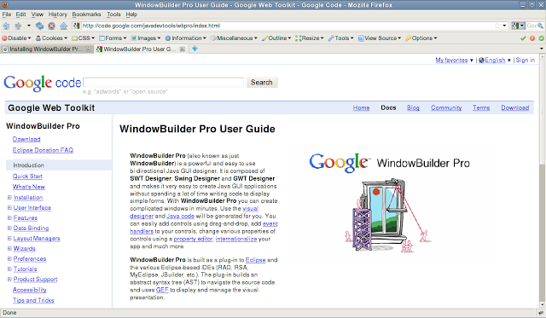

Thanks Google :)
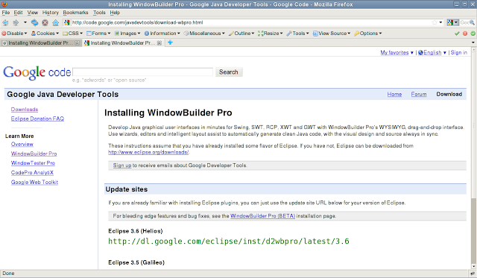
Installation :
In Eclipse -> Help menu -> Install New Software
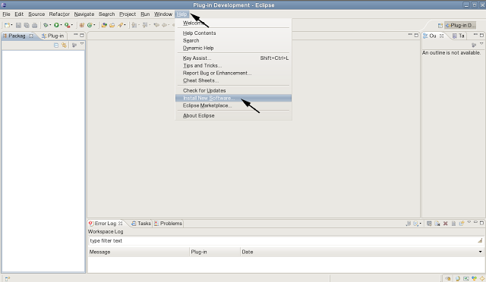
In the text field "Work with" enter the plug-in location of your Eclipse version ( Eclipse 3.6 Helios :
http://dl.google.com/eclipse/inst/d2wbpro/latest/3.6)
Click on "Add" button
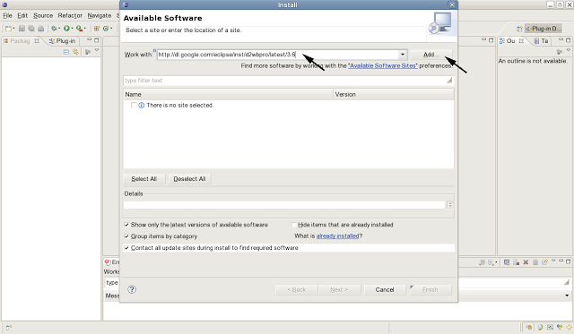
Give a name of your choice to this Repository -> Click on "OK"
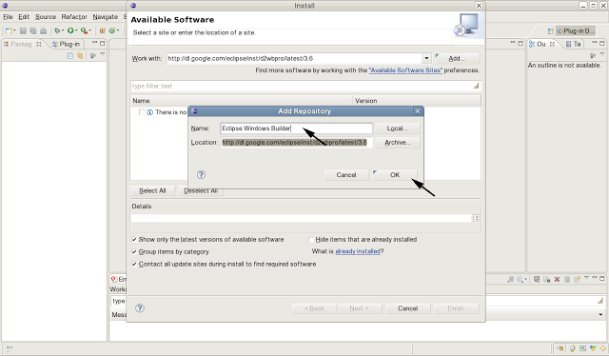
In "Available Software" dialog -> Select All -> Next
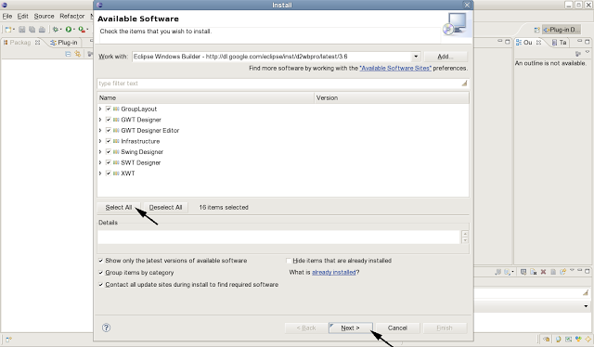
Install Details -> Next

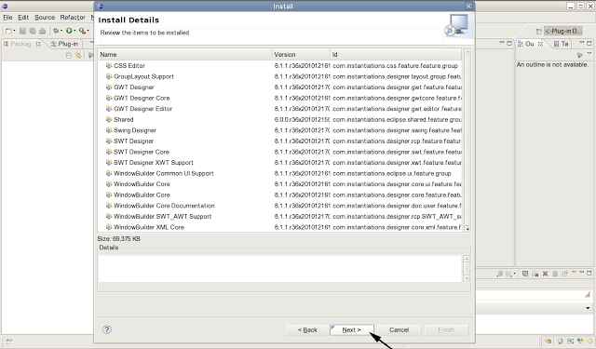
Review the license -> I accept -> Finish
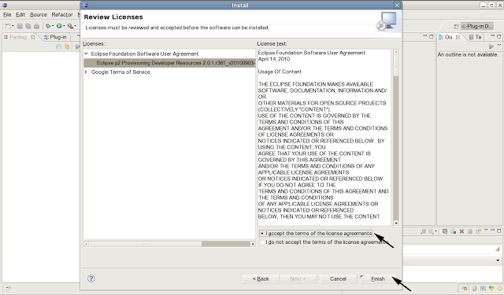
Installing Software
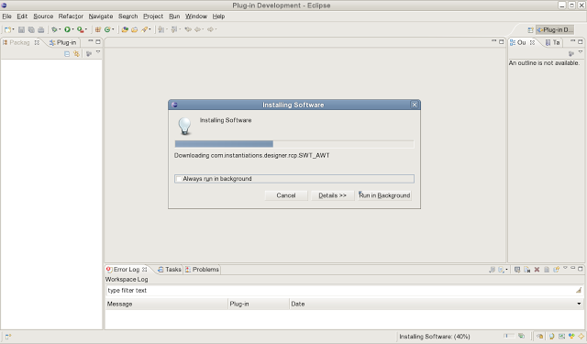
In "Security Warning" -> Click "OK" to continue
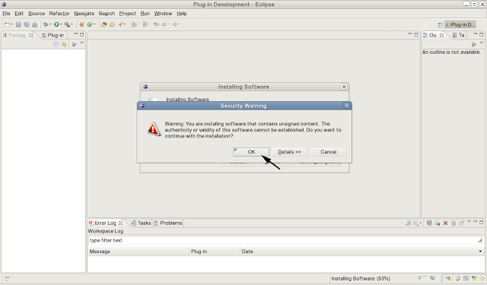
When installation finished -> Restart Now
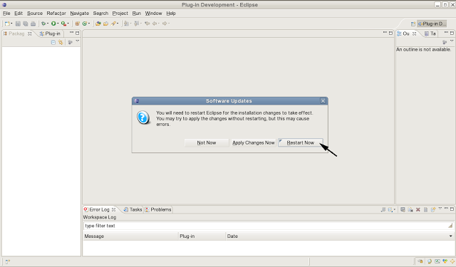
Hello World Swing
Create a new Java Project
File menu -> New -> Java Project
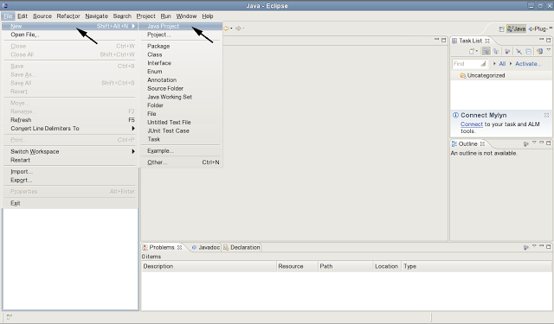
Give a name to your project in "Project name" -> Finish
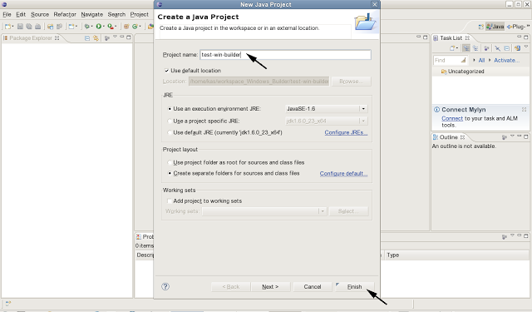

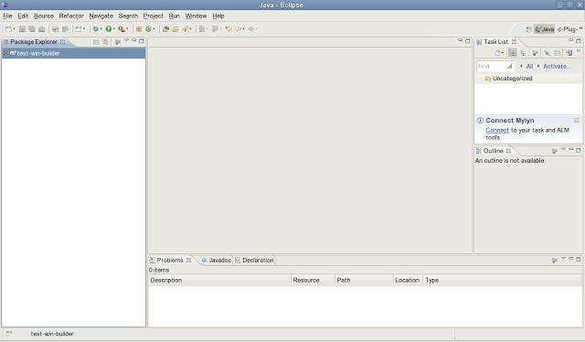
In "Package Explorer" -> Right click the project name -> New -> Other
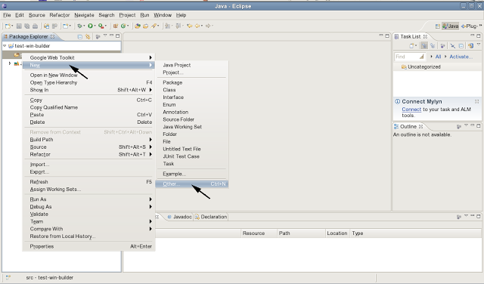
In "Select a wizard" dialog -> Select WindowBuilder -> Swing Designer -> Jframe -> Next
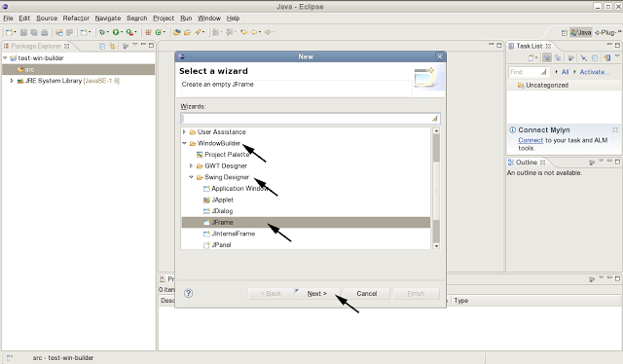
Enter a name for the JFrame -> Finish
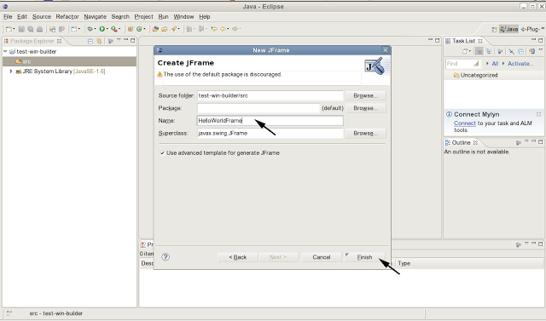
HelloWorldFrame.java (the name given to the JFrame class) is opened in the editor (source). To open the Swing Designer -> Click on "Design" tab
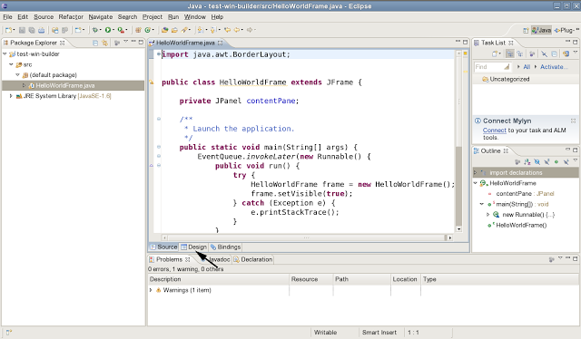

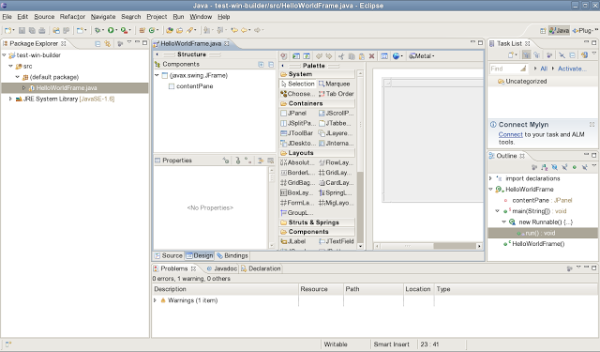
To open the Swing palette in it's own view -> Window menu -> Show View -> Other
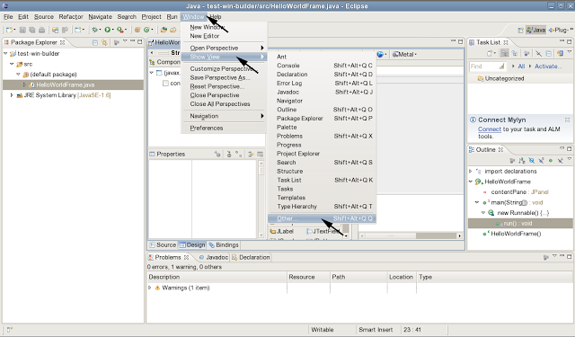
Under WindowBuilder -> Palette
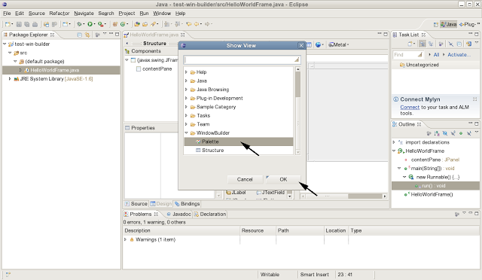

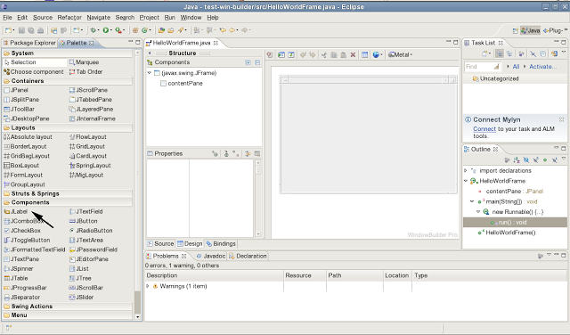
Add JLabel to the Frame
Click on JLabel component in the palette -> Drag to the Frame
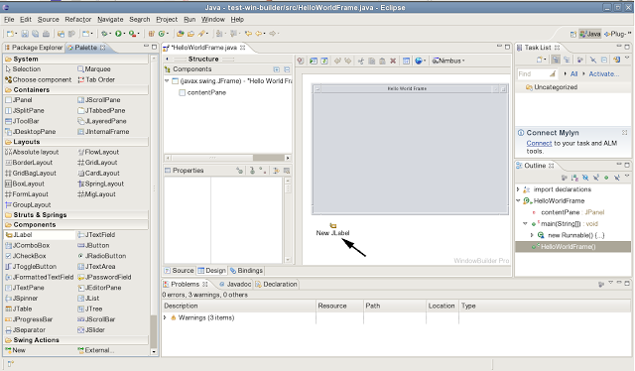

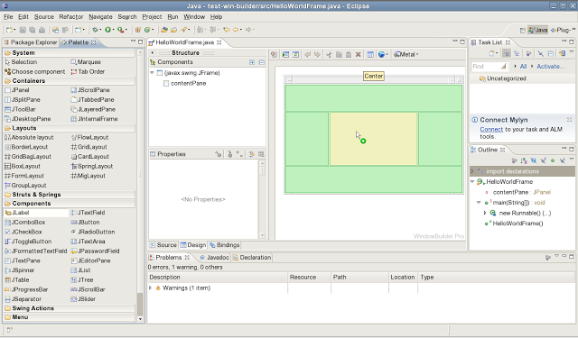
Drop on the Frame. The JLabel is added
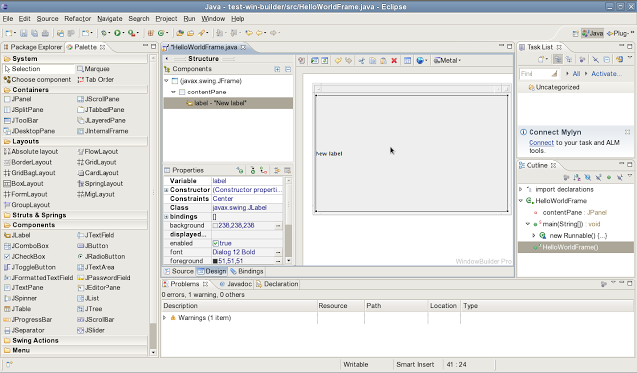
In the "Properties" dialog -> Modify the label's text -> Hello World Swing !!!
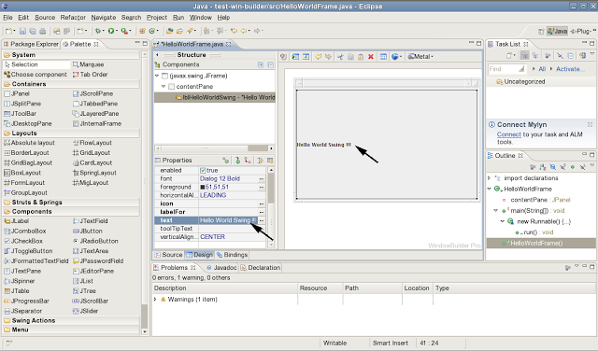
The source is modified. Notice the clean code.
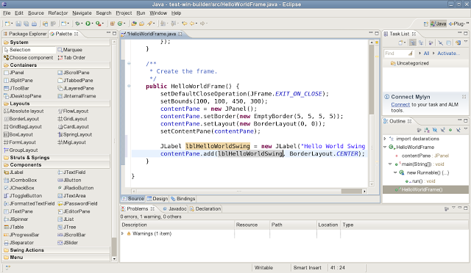
Run the application
Right click on the project (in Package Explorer) -> Run As -> Java Application
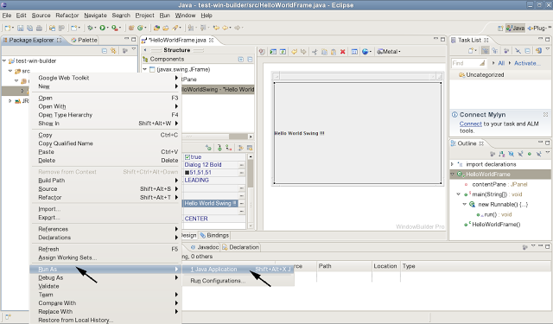
Et voilà
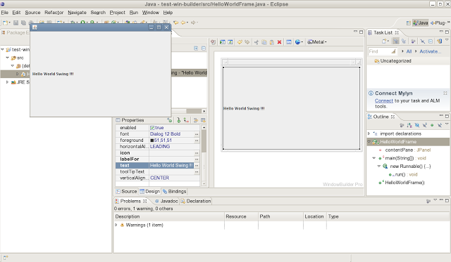
Going further
Other modification to JFrame are easy made, like changing the Frame's title, icon, or adding any other components, or modifying the layout, etc.
Enjoy an easy and efficient design.
