BERNARD ARIKU OKO

FULLSTACK ENGINEER
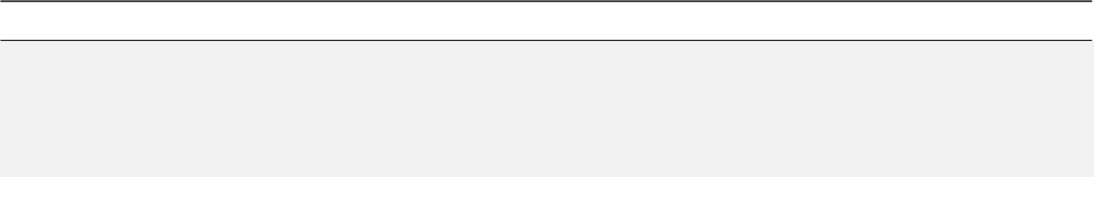

ABUJA, NIGERIA | +234 811 797 4441 | BERNARDARIKUOKO@GMAIL.COM

A seasoned Full Stack Engineer, specializes in MERN stack development, with 6+ years experience. I have led numerous projects, showcasing my proficiency in creating robust, scalable web applications
My expertise lies in architecting high-performance web applications, leveraging MongoDB, Express.js, React.js, and Node.js My professional journey reflects an unwavering commitment to continuous learning and adaptation.

GITHUB: @BERNARDIHO10 | LINKEDIN: @BERNARDIHO10 | TWITTER: @BERNARD_IHO

PROFESSIONAL EXPERIENCE
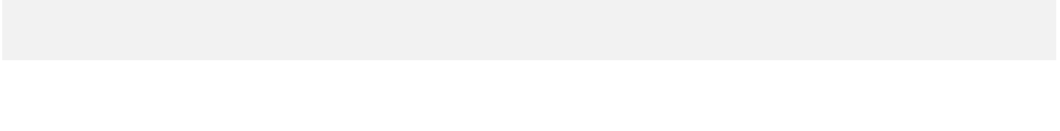

BOOKS EMBASSY (www.booksembassy.com) | 2nd Floor Gwandal Plaza
Full Stack Engineer : Aug 2021 – PRESENT | FCT, Abuja, Nigeria

Lunched and lead the development of the companies website and recuruited 5 developers to the team.

Grew office revenue by 30% in first 6months. Promoted wiithin 1 year to product manager due to strong performance and organizational impact(one year ahead of schedule).

- Developed and optimized an educational consulting platform, focusing on user registration and document upload functionalities.

- Implemented cost-effective cloud solutions, leading to a 25% reduction in operational costs and increased profitability.

- Engineered a scalable web infrastructure capable of handling a significant increase in user signups and document uploads.

- Integrated a custom analytics dashboard to track user engagement and document management efficiency.

- Deployed innovative features to enhance the user experience, increased user satisfaction and higher engagement rates.

- Analyzed data from 500 monthly active users and usd output to guide marketing and product strategies

BODYMOTIONSPHYSIO (www.bodymotionsphysio.com) | Yesuf Abiodun Way, Victoria Island
Backend Engineer : Sept 2019 – June 2021 | Lagos, Nigeria

Body Motions Physio is a leading healthcare provider specializing in physiotherapy services.

My role as a Backend Engineer was crucial in enhancing the digital experience for patients, significantly improving site performance and patient engagement, which positively impacted the company's reputation and patient base.

    - Collaborated on patient-centric features, resulting in a 25% increase in patient engagement.

    - Automated appointment scheduling, boosting operational efficiency by 30%.

    - Overhauled the obsolete legacy source code of two production applications, resulting in reduced run time performance by 50%

  - Developed and maintained secure, HIPAA-compliant patient data systems, ensuring data integrity and confidentiality.

- Enhanced the website's backend, leading to a 20% increase in site traffic through improved performance and reliability.
EFIKO FREELANCE MARKETPLACE (www.efiko.co) | Suite F4, Alibro Atrium,
Frontend Engineer : Feb 2017 – July 2019 | FCT, Abuja, Nigeria

Efiko is a dynamic freelance marketplace that offers a wide range of services

Starting as a Junior Developer, I demonstrated exceptional skill and dedication, leading to a rapid promotion

to Senior Developer in under two years. My contributions, especially in frontend development, were instrumental in enhancing the platform's user experience and overall performance directly contributing to its substantial user growth and market presence.

    - Enhanced site functionality with new features, contributing to a 30% rise in user activity.

    - Performed site test and fixed minor bugs

  - Optimized site speed, resulting in a 45% improvement in page load times, boosting SEO and traffic

- Improved website accessibility and user engagement, leading to a 20% increase in user registrations.

SKILLS & CERTIFICATIONS

Softskills: Communication and collaboration, Problem-solving and critical thinking, Adaptability and learning agility

Front-End: HTML, CSS, JavaScript, Reactjs, Material UI,

Back-End: Java, C++, Go, Python, PHP, Laravel, Express, Nodejs

DevOps: Docker, Kubernetes, Jenkins

Testing: Jest

Database: MongoDb, Mysql, Postgres

Version Control: Git

Collaboration & Communication: Slack, Jira, Trello

Certifications: Microsoft Certified: Azure AI Fundamentals (ID: AD1435CCE4158056)

EDUCATION

BSC in Electronic Computer Technology (with 2nd Class Honours)

| UNIVERSITY OF CALABAR, NIGERIA

WAEC (A-Levels)

| CALVARY GROUP OF SCHOOLS | ABUJA, NIGERIA

FUTURE APPLICATION CERTIFICATIONS

Currently undergoing certifications in Microsoft AI Engineer Associate, Microsoft Azure AI Solution

HOBBIES AND INTERESTS

Football has been a major passion of mine. I achieved significant milestones, including winning the Deans cup in University and taking second place in the Nigerian University Games Association football tournament. I was also voted the third-best player and earned the title of highest goal scorer. Notably, I received the award for fair play. Football has taught me valuable lessons in discipline and teamwork.

REFERENCES

Joe Agi(SAN). CEO - Joe Agi, SAN & Associates | +234-803-331-5050

Mrs Tosin Oko. HOD University of Calabar | +234-809-096--9457

PORTFOLIO: https://bernardarikuoko.vercel.app/

