The costs of each style and the price of each unsold item are shown in the table below. We know from the case that Obermeyer earns 24% of the wholesale price on each parka sold, and for those unsold items it loses 8% of the wholesale price. With those numbers we can calculate the cost of understock and the cost of overstock, from there we can derive the cost of each item and the sale price.

|  |  |  |  |  |  |
| --- | --- | --- | --- | --- | --- |
| Style | Wholesale price | Cost Understocked  (Price *24%) | Cost Overstocked (Price*8%) | Cost  (Price-Cu) | Sales Price (Cost – Co) |
| **Gail** | 110 | 26.4 | 8.8 | 83.6 | 74.8 |
| **Isis** | 99 | 23.76 | 7.92 | 75.24 | 67.32 |
| **Entice** | 80 | 19.2 | 6.4 | 60.8 | 54.4 |
| **Assault** | 90 | 21.6 | 7.2 | 68.4 | 61.2 |
| **Teri** | 123 | 29.52 | 9.84 | 93.48 | 83.84 |
| **Electra** | 173 | 41.52 | 13.84 | 131.48 | 117.64 |
| **Stephanie** | 133 | 31.92 | 10.64 | 101.08 | 90.44 |
| **Seduced** | 73 | 17.52 | 5.84 | 55.48 | 49.64 |
| **Anita** | 93 | 22.32 | 7.44 | 70.68 | 63.24 |
| **Daphne** | 148 | 35.52 | 11.84 | 112.48 | 100.64 |

The second step was to use the Montecarlo Method to generate random variable samples of the demand which are normally distributed, taking as reference the mean and the standard deviation of each style shown in Exhibit 10.

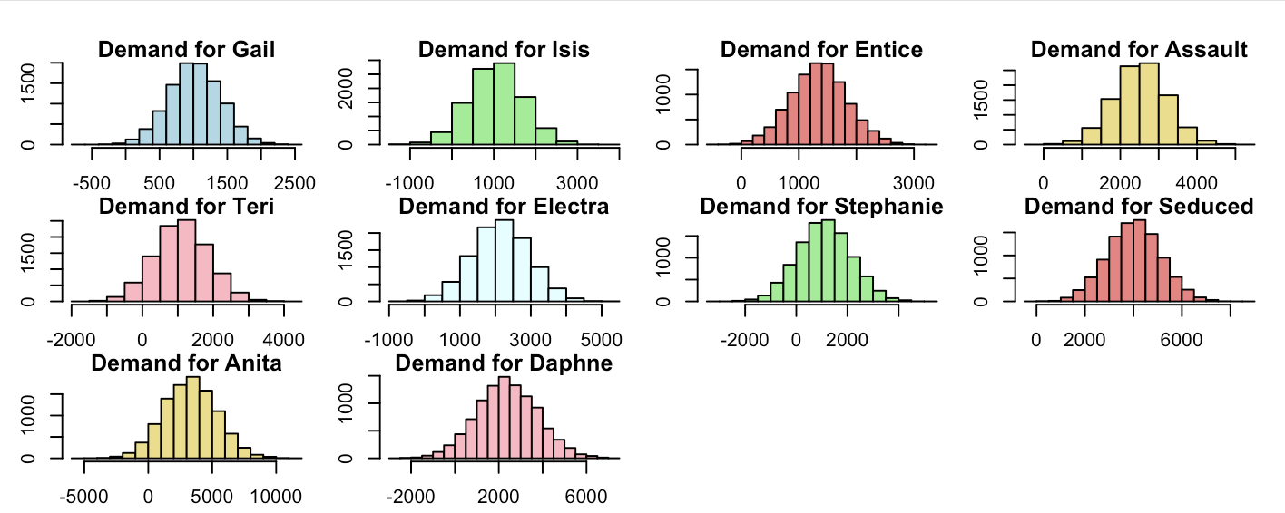

Once all the data has been calculated, it is time to estimate how many parkas should be produced for each style. We will create a general function and then calculate the optimum Q for each style.

When optimizing the parkas with cheaper wholesale prices, they reach the maximum of the range of values. We will reduce the range of those values, as they are the cheapest ones, the cost of understock will not impact that much.

|  |  |  |  |
| --- | --- | --- | --- |
| Style | Optimum Q* | Optimum Q* adjusted to have < = 20000 | Half of the Optimal Q* for the initial order |
| **Gail** | 1275 | 1275 | 638 |
| **Isis** | 1488 | 1488 | 744 |
| **Entice** | 1600 |  |  |
| **Assault** | 2800 |  |  |
| **Teri** | 1619 | 1619 | 810 |
| **Electra** | 2689 | 2689 | 1345 |
| **Stephanie** | 1819 | 1819 | 910 |
| **Seduced** | 4600 |  |  |
| **Anita** | 4400 | 2800 |  |
| **Daphne** | 3331 | 3331 | 1666 |
| **Totals** | 25621 | 20,233 |  |