Deep Learning
Sequence-Based Data: Sentiment Analysis with RNN and GRU
Universidad de Deusto - Facultad de Ingeniería
Daniel Sánchez - May 2025

1. Introduction
This project addresses sequence-based data processing as covered in topic 10 of the Deep Learning course. The task chosen is binary sentiment analysis on the IMDB movie review dataset — a classic NLP benchmark that requires a model to classify a review as positive or negative.
Text is inherently sequential: the meaning of a word depends on the words that precede it. A standard multi-layer perceptron (MLP) processes each input independently and therefore cannot capture this temporal dependency. Convolutional neural networks (CNNs) improve on this by looking at local windows of tokens, but they still lack a persistent memory across the full sequence.
Recurrent Neural Networks (RNNs) were specifically designed to handle sequences by maintaining a hidden state that is updated at every time step. This project implements and compares two architectures:
- Vanilla RNN — the baseline architecture introduced in the 2010s.
- Gated Recurrent Unit (GRU, 2014) — an improvement that addresses the long-term memory limitations of the vanilla RNN via reset and update gates.

2. Dataset
The IMDB Large Movie Review Dataset consists of 50,000 English movie reviews split evenly into 25,000 training samples and 25,000 test samples. Each review is labelled as either positive (1) or negative (0), with a balanced class distribution of 50% each.
The dataset was loaded via the Hugging Face datasets library. Each review was preprocessed as follows:
- HTML tags were stripped with a regex substitution.
- Text was lowercased and tokenised by extracting alphabetic tokens only (regex \b[a-z]+\b).
- Sequences were truncated to a maximum of 256 tokens.
A vocabulary was built from the training set only, retaining words that appear at least 5 times (MIN_FREQ = 5). Tokens outside the vocabulary are mapped to a special <unk> token. Sequences are padded within each batch to the length of the longest sequence in that batch.
Property | Training set | Test set
Samples | 25,000 | 25,000
Positive / Negative | 50% / 50% | 50% / 50%
Max sequence length | 256 tokens | 256 tokens
Vocabulary size | ~30,000 tokens | (same vocab)
Table 1. Dataset summary.

3. Model Architecture

3.1 General pipeline
Both models share the same input/output pipeline:
- Embedding layer: maps each token ID to a dense vector of size 128. The padding token is ignored (padding_idx=0).
- Recurrent layer: processes the sequence left to right, updating a hidden state at every step.
- Classifier head: the final hidden state (many-to-one configuration) is passed through a dropout layer and a linear layer, producing a scalar, and then through a sigmoid to obtain a probability.
- Loss: Binary Cross-Entropy (BCELoss). Optimiser: Adam with learning rate 1e-3.
- Gradient clipping (max_norm=1.0) is applied to prevent exploding gradients, a known problem with RNNs.

3.2 Vanilla RNN
The recurrent layer is nn.RNN with tanh activation, matching the slide equation: h_t = tanh(W_hh · h_{t-1} + W_hx · x_t + b_h). Two stacked layers are used (num_layers=2), with dropout=0.3 between them.

3.3 GRU
The recurrent layer is replaced with nn.GRU. The GRU introduces two learned gates per time step:
- Reset gate r_t: controls how much of the previous hidden state to forget when computing the candidate hidden state.
- Update gate z_t: controls the trade-off between the previous hidden state and the new candidate, acting as a weighted average: h_t = z_t · h_{t-1} + (1 − z_t) · ĥ_t.
These gates allow the GRU to selectively preserve long-range information, directly addressing the bad long-term memory limitation of the vanilla RNN. All other hyperparameters remain identical.

Hyperparameter | RNN | GRU
Embedding dim | 128 | 128
Hidden size | 256 | 256
Num layers | 2 | 2
Dropout | 0.3 | 0.3
Epochs | 5 | 5
Learning rate | 1e-3 | 1e-3
Batch size | 64 | 64
Table 2. Hyperparameters (identical for both models).

4. Results

4.1 Vanilla RNN
The vanilla RNN failed to learn any useful representation. Training accuracy oscillated around 50% for all 5 epochs, and the loss barely moved. The model was effectively guessing randomly.
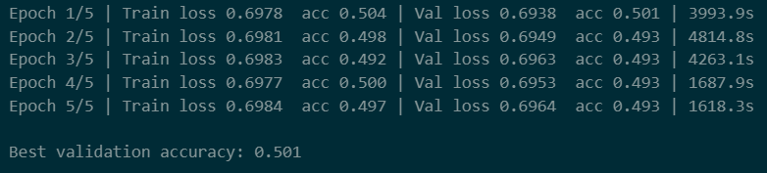
Figure 1. Vanilla RNN training log — loss and accuracy stagnate across all 5 epochs.
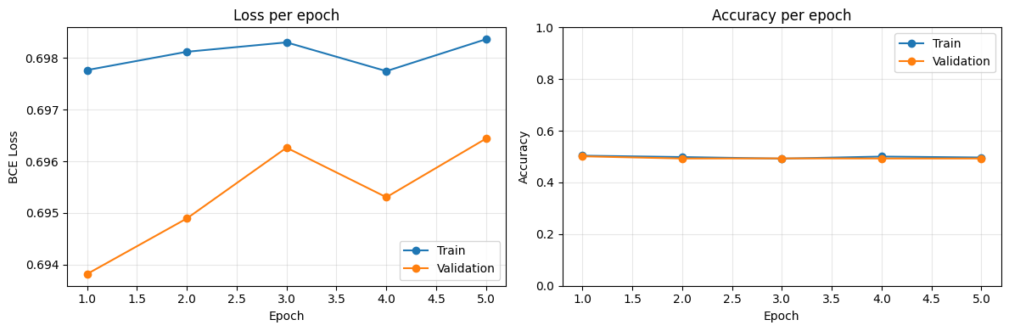
Figure 2. Vanilla RNN training curves — both train and validation accuracy remain flat at ~50%.
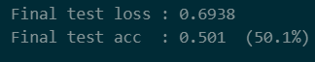
Figure 3. Final test accuracy of the vanilla RNN: 50.1%.
The inference results confirm the failure: clearly positive reviews were classified as negative and vice versa, with confidence values very close to 0.50.
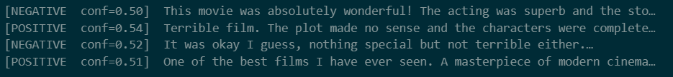
Figure 4. RNN inference — predictions are inverted and near-random.

4.2 GRU
Switching from nn.RNN to nn.GRU (a one-line change in the model definition) produced dramatically better results. The model learned rapidly from epoch 2 onwards, reaching 87.3% test accuracy.
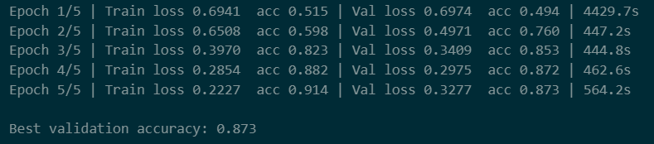

Figure 5. GRU training log — accuracy rises steadily from 50% to 91% (train) / 87% (val).
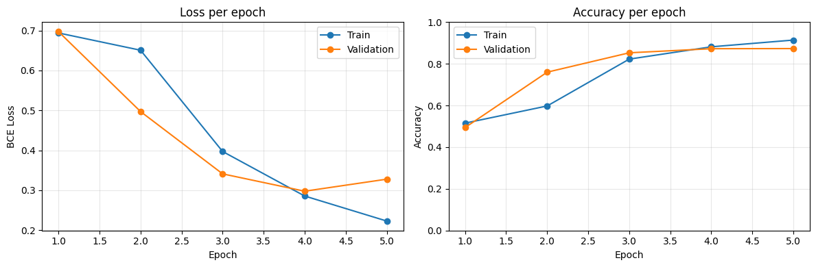
Figure 6. GRU training curves — clear learning signal, slight overfitting from epoch 4.
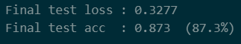
Figure 7. Final test accuracy of the GRU: 87.3%.
The inference results on custom reviews confirm the model's capability:
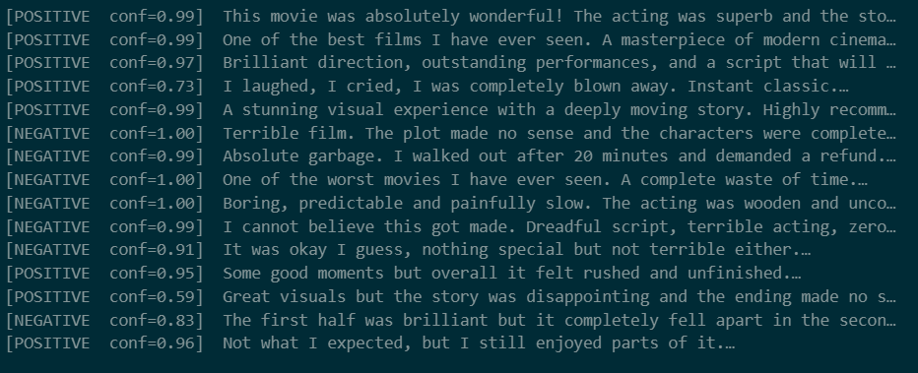
Figure 8. GRU inference — clearly positive/negative reviews are predicted correctly with high confidence (0.97–1.00). Ambiguous reviews show lower confidence, as expected.

4.3 Summary comparison
Metric | Vanilla RNN | GRU
Best val. accuracy | 50.1% | 87.3%
Final test accuracy | 50.1% | 87.3%
Final test loss | 0.6938 | 0.3277
Learning behaviour | No learning | Rapid convergence
Inference quality | Random / inverted | Correct, high confidence
Table 3. Performance comparison between vanilla RNN and GRU.

5. Discussion

5.1 Why the vanilla RNN failed
The vanilla RNN suffers from two well-known problems that are clearly visible in the results:
- Vanishing gradients: with sequences of up to 256 tokens, gradients from the early time steps become vanishingly small by the time they propagate back through 256 unrolled cells. The weights are barely updated, so the model cannot learn which words in the beginning of a review are important.
- Bad long-term memory: at each time step, the hidden state is fully recomputed as a weighted sum of the input and previous hidden state. Early context is continuously overwritten and lost. A review that opens with strong negative language may be forgotten by the time the model processes the end.
Both problems are inherent to the architecture and cannot be fixed by training longer or adjusting the learning rate alone.

5.2 Why the GRU succeeded
The GRU's update gate directly solves the long-term memory problem: when z_t is close to 1, the hidden state is simply carried forward unchanged, effectively creating a direct gradient path through time and preventing vanishing gradients. The reset gate additionally allows the model to ignore irrelevant parts of the previous state when the new input is informative.
This is exactly the motivation described in the topic 10 slides: the GRU was designed as a fix for the bad long-term memory limitation of vanilla RNNs.

5.3 Analysis of ambiguous cases
The GRU handled clearly positive and negative reviews with near-perfect confidence. For ambiguous mixed reviews, confidence dropped to 0.59–0.95, which is the correct behaviour — the model is uncertain because the ground truth is genuinely ambiguous. This shows the sigmoid output is well-calibrated.

5.4 Potential further improvements
Improvement | Expected benefit
LSTM (3 gates) | Even stronger long-term memory protection than GRU
Bidirectional GRU | Reads sequence in both directions; captures context from future tokens
Pre-trained embeddings (GloVe) | Better initialisation; words start with meaningful geometry
Transformer / BERT fine-tuning | State of the art for NLP; attention mechanism replaces recurrence entirely
More epochs + LR scheduling | The GRU curve shows no clear convergence plateau at epoch 5
Table 4. Possible improvements ordered by expected impact.

6. Conclusion
This project demonstrated the complete pipeline for sequence-based NLP with PyTorch: data loading and preprocessing, vocabulary construction, Dataset/DataLoader with variable-length padding, model definition, Backpropagation Through Time (BPTT) with gradient clipping, and evaluation.
The experiment confirmed the theoretical claims of the course slides. The vanilla RNN, while conceptually sound, is unable to learn from long sequences due to vanishing gradients and poor long-term memory. The GRU, introduced in 2014 as a direct response to these limitations, achieved 87.3% test accuracy on the IMDB dataset with identical hyperparameters — a 37-percentage-point improvement from a single architectural change.
The results validate the GRU's gating mechanism as an effective solution and motivate the further step to LSTM and Transformers for even more complex NLP tasks.

