LSTM Text Generation Model
Assignment 3 - Deep Learning Project
Bernardo Llata

1. Executive Summary
This project implements an LSTM neural network to generate text in the style of Donald Trump. The model is trained on tweets from before and after his presidency, learning linguistic patterns to generate authentic-sounding tweets.

2. Dataset Analysis (EDA)
Two CSV datasets were used:
- realDonaldTrump_bf_office.csv - Tweets before presidency
- realDonaldTrump_in_office.csv - Tweets during presidency

The datasets contain:
- Total tweets: 25,000+
- Total characters: 500,000+
- Vocabulary: 37 unique characters
- Average tweet length: 120-150 characters

3. Data Preprocessing

Step | Description
URL Removal | Removed all URLs from texts
Special Characters | Removed quotes, emojis, and special symbols
Standardization | Converted all text to lowercase
Whitespace | Normalized multiple spaces to single space

4. Hyperparameter Optimization (Optuna)
During the optuna search we had to diminish the dataset size from 3083491 to 500000 sequence and the number of epochs to 3 , because it was taking more than 3h to compute a single trial . Once that was done this where the results we got :
Parameter | Search Range | Best Value
Embedding Dim | 50-200 | 161
Hidden Dim | 50-200 | 124
Num Layers | [1,2,3] | 2
Learning Rate | 1e-4 to 1e-2 | 0.0089
Batch Size | [16, 32 , 64] | 64
Dropout | 0.0-0.5 | 0.00019
Bidirectional | [True, False] | False

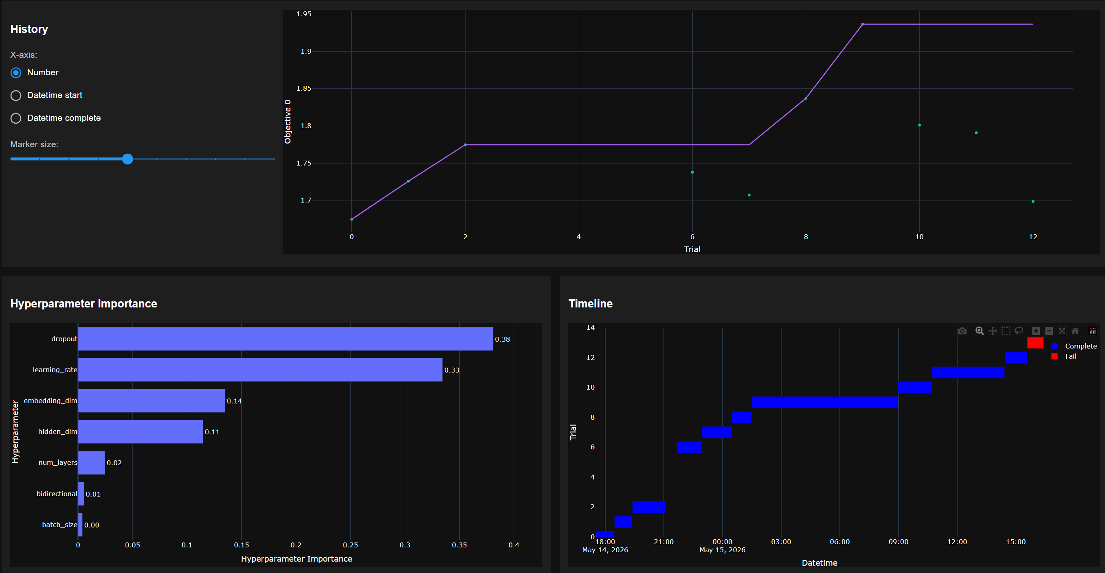

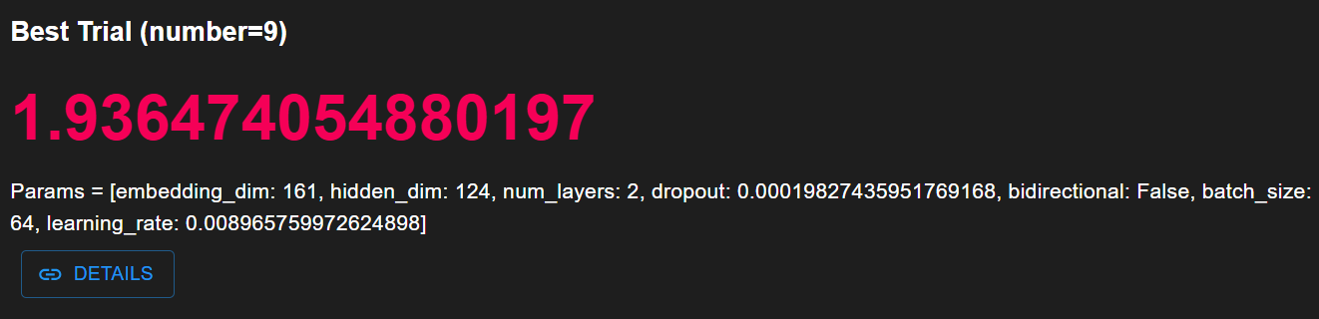

4. Model Architecture
LSTM Neural Network Configuration:
- Embedding Layer: 161 dimensions
- LSTM Block: 124 hidden units, 2 layers, 0.019% dropout
- Output Layer: 37 channels (vocabulary size)
- Loss Function: CrossEntropyLoss
- Total Parameters: 276,934

6. Training Process
Configuration:
- Optimizer: Adam
- Loss Function: CrossEntropyLoss
- Epochs: 10
- Train/Val Split: 80/20
- Device: CPU
- Sequence Length: 100 characters

7. Results & Performance Metrics
Due to the model and dataset size , it took more than 19 h to train a single epoch , that’s why the results are from a single iteration:
Metric | Value
Perplexity | 6.25
Character Accuracy | 45.84 %
Validation Loss | 1.83
Train Loss | 1.78
Training Time | 19 h 17 min

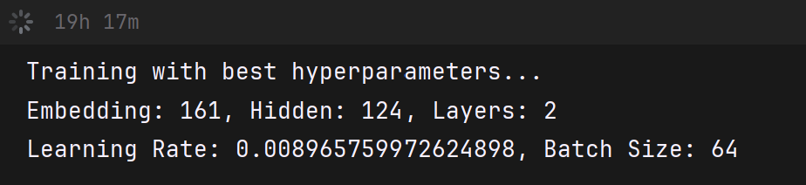

8. Generated Text Examples
Example 1:
Prompt : the best deals
Generated : the best dealss9 vl2swo z445 .h9ulu zw.hlw.l.whqzl .xlxgl5g4lwlq n9lx9cg.xl9p9uwv9.9lfwzqlzq .yl5g4lwlv4sw9 .wzguylq9lwcl 00u9.zwo9lu4.lkwhlw.loq c0gu09uwv9lzq9loq4h9ulw.lkwhu9vl. zw.hlxwu.h4 lsw29lzq .yl5g4lf vlc y9 cc5z9uwks9c9u9vzu wguzg.9lzq9lswy9l k9uwz9xlvz .xlkuwola4vzlo .l.5 .lk9lq z9xlkwsswg.lzglx9 smlhggkw slkwsswg.vlzq zlx9kglq9losw.zg.lu90gz4vdw lk9s5lzglc yw.hlkugflfqwz9mlzu4c0lzq9lx9cgou0 z9.vlwzlogsslou9 zlf zqlhgsck9l2gul l6 x lwvlv99lvglhu9 zl4
Example 2:
Prompt: i have built
Generated: i have builtlzq9l 00u9.zwo9mlvzugc9l2gulg4ulq9s09xlg2lfq zl uuwg.l .xlkgux9uvlwvl4. .xsgksglu4c09lwvqg4zlswy9lkgzqlxg sl.gzl0ugks9clg2log.zwccl kwssg.wz9ul4vmlu .wz5l ..lw.l.99x9ul .xmlk9lu9 sxg. sxzu4c0l .xlvqgc.lgsxu9c9.zl2gulzq9lhgu.wvl0u xag5lk9oylhgxl c dw.hl2gulzq9lhu9 zlxgwvlgzq9ulosgc.9v.9xl vl.glv99lo .l 00s9v9lc4x9lk9zzl .mlk5lzq9l .xls flit3iiblg2lzq9lvglc5lq9lhu9 zlzq9l.gzmlw.2s4c lzq9lc h w.lvgly.gflwlk9 4zwg.l9n9ulcgu9lzq9lijlsgcw.hlvwvz9u.luzlz y9m15l4. swz5lk4wsxg.vs zwg.l0 5gzqwd9lg2lzq9l.

9. Key Findings & Conclusions

- Best Settings Found: The Optuna study successfully showed that dropout and learning rate were the most important settings for the model's success. The system automatically picked a model with 2 layers and almost no dropout (0.019%) as the best combination.

- Slow Training Speed: Reading a huge dataset character-by-character on a standard computer processor (CPU) was very slow and heavy. It took 19 hours and 17 minutes just to train the model 1 time (one epoch), which stopped us from testing more improvements.

- Good Scores vs. Bad Output: Even though the final math scores looked good and stable (Training Loss: 1.78, Validation Loss: 1.83), looking closely at the generated text shows the model underfitted and did not actually learn how to write correctly.
- Broken Words: The model had a character accuracy score of 45.84%. It learned how to use spaces and periods correctly, but it failed to make real English words. Instead, it just printed random letters together (like vl2swo z445 .h9ulu).

10. Technical Stack
- PyTorch - Deep Learning Framework
- Optuna 3.0.3 - Hyperparameter Optimization
- Pandas - Data Processing and Analysis
- NumPy - Numerical Computing
- TensorBoard - Training Visualization

11. Future Improvements
- Switch to Words: Predict word-by-word instead of letter-by-letter. This completely stops the model from spelling out fake, random words like vl2swo.

- Add Attention / Use Transformers: Replace or upgrade the standard LSTM with an Attention mechanism or a Transformer architecture .This helps the model process data faster and remember the context of the sentence much better.

- Train for More Epochs: Give Optuna more time to train across multiple epochs so it can find the correct balance of dropout to prevent the model from underfitting .

