Music Genre

| Bernardo Faria  MEIC  Lisbon, Portugal  bernardo.faria@tecnico.ulisboa.pt | Samuel Vicente  MEIC  Lisbon, Portugal  samuel.vicente@tecnico.ulisboa.pt | Sofia Martins  MEIC  Lisbon, Portugal  sofia.carvalho.martins@tecnico.ulisoa.pt |
| --- | --- | --- |

# ABSTRACT

UPDATED—22 December 2020. FAZER NO FIM This sample paper describes the formatting requirements for SIGCHI conference proceedings, and offers recommendations on writing for the worldwide SIGCHI readership. Please review this document even if you have submitted to SIGCHI conferences before, as some format details have changed relative to previous years. Abstracts should be about 150 words and are required.

## Author Keywords

Authors’ choice; of terms; separated; by semicolons; commas, within terms only; this section is required.

## ACM Classification Keywords

H.5.m. Information interfaces and presentation (e.g., HCI): Miscellaneous; See<http://acm.org/about/class/1998> for the full list of ACM classifiers. This section is required.

# INTRODUCTION

Music is a passion for us, the authors of this paper and is also a world of choices: there are more than a thousand music genres that have been created until today. In this streaming era, genres are becoming more blended, and even Spotify has labeled over 3,000 genres to their available content. There is a lot to choose from. Each one of us has an interest in different musical genres. This difference, together with our passion for this art, helped us choose the domain of musical genres and to present popular artists within each one.

Music is not just listening to it: it is far beyond. It is also knowing the background, what is behind it. It is relevant for us to learn when a certain genre originated. It may be more recent, but it did not cause a major impact; it may be older and have recently return to the top of the lists, a resurgence. It is very interesting to watch the evolution of this art: this is our proposition.

Recently, it is increasingly common to use platforms to listen to music: these concentrate almost every single proof of each genre. We can say they have everybody’s cup of tea. Therefore, we found interesting using these platforms’ data to obtain information about the most recent decades. With our project, we intend to have an overview of the evolution of the biggest music genres, their origin, and their popularity; which are the most famous artists; what is the geographic distribution of artists compared to a genre: is it a genre popular in a certain country, but the artists who elevated them to the tops are from the other side of the globe? This also takes us into a journey around the world, to discover these crossings in this art history.

## Our First Questions

Finally, we wrote some initial questions, which we, as a group, were interested in answering. Based on these, we started developing our work: how has a genre popularity evolved over the decades? What are the most popular artists of this same genre? And where did they come from? What more artists, whether on the top or not, are related to these? How has a particular genre evolved in a particular country? And did an artist always kept the same genre, or did it try new paths, risking different or even opposite genres? There were our initial questions that motivated us to carry out this project

# Related work

Music is a common art in the daily basis of most people, thus is an art well studied and investigated, for business purposes or simply to admire how music works. For our study, we searched how visualizations of these studies are being created and what could we improve.

This art could turn into a general study of timelines or in a deeper way, how different characteristics like volume, mood, melody, instruments, tempo etc. that can be extracted from the audio file change depending its genres, existing multiple visualizations about it.

Due to technology, there are various authors that generate a visual studies of specific sound properties that enable users to interact and visualize the music in a way that is more understandable, meaningful, and entertaining. One of the interactive interfaces which is Visualizing Genres [1] is presented for how visualizing genre data could help us understand its music landscape with publicly available data. The interface consulted Spotify’s API to get their assigned genres, which is one of the objectives for our visualization, even lacking interactivity, since the only interaction available is selecting a square, which represents a genre.

In order to design and develop music visualization it is possible to have real-time animation where animation is generated based on the music data when it is played, like the Windows Media Player (1998) and preprocessed animation that is developed by the author according to specific ideas about the purpose of the animation. One related work that

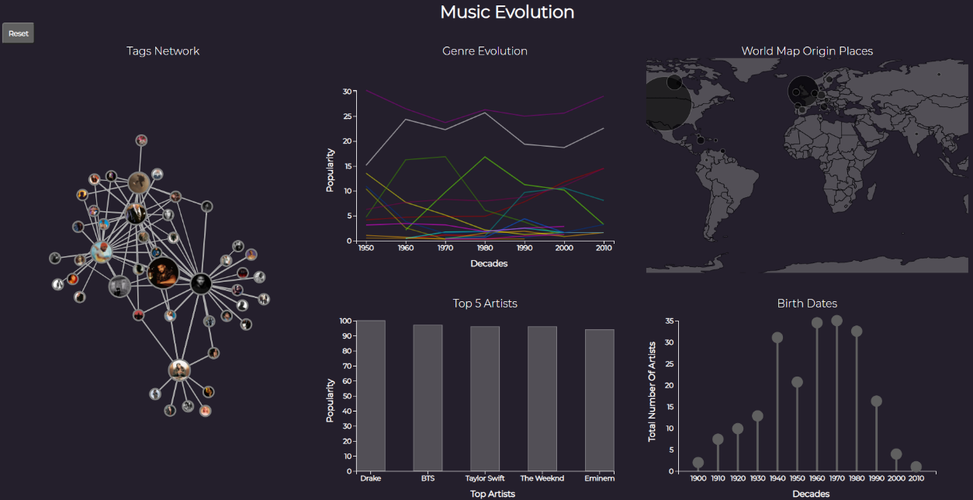

Figure 1. Layout

helped our visualization is Musicmap [2] that attempts to provide a genealogy of popular music genres, including their relations and history, making easy to understand despite its complexity. The authors choose a specific number of genres, determining forms of hierarchy and analogy and ordering everything in a logical way.

MusicPopcorn [3] displays in a network idiom how genres and sub genres are related with inserting the notion of genre hierarchy. This introduction of a network to understand the relations with genres gave us the idea to display how the genres and artists can also relate.

These visualizations had the genre in common but the artists and how they are connected even though the genre it is not the same are not displayed, we found that this type of relations were not being used as a form of data visualization. Therefore, we decided to use as an idea these sources and join them in a visualization that could also answer us to the initial questions.

# THE DATA

Since the source of our dataset was an essential aspect to us, we planned to retrieve from platforms that we used, so we can also learn what these APIs provide us. This search has happened while we also look for questions to answer, since we did not know what we had information about before we retrieved the data.

First, we choose Spotify [4] and LastFM [5] since these are the most popular platforms. The first one had multiple attributes that led to a complex dataset that could turn into an unhelpful one. We had to retrieve also from the second one to compare and decide how we would proceed.

We figured out the sources did not have the same fields so we could join data in an easier way, so we moved to scrapping more sources and decide after. In the end, we had four sources: LastFM, Spotify API, MusicBrainz [6] and AllMusic [7], that turned into several datasets, since it was not possible to merge it into one.

The most important attribute is time that will help us answer some questions, so time turned into decades.

The purpose of this visualization is also use data about artists, but there are an enormous amount of artists and bands. With that in mind and to have quality information instead of quantity we decided to only use artists that hit in some point the top 100. These artists have their personal information in multiple platforms and also their genre, so we gathered this information in a dataset only about the artist, that has attributes like popularity and place of origin.

After genre and artists derives their music, so we also had to decide if we would focus in songs, EPs or albums. The albums were the field that most appeared in these platforms, it is the album that reaches the Top.

# visualization

## Overall Description

The solution achieved is a data visualization that is divided into 5 sections (see Figure 1). Each section displays different type of information and it is possible to interact with it and between sections. There is also a button that resets to the initial state of the visualization.

At first, the visualization will display all genres on the Genre Evolution, one line per genre, as well for all the artists locations in the World Map and the Birth Dates. The Most Popular Artists initiate with the most popular artists. The Tags Network is initialized with the main node as the most popular artist.

Data can be filtered by interacting with each section. Besides selecting there is also the possibility to use hovering to read what is selected.

Next, we will present how each idiom works and how to interact with it.

### Genre Evolution

The line chart (see Figure 2) displays the genres and how they evolve throughout the decades, using the popularity attribute. This idiom starts by representing all genres, one per each line, throughout the decades (from 1950 to 2010). Hovering on a line, a small box appears indicating which genre is being hovered. Also, while hovering, this same line turns off its opacity (brighter), while the other lines turn on their opacity (less bright), making the visualization clearer about which mark is being selected. Clicking on a line, a genre is selected, and three interactions occur on three idioms: the bar chart now shows up to the top 5 artists of the selected genre, the lollipop chart represents the total number of artists of the selected genre that were born in each decade, and the network selects the most popular artist of the genre, it places it on the central node, and linked to it are related artists (in terms of tags).

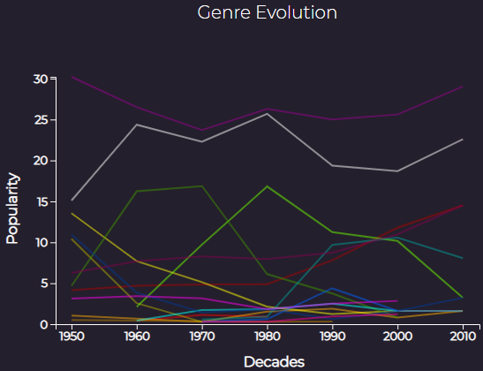

Figure 2. Line chart.

### World Map

Figure 3. Bubble map.

The bubble map (see Figure 3) represents the birthplaces / locations where an artist was born or created. In the initial state, displays a bubble on top of the countries of all the artists of our dataset. The size of the bubble indicates if that country has more or less artists: the bigger the bubble, the more artists that country has. Hovering on a bubble, a small box appears indicating the name of the country and the total number of artists of that country. Also, while hovering a bubble, this same bubble turns off its opacity (brighter), making the visualization clearer about which mark is being selected. Clicking on a bubble, the country the bubble represents is selected, and four interactions occur on four idioms: the bar chart now shows up to the top 5 artists born on the selected country, the lollipop chart represents the total number of artists of the selected country that were born in each decade, the line chart represents all the genres that are linked to this specific country, and finally the network selects the most popular artist of that country, it places it on the central node, and linked to it are related artists (in terms of tags).

### Most Popular Bands

Figure 4. Bar chart.

The bar chart (see Figure 4) represents up to the 5 most popular artists of a specific music genre or a specific location, or an artist itself when selected on the network. The popularity is measured in a scale from 0 to 100. Hovering a bar, that bar gets highlighted and a small box appears showing the exact popularity of the artist that is being hovered. By clicking a bar, that artist is selected for the entire visualization, interacting with the four idioms: the line chart shows the genres associated with the artist selected; the lollipop chart highlights the lollipop of the decade of birth/origin of the artist; the bubble map highlights the bubble of the country where the artist was born/created; and the network places the artist on the central node, and link to it are related artists (in terms of tags).

### Birth Dates

The lollipop chart (see Figure 5) represents the total number of artists born in each decade, from 1900 to 2010. In the initial state, it represents all the artists birthdates per decade. There are two different hover events: when no artist is selected, the hover shows a small box containing the total number of artists of a specific genre (this happens when clicking on the line chart), of a specific country (this happens when clicking on the bubble map), or the total number of all the artists (this happens in the initial state or when the “reset” button is pressed); when an artist is selected (this happens when clicking on the bar chart or the network), the lollipop that has that artist birthdate gets highlighted, and the hover for that lollipop shows the name of the artist and its exact birth year.

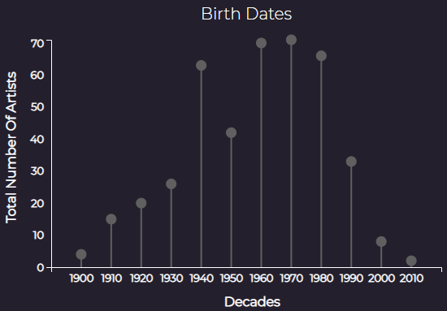

Figure 5. Lollipop chart.

### Tags Network

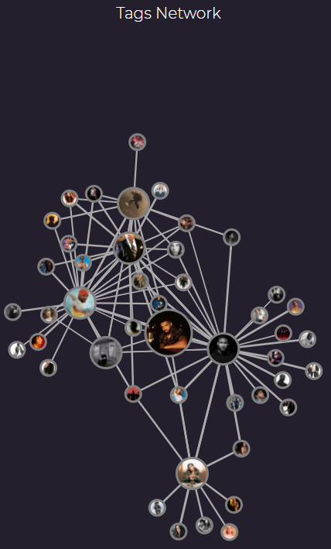

Figure 6. Network.

Our last idiom is the network (see Figure 6). In the initial state, its central node has the most popular artist of all. The links represent the tags that connect the artists, and these are represented on each node, with a picture of the artist. There are three node sizes: the bigger node is the most popular artist selected; the medium nodes are the artists that are directly connected to the central artist; the small nodes represent artists directly connected with the medium nodes. So, in the end, we have a 2 depth-level network. This idiom has two hover events: when hovering a node, a small box appears indicating the name of the artist that is being hovered; when hovering a link, it displays the tags that formed that same link. Clicking on a node, four interactions occur in the other four idioms: the line chart displays the genres associated with the selected artists; the bubble map highlights the bubble of the country where the artist was formed; the bar chart displays only the bar of that same artists, showing its overall popularity; and finally, the lollipop chart highlights the lollipop that represents the decade which has the year that artist was born/created.

## Rationale

## Demonstrate the Potential

# Implementation Details

* Ter hover no line chart em vez de uma legenda enorme

**CONCLUSION AND FUTURE WORK**

# Balance is always the main subject of discussion in music genre genealogies and the capital reason why an absolute visual reference has been absent thus far (and probably always will be).

# ACKNOWLEDGMENTS

Sample text: We thank all the volunteers, and all

# REFERENCES

1. Plantinga, Bo. Visualizing Genres. Jan, 2020. Retrieved from <https://tabsoft.co/2SCcgd0>
2. Crauwels, Kwinten. Musicmap. Oct, 2020. Retrieved from <https://musicmap.info/>
3. Lamere, Paul. MusicPopcorn Sep, 2013. Retrieved from https://musicmachinery.com/2013/09/22/5025/
4. Spotify
5. LastFM
6. MusicBrainz
7. AllMusic