Pantallazos de mi proyecto Azure

az login

[
{
"cloudName": "AzureCloud",
"homeTenantId": "899789dc-202f-44b4-8472-a6d40f9eb440",
"id": "77c88c55-f1f1-487b-91fd-8d3122bf6a57",
"isDefault": true,
"managedByTenants": [],
"name": "Azure for Students",
"state": "Enabled",
"tenantId": "899789dc-202f-44b4-8472-a6d40f9eb440",
"user": {
"name": "bernardojose.llamas286@comunidadunir.net",
"type": "user"
}
}
]

az account set –subscription=77c88c55-f1f1-487b-91fd-8d3122bf6a57

az ad sp create-for-rbac –role="Contributor"

{
"appId": "672bac55-c81e-40ac-a08c-21faa9e1c33b",
"displayName": "azure-cli-2022-03-08-19-19-31",
"password": "cYlIepC_9eTZ_e7r5X0BKJEloQXDN_R8Gw",
"tenant": "899789dc-202f-44b4-8472-a6d40f9eb440"
}

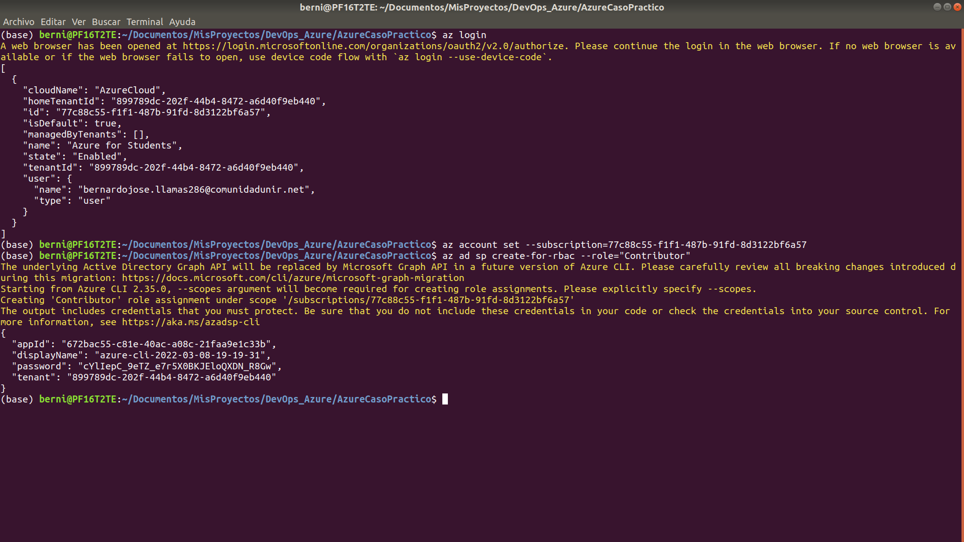
az ad sp create-for-rbac --role="Contributor" –scopes="/subscriptions/77c88c55-f1f1-487b-91fd-8d3122bf6a57"

{
"appId": "66140cd9-607e-4d24-84db-92061d00ffde",
"displayName": "azure-cli-2022-03-08-19-26-13",
"password": "2uMylDduNa9z.Kf2g2MTojv9BV9d~x8_1g",
"tenant": "899789dc-202f-44b4-8472-a6d40f9eb440"
}

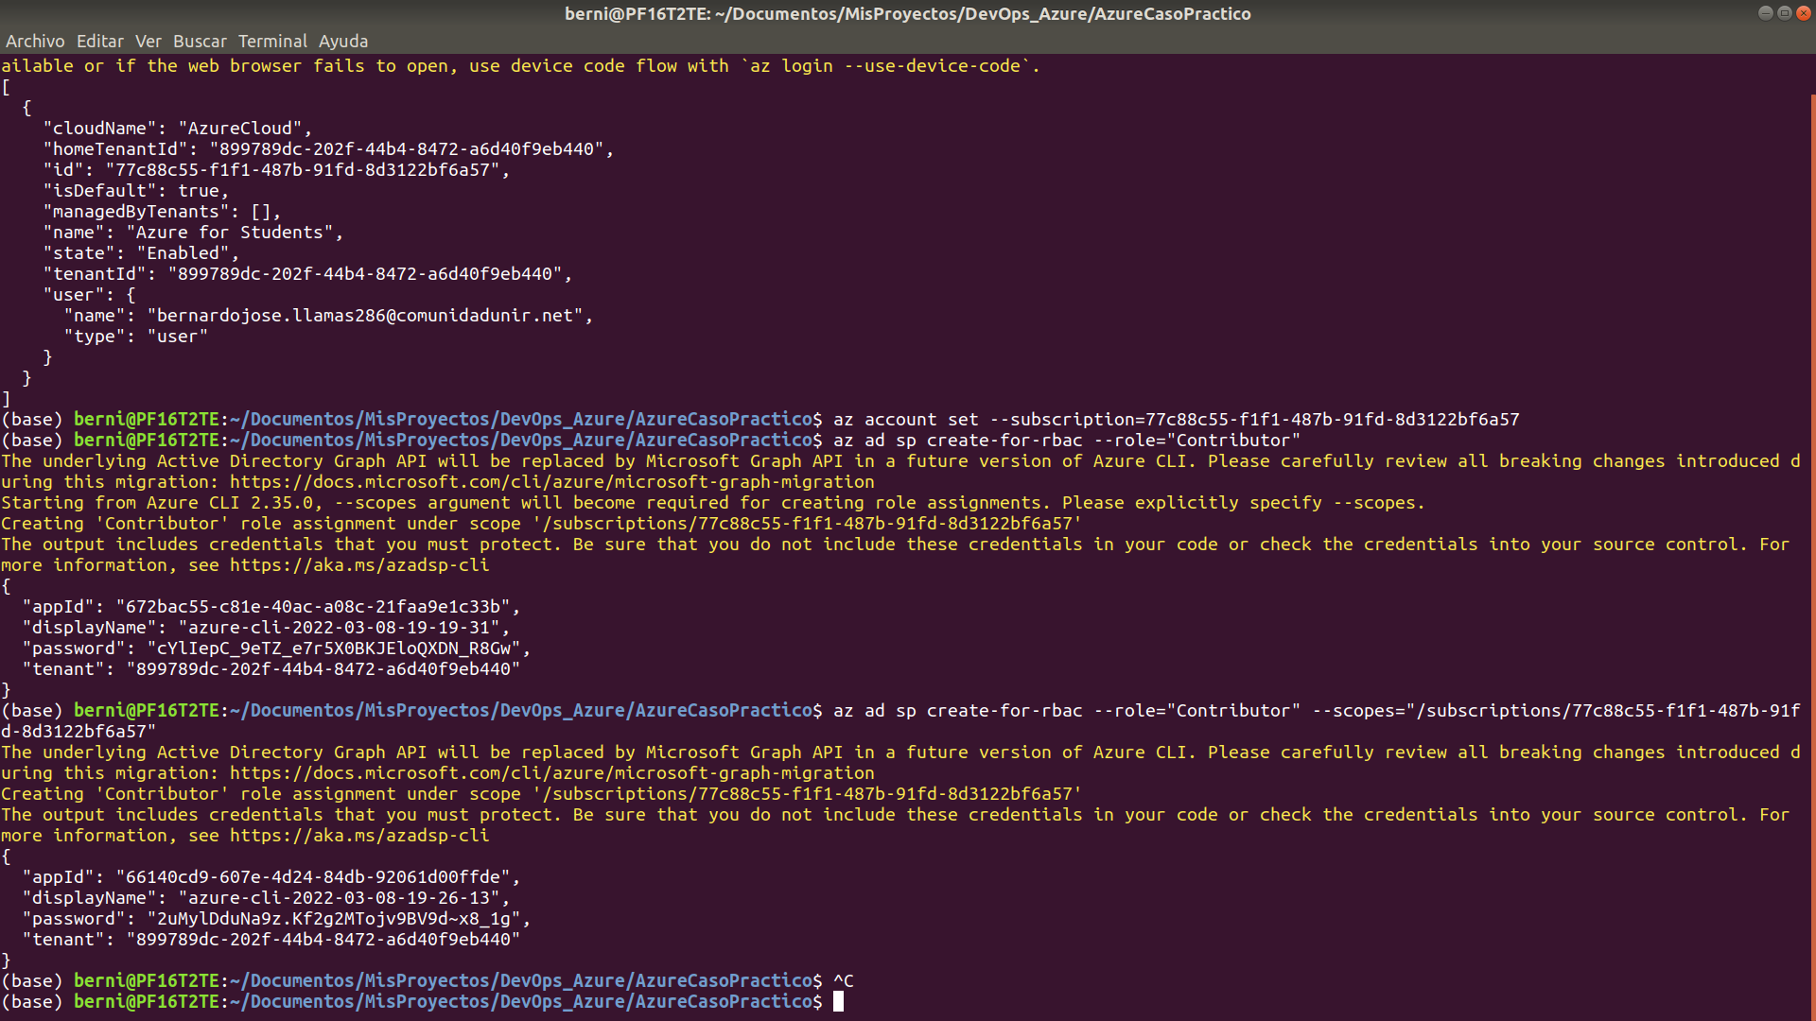
az vm image accept-terms --urn cognosys:redis-with-centos-8-2:redis-with-centos-8-2:1.2019.1008
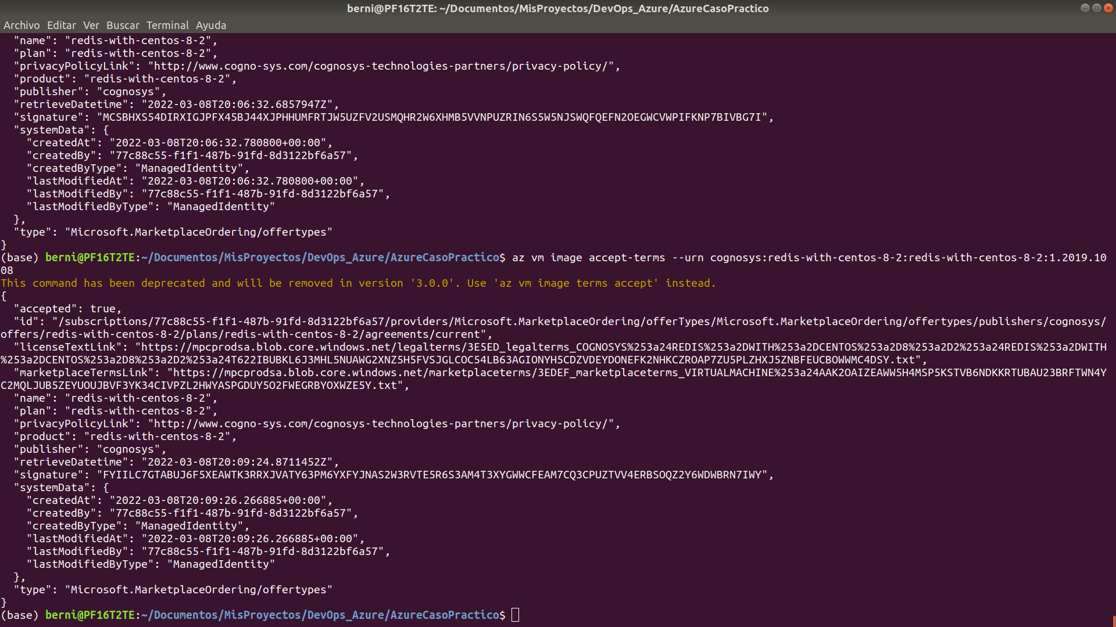
az vm image terms show --urn cognosys:redis-with-centos-8-2:redis-with-centos-8-2:1.2019.1008
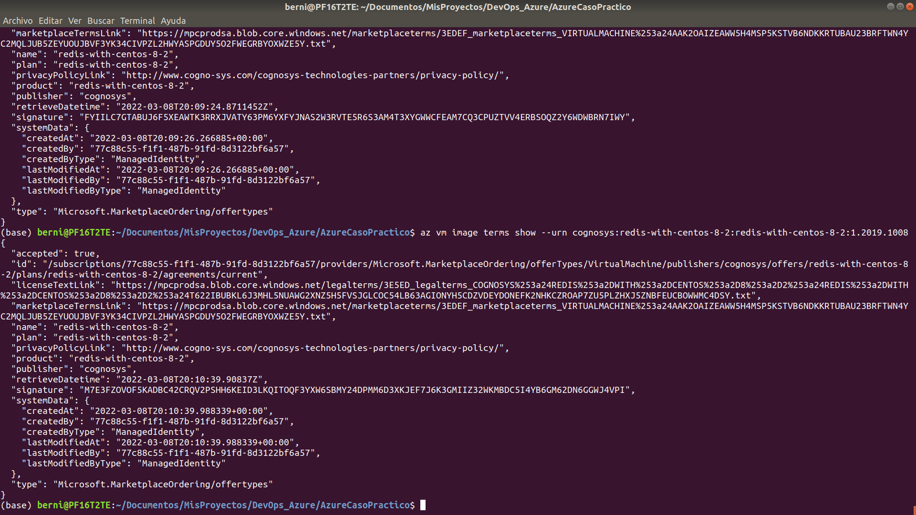
Definir la localización

az account list-locations -o table
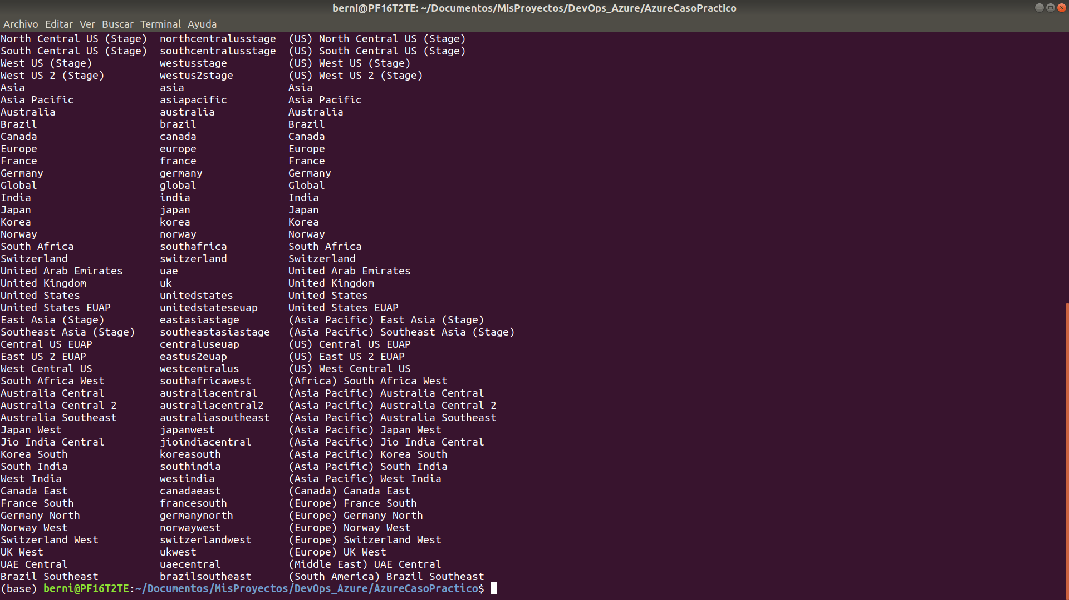

az vm list-sizes --location germanywestcentral

en vars.tf:
variable "location" {
type = string
description = "Región de Azure donde crearemos la infraestructura"
default = "Germany West Central"
}

variable "vm_size" {
type = string
description = "Tamaño de la máquina virtual"
default = "Standard_M416s_v2"
}

terraform init

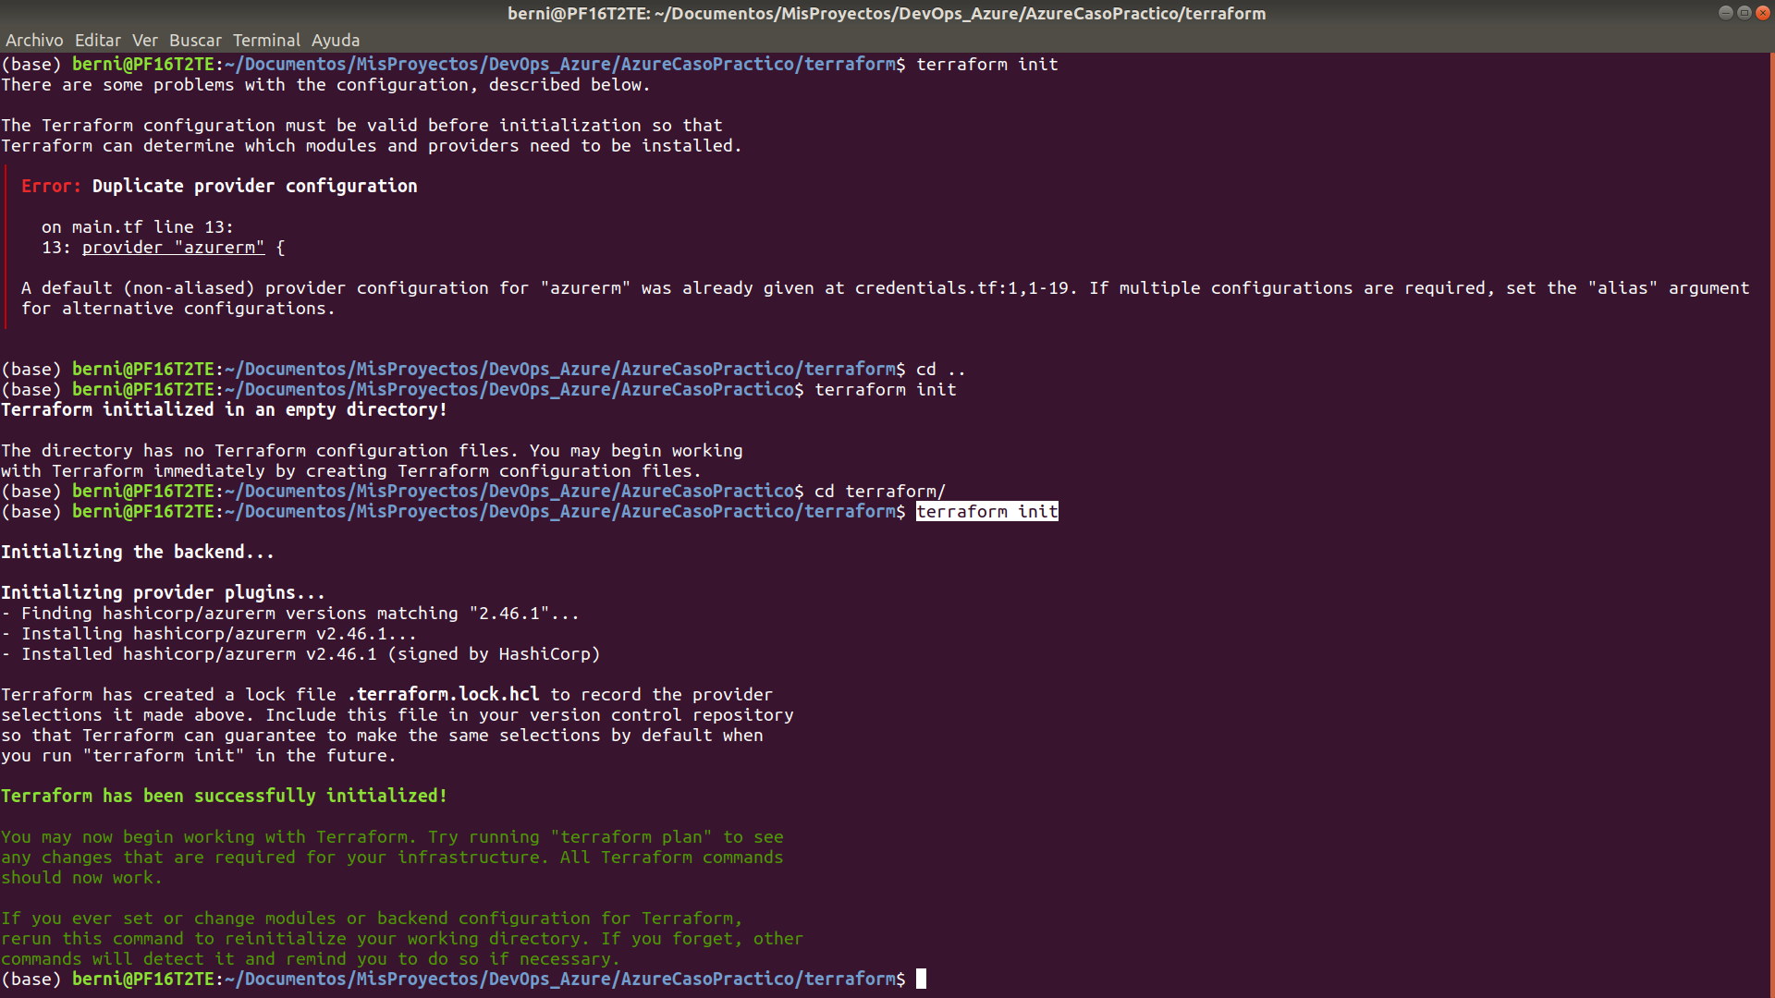

terraform plan

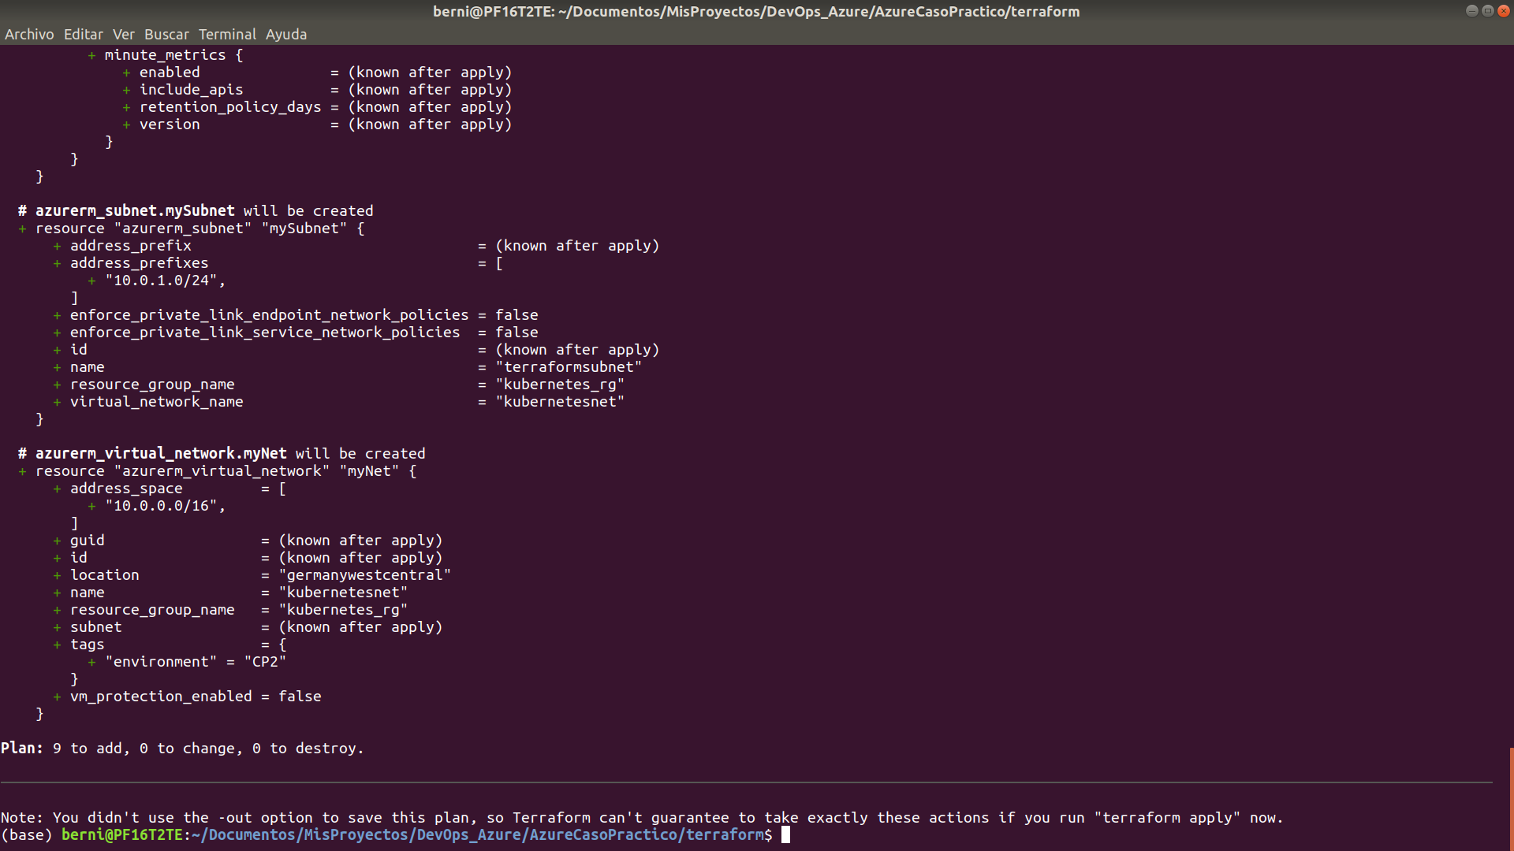
terraform apply

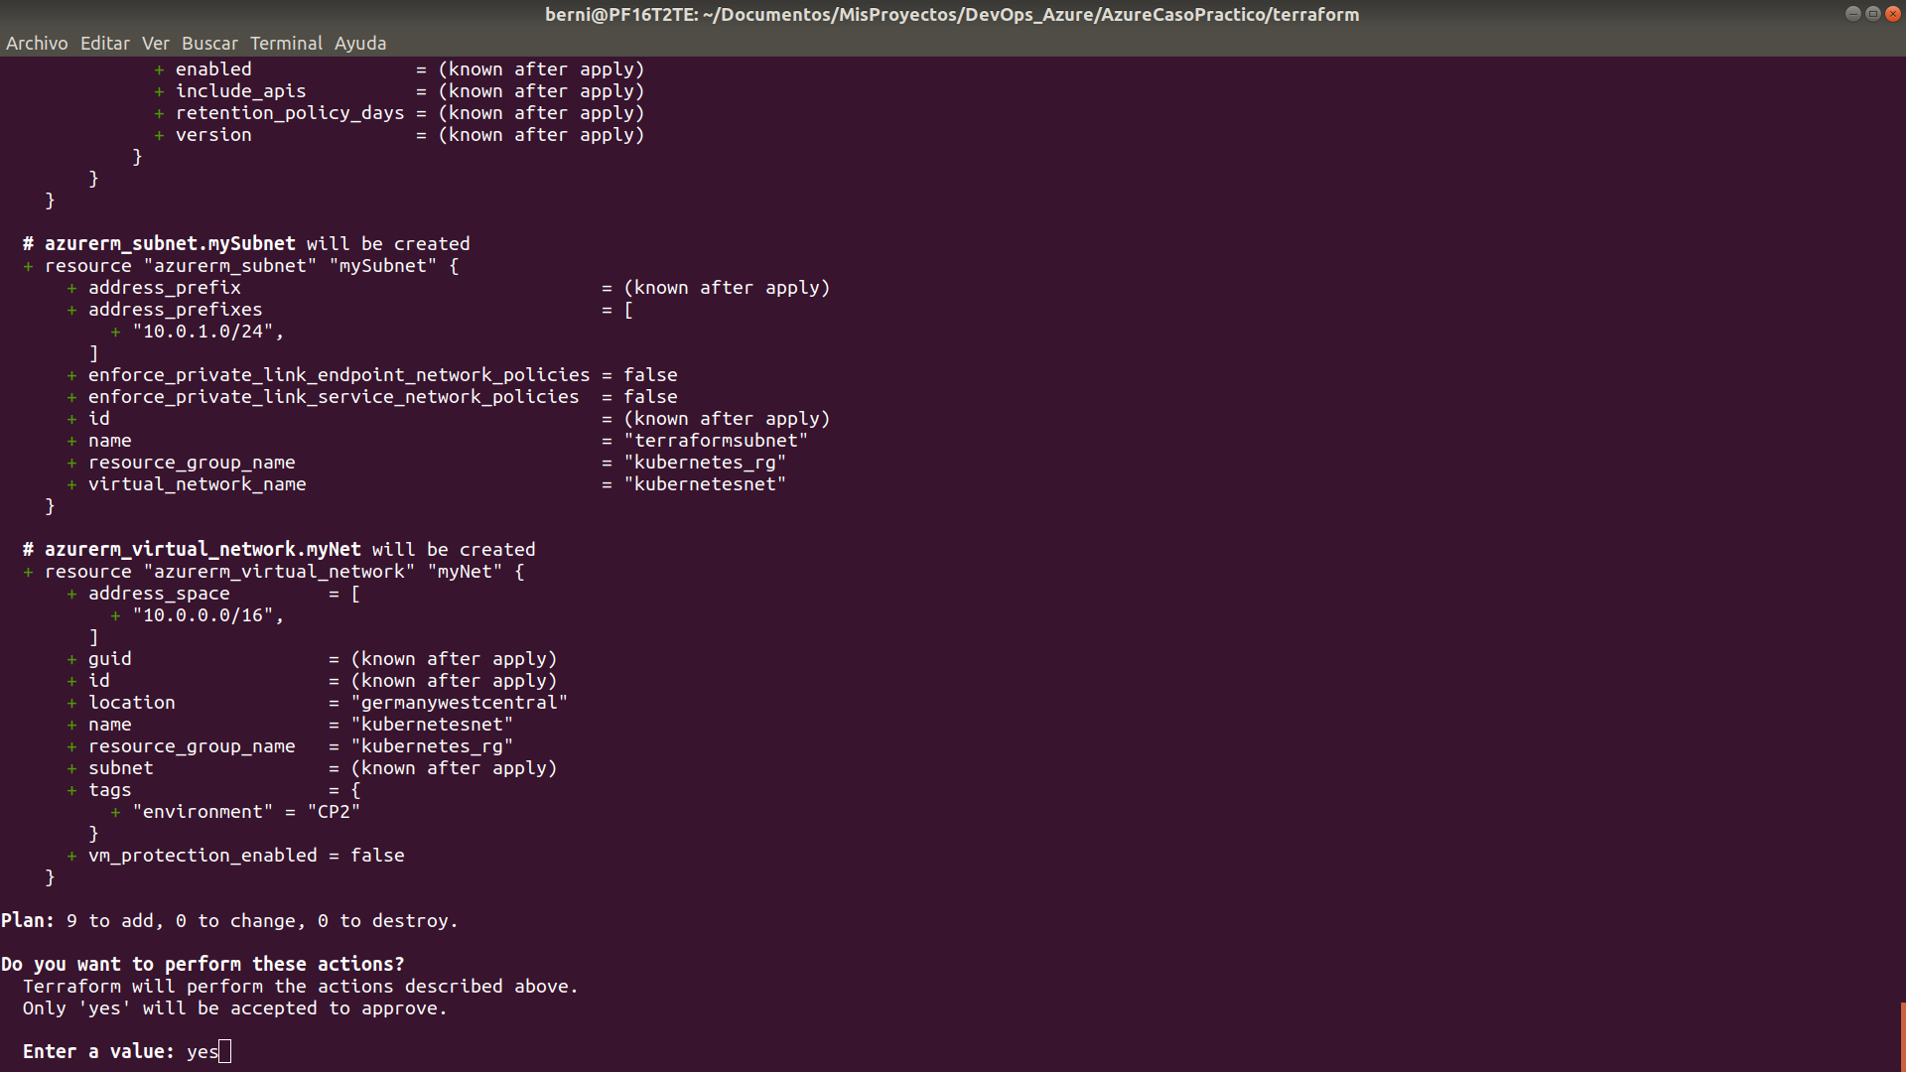

hay un error con la región:
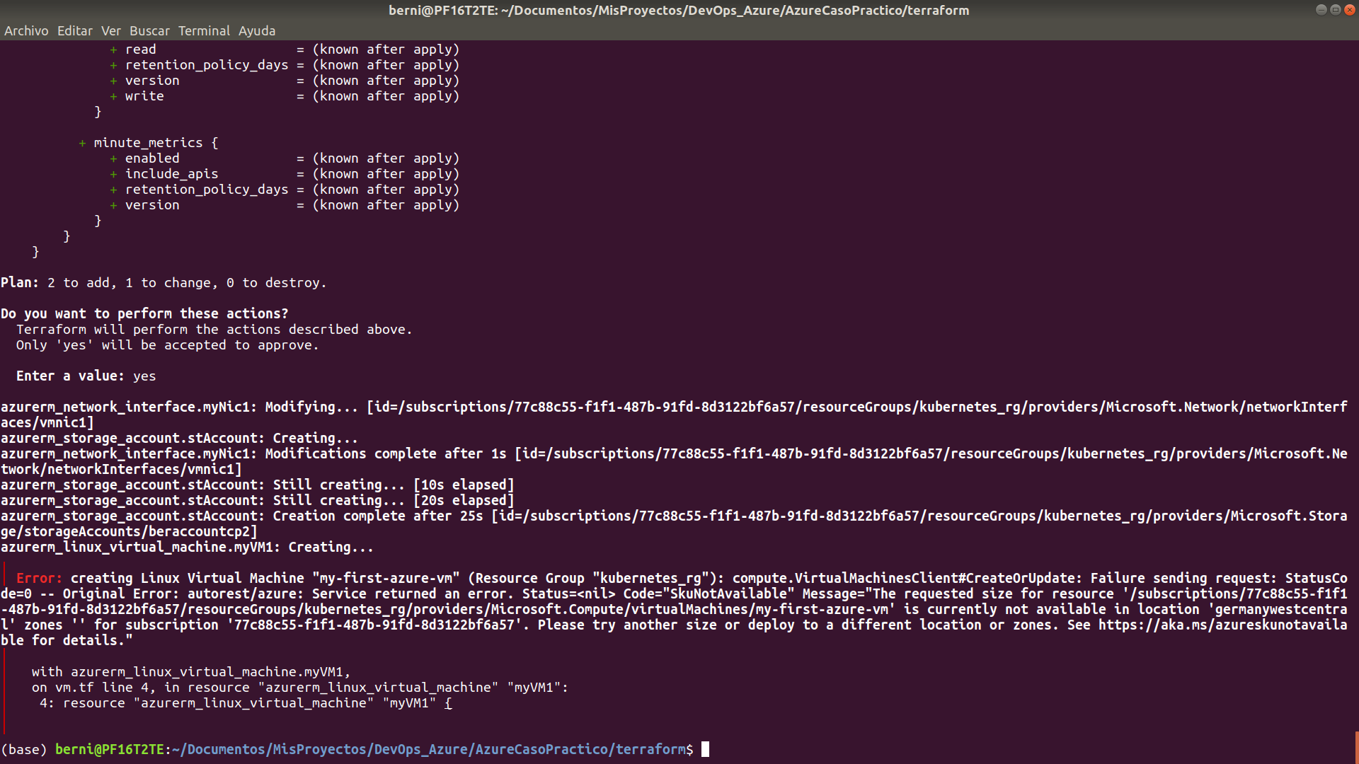
tenemos que buscar otra región

az vm list-sizes --location ukwest

en vars.tf:
variable "location" {
type = string
description = "Región de Azure donde crearemos la infraestructura"
default = "UK West"
}

variable "vm_size" {
type = string
description = "Tamaño de la máquina virtual"
default = "Standard_M416s_v2"
}

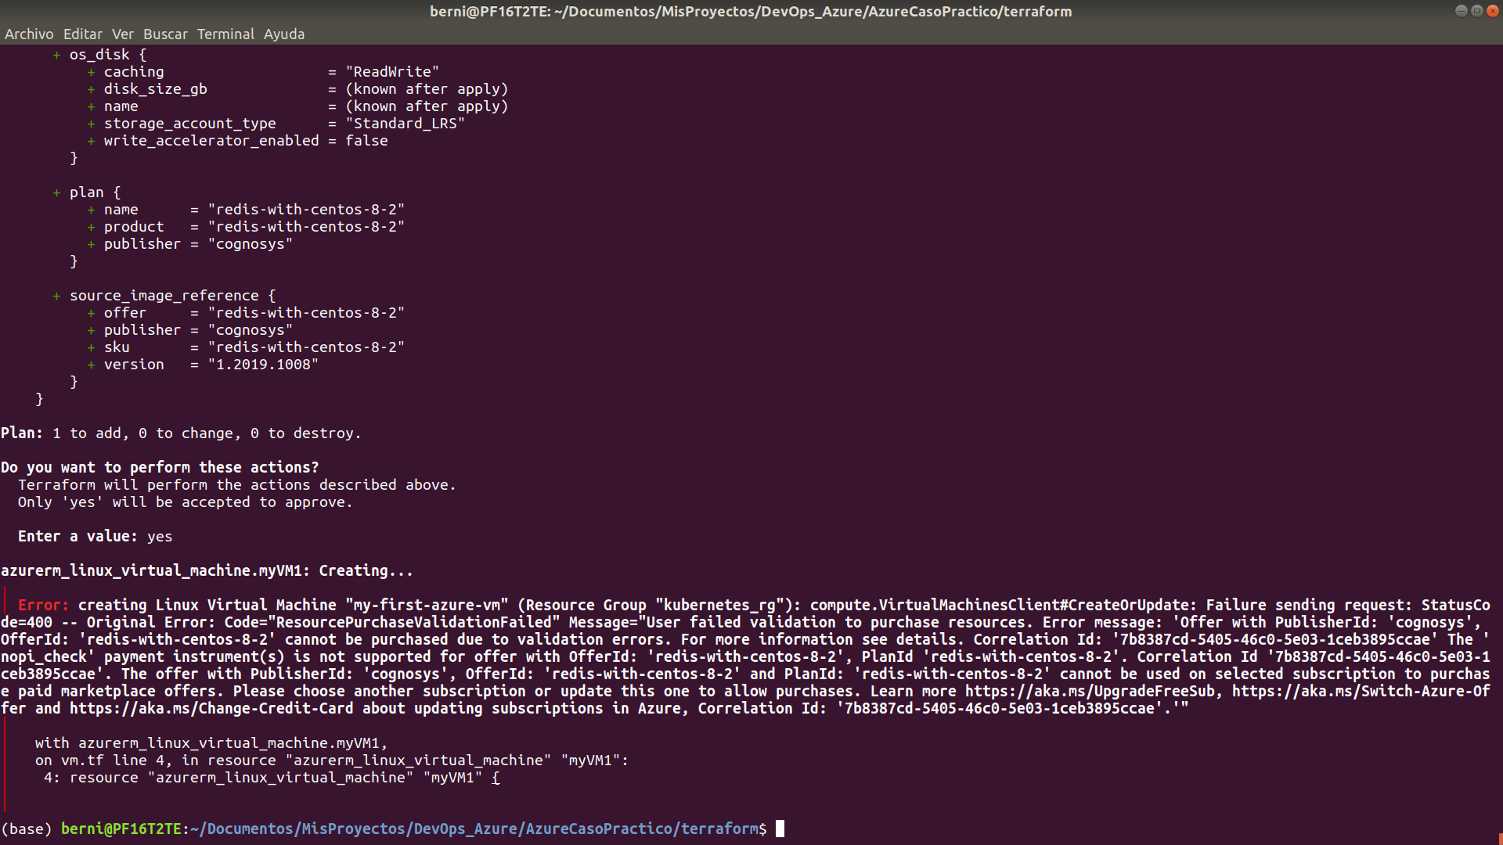
este error nos obliga a repetir pasos

az vm image accept-terms --urn cognosys:ubuntu-22-04-lts:ubuntu-22-04-lts:1.2021.1112
{
"accepted": true,
"id": "/subscriptions/77c88c55-f1f1-487b-91fd-8d3122bf6a57/providers/Microsoft.MarketplaceOrdering/offerTypes/Microsoft.MarketplaceOrdering/offertypes/publishers/cognosys/offers/redis-with-centos-8-2/plans/redis-with-centos-8-2/agreements/current",
"licenseTextLink": "https://mpcprodsa.blob.core.windows.net/legalterms/3E5ED_legalterms_COGNOSYS%253a24UBUNTU%253a2D22%253a2D04%253a2DLTS%253a24UBUNTU%253a2D22%253a2D04%253a2DLTS%253a24T622IBUBKL6J3MHL5NUAWG2XNZ5H5FVSJGLCOC54LB63AGIONYH5CDZVDEYDONEFK2NHKCZROAP7ZU5PLZHXJ5ZNBFEUCBOWWMC4DSY.txt",
"marketplaceTermsLink": "https://mpcprodsa.blob.core.windows.net/marketplaceterms/3EDEF_marketplaceterms_VIRTUALMACHINE%253a24AAK2OAIZEAWW5H4MSP5KSTVB6NDKKRTUBAU23BRFTWN4YC2MQLJUB5ZEYUOUJBVF3YK34CIVPZL2HWYASPGDUY5O2FWEGRBYOXWZE5Y.txt",
"name": "redis-with-centos-8-2",
"plan": "redis-with-centos-8-2",
"privacyPolicyLink": "http://www.cogno-sys.com/cognosys-technologies-partners/privacy-policy/",
"product": "redis-with-centos-8-2",
"publisher": "cognosys",
"retrieveDatetime": "2022-03-09T20:21:07.767242Z",
"signature": "WA22DZGQH2O26ALO2GPUYN2ABSBAVQYASQLVFPSC4XYLWIQU52NECVFTV4UB3M676PMYDBYM3B73ZA7WIH56YCDUCQHXRLQGESWHQKA",
"systemData": {
"createdAt": "2022-03-09T20:21:08.870819+00:00",
"createdBy": "77c88c55-f1f1-487b-91fd-8d3122bf6a57",
"createdByType": "ManagedIdentity",
"lastModifiedAt": "2022-03-09T20:21:08.870819+00:00",
"lastModifiedBy": "77c88c55-f1f1-487b-91fd-8d3122bf6a57",
"lastModifiedByType": "ManagedIdentity"
},
"type": "Microsoft.MarketplaceOrdering/offertypes"
}

az vm image terms show --urn cognosys:ubuntu-22-04-lts:ubuntu-22-04-lts:1.2021.1112

{
"accepted": true,
"id": "/subscriptions/77c88c55-f1f1-487b-91fd-8d3122bf6a57/providers/Microsoft.MarketplaceOrdering/offerTypes/VirtualMachine/publishers/cognosys/offers/ubuntu-22-04-lts/plans/ubuntu-22-04-lts/agreements/current",
"licenseTextLink": "https://mpcprodsa.blob.core.windows.net/legalterms/3E5ED_legalterms_COGNOSYS%253a24UBUNTU%253a2D22%253a2D04%253a2DLTS%253a24UBUNTU%253a2D22%253a2D04%253a2DLTS%253a24T622IBUBKL6J3MHL5NUAWG2XNZ5H5FVSJGLCOC54LB63AGIONYH5CDZVDEYDONEFK2NHKCZROAP7ZU5PLZHXJ5ZNBFEUCBOWWMC4DSY.txt",
"marketplaceTermsLink": "https://mpcprodsa.blob.core.windows.net/marketplaceterms/3EDEF_marketplaceterms_VIRTUALMACHINE%253a24AAK2OAIZEAWW5H4MSP5KSTVB6NDKKRTUBAU23BRFTWN4YC2MQLJUB5ZEYUOUJBVF3YK34CIVPZL2HWYASPGDUY5O2FWEGRBYOXWZE5Y.txt",
"name": "ubuntu-22-04-lts",
"plan": "ubuntu-22-04-lts",
"privacyPolicyLink": "http://www.cogno-sys.com/cognosys-technologies-partners/privacy-policy/",
"product": "ubuntu-22-04-lts",
"publisher": "cognosys",
"retrieveDatetime": "2022-03-09T20:22:24.3065429Z",
"signature": "GSOCJYW4BWZCLIOVZJJHEFEP2P3F43QGS2L7R5D3EBR2AJ7XDVQ43DILIUFZ3L6LTQ3JRQJD77SI4VTINQPJDEF2QELPFUM5SW4K62A",
"systemData": {
"createdAt": "2022-03-09T20:22:24.393484+00:00",
"createdBy": "77c88c55-f1f1-487b-91fd-8d3122bf6a57",
"createdByType": "ManagedIdentity",
"lastModifiedAt": "2022-03-09T20:22:24.393484+00:00",
"lastModifiedBy": "77c88c55-f1f1-487b-91fd-8d3122bf6a57",
"lastModifiedByType": "ManagedIdentity"
},
"type": "Microsoft.MarketplaceOrdering/offertypes"
}

az vm list-sizes --location ukwest
{
"maxDataDiskCount": 4,
"memoryInMb": 16384,
"name": "Standard_DC4s_v2",
"numberOfCores": 4,
"osDiskSizeInMb": 1047552,
"resourceDiskSizeInMb": 204800
}

Funciona el Loop de Vms
