Pantallazos de mi proyecto Azure

az login

[
{
"cloudName": "AzureCloud",
"homeTenantId": "899789dc-202f-44b4-8472-a6d40f9eb440",
"id": "77c88c55-f1f1-487b-91fd-8d3122bf6a57",
"isDefault": true,
"managedByTenants": [],
"name": "Azure for Students",
"state": "Enabled",
"tenantId": "899789dc-202f-44b4-8472-a6d40f9eb440",
"user": {
"name": "bernardojose.llamas286@comunidadunir.net",
"type": "user"
}
}
]

az account set –subscription=77c88c55-f1f1-487b-91fd-8d3122bf6a57

az ad sp create-for-rbac –role="Contributor"

{
"appId": "672bac55-c81e-40ac-a08c-21faa9e1c33b",
"displayName": "azure-cli-2022-03-08-19-19-31",
"password": "cYlIepC_9eTZ_e7r5X0BKJEloQXDN_R8Gw",
"tenant": "899789dc-202f-44b4-8472-a6d40f9eb440"
}

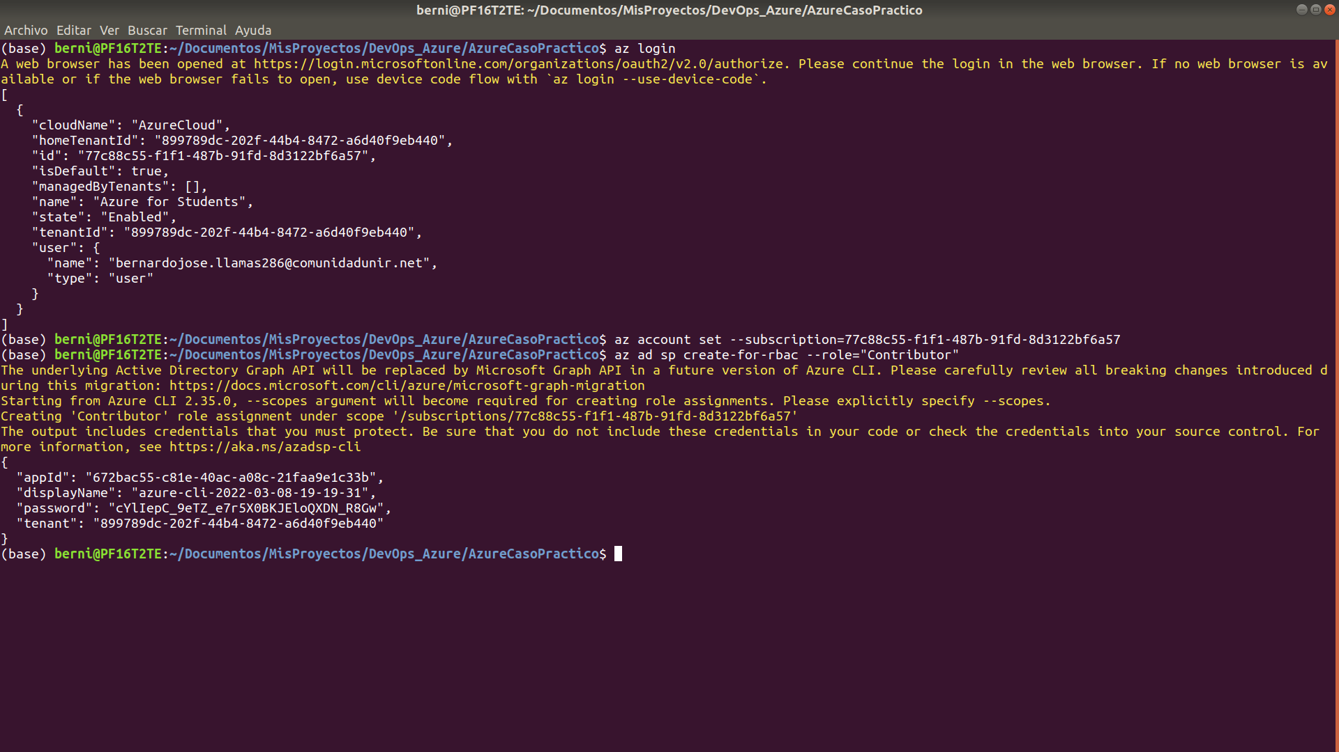
az ad sp create-for-rbac --role="Contributor" –scopes="/subscriptions/77c88c55-f1f1-487b-91fd-8d3122bf6a57"

{
"appId": "66140cd9-607e-4d24-84db-92061d00ffde",
"displayName": "azure-cli-2022-03-08-19-26-13",
"password": "2uMylDduNa9z.Kf2g2MTojv9BV9d~x8_1g",
"tenant": "899789dc-202f-44b4-8472-a6d40f9eb440"
}

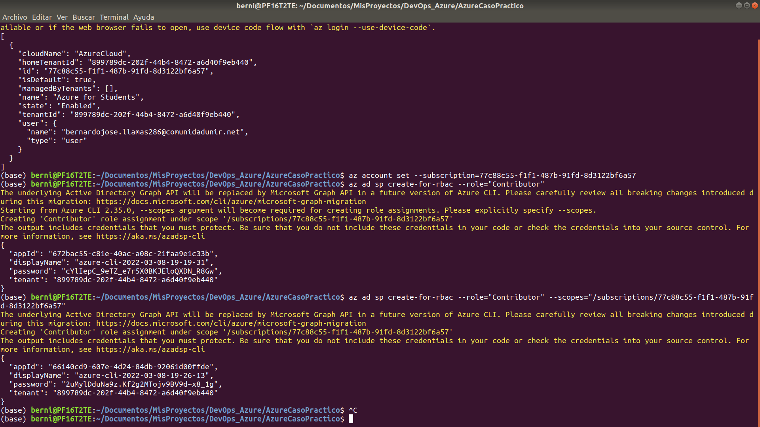
az vm image accept-terms --urn cognosys:redis-with-centos-8-2:redis-with-centos-8-2:1.2019.1008
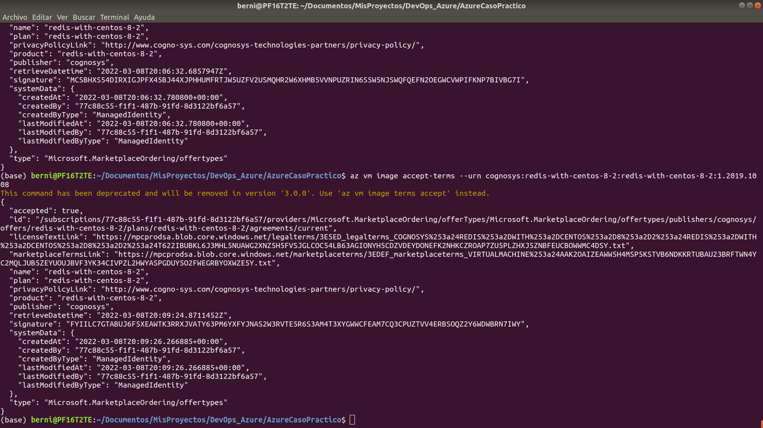
az vm image terms show --urn cognosys:redis-with-centos-8-2:redis-with-centos-8-2:1.2019.1008
