BERNARD GODONOU - 669146

LAB 2- JavaSocket Report
Objective: The idea of this lab is to understand the working process of any client server architecture application.
Key concepts:
A socket is one endpoint of a two-way communication link between two programs running on the network. The socket is bound to a port number so that the TCP layer can identify the application that data is destined to be sent.
A server is a program that runs on a specific system and listens on a specific port

ServerClient program: 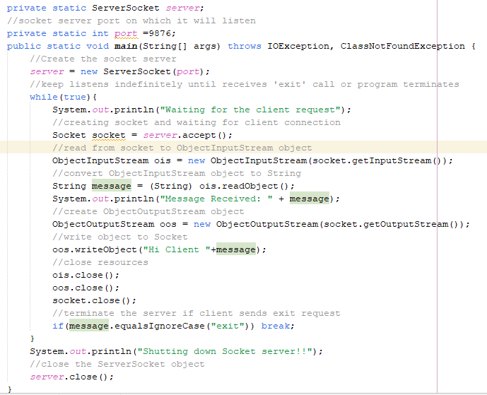
This program first creates a socket based on the port number which in this case is 9876. It then read from socket to an object which is converted to a string for use. Once the client sends a request, the server will reply with a message and continuously until client sends exit request.

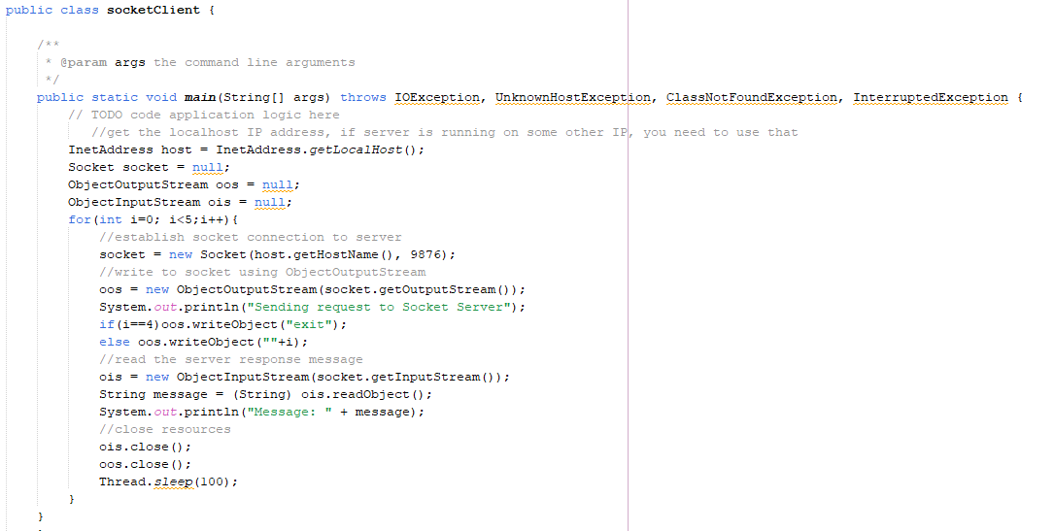

Output
Client request received
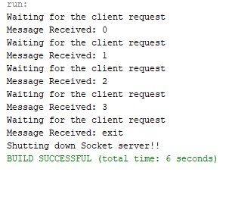
Server Response:
