***Software Used for MISIONEROS STUDIO’S PROJECT 2:***

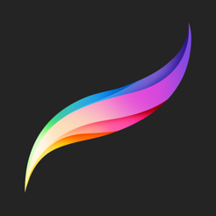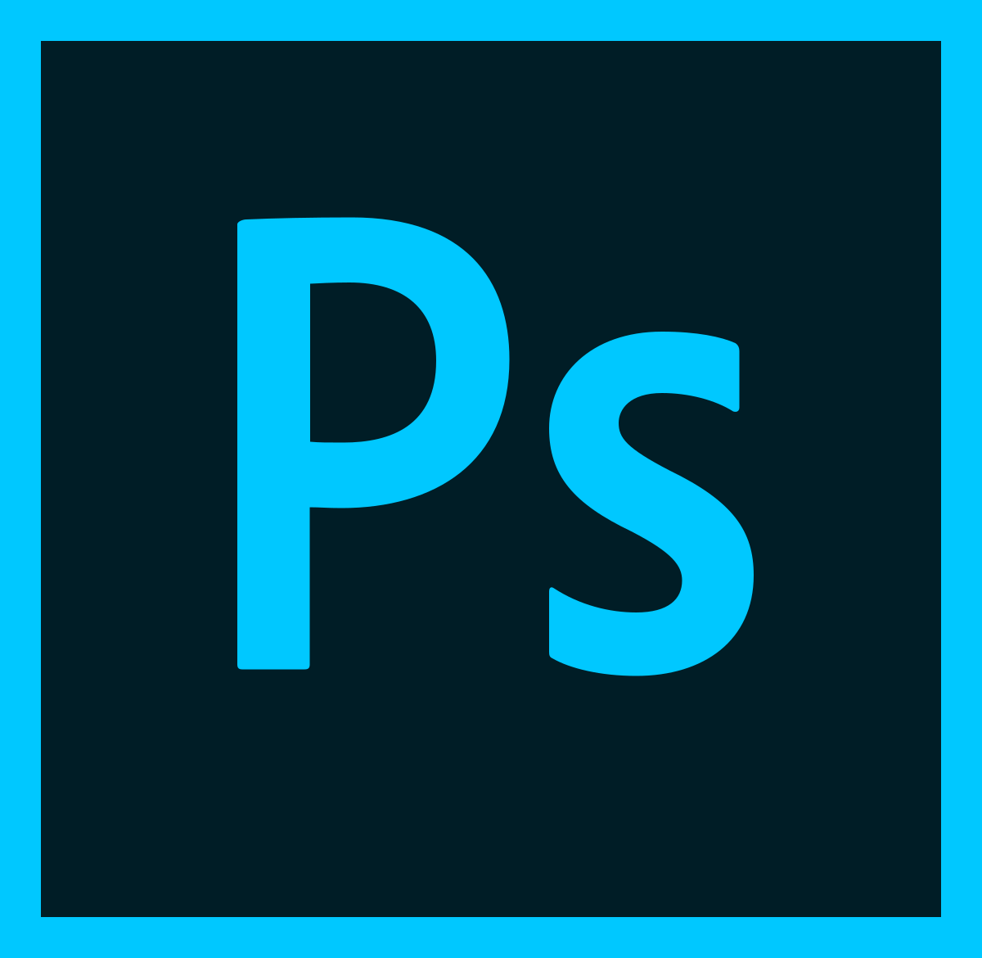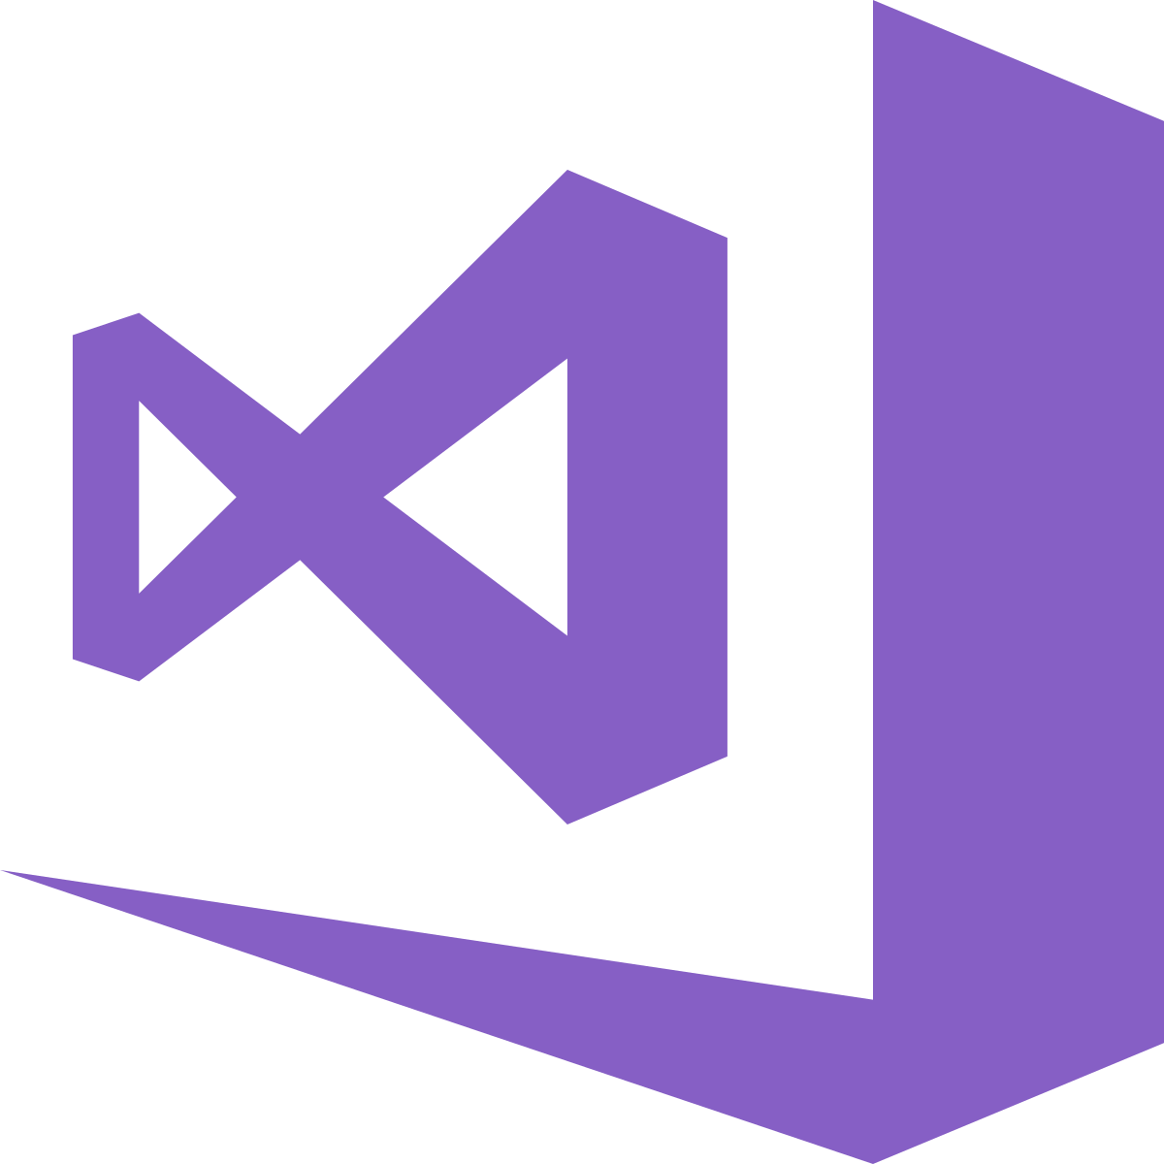

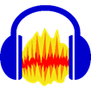

The software the team needs heavily depends on their role in the team, the software will be structured as following:

**Code:**

* Visual Studio
* Draw.io

**Art:**

* Photoshop
* Procreate
* Tiled
* Adobe Illustrator
* Audacity

**QA:**

* Google Docs
* Visual Studio

**UI:**

* Photoshop
* Draw.io
* Adobe Illustrator

**Management:**

* HacknPlan
* Slack
* Google Calendar

**Design:**

* Google Docs
* Photoshop