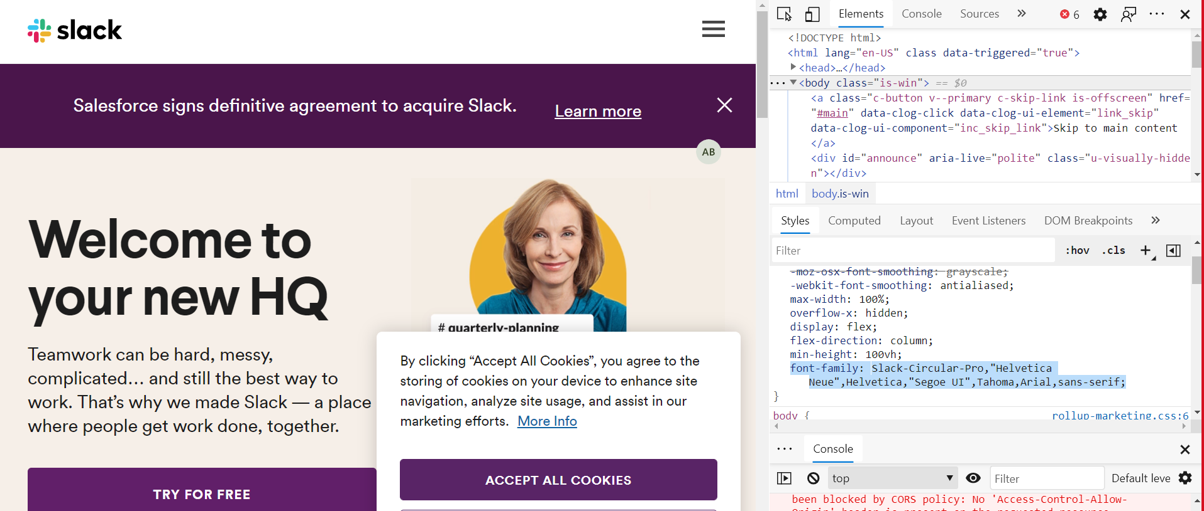

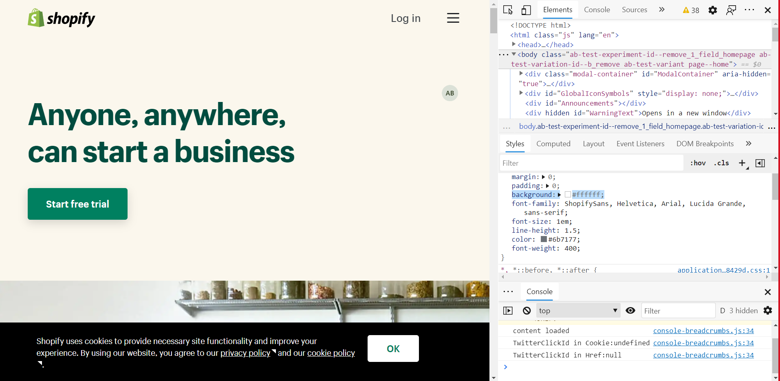

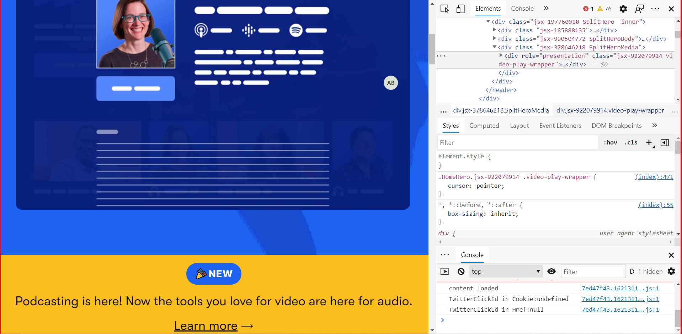

|  |  |  |
| --- | --- | --- |
|  | Diferente | Asemanari |
| Chrome | Unele functionalitati nu sunt suportate de Edge | Interfata de inspectare este aceiasi |
| Edge | Apar erori |  |

Pb2)

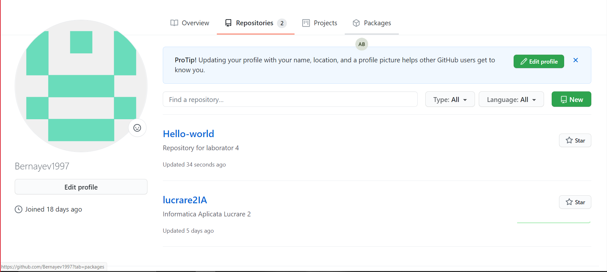

https://github.com/Bernayev1997/Hello-world.git

Pb3)

principalelor funcționalitări de utilizare:

* simple copy-and-paste HTML code
* CodePen is perfect for sharing code at conferences and meet-ups
* CodePen can be used for teaching

