**Hotel Management System - – Beyond the Hills**

**Team Project**

Bernd Opoku-Boadu | 35072024

Cyril Paa Kwesi Kujar | 62012024

John Terence Manful | 55132024

Kwaku Agyenim-Boateng | 67212024

CS323: Database Systems

Dr.Stephane Nwolley & David Sampah

21st November 2022

Stage1: Scenario and Conceptual Database Design

Task 1.1

Company Background

A rich hotelier Bernd has a conglomerate of five Hotels. His hotels, *Beyond the Hills,* provide a range of 5-star luxury suites and studio apartments honing modest qualities of both small and larger high-priced hostels. The purpose of his establishment is to provide paid lodging for travellers on a short-term basis. Currently, the various branches are located in Accra, Berekuso, Kumasi, Takoradi and Cape Coast. The hotel consists of over 1000 rooms of various types as well as top notch recreational facilities.

Case Study

Bernd’s conglomerate works based on a booking/ reservation system. The guest books a room or walks into the reception, the employee(receptionist) takes down the guest details and creates a booking or looks up a Guest booking on the database system. On the system, it displays the guest’s room and room type and after the stay, the guest’s bill is generated. His hotel also has an in-house restaurant where guests from the hotel or outside can come and eat.

Reason For This Project

Due to an increase in tourism in Ghana, the number of travellers requiring accommodation is increasing and Beyond the Hill’s current management system cannot keep up. Bernd initially started his business using a file-based system to manage his hotels’ data and has realized some data inconsistencies due to the increasing number of bookings across the company’s various branches. The file-based system has also led to data redundancy and causes the company to face several security issues. Due to this the company has encountered problems with room reservations and billing. For these reasons, it is advised that the company switch to a relational based system. This team project is aimed at building and delivering an efficient and effective hotel database management system that Daddy Bernd can use to maximize his profitability and service capacity. It would be to avoid all the problems he currently faces with booking reservations and data inconsistency amongst all departments as the priority of his hotels are his guests’ comfort.

Target Market

*General Public*

People traveling from other regions to ours for business trips, vacations, among others would find it beneficial to stay with us should there be no available accommodation for them from friends and family. Also, couples looking to have some time for themselves away from the kids would find it good to have a place that treats them like royalty and allows them to destress.

*Travellers*

People from other countries looking to take a vacation, business trip or luxury can opt to stay with us. Also, people that need the nearest hostel or hotel for a night after a trip can look to stay with us.

Functionality

1. Get information on current reservations
2. Generate bill for room and services used by the customer
3. Track room availability
4. Keep track of services and amenities and their uses
5. Automates different types of report i.e., hotel bookings and activities in a month
6. Keep track of which employee aided a booking

Task 1.2

Extended Entity Relationship Diagram

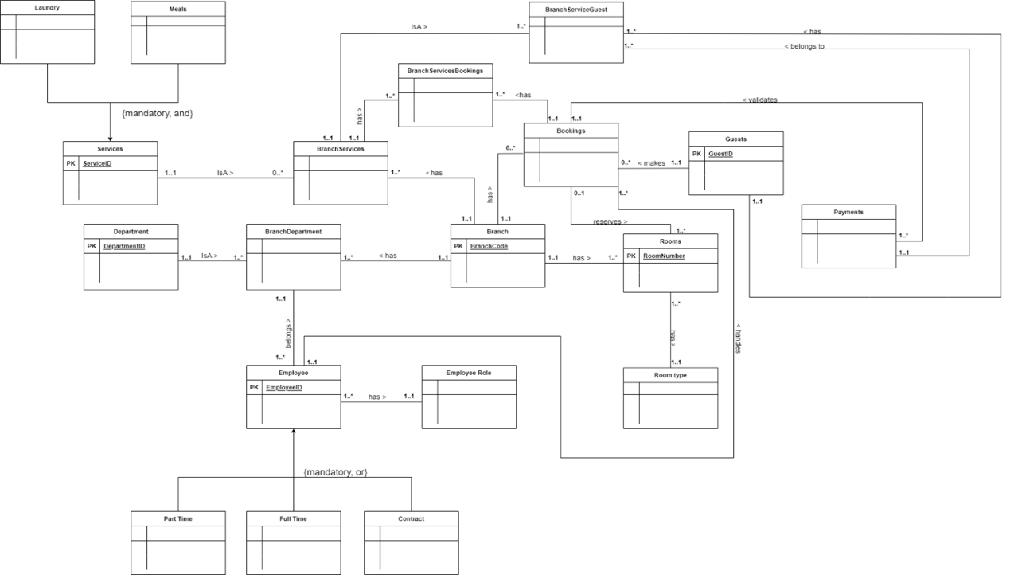

Strong Entities

1. Branch
2. Department
3. Room
4. Services
5. Guest
6. Employee

Weak Entities

1. Booking
2. Payment
3. BranchDepartment
4. BranchService
5. BranchServiceGuest
6. BranchServiceBooking
7. Room type
8. Employee role
9. Part time
10. Full time
11. Contract
12. Meals
13. Laundry

Entities and Non-Key Attributes

1. Branch: branchName, City, NumRooms, Telephone, PostalCode, Email
2. Department: Name, Location, Email
3. Room: Smoking, Availability
4. Services: serviceName, StartDate, EndDate, AmountCharged, DeliveryStatus
5. Guest: Fname, Lname, Gender, Telephone, Address, Email
6. Employee: Fname, Lname, Gender, Telephone, Address, Email, DailyWorkingHours
7. Booking: BookingDate, BookingTime, ArrivalDate, DepartureDate, SpecialRequests, checkInStatus
8. Payment**:** PaymentMethod, Charge, AdditionalCharge, PaymentDate
9. BranchDepartment:
10. BranchService:
11. BranchServiceGuest:
12. BranchServiceBooking:
13. Room type: Description, Price
14. Employee role: Title, Description
15. Part time: NumberOfWorkingDays, HourlyRate
16. Full time: Salary, Bonus,
17. Contract: StartDate, EndDate, ContractFee
18. Meals: Food, NumberOfServings
19. Laundry:LoadType, Quantity

Assumptions

1. All users are authenticated and logged in
2. Every person has their own unique id.
3. If you’ve never booked a room at a branch before, then you’re not a Guest.
4. A branch must have at least one department.
5. A branch is managed by exactly one employee.

Enterprise Rules

* + A branch has one or more rooms
  + A room can be found in a branch
  + A branch has 0,1 or many bookings
  + A booking relates to one branch
  + A branch has many BranchDepartment
  + A BranchDepartment belongs to one Branch
  + A branch has one or more BranchServices
  + A BranchService belongs to one branch
  + A Guest has one or more BranchServiceGuest
  + A BranchServiceGuest belongs to exactly one guest

- A guest makes zero or more bookings

- A booking is made by exactly one guest

* + A room has a room type
  + A room type exists for many rooms
  + A booking can have many rooms
  + A room can have zero or one booking
  + A booking is validated by one or many payments
  + Each payment validates a booking
  + A payment belongs to exactly one or more BranchServiceGuest
  + A BranchServiceGuest has exactly one payment
  + A BranchServiceGuest belongs to exactly one branch service
  + A BranchService can have one or more BranchServiceGuest
  + A BranchService belongs to exactly one service
  + A service can be zero or more BranchServices
  + A Booking has one or more BranchServicesBookings
  + A BranchServicesBooking belongs to exactly one Booking.
  + An employee handles zero or many bookings.
  + A booking is handled by exactly one employee
  + A BranchService has one or more BranchServiceBookings
  + A BranchServiceBooking belongs to exactly one BranchService.
  + A department can be one or more BranchDepartments
  + A BranchDepartment belongs to exactly one department
  + A BranchDepartment has one or more employees
  + An employee belongs to exactly one BranchDepartment
  + A role can have many employees
  + An employee can have exactly one rol

Relationship

* Hotel **has** rooms
* Hotel **has** employees
* Employees **manage** hotel
* Employee **has a** role
* Booking **reserves** room
* Room **has a** type
* Guest **occupies** Room
* Guest **makes** Booking
* Payment **validates** Booking
* Payment **secures** room

Generalisation / Specialisation

* A full-time employee is an employee
* A part-time employee is an employee
* A contract employee is an employee
* A meal service is a service
* A laundry service is a service

Task 2.1

Logical Database Design

Branch: **BranchId**, branchName, City, NumRooms, Telephone, PostalCode, Email

Department: **DepartmentCode,** Name, Location, Email

Room: **RoomNumber, *RoomType, BranchId,*** Smoking, Availability

Services: **ServiceID,**serviceNameStartDate, EndDate, AmountCharged, DeliveryStatus

Guest: **GuestID***,* Fname, Lname, Gender, Telephone, Address, Email

Employee: **EmpID**, ***EmpRole***, Fname, Lname, Gender, Telephone, Address, Email, DailyWorkingHours

Booking: **BookingID**, ***BranchId, GuestID***, ***RoomNumber, EmpId,*** BookingDate, BookingTime, ArrivalDate, DepartureDate, SpecialRequests, checkInStatus

Payment**: InvoiceNo, *BookingID,*** ***ServiceId***, PaymentMethod, Charge, AdditionalCharge, PaymentDate

BranchDepartment*:* ***BranchId*** *,* ***DepartmentCode***

BranchService*:* ***BranchId, ServiceID***

BranchServiceGuest: ***BranchId, ServiceID, GuestID***

BranchServiceBooking: ***BranchId, ServiceID, BookingID***

Room type: **RoomType,** Description, Price

Employee role: **RoleID**, Title, Description

Part time: ***EmpID*,**  NumberOfWorkingDays, HourlyRate

Full time: ***EmpID*,** Salary, Bonus,

Contract: ***EmpID*,** StartDate, EndDate, ContractFee

Meals:  ***ServiceID*,** Food, NumberOfServings

Laundry: ***ServiceID*,** LoadType, Quantity