

Technical Safety Concept Lane Assistance

**Document Version: 1.0.0**

**Released on 2017-12-19**



# Document history

|  |  |  |  |
| --- | --- | --- | --- |
| Date | Version | Editor | Description |
| 19.12.2017 | 1.0.0 | Bernhard Rode | Initial version of the safety concept |
|  |  |  |  |
|  |  |  |  |
|  |  |  |  |
|  |  |  |  |

# Table of Contents

Table of Contents

Document history 2

Table of Contents 2

Purpose of the Technical Safety Concept 3

Inputs to the Technical Safety Concept 3

Functional Safety Requirements 3

Refined System Architecture from Functional Safety Concept 4

Functional overview of architecture elements 5

Technical Safety Concept 6

Technical Safety Requirements 6

Refinement of the System Architecture 10

Allocation of Technical Safety Requirements to Architecture Elements 10

Warning and Degradation Concept 10

# Purpose of the Technical Safety Concept

The Technical Safety Concept defines how the subsystems interact at the message level and describes how the ECUs communicate with each other.

# Inputs to the Technical Safety Concept

## Functional Safety Requirements

|  |  |  |  |  |
| --- | --- | --- | --- | --- |
| **ID** | **Functional Safety Requirement** | **ASIL** | **Fault Tolerant Time Interval** | **Safe State** |
| Functional  Safety  Requirement  01-01 | The lane keeping item shall ensure that the lane departure oscillating torque amplitude is below Max_Torque_Amplitude | C | 50ms | The EPS ECU will set the oscillating torque to zero |
| Functional  Safety  Requirement  01-02 | The lane keeping item shall ensure that the lane departure oscillating torque frequency is below Max_Torque_Frequency | C | 50ms | The EPS ECU will set the oscillating torque to zero |
| Functional  Safety  Requirement  02-01 | the electronic power steering ECU shall ensure that the lane keeping assistance torque is applied for only Max_Duration | B | 500ms | The EPS ECU will set the oscillating torque to zero |

## Refined System Architecture from Functional Safety Concept

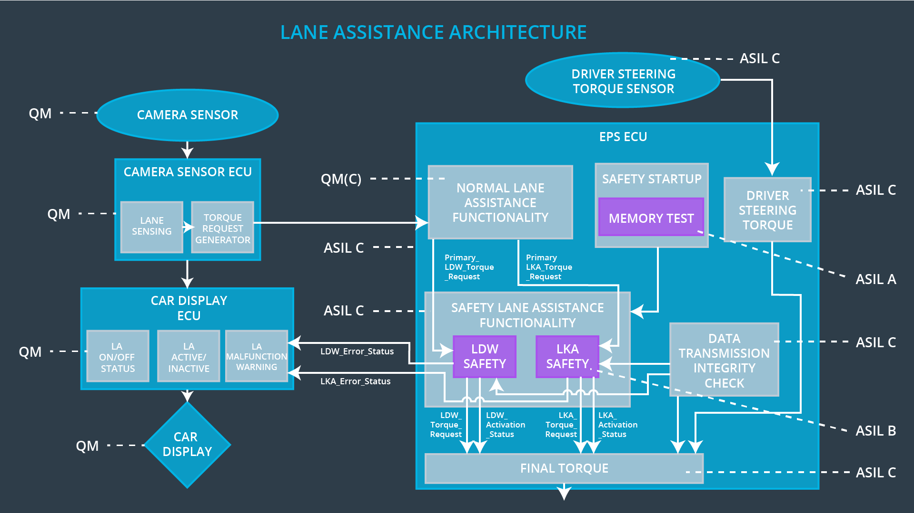

### Functional overview of architecture elements

|  |  |
| --- | --- |
| **Element** | **Description** |
| Camera Sensor | The camera sensor reads in images from the road |
| Camera Sensor ECU - Lane Sensing | Identifies when the vehicle has accidently departed its lane |
| Camera Sensor ECU - Torque request generator | Sends request to the electronic power steering ECU |
| Car Display | The car display shows messages to the driver |
| Car Display ECU - Lane Assistance On/Off Status | Shows the on or off status of the lane assistance function |
| Car Display ECU - Lane Assistant Active/Inactive | Shows the activation status of the lane assistance function |
| Car Display ECU - Lane Assistance malfunction warning | Shows that lane assistance function has malfunctioned |
| Driver Steering Torque Sensor | The driver steering torque sensor detects the steering input by the driver |
| Electronic Power Steering (EPS) ECU - Driver Steering Torque | Steering input by the driver |
| EPS ECU - Normal Lane Assistance Functionality | Keeps the car in lane when it has accidently departed its lane |
| EPS ECU - Lane Departure Warning Safety Functionality | Determines when the warning messages are sent to the display |
| EPS ECU - Lane Keeping Assistant Safety Functionality | Determines when to activate the lane keeping assistant functionality |
| EPS ECU - Final Torque | The torque that is sent to the steering wheel |
| Motor | The steering motor provides force to the steering wheel |

# Technical Safety Concept

## Technical Safety Requirements

**Lane Departure Warning (LDW) Requirements:**

Functional Safety Requirement 01-01 with its associated system elements

(derived in the functional safety concept)

|  |  |  |  |  |
| --- | --- | --- | --- | --- |
| **ID** | **Functional Safety Requirement** | **Electronic Power Steering ECU** | **Camera ECU** | **Car Display ECU** |
| Functional  Safety  Requirement  01-01 | The lane keeping item shall ensure that the lane departure oscillating torque amplitude is below Max_Torque_Amplitude | X |  |  |

Technical Safety Requirements related to Functional Safety Requirement 01-01 are:

|  |  |  |  |  |  |
| --- | --- | --- | --- | --- | --- |
| **ID** | **Technical Safety Requirement** | **ASIL** | **Fault Tolerant Time Interval** | **Architecture Allocation** | **Safe State** |
| Technical  Safety  Requirement  01 | The LDW safety component shall ensure that the amplitude of the ‘LDW_Torque_Request’ sent to the ‘Final electronic power steering Torque’ component is below ‘Max_Torque_amplitude’ | C | 50 ms | LDW Safety | LDW torque output is set to zero |
| Technical  Safety  Requirement  02 | The validity and integrity of the data transmission for ‘LDW_Torque_Request’ signal shall be ensured | C | 50 ms | Data Transmission Integrity Check | LDW torque output is set to zero |
| Technical  Safety  Requirement  03 | As soon as a failure is detected by the LDW function, it shall deactivate the LDW feature and the ‘LDW_Torque_Request’ shall be set to zero | C | 50 ms | LDW Safety | LDW torque output is set to zero |
| Technical  Safety  Requirement  04 | As soon as the LDW function deactivates the LDW feature, the ‘LDW Safety’ software block shall send a signal to the car display ECU to turn on a warning light | C | 50 ms | LDW Safety | LDW torque output is set to zero |
| Technical  Safety  Requirement  05 | Memory test shall be conducted at start up of the EPS ECU to check for any faults in memory | A | Length of vehicle ignition cycle | Safety startup - Memory test | LDW torque output is set to zero |

Functional Safety Requirement 01-2 with its associated system elements

(derived in the functional safety concept)

|  |  |  |  |  |
| --- | --- | --- | --- | --- |
| **ID** | **Functional Safety Requirement** | **Electronic Power Steering ECU** | **Camera ECU** | **Car Display ECU** |
| Functional  Safety  Requirement  01-02 | The lane keeping item shall ensure that the lane departure oscillating torque frequency is below Max_Torque_Frequency | X |  |  |

Technical Safety Requirements related to Functional Safety Requirement 01-02 are:

|  |  |  |  |  |  |
| --- | --- | --- | --- | --- | --- |
| **ID** | **Technical Safety Requirement** | **ASIL** | **Fault Tolerant Time Interval** | **Architecture Allocation** | **Safe State** |
| Technical  Safety  Requirement  01 | The LDW safety component shall ensure that the frequency of the ‘LDW_Torque_Request’ sent to the ‘Final electronic power steering Torque’ component is below ‘Max_Torque_Frequency | C | 50 ms | LDW Safety | LDW torque output is set to zero |
| Technical  Safety  Requirement  02 | The validity and integrity of the data transmission for ‘LDW_Torque_Request’ signal shall be ensured | C | 50 ms | Data Transmission Integrity Check | LDW torque output is set to zero |
| Technical  Safety  Requirement  03 | As soon as a failure is detected by the LDW function, it shall deactivate the LDW feature and the ‘LDW_Torque_Request’ shall be set to zero | C | 50 ms | LDW Safety | LDW torque output is set to zero |
| Technical  Safety  Requirement  04 | As soon as the LDW function deactivates the LDW feature, the ‘LDW Safety’ software block shall send a signal to the car display ECU to turn on a warning light | C | 50 ms | LDW Safety | LDW torque output is set to zero |
| Technical  Safety  Requirement 05 | Memory test shall be conducted at start up of the EPS ECU to check for any faults in memory | A | Length of vehicle ignition cycle | Safety startup - Memory test | LDW torque output is set to zero |

**Lane Departure Warning (LDW) Verification and Validation Acceptance Criteria:**

Not needed.

**Lane Keeping Assistance (LKA) Requirements:**

Functional Safety Requirement 02-1 with its associated system elements

(derived in the functional safety concept)

|  |  |  |  |  |
| --- | --- | --- | --- | --- |
| **ID** | **Functional Safety Requirement** | **Electronic Power Steering ECU** | **Camera ECU** | **Car Display ECU** |
| Functional  Safety  Requirement  02-01 | The lane keeping item shall ensure that the lane keeping assistance torque is applied for only Max_Duration | X |  |  |

Technical Safety Requirements related to Functional Safety Requirement 02-01 are:

|  |  |  |  |  |  |
| --- | --- | --- | --- | --- | --- |
| ID | Technical Safety Requirement | ASIL | Fault Tolerant Time Interval | Allocation to Architecture | Safe State |
| Technical  Safety  Requirement  01 | The LKA safety component shall ensure that the duration of the torque sent to the 'Final electronic power steering Torque' component is no more than Max_Duration | B | 500 ms | LKA Safety | LKA torque output is set to zero |
| Technical  Safety  Requirement  02 | The validity and integrity of the data transmission for LKA_Torque_Request signal shall be ensured | B | 500 ms | Data Transmission Integrity Check | LKA torque output is set to zero |
| Technical  Safety  Requirement  03 | As soon as a failure is detected by the LKA function, it shall deactivate the LKA feature and the ‘LKA_Torque_Request’ shall be set to zero | B | 500 ms | LKA Safety | LKA torque output is set to zero |
| Technical  Safety  Requirement  04 | As soon as the LKA function deactivates the LKA feature, the ‘LKA Safety’ software block shall send a signal to the car display ECU to turn on a warning light | B | 500 ms | LKA Safety | LKA torque output is set to zero |
| Technical  Safety  Requirement  05 | Memory test shall be conducted at start up of the EPS ECU to check for any faults in memory | B | 500 ms | Safety startup - Memory test | LKA torque output is set to zero |

**Lane Keeping Assistance (LKA) Verification and Validation Acceptance Criteria:**

Not needed.

## Refinement of the System Architecture



## Allocation of Technical Safety Requirements to Architecture Elements

For this particular item, all technical safety requirements are allocated to the Electronic Power Steering ECU.

## Warning and Degradation Concept

|  |  |  |  |  |
| --- | --- | --- | --- | --- |
| **ID** | **Degradation Mode** | **Trigger for Degradation Mode** | **Safe State invoked?** | **Driver Warning** |
| WDC-01 | turn off the functionality | Steering torque exceeds maximum levels | Yes | Warning light on dashboard |
| WDC-02 | turn off the functionality | Steering torque exceeds maximum levels | Yes | Warning light on dashboard |