ID-List

ID | Description | Imageexample
1 | Axial-lead fixed resistor  Properties: linear resistance, through-hole resistor, color banded code, four and five bands | 
2 | SMD resistor 1206  Properties: 1206 package,  fixed resistor, linear resistance, resistance value written with 3 numbers | 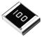
3 | DIP 14 IC-packages  Properties: Dual in-line package (DIP or DIL), rectangular housing and two parallel rows of electrical connecting pins, through-hole soldering, inter-lead spacing (lead pitch) of 2.54 mm | 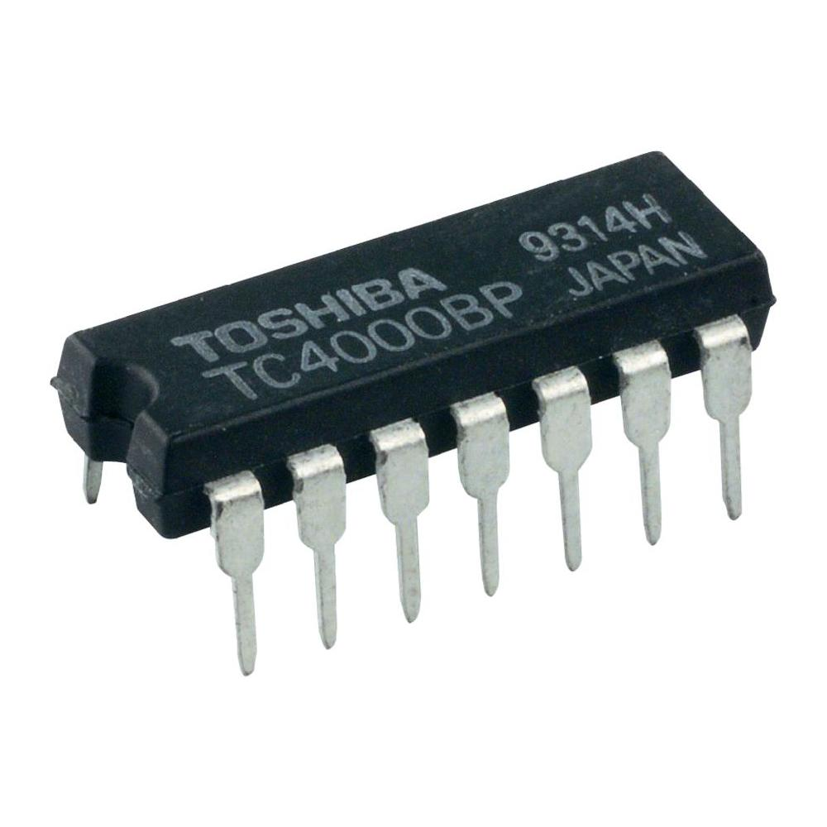
4 | PCI  Properties: local computer bus for attaching hardware devices in a computer | 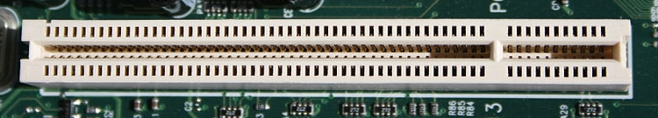
5 | QFP100  Properties: IC chip in QFP100 package | 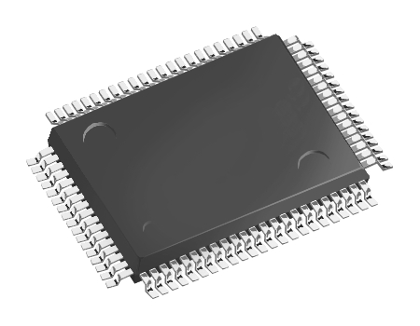
6 | SMD resistor 0805  Properties: 0805 package,  fixed resistor, linear resistance, resistance value written with 3 numbers

