Progress Documentation
Team Name: Pokémon Database Management System
Team Members:
- Michal Salabura
- Bernard Joyce
- Nikita Smiichyk
- Oliver Halpenny
- Hanna Bokariuk

Team Responsibilities
The responsibilities for the Pokémon Database Management System project were distributed among team members in accordance with the Gantt chart. Some tasks were completed individually, while others were carried out collaboratively. All team members contributed to the design of the database schema and to the design and creation of database tables, and all team members also participated in the preparation and delivery of the project presentation.
Michal Salabura
- Original Project Concept — proposed and developed the core idea and overall concept of the Pokémon Database Management System.
- ER Diagram (ERD) Design — responsible for developing the ER diagram for the project.
- Database Schema Design — contributed to the development of the logical database schema.
- Table Design and Creation — contributed to the physical design and creation of tables in the database.
- Database Normalisation (1NF, 2NF, 3NF) — contributed to the analysis and implementation of the database normalisation process.
- Database Connectivity — assisted with configuring and testing JDBC connectivity.
- Triggers — implemented a trigger to remove a trainer’s Pokémon and reassign the gym leader before deleting a trainer.
- Indexes — created Index 1 and Index 2 to improve query performance.
- Views (Calculated Statistics) — developed views for calculated Pokémon and trainer statistics.
- Stored Procedures — developed procedures such as adding a new Pokémon species.
- Java Development — provided the required driver, and prepared instructions for manually compiling.
- Transactions — implemented the Pokémon trading transaction.
Bernard Joyce
- Database Schema Design — contributed to the design and refinement of the overall logical database schema.
- Table Design and Creation — actively participated in the design and creation of core database tables.
- Database Connectivity — worked on establishing and testing the connection between the Java application and the MySQL database.
- Triggers — implemented a trigger to limit Pokémon IV, ensuring that IVs remain within valid predefined constraints.
- Views — designed and implemented multiple database views to summarise trainer data and present aggregated Pokémon statistics for reporting and analysis purposes.
- Database Administration — responsible for creating a dedicated database user, configuring access privileges, and supporting basic database security and maintenance tasks.

Hanna Bokariuk
- Project Description — contributed to defining the project scenario and overall system purpose.
- Entity and Attribute Identification — documented the entities and their attributes for the database.
- CRUD operations (Create, Read, Update, Delete) — developed and tested basic SQL queries for inserting, reading, updating and deleting data in the main database tables.
- Database Normalisation (1NF, 2NF, 3NF) — responsible for carrying out and documenting the normalisation process.
- Database Schema Design — contributed to the development of the logical database schema.
- Database Connectivity — assisted with the configuration and testing of the database connection.
- Triggers — implemented the after_trainer_delete trigger for logging deleted trainers (audit purposes).
- System Research and Uniqueness Analysis — analysed existing systems with similar functionality and identified the distinctive features that differentiate the proposed system.
- Documentation — contributed to the main written documentation, including the process description, normalisation and the final conclusion.
- Presentation — prepared and structured the project presentation.
Nikita Smiichyk
- Database Schema Design — contributed to the overall database schema design.
- Table Design and Creation — contributed to the design and creation of database tables.
- Database Connectivity — implemented the core Java–MySQL connection logic.
- Triggers — implemented a trigger to ensure Pokémon levels remain within valid limits.
- Indexes — created Index 3 to support query performance.
- Views — contributed to views, including a view that displays each trainer’s strongest Pokémon.
- Java Development — implemented the Java application and developed the core logic for database connectivity, command execution and formatted output.
- Transactions — implemented the transaction for purchasing a new Pokémon.
- Stored Procedures — contributed to procedures such as adding a new trainer.
- System Testing — carried out functional testing of the database and Java application, verifying the correctness of SQL queries, triggers, transactions and overall system behaviour.
- Presentation Preparation — assisted in the preparation and refinement of presentation materials.

Oliver Halpenny
- Database Schema Design — actively contributed to the design and refinement of the overall logical database schema, ensuring consistency between entities and relationships.
- Table Design and Creation — participated in the design and physical creation of database tables, including the definition and validation of relational structures.
- Database Connectivity — assisted with testing and validating the database connection between the MySQL database and the Java application.
- Triggers — implemented a trigger to enforce the maximum number of Pokémon allowed per trainer, ensuring compliance with defined business rules.
- Indexes — contributed to the design and implementation of indexes (e.g. Index 4) to support query optimisation and performance improvement.
- Views — created views to display Pokémon together with all of their associated types, supporting data presentation and reporting.

1. Overview
The Pokémon Database Management System project was developed to model and manage the world of Pokémon — including Trainers, Pokémon species, Gyms, Regions, and Towns — using MySQL and Java (JDBC). The database ensures logical relationships between entities through normalization and the use of primary and foreign keys.
This final specification describes the complete database design, implementation and supporting features developed for the CA1 project.
2. Project Scenario.
This database is designed for people playing the Pokémon game to find what is the best type of Pokémon to use in a fight and where and when to find that Pokémon type. Each species has an advantage over another which can be used to gain an advantage in a Pokémon battle. For example a water type Pokémon is more effective against a fire type Pokémon than a earth type Pokémon.
The end user being someone playing the Pokémon game might want to fight a gym leader and they might want to know what that gym leaders type specialisation is and what type has an advantage over that type and where to find that type and when to find it. For example a player could be fighting a gym leader that specialises in fire type Pokémon and they want to find what Pokémon has an advantage over fire types, then they could want to find that type so what region they are typically in and when in the game they start to show up.
Explaining use case with another example:
Jimmy is a 15-year-old Pokemon game player and is using the database to help him play. As Jimmy I want to be to find out what Pokémon have an advantage over other Pokémon so that I can beat gym leaders easier. I also want to be able to find where these Pokémon are in the game and at what level these Pokemon will be able to be caught at in the game so that I can use them against the gym leaders.
3. Primary Business Rules
Trainers and Pokémon
A Trainer can train many Pokémon, but each Pokémon caught belongs to exactly one Trainer.
Trainers and Towns
Each Trainer comes from one Town (TownID), but a Town can have many Trainers.
Gyms and Leaders
Each Gym must have exactly one Leader (Trainer), and each Trainer can lead one Gym.
Towns and Gyms
Each Gym is located in one Town, and each Town has exactly one Gym.
Towns and Regions
Each Town belongs to one Region, and a Region may contain zero or many Towns.
Pokémon Species
The TrainerPokemon table references Pokémon, meaning each caught Pokémon is of one Pokémon species, but each Pokémon species can appear in many TrainerPokemon records.
Pokémon Types
Each Pokémon species can have zero or more Types (e.g., Fire, Water).
Each Type can belong to many Pokémon species.
Type Advantages
Each Type can have advantages or disadvantages against other Types.
Wild Pokémon
Each Wild Pokémon species appears in one Region, but a Region can have zero or many Wild Pokémon species.
Entity and Attribute Identification
Trainers
- TrainerID INT PRIMARY KEY
- HomeTownID INT FOREIGN KEY REFERENCES Towns(TownID) NOT NULL
- Name VARCHAR(50) NOT NULL
- Gender VARCHAR(50) NOT NULL
- Age INT
TrainerPokemon
- CaughtID INT PRIMARY KEY
- TrainerID INT FOREIGN KEY REFERENCES Trainers(TrainerID) NOT NULL
- PokemonID INT FOREIGN KEY REFERENCES Pokemon(PokemonID) NOT NULL
- Nickname VARCHAR(50) NOT NULL
- Level INT NOT NULL
- HP INT NOT NULL
- Attack INT NOT NULL
- Defense INT NOT NULL
Gym
- GymID INT PRIMARY KEY
- LeaderID INT FOREIGN KEY REFERENCES Trainers(TrainerID) NOT NULL
- TownID INT FOREIGN KEY REFERENCES Towns(TownID) NOT NULL
- TypeSpecialisation INT FOREIGN KEY REFERENCES Types(TypeID) NOT NULL
- BadgeID INT FOREIGN KEY REFERENCES Badges(BadgeID) NOT NULL
Towns
- TownID INT PRIMARY KEY
- RegionID INT FOREIGN KEY REFERENCES Regions(RegionID) NOT NULL
- Name VARCHAR(50) NOT NULL
- Population INT NOT NULL
Regions
- RegionID INT PRIMARY KEY
- Name VARCHAR(50) NOT NULL
- Climate VARCHAR(50) NOT NULL
Pokemon
- PokemonID INT PRIMARY KEY
- Name VARCHAR(50) NOT NULL
- BaseHP INT NOT NULL
- BaseAttack INT NOT NULL
- BaseDefense INT NOT NULL
PokemonTypes
- PokemonID INT FOREIGN KEY REFERENCES Pokemon(PokemonID) NOT NULL
- TypeID INT FOREIGN KEY REFERENCES Types(TypeID) NOT NULL
Types
- TypeID INT PRIMARY KEY
- TypeName VARCHAR(50) NOT NULL
TypeAdvantages
- Type1 INT FOREIGN KEY REFERENCES Types(TypeID) NOT NULL
- Type2 INT FOREIGN KEY REFERENCES Types(TypeID) NOT NULL
- AdvantageType VARCHAR(50) NOT NULL
WildPokemon
- WildID INT PRIMARY KEY
- PokemonID INT FOREIGN KEY REFERENCES Pokemon(PokemonID) NOT NULL
- RegionID INT FOREIGN KEY REFERENCES Regions(RegionID) NOT NULL
- LocationDescription VARCHAR(50) NOT NULL
- MinLevel INT NOT NULL
- MaxLevel INT NOT NULL
Badge
- BadgeID INT PRIMARY KEY
- Name VARCHAR(50) NOT NULL

Sample Test Data in Combined Tables
Pokemon + Type Table
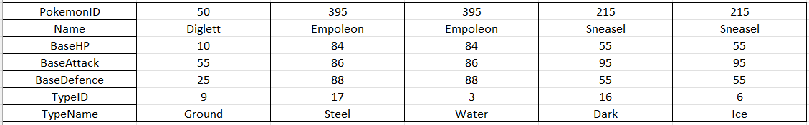
Trainer + Trained Pokemon
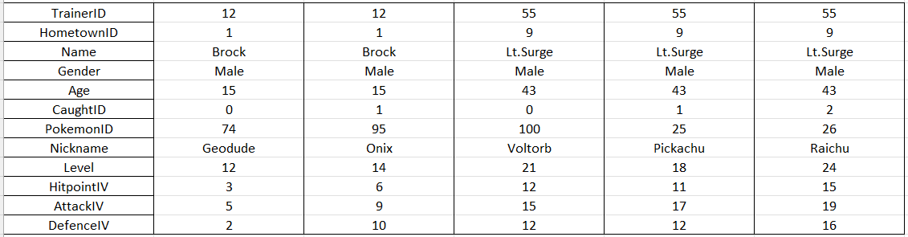
Regions + Towns
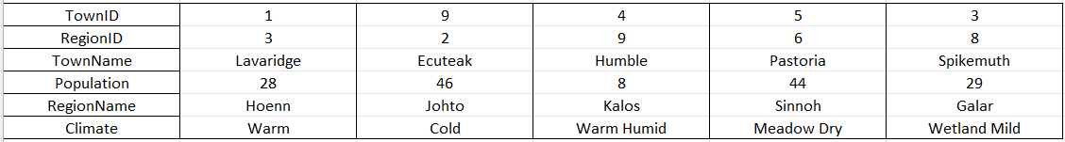

4. ER Diagram Representation
The ERD below presents the full database structure, including entities, primary keys, foreign keys and relationships.

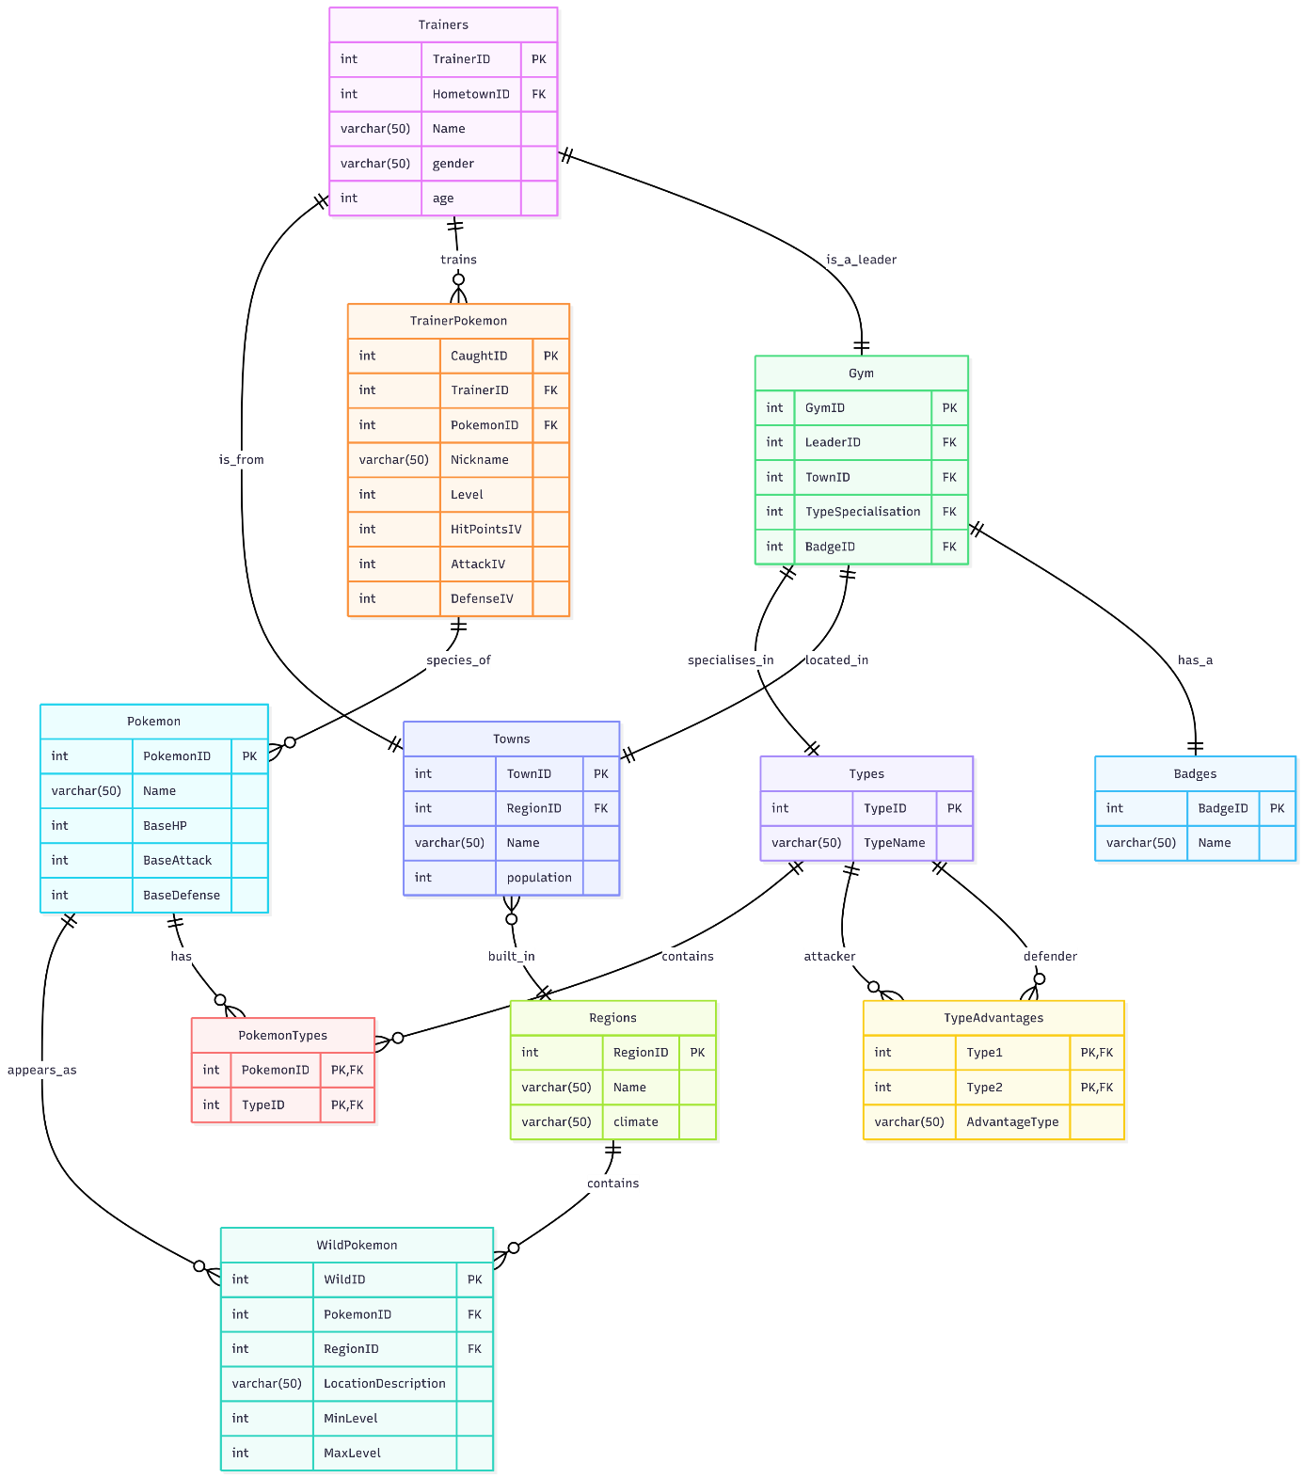
5. Normalisation
Database normalisation is the process of structuring a relational database to reduce redundancy and eliminate undesirable characteristics such as insertion, update and deletion anomalies. The database for this project was designed using the principles of First, Second and Third Normal Forms (1NF, 2NF and 3NF).
Unnormalised Form (UNF)
At the unnormalised stage, all the required data could theoretically be stored in a single large table containing information about trainers, Pokémon, towns, regions, gyms, types and wild Pokémon.
This structure is unsuitable because:
- A trainer can own multiple Pokémon.
- A Pokémon can have multiple Types.
- A Region can contain many Towns and Wild Pokémon.
- There is significant data redundancy.
- Update, insert and delete anomalies would occur.
Therefore, the database must be normalised.
First Normal Form (1NF)
Rule of 1NF: All attributes must be atomic, and there must be no repeating groups or multi-valued attributes.
The original unnormalised structure was decomposed into separate entity tables. Primary keys were defined and repeating groups were removed by storing data in individual tables instead of one combined table.
Handling Many-to-Many Relationships (1NF)
Two important many-to-many relationships were resolved at this stage.
Trainers and Pokémon
Originally:
- One Trainer can own many Pokémon.
- The same Pokémon species can belong to many Trainers.
This many-to-many relationship was resolved using the junction table TrainerPokemon:
- Trainers(TrainerID, Name, Gender, Age, HomeTownID)
- Pokemon(PokemonID, Name, BaseHP, BaseAttack, BaseDefense)
- TrainerPokemon(CaughtID, TrainerID, PokemonID, Nickname, Level, HP, Attack, Defense)
This converts the relationship into two one-to-many relationships.
Pokémon and Types
Originally:
- One Pokémon can have multiple Types.
- One Type can apply to many Pokémon.
This was resolved using the junction table PokemonTypes:
- Types(TypeID, TypeName)
- PokemonTypes(PokemonID, TypeID)
Again, the many-to-many relationship is transformed into two one-to-many relationships
Result of 1NF
After applying 1NF:
- All attributes contain single atomic values.
- All repeating groups and multi-valued attributes have been removed.
- All entities are stored in separate tables.
The database is now in First Normal Form (1NF)
Second Normal Form (2NF)
Rule of 2NF:
The table must already be in 1NF, and all non-key attributes must depend on the whole primary key, not on part of it.
Example: TrainerPokemon
- Primary Key: CaughtID
- Non-key attributes: TrainerID, PokemonID, Nickname, Level, HP, Attack, Defense
All non-key attributes depend fully on CaughtID, not on a part of the key.
There are no partial dependencies.
Therefore, TrainerPokemon is in 2NF.
Example: PokemonTypes
- Composite Key: (PokemonID, TypeID)
- No additional non-key attributes.
All attributes depend on the full composite key.
Therefore, PokemonTypes is in 2NF.
Other tables such as Trainers, Pokemon, Towns and Regions all use single primary keys and all non-key attributes depend fully on those keys.
Therefore, the database satisfies Second Normal Form (2NF).
Third Normal Form (3NF)
Rule of 3NF:
- The table must already be in 2NF.
- There must be no transitive dependencies.
- No non-key attribute should depend on another non-key attribute.

Example: Gym
Attributes:
- GymID (PK)
- LeaderID (FK)
- TownID (FK)
- TypeSpecialisation (FK)
- BadgeID (FK)
Descriptive data such as Type Name and Badge Name are not stored in the Gym table. Instead, they are stored in:
- Types(TypeID, TypeName)
- Badge(BadgeID, Name)
This eliminates transitive dependencies such as:
- GymID → BadgeID → BadgeName
- GymID → TypeID → TypeName
Therefore, the Gym table is in 3NF.
Example: WildPokemon
Attributes:
- WildID (PK)
- PokemonID (FK)
- RegionID (FK)
- LocationDescription
- MinLevel
- MaxLevel
All non-key attributes depend directly on the primary key.
There are no transitive dependencies.
Therefore, WildPokemon is in 3NF.
Trainers, Towns, Regions and Pokemon tables also contain no transitive dependencies.
Therefore, the database satisfies Third Normal Form (3NF).
Final Result of Normalisation
After applying 1NF, 2NF and 3NF, the final fully normalised database consists of the following tables:
- Trainers
- TrainerPokemon
- Pokemon
- PokemonTypes
- Types
- TypeAdvantages
- Regions
- Towns
- Gym
- WildPokemon
- Badges
Benefits:
- Data redundancy is minimised.
- Insert, update and delete anomalies are eliminated.
- Data integrity is enforced using primary and foreign keys.
- The design accurately represents the business rules of the Pokémon system.
- The database is efficient, scalable and easy to maintain.
6. Table Creation
Logical structure based on ERD converted into SQL CREATE TABLE statements
The following screenshot demonstrates the successful execution of a CREATE TABLE statement in MySQL.
Each table uses an appropriate data type such as INT and VARCHAR, includes primary and foreign key constraints. We also used constraints such as NOT NULL to ensure that the database accepts only valid data and prevents missing critical information.
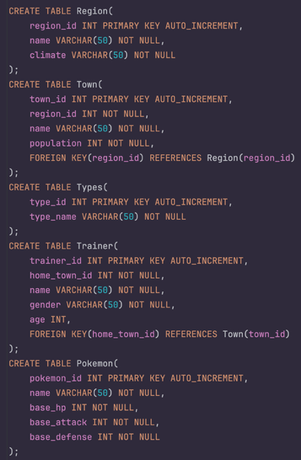
7. CRUD Operations.
Execution of the CREATE operation — inserting rows into the Region table using the INSERT statement:
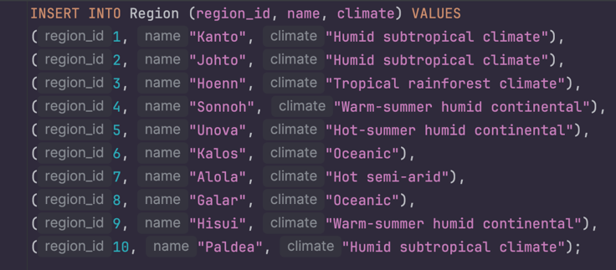
Execution of the READ operation — a SELECT query with multiple JOINs, where we get all Pokémon and their types:
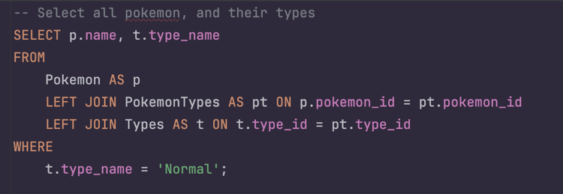
the query results are displayed:
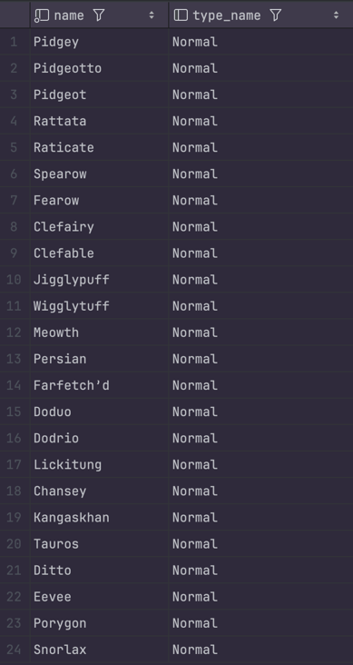
Here are examples of update and delete statements:
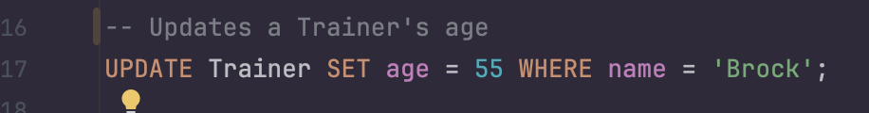
In this case, we updated a trainer’s age using an SQL UPDATE.

The DELETE example demonstrates removing a Gym record based on the Town it belongs to using a subquery.
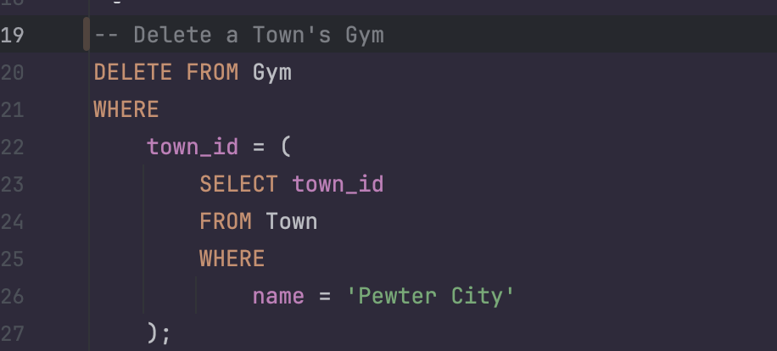

8. JOIN Queries
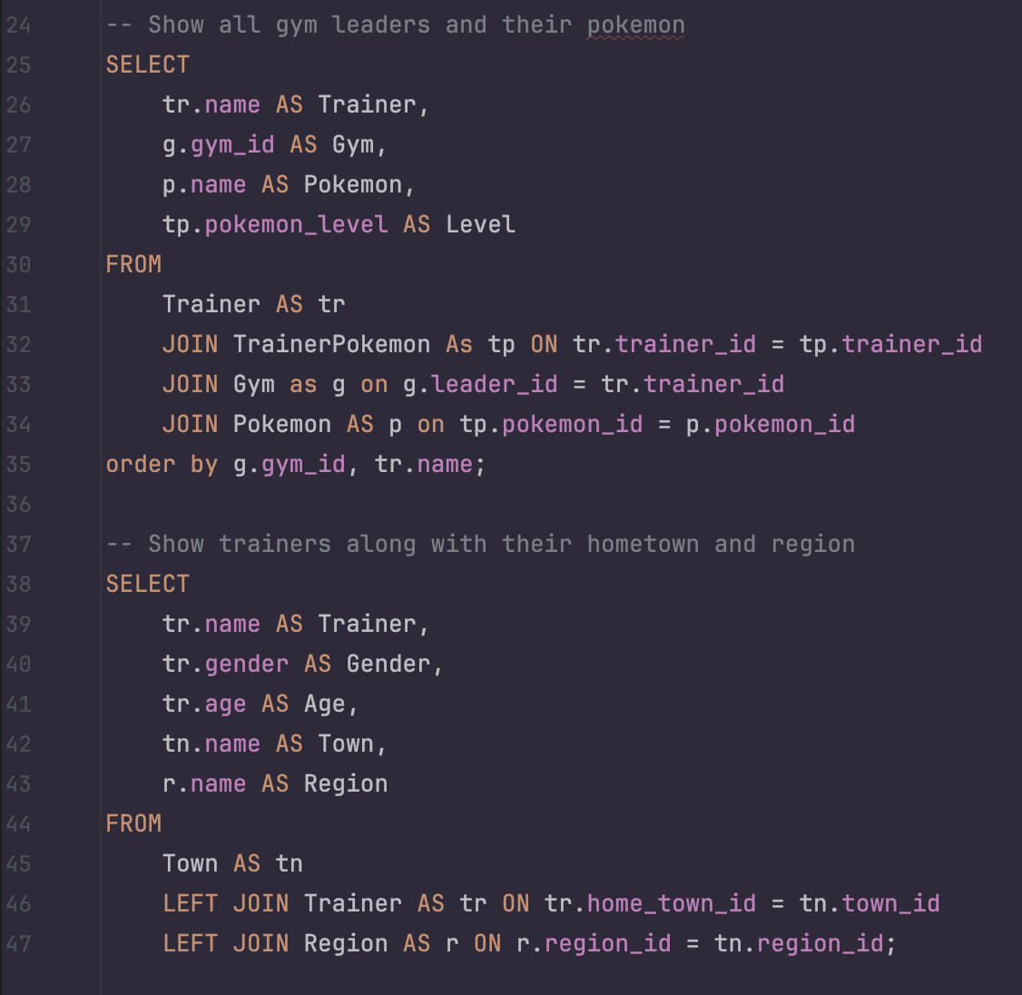
These queries demonstrate how we retrieve complex data using JOIN statements.
- The first query identifies Gym Leaders, the Pokémon they use, and their levels by joining four tables.
- The second one shows trainers together with their hometown and region using left joins.
This confirms that the relationships between our tables are correctly implemented and can be used for meaningful data analysis.

9. Views
SQL views were developed to simplify data retrieval and improve the usability of complex relational data:
- TrainerPokemonStats – calculates real-time HP, Attack, and Defense for each caught Pokémon based on its base stats, IVs, and level.
- PokemonWithTypes – aggregates multiple Pokémon types (e.g., Water/Ice) into one row using GROUP_CONCAT(), simplifying presentation and reporting.
- TrainerSummary – provides an overview of each trainer, including the total number of Pokémon owned, gym leadership status, hometown, region, and gym details.
- TrainerPokemonMaxLevelView - Displays each trainer’s highest-level Pokémon
These views reduce query complexity, optimize performance, and make it easier to generate analytical and user-facing reports.
The following screenshot demonstrates querying a view

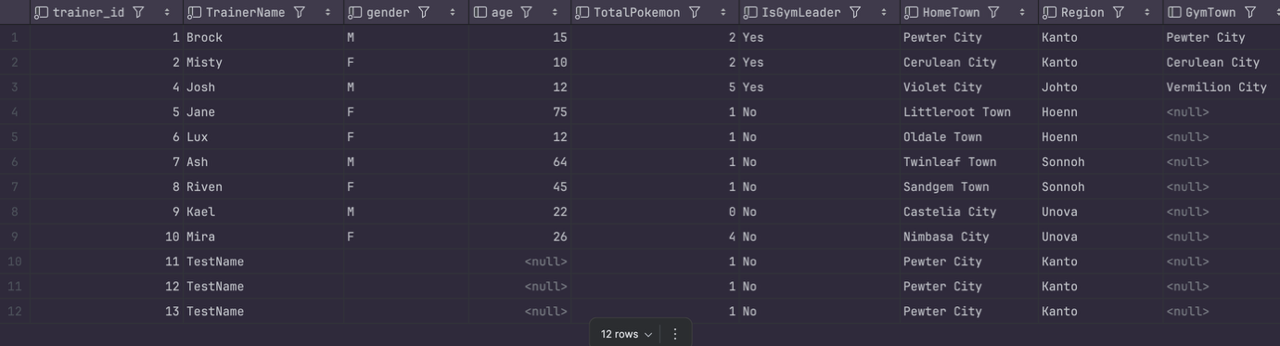

10. Triggers
Several SQL triggers were implemented to automate processes, maintain data consistency, and improve database reliability. The triggers include:
- after_trainer_delete – logs deleted trainers into a separate DeletedTrainers table for auditing and traceability.
- delete_trainer_pokemon – removes all Pokémon belonging to a trainer before their record is deleted, preventing orphaned data.
- change_leader_if_deleted – automatically reassigns a gym leader if the current leader is deleted, ensuring every gym remains managed.
- check_pokemon_level – enforces valid Pokémon levels between 1 and 100 upon insertion.
- cap_max_iv – caps the Pokémon’s IV (individual values) to a maximum of 31, ensuring balanced and realistic statistics.
These triggers collectively preserve data integrity and automate essential maintenance tasks, reducing manual intervention and preventing logical inconsistencies within the Pokémon Database.
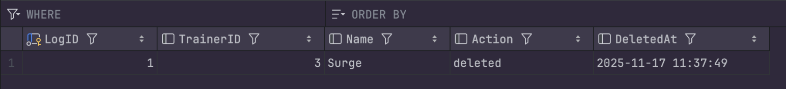
11. Indexes
Several indexes were created to enhance database performance, especially during frequent join operations:
- index_wildpokemon_region – improves joins between WildPokemon and Region, speeding up regional Pokémon queries.
- index_wildpokemon_pokemon – optimizes lookups involving Pokemon and WildPokemon tables.
- idx_pokemontypes_pokemon_id and idx_pokemontypes_type_id – enhance joins between Pokemon and Types, ensuring faster retrieval of Pokémon type information.
Indexes were verified using the EXPLAIN command, confirming their active use by the MySQL query optimizer. Together, these indexes contribute to faster data access and improved overall database efficiency.
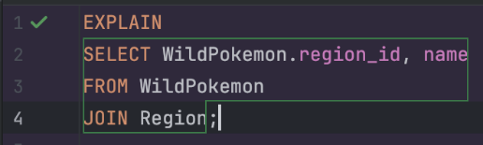

12. Java Integration (JDBC Application)
The project includes a Java console application that connects to the MySQL Pokémon database using JDBC. The Java layer is responsible for executing SQL queries, retrieving data and displaying the results to the user in a readable format.
The DBConnect class handles the database connection. It uses the MySQL JDBC driver (com.mysql.cj.jdbc.Driver) and connects to the Pokemon database via the URL jdbc:mysql://127.0.0.1:3306/Pokemon with the configured username and password. If the driver is missing or the connection fails, appropriate error messages are printed to the console.
The DBCommand class provides helper methods to execute SQL queries. It offers a runQuery method for simple queries without parameters and a runQueryWithParam method for parameterised queries. Both methods obtain a connection via DBConnect, prepare a PreparedStatement, execute it and pass the resulting ResultSet to the output formatter.
The DBOutputFormatter class formats and prints the ResultSet in a table-like structure. It uses the result set metadata to print column names as headers and then iterates through all rows, aligning columns for better readability in the console output.
The Main class provides an interactive text-based menu for the user. Through this menu, the user can:
- list Pokémon by type (using a grouped view of Pokémon and their types),
- display trainers and their Pokémon,
- show wild Pokémon by region,
- show gyms and their leaders,
- and display calculated Pokémon statistics using the TrainerPokemonStats view.
Each menu option builds an appropriate SQL query and passes it to DBCommand.runQuery, which then fetches and prints the data. This structure cleanly separates concerns between database connectivity (DBConnect), query execution (DBCommand), result formatting (DBOutputFormatter) and user interaction (Main).
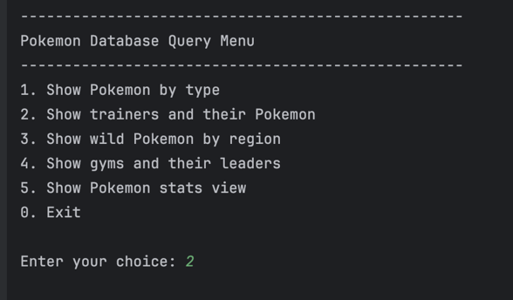
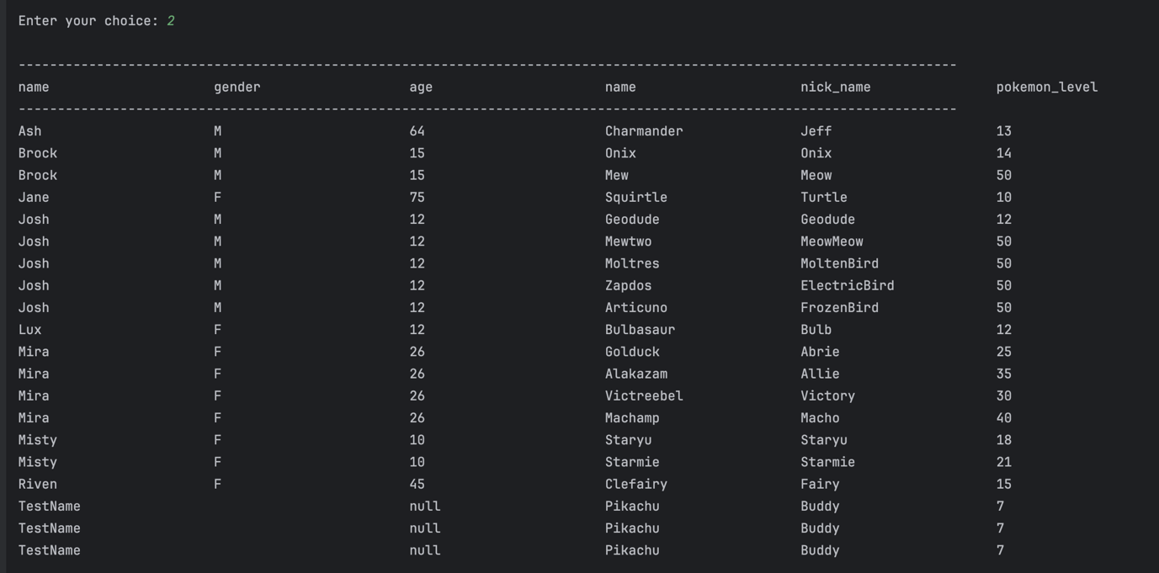
13. Advanced SQL Features (Stored Procedures and Transactions)
Advanced SQL features were implemented to enhance the functionality, consistency and reliability of the Pokémon database. These include several stored procedures and transaction-based operations that automate complex actions and ensure data integrity during multi-step updates.
Stored Procedures
A set of stored procedures was created to automate commonly used operations within the Pokémon system. These procedures encapsulate logic that would otherwise require multiple client-side queries, making the database more efficient and reducing the chance of errors.
The following stored procedures were implemented:
- TradePokemon
This procedure performs a two-way Pokémon trade between two trainers. It validates both Pokémon IDs, checks ownership and safely performs the swap. If anything goes wrong, the procedure automatically rolls back all changes to maintain data integrity.
- BuyPokemon
This procedure allows a trainer to “buy” or acquire a wild Pokémon from the WildPokemon table. It inserts the new record into TrainerPokemon and removes the Pokémon from the wild encounter list. The entire operation is transaction-protected to avoid partial inserts.
- AddPokemon
Adds a new Pokémon species to the Pokémon table, including base stats. It simplifies adding new species to the database without repeating SQL.
- AddTrainerWithStarter
Creates a new trainer and immediately assigns them a starter Pokémon. This procedure contains its own transaction to ensure that both inserts succeed together.
These procedures significantly reduce repetitive SQL logic and ensure that complex operations remain consistent and maintainable.
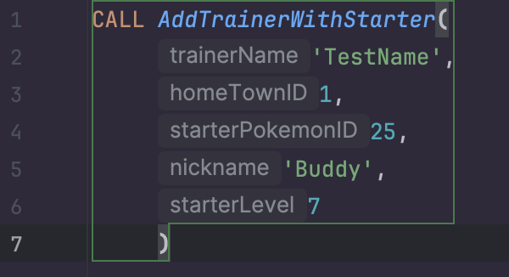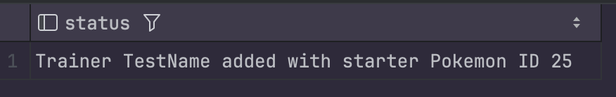
Transactions
Transactions are used in the stored procedures to guarantee that multi-step processes either complete fully or not at all. This prevents the database from entering an inconsistent state, such as a trainer losing a Pokémon without receiving another during a trade.
Both major procedures utilise transactions:
- TradePokemon (Transaction Example)
- START TRANSACTION
- Validate Pokémon
- Update trainer ownership of both Pokémon
- COMMIT if successful
- ROLLBACK on error
- Uses a structured EXIT HANDLER FOR SQLEXCEPTION
- BuyPokemon (Transaction Example)
- Inserts the caught Pokémon
- Deletes the wild instance
- Automatically rolls back if either step fails
These transaction-protected procedures demonstrate proper use of COMMIT and ROLLBACK, fulfilling the coursework requirement for safe, atomic database modifications.
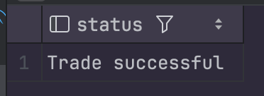
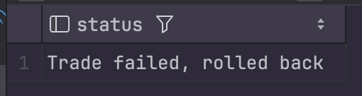
14. Summary of Advanced SQL Usage
The advanced SQL components implemented in this project provide the following benefits:
- Data Safety: Transactions prevent partial updates and maintain logical consistency.
- Efficiency: Stored procedures reduce code duplication and improve performance.
- Maintainability: Encapsulated database logic makes future expansion easier.
- Realism: Operations such as trading and catching Pokémon reflect real game mechanics.
These features integrate seamlessly with the triggers, indexes and views and form a complete and robust database backend for the Java application.
15. Database Administration
Database administration tasks were implemented to manage user access, security and permissions within the Pokémon database. This ensures that the system remains protected, well-structured and properly controlled, following best practices for multi-user database environments.
User Creation
A dedicated MySQL user account named pokemonuser was created for application-level access. This prevents the Java application from using an administrative account and increases overall security.
SQL command used to create the user:
CREATE USER 'pokemonuser'@'localhost' IDENTIFIED BY 'password123';
This user is authenticated locally and has a secure, limited-access configuration.
Privilege Assignment
Limited privileges were granted to ensure that the application can perform required actions without risking schema changes or administrative operations.
GRANT SELECT, INSERT, UPDATE, DELETE ON Pokemon.* TO 'pokemonuser'@'localhost';
After assigning privileges, they were refreshed with:
FLUSH PRIVILEGES;
Privilege Verification
To confirm that permissions were assigned correctly, the following command was executed:
SHOW GRANTS FOR 'pokemonuser'@'localhost';
This verifies that the user has the correct, restricted access expected by the system.
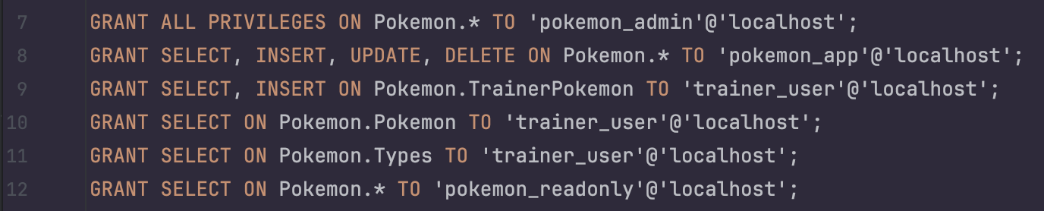
The database administration setup provides:
- Controlled access for application-level users
- Increased security through restricted privileges
- Clear separation between administrative and operational roles
- Compliance with project requirements for user and privilege management
This administrative configuration ensures that the Pokémon Database Management System remains secure, reliable and ready for integration with the Java JDBC application.
16. Java Database Connectivity
- Java application connects to the MySQL database using JDBC
- Queries are executed based on user menu selection (interactive console program)
- Results are formatted into readable tables and displayed row-by-row
- Demonstrates secure connection, query handling, and integration between backend (Java) and database (MySQL)

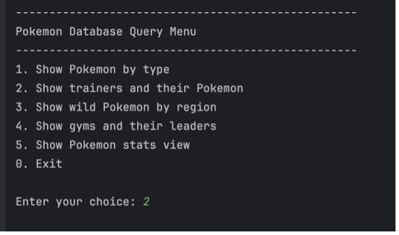
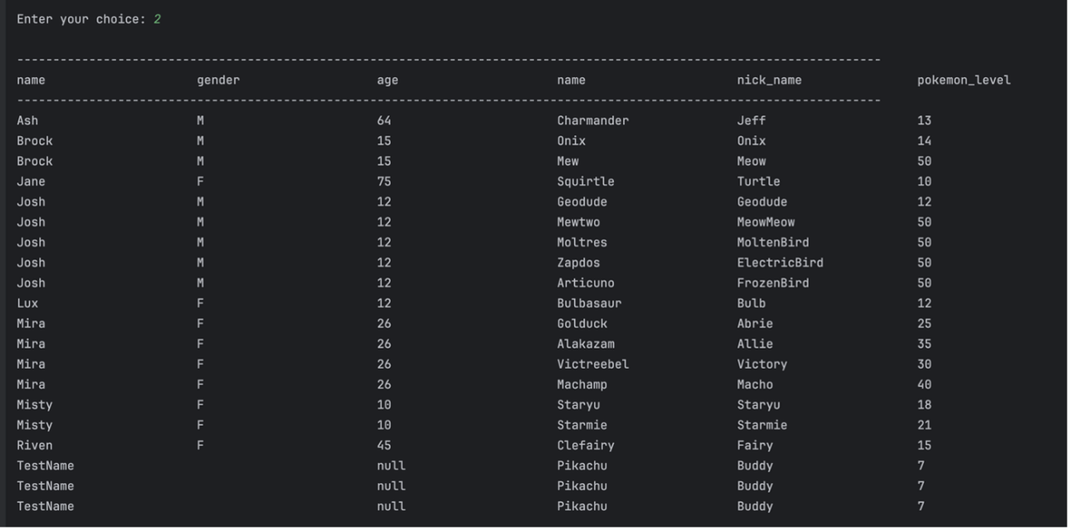

17. Unique Application Features (Team Proposals)
While the core functionality of the Pokémon Database Management System focuses on storing, managing and retrieving structured Pokémon-related data, the team also explored a range of potential enhancements that would make the application more engaging, user-friendly and competitive when compared to existing tools such as the official Pokédex.
These proposed features are not required for the database specification but demonstrate creative thinking, understanding of user needs and the potential for future system expansion.
Smart Battle Assistant
A feature that recommends the most effective Pokémon for a specific opponent based on type matchups, stats and weaknesses. The user selects an opponent Pokémon or type, and the system suggests the best counter-options. This transforms the database from a static information source into a functional strategy assistant.
Trainer Statistics and Ranking System
A personalised profile where each trainer can track:
- number of Pokémon caught,
- battle statistics,
- completed challenges and achievements.
A ranking leaderboard could introduce a competitive aspect, encouraging users to stay active and improve their performance.
Randomised Gameplay Challenges
The system could periodically generate mini-missions such as: “Build a Water-type team with at least one Pokémon above level 40” or “Catch a Pokémon with a Defense IV above 25.” These challenges add fun, replayability and motivation for users to interact with the application regularly.
Pokémon Trading Between Users
A trading system allowing users to exchange rare or valuable Pokémon.
This encourages social interaction, collaborative gameplay and long-term engagement.
The database already supports this structurally through the TradePokemon stored procedure.
Custom Team Builder
Users could assemble and save customised teams of Pokémon for different battle scenarios.
The system could evaluate team strengths, weaknesses and type balance, helping trainers optimise their strategies.
Interactive Habitat and Region Explorer
An enhanced map-based view that shows where specific Pokémon can be found, including levels and encounter probability. This improves exploration and makes the database more visually intuitive.

18. Reflective Analysis (Team Summary)
The Pokémon Database project provided our team with practical experience in database development, SQL implementation and working with structured data. Throughout the project, we gained a better understanding of the importance of planning, communication and thoughtful task distribution within a team. At the beginning, we aimed to divide the work evenly among all members, but in practice this turned out to be more challenging than expected. Each team member had their own working pace, individual schedule and different amounts of time available, which made it difficult to synchronise tasks. However, we adapted along the way and organised the process so that everyone could contribute effectively.
Despite differences in availability, every team member participated and contributed to the final result. Moreover, each of us had to understand not only our own part of the project but also other components. Even if someone did not work directly on a particular section, preparing for the presentation and understanding the overall system required reviewing the team’s work, studying the database structure, normalisation principles, triggers, views and other SQL features. This helped all of us improve our knowledge and strengthen our understanding of the subject.
Working on the database taught us how to apply normalisation in practice, build tables with clear relationships and implement constraints, triggers and views. We encountered real technical challenges—from debugging queries to adjusting the data schema—and learned to solve them through documentation, team discussions and experimentation. Testing CRUD operations, triggers, procedures and views helped us better understand how a relational database behaves and how various SQL mechanisms influence system functionality.
Despite the difficulties, the project was a valuable experience. We developed technical skills, learned flexibility in teamwork, and gained insight into how real information systems are designed and tested. This experience will benefit us in future projects and our further professional development.

19. Conclusion
The Pokémon Database Management System successfully meets the requirements of CA1 Milestone 2 and demonstrates a complete, functional and well-structured relational database supported by advanced SQL features. The project includes a fully normalised schema, implemented triggers, views, indexes, stored procedures, transactions and a working Java JDBC integration. Through testing and refinement, the system proved to be reliable, consistent and capable of handling all required operations.
The project gave the team valuable experience in database design, collaborative development and system testing. With the foundation now complete, the application can be further extended with additional features, user interface improvements and enhanced gameplay elements. Overall, the project provides a strong basis for continued development in future modules and practical environments.

