Project Specification
Pokémon Database Management System
Team Members:
- Michal Salabura
- Bernard Joyce
- Nikita Smiichyk
- Oliver Halpenny
- Hanna Bokariuk

1. Overview
The Pokémon Database Management System project was developed to model and manage the world of Pokémon — including Trainers, Pokémon species, Gyms, Regions, and Towns — using MySQL and Java (JDBC). The database ensures logical relationships between entities through normalization and the use of primary and foreign keys.
This final specification describes the complete database design, implementation and supporting features developed for the CA1 project.
2. Process Documentation
2.1 ERD
- ERD: Designed a diagram illustrating relationships between entities and keys (detailed earlier in the Project Description document).
- Normalization: Achieved 3NF to ensure data integrity and reduce redundancy (detailed earlier in the Project Description document).
- Entity & Attribute Identification: Created a comprehensive list of tables and fields (Trainers, Pokémon, Gyms, Towns, Regions, etc.), including data types and constraints (detailed earlier in the Project Description document).
- The ERD below presents the full database structure, including entities, primary keys, foreign keys and relationships.

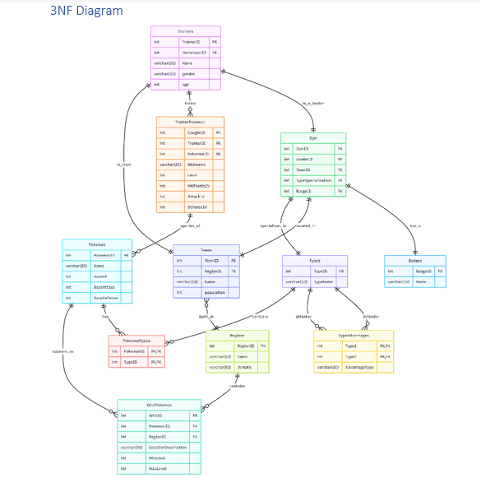
2.2. Table Creation (SQL Schema)
The following screenshot demonstrates the successful execution of a CREATE TABLE statement in MySQL.
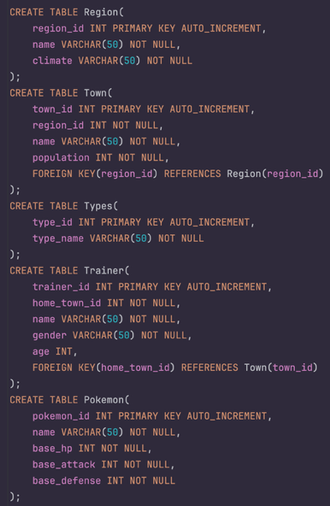
2.3. CRUD Operations (INSERT / SELECT)
Example of inserting and retrieving data to validate table structure and database connectivity.

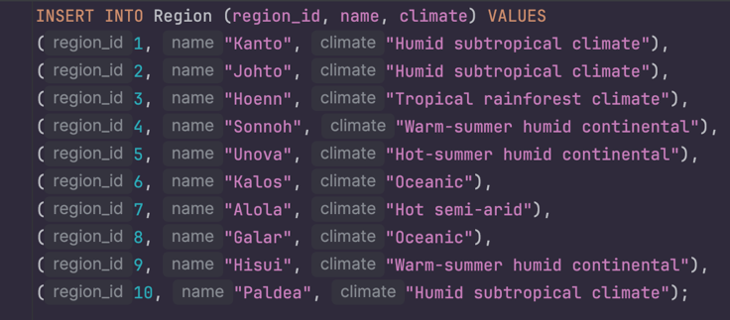
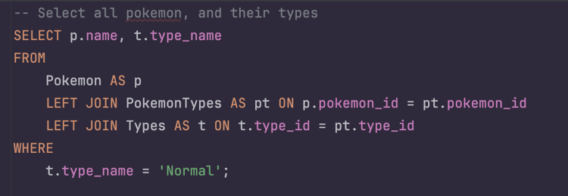
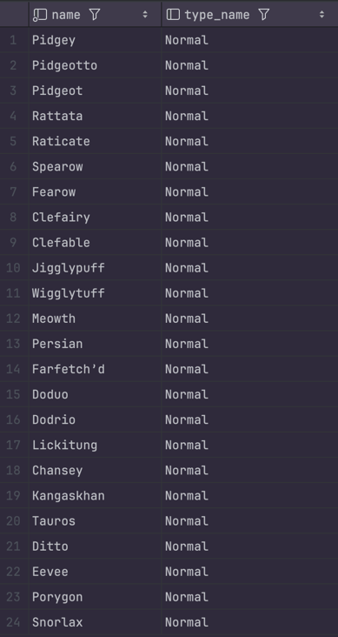

2.4. Views
Three key SQL views were developed to simplify data retrieval and improve the usability of complex relational data:
- TrainerPokemonStats – calculates real-time HP, Attack, and Defense for each caught Pokémon based on its base stats, IVs, and level.
- PokemonWithTypes – aggregates multiple Pokémon types (e.g., Water/Ice) into one row using GROUP_CONCAT(), simplifying presentation and reporting.
- TrainerSummary – provides an overview of each trainer, including the total number of Pokémon owned, gym leadership status, hometown, region, and gym details.
These views reduce query complexity, optimize performance, and make it easier to generate analytical and user-facing reports.
The following screenshot demonstrates querying a view

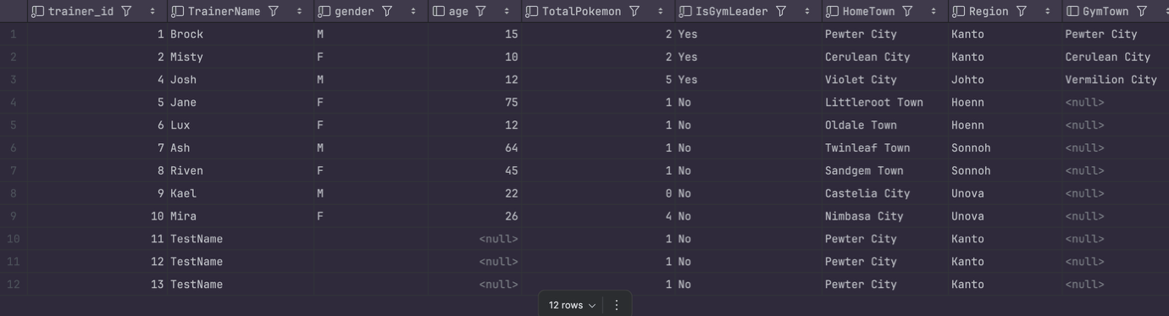
2.5. Triggers, Indexes
Database Triggers
Several SQL triggers were implemented to automate processes, maintain data consistency, and improve database reliability. The triggers include:
- after_trainer_delete – logs deleted trainers into a separate DeletedTrainers table for auditing and traceability.
- delete_trainer_pokemon – removes all Pokémon belonging to a trainer before their record is deleted, preventing orphaned data.
- change_leader_if_deleted – automatically reassigns a gym leader if the current leader is deleted, ensuring every gym remains managed.
- check_pokemon_level – enforces valid Pokémon levels between 1 and 100 upon insertion.
- cap_max_iv – caps the Pokémon’s IV (individual values) to a maximum of 31, ensuring balanced and realistic statistics.
These triggers collectively preserve data integrity and automate essential maintenance tasks, reducing manual intervention and preventing logical inconsistencies within the Pokémon Database.
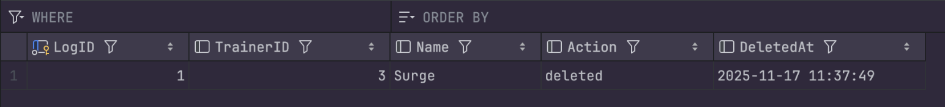
Indexes
Several indexes were created to enhance database performance, especially during frequent join operations:
- index_wildpokemon_region – improves joins between WildPokemon and Region, speeding up regional Pokémon queries.
- index_wildpokemon_pokemon – optimizes lookups involving Pokemon and WildPokemon tables.
- idx_pokemontypes_pokemon_id and idx_pokemontypes_type_id – enhance joins between Pokemon and Types, ensuring faster retrieval of Pokémon type information.
Indexes were verified using the EXPLAIN command, confirming their active use by the MySQL query optimizer. Together, these indexes contribute to faster data access and improved overall database efficiency.
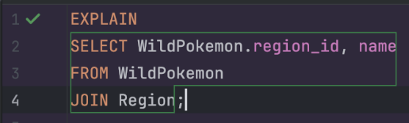

2.6. Java Integration (JDBC Application)
The project includes a Java console application that connects to the MySQL Pokémon database using JDBC. The Java layer is responsible for executing SQL queries, retrieving data and displaying the results to the user in a readable format.
The DBConnect class handles the database connection. It uses the MySQL JDBC driver (com.mysql.cj.jdbc.Driver) and connects to the Pokemon database via the URL jdbc:mysql://127.0.0.1:3306/Pokemon with the configured username and password. If the driver is missing or the connection fails, appropriate error messages are printed to the console.
The DBCommand class provides helper methods to execute SQL queries. It offers a runQuery method for simple queries without parameters and a runQueryWithParam method for parameterised queries. Both methods obtain a connection via DBConnect, prepare a PreparedStatement, execute it and pass the resulting ResultSet to the output formatter.
The DBOutputFormatter class formats and prints the ResultSet in a table-like structure. It uses the result set metadata to print column names as headers and then iterates through all rows, aligning columns for better readability in the console output.
The Main class provides an interactive text-based menu for the user. Through this menu, the user can:
- list Pokémon by type (using a grouped view of Pokémon and their types),
- display trainers and their Pokémon,
- show wild Pokémon by region,
- show gyms and their leaders,
- and display calculated Pokémon statistics using the TrainerPokemonStats view.
Each menu option builds an appropriate SQL query and passes it to DBCommand.runQuery, which then fetches and prints the data. This structure cleanly separates concerns between database connectivity (DBConnect), query execution (DBCommand), result formatting (DBOutputFormatter) and user interaction (Main).
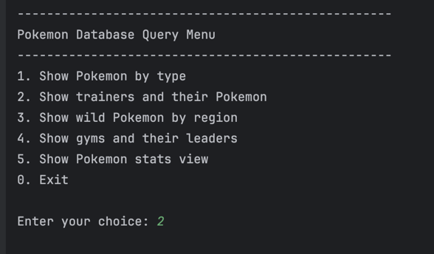
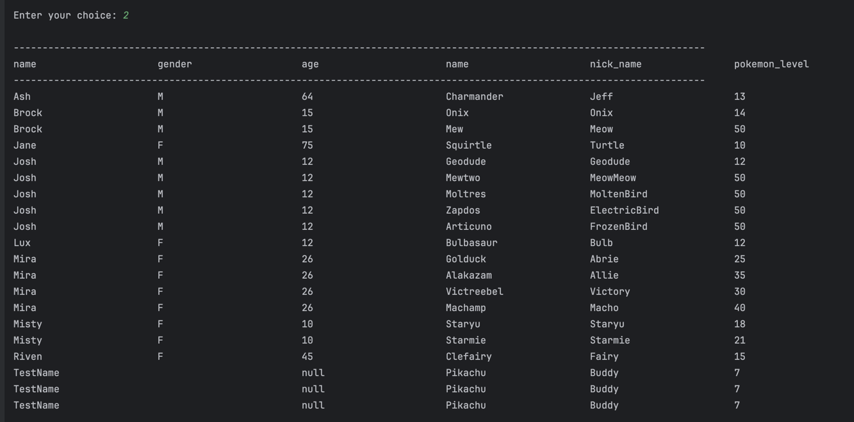
2.7. Advanced SQL Features (Stored Procedures and Transactions)
Advanced SQL features were implemented to enhance the functionality, consistency and reliability of the Pokémon database. These include several stored procedures and transaction-based operations that automate complex actions and ensure data integrity during multi-step updates.
2.7.1 Stored Procedures
A set of stored procedures was created to automate commonly used operations within the Pokémon system. These procedures encapsulate logic that would otherwise require multiple client-side queries, making the database more efficient and reducing the chance of errors.
The following stored procedures were implemented:
- TradePokemon
This procedure performs a two-way Pokémon trade between two trainers. It validates both Pokémon IDs, checks ownership and safely performs the swap. If anything goes wrong, the procedure automatically rolls back all changes to maintain data integrity.
- BuyPokemon
This procedure allows a trainer to “buy” or acquire a wild Pokémon from the WildPokemon table. It inserts the new record into TrainerPokemon and removes the Pokémon from the wild encounter list. The entire operation is transaction-protected to avoid partial inserts.
- AddPokemon
Adds a new Pokémon species to the Pokémon table, including base stats. It simplifies adding new species to the database without repeating SQL.
- AddTrainerWithStarter
Creates a new trainer and immediately assigns them a starter Pokémon. This procedure contains its own transaction to ensure that both inserts succeed together.
These procedures significantly reduce repetitive SQL logic and ensure that complex operations remain consistent and maintainable.
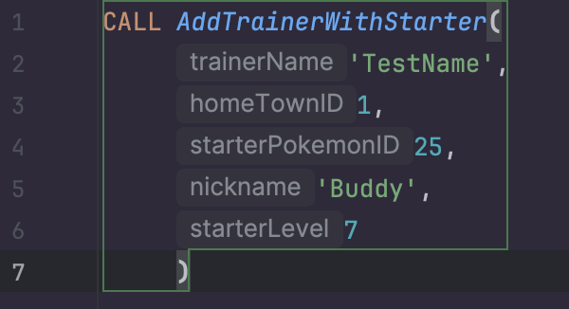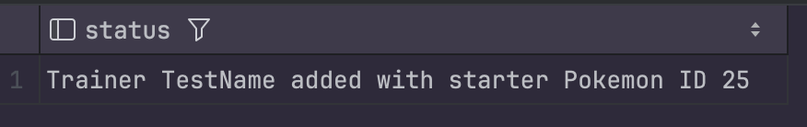
2.7.2 Transactions
Transactions are used in the stored procedures to guarantee that multi-step processes either complete fully or not at all. This prevents the database from entering an inconsistent state, such as a trainer losing a Pokémon without receiving another during a trade.
Both major procedures utilise transactions:
- TradePokemon (Transaction Example)
- START TRANSACTION
- Validate Pokémon
- Update trainer ownership of both Pokémon
- COMMIT if successful
- ROLLBACK on error
- Uses a structured EXIT HANDLER FOR SQLEXCEPTION
- BuyPokemon (Transaction Example)
- Inserts the caught Pokémon
- Deletes the wild instance
- Automatically rolls back if either step fails
- AddTrainerWithStarter (Transaction Example)
- Inserts new trainer
- Inserts starter Pokémon
- Commits only if both succeed
These transaction-protected procedures demonstrate proper use of COMMIT and ROLLBACK, fulfilling the coursework requirement for safe, atomic database modifications.
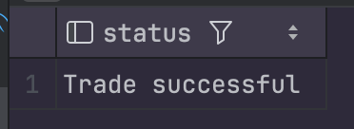
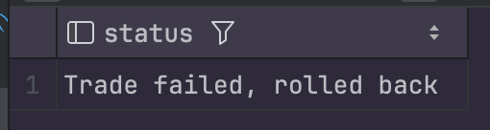
2.7.3 Summary of Advanced SQL Usage
The advanced SQL components implemented in this project provide the following benefits:
- Data Safety: Transactions prevent partial updates and maintain logical consistency.
- Efficiency: Stored procedures reduce code duplication and improve performance.
- Maintainability: Encapsulated database logic makes future expansion easier.
- Realism: Operations such as trading and catching Pokémon reflect real game mechanics.
These features integrate seamlessly with the triggers, indexes and views and form a complete and robust database backend for the Java application.
2.8. Database Administration
Database administration tasks were implemented to manage user access, security and permissions within the Pokémon database. This ensures that the system remains protected, well-structured and properly controlled, following best practices for multi-user database environments.
2.8.1 User Creation
A dedicated MySQL user account named pokemonuser was created for application-level access. This prevents the Java application from using an administrative account and increases overall security.
SQL command used to create the user:
CREATE USER 'pokemonuser'@'localhost' IDENTIFIED BY 'password123';
This user is authenticated locally and has a secure, limited-access configuration.
2.8.2 Privilege Assignment
Limited privileges were granted to ensure that the application can perform required actions without risking schema changes or administrative operations.
GRANT SELECT, INSERT, UPDATE, DELETE ON Pokemon.* TO 'pokemonuser'@'localhost';
After assigning privileges, they were refreshed with:
FLUSH PRIVILEGES;
2.8.3 Privilege Verification
To confirm that permissions were assigned correctly, the following command was executed:
SHOW GRANTS FOR 'pokemonuser'@'localhost';
This verifies that the user has the correct, restricted access expected by the system.
2.8.4 Summary
The database administration setup provides:
- Controlled access for application-level users
- Increased security through restricted privileges
- Clear separation between administrative and operational roles
- Compliance with project requirements for user and privilege management
This administrative configuration ensures that the Pokémon Database Management System remains secure, reliable and ready for integration with the Java JDBC application.

3. Unique Application Features (Team Proposals)
While the core functionality of the Pokémon Database Management System focuses on storing, managing and retrieving structured Pokémon-related data, the team also explored a range of potential enhancements that would make the application more engaging, user-friendly and competitive when compared to existing tools such as the official Pokédex.
These proposed features are not required for the database specification but demonstrate creative thinking, understanding of user needs and the potential for future system expansion.
3.1. Smart Battle Assistant
A feature that recommends the most effective Pokémon for a specific opponent based on type matchups, stats and weaknesses.
The user selects an opponent Pokémon or type, and the system suggests the best counter-options.
This transforms the database from a static information source into a functional strategy assistant.
3.2. Trainer Statistics and Ranking System
A personalised profile where each trainer can track:
- number of Pokémon caught,
- battle statistics,
- completed challenges and achievements.
A ranking leaderboard could introduce a competitive aspect, encouraging users to stay active and improve their performance.
3.3. Randomised Gameplay Challenges
The system could periodically generate mini-missions such as:
“Build a Water-type team with at least one Pokémon above level 40”
or
“Catch a Pokémon with a Defense IV above 25.” These challenges add fun, replayability and motivation for users to interact with the application regularly.
3.4. Pokémon Trading Between Users
A trading system allowing users to exchange rare or valuable Pokémon.
This encourages social interaction, collaborative gameplay and long-term engagement.
The database already supports this structurally through the TradePokemon stored procedure.
3.5. Custom Team Builder
Users could assemble and save customised teams of Pokémon for different battle scenarios.
The system could evaluate team strengths, weaknesses and type balance, helping trainers optimise their strategies.
3.6. Interactive Habitat and Region Explorer
An enhanced map-based view that shows where specific Pokémon can be found, including levels and encounter probability. This improves exploration and makes the database more visually intuitive.

4. Reflective Analysis (Team Summary)
The Pokémon Database project provided our team with practical experience in database development, SQL implementation and working with structured data. Throughout the project, we gained a better understanding of the importance of planning, communication and thoughtful task distribution within a team. At the beginning, we aimed to divide the work evenly among all members, but in practice this turned out to be more challenging than expected. Each team member had their own working pace, individual schedule and different amounts of time available, which made it difficult to synchronise tasks. However, we adapted along the way and organised the process so that everyone could contribute effectively.
Despite differences in availability, every team member participated and contributed to the final result. Moreover, each of us had to understand not only our own part of the project but also other components. Even if someone did not work directly on a particular section, preparing for the presentation and understanding the overall system required reviewing the team’s work, studying the database structure, normalisation principles, triggers, views and other SQL features. This helped all of us improve our knowledge and strengthen our understanding of the subject.
Working on the database taught us how to apply normalisation in practice, build tables with clear relationships and implement constraints, triggers and views. We encountered real technical challenges—from debugging queries to adjusting the data schema—and learned to solve them through documentation, team discussions and experimentation. Testing CRUD operations, triggers, procedures and views helped us better understand how a relational database behaves and how various SQL mechanisms influence system functionality.
Despite the difficulties, the project was a valuable experience. We developed technical skills, learned flexibility in teamwork, and gained insight into how real information systems are designed and tested. This experience will benefit us in future projects and our further professional development.

5. Conclusion
The Pokémon Database Management System successfully meets the requirements of CA1 Milestone 2 and demonstrates a complete, functional and well-structured relational database supported by advanced SQL features. The project includes a fully normalised schema, implemented triggers, views, indexes, stored procedures, transactions and a working Java JDBC integration. Through testing and refinement, the system proved to be reliable, consistent and capable of handling all required operations.
The project gave the team valuable experience in database design, collaborative development and system testing. With the foundation now complete, the application can be further extended with additional features, user interface improvements and enhanced gameplay elements. Overall, the project provides a strong basis for continued development in future modules and practical environments.

