**Introduction :**

Unlocking insights into the global air transportation network with Tableau can be a powerful way to analyze and visualize data related to airlines, airports, routes, and passenger trends. Tableau is a popular data visualization and business intelligence tool that can help you create interactive dashboards and reports to make sense of complex aviation data.

**Data Collection:**

Start by collecting the relevant data for your analysis. This data can include information on airlines, airports, flight routes, passenger counts, cargo volumes, and more. You may obtain this data from various sources, such as aviation authorities, airline companies, or publicly available datasets.

**Analyze the Data**:

With your dashboards in place, start analyzing the data. Look for patterns, trends, and anomalies. For example, you might explore the following:

* Seasonal variations in air travel.
* Busiest airports and their connections.
* Popular airline routes.
* Changes in passenger behavior post-pandemic.

**Create Visualizations**: Start by creating visualizations to explore the data. Tableau offers a drag-and-drop interface, making it easy to create charts, graphs, maps, and other visualizations. Here are some common visualizations you can use:

* **Bar charts**: Show the number of flights by airline or airport.
* **Line charts**: Display trends in passenger counts over time.
* **Maps**: Plot airports on a world map and use color-coding to represent traffic volume.
* **Heatmaps**: Visualize flight routes' density or passenger demand.

**Storytelling**: Use Tableau's story feature to create a narrative around your insights. This can be particularly useful when presenting your findings to stakeholders or colleagues. Stories allow you to guide the audience through a series of visualizations and explain the significance of your findings.

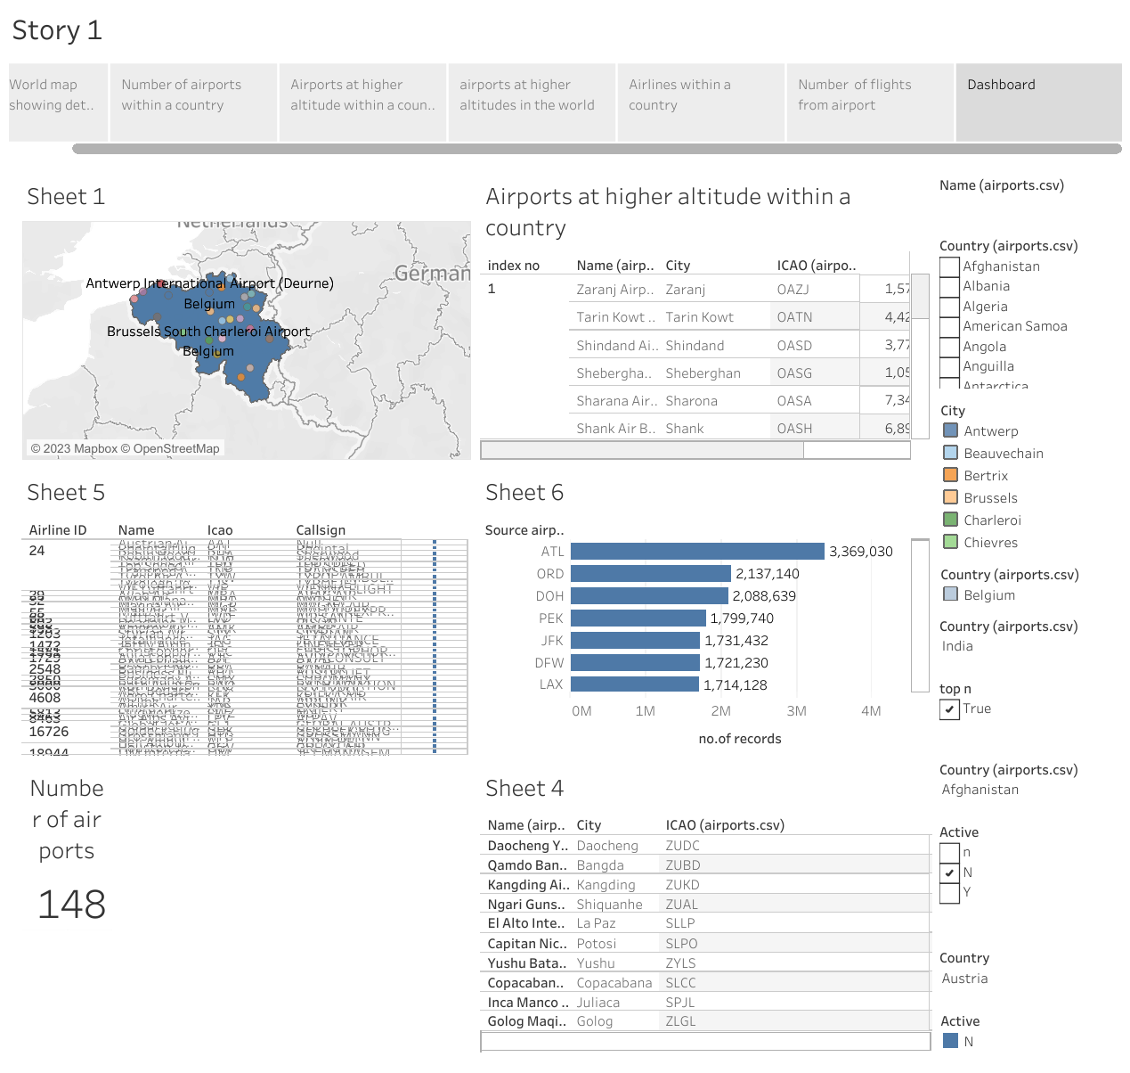

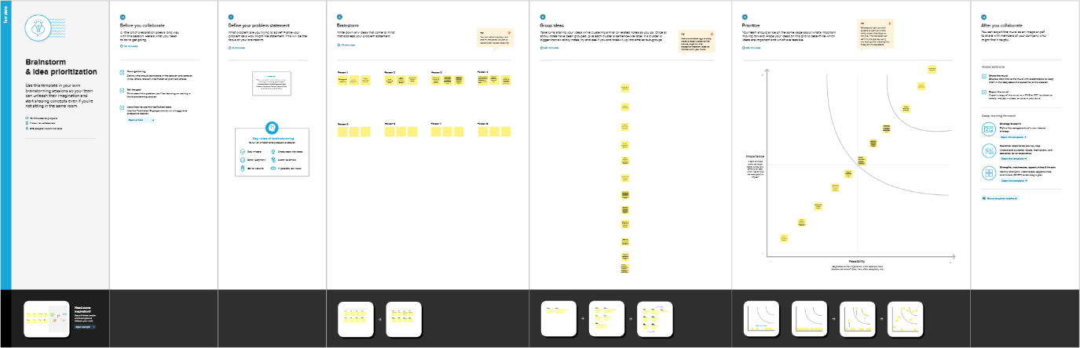 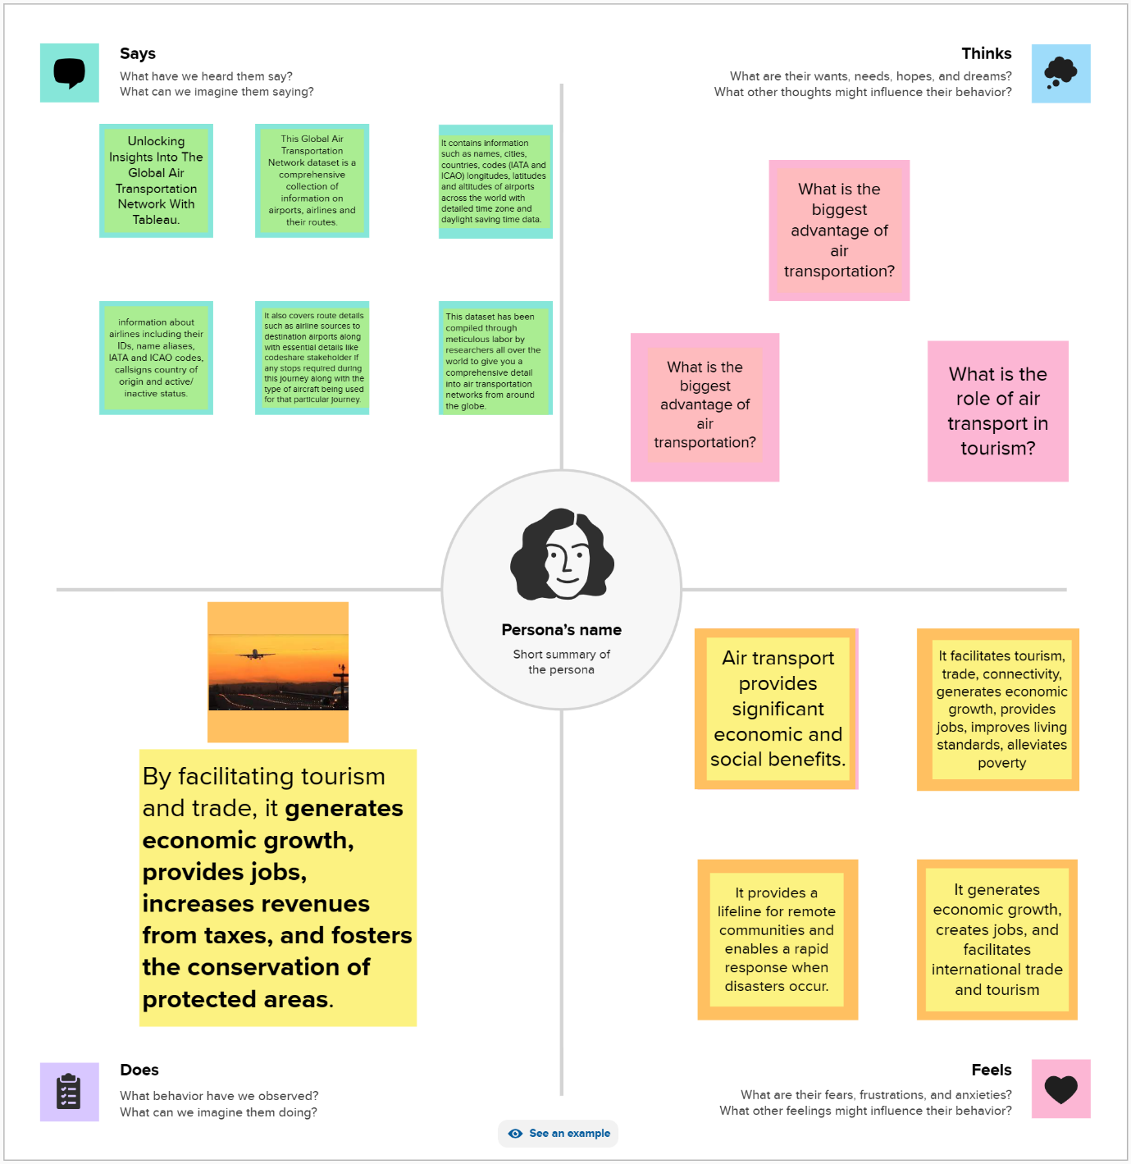

**Feedback and Iteration**: Gather feedback from users and stakeholders and iterate on your visualizations and dashboards to make them more informative and user-friendly

**Conclusion :** Tableau is a powerful tool for uncovering insights in complex data, and it can be especially valuable when analyzing the global air transportation network, which involves a vast amount of data. By following these steps, you can unlock valuable insights that can inform decision-making and improve understanding of the aviation industry.

**Future Scope**

Air travel has now become one of the most commonly used modes of transportation across the world due to its ease of access, faster commute, and reasonable costs. Its increasing demand has made it possible to achieve connectivity to nearly every part of the world, with a growing number of direct flights to major cities

We assume that cities are randomly and uniformly distributed. The critical assumption is that we assume that the number of routes is constant and that we make no assumptions on which routes should or shouldn’t exist or what the range of a route should be. That means the model is a pure theoretical spatial graph, aimed at only analyzing its fundamental properties as a function of distance cost.