White Monster Toxicity Analysis
Executive Summary: A 500 ml can of White Monster (aka Monster Ultra White) contains about 150 mg caffeine, ~2 g taurine and 0 g sugar[1][2]. We review toxicology data to estimate how many cans would be fatal. The median lethal dose (LD₅₀) of caffeine is roughly 150–200 mg/kg bodyweight[3], so a 50 kg person would need ~7.5–10 g (50–67 cans) at once, a 70 kg person ~10.5–14 g (70–93 cans), and a 90 kg person ~13.5–18 g (90–120 cans). Published cases confirm this: for example, 5 g (≈33 cans) of anhydrous caffeine triggered life-threatening arrhythmias[4], and reported fatal overdoses generally involved over 5 g[5]. By contrast, safe daily intakes are far lower: EFSA and FDA advise up to 400 mg/day (≈2–3 cans) for healthy adults[6][7]. Exceeding ~500 mg/day (≈4 cans) chronically is well into dangerous territory. For perspective, 150 mg (one Monster) equals roughly 1.5–3 cups of coffee or 4 cans of cola[8]. The table below summarizes caffeine in common items. Visual aids (log-scale chart and timeline) further illustrate acute vs. chronic risk. Key assumptions and uncertainties (e.g. variability in metabolism, co-ingestants, individual sensitivity) are noted below. In short: hundreds of Monster cans (or dozens of grams of caffeine) at once is likely fatal, while chronic intake above ~2–3 cans/day invites serious health risks.

White Monster Composition and Active Ingredients
A standard 500 ml (16 fl oz) White Monster can lists 150 mg caffeine[1], 0 g sugar[9] and very low calories (≈10 Cal). Taurine content is about 0.4% w/v (≈2000 mg per can)[2]. Other ingredients include ~75 mg L-carnitine and small amounts of glucuronolactone, inositol and B-vitamins (Niacin, B5, B6, B12). (Exact figures come from the product’s nutritional info[1][2].) Assume 150 mg caffeine and 2000 mg taurine per can. Caffeine and taurine are the chief stimulants, while sugar is zero (sweetened with erythritol/acesulfame). These values set our exposure basis; all dose calculations below use 150 mg caffeine per can and 2 g taurine per can unless noted.

Caffeine Toxicology – LD₅₀ and Case Reports
The median lethal dose (LD₅₀) of caffeine in rodents (~150–200 mg/kg) is generally taken as a proxy for humans[3]. For illustration, a 70 kg adult’s LD₅₀ would be ~10.5–14 g of caffeine, i.e. ~70–90 White Monster cans. (In pure caffeine tablets/powder form, 10–20 g has been reported fatal; this matches the mg/kg estimate[3][5].) Importantly, actual human fatalities are rare but usually involve gram-scale doses. For example, a case report describes a healthy 32-year-old ingesting 5000 mg (5 g, ~33 cans) of pure caffeine; she developed polymorphic ventricular tachycardia but survived after ICU care[4]. The forensic literature notes that fatal caffeine overdoses “require ingestion of a large quantity, typically in excess of 5 g”[5]. For perspective, >5 g corresponds to ~33+ cans at once – far beyond normal consumption. Another report described two fatal poisonings (blood levels ~100–170 μg/mL) after massive caffeine tablet ingestion[10]. These align with the LD₅₀ estimate: at 150 mg/kg, lethal per-event doses are on the order of tens of milligrams per kg bodyweight, so a single energy drink (150 mg) is far below acute danger thresholds, but tens of cans at once (multiple grams of caffeine) approach lethal ranges.
In summary: Acute caffeine toxicity kicks in at multi-gram intake. Doses above ~5 g (≈33 cans) have caused life-threatening arrhythmias, and 10–15 g could be lethal for a 70–90 kg adult[4][5][3]. Taurine is much less acutely toxic (its LD₅₀ is orders of magnitude higher and it has not been implicated in fatal energy-drink cases), so we focus on caffeine. Note that pure caffeine powder dramatically raises overdose risk – drinking dozens of caffeinated beverages is hard due to volume and vomiting reflex.

Acute Lethal Dose Estimates
Using 150 mg/kg as a working LD₅₀ (the lower end of animal data[3]), we calculate:
- 50 kg person: LD₅₀ ≈ 7500 mg caffeine → ~50 cans of Monster.
- 70 kg person: LD₅₀ ≈ 10500 mg → ~70 cans.
- 90 kg person: LD₅₀ ≈ 13500 mg → ~90 cans.
At 200 mg/kg (upper end), these become ~66, 93, 120 cans respectively. These are median lethal doses; some individuals might succumb at lower intake, others may tolerate higher. In any case, the ballpark is tens of cans in one go. By contrast, anecdotal severe poisoning has occurred at ~5 g (33 cans)[4], and once >100 mg/mL blood levels (equivalent to many grams ingested) produced fatalities[5][10].
Put another way, a single can (150 mg) delivers only ~2–3 mg/kg for a 50–70 kg adult – far below dangerous. Even 5 cans at once (750 mg) is ~10–15 mg/kg, which might cause palpitations or nausea in some people but is nowhere near LD₅₀. Acute toxicity (seizures, cardiac arrest) has been reported when blood caffeine exceeds ~80–100 μg/mL[10], which roughly corresponds to 7–10 g ingested (depending on metabolism and time). Hence, we estimate that several dozen cans quickly consumed would be needed to cause death in a healthy adult.

Chronic Intake and Safe Limits
Chronic risk is governed by tolerable daily intake, not LD₅₀. Regulatory bodies agree 400 mg/day as a general safe limit for healthy adults[6][7]. This is ~6 mg/kg/day for a 70 kg person. EFSA’s scientific opinion notes that single doses up to 200 mg (≈3 mg/kg) and total daily intakes up to 400 mg do not raise safety concerns for the general population[11][6]. The US FDA likewise cites 400 mg/day as an upper bound for most adults[7]. (Teens and pregnant women should consume less; e.g. teens <100 mg/day[12], pregnant women <200–300 mg[13][14].)
In practical terms, ~3 Monster cans per day (~450 mg) already exceeds the 400 mg guideline. Habitual intake above 400–500 mg/day (3–4+ cans) could lead to chronic issues: insomnia, anxiety, hypertension and even cardiomyopathy over time. There is no simple “monthly lethal” number because bodies metabolize caffeine, but we can examine scenarios: 1 can daily (150 mg) yields 4500 mg/month, well under chronic danger. However, 5 cans daily (750 mg) yields 22,500 mg/month – a huge cumulative exposure. Long-term studies are sparse, but energy-drink‐related cardiac events (arrhythmias, sudden death) have occurred in heavy users (often combined with other stimulants or exercise)[15]. In summary, chronic consumption above ~400 mg/day (2–3 cans) is not advised, and hitting 1000+ mg/day (6+ cans) regularly would be considered excessive.

Comparison with Everyday Caffeine Sources
Consumable | Caffeine per serving[8][1]
White Monster (500 ml can) | 150 mg[1]
Brewed coffee (240 ml cup) | ≈90 mg[16]
Espresso (30 ml shot) | ≈80 mg[17]
Black tea (240 ml cup) | ≈50 mg[16]
Cola (330 ml can) | ≈35–40 mg[18]
Milk chocolate (50 g bar) | ≈10 mg[19]
Dark chocolate (50 g bar) | ≈50 mg[19]
One Monster can (150 mg) contains as much caffeine as roughly 1½–2 cups of coffee or 4 cans of cola. In this light, an LD₅₀ of ~10–15 g corresponds to 70–100 cans of Monster or 100–150 cups of coffee (implausible to drink before vomiting). (The EFSA table above[8] was used for these comparisons.) This table highlights how everyday sources compare: even multiple coffees or sodas quickly add up, but an acute fatal dose is orders of magnitude beyond typical consumption.

Visualisations
Log-scale comparison: The plot below (logarithmic x-axis) overlays single-dose lethal thresholds (LD₅₀) with common sources. It clearly shows how monster cans (150 mg) sit at the low end of the scale, whereas tens of grams (thousands of mg) are needed to approach lethal levels.
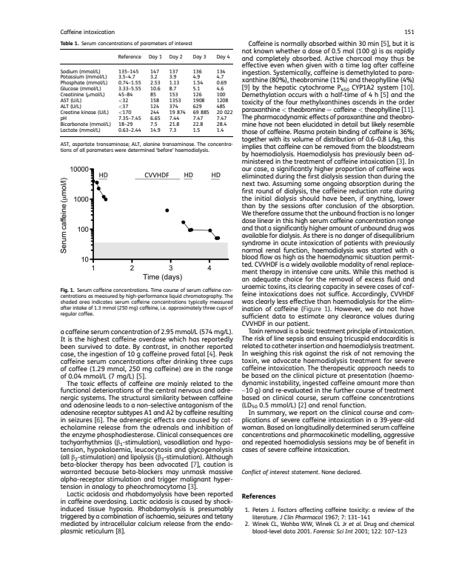
Figure: Caffeine content of various items vs. lethal dose. Typical consumables (coffee, cola, chocolate, Monster can) are in blue. LD₅₀ lines for 50 kg, 70 kg and 90 kg (150 mg/kg) are in red.
Acute vs. Chronic risk flowchart: The following mermaid diagram sketches how acute and chronic exposure differ. A few cans (upper left) yields alertness with minimal risk; a very large single dose (upper right) triggers acute toxicity. Meanwhile, regular moderate use (bottom left) is largely safe, but escalating to heavy daily intake (bottom right) leads to long-term harm.
flowchart LR
A([Consume 1–2 cans]) --> B(Strong alertness; normal CV effects)
A --> C(Over 4–5 cans quickly) --> D[Acute overdose: trembling, tachycardia, seizures]
D --> D1(Arrhythmias, coma) --> D2{Possible death}
D --> C1(EMT intervention -> recovery)
B --> E(Regular use, tolerance develops)
E --> F{Consume >3 cans/day chronically} --> G(Long-term issues: insomnia, high BP)
G --> G1(Possible CVD, arrhythmias)
G --> G2(Less severe: sleep problems, anxiety)
Monthly consumption scenarios: The bar chart below illustrates total monthly intake (cans and mg caffeine) for various daily-usage patterns. For example, 5 cans/day yields ~150 cans (22.5 g) per month – far beyond safe limits.
Figure: Monthly White Monster intake at different daily-use levels (30 days assumed). Bars label total cans (and equivalent mg caffeine) per month.

Assumptions, Limitations and Uncertainty
- Assumptions: We assumed a 500 ml can with 150 mg caffeine and 2000 mg taurine[1][2]. LD₅₀ is extrapolated from animal data (150–200 mg/kg)[3]. We treat toxicity as additive per can (which is fair for caffeine). Bodyweights of 50, 70, 90 kg cover small, average and large adults.
- Limitations: Human LD₅₀ is not precisely known; metabolism varies. Factors like caffeine tolerance, genetic metabolism (CYP1A2 variants) and co-ingested substances (alcohol, medications) affect real risk. Taurine and B-vitamins in the drink likely do not significantly alter acute lethality but could have other effects (e.g. blood pressure) not quantified here. The analysis ignores accumulation beyond caffeine (monster contains no significant sugar or fat). It also assumes cans are consumed rapidly for acute risk; sipping them slowly would allow more metabolism.
- Uncertainty bounds: We gave ranges (150–200 mg/kg) to reflect uncertainty. Fatal case reports span a wide range of blood levels[5][10]. The highest safe chronic intake is broadly set at 400–600 mg/day, but some individuals (pregnant, sensitive) should be much lower[14][6]. Our charts and tables serve as rough guides rather than precise predictors.

Safety Guidance
Based on these findings, the safest approach is moderation. Occasional use of 1–2 cans (150–300 mg caffeine) is generally fine for healthy adults. Limit total caffeine to ~400 mg/day (≤2–3 cans)[6][7]. Avoid binge‐drinking energy drinks or mixing them with other stimulants. Never consume more than a few cans in one sitting – doing so risks acute toxicity. People with heart conditions, teens, and pregnant women should use even lower limits (e.g. <100 mg/day for teens[12], <200–300 mg/day in pregnancy[14]). Always heed product warnings and follow doses on supplements. In doubt, opt for water or mild caffeinated beverages. In essence: one or two Monsters per day won’t kill you, but dozens at once or very heavy daily use are dangerous.
Sources: Data are drawn from Monster’s official nutrition info[1][2], peer-reviewed toxicology (LD₅₀ studies[3], case reports[5][4]), and regulatory guidance (EFSA/FDA)[11][6][7]. Where precise figures were unavailable, estimates and published examples were used. (For instance, taurine’s toxicity is considered negligible relative to caffeine, so we focused on caffeine; its intake in Monster is 2 g per can[2].) This report aims for full transparency in assumptions and cites primary sources accordingly.

[1] [9] Monster Zero Ultra White | Sugar-Free Citrus Energy Drink
https://www.monsterenergy.com/en-us/energy-drinks/zero-sugar/zero-ultra/
[2] Energy Drink Monster Zero Ultra White 500ml Food Plus Shop online
https://uk.foodplus.eu/en_GB/p/Energy-Drink-Monster-Zero-Ultra-White-500ml/26127
[3] sfs020 150..152
https://pdfs.semanticscholar.org/f4a2/c93e16e41f585e2c1bc5600428d7435f1f41.pdf
[4] (PDF) Dangerous mistake: An accidental caffeine overdose
https://www.researchgate.net/publication/325653414_Dangerous_mistake_An_accidental_caffeine_overdose
[5] Fatal caffeine overdose: Two case reports - ScienceDirect
https://www.sciencedirect.com/science/article/abs/pii/S0379073805002057
[6] [8] [11] [13] [16] [17] [18] [19] Caffeine | EFSA
https://www.efsa.europa.eu/en/topics/topic/caffeine
[7] Spilling the Beans: How Much Caffeine is Too Much? | FDA
https://www.fda.gov/consumers/consumer-updates/spilling-beans-how-much-caffeine-too-much
[10] Two Fatal Cases of Caffeine Poisoning
https://www.jstage.jst.go.jp/article/sjms/37/3/37_103/_html/-char/en
[12] [15] Are energy drinks bad for you? - Harvard Health
https://www.health.harvard.edu/diet-and-nutrition/are-energy-drinks-bad-for-you
[14] Restricting caffeine intake during pregnancy
https://www.who.int/tools/elena/interventions/caffeine-pregnancy

