KPI 1: Charging Duration

Charging Duration measures session efficiency and user experience. The trends show peak charging occurs at 6 AM for the registered Users and 7AM for the unregistered, reflecting morning routines, and charging declines throughout the day. This pattern suggests a consistent morning charging preference among users, with little difference between registered and unregistered users.

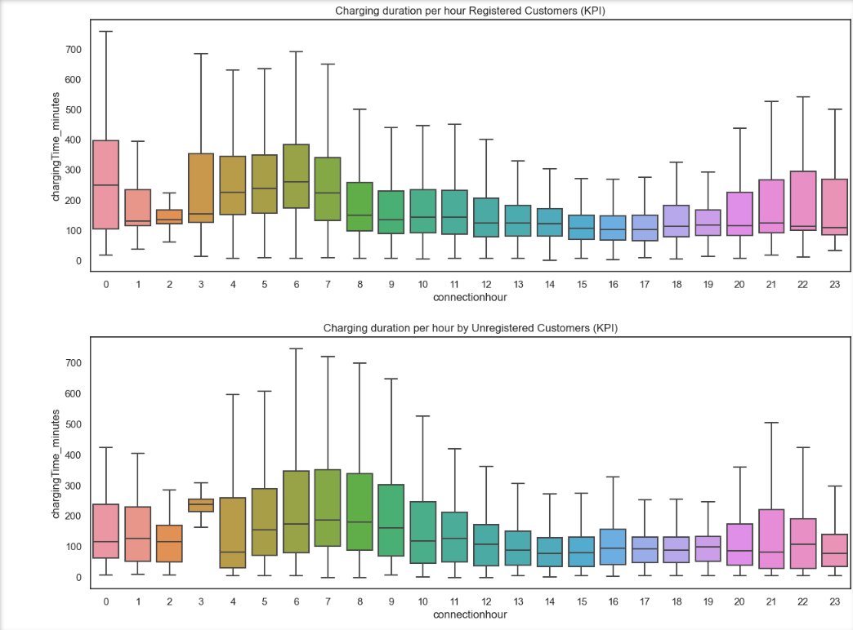

KPI 2: Average Session Duration

Average Session Duration reveals session length and station turnover. Sessions often exceed charging times, suggesting cars remain parked longer than needed, especially overnight.

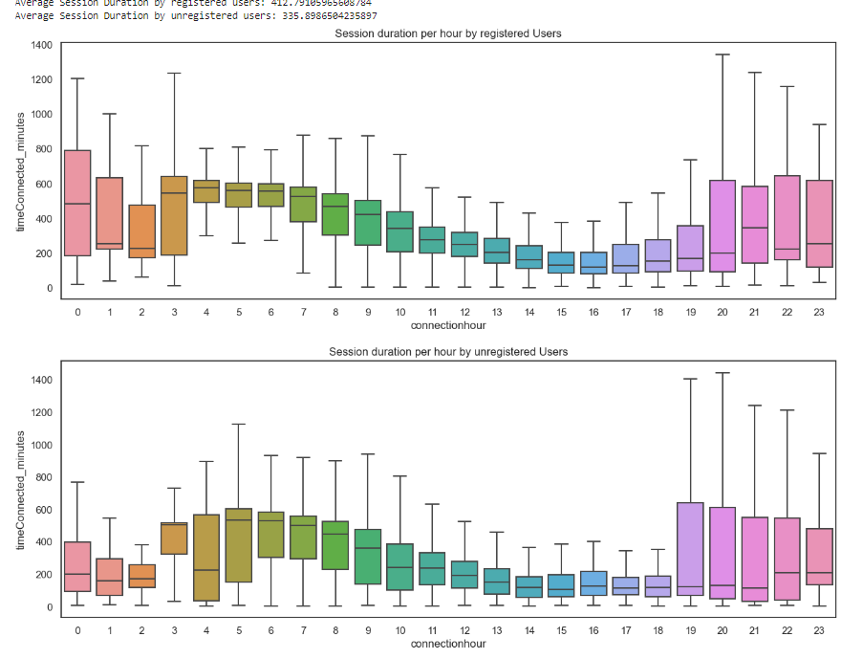

KPI 3: Idle Time

Idle Time measures station efficiency. Idle times mirror session lengths, suggesting potential for improved turnover rates. Variability is observed in idle times.

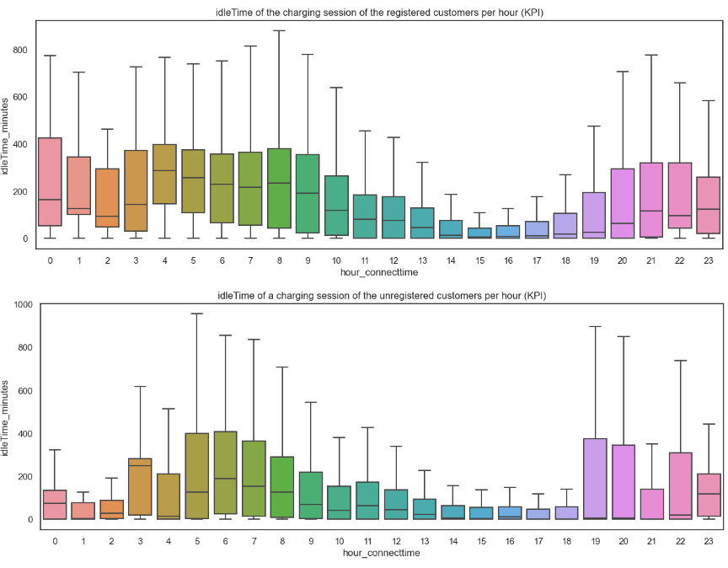

KPI 4: General Demand

General Demand tracks daily station usage trends. Similar patterns are seen for registered and unregistered users, with peak usage at 6-7 AM. Unregistered users show a 5 PM spike, diverging from registered users' nighttime decline.

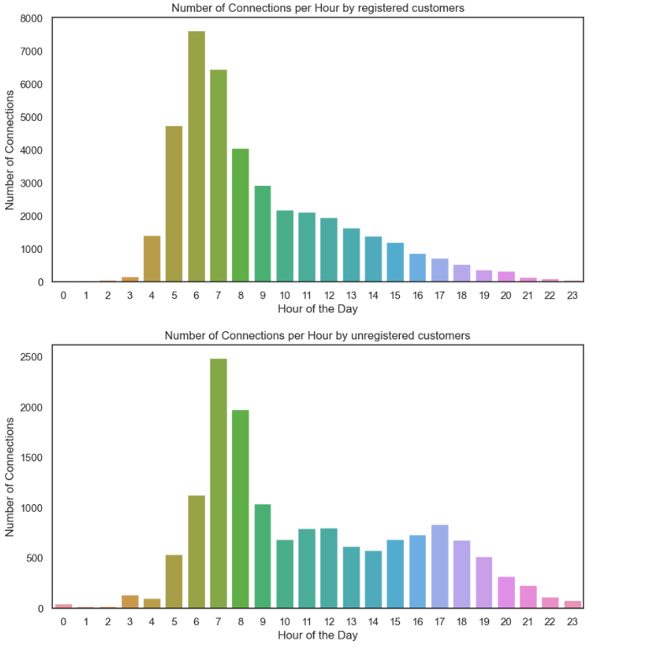

In the following lineplot we can put the registered and unregistered more into relation:

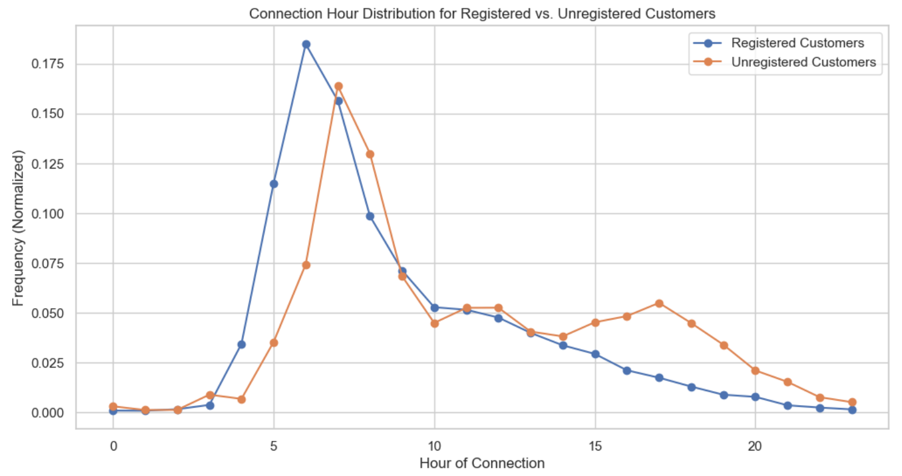

KPI 5: Proportion of the Stations

Proportion of the Stations gauges station occupancy. Peak demand at 6 AM for registered users and 7 AM for unregistered users suggests a need for stations near workplaces for morning usage spikes.

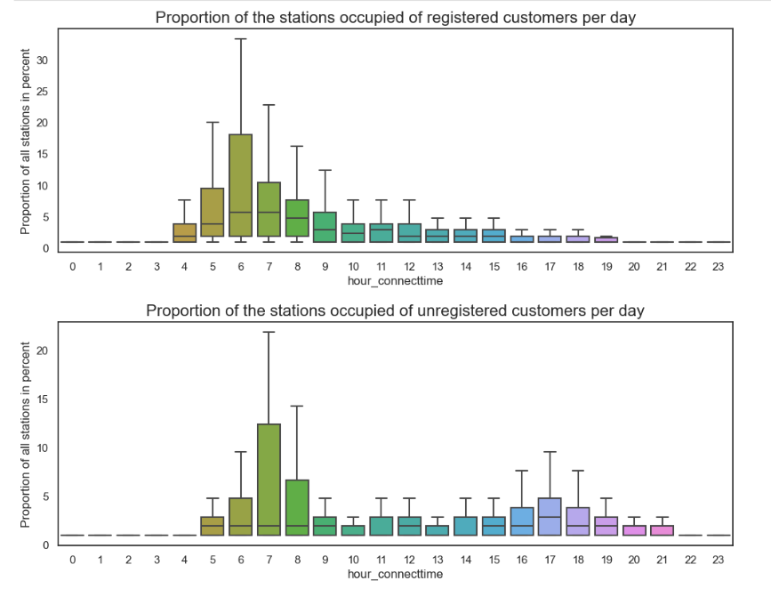

KPI 6: Average kWh Delivered per Hour

This KPI tracks the average kilowatt-hours (kWh) delivered per hour, revealing patterns in charging demand and energy usage. Peak deliveries occur at 6 AM, 1 AM, and a secondary peak at 10 PM, with an average delivery of approximately 13 kWh per session. The data suggests a higher kWh delivered per session during the night.

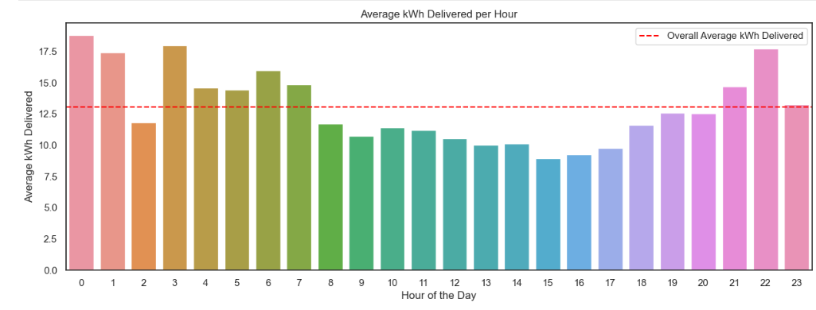

KPI 7: Most Utilized Stations

The "Most Utilized Stations" KPI tracks the usage frequency of EV charging stations, guiding maintenance and expansion planning. It highlights the busiest and least busy stations, helping prioritize service reliability and resource allocation for network efficiency.

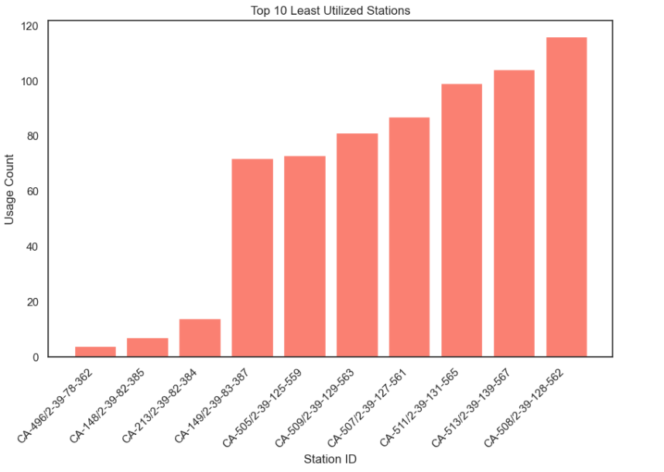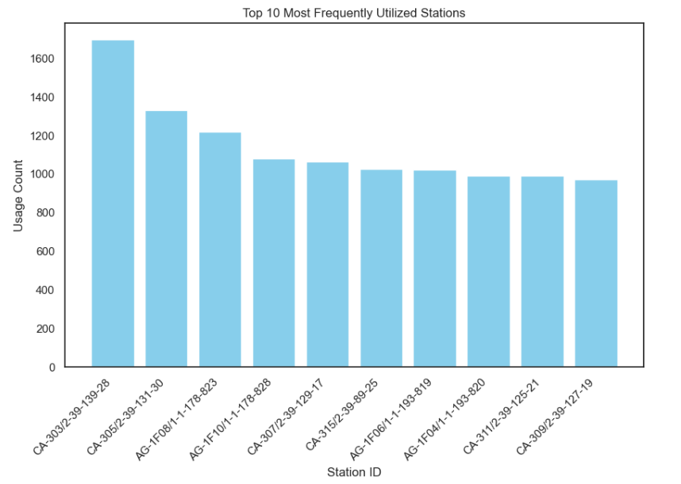

KPI 8: Downtime

Downtime provides insights into station usage patterns. A histogram of disconnect time shows daytime disconnections. Plots highlight stations with low and high downtime, identifying efficiency and room for improvement. Notably, stations like CA-213/2-39-83-384 exhibit inefficiency in downtime.

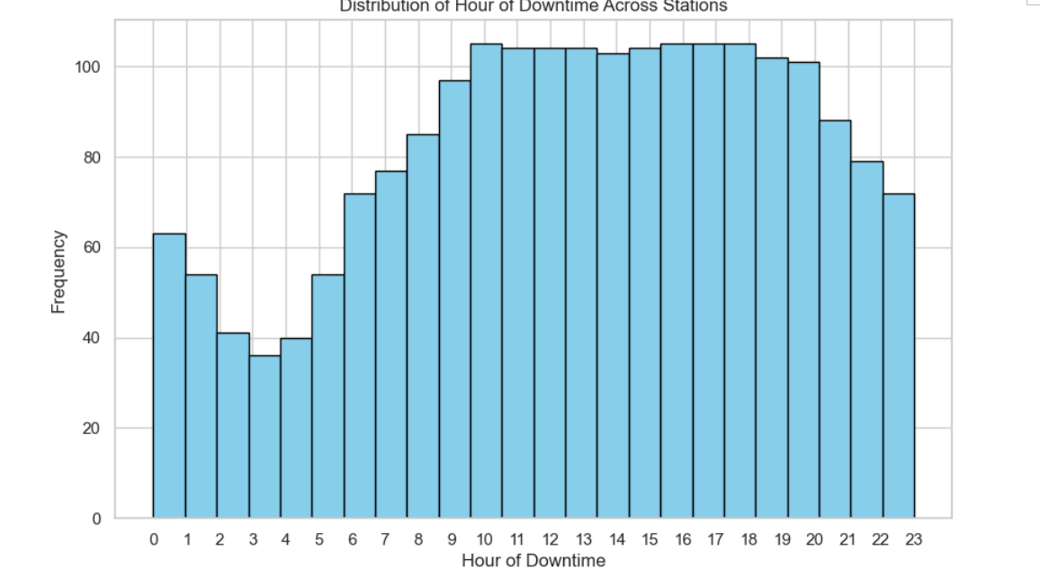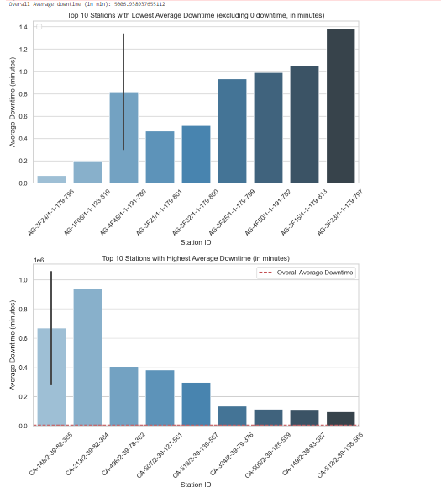

KPI 9: Registered vs. Unregistered Ratio

The ratio of registered to unregistered users highlights user engagement. Registered users outnumber unregistered ones nearly threefold, indicating commitment and potential for increased registration.

