**Home Page:**

Slogan - “Ensure your remembered”.

Welcome to Marque Marketing! Here is your start to developing the website you always dreamed of for your company, look around to find out what best suits your needs, thank!

Service discount – “Our New Year sale is still active. Start the New Year off with a bang and give your company that New Year’s look!”

Testimonial – “As a new business owner I needed a website to get my name out there and Marque Marketing made the process easy and affordable”.

**About our Company Page:**

Marque Marketing has been servicing business owners since mid-2020. We as Web Designers began only working in the tri state area of Pennsylvania, New Jersey, and New York. Fortunately, due to business growth, we have been able to expand our work to other states. So, if your new to Marque Marketing or a returning customer we are here for you no matter your location! The process of web design can seem taxing but here at Marque Marketing we include you, the customer, and owner of the website in on the process so you can directly see the growth of your own branding.

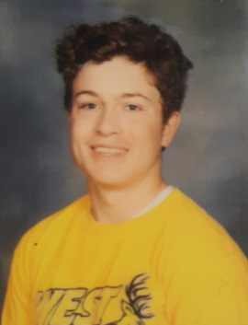

**Our Service Page:**

Package 1 – This package is geared towards advertisement. Here we can help you get your name out there in a fresh new landscape through our own connections of newsletters, social media, blogs, etc.

Package 2 – This package is about upgrading or re-designing a website. We will help you take your current website, brochures, flyers or any means of electronic marketing and create a new layout that better represents our product or goal for your target audience.

Package 3 – If you’re a new business owner and are need of a website, with this package we will help work with you to create the best content layout for your products and services. We will help set up brochures and flyers as well as a social media presence that you will be able to easily manage.

In both package 2 and 3 the same services can be done for setting up a shopping cart, logo design and theme, and any other general design layout features that the customer would want.

**Our Portfolio page:**

<https://buckscountyalive.com/>

Here is a website we designed for Bucks County Alive. On this home page all the navigation elements are laid out as well as upcoming content that the user would want to check out.

<https://conqueringcuisine.com/>

Here is another website we did for Conquering Cuisine. With this style layout we offer a content area that is visual based where updates as well as a navigation system can provide the user with a detailed yet simplistic feel.

Contact Page:

Name – Roman Berretta

Instagram – rberretta14

Twitter – rberretta14

Facebook – Roman Berretta

Email – [berretta.r065@student.cbsd.org](mailto:berretta.r065@student.cbsd.org)

Ill add logo icons for the social media platforms