Dual-Color LED

Introduction
A dual-color light emitting diode (LED) is capable of emitting two different colors of light, here red and green, rather than only one color. It has 3 leads; common cathode or common anode is available. A dual-color LED features two LED terminals, or pins, arranged in the circuit in anti-parallel and connected by a cathode/anode. Positive voltage can be directed towards one of the LED terminals, causing that terminal to emit light of the corresponding color; when the direction of the voltage is reversed, the light of the other color is emitted. In a dual-color LED, only one of the pins can receive voltage at a time. As a result, this type of LED frequently functions as indicator lights for a variety of devices, including televisions, digital cameras, and remote controls.

Board
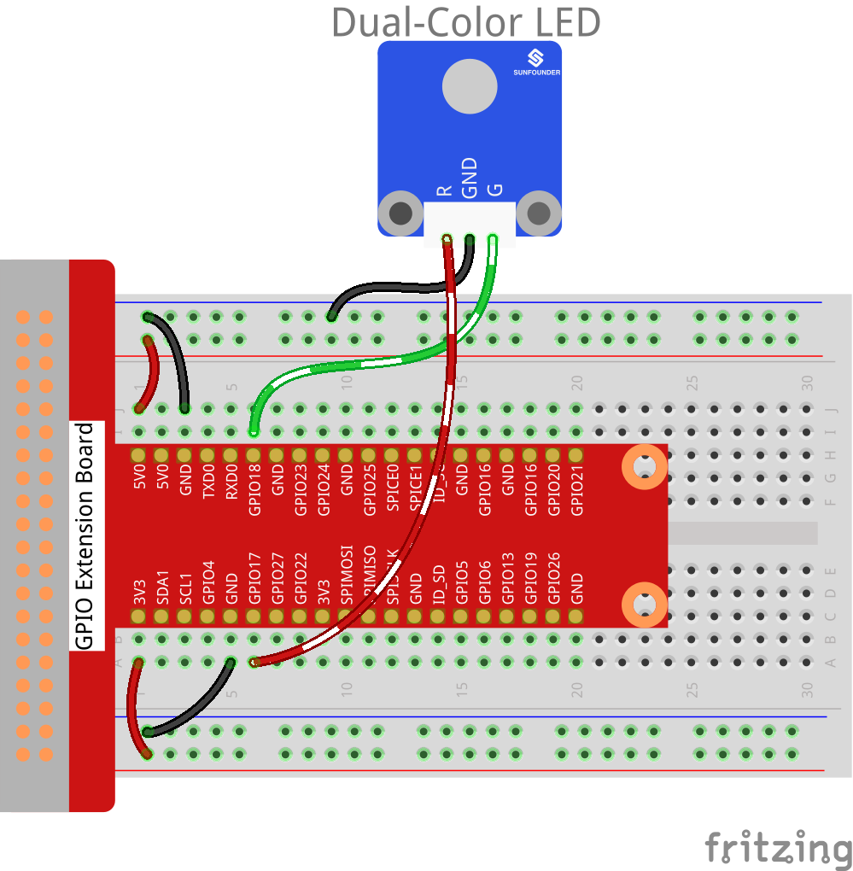

Raspberry Pi | T-Cobbler | Dual-Color LED Module
GPIO0 | GPIO17 | R
GND | GND | GND
GPIO1 | GPIO18 | G

Script

