Chapter One | Introduction and Background

The learning through activities included in the curriculum of Chiang Mai University because the learning through activities is an important for students. The experience that students receive from the activities is necessary and very important in the future. Because society does not only need talent alone, but the society need people with good knowledge of academic subjects, and able to work with other people. These aspects are what indicate students graduated with quality and ready for the future.

Nowadays, most of the problems about learning through activities in Chiang Mai University came from the traditional procedure. When Chiang Mai University used the traditional method to assess the students activities, The instructors must sign the signature in the activities passport book to allow the students pass the activities. There are many problems from using the activities passport book, such as students lost their passport book and students ask friends to forged the signatures to sign name for passing the activities. When the instructors use paper for evaluating the grade of activities, It is difficult for the instructors to spend time with the evaluate score to each student.

To solve these problems, The learning through activities system is proposed. The learning through activities system provides the activities information to the students plan to achieve the courses. In addition, the learning through activities system provides the students information to the instructors to evaluate the student grade. The instructors do not need to use a piece of paper to check the students who have participated the activities. The learning through activities helps the instructors solve the problems of data lost by losing the student grade paper.

Therefore, The learning through activities system aids the people who faces problem when they use the activities passport books. The learning through activities system helps people manage the activities easier. The user can manage the activities whenever he wants.

Chapter Two | Literature Review

2.1 Business Review

The learning through activities is a part of the curriculum of Chiang Mai University. There are various assessment techniques for learning through the activity courses in each faculty of Chiang Mai University. Some faculty use the collecting the activities hours and another faculties are just counting the course. Therefore, the instructors evaluate the activities course in deferent way.
In addition, The activities types are different, such as the mandatory activities and the optional activities. As a result, the students cannot have the clear standard used to assess the activities results, and the students cannot plan to achieve the courses.

Most of the faculties in Chiang Mai University are using the activities passport book for evaluating the score of the activities. When the students attend the activities will receive a passport book for assessing the participate activities. In the activities passport book, The students can write the description of feeling when participated the activities. Then, the students submits the passport book to the instructors. After that, the instructors will sign the signature to confirms the participation activities of each student. Then, the instructors provide the grade for students. There are many problems when use the activities passport book. Most problems are the students forget the activities passport book when come to join the activities. Therefore, the learning through activities system provides clear standards used to evaluate the activities results for each faculty has the same understanding.

Work Flow

Student has participated to the activities

Student writes the activities passport book.

Student submits the activities passport book
to the instructor.

The student joining
the activities complete?

Not complete
The student doing
the activity again.

Complete
The instructor sign the signature
in the activities passport book.

The student passes
the activities

(รูปนี้ดูดีๆนะ มีบางคำในกล่องที่เปลี่ยน)

Student Information System Chiang Mai University (CMU SIS)

The student information system of Chiang Mai University shows the information of activities that students participate.The information of students activities consist of academic year, activity id, name of activities, and date of participate the activities.

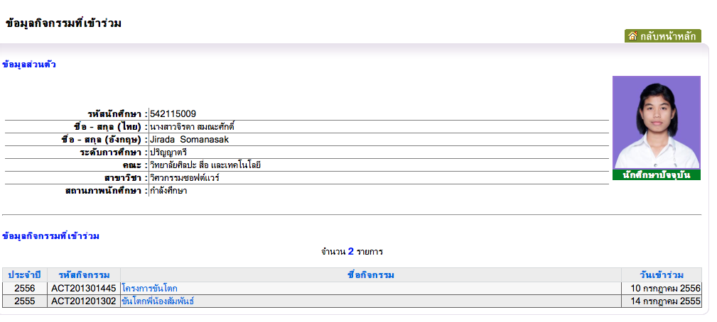
Figure 1: Student activities information of Chiang Mai University

Figure 1 shows student activities information of Chiang Mai University. The students can views the information of activities that participated. The instructors can view the overall the activities of each advisee.

The disadvantage of student information system is the user interface does not look friendly. This system is difficult to use because it is very hard to find the activities information. In the student information system of the Chiang Mai University show the overall activities that students participated but the system does not provides the details of each activity. The information of each activity is important for students to plan how to achieve the course in the next semester.

Management Information System Prince Of Songkla university, Pattani campus
(MIS Center PSU Pattani)

The MIS Center System provides the information of activities course for students and instructors. The students can selects the semester and type of the activities. Then, the MIS Center System provides the activities information separate by types that students select. This application contains services for users' management such as the students can change password and update the users' information.

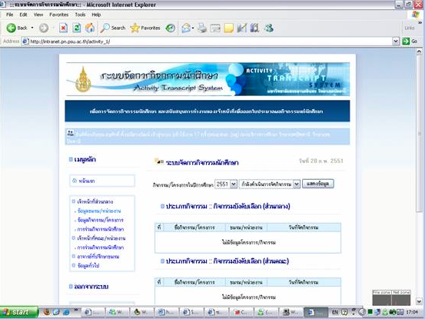

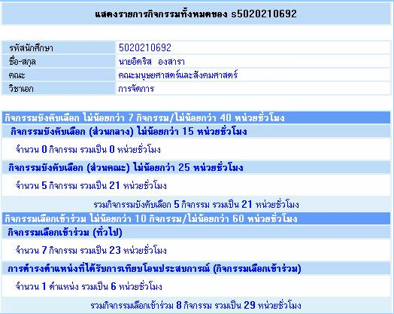
Figure 2: Student activities information of PSU Pattani.
เเก้ข้อมูลรูปไม่เปลี่ยน

Figure 2 shows student activities information of Prince of Songkla university, Pattani campus. Students can view semester activities. The students can select a year, and semester that they want to views and after that an application provides.
The disadvantages of system is the students cannot see information of each activity. So, it cannot help students plan about how to achieve the courses.

Activity Transcript of Sirindhorn International Institute of Technology(SIIT)
Thammasat University

This system provide the activity transcript of Sirindhorn International Institute of Technology(SIIT), Thammasat Universityprovide by show the information of each activity that students participated and show the total time.

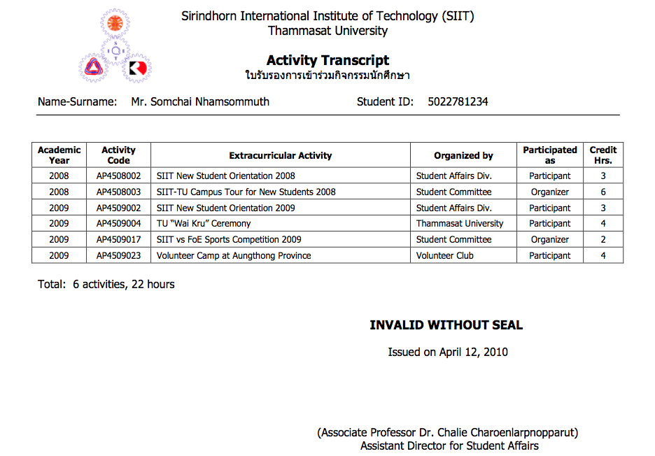
Figure 3: Activity Transcript of SIIT Thammasat University.

Figure 3 shows activities transcript of each student in Sirindhorn International Institute of Technology, Thammasat University. The activities transcript show academic year, activity code, extracurricular activity, name of organizer and credit hours. The student can view the total activities and total time that student participated.

The disadvantage of the activity transcript of SIIT Thammasat University system is the activity transcript not provides the grade for each course that students joined the activity.So, the students cannot plan for future to achieve the course in the next semester.

Summarize

From the system that show above, each university has different the learning through activities system. For Chiang Mai university, students and instructors can see only the name of activities. They cannot plan about how to achieve the course.For Prince Of Songkla university, Pattani campus. Students can select the semester and type of activities. Then, students can see activities information separate by type of activities. The MIS Center PSU Pattani system has announce about the time of each activity that user must achieve, but it cannot shows the details of each activity.So, the students cannot know what activities that they joined.For Activity Transcript of Sirindhorn International Institute of Technology, Thammasat University show the list of activities that students participated and show the total time,but it does not contain the grade for each activity course that students have.The students cannot plan for achieve the course in the next semester. To solve the problem, The Learning Through Activities system will improve the ability that others web cannot do. The Learning Through Activities system provides the information of each activity and evaluate the grade for students.
The Learning Through Activities system can help students and instructors have clear standards to have the same understanding. Also, the students can plan how to achieve the course.

Chapter Four | Project Plan

4.1 Motivation

Nowadays, Chiang Mai University need to make the students has more than talent. Chiang Mai University needs to make the students with good knowledge of academic subjects, professional in the field, and able to work with other people. So,Chiang Mai University provide the activities for students to participate.Chiang Mai University has various assessment techniques for the Learning through the activities courses in each faculty. Some use the collecting the activity hours, some are just counting the courses. There are also the different activity types such as the mandatory activities, the optional activities. In addition, there are different result as well. As a result, Chiang Mai University have not clear standard to evaluate the score of the activities. Therefor we decide to make The learning through activities system for provides the clear standards used to evaluate the activities results for each faculty has the same understanding.

4.3 Deliverables and Limits

4.3.1 Deliverables

Architecture Overview

Activity
Management
User
Management
Participate Histories
Management

Grade
Management

Activity Transcript
Management

(รูปไม่ต้องเปลี่ยน เปลี่ยนเเต่ตัวหนังสือนะ)
Figure 6 : Architecture Overview of Learning through activities system

Figure 6 shows overall of architecture Learning through activities system. This system consist of User management, Activity management, Participate management, grade management and activity transcript.

User management
The user management part allows users involve administrator, student, and instructor to manage the information. The students information consist of student id, name, faculty,and the history of participated the activities.The user can update the information by add and edit the name, surname, address, and telephone number.

Activity management
The activity management part. The user can provides the information of each activity such as the name of activity, date, time, place and the description of the activity. Moreover, The user can add the people into the activities.

Participate Histories Management
The participate histories management part shows date and the information of each activity that user has to participated.The user can see the list of activities separate by type of activity.The students can write the description about the experience of participating the activities on the website. Moreover, the user can gather the information of the students who attends the activities.

Grade management
The grade management part, the system can evaluate the grade of each activity .Both students and instructors can see the grade for each activity course. The learning through activities system provides grade information such as activity name, grade and credit.

Activity Transcript Management
The learning through activities system provide a PDF file management for create the activity transcript. In the activity transcript show the name of student, and information of activity such as ID, name, and credit of each activity.

4.3.2 Software Document
- Project Proposal
- Project Plan
- Software Requirement Specification
- Software Design Document
- Test Plan
- Unit Test Document
- System Test Document
- Traceability Record

4.3.3 Limits
- Internet connection is required for using the learning through activities system.
- Web browser is required for using application.
- The student should have CMU account (542115009.cmu.ac.th)

