Use case (User management part)

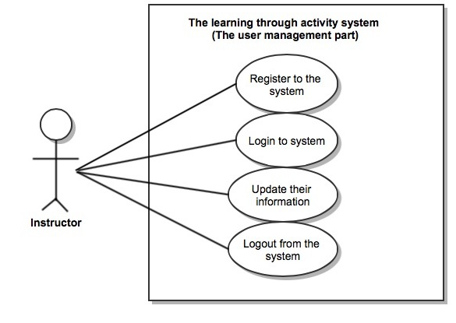
URS (User management part)

URS01: The user can register themselves to the system.
SRS01: The system provides the UI which receive name, surname, picture, username and password for registration.
SRS02: The system can check the name format. The name format should be only character and its length is less than thirty-five.
SRS03: The system can check the surname format. The surname format should be only character and its length is less than forty.
SRS04: The system can check the picture format. The picture which size is 250x400 pixels.
SRS05: The system can check the username format. The username format must be 4-20 characters.
SRS06: The system can check the password format. The passwords must have at least 6 characters and contain at least one upper case letters, lower case letters and numbers.
SRS07: The system shall add new user information to the database using name, surname, username, password and picture.
SRS08: The system shall provide the successful registration page.
SRS09: The system shall display the error message “Sorry the information is incorrect, Please try again”
SRS10: The system shall display the error message “The username is already existed”

URS02: The user can login to the system.
SRS05: The system can check the username format.The username format must be 4-20 characters.
SRS06: The system can check the password format. The passwords must have at least 6 characters and contain at least one upper case letters, lower case letters and numbers.
SRS11: The system provide the login user interface which receive the username and password
SRS12: The system validate the username and password
SRS13: The system shall display the error message “Sorry your username or password is incorrect, Please try again”

URS03: The user can update their information.
SRS14: The system provides the UI which receive name, surname, picture, and password for updating information.
SRS02: The system can check the name format. The name format should be only character and its length is less than thirty-five.
SRS03: The system can check the surname format. The surname format should be only character and its length is less than forty.
SRS05: The system can check the picture format. The picture which size is 250x400 pixels.
SRS07: The system can check the password format.The passwords must have at least 6 characters and contain at least one upper case letters, lower case letters and numbers.
SRS10: The system shall display the error message “Sorry the information is incorrect, Please try again”
SRS15: The system shall update the user information to the server using name, surname, username, password and picture.
SRS16: The system shall provide the information of user on the top right of index page.

URS04: The user can logout from the system.
SRS17: The system provide the UI of user which log out button
SRS18: The system deletes session out of the user
SRS19: The system provide the index page of user

The Activity management part

Use case diagram
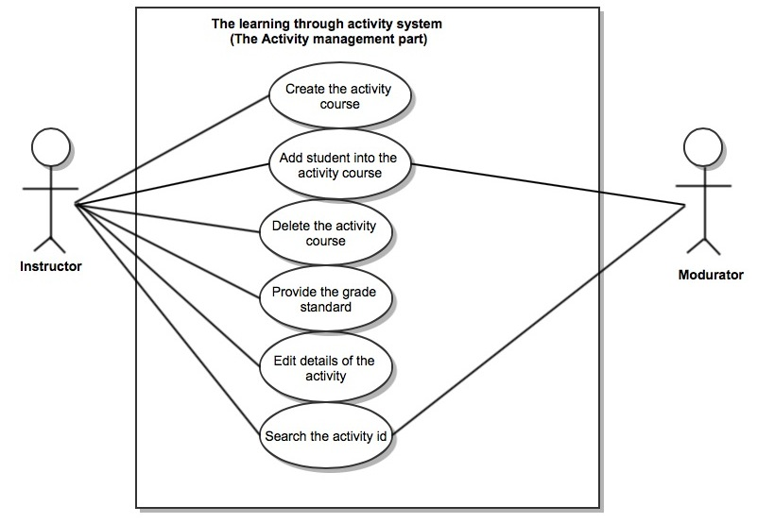

URS05: The user can create the activity course.
SRS20: The system provides UI for user create the activity id, name, description and credit.The submit button is required for add the activity.
SRS21: The system can add the id, name, description and credit of activity to the server.

URS06: The user can edit details of the activity.
SRS22: The system shows the detail of activity that user selected.
SRS23: The system provides UI for edit activity. The UI must contain the id, name description and credit of activity from server for the user to edit. The save button is required for save change the activity details.

URS07: The user can delete the activity course.
SRS24: The system validate the activity id that user input. The activity id must contain 6 digits
SRS22: The system shows the detail of activity that user selected.
SRS25: The system provides UI for show the detail of activity. The UI must contain the id, name, description and credit of the activity from server for the user to delete.
SRS26: The system deletes the details of activity in the server.
SRS27: The system display the error message “Not found the related activity”. When the activity id that user input not match with activity information in the server.

URS08: The user can provide the grade standard for each activity.
SRS22: The system shows the detail of activity that user selected.
SRS28: The system validate the user input. The grade standard must contain with 8 grades.
SRS29: The system save the grade standard that user provides in the server.

URS09: The user can add student into the activity course.
SRS22: The system shows the detail of activity that user selected.
SRS30: The system validate the student id that user input. The student id should contain in the server.
SRS31: The system add the student information to the activity course.
SRS32: The system display error message “Not found the related student information”. When the server not have information of the student id that user input.

URS10: The user can see the activity by search the activity id.
SRS24: The system validate the activity id that user input. The activity id must contain 6 digits.
SRS33: The system retrieve the activity information that related with user input shows on the activity page.
SRS27: The system display the error message “Not found the related activity”. When the activity id that user input not match with activity information in the server.

User Management Part

URS01: The instructor can register themselves to the system.
The instructor has to register their information in order to use the system. The user has to provide their name, surname, username, password, and picture to register to the system.

Input and Output

Input | Description | Example | Output
Name | Only alphabet is allowed. No special character can be used. The length should not over 35 characters. | “Peter” | The system shows the name of user on their profile.
Surname | Only alphabet is allowed. No special character can be used. The length should not over 40 characters. | “Lawrence” | The system shows surname of user on their profile.
Username | The username must be 4-20 characters. | “Peter” | The system shows the username on the top right.
Password | Passwords must have at least 6 characters and contain at least one upper case letters, lower case letters and numbers. | “54Camt” | The system shows overall information of user when username and password are match.
Picture | It is the picture profile of each user. The picture which size is 250x400 pixel and only jpg file. |  | The system shows picture on user profile.

Flow of Execution
- The user browses for the registration page.
- The user input all the information in the page
- The system validates the format of the input data and the existing data.
- The system shows successful registration and show index page.
Alternative flow: the validation error
A 3 If the user input data in wrong format, the system should provide the error message as followed: The error message is “Sorry the format of information is incorrect, Please try again”
After the error message, the system asks the user to read the error message and update the data.
B 3 If the username is already in the system, the system does not allow the user to register the new customer to the system. The system should provide the error message as followed:
The error message is “The username is already existed”
After the error message, the system asks the user to read the error message and the system returns the user to the register page to edit the information.

URS02: The instructor can login to the system
The registered user can login to the system using their username and password.

Prerequisite
The user has registered in system.

Input and Output

Input | Description | Example | Output
Username | The username must matching with the username that user provides on registration. | “Peter” | The system shows the username on the top right.
Password | The password must matching with the password that user provides on registration. | “54Camt” | The system shows overall information of user when username and password are met.

Flow of Execution
- The user browses to login page.
- The user provides username and password
- The system validates username and password
- The system shows the index page.

Alternative flow: the validation error
A 3 If the username and password are incorrect or not matched, the system should provide the error message “Sorry your username or password is incorrect, Please try again”
After the error message, the system asks the user to read the error message and update the data.

URS03: The instructor can update their information
The instructor can update their information by edit name, surname, password, and picture.

Input and Output

Input | Description | Example | Output
Name | Only alphabet is allowed. No special character can be used. The length should not over 35 characters. | “John” | The system shows the updated name of user on their profile.
Surname | Only alphabet is allowed. No special character can be used. The length should not over 40 characters. | “Butter” | The system shows updated surname of user on their profile.
Password | Passwords must have at least 6 characters and contain at least one upper case letters, lower case letters and numbers. | “54John” | The system shows all updated information of user when username and new password are matched.
Picture | It is the picture profile of each user. The picture which size is 250x400 pixel and only jpg file. |  | The system shows new picture on user profile.

Flow of Execution
- The instructor browses for the editing page.
- The instructor update their information in the page
- The system validates the format of the input data and the existing data.
- The system shows the updated information of user on the user profile.

Alternative flow A: the validation error
A 3 If the instructor input data in wrong format, the system should provide the error message as followed:
The error message is “Sorry the information is incorrect, Please try again”
After the error message, the system asks the user to read the error message and update the data.

URS04: The instructor can logout from the system.
The instructor can logout from the system when their want to close the system.

Prerequisite
The instructor has to login to the system.

Input and Output

Input | Description | Output
Click the logout button | The logout button stay on every page of website. | After the user logout from the website. The system go out from the user profile and shows the homepage of website.

Flow of Execution
- The system delete the session of user
- The system shows the homepage of website.

Alternative flow A: the validation error
A 1 If the user still doing the work and their information not yet save, the system should provide the prompt message as followed:
The prompt message is “You should save the data before”
After the prompt message, the system asks the user to read the message and save their data.

Activities Management Part

URS05: The instructor can create the activity course into the system.
The instructor can create the activity course by add the details of activity course with activity id, name, description and credit of the activity into the system.

Prerequisite
The user has to login as an instructor to the system.

Input and Output

Input | Description | Example | Output
Activity ID | The activity id must contain 6 digits number. The first two numbers indicate the academic year. The following number is the faculty code and the last is a activity code | “542101” | The system shows the activity information on the activity page.
Activity name | Only characters is allowed. No symbols can be used. The length should not over 40 characters. | “Sport day”
description | It helps describe the purpose of activity and the activity guidelines. | “It is an activity that allows students to play the sports to help create the harmony  ”
Credit | The credit of activity depend on the condition of each activity | “1,2,3”  “pass or fail”
Location | The location of do the activity | “CAMT”
Time | The instructor must provide the start time and end time of activity | Start 9.00 am  End 12.00 am
Type | Type of activity depend on the size of activity | University,Faculty,  SMO,Club
Create date | The date of creation to help the user to know the duration of the activities | “2/4/2014”

Flow of Execution
- The instructor brows the activity page.
- The system provides UI for user add the activity id, name, description and credit.
- The instructor adds the details of product.
- The system save the product into the server.

Alternative flow A: the validation error
A 3 If the user input data in wrong format, the system should provide the error message as followed:
The error message is “Sorry the information is incorrect, Please try again”
After the error message, the system asks the user to read the error message and update the data.

URS06: The instructor can edit details of the activity.
The instructor can edit the name, description and credit of the activity. Then, the system update the information of activity in the server.

Prerequisite
The user has to login as an administrator to the system.

Input and Output

Input | Description | Example | Output
Activity ID | The activity id must contain 6 digits number. The first two numbers indicate the academic year. The following number is the faculty code and the last is a activity code | “542102” | The system update the activity information on the activity page.
Activity name | Only characters is allowed. No symbols can be used. The length should not over 40 characters. | “Sport night”
description | It helps describe the purpose of activity and the activity guidelines. | “the sport that helps the student has experience to work with other”
Credit | The credit of activity depend on the condition of each activity | “1,2,3”  “Pass or Fail”
Location | The location of do the activity | “Econ”
Time | The instructor must provide the start time and end time of activity | Start 8.00 am  End 11.00 am
Type | Type of activity depend on the size of activity | University,Faculty,  SMO,Club

Flow of Execution
- The user brows the activity page.
- The system shows the detail of activity that user selected.
- The system provides UI for user edit the activity id, name, description, and credit.
- The user edits the details of activity.
- The system validate the user input
- The system adds the new details of activity to the server.
Alternative flow A: the validation error
A 5 If the user input data in wrong format, the system should provide the error message as followed:
The error message is “Sorry the information is incorrect, Please try again”
After the error message, the system asks the user to read the error message and update the data.

URS07: The instructor can delete the activity course by search the activity ID.
The instructor can delete the activity course that unusable by search the activity id. The system delete the activity information from the server.

Prerequisite
The user must login as the instructor.

Input and Output

Input | Description | Output
Activity ID | The activity id that user search should matched with the activity course in the server. Then, the system shows the activity information depend on id.

Flow of Execution
- The user browses to activity page.
- The system provides the search activity.
- The user search the activity by enter activity id.
- The system check the activity id format.
- The system shows the related activities, which show activity name, description, and credit of each related activity.

Alternative flow A, the validation error
A 4. If there has no related activity in server, the system will prompt message “Not found the related activity”.

URS08: The instructor can provide the grade standard for each activity.
The instructor can provide the grade standard for each activity by define the condition for pass the course. Each grade of the activity depend on hours of participation.

Prerequisite
The user has to login as an instructor to the system.

Input and Output

Input | Description | Example | Output
Grade | Each activity contain 8 grades  the grade shows A, B+,B,C+,C, D+, D and F.  Each grade depend on the standard that user provide. | “A” | The system shows the grade standard of each activity on the page.

Flow of Execution
- The user browses to activity page.
- The system shows all the activity.
- The user select the activity that want to provide the grade standard.
- The system shows the activity information.
- The user provides the standard of each grade.

URS09: The user can add student into the activity course.
When the student cannot sign to participation activity on mobile part. The user can add the student into the activity course on the server part.
Prerequisite
The user has to login as and the instructor or the mandatory.

Input and Output

Input | Description | Example | Output
Activity id | The activity id use to search the course that the user want to add the student. | “542103” | Show information of the activity.
Student id | The student id use to identify the information of each student. The id that user search must related with the student id on the server. | “542115009” | The system add the student into the activity course.
Flow of Execution
- The user browses to activity page.
- The user select the activity that want to add the student.
- The user add the id of the student into the activity course.
- The system save the student information into the activity course.
Alternative flow A, the validation error
A 3 The system check the student id while the user input. If there has no related student id in server, the system not show the student id.

URS10: The instructor can see the activity by search the activity name.
The instructor can save time to find the activity course by search the activity id. The overall activity that related with id that user search can shows.

Prerequisite
The instructor should know the name or related information of the activity that want to see.

Input and Output

Input | Description | Example | Output
Activity name | The activity name use to identify the information of each activity. | “Sport day” | The system shows the activities that related with user input on the activity page.

Flow of Execution
- The instructor browses to activity page.
- The instructor input the activity name.
- The system validate the user input.
- The system shows the overall activities related with user input.

Alternative flow A, the validation error
A 3 If there has no related activity in server, the system will prompt message “Not found the related activity”.

