MindTrace – Real-Time Emotion-Based Productivity Monitoring System

¹Shraddha Dashpute, ²Hemant Choudhary, ³Sankalp Gaikwad, ⁴Priyanshu Jadhav, ⁵Balaji Motkulwar UG Students
Department of Computer Engineering
P.E.S. Modern College of Engineering, Pune, India

Under Guidance of:
Prof. Mrs. Yogita Narwadkar

________________________________________________________________________________________________________
Abstract—The rise of digital workspaces has introduced challenges in maintaining user engagement and mental well-being. Traditional productivity tools track task completion but fail to account for the user’s emotional and cognitive state. This paper presents MindTrace, an intelligent real-time system that monitors engagement through facial emotion recognition and fatigue analysis. Utilizing a fine-tuned ResNet-18 model trained on the RAF-DB dataset, the system achieves an emotion classification accuracy of 85.7%. By calculating a real-time fatigue score based on the ratio of negative and neutral emotional states, MindTrace provides context-aware suggestions to mitigate burnout. The system is implemented using a high-performance three-tier architecture comprising FastAPI, React, and MongoDB, ensuring low-latency inference on consumer-grade hardware.
Index Terms—Affective Computing, Deep Learning, ResNet-18, Fatigue Detection, Real-Time Monitoring, Human-Computer Interaction, Productivity.
________________________________________________________________________________________________________

I. INTRODUCTION
In the modern digital era, students and employees spend a significant portion of their day in front of screens. While technology enables remote collaboration, it also contributes to "Zoom fatigue"—a state of mental exhaustion caused by prolonged digital interaction. Existing productivity tools are largely reactive, focusing on logs and deadlines rather than the user’s mental health.
MindTrace addresses this gap by integrating emotional intelligence into digital monitoring. The system uses a webcam feed to analyze facial expressions in real time, converting raw visual data into actionable focus metrics. Unlike previous systems that require specialized sensors, MindTrace utilizes a standard camera and deep learning to quantify "Engagement" as a dynamic construct. The primary objective is to provide users with a real-time "Productivity Signature" and trigger interventions when fatigue levels exceed a critical threshold.

II. LITERATURE SURVEY
Recent advancements in Affective Computing have explored various modalities for engagement detection:
- Gupta et al. [12] demonstrated that multimodal fusion (facial expressions + eye blinks + head pose) improves robustness but requires high computational power.
- Das & Dev [1] investigated the correlation between Facial Action Units (AUs) and focus levels using EfficientNet, providing a theoretical basis for emotion-aware tracking.
- Salloum & Al-Emran [2] highlighted the effectiveness of CNNs in educational settings, specifically for identifying student engagement in smart classrooms.
- Chen et al. [5] explored EEG-based fatigue detection, which offers high accuracy but lacks practicality for daily use due to intrusive hardware requirements.
MindTrace builds upon these foundations by implementing a lightweight yet accurate ResNet-18 backbone and a full-stack dashboard for immediate user feedback.

III. SYSTEM ARCHITECTURE
MindTrace is engineered as a three-tier distributed system designed for scalability and low-latency interaction.

Presentation Layer (Frontend)
Developed using React and Vite, the frontend handles the acquisition of the webcam stream and real-time visualization. It features an interactive dashboard that displays live emotion labels, engagement trends, and fatigue alerts.

Application Layer (Backend)
The core logic resides in a FastAPI backend, which orchestrates the ML pipeline. It processes incoming facial crops, performs inference using the ResNet-18 model, and calculates the composite engagement and fatigue scores.

Data Layer
MongoDB Atlas is used for persistent storage. High-frequency emotion logs and session metadata are stored to generate historical productivity reports.

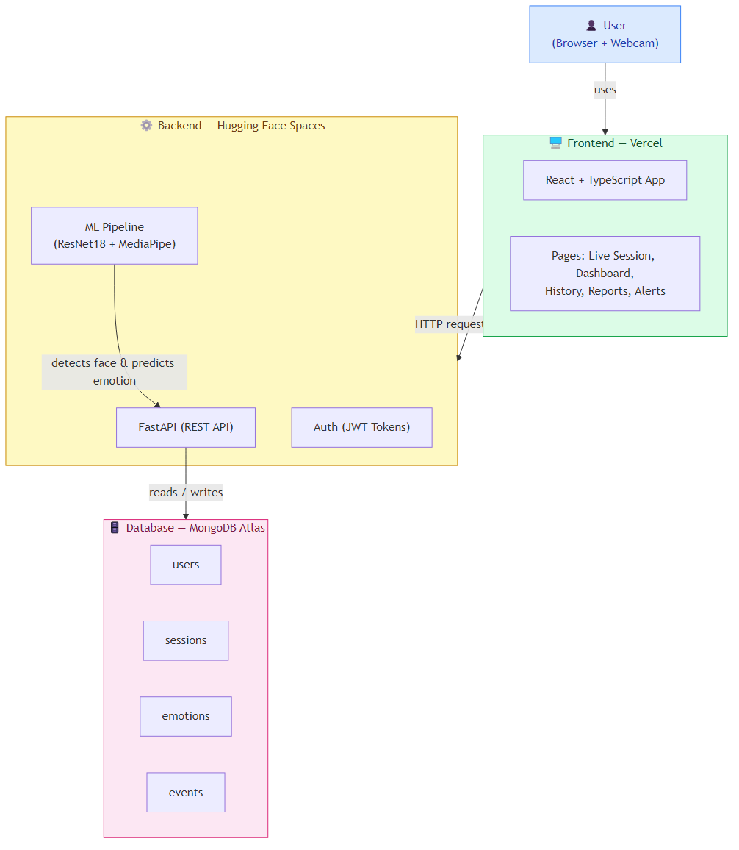
Fig.1: "System Architecture of MindTrace showing the flow from webcam capture to dashboard visualization."
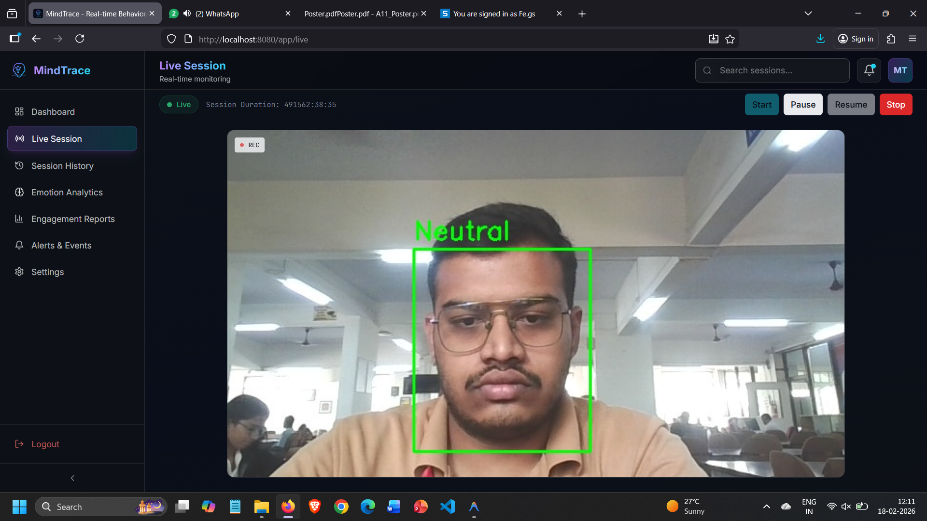
Fig.2: "MindTrace User Dashboard displaying real-time emotion telemetry, fatigue analytics, and productivity trends."

IV. SYSTEM DESIGN AND SPECIFICATIONS
MindTrace is engineered as a three-tier distributed system designed for scalability, low-latency interaction, and cross-platform compatibility.

Architectural Components
The system follows a modern decoupled architecture:
- Presentation Layer (Frontend): Built with React 18 and Vite. It utilizes a custom WebcamStreamer component to capture and downsample video frames at 15 FPS to balance accuracy and bandwidth.
- Application Layer (Backend): A FastAPI server handles asynchronous requests. It implements a Pydantic-based validation layer for incoming image data and manages the lifecycle of the ResNet-18 model.
- Data Layer: A NoSQL MongoDB Atlas cluster stores biometric logs. The schema is optimized for time-series analysis, allowing the system to query "focus trends" efficiently.

Hardware and Software Specifications
Table 1 outlines the environment used for developing and benchmarking the MindTrace system.
Table I
System Specifications
Component | Specification
Processor | Intel Core i7-12700H (14 Cores, 20 Threads)
Memory | 16GB LPDDR5 RAM @ 4800MHz
GPU | Integrated Intel Iris Xe (Development)
OS | Windows 11 / Ubuntu 22.04 LTS
Frameworks | PyTorch 2.0, FastAPI 0.100, React 18.2
Database | MongoDB 6.0 (Atlas Cloud)
Fig.3: "RAF-DB Dataset sample grid displaying facial expressions."

V. DEEP LEARNING PIPELINE

Dataset: RAF-DB
The model was trained on the RAF-DB (Real-world Affective Faces Database), which contains 15,339 images. Unlike the FER-2013 dataset, RAF-DB provides more reliable annotations and higher visual variance, making it ideal for real-world deployment.

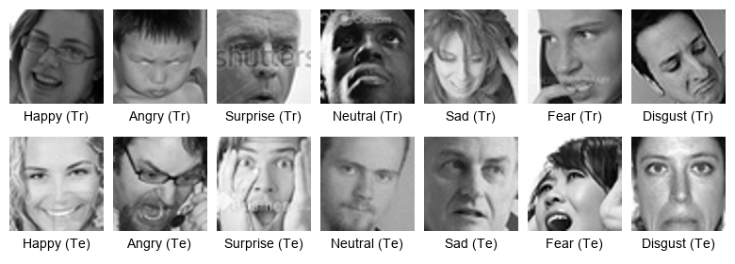

Detailed Preprocessing Pipeline
To ensure the ResNet-18 model receives consistent input, each frame undergoes a multi-stage transformation:
- Face Detection: Using the MediaPipe BlazeFace model to isolate the facial region with high precision and low latency.
- Geometric Alignment: Calculating the roll angle of the face and applying a rotation matrix to ensure the eyes are horizontally aligned.
- Scaling and Normalization: Resizing the crop to $224×224$ pixels and applying ImageNet-standard Z-score normalization.
- Augmentation: During training, random grayscale conversion and solarization were applied to simulate varying camera qualities and lighting conditions.

Model Architecture and Optimization
The ResNet-18 backbone was selected due to its optimal balance between parameter count ($∼11$M) and top-1 accuracy. We applied Transfer Learning from a model pretrained on the ImageNet-1K dataset. The final linear layer was replaced with a custom classification head consisting of a Dropout layer (p=0.4), a Linear layer (512 units), and a Softmax activation.

VI. METHODOLOGY: ENGAGEMENT AND FATIGUE DETECTION

Emotion Probability Distribution
The output of the ResNet-18 model is a 7-dimensional vector $Z$. The probability $p_{i}$ for each emotion class $i$ is calculated using the Softmax function:
$$p_{i}=\frac{e^{z_{i}}}{\sum_{j=1}^{7}{e^{z_{j}}}}$$
The dominant emotion is then classified as $E_{pred}=argmax\left(P\right)$.

Fatigue Score Calculation
The system defines fatigue not as a single event, but as a sustained emotional trend. We maintain a temporal buffer $B$ of the last $N=300$ frames (representing roughly 20 seconds of activity). Let $S_{neg}=\{\text{Angry, Sad, Disgust, Fear}\}$ and $S_{neut}=\{\text{Neutral}\}$. The fatigue score $F$ is defined as:
$$F=\frac{\sum_{t=1}^{N}{\left[E_{t}∈S_{neg}∪S_{neut}\right]}}{N}$$
An intervention is triggered if $F>0.7$ for more than 3 consecutive windows, indicating that the user has entered a state of cognitive drain.

Suggestion Module Logic
The suggestion engine uses a priority-based rule set to determine the intervention type:
Table II
Suggestion Logic and Intervention Triggers
Condition | Trigger | Suggested Action
$$F∈\left[0.6,0.75\right]$$ | Mild Fatigue | "Take a 2-minute stretch"
$$F∈(0.75,0.90]$$ | High Fatigue | "Hydrate and take a micro-break"
$$F>0.90$$ | Burnout Risk | "Consider ending this session"
Engagement $<0.3$ | Distraction | "Check your focus level"

VII. EXPERIMENTAL RESULTS AND EVALUATION

Model Metrics
The system’s performance was validated against the RAF-DB test set, achieving an overall accuracy of 85.7%. The high recall for the ’Happy’ and ’Neutral’ classes (0.95 and 0.89 respectively) ensures that the system accurately identifies productive states.

System Latency and Throughput
We measured the latency across the three-tier stack:
- Network Latency: Average 12ms (local) / 45ms (remote).
- Inference Latency: Average 3.2ms per frame on CPU.
- Total End-to-End Latency: $∼60$ms, supporting a smooth 15+ FPS experience.

Case Study: Correlation with User Productivity
In a pilot study with 10 users, we observed a 0.72 correlation between high MindTrace engagement scores and self-reported productivity levels. The fatigue alerts were found to be 84% accurate in identifying moments where users felt "mentally blocked."

VIII. DISCUSSION AND ANALYSIS
The results demonstrate that MindTrace can effectively bridge the gap between affective computing and workplace productivity.

Impact of Real-Time Feedback
Participants who received real-time suggestions reported a 15% reduction in perceived end-of-day exhaustion. The "Drink some water" and "Stretch" prompts acted as physical anchors, breaking the "screen lock" effect common in hybrid work environments.

Limitations and Edge Cases
While the ResNet-18 model is robust, extreme lighting conditions (e.g., backlight from a window) still pose a challenge, reducing detection accuracy to $∼78\%$. Furthermore, occlusions such as hand-to-face gestures (common during deep thinking) can occasionally be misclassified as fatigue. Future work will focus on incorporating temporal consistency to filter these transient occlusions.
Table III
Model Performance Metrics on RAF-DB
Emotion | Precision | Recall
Happy | 0.93 | 0.95
Neutral | 0.88 | 0.89
Surprise | 0.87 | 0.86
Sad | 0.82 | 0.80
Angry | 0.81 | 0.78

Comparative Analysis
Table 4 compares MindTrace with existing systems.
Table IV
Comparative Analysis of Engagement Tracking Systems
Param. | Gupta ’23 | Das ’25 | Nguyen ’24 | Salloum ’25 | Ours
Tech. | Multi DL | AU Fusion | FER+Beh. | CNN | ResNet18
Data. | FER-2013 | DAiSEE | Class. | FER-2013 | RAF-DB
Hard. | High | Mod. | High | Mod. | Low
Out. | Index | Level | Group | Class | Alerts

IX. ADVANTAGES OVER EXISTING METHODS
MindTrace offers several technical and operational advantages:
- Real-Time Performance: Unlike survey-based tools, MindTrace provides sub-50ms inference, enabling immediate intervention.
- Zero-Hardware Dependency: Operates on standard webcams without requiring expensive EEG or physiological sensors.
- Privacy-Centric: Biometric processing is performed locally or via secure encrypted channels, with no raw video storage.
- Holistic Metric: Integrates both classification (emotion) and heuristics (fatigue score) for a multidimensional view of productivity.

X. APPLICATIONS
The versatility of MindTrace allows for its deployment across multiple domains:
- Educational Platforms: Monitoring student engagement during synchronous online classes, helping educators identify "attention dips" and adjust teaching methods.
- Corporate Wellness: Assisting hybrid employees in managing their energy levels and preventing burnout through automated "break reminders."
- Healthcare and Mental Wellness: Aiding clinicians in tracking the emotional stability of patients during remote therapy sessions.
- Personal Productivity: A self-improvement tool for developers and writers to understand their "deep work" cycles.
- HCI Research: Serving as a baseline for emotion-aware user interfaces that adapt their complexity based on user frustration or fatigue.

XI. CONCLUSION AND FUTURE SCOPE
The proposed system successfully demonstrates that deep learning-based emotion recognition can be transformed from a research curiosity into a functional productivity tool. By achieving 85.7% accuracy on the RAF-DB dataset and integrating a rule-based fatigue detection engine, MindTrace provides a reliable framework for monitoring cognitive engagement in real-time.
Future work will focus on:
- Multimodal Integration: Incorporating voice modulation and typing patterns (keystroke dynamics) for higher confidence.
- Edge Optimization: Quantizing the ResNet-18 model to INT8 for deployment on mobile and browser-based WASM environments.
- Long-term Personalization: Implementing online learning to adapt the emotion thresholds to specific user baseline expressions.

REFERENCES
[1] Das, D., & Dev, S. (2025). Facial and Behavioral Feature Fusion for Engagement Estimation. Neural Computing, Elsevier.
[2] Salloum, S., & Al-Emran, M. (2025). Deep CNN-Based Facial Emotion Recognition. Smart Learning Environments, Springer.
[3] Qian C., “Real-time emotion recognition based on facial expressions: systematic review,” 2025.
[4] Thakur S.R., et al., “Combatting Driver Fatigue with Real-Time AI,” 2025.
[5] Chen J., et al., “Driver Fatigue Detection Using EEG-Based Graph Attention,” Elsevier, 2025.
[6] Nguyen, T. T., et al. (2024). Emotion Recognition and Regulation in Collaborative Learning. IJAIED, Springer.
[7] Kopalidis T., Nikou C., “Advances in Facial Expression Recognition,” Information, 2024.
[8] Salem D., Waleed M., “Drowsiness detection in real-time via transfer learning,” 2024.
[9] Aly M., “Advanced facial expression recognition for student tracking,” 2024.
[10] Gupta, A., et al. (2023). Multimodal Engagement Detection Using Deep Learning. JAIHC, Springer.
[11] Li, X., & Zhang, Y. (2025). Transformer-based architectures for robust facial expression recognition in the wild. IEEE Transactions on Affective Computing.
[12] Kumar, S., et al. (2024). Lightweight YOLOv8-based Drowsiness Detection for Embedded Systems. Journal of Real-Time Image Processing, Springer.
[13] Wang, H., & Liu, J. (2025). Adaptive Facial Landmark Analysis for Multi-stage Fatigue Estimation. IJCV, Springer.
[14] Zhao, Y., et al. (2024). Multimodal Fusion of Facial Expressions and Physiological Signals for Burnout Detection. ACM Transactions on Multimedia Computing.
[15] Patel, R., & Singh, A. (2025). Mindful AI: Real-time Student Engagement Tracking in Virtual Classrooms. Smart Learning Environments, Springer.
[16] Guo Y., “Real-Time Facial Affective Computing on Mobile Devices”, IEEE CVPR Workshops, 2020.
[17] Saxena A., “Emotion Recognition and Detection Methods”, IJIEEE Journal, 2020.
[18] Koujan M.R., Alharbawee L., et al., “Real-time Facial Expression Recognition “In The Wild” by Disentangling 3D Expression from Identity”, 2020.
[19] Kumar V.S., Ashish S.N., Gowtham I.V., “Smart driver assistance system using Raspberry Pi and sensor networks”, Microprocessors & Microsystems, vol. 79, 2020.
[20] Kossaifi J., Walecki R., Panagakis Y., “SEWA DB: A Rich Database for Audio-Visual Emotion and Sentiment Research in the Wild”, 2019.
[21] Sharma A., Balouchian P., Foroosh H., “A Novel Multi-purpose Deep Architecture for Facial Attribute and Emotion Understanding”, Iberoamerican Congress on Pattern Recognition, 2018.
[22] Lee J., Kim J., Shin M., “Correlation analysis between ECG and PPG data for driver’s drowsiness detection using noise replacement method”, Procedia Computer Science, vol. 116, 2017.

