Alpilla 600 MW Combined Cycle Power Plant
Topographic Survey and Site Setting-Out Report
Document number | ALP-EPC-00000-CV-RPT-0003
Revision / status | Rev A - IFR, issued 2026-11-20
Originator | Istanbul EPC Mühendislik ve Taahhüt A.Ş.
Discipline / type | civil / RPT Technical report
Review class | review
Basis | requirement:ER-02.01, scope_item:SC-004

Rev | Purpose | Date | Description | Prepared | Checked | Approved
A | IFR | 2026-11-20 | First issue for Owner review | EPCE | EPC civil lead | EPC engineering manager

1. Purpose and scope
This report presents the topographic survey of the site, the control network and benchmarks for setting out, the check of the Owner's levelled platform and the levels of the temporary construction area TP-A1, and fixes the setting-out rules for the works. Survey by Land survey subcontractor (role-play), point listing ALP-SUR-TOP-001 Rev 0 received 2026-11-13 (SRC-EPCE-0011): 291 points - 4 control pillars, 3 benchmarks, 271 spot heights, 13 existing features.

2. Reference systems
Item | Value | Remarks
Plant grid origin in UTM zone 35N (E 0 / N 0) | E 541,250.000 m / N 4,532,480.000 m m | TUREF (ITRF96), south-west plot corner
Rotation plant grid to UTM grid | -0.3281 deg | plant north = true north; grid convergence at site
Scale factor plant grid to UTM | 0.999612 | combined UTM point scale and height factor
Height datum | TUDKA-99 orthometric heights (m a.s.l.)
Site grade level | 15 m a.s.l.

Plant grid (E, N) in metres, origin at the south-west plot corner, plant north = true north (ALP-OWN-GEN-001). UTM = origin + k x R(rotation) x (E, N). All design drawings use plant grid coordinates; UTM coordinates are used for the authority submissions and the external connections.

3. Control network and benchmarks
Primary control pillars (GNSS static observations) with the residual of the transformation from plant grid to UTM against the measured coordinates:
Point | E plant | N plant | E UTM 35N | N UTM 35N | Height | Residual mm
CP-01 | 15.000 | 12.000 | 541265.052 | 4532491.905 | 15.046 | 11
CP-02 | 392.000 | 12.000 | 541641.906 | 4532489.755 | 15.018 | 6
CP-03 | 392.000 | 293.000 | 541643.520 | 4532770.638 | 15.071 | 1
CP-04 | 15.000 | 293.000 | 541266.673 | 4532772.793 | 15.083 | 3

Benchmark | E plant | N plant | Height m | Description
BM-01 | 30.0 | 296.0 | 15.312 | Site benchmark, brass bolt in concrete block; levelled from national benchmark NB-35-1147 (+18.412 m TUDKA-99), closure 3 mm
BM-02 | 381.0 | 15.0 | 15.108 | Site benchmark, brass bolt in concrete block; levelled loop BM-01 - BM-02, closure 2 mm
BM-03 | 90.0 | 590.0 | 15.466 | Temporary area benchmark, steel pin in concrete; from BM-01, closure 4 mm

4. Platform levels
Plot (208 spot heights on a 25 m grid, stream channel strip excluded): levels 14.70 to 15.17 m, mean deviation from the platform level +15.00 m -66 mm, standard deviation 76 mm; 186 of 208 points (89%) within +-0.15 m (acceptance tolerance). Trimming to +15.00 m: cut 747 m3, fill 9,324 m3 (grid cell method, 25 x 25 m cells).
Point | E | N | Level m | Deviation mm | Area
SP-0001 | 25 | 0 | 14.716 | -284 | south edge (setback fence)
SP-0003 | 25 | 50 | 14.848 | -152 | platform
SP-0007 | 25 | 150 | 14.826 | -174 | platform
SP-0014 | 50 | 0 | 14.717 | -283 | south edge (setback fence)
SP-0027 | 75 | 0 | 14.819 | -181 | south edge (setback fence)
SP-0040 | 100 | 0 | 14.766 | -234 | south edge (setback fence)
SP-0053 | 125 | 0 | 14.756 | -244 | south edge (setback fence)
SP-0066 | 150 | 0 | 14.738 | -262 | south edge (setback fence)
SP-0079 | 175 | 0 | 14.721 | -279 | south edge (setback fence)
SP-0092 | 200 | 0 | 14.790 | -210 | south edge (setback fence)
SP-0105 | 225 | 0 | 14.715 | -285 | south edge (setback fence)
SP-0118 | 250 | 0 | 14.782 | -218 | south edge (setback fence)
SP-0131 | 275 | 0 | 14.750 | -250 | south edge (setback fence)
SP-0132 | 275 | 25 | 14.840 | -160 | platform
SP-0144 | 300 | 0 | 14.753 | -247 | south edge (setback fence)
SP-0146 | 300 | 50 | 15.168 | +168 | old warehouse foundations
SP-0157 | 325 | 0 | 14.748 | -252 | south edge (setback fence)
SP-0170 | 350 | 0 | 14.703 | -297 | south edge (setback fence)
SP-0172 | 350 | 50 | 15.163 | +163 | old warehouse foundations
SP-0183 | 375 | 0 | 14.732 | -268 | south edge (setback fence)
SP-0185 | 375 | 50 | 14.849 | -151 | platform
SP-0196 | 400 | 0 | 14.775 | -225 | south edge (setback fence)

Temporary construction area TP-A1 (63 spot heights, 30 x 35 m grid): levels 13.75 to 15.76 m, rising to the north. Balanced platform level +14.79 m (cut = fill 14,320 m3); the laydown and fabrication areas are levelled to +14.79 m with a 1 % fall to the south-west drainage ditch and restored after Taking-Over (TQ-012).

5. Existing features
Point | E | N | Level m | Feature
FT-01 | 2 | 0 | 13.02 | stream channel bed at south end
FT-02 | 2 | 300 | 13.41 | stream channel bed at north end
FT-03 | 5 | 150 | 15.02 | stream channel top of wall
FT-04 | 390 | 0 | 14.95 | 11 kV cable marker, south (depth 1.0 m per utility)
FT-05 | 390 | 300 | 15.03 | 11 kV cable marker, north
FT-06 | 300 | 20 | 15.24 | old foundation corner SW
FT-07 | 360 | 60 | 15.27 | old foundation corner NE
FT-08 | 20 | 280 | 15.06 | meteorological mast base
FT-09 | 120 | 250 | 15.01 | groundwater well GW-1, top of casing 15.52
FT-10 | 250 | 150 | 15.00 | groundwater well GW-2, top of casing 15.49
FT-11 | 340 | 40 | 15.22 | groundwater well GW-3, top of casing 15.71
FT-12 | 200 | -60 | 1.10 | shoreline (mean sea level datum +0.0, 2026-10 survey)
FT-13 | 405 | 150 | 15.12 | access road edge at plant gate

- Stream channel on the west boundary: the 10 m water authority buffer (E 0-20) stays free of permanent structures; the channel bed falls from +13.41 m (north) to +13.02 m (south).
- 11 kV utility cable along the east boundary (E 390): no excavation within 2 m until its relocation by the Owner (due 2027-06-30); hand digging to locate before any crossing.
- Abandoned warehouse foundations (E 300-360, N 20-60) stand up to 0.25 m above the platform: demolition and removal by the Contractor before the platform trimming in that area.
- Meteorological mast (E 20, N 280) and groundwater wells GW-1 to GW-3 are kept; wells in conflict with foundations are replaced by the Contractor.

6. Setting-out rules
- All setting out from the control pillars CP-01, CP-02, CP-03, CP-04 and the benchmarks; pillars are checked against each other before each major setting-out and at least monthly (tolerance 10 mm plan, 5 mm height).
- Setting-out tolerances per ISO 4463-1: main grid lines +-10 mm, foundation axes +-5 mm, anchor bolt groups +-3 mm (template), levels +-5 mm.
- Every structure is set out from the plant grid; coordinates are taken from the IFC plot plan and the 3D model (never scaled from drawings).
- Construction benchmarks inside each CWA are levelled from BM-01 / BM-02 with loop closure <= 3 mm.

7. Findings
- Control network: transformation residuals 11 mm maximum (limit 20 mm) - the plant grid is fixed and can be used for setting out.
- Owner's platform: mean -66 mm against +15.00 m, 22 of 208 points outside +-0.15 m, with a systematic fall towards the south and the old warehouse foundations above the platform. Final trimming to +15.00 m needs about 9,324 m3 of structural fill and 747 m3 of cut; fill below the tolerance band (-0.15 m): 1,035 m3.
- TQ-039 (closed): Owner platform levels below +15.00 m (survey ALP-SUR-TOP-001) - answer: (b) with a limit. The Owner's earthworks contract levelled the platform to +15.00 m +- 0.15 m; the survey shows the platform within that tolerance except the south edge strip (N 0-25 m, 17 points), the old warehouse foundations (2 points; demolition is Contractor scope anyway) and three isolated points 1-3 cm beyond the band. The Contractor sets finished floor and road levels on the as-surveyed platform with local trimming only; structural fill needed below +14.85 m is paid by the Owner at the unit rate of the Price Schedule against a joint survey.

8. Site plan
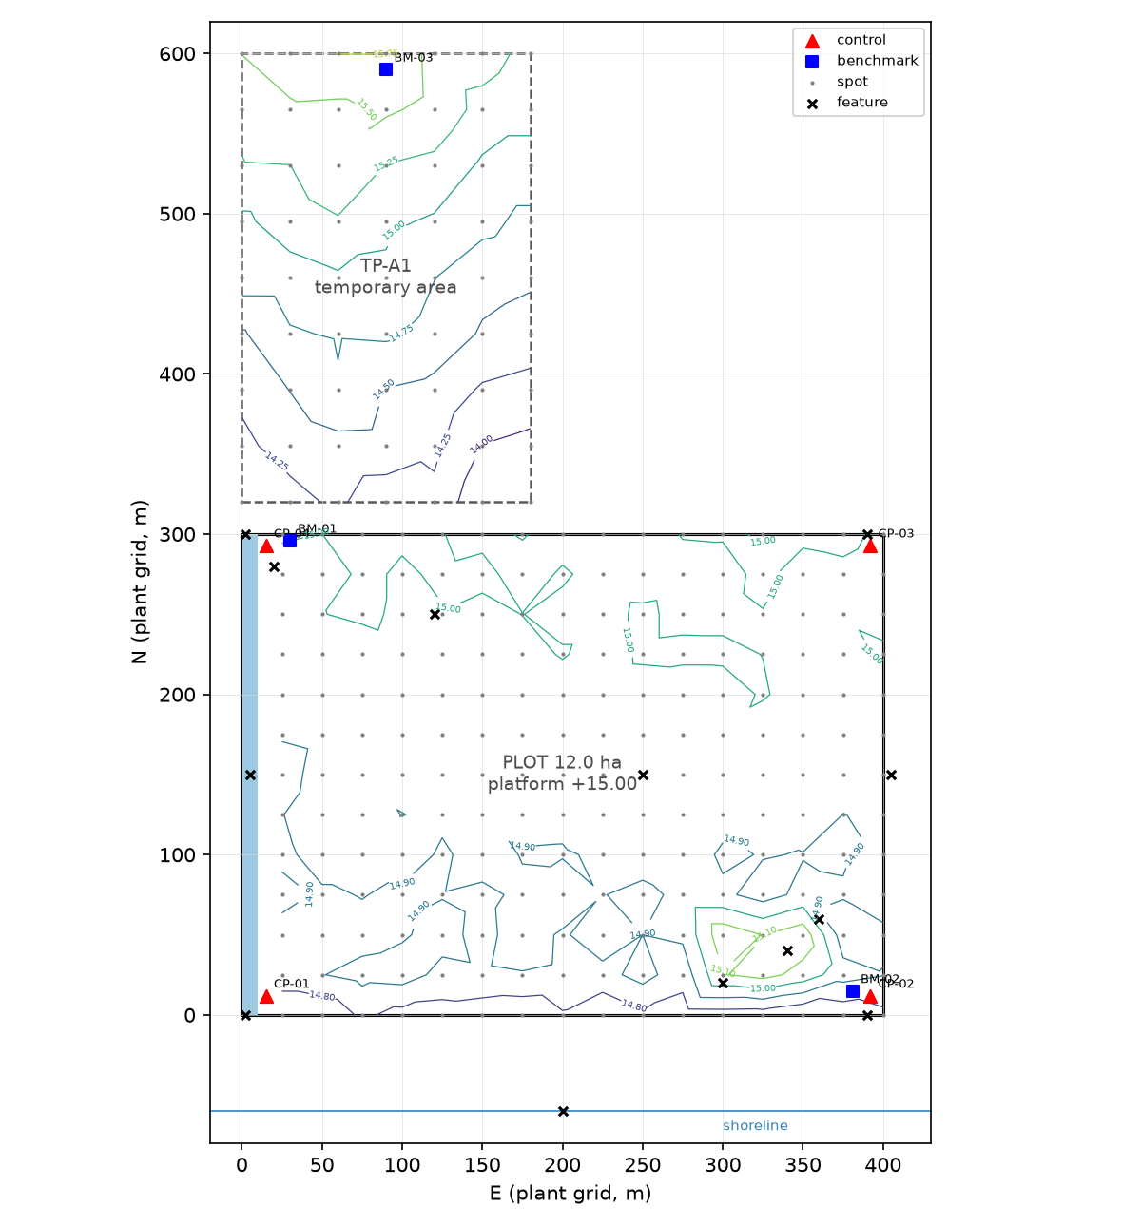
Figure 1 - Survey points and platform levels (plant grid, m); contours of the spot heights at 0.1 m (plot) and 0.25 m (TP-A1)

