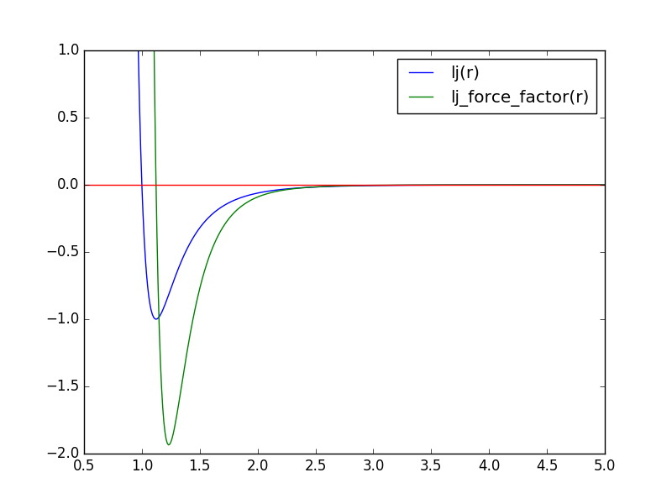

for $r>r_{min}$ the Lennard-Jones force factor is negative and the force must be attractive. Thus the force on particle $i$ must point in the direction from $i$ to $j$

hence

${\vec{F}}_{i} += {f_{LJ}\vec{dx}}_{ij}$

and

${\vec{F}}_{j} -= {f_{LJ}\vec{dx}}_{ij}$,

with

${\vec{dx}}_{ij}= {\vec{x}}_{j}- {\vec{x}}_{i}$