## Course: Deep Azure

## Project: Conversion of X12 documents to XML format, using Azure Batch

## Student: Martin Bertrand

**Problem statement**:

The company I work at receives EDI transactions from many business partners (clients and manufacturers). These files are received and transformed by Tibco products, running on local servers.

The infrastructure is sufficient to process the regular flow of transactions, with the exception of infrequent, but regular, large batches from certain clients. These batches can contain up to 40 000 distinct files, sent as fast as the network will permit. A performance bottleneck has been identified in the transform step. The original X12 files must be transformed into XML files, and sent to the backend server.

**Proposed solution**

This project will demonstrate how Azure Batch service could be used to provide my company an automatically scalable EDI transformation solution. It will transform X12 documents into XML files, using auto-scale and task queuing functionalities of Azure Batch.

**Azure Batch**

Azure Batch is particularly well suited for this type of problem. It provides a platform for running parallel, high-performance computing. In the context of this project, it will allow the solution to automatically scale and parallel process the large number of EDI files received. The transformation bottleneck of the whole EDI solution will therefore be greatly reduced.

**Results**

This project provides code to create the Azure Batch infrastructure and run a sample X12 to XML batch transformation.

**Limitations**

This project is a technology demonstration, not a real production solution. Processing a real batch would incur costs that cannot be justified in the context of this Azure course. The parameters used are therefore not optimal to minimize the total processing time. Further load testing and tuning is required to meet production targets.

**Links**:

2 minutes YouTube presentation: <https://youtu.be/M8QKy-FlpKM>

15 minutes YouTube presentation: <https://youtu.be/aznI3NiFVL0>

GitHub repository link: <https://github.com/BertBertrand/Week17-Final>

**Azure Batch**

Azure Batch platform service automates or simplifies:

* Running large-scale parallel and high-performance computing (HPC) applications on Azure.
* Job scheduling, via tasks, on a managed collection of virtual machines.
* Creation, configuration, management and deletion of compute resources and virtual networks as required, to meet the requirements of the application (auto-scaling).

Applications that will benefit from Azure Batch are intrinsically parallel, i.e. that are easily split into multiple tasks that can run independently and simultaneously on many computers.

Example Azure Batch usages:

* Batch processing
  + Invoices, billing
  + Inventory updates
  + Payroll
  + Financial reports
* High-performance computing applications
  + Computational Fluid Dynamic (CFD)
  + Deep Learning
  + Molecular Dynamics
  + Video processing

Azure Batch resources are modelled below:

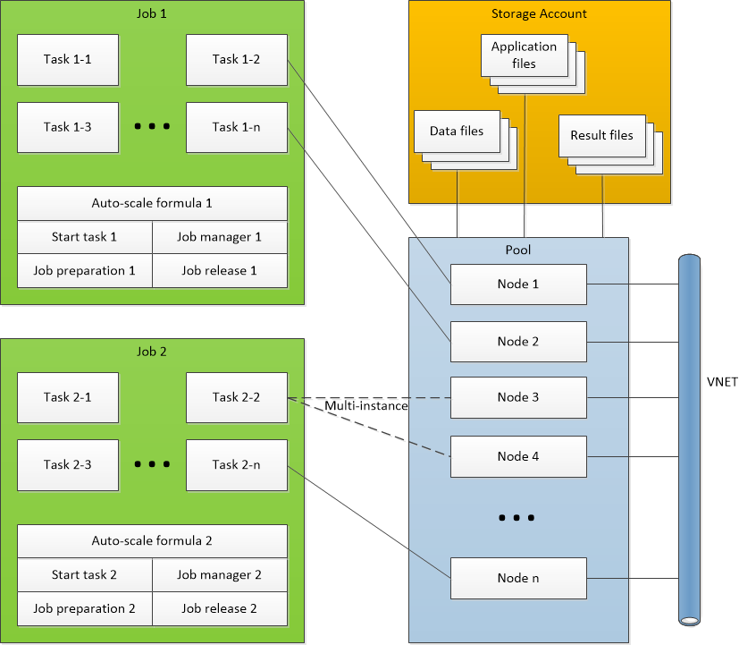

Prerequisites

* Azure account (subscription)
* Azure Batch account
* Azure Storage account

The application is broken into jobs and tasks. A job is:

* A collection of tasks.
* Defines on which pool (one or +) tasks will run.
* Provides priority and constraints configurations.
  + A constraint example is the maximum wall clock time allowed for completing a task.
  + Another is the number of retries on failures will be scheduled if a task fails.
* Defines an auto-scaling formula.
  + Number of nodes in the pool for the next scaling interval (configurable).
  + Based on:
    - Number of queues tasks.
    - Completion rate of tasks.
    - Time metrics.
    - Resource metrics.
    - Task metrics (Active, queued, running, completed).

Tasks are:

* A unit of computation.
* Scheduled to run inside a pool, on compute nodes.
* Queued until a node is ready or available.
* Defines:
  + What command to execute.
  + What application and data files are required.
  + Environment variables.
  + Constraints.
  + Application packages or container images to use.
* Can be configured as a multi-instance task. Such tasks run on more than 1 node at a time, and all start at the same time.
* Within a job, special tasks can be used:
  + Start task: prepares the operating system of the VM for task execution (application installation, starts background processes …).
  + Job manager task: controls and monitors job execution.
  + Job preparation task: first task to run on a node.
  + Job release task: last task to run on a node when it is about to be released (scaling down).
* Tasks can have dependencies between one another.
* The output of one task can be the input of another.

A pool is a collection of identical compute nodes, and defines:

* How many nodes of what size will be created.
* What scaling policy will be used.
* A tasks scheduling policy.
* Resources quotas.

Compute nodes:

* Are virtual machines (Windows or Linux) or cloud service VMs (Windows only).
* Provide CPU, memory and disks resources.
* Can be accessed like a regular VM (via RDP or SSH).
* Can be based on standard or custom images.
* Can be dedicated (more expansive but never pre-empted) or low-priority (less expansive, uses surplus capacity).
* Are all identical within a unique pool. Create other pools is different nodes are required.
* Can be added to the pool (scaling up), or removed from the pool (scaling down), depending on the auto-scaling formula, defined at the job level.
* Can be created for each job, and deleted as soon as it is complete, or be created ahead of time, thus reducing the start time, but increasing costs.

The application and data files:

* Are stored in a storage account.
* Application files are downloaded on nodes and executed.
* Data files are downloaded and then processed by the application.
* Result files can be sent back to the storage account for future use.
* Files associated to a compute node are lost when the node is destroyed.

Applications can be managed via packages:

* Can have many versions of an application used at the same time.
* Can be defined at the job, or task level.
* Job level: deployed to all nodes in the pool.
* Task level: only on nodes that are defined to run that particular package.

Networking:

* All nodes must be in the same region, in the same batch account, under the same subscription.
* Network Security Groups must allow communications between batch services and the nodes.

An API is available to:

* Communicate with Azure Batch services.
* Create and manage nodes.
* Schedule jobs and tasks.
* Can be used via CLI, REST, .NET, Python, Node.js or Java.

A typical Azure Batch workflow could be:

1. Create the required structure (accounts, permissions …).
2. Upload application and data files to the storage account
3. Define pools and nodes.
4. Define jobs and tasks.
5. Schedule jobs.
6. Monitor the execution of tasks.
7. Collect the results from the storage account.

Official documentation is available at <https://docs.microsoft.com/en-ca/azure/batch/batch-technical-overview>

**Project infrastructure**

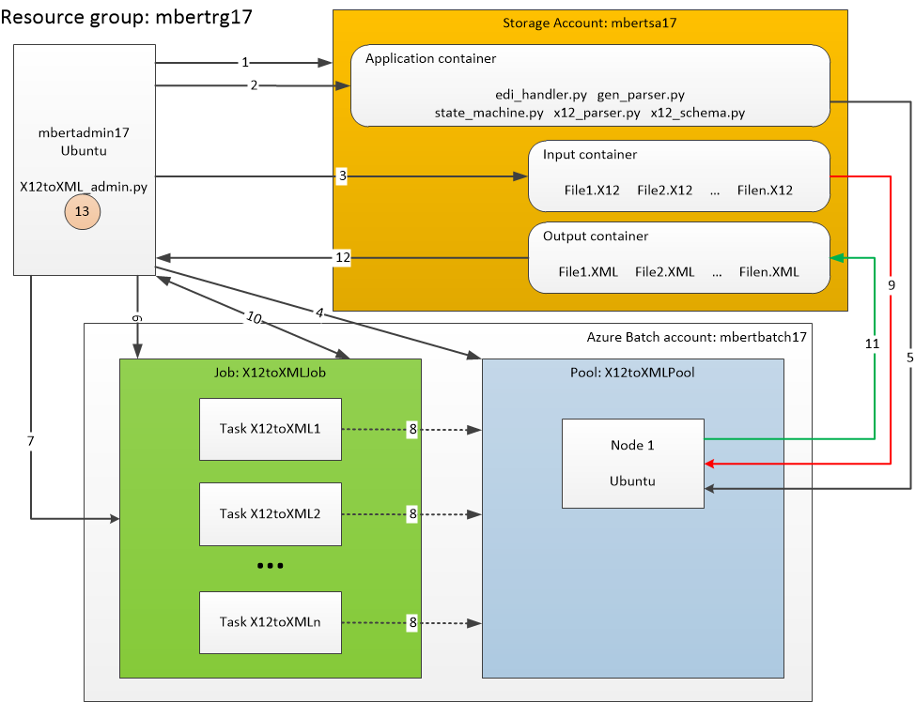

The architecture built for this project closely resembles the product resources, with the addition of an administration VM (mbertadmin17). This VM runs an administration script, which controls the creation of Azure Batch resources, the execution of the conversion tasks, and cleanup.

Operations performed on the project architecture:

1. Create containers in Azure Blob Storage.
2. Upload task scripts to the application container.
3. Upload the data files to the input container.
4. Create a Batch pool
5. The pool StartTask downloads the task scripts to the nodes as they join the pool.
6. Create a Batch job.
7. Add tasks to the job.
8. The tasks are scheduled on the nodes.
9. Each task downloads its input data from the input container of the storage.
10. Monitor tasks execution.
11. As tasks are completed, they upload the XML files to the output container of the storage.
12. Download XML files from storage.
13. Cleanup:
    1. Delete the container from the storage.
    2. Delete the pool and associated nodes.
    3. Delete the job and associated tasks.

Note: by default, 1 node is created in the pool. Depending on the parameters and load, additional nodes will be created automatically. For this demonstration application, the conversion script does not use much resources, so 1 node is sufficient.

**Files**

X12toXML_admin_create.bash

* Azure CLI script that creates the Azure components to start using Azure Batch.

X12toXML_admin.py

* Administration python script which controls all aspects related to Azure Batch.

gen_parser.py

* Conversion script of X12 files into XML.
* Prerequisite files:
  + edi_handler.py
  + state_machine.py
  + x12_parser.py
  + x12_schema.xml

File?.X12

* X12 input files.

File?.xml

* XML output files.

**Building the infrastructure**

The infrastructure is built using the X12toXML_admin_create.bash script. It is an Azure CLI script that creates:

* Resource group: mbertrg17.
* Storage account: mbertsa17
* Administration VM mbertadmin17, Linux Ubuntu 16.04.
* Azure Batch account: mbertbatch17
* Create a configuration file for the X12toXML_admin.py script.
* Upload the administration and application scripts to the administration VM.
* Upload the data files to the administration VM.
* Configure the administration VM to be able to run the administration python script.

Note: in a real scenario, files could be uploaded directly to containers within the Storage Account. This would ensure no disk resources are consumed on the administration VM to store data files.

The output of this script is:

Resource group: mbertrg17...

{

"id": "/subscriptions/6f5d1e5e-5295-4b19-9069-76eaa53bdb9c/resourceGroups/mbertrg17",

"location": "canadaeast",

"managedBy": null,

"name": "mbertrg17",

"properties": {

"provisioningState": "Succeeded"

},

"tags": null

}

RG mbertrg17 created.

------------------------------------------------------------

Storage account: mbertsa17...

{

"accessTier": "Hot",

"creationTime": "2018-01-11T00:40:01.947560+00:00",

"customDomain": null,

"enableHttpsTrafficOnly": false,

"encryption": {

"keySource": "Microsoft.Storage",

"keyVaultProperties": null,

"services": {

"blob": {

"enabled": true,

"lastEnabledTime": "2018-01-11T00:40:01.963159+00:00"

},

"file": {

"enabled": true,

"lastEnabledTime": "2018-01-11T00:40:01.963159+00:00"

},

"queue": null,

"table": null

}

},

"id": "/subscriptions/6f5d1e5e-5295-4b19-9069-76eaa53bdb9c/resourceGroups/mbertrg17/providers/Microsoft.Storage/storageAccounts/mbertsa17",

"identity": null,

"kind": "BlobStorage",

"lastGeoFailoverTime": null,

"location": "canadaeast",

"name": "mbertsa17",

"networkRuleSet": null,

"primaryEndpoints": {

"blob": "https://mbertsa17.blob.core.windows.net/",

"file": null,

"queue": null,

"table": "https://mbertsa17.table.core.windows.net/"

},

"primaryLocation": "canadaeast",

"provisioningState": "Succeeded",

"resourceGroup": "mbertrg17",

"secondaryEndpoints": null,

"secondaryLocation": null,

"sku": {

"capabilities": null,

"kind": null,

"locations": null,

"name": "Standard_LRS",

"resourceType": null,

"restrictions": null,

"tier": "Standard"

},

"statusOfPrimary": "available",

"statusOfSecondary": null,

"tags": null,

"type": "Microsoft.Storage/storageAccounts"

}

Storage account mbertsa17 created.

Storage account key: tEa7r63QsucmVSeszVHE/OUQy3oFnMgVcS7unYxklimQ4AksxhzcbzqCF3/3iMl65jgebuw653P68tkXx2Wwqw==

------------------------------------------------------------

Administration VM...

{

"fqdns": "",

"id": "/subscriptions/6f5d1e5e-5295-4b19-9069-76eaa53bdb9c/resourceGroups/mbertrg17/providers/Microsoft.Compute/virtualMachines/mbertadmin17",

"location": "CanadaEast",

"macAddress": "00-0D-3A-F4-36-8E",

"powerState": "VM running",

"privateIpAddress": "10.0.0.4",

"publicIpAddress": "52.242.22.59",

"resourceGroup": "mbertrg17",

"zones": ""

}

VM mbertadmin17 created.

VM mbertadmin17 public IP: 52.242.22.59

To connect to mbertadmin17: sshpass -p "7e8f_f+FF=j3Jj0" ssh -o StrictHostKeyChecking=no mbert@52.242.22.59

------------------------------------------------------------

Create batch account...

{

"accountEndpoint": "mbertbatch17.canadaeast.batch.azure.com",

"activeJobAndJobScheduleQuota": 20,

"autoStorage": {

"lastKeySync": "2018-01-11T00:43:18.253138+00:00",

"storageAccountId": "/subscriptions/6f5d1e5e-5295-4b19-9069-76eaa53bdb9c/resourceGroups/mbertrg17/providers/Microsoft.Storage/storageAccounts/mbertsa17"

},

"dedicatedCoreQuota": 100,

"id": "/subscriptions/6f5d1e5e-5295-4b19-9069-76eaa53bdb9c/resourceGroups/mbertrg17/providers/Microsoft.Batch/batchAccounts/mbertbatch17",

"keyVaultReference": null,

"location": "canadaeast",

"lowPriorityCoreQuota": 100,

"name": "mbertbatch17",

"poolAllocationMode": "BatchService",

"poolQuota": 20,

"provisioningState": "Succeeded",

"resourceGroup": "mbertrg17",

"tags": null,

"type": "Microsoft.Batch/batchAccounts"

}

Batch account mbertbatch17 created.

Batch key: QZJQExTyseDe7r5iyti0Z55ahMDFZ6gct3BtIPOur4d2qOMyZsblvgaqyJH2ndD3dW1T28t/GZZAd9wJxSIecA==

Batch account URL: htps://mbertbatch17.canadaeast.batch.azure.com

------------------------------------------------------------

Create the configuration file...

------------------------------------------------------------

Upload files to the administration VM...

Scripts...

Data files...

------------------------------------------------------------

Configure the administration vm...

Install Python and dependencies...

Hit:1 http://azure.archive.ubuntu.com/ubuntu xenial InRelease

Get:2 http://security.ubuntu.com/ubuntu xenial-security InRelease [102 kB]

Get:3 http://azure.archive.ubuntu.com/ubuntu xenial-updates InRelease [102 kB]

Get:4 http://azure.archive.ubuntu.com/ubuntu xenial-backports InRelease [102 kB]

Get:5 http://azure.archive.ubuntu.com/ubuntu xenial/main Sources [868 kB]

Get:6 http://security.ubuntu.com/ubuntu xenial-security/main Sources [105 kB]

Get:7 http://security.ubuntu.com/ubuntu xenial-security/restricted Sources [2,116 B]

Get:8 http://azure.archive.ubuntu.com/ubuntu xenial/restricted Sources [4,808 B]

Get:9 http://security.ubuntu.com/ubuntu xenial-security/universe Sources [48.9 kB]

Get:10 http://azure.archive.ubuntu.com/ubuntu xenial/universe Sources [7,728 kB]

Get:11 http://security.ubuntu.com/ubuntu xenial-security/multiverse Sources [1,520 B]

Get:12 http://security.ubuntu.com/ubuntu xenial-security/main amd64 Packages [423 kB]

Get:13 http://azure.archive.ubuntu.com/ubuntu xenial/multiverse Sources [179 kB]

Get:14 http://security.ubuntu.com/ubuntu xenial-security/main Translation-en [186 kB]

Get:15 http://azure.archive.ubuntu.com/ubuntu xenial-updates/main Sources [290 kB]

Get:16 http://security.ubuntu.com/ubuntu xenial-security/restricted amd64 Packages [7,224 B]

Get:17 http://azure.archive.ubuntu.com/ubuntu xenial-updates/restricted Sources [2,532 B]

Get:18 http://security.ubuntu.com/ubuntu xenial-security/restricted Translation-en [2,152 B]

Get:19 http://azure.archive.ubuntu.com/ubuntu xenial-updates/universe Sources [186 kB]

Get:20 http://azure.archive.ubuntu.com/ubuntu xenial-updates/multiverse Sources [7,968 B]

Get:21 http://security.ubuntu.com/ubuntu xenial-security/universe amd64 Packages [195 kB]

Get:22 http://azure.archive.ubuntu.com/ubuntu xenial-updates/main amd64 Packages [699 kB]

Get:23 http://security.ubuntu.com/ubuntu xenial-security/universe Translation-en [101 kB]

Get:24 http://azure.archive.ubuntu.com/ubuntu xenial-updates/main Translation-en [291 kB]

Get:25 http://security.ubuntu.com/ubuntu xenial-security/multiverse amd64 Packages [3,208 B]

Get:26 http://azure.archive.ubuntu.com/ubuntu xenial-updates/restricted amd64 Packages [7,588 B]

Get:27 http://azure.archive.ubuntu.com/ubuntu xenial-updates/restricted Translation-en [2,272 B]

Get:28 http://azure.archive.ubuntu.com/ubuntu xenial-updates/universe amd64 Packages [572 kB]

Get:29 http://azure.archive.ubuntu.com/ubuntu xenial-updates/universe Translation-en [231 kB]

Get:30 http://azure.archive.ubuntu.com/ubuntu xenial-updates/multiverse amd64 Packages [16.2 kB]

Get:31 http://azure.archive.ubuntu.com/ubuntu xenial-updates/multiverse Translation-en [8,052 B]

Get:32 http://azure.archive.ubuntu.com/ubuntu xenial-backports/main Sources [3,436 B]

Get:33 http://azure.archive.ubuntu.com/ubuntu xenial-backports/universe Sources [4,908 B]

Fetched 12.5 MB in 3s (4,065 kB/s)

Reading package lists...

Reading package lists...

Building dependency tree...

Reading state information...

python3 is already the newest version (3.5.1-3).

The following additional packages will be installed:

cpp cpp-5 dpkg-dev fakeroot g++ g++-5 gcc gcc-5 libalgorithm-diff-perl

libalgorithm-diff-xs-perl libalgorithm-merge-perl libasan2 libatomic1

libc-dev-bin libc6-dev libcc1-0 libcilkrts5 libdpkg-perl libexpat1-dev

libfakeroot libfile-fcntllock-perl libgcc-5-dev libgomp1 libisl15 libitm1

liblsan0 libmpc3 libmpx0 libpython3.5-dev libquadmath0 libssl-doc

libstdc++-5-dev libtsan0 libubsan0 linux-libc-dev make manpages-dev

python-pip-whl python3-setuptools python3-wheel python3.5-dev zlib1g-dev

Suggested packages:

cpp-doc gcc-5-locales debian-keyring g++-multilib g++-5-multilib gcc-5-doc

libstdc++6-5-dbg gcc-multilib autoconf automake libtool flex bison gdb

gcc-doc gcc-5-multilib libgcc1-dbg libgomp1-dbg libitm1-dbg libatomic1-dbg

libasan2-dbg liblsan0-dbg libtsan0-dbg libubsan0-dbg libcilkrts5-dbg

libmpx0-dbg libquadmath0-dbg glibc-doc libstdc++-5-doc make-doc

python-setuptools-doc

The following NEW packages will be installed:

build-essential cpp cpp-5 dpkg-dev fakeroot g++ g++-5 gcc gcc-5

libalgorithm-diff-perl libalgorithm-diff-xs-perl libalgorithm-merge-perl

libasan2 libatomic1 libc-dev-bin libc6-dev libcc1-0 libcilkrts5 libdpkg-perl

libexpat1-dev libfakeroot libffi-dev libfile-fcntllock-perl libgcc-5-dev

libgomp1 libisl15 libitm1 liblsan0 libmpc3 libmpx0 libpython3-dev

libpython3.5-dev libquadmath0 libssl-dev libssl-doc libstdc++-5-dev libtsan0

libubsan0 linux-libc-dev make manpages-dev python-pip-whl python3-dev

python3-pip python3-setuptools python3-wheel python3.5-dev zlib1g-dev

0 upgraded, 48 newly installed, 0 to remove and 7 not upgraded.

Need to get 78.2 MB of archives.

After this operation, 198 MB of additional disk space will be used.

Get:1 http://azure.archive.ubuntu.com/ubuntu xenial/main amd64 libmpc3 amd64 1.0.3-1 [39.7 kB]

Get:2 http://azure.archive.ubuntu.com/ubuntu xenial-updates/main amd64 libc-dev-bin amd64 2.23-0ubuntu9 [68.6 kB]

Get:3 http://azure.archive.ubuntu.com/ubuntu xenial-updates/main amd64 linux-libc-dev amd64 4.4.0-109.132 [829 kB]

Get:4 http://azure.archive.ubuntu.com/ubuntu xenial-updates/main amd64 libc6-dev amd64 2.23-0ubuntu9 [2,082 kB]

Get:5 http://azure.archive.ubuntu.com/ubuntu xenial/main amd64 libisl15 amd64 0.16.1-1 [524 kB]

Get:6 http://azure.archive.ubuntu.com/ubuntu xenial-updates/main amd64 cpp-5 amd64 5.4.0-6ubuntu1~16.04.5 [7,786 kB]

Get:7 http://azure.archive.ubuntu.com/ubuntu xenial/main amd64 cpp amd64 4:5.3.1-1ubuntu1 [27.7 kB]

Get:8 http://azure.archive.ubuntu.com/ubuntu xenial-updates/main amd64 libcc1-0 amd64 5.4.0-6ubuntu1~16.04.5 [38.8 kB]

Get:9 http://azure.archive.ubuntu.com/ubuntu xenial-updates/main amd64 libgomp1 amd64 5.4.0-6ubuntu1~16.04.5 [55.1 kB]

Get:10 http://azure.archive.ubuntu.com/ubuntu xenial-updates/main amd64 libitm1 amd64 5.4.0-6ubuntu1~16.04.5 [27.4 kB]

Get:11 http://azure.archive.ubuntu.com/ubuntu xenial-updates/main amd64 libatomic1 amd64 5.4.0-6ubuntu1~16.04.5 [8,920 B]

Get:12 http://azure.archive.ubuntu.com/ubuntu xenial-updates/main amd64 libasan2 amd64 5.4.0-6ubuntu1~16.04.5 [264 kB]

Get:13 http://azure.archive.ubuntu.com/ubuntu xenial-updates/main amd64 liblsan0 amd64 5.4.0-6ubuntu1~16.04.5 [105 kB]

Get:14 http://azure.archive.ubuntu.com/ubuntu xenial-updates/main amd64 libtsan0 amd64 5.4.0-6ubuntu1~16.04.5 [244 kB]

Get:15 http://azure.archive.ubuntu.com/ubuntu xenial-updates/main amd64 libubsan0 amd64 5.4.0-6ubuntu1~16.04.5 [95.3 kB]

Get:16 http://azure.archive.ubuntu.com/ubuntu xenial-updates/main amd64 libcilkrts5 amd64 5.4.0-6ubuntu1~16.04.5 [40.1 kB]

Get:17 http://azure.archive.ubuntu.com/ubuntu xenial-updates/main amd64 libmpx0 amd64 5.4.0-6ubuntu1~16.04.5 [9,786 B]

Get:18 http://azure.archive.ubuntu.com/ubuntu xenial-updates/main amd64 libquadmath0 amd64 5.4.0-6ubuntu1~16.04.5 [131 kB]

Get:19 http://azure.archive.ubuntu.com/ubuntu xenial-updates/main amd64 libgcc-5-dev amd64 5.4.0-6ubuntu1~16.04.5 [2,226 kB]

Get:20 http://azure.archive.ubuntu.com/ubuntu xenial-updates/main amd64 gcc-5 amd64 5.4.0-6ubuntu1~16.04.5 [8,638 kB]

Get:21 http://azure.archive.ubuntu.com/ubuntu xenial/main amd64 gcc amd64 4:5.3.1-1ubuntu1 [5,244 B]

Get:22 http://azure.archive.ubuntu.com/ubuntu xenial-updates/main amd64 libstdc++-5-dev amd64 5.4.0-6ubuntu1~16.04.5 [1,430 kB]

Get:23 http://azure.archive.ubuntu.com/ubuntu xenial-updates/main amd64 g++-5 amd64 5.4.0-6ubuntu1~16.04.5 [8,435 kB]

Get:24 http://azure.archive.ubuntu.com/ubuntu xenial/main amd64 g++ amd64 4:5.3.1-1ubuntu1 [1,504 B]

Get:25 http://azure.archive.ubuntu.com/ubuntu xenial/main amd64 make amd64 4.1-6 [151 kB]

Get:26 http://azure.archive.ubuntu.com/ubuntu xenial-updates/main amd64 libdpkg-perl all 1.18.4ubuntu1.3 [195 kB]

Get:27 http://azure.archive.ubuntu.com/ubuntu xenial-updates/main amd64 dpkg-dev all 1.18.4ubuntu1.3 [584 kB]

Get:28 http://azure.archive.ubuntu.com/ubuntu xenial/main amd64 build-essential amd64 12.1ubuntu2 [4,758 B]

Get:29 http://azure.archive.ubuntu.com/ubuntu xenial/main amd64 libfakeroot amd64 1.20.2-1ubuntu1 [25.5 kB]

Get:30 http://azure.archive.ubuntu.com/ubuntu xenial/main amd64 fakeroot amd64 1.20.2-1ubuntu1 [61.8 kB]

Get:31 http://azure.archive.ubuntu.com/ubuntu xenial/main amd64 libalgorithm-diff-perl all 1.19.03-1 [47.6 kB]

Get:32 http://azure.archive.ubuntu.com/ubuntu xenial/main amd64 libalgorithm-diff-xs-perl amd64 0.04-4build1 [11.0 kB]

Get:33 http://azure.archive.ubuntu.com/ubuntu xenial/main amd64 libalgorithm-merge-perl all 0.08-3 [12.0 kB]

Get:34 http://azure.archive.ubuntu.com/ubuntu xenial-updates/main amd64 libexpat1-dev amd64 2.1.0-7ubuntu0.16.04.3 [115 kB]

Get:35 http://azure.archive.ubuntu.com/ubuntu xenial/main amd64 libfile-fcntllock-perl amd64 0.22-3 [32.0 kB]

Get:36 http://azure.archive.ubuntu.com/ubuntu xenial-updates/main amd64 libpython3.5-dev amd64 3.5.2-2ubuntu0~16.04.4 [37.3 MB]

Get:37 http://azure.archive.ubuntu.com/ubuntu xenial/main amd64 libpython3-dev amd64 3.5.1-3 [6,926 B]

Get:38 http://azure.archive.ubuntu.com/ubuntu xenial-updates/main amd64 zlib1g-dev amd64 1:1.2.8.dfsg-2ubuntu4.1 [168 kB]

Get:39 http://azure.archive.ubuntu.com/ubuntu xenial-updates/main amd64 libssl-dev amd64 1.0.2g-1ubuntu4.10 [1,341 kB]

Get:40 http://azure.archive.ubuntu.com/ubuntu xenial-updates/main amd64 libssl-doc all 1.0.2g-1ubuntu4.10 [1,079 kB]

Get:41 http://azure.archive.ubuntu.com/ubuntu xenial/main amd64 manpages-dev all 4.04-2 [2,048 kB]

Get:42 http://azure.archive.ubuntu.com/ubuntu xenial-updates/universe amd64 python-pip-whl all 8.1.1-2ubuntu0.4 [1,110 kB]

Get:43 http://azure.archive.ubuntu.com/ubuntu xenial-updates/main amd64 python3.5-dev amd64 3.5.2-2ubuntu0~16.04.4 [413 kB]

Get:44 http://azure.archive.ubuntu.com/ubuntu xenial/main amd64 python3-dev amd64 3.5.1-3 [1,186 B]

Get:45 http://azure.archive.ubuntu.com/ubuntu xenial-updates/universe amd64 python3-pip all 8.1.1-2ubuntu0.4 [109 kB]

Get:46 http://azure.archive.ubuntu.com/ubuntu xenial/main amd64 python3-setuptools all 20.7.0-1 [88.0 kB]

Get:47 http://azure.archive.ubuntu.com/ubuntu xenial/universe amd64 python3-wheel all 0.29.0-1 [48.1 kB]

Get:48 http://azure.archive.ubuntu.com/ubuntu xenial/main amd64 libffi-dev amd64 3.2.1-4 [161 kB]

Fetched 78.2 MB in 6s (11.6 MB/s)

Selecting previously unselected package libmpc3:amd64.

(Reading database ... (Reading database ... 5%(Reading database ... 10%(Reading database ... 15%(Reading database ... 20%(Reading database ... 25%(Reading database ... 30%(Reading database ... 35%(Reading database ... 40%(Reading database ... 45%(Reading database ... 50%(Reading database ... 55%(Reading database ... 60%(Reading database ... 65%(Reading database ... 70%(Reading database ... 75%(Reading database ... 80%(Reading database ... 85%(Reading database ... 90%(Reading database ... 95%(Reading database ... 100%(Reading database ... 54182 files and directories currently installed.)

Preparing to unpack .../libmpc3_1.0.3-1_amd64.deb ...

Unpacking libmpc3:amd64 (1.0.3-1) ...

Selecting previously unselected package libc-dev-bin.

Preparing to unpack .../libc-dev-bin_2.23-0ubuntu9_amd64.deb ...

Unpacking libc-dev-bin (2.23-0ubuntu9) ...

Selecting previously unselected package linux-libc-dev:amd64.

Preparing to unpack .../linux-libc-dev_4.4.0-109.132_amd64.deb ...

Unpacking linux-libc-dev:amd64 (4.4.0-109.132) ...

Selecting previously unselected package libc6-dev:amd64.

Preparing to unpack .../libc6-dev_2.23-0ubuntu9_amd64.deb ...

Unpacking libc6-dev:amd64 (2.23-0ubuntu9) ...

Selecting previously unselected package libisl15:amd64.

Preparing to unpack .../libisl15_0.16.1-1_amd64.deb ...

Unpacking libisl15:amd64 (0.16.1-1) ...

Selecting previously unselected package cpp-5.

Preparing to unpack .../cpp-5_5.4.0-6ubuntu1~16.04.5_amd64.deb ...

Unpacking cpp-5 (5.4.0-6ubuntu1~16.04.5) ...

Selecting previously unselected package cpp.

Preparing to unpack .../cpp_4%3a5.3.1-1ubuntu1_amd64.deb ...

Unpacking cpp (4:5.3.1-1ubuntu1) ...

Selecting previously unselected package libcc1-0:amd64.

Preparing to unpack .../libcc1-0_5.4.0-6ubuntu1~16.04.5_amd64.deb ...

Unpacking libcc1-0:amd64 (5.4.0-6ubuntu1~16.04.5) ...

Selecting previously unselected package libgomp1:amd64.

Preparing to unpack .../libgomp1_5.4.0-6ubuntu1~16.04.5_amd64.deb ...

Unpacking libgomp1:amd64 (5.4.0-6ubuntu1~16.04.5) ...

Selecting previously unselected package libitm1:amd64.

Preparing to unpack .../libitm1_5.4.0-6ubuntu1~16.04.5_amd64.deb ...

Unpacking libitm1:amd64 (5.4.0-6ubuntu1~16.04.5) ...

Selecting previously unselected package libatomic1:amd64.

Preparing to unpack .../libatomic1_5.4.0-6ubuntu1~16.04.5_amd64.deb ...

Unpacking libatomic1:amd64 (5.4.0-6ubuntu1~16.04.5) ...

Selecting previously unselected package libasan2:amd64.

Preparing to unpack .../libasan2_5.4.0-6ubuntu1~16.04.5_amd64.deb ...

Unpacking libasan2:amd64 (5.4.0-6ubuntu1~16.04.5) ...

Selecting previously unselected package liblsan0:amd64.

Preparing to unpack .../liblsan0_5.4.0-6ubuntu1~16.04.5_amd64.deb ...

Unpacking liblsan0:amd64 (5.4.0-6ubuntu1~16.04.5) ...

Selecting previously unselected package libtsan0:amd64.

Preparing to unpack .../libtsan0_5.4.0-6ubuntu1~16.04.5_amd64.deb ...

Unpacking libtsan0:amd64 (5.4.0-6ubuntu1~16.04.5) ...

Selecting previously unselected package libubsan0:amd64.

Preparing to unpack .../libubsan0_5.4.0-6ubuntu1~16.04.5_amd64.deb ...

Unpacking libubsan0:amd64 (5.4.0-6ubuntu1~16.04.5) ...

Selecting previously unselected package libcilkrts5:amd64.

Preparing to unpack .../libcilkrts5_5.4.0-6ubuntu1~16.04.5_amd64.deb ...

Unpacking libcilkrts5:amd64 (5.4.0-6ubuntu1~16.04.5) ...

Selecting previously unselected package libmpx0:amd64.

Preparing to unpack .../libmpx0_5.4.0-6ubuntu1~16.04.5_amd64.deb ...

Unpacking libmpx0:amd64 (5.4.0-6ubuntu1~16.04.5) ...

Selecting previously unselected package libquadmath0:amd64.

Preparing to unpack .../libquadmath0_5.4.0-6ubuntu1~16.04.5_amd64.deb ...

Unpacking libquadmath0:amd64 (5.4.0-6ubuntu1~16.04.5) ...

Selecting previously unselected package libgcc-5-dev:amd64.

Preparing to unpack .../libgcc-5-dev_5.4.0-6ubuntu1~16.04.5_amd64.deb ...

Unpacking libgcc-5-dev:amd64 (5.4.0-6ubuntu1~16.04.5) ...

Selecting previously unselected package gcc-5.

Preparing to unpack .../gcc-5_5.4.0-6ubuntu1~16.04.5_amd64.deb ...

Unpacking gcc-5 (5.4.0-6ubuntu1~16.04.5) ...

Selecting previously unselected package gcc.

Preparing to unpack .../gcc_4%3a5.3.1-1ubuntu1_amd64.deb ...

Unpacking gcc (4:5.3.1-1ubuntu1) ...

Selecting previously unselected package libstdc++-5-dev:amd64.

Preparing to unpack .../libstdc++-5-dev_5.4.0-6ubuntu1~16.04.5_amd64.deb ...

Unpacking libstdc++-5-dev:amd64 (5.4.0-6ubuntu1~16.04.5) ...

Selecting previously unselected package g++-5.

Preparing to unpack .../g++-5_5.4.0-6ubuntu1~16.04.5_amd64.deb ...

Unpacking g++-5 (5.4.0-6ubuntu1~16.04.5) ...

Selecting previously unselected package g++.

Preparing to unpack .../g++_4%3a5.3.1-1ubuntu1_amd64.deb ...

Unpacking g++ (4:5.3.1-1ubuntu1) ...

Selecting previously unselected package make.

Preparing to unpack .../archives/make_4.1-6_amd64.deb ...

Unpacking make (4.1-6) ...

Selecting previously unselected package libdpkg-perl.

Preparing to unpack .../libdpkg-perl_1.18.4ubuntu1.3_all.deb ...

Unpacking libdpkg-perl (1.18.4ubuntu1.3) ...

Selecting previously unselected package dpkg-dev.

Preparing to unpack .../dpkg-dev_1.18.4ubuntu1.3_all.deb ...

Unpacking dpkg-dev (1.18.4ubuntu1.3) ...

Selecting previously unselected package build-essential.

Preparing to unpack .../build-essential_12.1ubuntu2_amd64.deb ...

Unpacking build-essential (12.1ubuntu2) ...

Selecting previously unselected package libfakeroot:amd64.

Preparing to unpack .../libfakeroot_1.20.2-1ubuntu1_amd64.deb ...

Unpacking libfakeroot:amd64 (1.20.2-1ubuntu1) ...

Selecting previously unselected package fakeroot.

Preparing to unpack .../fakeroot_1.20.2-1ubuntu1_amd64.deb ...

Unpacking fakeroot (1.20.2-1ubuntu1) ...

Selecting previously unselected package libalgorithm-diff-perl.

Preparing to unpack .../libalgorithm-diff-perl_1.19.03-1_all.deb ...

Unpacking libalgorithm-diff-perl (1.19.03-1) ...

Selecting previously unselected package libalgorithm-diff-xs-perl.

Preparing to unpack .../libalgorithm-diff-xs-perl_0.04-4build1_amd64.deb ...

Unpacking libalgorithm-diff-xs-perl (0.04-4build1) ...

Selecting previously unselected package libalgorithm-merge-perl.

Preparing to unpack .../libalgorithm-merge-perl_0.08-3_all.deb ...

Unpacking libalgorithm-merge-perl (0.08-3) ...

Selecting previously unselected package libexpat1-dev:amd64.

Preparing to unpack .../libexpat1-dev_2.1.0-7ubuntu0.16.04.3_amd64.deb ...

Unpacking libexpat1-dev:amd64 (2.1.0-7ubuntu0.16.04.3) ...

Selecting previously unselected package libfile-fcntllock-perl.

Preparing to unpack .../libfile-fcntllock-perl_0.22-3_amd64.deb ...

Unpacking libfile-fcntllock-perl (0.22-3) ...

Selecting previously unselected package libpython3.5-dev:amd64.

Preparing to unpack .../libpython3.5-dev_3.5.2-2ubuntu0~16.04.4_amd64.deb ...

Unpacking libpython3.5-dev:amd64 (3.5.2-2ubuntu0~16.04.4) ...

Selecting previously unselected package libpython3-dev:amd64.

Preparing to unpack .../libpython3-dev_3.5.1-3_amd64.deb ...

Unpacking libpython3-dev:amd64 (3.5.1-3) ...

Selecting previously unselected package zlib1g-dev:amd64.

Preparing to unpack .../zlib1g-dev_1%3a1.2.8.dfsg-2ubuntu4.1_amd64.deb ...

Unpacking zlib1g-dev:amd64 (1:1.2.8.dfsg-2ubuntu4.1) ...

Selecting previously unselected package libssl-dev:amd64.

Preparing to unpack .../libssl-dev_1.0.2g-1ubuntu4.10_amd64.deb ...

Unpacking libssl-dev:amd64 (1.0.2g-1ubuntu4.10) ...

Selecting previously unselected package libssl-doc.

Preparing to unpack .../libssl-doc_1.0.2g-1ubuntu4.10_all.deb ...

Unpacking libssl-doc (1.0.2g-1ubuntu4.10) ...

Selecting previously unselected package manpages-dev.

Preparing to unpack .../manpages-dev_4.04-2_all.deb ...

Unpacking manpages-dev (4.04-2) ...

Selecting previously unselected package python-pip-whl.

Preparing to unpack .../python-pip-whl_8.1.1-2ubuntu0.4_all.deb ...

Unpacking python-pip-whl (8.1.1-2ubuntu0.4) ...

Selecting previously unselected package python3.5-dev.

Preparing to unpack .../python3.5-dev_3.5.2-2ubuntu0~16.04.4_amd64.deb ...

Unpacking python3.5-dev (3.5.2-2ubuntu0~16.04.4) ...

Selecting previously unselected package python3-dev.

Preparing to unpack .../python3-dev_3.5.1-3_amd64.deb ...

Unpacking python3-dev (3.5.1-3) ...

Selecting previously unselected package python3-pip.

Preparing to unpack .../python3-pip_8.1.1-2ubuntu0.4_all.deb ...

Unpacking python3-pip (8.1.1-2ubuntu0.4) ...

Selecting previously unselected package python3-setuptools.

Preparing to unpack .../python3-setuptools_20.7.0-1_all.deb ...

Unpacking python3-setuptools (20.7.0-1) ...

Selecting previously unselected package python3-wheel.

Preparing to unpack .../python3-wheel_0.29.0-1_all.deb ...

Unpacking python3-wheel (0.29.0-1) ...

Selecting previously unselected package libffi-dev:amd64.

Preparing to unpack .../libffi-dev_3.2.1-4_amd64.deb ...

Unpacking libffi-dev:amd64 (3.2.1-4) ...

Processing triggers for man-db (2.7.5-1) ...

Processing triggers for libc-bin (2.23-0ubuntu9) ...

Processing triggers for install-info (6.1.0.dfsg.1-5) ...

Setting up libmpc3:amd64 (1.0.3-1) ...

Setting up libc-dev-bin (2.23-0ubuntu9) ...

Setting up linux-libc-dev:amd64 (4.4.0-109.132) ...

Setting up libc6-dev:amd64 (2.23-0ubuntu9) ...

Setting up libisl15:amd64 (0.16.1-1) ...

Setting up cpp-5 (5.4.0-6ubuntu1~16.04.5) ...

Setting up cpp (4:5.3.1-1ubuntu1) ...

Setting up libcc1-0:amd64 (5.4.0-6ubuntu1~16.04.5) ...

Setting up libgomp1:amd64 (5.4.0-6ubuntu1~16.04.5) ...

Setting up libitm1:amd64 (5.4.0-6ubuntu1~16.04.5) ...

Setting up libatomic1:amd64 (5.4.0-6ubuntu1~16.04.5) ...

Setting up libasan2:amd64 (5.4.0-6ubuntu1~16.04.5) ...

Setting up liblsan0:amd64 (5.4.0-6ubuntu1~16.04.5) ...

Setting up libtsan0:amd64 (5.4.0-6ubuntu1~16.04.5) ...

Setting up libubsan0:amd64 (5.4.0-6ubuntu1~16.04.5) ...

Setting up libcilkrts5:amd64 (5.4.0-6ubuntu1~16.04.5) ...

Setting up libmpx0:amd64 (5.4.0-6ubuntu1~16.04.5) ...

Setting up libquadmath0:amd64 (5.4.0-6ubuntu1~16.04.5) ...

Setting up libgcc-5-dev:amd64 (5.4.0-6ubuntu1~16.04.5) ...

Setting up gcc-5 (5.4.0-6ubuntu1~16.04.5) ...

Setting up gcc (4:5.3.1-1ubuntu1) ...

Setting up libstdc++-5-dev:amd64 (5.4.0-6ubuntu1~16.04.5) ...

Setting up g++-5 (5.4.0-6ubuntu1~16.04.5) ...

Setting up g++ (4:5.3.1-1ubuntu1) ...

update-alternatives: using /usr/bin/g++ to provide /usr/bin/c++ (c++) in auto mode

Setting up make (4.1-6) ...

Setting up libdpkg-perl (1.18.4ubuntu1.3) ...

Setting up dpkg-dev (1.18.4ubuntu1.3) ...

Setting up build-essential (12.1ubuntu2) ...

Setting up libfakeroot:amd64 (1.20.2-1ubuntu1) ...

Setting up fakeroot (1.20.2-1ubuntu1) ...

update-alternatives: using /usr/bin/fakeroot-sysv to provide /usr/bin/fakeroot (fakeroot) in auto mode

Setting up libalgorithm-diff-perl (1.19.03-1) ...

Setting up libalgorithm-diff-xs-perl (0.04-4build1) ...

Setting up libalgorithm-merge-perl (0.08-3) ...

Setting up libexpat1-dev:amd64 (2.1.0-7ubuntu0.16.04.3) ...

Setting up libfile-fcntllock-perl (0.22-3) ...

Setting up libpython3.5-dev:amd64 (3.5.2-2ubuntu0~16.04.4) ...

Setting up libpython3-dev:amd64 (3.5.1-3) ...

Setting up zlib1g-dev:amd64 (1:1.2.8.dfsg-2ubuntu4.1) ...

Setting up libssl-dev:amd64 (1.0.2g-1ubuntu4.10) ...

Setting up libssl-doc (1.0.2g-1ubuntu4.10) ...

Setting up manpages-dev (4.04-2) ...

Setting up python-pip-whl (8.1.1-2ubuntu0.4) ...

Setting up python3.5-dev (3.5.2-2ubuntu0~16.04.4) ...

Setting up python3-dev (3.5.1-3) ...

Setting up python3-pip (8.1.1-2ubuntu0.4) ...

Setting up python3-setuptools (20.7.0-1) ...

Setting up python3-wheel (0.29.0-1) ...

Setting up libffi-dev:amd64 (3.2.1-4) ...

Processing triggers for libc-bin (2.23-0ubuntu9) ...

PIP install azure-batch and azure-storage

Collecting pip

Downloading pip-9.0.1-py2.py3-none-any.whl (1.3MB)

Installing collected packages: pip

Found existing installation: pip 8.1.1

Not uninstalling pip at /usr/lib/python3/dist-packages, outside environment /usr

Successfully installed pip-9.0.1

Collecting azure-batch==4.0.0 (from -r scripts/requirements.txt (line 1))

Downloading azure_batch-4.0.0-py2.py3-none-any.whl (304kB)

Collecting azure-storage==0.36.0 (from -r scripts/requirements.txt (line 2))

Downloading azure_storage-0.36.0-py2.py3-none-any.whl (190kB)

Collecting azure-nspkg>=2.0.0 (from azure-batch==4.0.0->-r scripts/requirements.txt (line 1))

Downloading azure_nspkg-2.0.0-py2.py3-none-any.whl

Collecting msrestazure~=0.4.11 (from azure-batch==4.0.0->-r scripts/requirements.txt (line 1))

Downloading msrestazure-0.4.20-py2.py3-none-any.whl

Collecting azure-common~=1.1 (from azure-batch==4.0.0->-r scripts/requirements.txt (line 1))

Downloading azure_common-1.1.8-py2.py3-none-any.whl

Requirement already satisfied: requests in /usr/lib/python3/dist-packages (from azure-storage==0.36.0->-r scripts/requirements.txt (line 2))

Requirement already satisfied: cryptography in /usr/lib/python3/dist-packages (from azure-storage==0.36.0->-r scripts/requirements.txt (line 2))

Collecting python-dateutil (from azure-storage==0.36.0->-r scripts/requirements.txt (line 2))

Downloading python_dateutil-2.6.1-py2.py3-none-any.whl (194kB)

Collecting msrest<2.0.0,>=0.4.25 (from msrestazure~=0.4.11->azure-batch==4.0.0->-r scripts/requirements.txt (line 1))

Downloading msrest-0.4.25-py2.py3-none-any.whl (44kB)

Collecting keyring>=5.6 (from msrestazure~=0.4.11->azure-batch==4.0.0->-r scripts/requirements.txt (line 1))

Downloading keyring-10.6.0-py2.py3-none-any.whl

Collecting adal~=0.4.7 (from msrestazure~=0.4.11->azure-batch==4.0.0->-r scripts/requirements.txt (line 1))

Downloading adal-0.4.7-py2.py3-none-any.whl (49kB)

Requirement already satisfied: six>=1.5 in /usr/lib/python3/dist-packages (from python-dateutil->azure-storage==0.36.0->-r scripts/requirements.txt (line 2))

Collecting isodate>=0.5.4 (from msrest<2.0.0,>=0.4.25->msrestazure~=0.4.11->azure-batch==4.0.0->-r scripts/requirements.txt (line 1))

Downloading isodate-0.6.0-py2.py3-none-any.whl (45kB)

Collecting certifi>=2017.4.17 (from msrest<2.0.0,>=0.4.25->msrestazure~=0.4.11->azure-batch==4.0.0->-r scripts/requirements.txt (line 1))

Downloading certifi-2017.11.5-py2.py3-none-any.whl (330kB)

Collecting requests-oauthlib>=0.5.0 (from msrest<2.0.0,>=0.4.25->msrestazure~=0.4.11->azure-batch==4.0.0->-r scripts/requirements.txt (line 1))

Downloading requests_oauthlib-0.8.0-py2.py3-none-any.whl

Collecting secretstorage; sys_platform == "linux2" or sys_platform == "linux" (from keyring>=5.6->msrestazure~=0.4.11->azure-batch==4.0.0->-r scripts/requirements.txt (line 1))

Downloading SecretStorage-2.3.1.tar.gz

Requirement already satisfied: PyJWT>=1.0.0 in /usr/lib/python3/dist-packages (from adal~=0.4.7->msrestazure~=0.4.11->azure-batch==4.0.0->-r scripts/requirements.txt (line 1))

Requirement already satisfied: oauthlib>=0.6.2 in /usr/lib/python3/dist-packages (from requests-oauthlib>=0.5.0->msrest<2.0.0,>=0.4.25->msrestazure~=0.4.11->azure-batch==4.0.0->-r scripts/requirements.txt (line 1))

Installing collected packages: azure-nspkg, isodate, certifi, requests-oauthlib, msrest, secretstorage, keyring, python-dateutil, adal, msrestazure, azure-common, azure-batch, azure-storage

Running setup.py install for secretstorage: started

Running setup.py install for secretstorage: finished with status 'done'

Successfully installed adal-0.4.7 azure-batch-4.0.0 azure-common-1.1.8 azure-nspkg-2.0.0 azure-storage-0.36.0 certifi-2017.11.5 isodate-0.6.0 keyring-10.6.0 msrest-0.4.25 msrestazure-0.4.20 python-dateutil-2.6.1 requests-oauthlib-0.8.0 secretstorage-2.3.1

------------------------------------------------------------

Once the script is executed, the portal shows the resources under resource group mbertrg17:

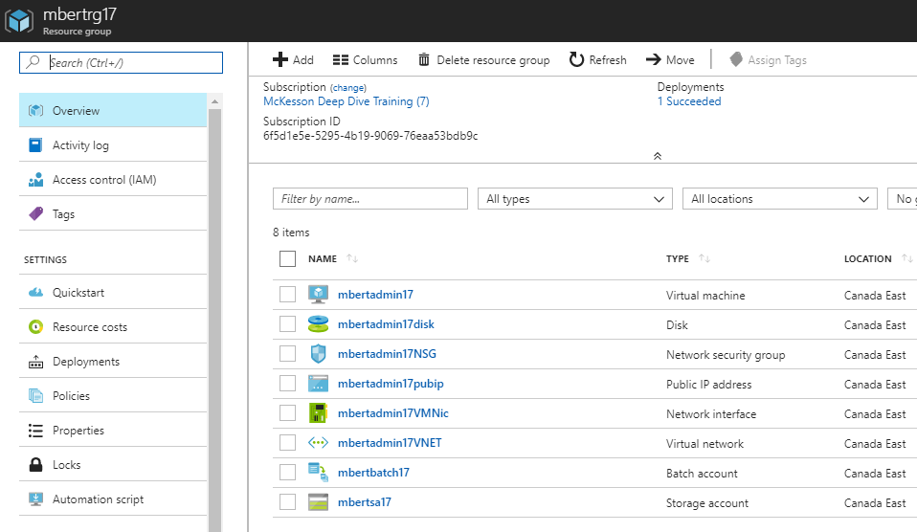

**Detailed explanation of the X12toXML_admin.py script**

This python script performs the following steps:

* Create 3 containers in the storage account:
  + “application”: contains all the scripts that will perform the transformation.
  + “input”: will contain all the X12 format data files.
  + “output”: will contain the XML transformed files.
* Upload the application and input files in the appropriate containers.
* Create a pool that will contain compute nodes.
* Create a job which will contain the tasks.
* Create tasks inside the job. One task is created per input file. Each task uploads the converted file to the “output” storage container.
* Waits for all tasks to complete.
* Download the output files from the output container.
* Delete the storage containers.
* Delete the job.
* Delete the pool.

The reason most resources are deleted is to reduce costs, since storage space is not free.

**X12toXML_admin_config.py**

X12toXML_admin.py uses certain values to be able to connect to the batch and storage accounts, and configure Azure Batch. The file is created while the infrastructure is built.

_BATCH_ACCOUNT_NAME = 'mbertbatch17'

_BATCH_ACCOUNT_KEY = 'QZJQExTyseDe7r5iyti0Z55ahMDFZ6gct3BtIPOur4d2qOMyZsblvgaqyJH2ndD3dW1T28t/GZZAd9wJxSIecA=='

_BATCH_ACCOUNT_URL = 'htps://mbertbatch17.canadaeast.batch.azure.com'

_STORAGE_ACCOUNT_NAME = 'mbertsa17'

_STORAGE_ACCOUNT_KEY = 'tEa7r63QsucmVSeszVHE/OUQy3oFnMgVcS7unYxklimQ4AksxhzcbzqCF3/3iMl65jgebuw653P68tkXx2Wwqw=='

_POOL_ID = 'X12toXMLPool'

_POOL_NODE_COUNT = 1

_JOB_ID = 'X12toXMLJob'

The variables and values are imported by X12toXML_admin.py. This prevents having to manually edit that script to put these values.

**Connect to VM mbertadmin17, using SSH:**

mbert@mb-mint18 ~ $ sshpass -p "SOMEPASSWORD" ssh -o StrictHostKeyChecking=no mbert@52.242.22.59

Welcome to Ubuntu 16.04.3 LTS (GNU/Linux 4.11.0-1016-azure x86_64)

* Documentation: https://help.ubuntu.com

* Management: https://landscape.canonical.com

* Support: https://ubuntu.com/advantage

Get cloud support with Ubuntu Advantage Cloud Guest:

http://www.ubuntu.com/business/services/cloud

14 packages can be updated.

14 updates are security updates.

mbert@mbertadmin17:~$

**Run X12toXML_admin.py:**

mbert@mbertadmin17:~$ pwd

/home/mbert

mbert@mbertadmin17:~$ l

total 8

drwxrwxr-x 2 mbert mbert 4096 Jan 11 00:43 datafiles/

drwxrwxr-x 2 mbert mbert 4096 Jan 11 00:43 scripts/

mbert@mbertadmin17:~$ cd scripts

mbert@mbertadmin17:~/scripts$ l

total 84

-rwxrwxr-x 1 mbert mbert 28705 Jan 11 01:24 edi_handler.py

-rwxrwxr-x 1 mbert mbert 2515 Jan 11 01:24 gen_parser.py

-rwxrwxr-x 1 mbert mbert 41 Jan 11 01:24 requirements.txt

-rwxrwxr-x 1 mbert mbert 1276 Jan 11 01:24 state_machine.py

-rwxrwxr-x 1 mbert mbert 8052 Jan 11 01:24 x12_parser.py

-rwxrwxr-x 1 mbert mbert 1760 Jan 11 01:24 x12_schema.xml

-rwxrwxr-x 1 mbert mbert 469 Jan 11 01:24 X12toXML_admin_config.py

-rwxrwxr-x 1 mbert mbert 20957 Jan 11 01:24 X12toXML_admin.py

mbert@mbertadmin17:~/scripts$ python3 X12toXML_admin.py

X12toXML_admin.py start: 2018-01-11 01:36:21

Creating containers: application, input and output...

Uploading file /home/mbert/scripts/gen_parser.py to container [application]...

Uploading file /home/mbert/scripts/edi_handler.py to container [application]...

Uploading file /home/mbert/scripts/state_machine.py to container [application]...

Uploading file /home/mbert/scripts/x12_parser.py to container [application]...

Uploading file /home/mbert/scripts/x12_schema.xml to container [application]...

Uploading file ../datafiles/File5.X12 to container [input]...

Uploading file ../datafiles/File4.X12 to container [input]...

Uploading file ../datafiles/File3.X12 to container [input]...

Uploading file ../datafiles/File1.X12 to container [input]...

Uploading file ../datafiles/File9.X12 to container [input]...

Uploading file ../datafiles/File6.X12 to container [input]...

Uploading file ../datafiles/File8.X12 to container [input]...

Uploading file ../datafiles/File2.X12 to container [input]...

Uploading file ../datafiles/File7.X12 to container [input]...

[…]

At this point in the execution, we can see via the portal that 3 containers were created in the storage account:

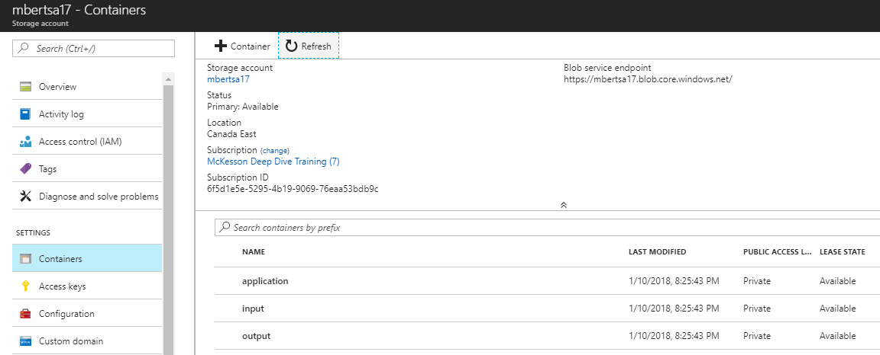

The application container contains the scripts:

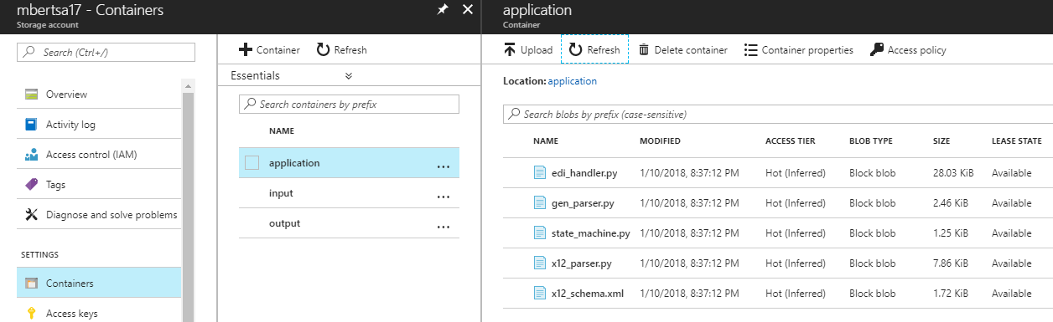

The input container contains the data files:

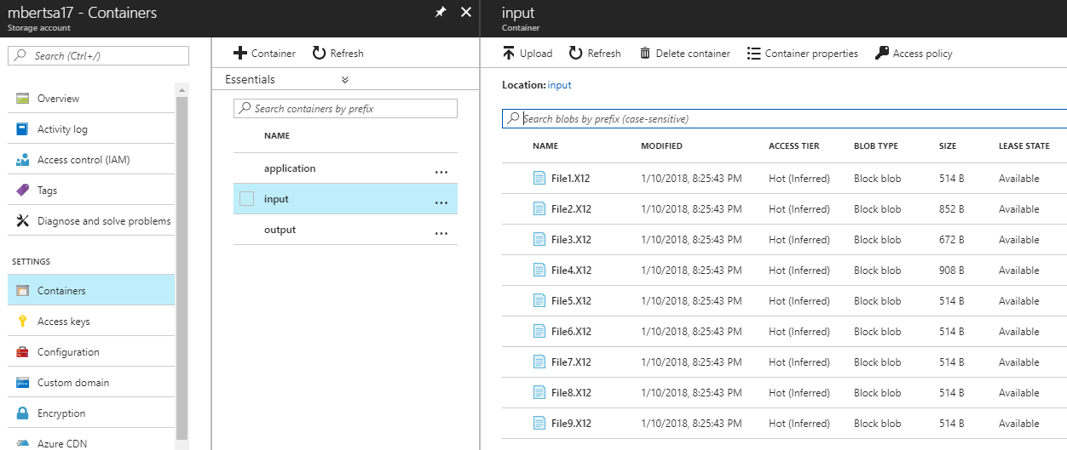

Then the script continues…

[…]

Creating pool [X12toXMLPool]...

[…]

The pool can now be seen in the portal:

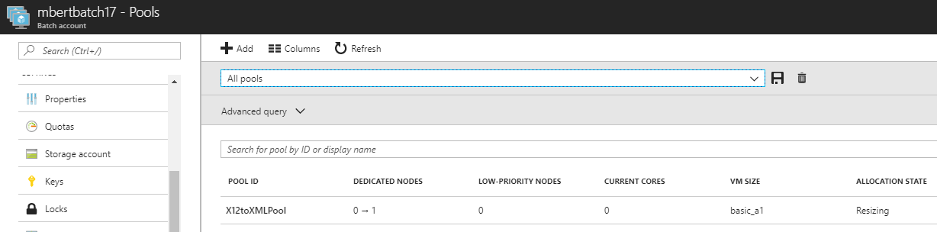

And the start task is defined for the pool:

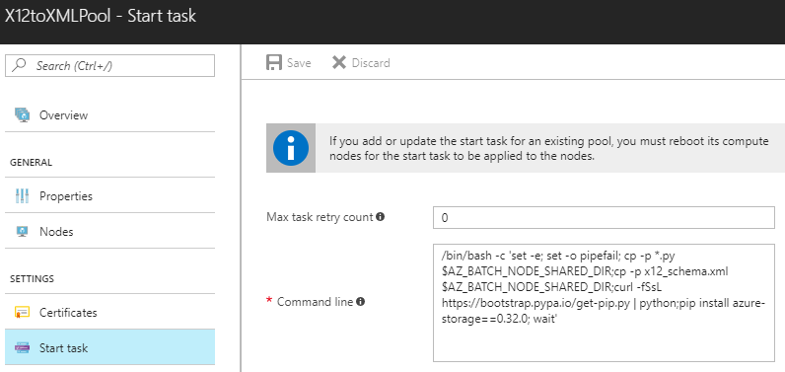

And the scripts are defined as resources for the pool:

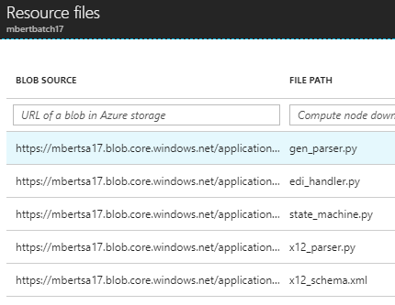

Next, the script does…

[…]

Creating job [X12toXMLJob]...

[…]

The job can be seen in the portal:

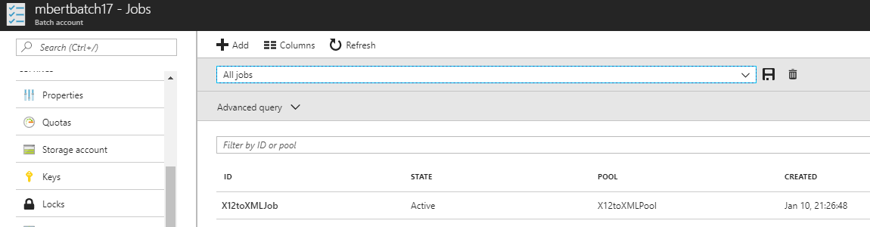

At this point, it contains no task:

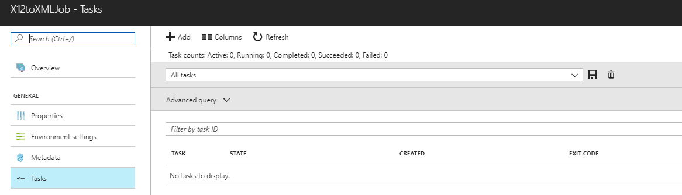

And finally tasks are added to the pool, one per input file. The script waits for the tasks to complete. We can see the newly created tasks in the console:

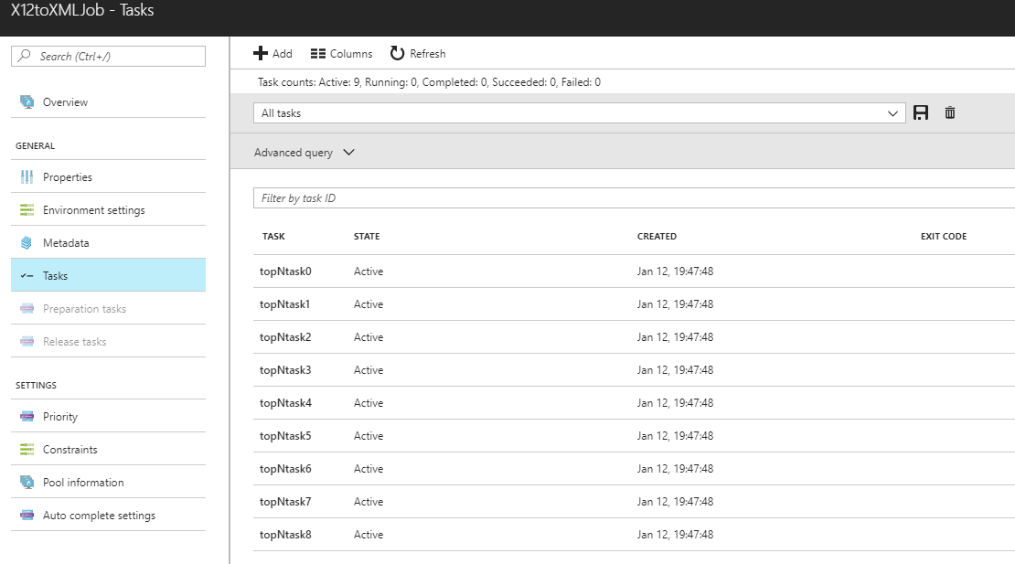

When completed, the exit code of each task is indicated in that same console page.

Each task uploads the converted file to the output container.

These files are visible in the container:

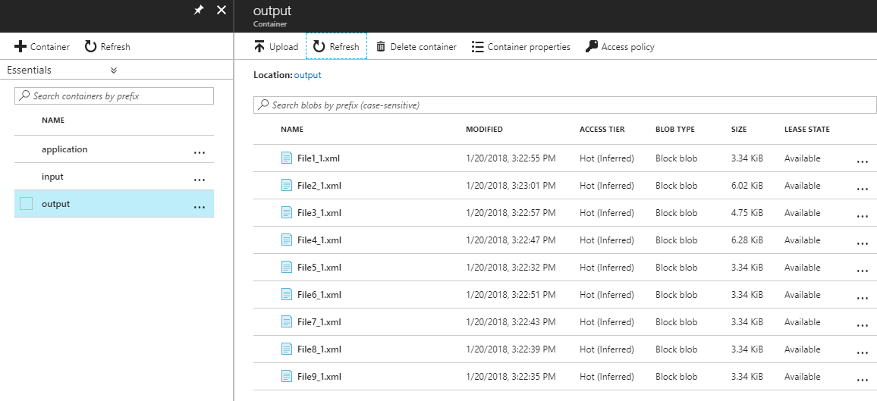

* NOTE: the administration script deletes the containers to eliminate the cost of storing files on Azure. These screen captures were taken while the script was running, just before the output container was deleted.

And the files are downloaded to the administration VM:

mbert@mbertadmin17:~$ pwd

/home/mbert

mbert@mbertadmin17:~$ ls -al

total 84

drwxr-xr-x 6 mbert mbert 4096 Jan 20 20:23 .

drwxr-xr-x 3 root root 4096 Jan 20 20:11 ..

-rw-r--r-- 1 mbert mbert 220 Aug 31 2015 .bash_logout

-rw-r--r-- 1 mbert mbert 3771 Aug 31 2015 .bashrc

drwx------ 2 mbert mbert 4096 Jan 20 20:13 .cache

drwxrwxr-x 2 mbert mbert 4096 Jan 20 20:13 datafiles

-rw-rw-r-- 1 mbert mbert 3419 Jan 20 20:23 File1_1.xml

-rw-rw-r-- 1 mbert mbert 6168 Jan 20 20:23 File2_1.xml

-rw-rw-r-- 1 mbert mbert 4859 Jan 20 20:23 File3_1.xml

-rw-rw-r-- 1 mbert mbert 6431 Jan 20 20:23 File4_1.xml

-rw-rw-r-- 1 mbert mbert 3419 Jan 20 20:23 File5_1.xml

-rw-rw-r-- 1 mbert mbert 3419 Jan 20 20:23 File6_1.xml

-rw-rw-r-- 1 mbert mbert 3419 Jan 20 20:23 File7_1.xml

-rw-rw-r-- 1 mbert mbert 3419 Jan 20 20:23 File8_1.xml

-rw-rw-r-- 1 mbert mbert 3419 Jan 20 20:23 File9_1.xml

-rw-r--r-- 1 mbert mbert 655 May 16 2017 .profile

drwxrwxr-x 3 mbert mbert 4096 Jan 20 20:18 scripts

drwx------ 2 mbert mbert 4096 Jan 20 20:11 .ssh

-rw-r--r-- 1 mbert mbert 0 Jan 20 20:13 .sudo_as_admin_successful

mbert@mbertadmin17:~$

The XML files can then be copied (or moved) to the server for the next step in the process.

The complete output of the script when it runs looks like this:

mbert@mbertadmin17:~/scripts$ l

edi_handler.py* helpers.py* state_machine.py* x12_schema.xml* X12toXML_admin.py*

gen_parser.py* requirements.txt* x12_parser.py* X12toXML_admin_config.py*

mbert@mbertadmin17:~/scripts$ python3 X12toXML_admin.py

X12toXML_admin.py start: 2018-01-20 20:18:35

Creating containers: application, input and output...

Uploading file /home/mbert/scripts/gen_parser.py to container [application]...

Uploading file /home/mbert/scripts/edi_handler.py to container [application]...

Uploading file /home/mbert/scripts/state_machine.py to container [application]...

Uploading file /home/mbert/scripts/x12_parser.py to container [application]...

Uploading file /home/mbert/scripts/x12_schema.xml to container [application]...

Uploading file ../datafiles/File5.X12 to container [input]...

Uploading file ../datafiles/File8.X12 to container [input]...

Uploading file ../datafiles/File1.X12 to container [input]...

Uploading file ../datafiles/File7.X12 to container [input]...

Uploading file ../datafiles/File6.X12 to container [input]...

Uploading file ../datafiles/File9.X12 to container [input]...

Uploading file ../datafiles/File4.X12 to container [input]...

Uploading file ../datafiles/File3.X12 to container [input]...

Uploading file ../datafiles/File2.X12 to container [input]...

Creating pool [X12toXMLPool]...

Creating job [X12toXMLJob]...

Adding 9 tasks to job [X12toXMLJob]...

Monitoring all tasks for 'Completed' state, timeout in 0:20:00..............................................................................................................................................................................................................................................................

Success! All tasks reached the 'Completed' state within the specified timeout period.

Downloading all files from container [output]...

Downloaded blob [File1_1.xml] from container [output] to /home/mbert/File1_1.xml

Downloaded blob [File2_1.xml] from container [output] to /home/mbert/File2_1.xml

Downloaded blob [File3_1.xml] from container [output] to /home/mbert/File3_1.xml

Downloaded blob [File4_1.xml] from container [output] to /home/mbert/File4_1.xml

Downloaded blob [File5_1.xml] from container [output] to /home/mbert/File5_1.xml

Downloaded blob [File6_1.xml] from container [output] to /home/mbert/File6_1.xml

Downloaded blob [File7_1.xml] from container [output] to /home/mbert/File7_1.xml

Downloaded blob [File8_1.xml] from container [output] to /home/mbert/File8_1.xml

Downloaded blob [File9_1.xml] from container [output] to /home/mbert/File9_1.xml

Download complete!

Deleting containers...

Sample end: 2018-01-20 20:23:03

Elapsed time: 0:04:28

Press ENTER to exit...

mbert@mbertadmin17:~/scripts$

**Lessons learned**

**#1: monitoring**

The administration script only shows the tasks are completed, but does not show the exit code. While it is running, the status and exit codes can be seen in the console:

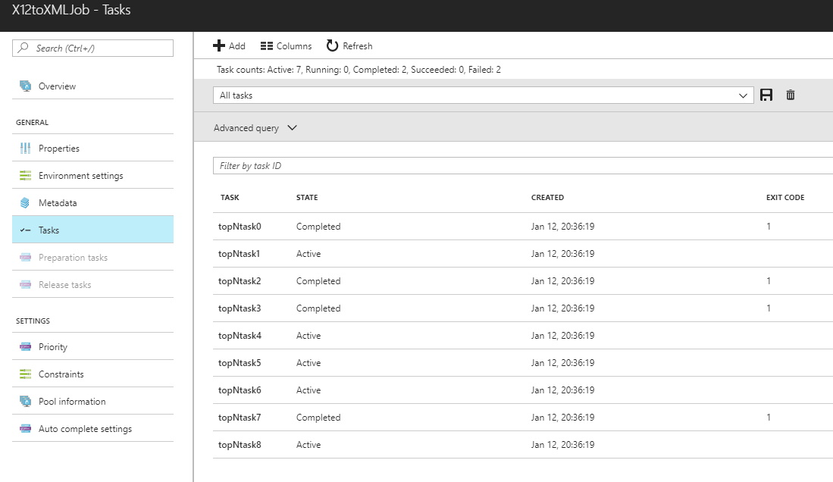

**#2: troubleshooting**

When the admin script was first run, the tasks failed. To debug, you can use:

* The tasks remain in the job and can be accessed by clicking on them:

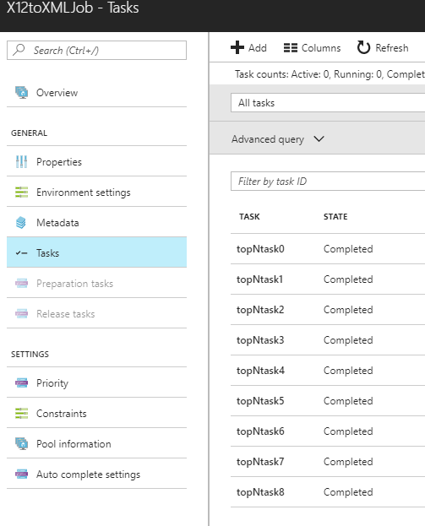

* When clicking on a task, you can verify it’s properties:

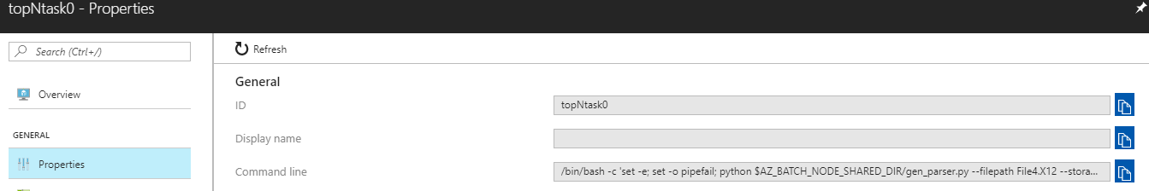

* The most important value to verify here is the value of “Command line”.

/bin/bash -c 'set -e; set -o pipefail; python $AZ_BATCH_NODE_SHARED_DIR/gen_parser.py --filepath File4.X12 --storageaccount mbertsa17 --storagecontainer output --sastoken "sr=c&sig=HcUiYlVXybBPRozvSLVA6Ad41jGQz32WUdwrboSVSoE%3D&sp=w&sv=2017-04-17&se=2018-01-13T02%3A47%3A48Z"; wait'

* Resource files:

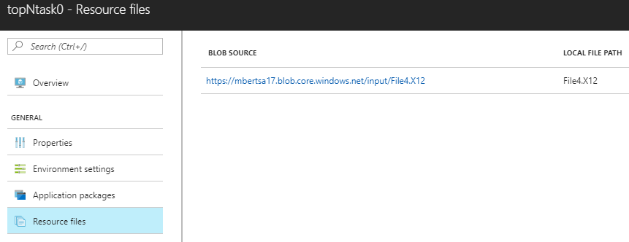

* The files on the node:

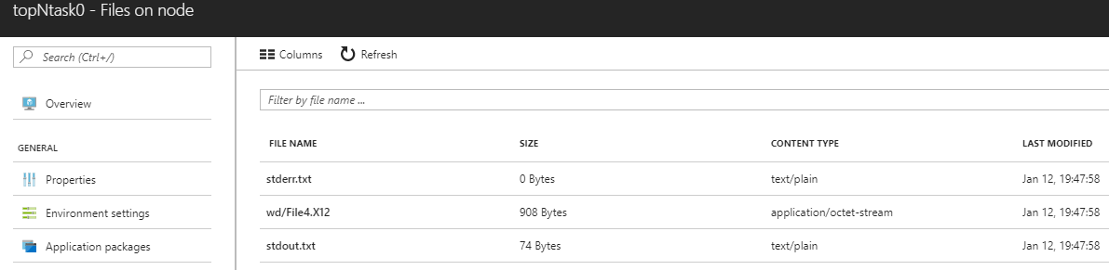

* In this particular example, stdout.txt showed:

Usage is:

gen_parser.py <EDI input file> [XML output file prefix]

Quite simply, the arguments defined in the Command line do not match the expected arguments of the script. This was corrected.

**#3: troubleshooting**

* Similar to #2, but this one did not show anything in stdout.txt. This time, it was in strerr.txt:

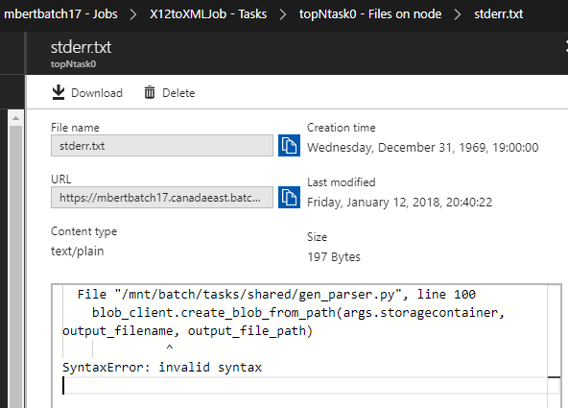

This example shows that any python error will be kept in the stderr.txt file, to facilitate debugging.

**#4: Accessing a node**

* More in depth troubleshooting can be done by accessing a node directly.
* Select the node:

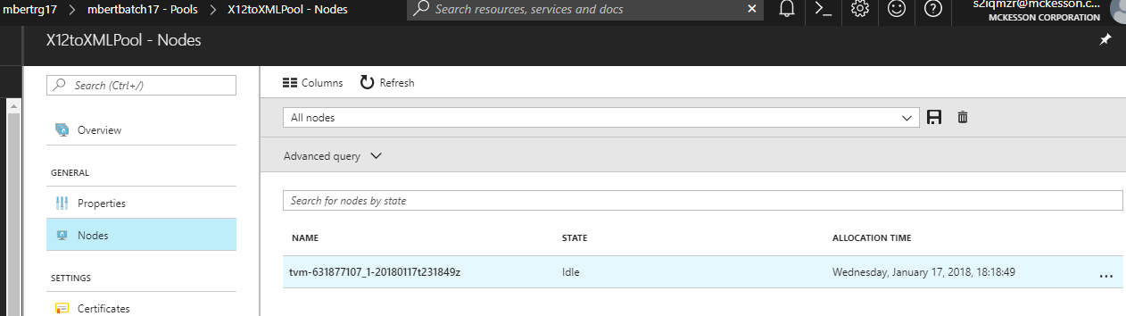

* Click on the  icon and select “Connect”.
* It will permit you to add a user:

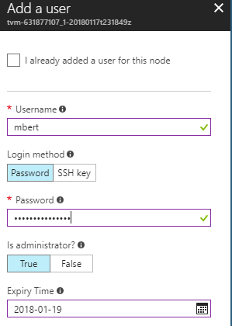

* … and will then provide connection information:

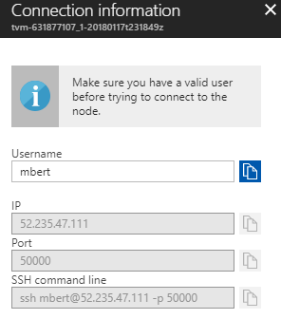

* Once on the node, you can troubleshoot, like you would with any other system.
* The user you created has full sudo rights.
* The files copied from the Storage Account containers are located in directories under /mnt/batch/tasks

**#5: Batch Labs** (<https://azure.github.io/BatchLabs/>)

* Use it to create, debug and monitor Batch applications.
* Available for Linux, Windows and OSX.
* You connect to it like you would do for the portal.
* Batch resources can be created directly in the tool. This is the view in Batch Labs after creating the demo Azure Batch resources (running X12toXML_admin_create.bash). There are no job, no pool and no app package at this point.

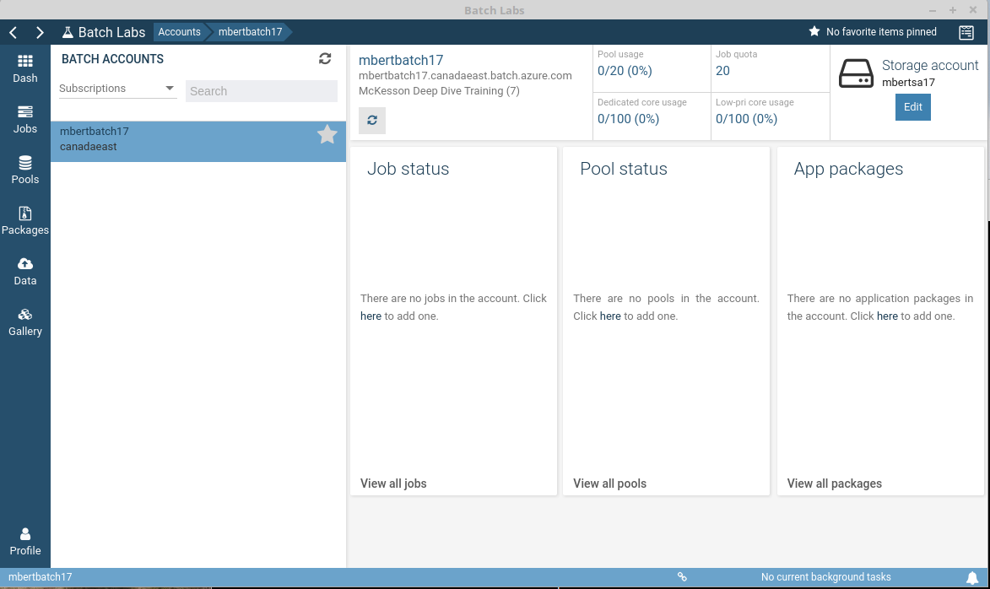

* After connecting to the administration VM (mbertadmin01), you can run the X12toXML_admin.py script. Batch Lab will then show:

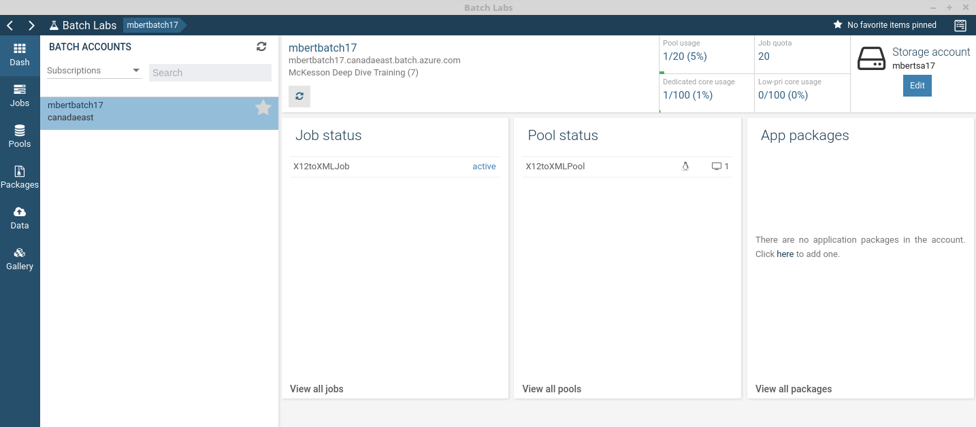

* You can see the created Job (X12toXMLJob) and the pool (X12toXMLPool).
* Also notice that the pool usage is no longer 0/20. A node was created.
* That node is 1/100 dedicated core available to this batch account.
* While the script is running, you can monitor the pool. Here it is starting the first node:

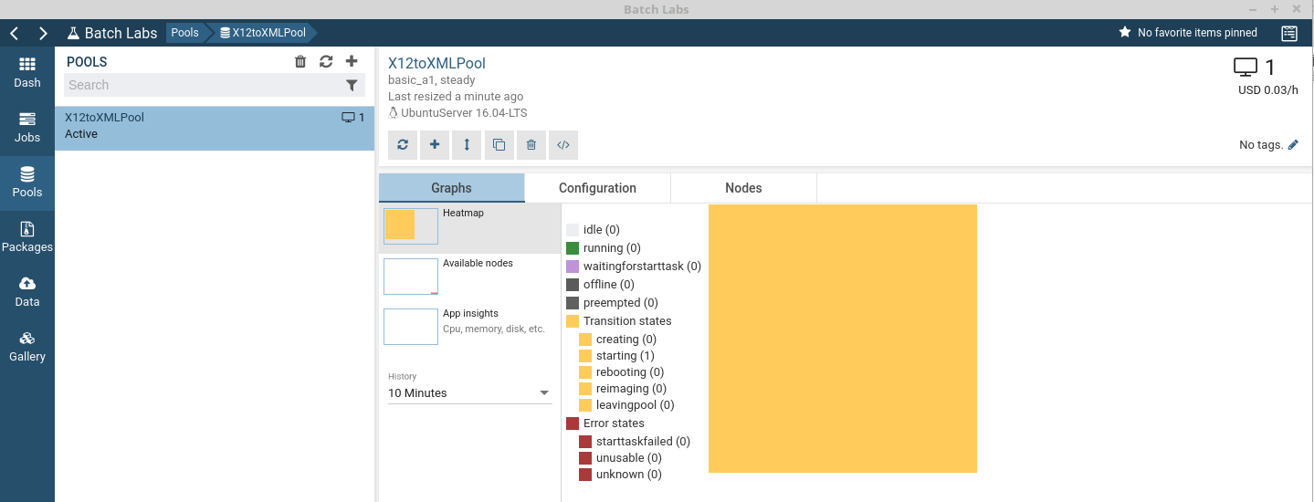

* While the node is executing tasks, it’s status turns to green:

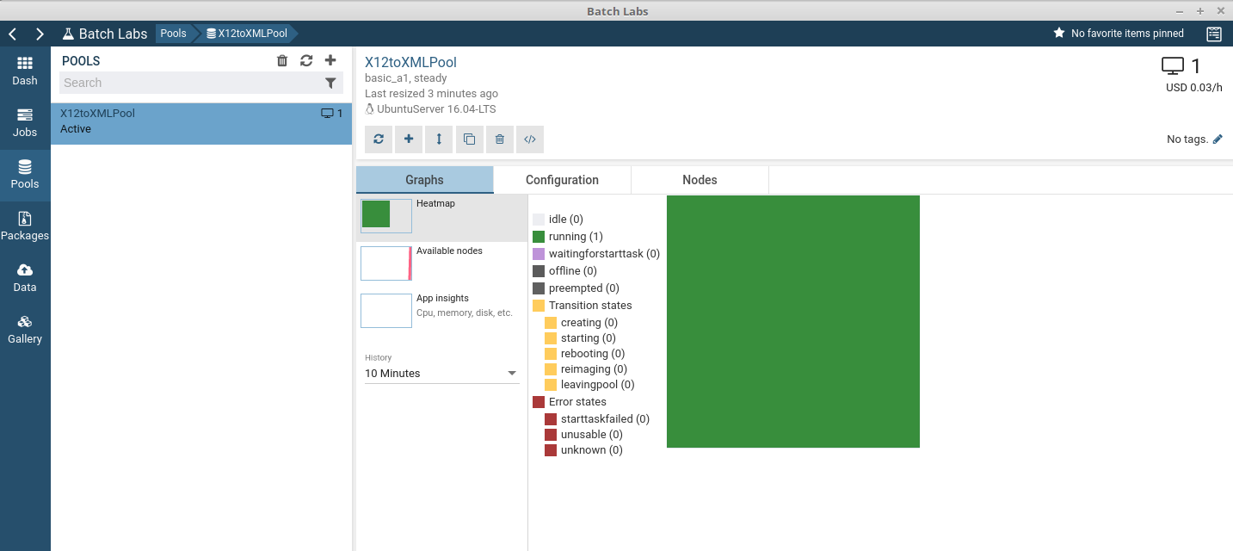

* You can also monitor the job:

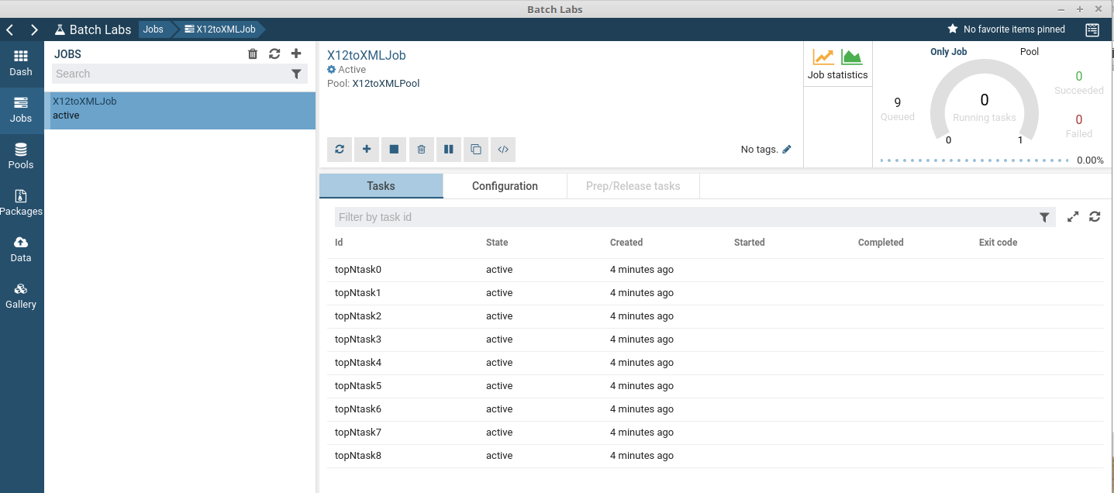

* Note that the administration script used in this demo deletes the job and pool when done. They do not appear in Batch Labs after this deletion. If you require viewing the historical data, edit the script to not delete the batch resources.

**Note:** Batch Explorer (<https://github.com/Azure/azure-batch-samples/tree/master/CSharp/BatchExplorer>)

Although referenced on some sites, this tool is no longer updated. Hence new Batch features will not be available, and will eventually be unusable. Use Batch Labs.

**Licenses**

All code created for this project

<https://creativecommons.org/licenses/by-sa/4.0/>

<https://creativecommons.org/licenses/by-sa/4.0/legalcode>

X12 to XML Python code:

Based on an article from

Jeremy Jones

Processing EDI Documents into XML with Python

http://www.devx.com/enterprise/Article/26854

Used under permission for single use, non-commercial:

You may use one of our articles for a non-commercial project (for example, a school project)

provided that QuinStreet's copyright clause accompanies the article:

Reproduced with permission.

Copyright 1999-2018 QuinStreet, Inc. All rights reserved.

Available at http://www.devx.com/licensing

X12toXML_admin.py

Based on Based on python_tutorial_client.py from Microsoft

# Copyright (c) Microsoft Corporation

#

# All rights reserved.

#

# MIT License

#

# Permission is hereby granted, free of charge, to any person obtaining a

# copy of this software and associated documentation files (the "Software"),

# to deal in the Software without restriction, including without limitation

# the rights to use, copy, modify, merge, publish, distribute, sublicense,

# and/or sell copies of the Software, and to permit persons to whom the

# Software is furnished to do so, subject to the following conditions:

#

# The above copyright notice and this permission notice shall be included in

# all copies or substantial portions of the Software.

#

# THE SOFTWARE IS PROVIDED *AS IS*, WITHOUT WARRANTY OF ANY KIND, EXPRESS OR

# IMPLIED, INCLUDING BUT NOT LIMITED TO THE WARRANTIES OF MERCHANTABILITY,

# FITNESS FOR A PARTICULAR PURPOSE AND NONINFRINGEMENT. IN NO EVENT SHALL THE

# AUTHORS OR COPYRIGHT HOLDERS BE LIABLE FOR ANY CLAIM, DAMAGES OR OTHER

# LIABILITY, WHETHER IN AN ACTION OF CONTRACT, TORT OR OTHERWISE, ARISING

# FROM, OUT OF OR IN CONNECTION WITH THE SOFTWARE OR THE USE OR OTHER

# DEALINGS IN THE SOFTWARE.

Batch Labs

BatchLabs, version 0.0.1

Copyright (c) Microsoft Corporation

All rights reserved.

MIT License

Permission is hereby granted, free of charge, to any person obtaining a copy of this software and associated documentation files (the ""Software""), to deal in the Software without restriction, including without limitation the rights to use, copy, modify, merge, publish, distribute, sublicense, and/or sell copies of the Software, and to permit persons to whom the Software is furnished to do so, subject to the following conditions:

The above copyright notice and this permission notice shall be included in all copies or substantial portions of the Software.

THE SOFTWARE IS PROVIDED *AS IS*, WITHOUT WARRANTY OF ANY KIND, EXPRESS OR IMPLIED, INCLUDING BUT NOT LIMITED TO THE WARRANTIES OF MERCHANTABILITY, FITNESS FOR A PARTICULAR PURPOSE AND NONINFRINGEMENT. IN NO EVENT SHALL THE AUTHORS OR COPYRIGHT HOLDERS BE LIABLE FOR ANY CLAIM, DAMAGES OR OTHER LIABILITY, WHETHER IN AN ACTION OF CONTRACT, TORT OR OTHERWISE, ARISING FROM, OUT OF OR IN CONNECTION WITH THE SOFTWARE OR THE USE OR OTHER DEALINGS IN THE SOFTWARE.